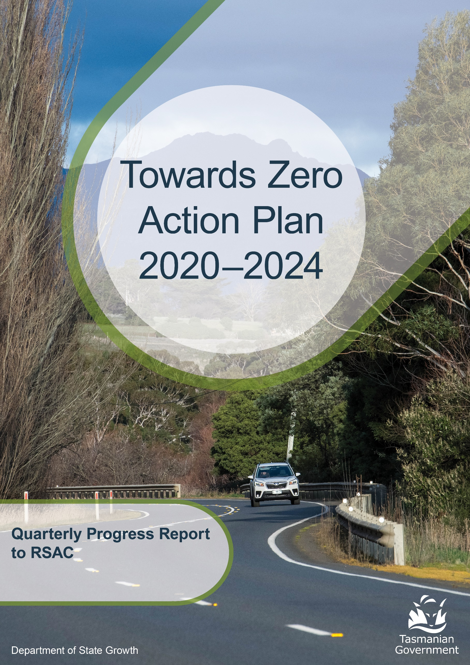
to 30 June 2025
Contents
Progress on meeting Towards Zero Strategy targets 3
Serious Casualties 3
Fatalities 3
2025 YTD 3
Serious Casualties Tasmania – Annual Count, Percentage Split by Quarter and Towards Zero Target 3
Annual fatalities – Rate per 100,000 population 4
Progress on meeting MAIB targets 5
Fatalities – 12 Month Rolling Total 5
Total Serious Claims – 12 Month Rolling Total 5
Statistics 6
Serious Casualties by Quarter by Age Group – 12 period moving average 6
Serious Casualties by Quarter by Sex – 12 period moving average 6
6
Serious Casualties by Quarter by Road User Type – 12 period moving average 7
Serious Casualties by Quarter by Speed Zone – 12 period moving average 7
Serious Casualties by Quarter by Crash Type (DCA) – 12 period moving average 8
Serious Casualties by Quarter by Urban/Non-Urban – 12 period moving average 8
Serious Casualty locations to 30 June 2025 (Black = Fatality, Red = Serious Injury) 9
Key themes and priority actions 2020-2024 10
Funding of key themes 10
Project status report 11
Progress on key themes 12
Rural roads grants program for local government 12
Infrastructure upgrades on low volume State roads 12
Motorcyclist safety on rural roads 13
Speed management and community engagement strategy 13
Safe system knowledge and skills training 14
Targeted infrastructure upgrades in high traffic urban areas 15
Vulnerable Road User Program 15
Community Road Safety Grants Program 16
Trial of innovative technologies 16
Innovative infrastructure treatment demonstrations 17
Learner Driver Mentor Program and Driver Mentoring Tasmania 18
Graduated Licensing System Project 18
Motorcyclist Graduated Licensing System review 19
RYDA program 20
Driving for Jobs Program 21
RACT education initiatives 21
Real Mates media campaign 22
Bicycle Network bike education 22
Safety around schools 23
Kidsafe child restraint check program 24
Full Gear motorcycle safety project 25
RACT Youth Road Safety Program 25
Inattention and distraction 28
Safe behaviour campaigns 29
Mandatory Alcohol Interlock Program (MAIP) 29
Protective clothing for motorcyclists 30
Road safety penalties review 30
Speed enforcement strategy 31
Enforcement of high-risk behaviours 31
Automated Traffic Enforcement Program 32
High-risk motorcycling enforcement 33
Road Rules Awareness 33
Tourist road safety signage program 34
Responsive electronic signage trial 34
Tourist education materials 34
Strategic partnerships 34
Tourist education at gateway entry points 35
Stakeholder alliances 35
Australasian New Car Assessment Program (ANCAP) 36
Safer cars for young drivers 36
Autonomous vehicle and crash avoidance readiness 36
Workplace driver safety 37
Light vehicle safety strategy 37

Progress on meeting Towards Zero Strategy targets
The key interim target for the Towards Zero – Tasmanian Road Safety Strategy 2017-2026 (Towards Zero Strategy) is to reduce the number of annual serious injuries and deaths on Tasmanian roads to fewer than 200 by 2026. This is an ambitious target of 100 fewer serious casualties per year than for the period 2012-2016 (annual average) and will move us towards the long-term goal of zero serious casualties on Tasmanian roads.

Serious Casualties
The number of serious casualties in 2024 was 336, compared to 345 in 2023, a 2.6 per cent decrease. The 2024 figure of 336 is a 8.2 per cent increase on the five year serious casualty average of 310.6 (2019-2023).

Fatalities
In 2024, there were 31 fatalities on Tasmanian roads which is 2 fewer than the number recorded in 2023. The figure of 31 fatalities in 2024 is a 16.2 per cent decrease on the five-year fatality average of 37 (2019-2023).

2025 YTD
There have been 185 serious casualties (26 fatalities and 159 serious injuries) to 30 June 2025, 18 more than the number recorded at the same time in 2024 (9 fatalities and 158 serious injuries) and an increase of 13.1 per cent on the five year average of 163.6 serious casualties.

Serious Casualties Tasmania – Annual Count, Percentage Split by Quarter and Towards Zero Target
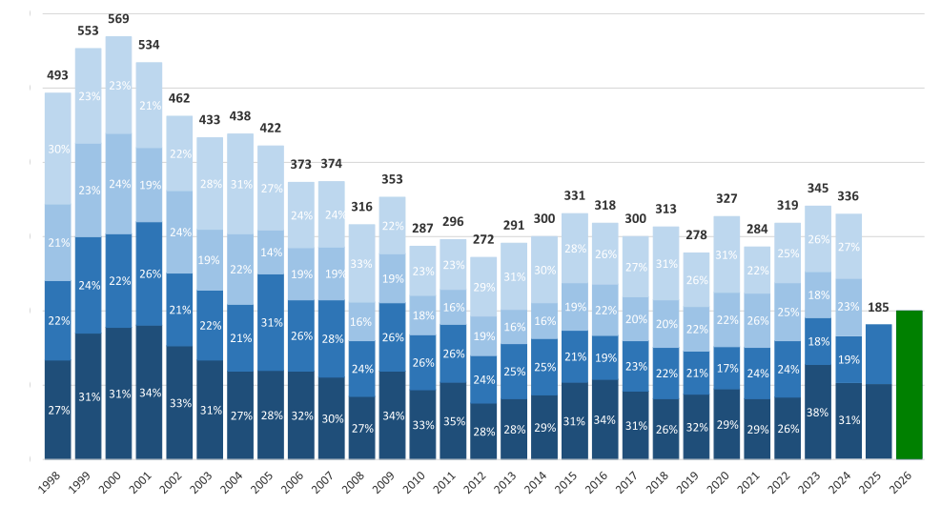

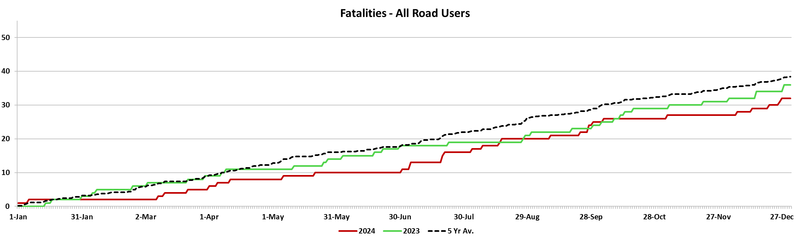

Annual fatalities – Rate per 100,000 population
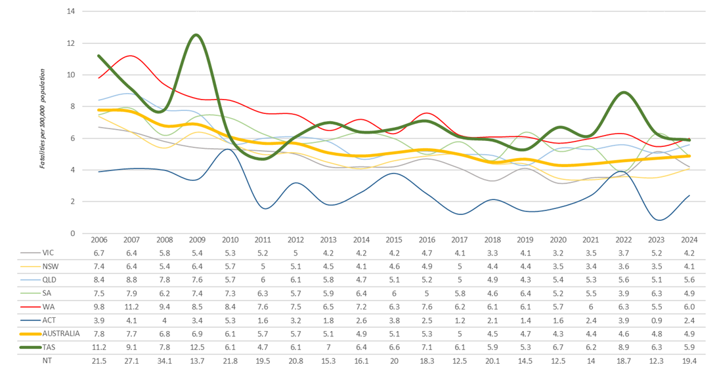

Note: NT omitted from chart for clarity purposes.

Progress on meeting MAIB targets
Motor Accidents Insurance Board (MAIB) injury statistics show the number of fatalities and the level of claims for serious injuries on our roads.
Various claim reduction targets are specified in the Memorandum of Understanding between the Department of State Growth (State Growth) and the MAIB. Progress against high level targets is shown below, expressed as 12 month moving totals.

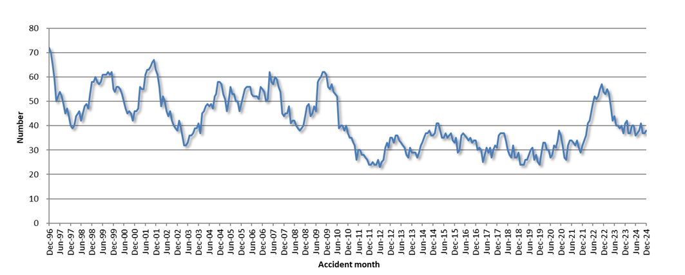
Fatalities – 12 Month Rolling Total

Total Serious Claims – 12 Month Rolling Total
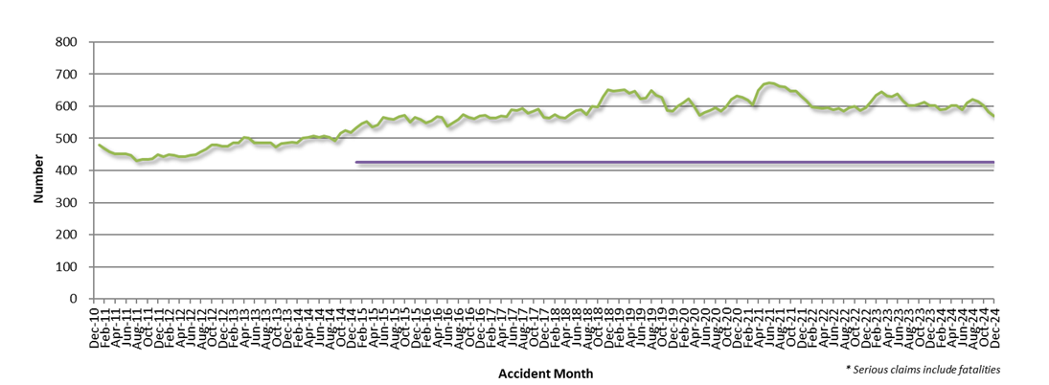

Statistics

Serious Casualties by Quarter by Age Group – 12 period moving average
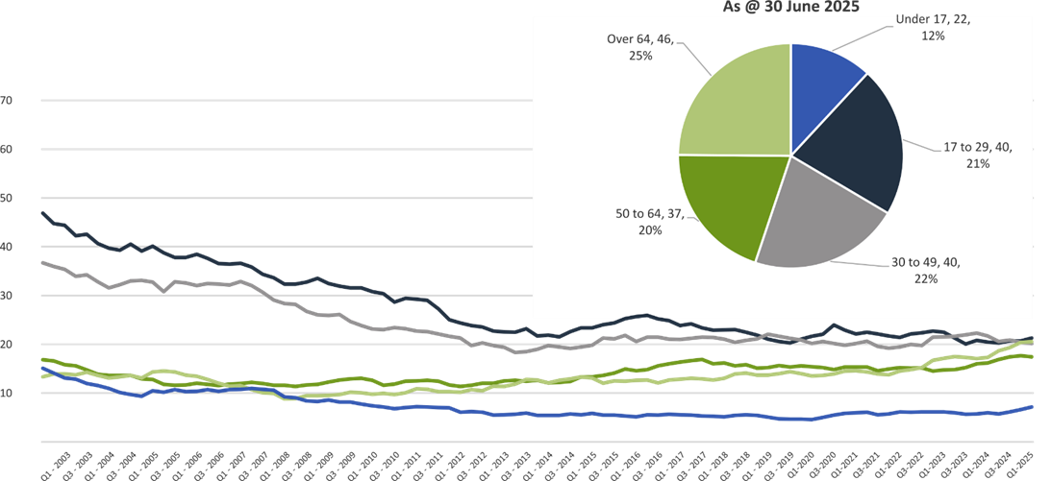

Serious Casualties by Quarter by Sex – 12 period moving average
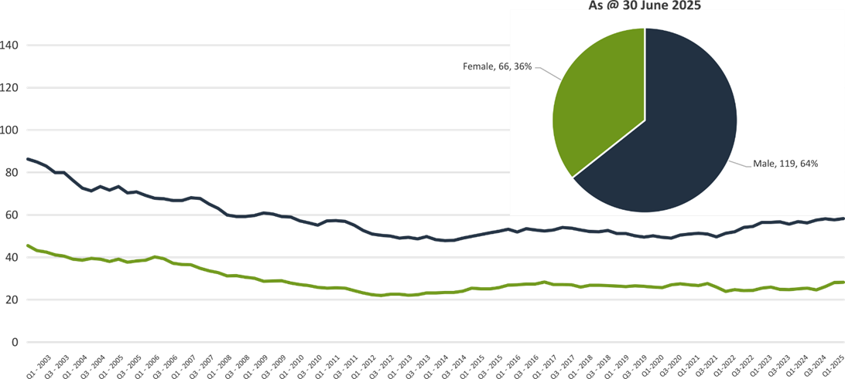

Serious Casualties by Quarter by Road User Type – 12 period moving average
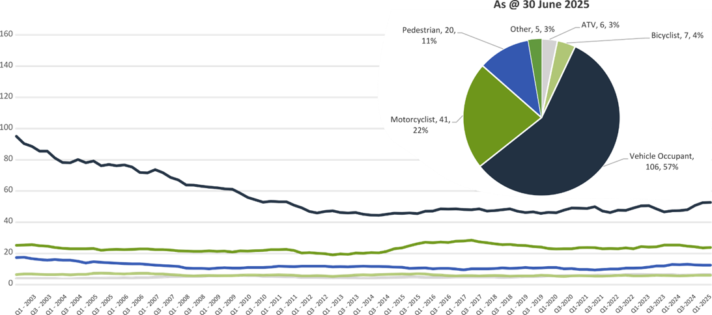

Serious Casualties by Quarter by Speed Zone – 12 period moving average
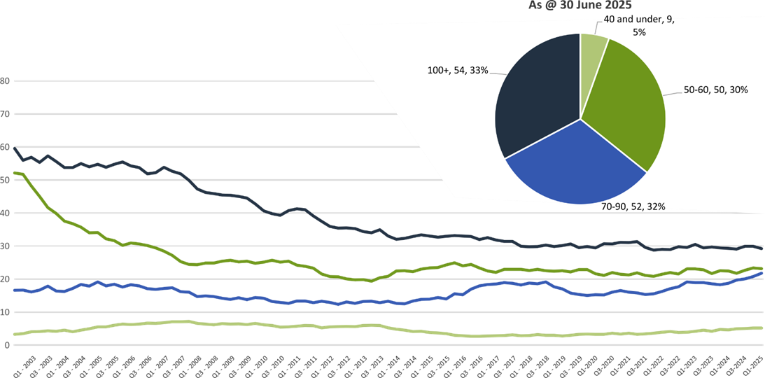

Pie chart excludes serious casualties where speed zone is recorded as ‘not known’

Serious Casualties by Quarter by Crash Type (DCA) – 12 period moving average
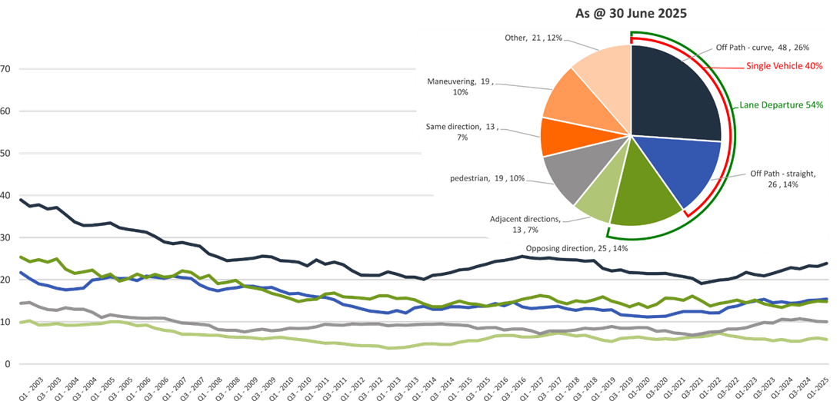

Other includes crash types: on-path (3%), overtaking (1%) & passenger and miscellaneous (3%).

Serious Casualties by Quarter by Urban/Non-Urban – 12 period moving average
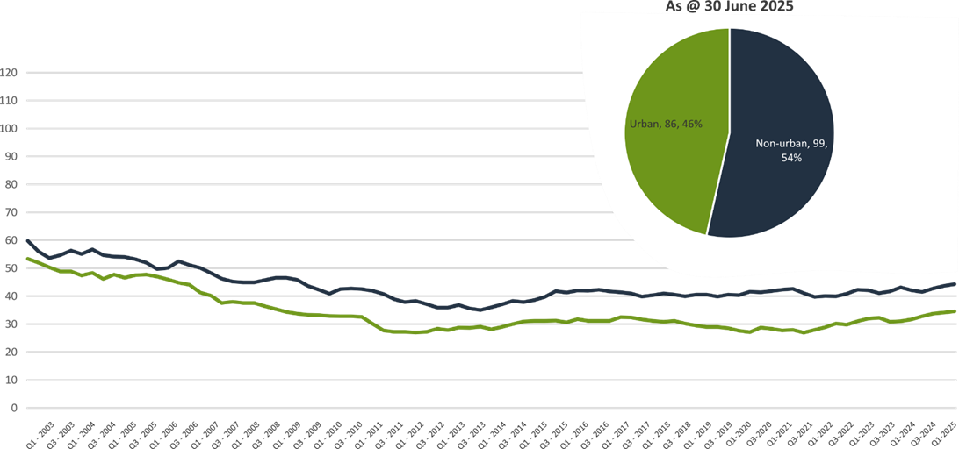

Based on the Australian Bureau of Statistics’ ‘significant urban area’ geographic definition.

Serious Casualty locations to 30 June 2025 (Black = Fatality, Red = Serious Injury)
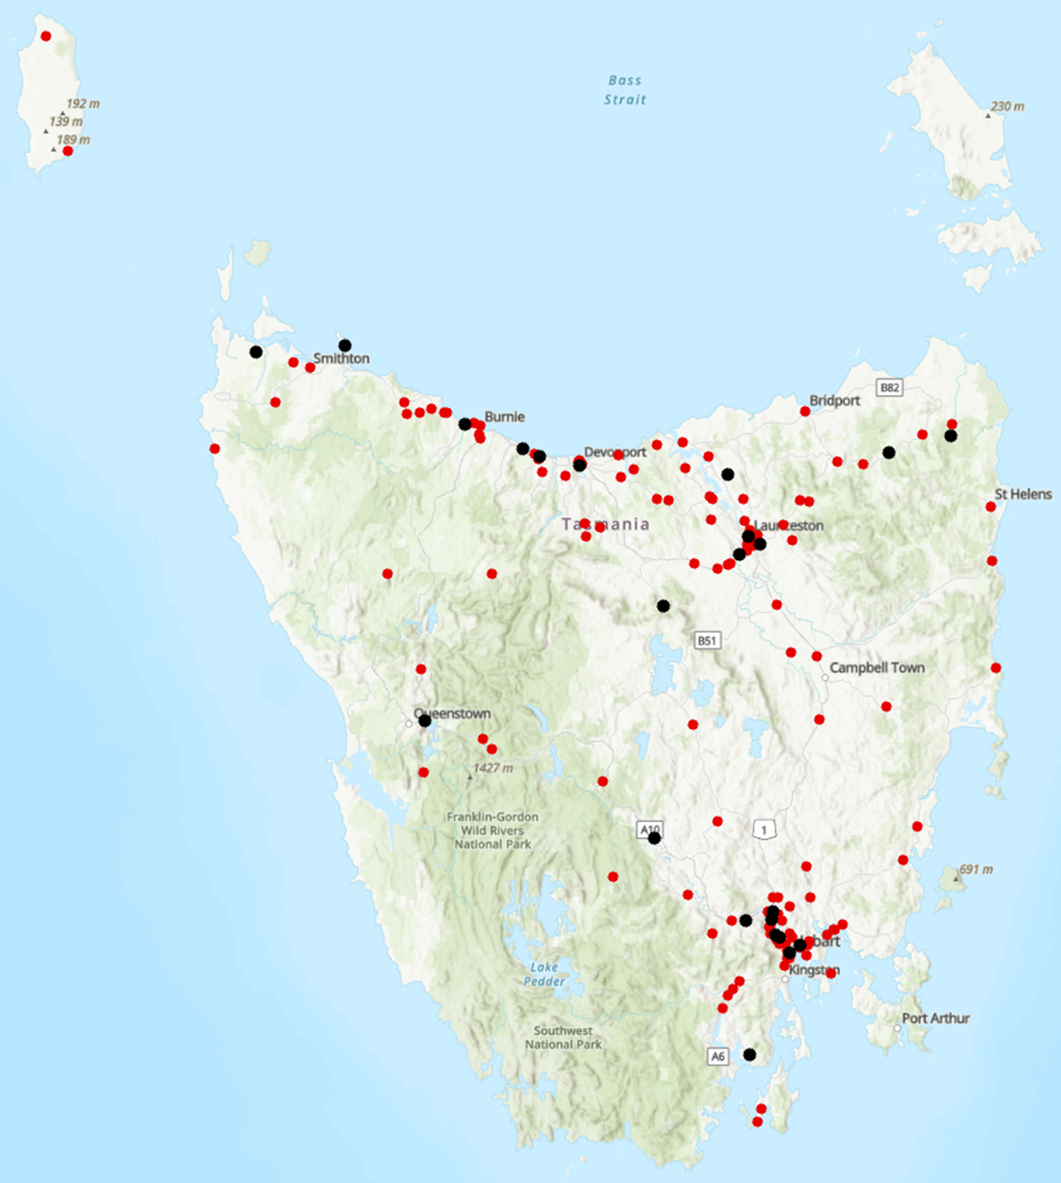

Key themes and priority actions 2020-2024
The Quarterly Progress Report details progress on key themes and priority actions under the Towards Zero Action Plan 2020-2024 and the Towards Zero – Tasmanian Road Safety Strategy 2017-2026.
The progress report should be read in conjunction with the Action Plan and understood in the context of the Towards Zero Strategy. These documents are available at: www.towardszero.tas.gov.au

Funding of key themes




Over $20 million Over $31 million
Over $12 million Over $4 million



$2 million Over $3 million

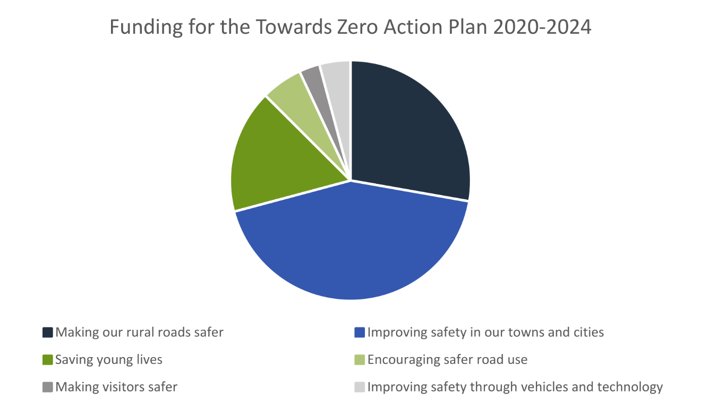

Project status report
Making our rural roads safer
Rural road grants program for local government | On schedule |  | Infrastructure upgrades on low volume State roads | On schedule
Motorcyclist safety on rural roads | On schedule |  | Speed moderation and community engagement strategy | On schedule
Safe system knowledge and skills training | On schedule
Improving safety in our cities and towns
Targeted infrastructure upgrades in high traffic urban areas | Not yet commenced |  | Vulnerable Road User Program | On schedule
Community Road Safety Program | On schedule |  | Trial of innovative technologies | On schedule
Innovative infrastructure treatment demonstrations | Not yet commenced
Saving young lives
Learner Driver Mentor Program and Driver Mentoring Tasmania | On schedule |  | Graduated Licensing System Project for drivers | Complete
Rotary Youth Driver Awareness Program | On schedule |  | Driving for Jobs Program | On schedule
RACT education initiatives | On schedule |  | Real Mates media campaign | On schedule
Bicycle Network bike education | On schedule |  | Safety around schools | On schedule
Kidsafe child restraint check program | On schedule |  | Full Gear motorcycle safety project | On schedule
Develop a Graduated Licensing System for motorcyclists | On schedule |  | RACT Youth Road Safety Program | On schedule
Encouraging safer road use
Inattention and distraction | On schedule |  | Safe behaviour campaigns | On schedule
Mandatory Alcohol Interlock Program | Major delays |  | Protective clothing for motorcyclists | On schedule
Road safety penalties review | On schedule |  | Speed enforcement strategy | On schedule
Enforcement of high-risk behaviours | On schedule |  | Automated Traffic Enforcement Program | On schedule
High-risk motorcycling enforcement | On schedule |  | Road Rules Awareness | On schedule
Making visitors safer
Tourist road safety signage program | On hold |  | Responsive electronic signage trial | On hold
Tourist education materials | On schedule |  | Strategic partnerships | On hold
Tourist education at gateway entry points | On schedule |  | Stakeholder alliances | On hold
Improving safety through vehicles and technology
ANCAP | On schedule |  | Safer cars for young drivers | Not yet commenced
Autonomous vehicle and crash avoidance readiness | On schedule |  | Workplace driver safety | Not yet commenced
Light vehicle safety strategy | On schedule


Progress on key themes


60 per cent of fatalities occur in rural areas

Rural roads grants program for local government
The Safer Rural Roads Program (SRRP) provides funding to councils to implement infrastructure treatments on rural road corridors to reduce lane departure crashes and the harm when they do occur. The allocation for the SRRP increased from $2 million to $2.5 million under the current Action Plan.
Current situation / comments
The 2025 round of the SRRP opened for applications on 17 March 2025 and closed on 16 May 2025. The SRRP received nine submissions. These applications were assessed by the program’s Assessment Committee on 2 June 2025. A paper has been prepared for the Strategy Oversight Committee (SOC) to endorse the recommended SRRP projects. Following the SOC’s endorsement, a Minute will be prepared for the Minister for final approval of these projects. Once Ministerial approval has been received, local governments will be informed of application outcomes.
The Road Safety Branch continues to work with councils that have outstanding projects from previous funding rounds.
Status | risk |  | On schedule/progressing/low risk

Infrastructure upgrades on low volume State roads
This program will provide funding for lower volume State roads, where cost effective treatments such as shoulder sealing, pavement markings, curve warnings, roadside hazard removal and safety barriers will achieve maximum value for money.
Current situation / comments
This program of works has supported Road Safety Levy co-contributions under the Australian Government’s RSP. This has taken advantage of the opportunity that Australian Government co-funding has presented for targeted shoulder sealing and junction upgrades across Tasmania.
The projects included under the current stage of the Australian Government’s Road Safety Program (2023-2027) include:
- Sheffield Main Road – Shoulder sealing - $12 million
- Frankford Main Road / Chapel Road – Junction realignment - $1.2 million
- Pipers River Road / Waddles Road – Junction realignment - $1.2 million
- Brooker Highway / Foreshore Road – Signalised intersection - $9.7 million
- Midland Highway / Lake Leake Road – Channelised right turn lane - $3.4 million.
Status |  |  | On schedule/progressing/low risk

Motorcyclist safety on rural roads
Road safety audits will be conducted on high-risk touring routes across Tasmania. This program will involve local motorcyclists and a safe system approach will inform audits. Findings will be shared with stakeholders to identify countermeasures that go beyond typical infrastructure solutions.
Current situation / comments
Safe System motorcycle road safety audits
On 28 September 2024, an audit was conducted on the Lyell Highway between Derwent Bridge and Queenstown. The Department of State Growth is currently considering the audit report with selected treatments expected to commence by the end of 2025.
Selected treatments for the Tasman Highway between Scottsdale and St Helens began construction in June 2025 and are expected to be completed by the end of July 2025.
Status |  |  | On schedule/progressing/low risk

Speed management and community engagement strategy
Speed management requires a holistic strategy encompassing public education, road risk assessments, enforcement, speed limit setting, infrastructure measures, vehicle technologies, outcomes and evaluation. This project will involve community engagement to inform and build support for action on safer speeds. A significant ongoing coordination effort will be required to support the strategy.
Current situation / comments
Public consultation on the Speed Management Consultation Paper showed strong support for the draft framework, including principles, proposed action areas and outcomes. Work has now commenced on defining the requirements for Strategy framework, including detailed draft actions, an implementation and evaluation plan, as well as data analysis to inform proposed outcomes. A consultant will be engaged to support this development work, in collaboration with the Department of State Growth and the project governance structure. Due to caretaker conventions, the intention is for a procurement process to follow the outcome of the election in July 2025.
Status |  |  | On schedule/progressing/low risk

Safe system knowledge and skills training
This initiative aims to improve Safe System knowledge for all those in a position to influence road safety outcomes. The initiative will focus on Safe System infrastructure design, including appropriate speed setting, and will consist of technical training sessions, workshops and forums across Tasmania.
Current situation / comments
The Department of State Growth has developed a Safe System induction module to provide an introduction to the Safe System to all Transport Group employees, and staff across Tasmania Police and local government.
All new members of the Transport Group are now automatically enrolled in the unit upon commencing their role. The Department of State Growth has provided the unit to Tasmania Police and the Local Government Association of Tasmania. The unit will also be progressively provided to each local government.
On the 17 and 18 June 2025, Safe System Solutions Pty Ltd held a Safe System Assessments workshop in Hobart that was attended by ten Department of State Growth members, three local government and three Tasmania Police officers.
Status |  |  | On schedule/progressing/low risk


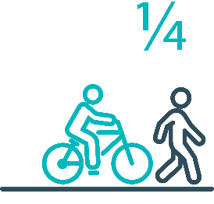
Pedestrians and cyclists are vulnerable and represent one in four serious casualties in our towns and cities

Targeted infrastructure upgrades in high traffic urban areas
This program provides for delivery of a range of infrastructure safety upgrades to make our towns and cities safer. This will include shoulder sealing, intersection improvements, safety barriers and pavement marking at high traffic areas. This program targets high volume state roads that are not planned for major investment in the short term.
Current situation / comments
This initiative has not yet commenced and will be considered as part of the next action plan.
However, funding allocated to this initiative to date, under the Action Plan, has supported the Road Safety Levy co-contributions under the Australian Government’s Road Safety Program (RSP). This has taken advantage of the opportunity that Australian Government co-funding has presented for targeted shoulder sealing and junction upgrades across Tasmania, and the upgrade of nearly 600 electronic school zone signs across approximately 220 locations.
Status |  |  |  | Not yet commenced

Vulnerable Road User Program
The Vulnerable Road User Program (VRUP) is an established grants program which assists local government with the costs of installing safety improvements in built up areas. The aim of the program is to reduce conflict between vehicles and vulnerable road users - cyclists, pedestrians and motorcyclists.
Additionally, the program has a focus on increasing Safe System knowledge and capacity in local governments. The funding available under the VRUP was increased from $1 million to 2 million per annum, under the current Action Plan.
Current situation / comments
The 2025 round of the VRUP opened for applications on 17 March 2025 and closed on 16 May 2025. The VRUP received 31 applications. These applications were assessed by the program’s Assessment Committee on 6 June 2025. A paper has been prepared for the Strategy Oversight Committee (SOC) to endorse the recommended VRUP projects. Following endorsement by the SOC, a Minute will be prepared for the Minister to approve these projects. Once Ministerial approval has been received, local governments will be informed on applications outcomes.
The Road Safety Branch continues to work with councils that have outstanding projects from previous funding rounds.
Status |  |  | On schedule/progressing/low risk

Community Road Safety Grants Program
The Community Road Safety Grants Program (CRSGP) is an established grants program that aims to build community engagement to address local road safety issues. The program supports local councils, schools, community groups, research institutions and charity organisations to promote road safety at the grass roots level.
Current situation / comments
The 2024-25 Community Road Safety Grants Program (CRSGP) opened on 10 March 2025 and closed on 2 May 2025. A total of 14 applications were received, with 12 in the Medium/Large Grants category and two in the Small Grants category. The total funding requested amounted to $399,144. Following assessment and recommendations by the funding panel, 11 applications were approved, resulting in an allocation of $305,844 from the Road Safety Levy (RSL) budget. The unallocated amount of $13,341 will be carried forward to the next CRSGP.
Although the assessment and selection phases have been completed, there have been delays in final ministerial approvals due to the upcoming State Election on 19 July 2025. Final approval from the Minister for Transport is required to issue grant deeds and disburse funds to complete the 2024-25 round.
Status |  |  | On schedule/progressing/low risk

Trial of innovative technologies
This project will include monitoring, investigation and trialling of new and emerging technology based approaches to improving safety for vulnerable road users.
Current situation / comments
The Department of State Growth has agreed to participate in a trial of Motorcycle Perceptual Countermeasures (PCMs) being conducted by the Centre for Automotive Safety Research (CASR), to be largely funded by the Australian Government’s National Road Safety Action Grants (NRSAG) program.
The trial aims to build upon the Austroads report AP-R688-23 Motorcycle Rider Perceptual Countermeasures (April 2023), to undertake further analysis of potential benefits and or risks identified through this study. The Austroads report found that PCM decreased the travel speed of motorcycles at the apex of the treated curves, and better positioned the riders in the lane.
In May 2025, Safe System Solutions facilitated a stakeholder workshop to discuss the possible locations and design of treatments that will be included in the trial. Six Tasmanian representatives attended the meeting. CASR are now finalising the design with the treatments expected to be installed in December 2025.
Status |  |  | On schedule/progressing/low risk

Innovative infrastructure treatment demonstrations
This project will investigate, trial and demonstrate innovative Safe System urban infrastructure treatments to improve road safety in our urban areas. We will work with local councils to show how Tasmania’s cities and towns can be improved for the benefit of all road users, particularly cyclists and pedestrians.
Current situation / comments
This project has not yet commenced and will be considered as part of the next Action Plan
Status |  |  |  | Not yet commenced.




92 young people are seriously injured or killed on our roads every year

Learner Driver Mentor Program and Driver Mentoring Tasmania
The Learner Driver Mentor Program (LDMP), supported by Driver Mentoring Tasmania (DMT), is a well-established program that supports disadvantaged learner drivers to gain supervised on-road driving hours to gain a licence. DMT supports LDMP providers through peak body support and coordination.
Current situation / comments
Between 1 April and 30 June 2025, the LDMP provided 4,504 hours of supervised driving support. During this period, 337 learner drivers were actively engaged in the program, with an additional 454 learners on the waitlist, an increase in demand compared to the same period last year.
Winter months continue to present challenges with mentor retention, impacting the program's capacity to meet learner demand. In response to the increasing need, 14 new volunteer mentors were inducted and trained during the quarter. Additionally, the program is actively exploring options to expand volunteer participation through the Federal Government's Mutual Obligation Scheme to strengthen mentor numbers.
A Funding Assessment Panel was also convened during this quarter to determine the distribution of funding for the 2025–2027 period, ensuring the program remains well-resourced to meet growing community demand.
Status |  |  | On schedule/progressing/low risk

Graduated Licensing System Project
Changes have been made to the Graduated Licensing System (GLS) for drivers to better protect young and novice drivers and improve the licensing pathway. Young drivers are overrepresented in crash statistics and most at risk when they first get their Ps and start driving solo. The changes to the GLS aim to address this risk and improve road safety outcomes for both young and novice drivers.
Current situation / comments
The Tasmanian Government implemented regulatory changes to the GLS on 1 December 2020. Tasmania’s GLS now meets the enhanced model under the national driver GLS framework. The GLS changes were accompanied by a public education campaign explaining the policy changes and how they would apply to current and new learners.
Complementing the policy changes are three digital products that were progressively launched from July 2021.
The Plates Plus learning and assessment platform was designed to improve learner driver education by focusing on developing safe behaviours and attitudes. It is an innovative tool that takes users through a series of interactive exercises to ensure new drivers know the road rules and understand the impact of the fatal five road behaviours.
A public education campaign accompanied the launch of the Plates Plus platform and ran until September 2021. The campaign encouraged take-up by promoting the convenience of the platform, which is accessible from any device connected to the internet.
The Plates Plus logbook app launched in November 2021. For many Tasmanian learners, this will replace the existing hard copy logbook. It provides an easy and efficient way to record supervised driving hours during the learner licensing phase. A public education campaign targeting 15 to 25-year-olds accompanied the launch of the Plates Plus logbook app. To engage with this age group, the campaign focused on selected social media platforms.
The computer-based hazard perception test (HPT) was launched on 7 March 2022. The HPT is a mandatory assessment that has been introduced to the learner licensing pathway. The HPT assesses a learner’s ability to identify and react to safely avoid hazards. It features high-quality 3D clips developed by Austroads in conjunction with the Centre for Automotive Safety Research, using real Australian crash data to identify the most dangerous driving situations for novice drivers.
The HPT was the final product to be delivered under the GLS project.
State Growth contracted the Queensland University of Technology (QUT) Centre for Accident Research and Road Safety – Queensland (CARRS-Q) to undertake an evaluation of the changes over a seven-year period, including crash and offence-based analyses and personal experiences of Tasmanian residents. The intermediate phase of the evaluation has been completed. The final phase is expected to commence in late 2025. This phase will consider crash involvement, licensing and offence trends, surveys, focus group and stakeholder consultations.
Status | Complete

Motorcyclist Graduated Licensing System review
The Tasmanian motorcyclist GLS is being reviewed to identify enhancements to ensure novice motorcyclists are as safe as possible on Tasmanian roads.
Current situation / comments
Following initial consideration by the Department of State Growth, the Centre for Automotive Safety Research (CASR) was engaged to conduct a review of the Tasmanian motorcyclist GLS. The findings and recommendations of the review were presented to the Road Safety Advisory Council (RSAC) at its May 2022 meeting.
A public consultation process sought feedback on CASR’s recommendations. Feedback was collated and presented to the RSAC at its November 2022 meeting, together with a package of options to amend the motorcyclist GLS. At the RSAC’s request, additional information was provided and considered at its March 2023 meeting. The RSAC endorsed a package of recommended changes to the motorcyclist GLS which the former Minister for Infrastructure and Transport approved. Consideration of the package by the Tasmanian Government was delayed due to the caretaker and election periods and formation of a new Government. In October 2024, the Minister for Transport approved a package of changes to the motorcyclist GLS. Implementation is in progress, with regulatory amendments being prepared.
Status |  |  | On schedule/progressing/low risk

RYDA program
RYDA is a one-day interactive road safety education program for Year 10-12 students to assist them to respond positively to the challenges and responsibilities of being a driver or passenger. RYDA’s curriculum consists of six sessions, each focusing on critical aspects of road safety, including speed management, distraction avoidance, and the importance of responsible driving. Professional facilitators, including Tasmania Police and experts from road safety organisations, lead the sessions. Rotary volunteers support the program's operations, handling logistics, coordination with schools, and ensuring smooth delivery across six statewide locations.
RYDA has proven to be a transformative experience for students, fostering attitudinal changes towards driving. The program encourages young drivers to think critically about their behaviour on the road, equipping them with the knowledge and skills needed to make safer choices. Additionally, students who participate in RYDA receive a five-hour reduction in the mandatory driving hours required for their learner’s licence, further incentivising participation.
Current situation / comments
RYDA provides a full day of interactive road safety training, preparing young drivers and passengers for the responsibilities of the road. The program includes six 30-minute sessions covering topics such as:
- Mind Matter (Overcoming Mind State – How mood influences driving)
- Speed and Stopping (Effect of speed and other factors on stopping)
- The ‘I’ in Drive (Knowing Yourself / Self Control / Speaking Up / Risk Awareness)
- Crash Investigator (Understanding crash factors – Interview with a crash survivor), and
- Drive SOS (Drive So Others Survive).
RYDA is conducted throughout Tasmania, including regional areas such as Smithton and Huonville. The program has seen increased interest since the introduction of the five-bonus learner licence logbook hours under the Graduated Licensing System (GLS).
Funding for the RYDA program for the financial years 2025-26 and 2026-27 is to be approved following the completion of the caretaker period after the upcoming State Election on 19 July 2025.
Between 9 August 2024 and 30 May 2025, RYDA engaged 5301 students across 80 different schools statewide.
RYDA Session | South | Huonville | North | Smithton | North West | Total
Schools | 34 | 4 | 21 | 2 | 19 | 80
No. of students attending | 2713 | 119 | 1122 | 54 | 1293 | 5301

Status |  |  | On schedule/progressing/low risk

Driving for Jobs Program
The Driving for Jobs (DfJ) Program aims to support disadvantaged students who would otherwise be unable to enter and progress through the Graduated Driver Licensing System (GLS). The program provides students at selected schools with the opportunity to increase their road safety knowledge whilst also improving their job readiness. Students undertake a personalised intensive program with a strong road safety focus including professional on-road driving lessons and participation in the Rotary Youth Driver Awareness Program (RYDA).
Current situation / comments
The DfJ Program operates at Jordan River Learning Federation (JRLF) and Claremont College in the South and Launceston and Newstead Colleges in the North.
In 2024, the Department for Education, Children and Young People (DECYP) delivered an average of eight to 18 driving lessons per week at each DfJ school. In 2025, each DfJ school will deliver six lessons per day, estimating 12 lessons per week for two days and 18 lessons per week for three days.
The DfJ program continues to deliver meaningful road safety and licensing outcomes for young Tasmanians. Between February and August 2024, 12 students successfully obtained their provisional licence through participation in the DfJ initiative. Recognising its value, the RSAC approved increased funding in November 2024, allocating up to $310,014 for the 2025-26 financial year, with delivery continuing at the four existing DfJ schools.
In 2025, two road safety components are mandatory within the DfJ framework:
- the Road Safety Education (RSE) Learning Management System (LMS), and
- the Rotary Youth Driver Awareness (RYDA) program.
This integration aims to deepen participants’ road safety understanding and improve long-term driving behaviours.
Following the upcoming State Election on 19 July 2025, final approval of the Road Safety Levy budget will proceed upon conclusion of the caretaker period. The allocated funding of $310,014 has been assessed as sufficient to support continued program delivery and student engagement in the 2025 operational period.
Status |  |  | On schedule/progressing/low risk

RACT education initiatives
The RACT delivers a range of community and school-based road safety education programs for seniors community groups and primary and secondary students.
Current situation / comments
RoadSafe Program
This program focuses on road safety education for primary school students. Within this quarter, RACT delivered six presentations to over 106 students in grades 3-4. These sessions introduced fundamental road safety practices, tailored to younger audiences to ensure long-term retention of safe driving principles.
Ready for the Road Program
Targeting high school students (Years 10-12), this program educates students on the Graduated Licensing System (GLS) and specific rules for L and P plate drivers. In this quarter, the program had seven sessions across the state. These sessions reached over 154 students and were complemented by four practical "Distracted Driving" courses, giving students hands-on experience in managing distractions while driving.
Years Ahead Program
Aimed at senior drivers, this program was delivered six times in this quarter, across Tasmania, engaging 100 participants. The sessions offered road rule updates and safe driving tips, helping seniors maintain their driving skills and knowledge.
Status |  |  | On schedule/progressing/low risk

Real Mates media campaign
The MAIB-funded Real Mates campaign engages with young men to encourage them to avoid the risks of drink driving by empowering them to speak up and stop a mate from driving after drinking.
Current situation / comments
A new Real Mates campaign was launched in September 2024 to coincide with Grand Final weekend and further bursts ran between January and March to maintain visibility and reinforce the key messages Planning ahead and ensuring your mates all get home safely after a night out is the focus of the new campaign. The campaign introduces updated ‘Bro Code’ rules, which are unwritten social codes among male friends than now include practical safety measures such as making a plan to get home, offering a place to stay, having a designated driver, covering taxi or uber costs, calling a parent for a life and never leaving a friend behind. In this context, a ‘bro’ can be anyone who looks out for you, whether it’s a friend, sibling or parent. The campaign specifically targets males aged 17 to 25, who account for around a quarter of all alcohol related crashes in Tasmania over the past five years. With fewer transport options in rural and regional areas, the importance of planning ahead is a key message.
While the campaign has run on television and radio, it has featured predominantly on social media platforms to specifically target this cohort. The first burst of the campaign ran through to the end of December last year, with a second burst delivered in the new year. Road Safety Branch staff visited a University of Tasmania open day early in the year to further promote the campaign. Supporting merchandise for the campaign continues to be distributed to hospitality venues and clubs statewide by the Tasmanian Hospitality Association and Clubs Tasmania.
Status |  |  | On schedule/progressing/low risk

Bicycle Network bike education
The Bicycle Network delivers the Ride2School program designed to promote safe cycling habits, road safety awareness, and positive road-sharing behaviour among primary-aged students. Through engaging educational sessions, the program encourages young students to embrace cycling as a safe and sustainable mode of transport.
Current situation / comments
In 2024-25, the Ride2School program received $92,970 in funding to support its core activities and expand road safety efforts. The Learn2Ride initiative was successfully introduced at St Therese’s Catholic School and East Derwent Primary School, both reporting significant improvements in student engagement and capability.
Bicycle Education Workshops
The program saw substantial growth in Bicycle Education workshops, with 135 sessions held across the state, an 18.42 per cent increase from the previous year. Four new schools were engaged, reinforcing the program’s reach and impact.
ActiveMaps Initiative
ActiveMaps continued within the Ride2School framework, but school engagement remained limited. To reinvigorate interest, Bicycle Network re-engaged the Tasmanian Youth Climate Leaders to promote ActiveMaps in Southern Tasmanian high schools during the 2025-26 financial year.
Program Budget and Financial Overview
The program operated close to budget, concluding with a modest overspend of $1,720. Rising operational costs continue to pose challenges, with over $89,500 of the $92,970 grant allocated to core staff and operational overheads.
Program Engagement and Promotion
Ride2School success is driven by strong word-of-mouth referrals and relationship building within school communities. Positive feedback from students, parents, and teachers contribute to program uptake. Promotional efforts via DECYP communications, school newsletters, social media, and Bicycle Network campaigns have broadened visibility and engagement. The Smoothie Bike remains a popular engagement tool at school and community events.
Status |  |  | On schedule/progressing/low risk

Safety around schools
Safety around schools is promoted through designated crossings, lower speed zones, more than 100 school crossing patrol officers and public education. The current Safety around Schools project, including the Love 40 campaign, encourages drivers to lower their speed and keep a look out for children in school zones and around buses.
Current situation / comments
The Safety Around Schools campaign is an ongoing initiative that is conducted at the commencement of each school term. In 2025, the Love 40 campaign was revitalised with a new theme titled ‘Grow Up, There’s No Excuse in a School Zone.’ This campaign features children dressed and acting like adults, delivering familiar excuses that drivers often give for not adhering to school zone rules. With the first iteration of the campaign launched in February 2019, the Love 40 campaign is part of the current Towards Zero Action Plan 2020-2024.
Status |  |  | On schedule/progressing/low risk

Kidsafe child restraint check program
Kidsafe Tasmania conducts free child restraint checking and training sessions for professionals to ensure young children are safely and lawfully seated and restrained in cars. Kidsafe also distribute and promote educational materials to inform the public of the correct child restraint type for a child’s age and size.
Current situation / comments
Between 1 January and 30 June 2025, Kidsafe Tasmania conducted a series of free child restraint checks and provided training sessions for professionals, focusing on empowering communities and improving child passenger safety. Key activities included:
Child Restraint Checks & Fitting
Kidsafe Tasmania offered free child restraint checks and education at community organisations, including Child and Family Centres, with trained child restraint fitters. Outreach services were provided across the State, focusing on rural and culturally diverse communities. Over the past six months, the program has seen a steady increase in demand, highlighting the vital need for accessible, expert support to ensure child safety on the roads. Since the program's inception, approximately 5,000 child restraints have been checked, reflecting the significant impact of this initiative. A key focus has been supporting vulnerable families, particularly in areas of social and economic disadvantage, where access to professional advice and proper fittings may be limited. This underscores the need for expanded outreach, partnerships, and continued awareness-raising about child restraint safety.
Professional Training Sessions
Kidsafe Tasmania provided free training days to childcare centres, community transport providers, and rental car agencies to enhance knowledge about regulatory requirements and best practices for child restraints. Participants had the opportunity to be accredited through Kidsafe Western Australia & Queensland. The organisation has expanded its footprint by collaborating with businesses and organisations that transport children in child restraints. This includes partnerships with car rental companies, government departments, and community organisations supporting vulnerable families. Tailored education, training, and support have been provided to ensure every child travels safely, regardless of the driver. This initiative reflects Kidsafe Tasmania's commitment to injury prevention through collaboration, capacity building, and practical solutions. Additional funding from the Community Road Safety Grants (CRSG) Program enabled the training of seven qualified fitters from QLD Kidsafe RTO.
Promotion of Child Restraint Check Services
Kidsafe Tasmania promoted child restraint check services through various media channels, including social media, radio, and newspapers, to target key audiences. The organisation conducted an advertisement with 7HO, several media releases, and social media campaigns, and developed flyers to advertise sessions.
Hard Copy and Digital Resources with Stakeholder Consultation
Kidsafe Tasmania provided details on how to use its website for more information and continually consulted with stakeholders to refine its resources. They developed engaging, instructional materials in both hard copy and digital formats, distributed extensively in Year 5 of funding. Kidsafe Tasmania is also aware of a federal review that may impact restraint laws and information for users, with a representative on the task force.
Status |  |  | On schedule/progressing/low risk

Full Gear motorcycle safety project
The Glenorchy City Council, in partnership with Bucaan House, delivers its successful Full Gear motorcycle safety project (Full Gear), which helps at-risk young motorcycle riders to enter the licensing system and adopt safe riding practices.
Current situation / comments
The Full Gear Motorcycle Safety Program is structured into two main components:
Training Programs:
- Three six-week programs (five-six participants each) and two three-week programs, including a pre-learner motorcycle course at Stay Up Right Training, and
- Participants create a Road Safety slogan and design for hoodies.
In the 2024-25 financial year, courses were delivered in Chigwell and Goodwood by Karadi Aboriginal Corporation.
Highlights from Karadi Aboriginal Corporation Sessions:
- September to October 2024: six participants (five males, one female) started the program; three completed the two-day bike program, and
- May 2025: six male participants completed the course; four passed the two-day bike course with Stay Up Right.
For the Chigwell session in May 2025, five participants started the program and are expected to complete their two-day course in August. The program’s overall attendance rate is 95 per cent.
Road Safety Marketing Campaign:
The primary objective is to promote positive and safe motorbike riding through a campaign designed by young people. Since 2017, 16 road safety campaigns have been developed and led by participants. These campaigns, often featured on stickers or hoodies, have become 'word-of-mouth' initiatives. The Full Gear Program has not required formal advertisement, as past participants refer new participants, fostering a sense of achievement and community leadership.
Status |  |  | On schedule/progressing/low risk

RACT Youth Road Safety Program
The Youth Road Safety program is a five-year comprehensive road safety education program for all Tasmanian students in years 9 to 12, delivered in partnership with the RACT. This program is being funded through an $8 million election commitment. This initiative aims to drive down rates of serious injury and death among young drivers, who are overrepresented in our road trauma statistics. It will include road safety classroom education, as well as a dedicated program to support disadvantaged youth to obtain their licence.
Current situation / comments
The RACT Youth Road Safety Program is now well underway after commencing in December 2025. RACT is the delivery partner for the $8 million, five-year, election commitment to take a comprehensive approach to road safety education, creating a cultural shift in how young Tasmanians approach road safety and getting behind the wheel.
The project has been working closely with State Growth, DECYP and other key stakeholders to develop three focus areas:
- Education: embedding road safety learning in years 9 to 12 to equip young drivers with the knowledge they need
- Driver Supervisors: support parents, guardians, mentors, and instructors with better tools and guidance to help young drivers navigate the road safely, and
- Community: tailoring solutions that reflect the unique needs of different regions and support young people experiencing disadvantage.
Consultation and collaboration are vital to the program's success. This means taking the time to collect high quality data, understanding the evidence and listening, not only to experts, but young people themselves, their parents and guardians and their communities to design a program to inspire an entire new generation of safer drivers.
An update on key findings will be provided to RSAC at its 12 August 2025 meeting.
The following activities have been completed this quarter:
- Literature review commissions and conducted with presentation scheduled for Steering Committee 23 July 2025
- Independent Consultant awarded as per Grant requirement (Social Ventures Australia)
- Coordinated comprehensive stakeholder input into draft Theory of Change (Project Logic) work which is now progressed ready for Steering Committee input before finalising late July
- Scoped required work for Outcomes Framework to commence after Theory of Change is finalised
- Developed Community Engagement Framework
- Visited RACQ and RYDA to see programs in action to consider strengths, weaknesses, and degree of alignment to best practice, and
- Continued stakeholder engagement with State Growth, DECYP, industry, and other key stakeholders.
Focus Area 1 – Education
- Confirmed quick wins and next phase with key representatives from DECYP.
Focus Area 2 - Parent / Driver Supervisor
- Developed and carried out engagement plan for parent/driver supervisors, conducted focus groups and ‘drop ins’ to capture motivations and experiences to guide direction with focus area 2.
Focus Area 3 – Community / Disadvantage
- Developed and socialised scope for SROI brief for Learner Driver Mentor Programs and Driving for Jobs supporting disadvantaged young people.
Status |  |  | On schedule/progressing/low risk


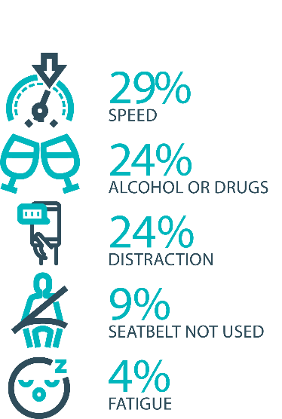

The fatal five behaviours contributing to serious casualties

Inattention and distraction
Inattention and distraction are concerning causes of serious casualty crashes and may have a far greater impact than current data suggests. There are a number of research projects and enforcement initiatives that are being used to address this issue. This project will include consideration of emerging strategies for tackling distraction, encouraging compliance through enforcement and influencing driver behaviour through public education campaigns.
Current situation / comments
Enforcement
Tasmania is experiencing a disturbing upward trend in fatal crashes having suffered 49 road deaths for the 2024-25 financial year-to-date as at the date of reporting, as opposed to 27 during the 2023-24 financial year. 29 individuals have been killed during the 2025 calendar year-to-date alone, compared with nine over the same period in 2024. 13 of the 2025 calendar year-to-date crashes (44.8%) have been informally attributed to ‘inattentive’ behaviours. Eight (29.6%) involve alcohol/drugs/speed. Four (13.7%) are suspected to be the result of medical episodes.
Tasmania Police has directly interdicted with 7,300 more drivers during the 2024-25 period than in 2023-24, issuing approximately 6,200 more infringement notices over the same period. This reflects an enhanced ‘whole of agency’ approach to road safety. Total mobile/static/major Road Policing Operations are up by an average of 39.2 per cent.
Public Education
The We’re Looking Out for You road safety campaign has run over public holidays and other holiday periods. The campaign focuses on encouraging drivers to reflect on their behaviour during the holiday period, emphasising the importance of getting home safety. With the tagline ‘We're looking out for you this holiday season.’ it highlights that getting caught breaking road rules could actually save lives, helping to prevent a catastrophic crash before it occurs.
Status |  |  | On schedule/progressing/low risk

Safe behaviour campaigns
Targeted media campaigns will continue to educate people about high-risk behaviours and to highlight the dangers of the ‘Fatal Five’.
Current situation / comments
Launched in July 2024, the new Over is Over campaign aims to reshape road safety attitudes and challenge the misconception that driving just a few kilometres over the speed limit is acceptable. This campaign underscores the disconnect between current speeding behaviours and historical safety measures, such as mandatory seatbelt use, reduced blood alcohol limits, random breath testing, and restrictions on mobile phone use while driving. Although these regulations faced initial resistance, they have become widely accepted and have significantly improved safety on Tasmanian roads over the past 50 years. The Over is Over campaign runs across television, radio, and social media and is currently being featured on organic social media, billboards and several Metro bus backs.
A new Love40 campaign was launched in February this year in line with schools returning for 2025. Titled ‘There’s No Excuse in a School Zone’, the campaign features children dressed and acting like adults, delivering familiar excuses that drivers often give for not following the rules in a school zone. The new campaign features on television, radio and digital media platforms.
The ‘You Can’t Beat Tassie Roads’ motorcycle campaign and the cycling safety campaign have run at various intervals over the summer/daylight savings period. The motorcycle campaign serves as a reminder for touring motorcyclists, both local and from interstate or overseas, to drive carefully on Tasmanian roads. The purpose of this cycling safety campaign is to promote mutual respect and safety between cyclists and motorists on shared roads. It emphasises that everyone is accountable for their actions, regardless of their mode of transportation, and encourages road users to support one another to ensure everyone's safe return to their loved ones.
The ‘Driving Tired? Wake Up to Yourself’ fatigue campaign continued to run across TV, online, radio and social media platforms in March / April. Launched in Tasmania in November last year, the campaign is centred around a powerful television advertisement that highlights the devastating consequences of driving while fatigued.
Fatigue remains a significant concern on Tasmanian roads, with research showing that 15 to 20 per cent of serious and fatal crashes involve inattention, distraction or poor decision-making - all common signs of fatigue. Backed by research from Monash University and the Victorian Transport Accident Commission, the campaign continues to raise awareness that fatigue can affect anyone, even on short trips or close to home, reinforcing the importance of getting adequate sleep before driving.
Status |  |  | On schedule/progressing/low risk

Mandatory Alcohol Interlock Program (MAIP)
The MAIP aims to have repeat and high-level drink driving offenders demonstrate they are able to separate their drinking from driving through the installation of an alcohol interlock in their vehicle. New measures will be introduced to increase participation in the MAIP.
Current situation / comments
Drafting instructions for the revised framework were provided to the Office of Parliamentary Counsel (OPC) in October 2019. Parliamentary priorities, including COIVD-19, caused reprioritisation of OPC work. Drafting instructions were withdrawn from OPC in May 2021, before the first draft of amendments had been received, to enable the new Road User Services’ managers to review the drafting instructions to ensure that they remain current. The revised instructions were re-submitted to OPC on 15 February 2022. Again, Parliamentary priorities slowed the work of OPC. Nonetheless, version 2 of the amendments were received in November 2022. Drafting work has been suspended pending a review to determine whether the proposed amendments will create a best practice program. Road Safety Branch commenced the review in late 2024. In March 2025, it was decided to delay a full review of the MAIP until 2035. The drafting instructions are to be revised to accommodate the Government’s stated desire for an efficient legislative corpus.
Status | Major delays/on hold/high risk

Protective clothing for motorcyclists
Motorcyclists are overrepresented in Tasmania’s road trauma figures. Motorcyclists are vulnerable road users due to a lack of physical protection. Protective clothing can reduce injury severity in the event of a crash. Tasmania is a funding member of MotoCAP. MotoCAP provides safety assessment star ratings for protective clothing and prepares education materials for motorcyclists.
Current situation / comments
For the 2025 calendar year, a brochure educating riders on the importance of wearing protective motorcycle gear has been included in all motorcycle licence renewal papers. The brochure reiterates the importance of wearing full gear on every ride and directs motorcyclists to the MotoCAP website to check gear safety ratings before purchase.
Status |  |  | On schedule/progressing/low risk

Road safety penalties review
For enforcement activities to improve safety on our roads, they need to be backed up with appropriate penalties. Tasmania’s road safety penalties will be reviewed to ensure they are up-to-date and provide an appropriate deterrence to those who break the rules and put themselves and others at risk.
Current situation / comments
The Department previously completed a review of road safety penalties in 2020, which showed that Tasmania was largely consistent with other jurisdictions, except for speeding offence penalties, which were lower.
The results of that review were presented to the RSAC in November 2020. RSAC recommended not amending penalty values due to the economic impacts of COVID-19 and general parity with other jurisdictions.
Since November 2020, some jurisdictions have implemented higher penalties, which has widened the gap between Tasmania’s penalties and some jurisdictional averages.
The Road Safety Branch (RSB) undertook a review of Tasmanian road safety penalties to compare Tasmanian penalties to the average of other Australian jurisdictions for the fatal five road offences – speed, mobile phones, alcohol and drugs and failure to wear a seatbelt.
The review compared Tasmania’s penalty levels to a ‘jurisdictional average’ (i.e., an average of all other jurisdictions, without inclusion of Tasmania’s penalties) to avoid skewing the average. To ensure that the comparison of monetary penalties considers the differences in earning potential across the jurisdictions, comparisons are being done as a percentage of each jurisdiction’s seasonally adjusted average weekly wage (not a whole dollar value).
A recommendation to consider endorsing amendments to the monetary penalties for offences relating to illegal mobile phone use, seatbelt non-compliance, registration, and speed, was provided to RSAC for review in its May 2023 meeting. RSAC considered the proposal, recommending penalties should not be amended until the effects of the new automatic traffic enforcement program have been considered. RSAC agreed to review penalties again when the evaluation is complete.
Status |  |  | On schedule/progressing/low risk

Speed enforcement strategy
As one of the primary ‘fatal five’ contributory factors, speeding is directly addressed within the Tasmania Police Safe Roads Strategy 2024-2026.
The Strategy directs enhanced speed enforcement strategies and techniques to increase the rate of detection and increase the perception that offending drivers and riders will be caught, through the coordination of high-visibility speed enforcement in high-risk areas across all police districts. To this end, Tasmania Police have detected almost 22,700 speeding offenders 2024-25 financial YTD, a figure that exceeds the previous reporting period by more than 4,500.
In support of police Crash Investigation Services, Tasmania Police has invested in state-of-the-art crash reconstruction software to support criminal and/or coronial investigations arising out of fatal and serious road crashes. This brings local investigative capability into line with other police jurisdictions.
Specific to ‘hooning’ legislation, Tasmania Police have also invested in significant new stores of ‘wheel clamp’ devices. The application of wheel clamps forms part of a wider effort to target speeding, disqualified driving, reckless and dangerous driving behaviours.
Status |  |  | On schedule/progressing/low risk

Enforcement of high-risk behaviours
To reduce high-risk behaviours and increase compliant road user behaviour, State Growth and Tasmania Police will work collaboratively to investigate and introduce new enforcement techniques and technologies to detect high-risk behaviours that address the ‘fatal five’, including mobile phone use, speeding and failure to wear a seatbelt.
Current situation / comments
The Tasmania Police Safe Roads Strategy 2024-2026 focuses the activities of all police on the fatal five causes of serious and fatal crashes, which are the highest risk driver behaviours: speeding; alcohol and drugs; distraction and inattention; seatbelts; and fatigue.
During the 2024-25 financial YTD, almost 2000 more ‘high risk traffic offenders’ have been proceeded against than during the previous reporting period. This equates to a total of 18,500 high risk offenders.
Tasmania Police has recently taken receipt of ‘Best Practice Guidelines’, formulated as part of the Road Safety Enforcement Allocation Model (RSEAM) project. All recommendations will be considered for implementation in the interests of optimising police enforcement activities.
The Police Offences Amendment Bill 2025 has been submitted to Legislative Council, recommending amended ‘road rage’ legislation to target aggressive or irrational driving behaviour on our roads. The proposed legislation refines the definition to capture behaviours such as verbal abuse, violent of aggressive gestures, some forms of altercations, property damage a collision between vehicles or an assault. Being a prescribed offence, it will make any vehicle used in a road rage incident liable to clamping or confiscation.
Status |  |  | On schedule/progressing/low risk

Automated Traffic Enforcement Program
Automated Traffic Enforcement (ATE) (i.e. speed cameras) is relatively underutilised as a deterrence and enforcement mechanism in Tasmania. This project investigates proven and emerging camera technologies for use at high-risk locations and across the entire road network.
Current situation / comments
On 30 September 2022, mobile speed camera enforcement services being delivered by Sensys Gatso Australia began issuing Infringement Notice’s to motorists detected speeding.
Currently there are 16 mobile speed camera systems operating in Tasmania being deployed at over 400 unique locations each month. Mobile speed camera deployment locations have been chosen based on crash risk, road safety infrastructure and vehicle operating speeds.
The introduction of the mobile speed camera program has been supported by the new enforcement focus of the ‘Over is Over’ marketing campaign and the development of a program website (speedcameras.tas.gov.au).
The Road User Portal (portal.speedcameras.tas.gov.au) was developed in early 2023 to support enforcement and allow motorists to view their offence images and video. The Road User Portal aims to improve transparency and build confidence in automated traffic enforcement.
In addition to speed enforcement, the Government has allocated an additional $9.3 million over three years to allow for an expansion of enforcement to 16 cameras, provide an additional one year of enforcement, and implement emerging technologies such as mobile phone, seatbelt, and average speed enforcement.
To support the implementation of these emerging technologies, the project team progressed legislative and regulatory amendments in 2022 which have enabled photographic detection devices to be used in the detection and prosecution of mobile phone, seatbelt, and average speed offences.
In August 2023, mobile phone and seatbelt enforcement commenced using four camera systems with approximately 50 deployment per month. The implementation of mobile phone and seatbelt enforcement has been supported by the ‘Click. Store. Go.’ campaign, which encourages positive behaviour change and informs motorists that detection cameras are now live.
An on-road trial of registration enforcement technology commenced in mid-2024.
An on-road technology trial of mobile average speed enforcement commenced in April 2025 with ongoing review of technology, operational, and evidentiary requirements being review by the project team throughout 2025.
In addition to mobile enforcement cameras, the ATE Program has installed two fixed speed cameras on the Tasman Bridge in March 2025 and two fixed speed cameras on the new Bridgewater Bridge in May 2025.
Status |  |  | On schedule/progressing/low risk

High-risk motorcycling enforcement
Speed is a factor in at least a quarter of motorcyclist serious casualties. Speed cameras offer no deterrence to motorcyclists, whose numberplates are mounted only on the back. Introduction of rear-facing speed cameras will improve detection and deterrence of speeding. This is being considered as part of the Automated Traffic Enforcement Program.
Current situation / comments
The Tasmania Police Safe Roads Strategy 2024-2026 approaches the enforcement of high-risk motorcycle behaviours from several angles. Tasmania Police has:
- worked with the Department of State Growth to re-introduce Automated Mobile Speed Enforcement Cameras that have both a rearward and forward-facing capability to better target and detect high-risk motorcycle behaviour.
- introduced an online public portal for members of the public to upload footage relating to traffic offences they have witnessed. Tasmania Police reviews these submissions and allocate prima facie offences to an officer for investigation and follow-up.
- published the Tasmania Police Safe Roads Strategy 2024 – 2026 which provides for increased patrol hours on rural roads, including many of the popular motorcycle touring routes. The increased patrol hours will be conducted in a mix of covert and overt patrols that will discourage and detect high-risk motorcycle behaviours increasing the perception amongst riders they will be caught anywhere at any time.
Status |  |  | On schedule/progressing/low risk

Road Rules Awareness
Compliance with Road Rules makes our behaviour on the roads predictable, improving safety for all road users. This initiative will ensure that user-friendly and tailored information resources are developed so that the Road Rules are easily understood and adhered to by all road users.
Current situation / comments
The Tasmanian Road Rules Handbook and the Misunderstood Road Rules series of pamphlets are distributed to Service Tasmania locations when required.
Status | Major delays/on hold/high risk |  | On schedule/progressing/low risk





11 per cent of all serious casualties on our roads are non-Tasmanian residents

Tourist road safety signage program
This program will see the installation of tourist signage strategically placed across the road network. The signs will provide important road safety information, relevant to the area road users are travelling in. This program will be undertaken in collaboration with stakeholders, local government and State Roads.
Current situation / comments
This program is currently on hold.
Status | On hold |  | On schedule/progressing/low risk

Responsive electronic signage trial
This project will trial a responsive electronic sign with real time information at regional tourism gateways.
Current situation / comments
This project is currently on hold.
Status | On hold

Tourist education materials
A range of education materials developed using images, symbols and multi-lingual material delivered to specific audiences through targeted communications channels. This includes vehicle hangers, brochures, posters, roadside signs, editorial content, film and digital content.
Current situation / comments
Communications materials are being distributed upon request from stakeholders.
Status |  |  | On schedule/progressing/low risk

Strategic partnerships
Developing strategic partnerships based on synergies with target audiences will enable the effective promotion of road safety messages and education.
Current situation / comments
This project is currently on hold.
Status | On hold

Tourist education at gateway entry points
As an island state, we have the opportunity to strategically place messaging at our gateway airports and seaports to reach visitors with important road safety messaging prior to them driving in Tasmania. This includes a range of educational materials, electronic and static signs and billboards.
Current situation / comments
Printed collateral is in stock and digital billboards display road safety messaging at gateway locations.
Status |  |  | On schedule/progressing/low risk

Stakeholder alliances
Sharing information and collaborating to develop effective strategies and tools to address road safety issues is vital. This project will develop formal and informal stakeholder alliances to encourage input and create opportunities to deliver joint initiatives.
Current situation / comments
This activity is currently on hold.
Status | On hold




The rate of fatal crashes is four times higher for vehicles 15+ years old than for vehicles made in the last five years

Australasian New Car Assessment Program (ANCAP)
Tasmania is a funding member of ANCAP. ANCAP plays a vital role in informing consumers about safety performance of new vehicles and advocates for improved vehicle safety design and specification through public education campaigns, advocacy activities and engagement with governments, corporate fleets, the media and consumers. Activities related to ANCAP will include promotion of safer vehicles and options for an annual vehicle fleet report.
Current situation / comments
Tasmania continues to provide funding support to ANCAP. ANCAP has developed a Strategic Plan for 2023-2030. Tasmania has increased its support of ANCAP with funding of up to $90,000 per annum from the Road Safety Levy. ANCAP published 18 new vehicle ratings between 1 April 2025 and 30 June 2025. All vehicles rated by ANCAP are evaluated against four key areas of assessment which focus on the protection of vehicle occupants, those outside the vehicle, and the ability of a vehicle to actively avoid a crash.
Status |  |  | On schedule/progressing/low risk

Safer cars for young drivers
This project aims to increase awareness of the Used Car Safety Rating database amongst first time car buyers. This could be promoted through education materials and campaigns and may be able to integrate with the GLS online learning platform.
Current situation / comments
This project has not yet commenced and will be considered as part of the Light Vehicle Safety Strategy.
Status |  |  |  | Not yet commenced

Autonomous vehicle and crash avoidance readiness
This project involves the monitoring and development of safety and autonomous vehicle technologies.
Current situation / comments
A regulatory framework for the use of autonomous vehicles is being considered at a national level and Tasmania is participating in that process. Tasmania is also participating in national work programs to better understand the safety and education implications of developments in Advanced Driver Assistance Systems.
Status |  |  | On schedule/progressing/low risk

Workplace driver safety
Vehicle use in road traffic is the most significant contributor to work-related traumatic injury. This project will aim to promote and encourage employers to adopt safe driving policies based on the Worksafe, ‘Vehicles as a workplace’ guide.
Current situation / comments
This project has not yet commenced and will be considered as part of the next Action Plan.
Status |  |  |  | Not yet commenced.

Light vehicle safety strategy
A light vehicle safety strategy will be developed to provide public education and undertake enforcement activities to enhance the safety standard of Tasmania’s vehicle fleet.
Current situation / comments
A draft light vehicle safety strategy is being developed. The draft strategy aims to accelerate an increase in the number of newer and safer vehicles and removal of older cars from the light vehicle fleet while increasing the safety of the current vehicle fleet. The draft strategy will be considered as part of the next Action Plan

Status |  |  | On schedule/progressing/low risk

Funding
Road Safety Levy Overview for the Financial Year 2024/25
As at 30 June 2025(Quarter 4)
Road Safety Levy Opening Summary
Opening Balance as at 01 July 2024 |  |  | $28,085,482
Annual Allocation to Road Safety Operations |  |  | $2,600,000
Revenue Summary
 |  | Forecast (FY25)  $ | Actual (YTD)  $
Motor Accident Insurance Board Funding |  | 1,560,908 | 1,597,359
Revenue Inflows from Registrations |  | 18,157,313 | 19,966,145
Funds Available for Distribution |  | 45,203,703 | 47,048,986
Expenditure Summary
Theme no. | Theme | Budget  (FY25)  $ | Actual (YTD)  $
1 | Making our Rural Roads Safer | 11,945,032 | 3,966,913
2 | Improving Safety in our Towns and Cities | 4,133,865 | 2,278,503
3 | Saving Young Lives | 3,786,044 | 2,035,619
4 | Encouraging Safer Road Use* | 6,834,872 | 6,350,170
5 | Making Visitors Safer | 263,282 | 139,376
6 | Improving Safety Through Vehicles and Technology | 2,890,000 | 189,782
7 | General Support | 699,578 | 604,591
Budget and Expenditure by Category |  | Forecast  (FY25)  $ | Actual (YTD)  $
Infrastructure Expenditure |  | 15,049,242 | 6,001,055
Policy & Projects Expenditure* |  | 15,504,309 | 9,564,399
Total Expenditure |  | 30,553,552 | 15,565,454
Balance as of 30 June 2025 |  | 14,650,152 | 31,483,532
Forecast Closing Balance of FY25 |  | 14,650,152
*includes MAIB expenditure
MAIB Funding
As at 30 June 2025

2024/25 Financial Year | Budget  $ | Actual (ytd)  $ | Balance  $
Expenditure (State Growth)
Administration & Public Relations | 360,934 | 271,627 | 89,307
Public Education | 1,124,974 | 1,172,017 | -44,043
Research | 75,000 | 64,105 | 10,895
Subtotal | 1,560,908 | 1,507,749 | 56,159
Expenditure (Tasmania Police)
Salaries | 2,299,342 | 2,313,074 | -13,732
Operating Expenses | 188,000 | 171,186 | 16,814
Equipment | 579,677 | 433,195 | 146,482
Subtotal | 3,067,019 | 2,917,456 | 149,563
Total

 | Department of State Growth  Road Safety Branch  Towards Zero Action Plan 2020-2024  GPO Box 536  Hobart TAS 7001 Australia
 | Phone: | 6166 3243
 | Email: | rsac@stategrowth.tas.gov.au
 | Web: | www.rsac.tas.gov.au
 | © State of Tasmania June 2025

