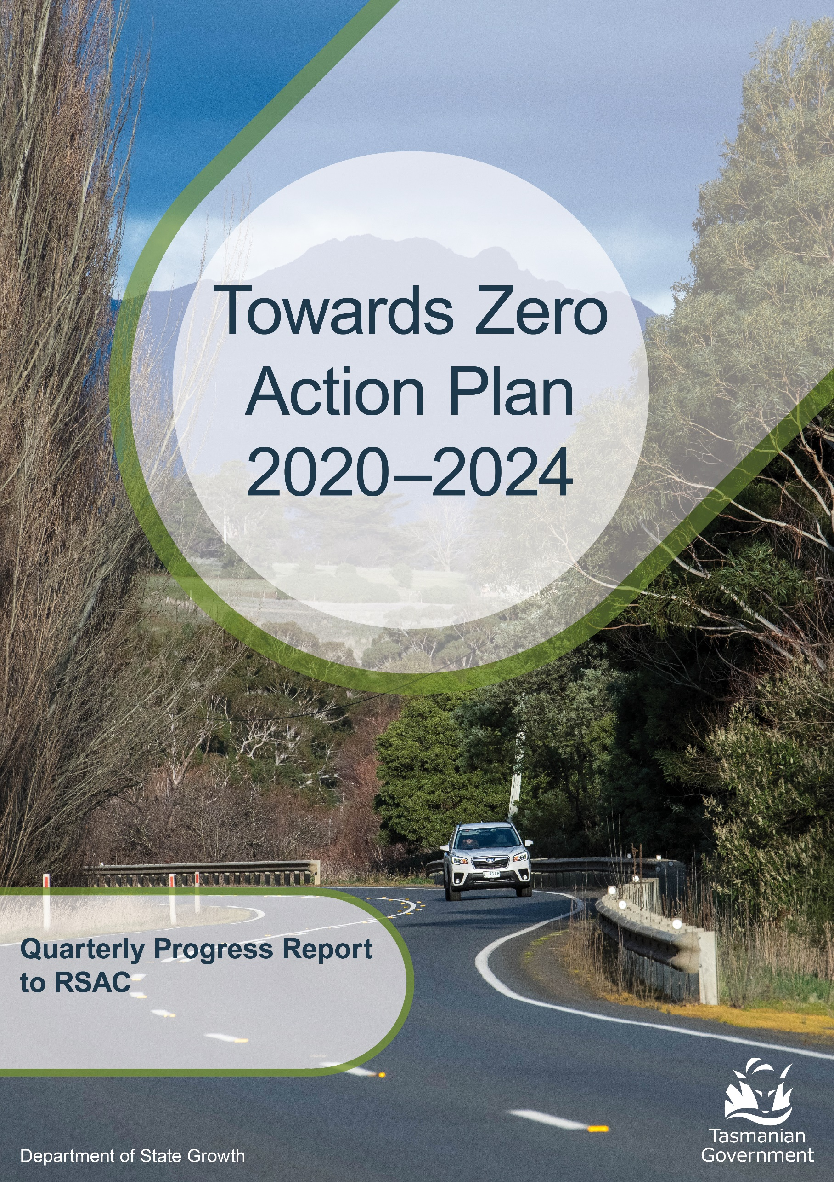

**to 31 December 2024**

Contents

Progress on meeting Towards Zero Strategy targets 3

Serious Casualties 3

Fatalities 3

Serious Casualties Tasmania – Annual Count, Percentage Split by Quarter and Towards Zero Target 4

Annual fatalities – Rate per 100,000 population 4

Progress on meeting MAIB targets 5

Fatalities – 12 Month Rolling Total 5

Total Serious Claims – 12 Month Rolling Total 5

Statistics 6

Serious Casualties by Quarter by Age Group – 12 period moving average 6

Serious Casualties by Quarter by Sex – 12 period moving average 6

6

Serious Casualties by Quarter by Road User Type – 12 period moving average 7

Serious Casualties by Quarter by Speed Zone – 12 period moving average 7

Serious Casualties by Quarter by Crash Type (DCA) – 12 period moving average 8

Serious Casualties by Quarter by Urban/Non-Urban – 12 period moving average 8

Serious Casualty locations to 31 December 2024 (Black = Fatality, Red = Serious Injury) 9

Key themes and priority actions 2020-2024 10

Funding of key themes 10

Project status report 11

Progress on key themes 12

Rural roads grants program for local government 12

Infrastructure upgrades on low volume State roads 13

Motorcyclist safety on rural roads 13

Speed moderation and community engagement strategy 14

Safe system knowledge and skills training 14

Targeted infrastructure upgrades in high traffic urban areas 16

Vulnerable Road User Program 16

Community Road Safety Grants Program 17

Trial of innovative technologies 18

Innovative infrastructure treatment demonstrations 18

Learner Driver Mentor Program and Driver Mentoring Tasmania 19

Graduated Licensing System Project 19

Motorcyclist Graduated Licensing System review 20

RYDA program 21

Driving for Jobs Program 21

RACT education initiatives 22

Real Mates media campaign 22

Bicycle Network bike education 23

Safety around schools 23

Kidsafe child restraint check program 23

Full Gear motorcycle safety project 24

Inattention and distraction 25

Safe behaviour campaigns 25

Mandatory Alcohol Interlock Program (MAIP) 26

Protective clothing for motorcyclists 27

Road safety penalties review 27

Speed enforcement strategy 28

Enforcement of high-risk behaviours 28

Automated Traffic Enforcement Program 29

High-risk motorcycling enforcement 29

Road Rules Awareness 30

Tourist road safety signage program 31

Responsive electronic signage trial 31

Tourist education materials 31

Strategic partnerships 31

Tourist education at gateway entry points 32

Stakeholder alliances 32

Australasian New Car Assessment Program (ANCAP) 33

Safer cars for young drivers 33

Autonomous vehicle and crash avoidance readiness 33

Workplace driver safety 34

Light vehicle safety strategy 34

# 

# Progress on meeting Towards Zero Strategy targets

The key interim target for the Towards Zero – Tasmanian Road Safety Strategy 2017-2026 (Towards Zero Strategy) is to reduce the number of annual serious injuries and deaths on Tasmanian roads to fewer than 200 by 2026. This is an ambitious target of 100 fewer serious casualties per year than for the period 2012-2016 (annual average) and will move us towards the long-term goal of zero serious casualties on Tasmanian roads.

## Serious Casualties

The number of serious casualties in 2024 was 334, compared to 347 in 2023, a 3.7 per cent decrease. The 2024 figure of 334 is a 7.2 per cent increase on the five year serious casualty average of 311.6 (2019-2023).

## Fatalities

In 2024, there were 32 fatalities on Tasmanian roads which is 4 fewer than the number recorded in 2023. The figure of 32 fatalities in 2024 is a 15.8 per cent decrease on the five-year fatality average of 38 (2019-2023).

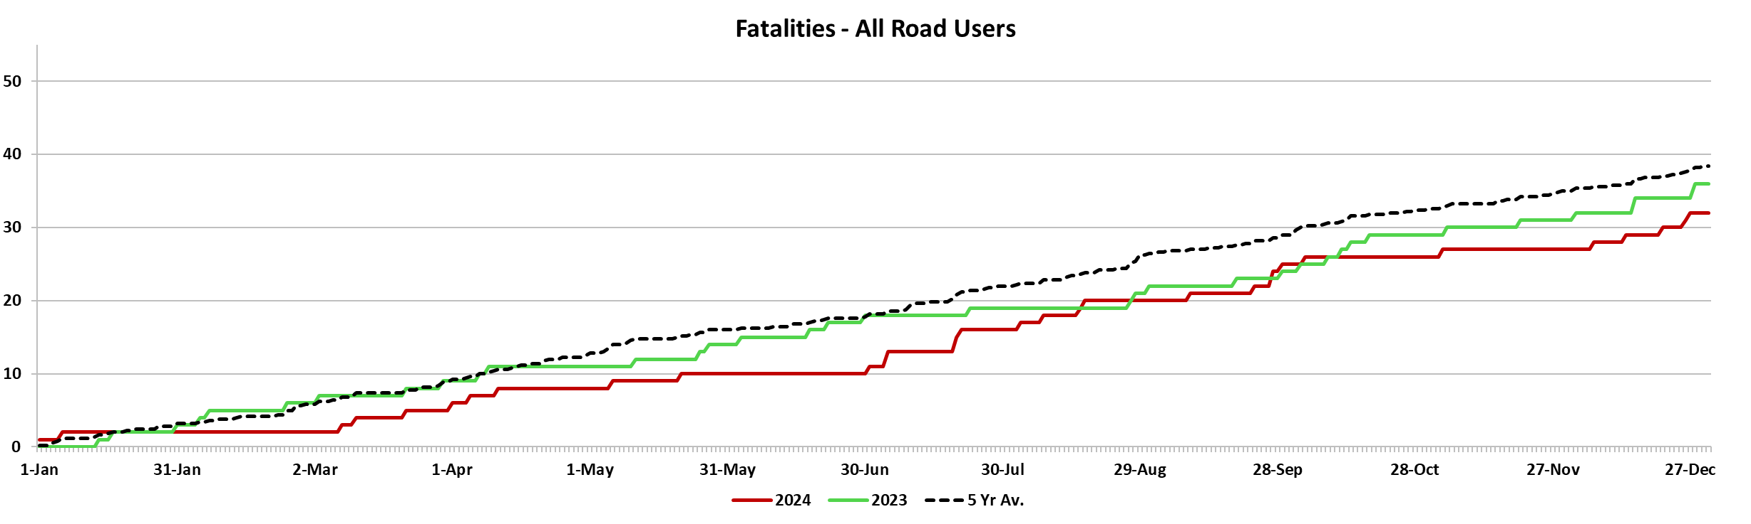



### Serious Casualties Tasmania – Annual Count, Percentage Split by Quarter and Towards Zero Target

### Annual fatalities – Rate per 100,000 population

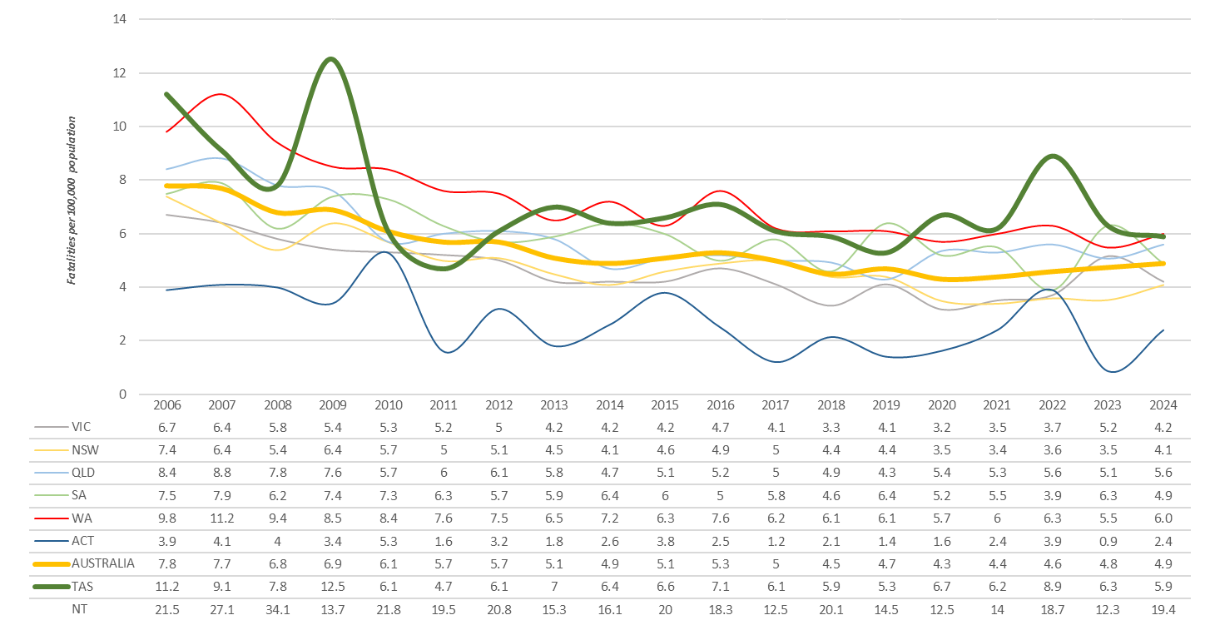

*Note: NT omitted from chart for clarity purposes.*

# Progress on meeting MAIB targets

Motor Accidents Insurance Board (MAIB) injury statistics show the number of fatalities and the level of claims for serious injuries on our roads.

Various claim reduction targets are specified in the Memorandum of Understanding between the Department of State Growth (State Growth) and the MAIB. Progress against high level targets is shown below, expressed as 12 month moving totals.

### Fatalities – 12 Month Rolling Total

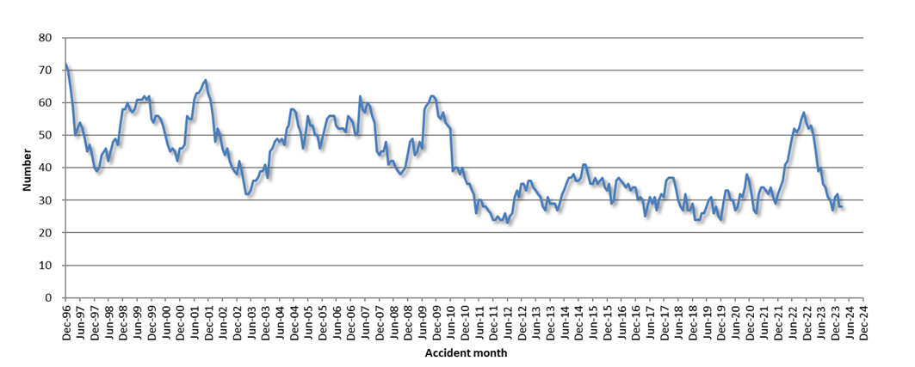

### Total Serious Claims – 12 Month Rolling Total

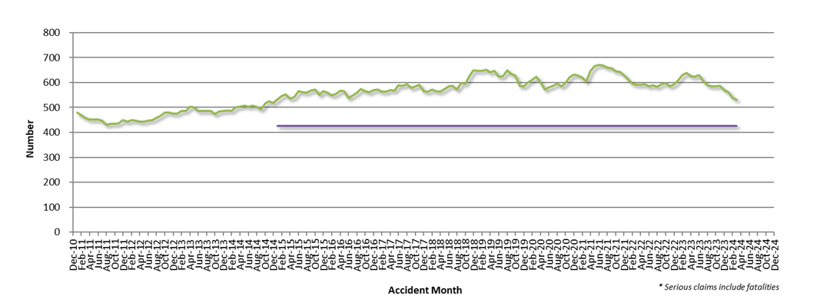

# Statistics

### Serious Casualties by Quarter by Age Group – 12 period moving average

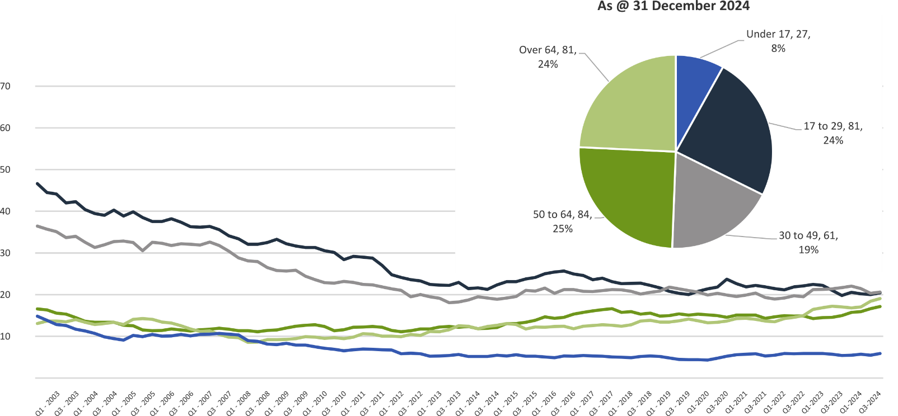

### Serious Casualties by Quarter by Sex – 12 period moving average

***

### Serious Casualties by Quarter by Road User Type – 12 period moving average

### Serious Casualties by Quarter by Speed Zone – 12 period moving average

Pie chart excludes serious casualties where speed zone is recorded as ‘not known’

### Serious Casualties by Quarter by Crash Type (DCA) – 12 period moving average

Other includes crash types: on-path (3%), overtaking (1%) & passenger and miscellaneous (3%).

### Serious Casualties by Quarter by Urban/Non-Urban – 12 period moving average

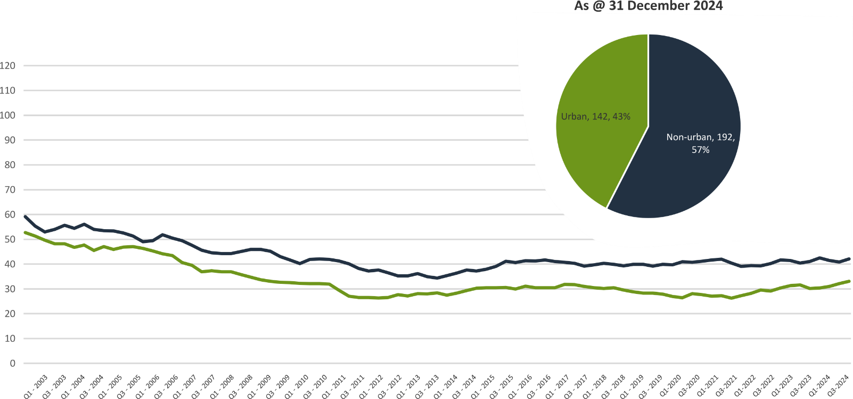

Based on the Australian Bureau of Statistics’ ‘significant urban area’ geographic definition.

### Serious Casualty locations to 31 December 2024 (Black = Fatality, Red = Serious Injury)

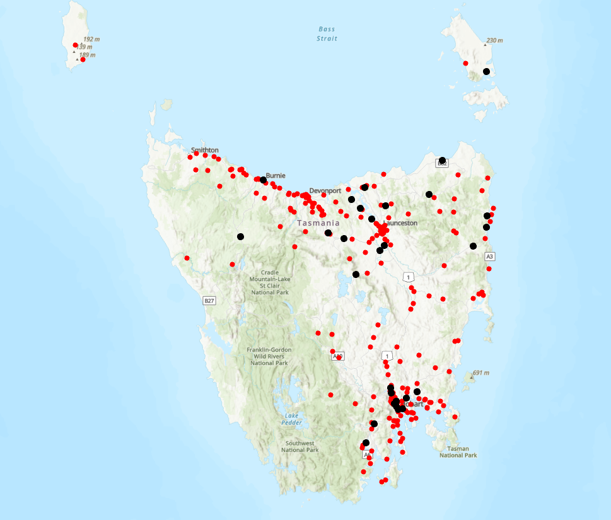

# Key themes and priority actions 2020-2024

The Quarterly Progress Report details progress on key themes and priority actions under the Towards Zero Action Plan 2020-2024 and the Towards Zero – Tasmanian Road Safety Strategy 2017-2026.

The progress report should be read in conjunction with the Action Plan and understood in the context of the Towards Zero Strategy. These documents are available at: www.towardszero.tas.gov.au

## Funding of key themes



Over $20 million Over $31 million

Over $12 million Over $4 million



$2 million Over $3 million

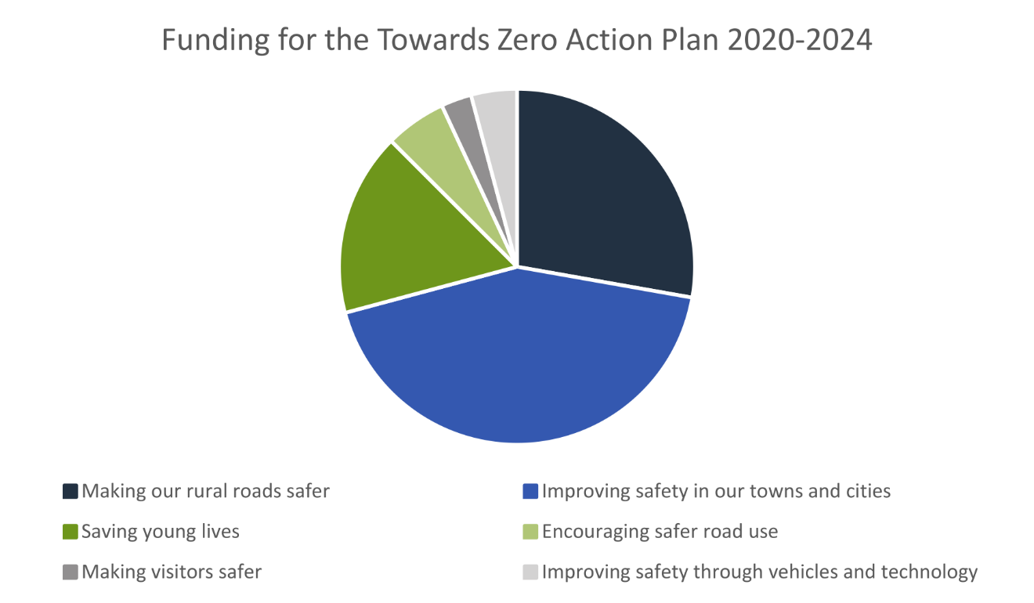

# Project status report

|  |  |  |  |  |
| --- | --- | --- | --- | --- |
| Making our rural roads safer | | | | |
| Rural road grants program for local government | On schedule |  | Infrastructure upgrades on low volume State roads | On schedule |
| Motorcyclist safety on rural roads | On schedule |  | Speed moderation and community engagement strategy | On schedule |
| Safe system knowledge and skills training | On schedule |  |  | |
| Improving safety in our cities and towns | | | | |
| Targeted infrastructure upgrades in high traffic urban areas | Not yet commenced |  | Vulnerable Road User Program | On schedule |
| Community Road Safety Program | On schedule |  | Trial of innovative technologies | Not yet commenced |
| Innovative infrastructure treatment demonstrations | Not yet commenced |  |  | |
| Saving young lives | | | | |
| Learner Driver Mentor Program and Driver Mentoring Tasmania | On schedule |  | Graduated Licensing System Project for drivers | **Complete** |
| Rotary Youth Driver Awareness Program | On schedule |  | Driving for Jobs Program | On schedule |
| RACT education initiatives | On schedule |  | Real Mates media campaign | On schedule |
| Bicycle Network bike education | On schedule |  | Safety around schools | On schedule |
| Kidsafe child restraint check program | On schedule |  | Full Gear motorcycle safety project | On schedule |
| Develop a Graduated Licensing System for motorcyclists | On schedule |  |  | |
| Encouraging safer road use | | | | |
| Inattention and distraction | On schedule |  | Safe behaviour campaigns | On schedule |
| Mandatory Alcohol Interlock Program | Major delays |  | Protective clothing for motorcyclists | On schedule |
| Road safety penalties review | On schedule |  | Speed enforcement strategy | On schedule |
| Enforcement of high-risk behaviours | On schedule |  | Automated Traffic Enforcement Program | On schedule |
| High-risk motorcycling enforcement | On schedule |  | Road Rules Awareness | On schedule |
| Making visitors safer | | | | |
| Tourist road safety signage program | On hold |  | Responsive electronic signage trial | On hold |
| Tourist education materials | On schedule |  | Strategic partnerships | On hold |
| Tourist education at gateway entry points | On schedule |  | Stakeholder alliances | On hold |
| Improving safety through vehicles and technology | | | | |
| ANCAP | On schedule |  | Safer cars for young drivers | Not yet commenced |
| Autonomous vehicle and crash avoidance readiness | On schedule |  | Workplace driver safety | Not yet commenced |
| Light vehicle safety strategy | On schedule |  |  | |

# Progress on key themes



60 per cent of fatalities occur in rural areas

## Rural roads grants program for local government

The Safer Rural Roads Program (SRRP) provides funding to councils to implement infrastructure treatments on rural road corridors to reduce lane departure crashes and the harm when they do occur. An allocation of $10 million was made to the SRRP to be administered over five funding rounds of $2 million for the life of the Action Plan.

Current situation / comments

The Australian Government’s Road Safety Program (RSP) is a $3 billion Commonwealth Budget commitment. Under the RSP, Tasmania has been notionally allocated up to $66 million in funding for small-scale road safety infrastructure projects.

The RSP provided valuable additional funding to the SRRP. As a result, two funding rounds were held during the 2020–2021 financial year (FY21).

In FY21, 61 applications were received under the SRRP with 59 receiving funding. The successful projects from FY21 total approximately $10 million in value. This includes funding of $5.88 million from the Australian Government’s RSP, $2.45 million from the Road Safety Levy, and $1.64 million from Local Government co-contributions.

As of 31 December 2024, 58 projects from the FY21 program rounds have been delivered, and one project is in the acquittal stage.

The 2022–2023 funding round for the SRRP awarded $3.2 million from the Road Safety Levy for 18 successful applicants. For these approved SRRP applications, $3.2 million of funding, alongside $1.6 million in co-contributions from councils, has allowed for $4.8 million of infrastructure to be built to improve safety on rural roads. Funded infrastructure treatments include guardrails, pavement widening, line marking and traffic signage.

As of 31 December 2024, 14 of the 2022-23 SRRP projects have been completed, two are in the process of acquittal and one has been withdrawn.

The 2023-24 funding round of the SRRP opened on 4 December 2023 and closed on 23 February 2024. This round had a combined sum of funding approved with the VRUP of $4.68 million.

As of 31 December 2024, the status of the 14 SRRP projects in the 2023-24 round comprised four projects at the stage of finalising plans, three projects have submitted finalised plans (for Traffic Engineering review), and seven projects are in the delivery of works stage.

The 2025 round of the SRRP has been delayed. The Road Safety Branch is progressing administrative processes to have the round opened in early 2025.

|  |  |  |  |  |
| --- | --- | --- | --- | --- |
| Status | risk |  | On schedule/progressing/low risk |  |

## Infrastructure upgrades on low volume State roads

This program will provide funding for lower volume State roads, where cost effective treatments such as shoulder sealing, pavement markings, curve warnings, road side hazard removal and safety barriers will achieve maximum value for money.

Current situation / comments

This program of works has supported Road Safety Levy co‑contributions under the Australian Government’s RSP. This has taken advantage of the opportunity that Australian Government co‑funding has presented for targeted shoulder sealing and junction upgrades across Tasmania.

|  |  |  |  |  |
| --- | --- | --- | --- | --- |
| Status |  |  | On schedule/progressing/low risk |  |

## Motorcyclist safety on rural roads

Road safety audits will be conducted on high-risk touring routes across Tasmania. This program will involve local motorcyclists and a safe system approach will inform audits. Findings will be shared with stakeholders to identify countermeasures that go beyond typical infrastructure solutions.

Current situation / comments

Safe System motorcycle road safety audits

On 28 September 2024, an audit was conducted on the Lyell Highway between Derwent Bridge and Queenstown. The Department of State Growth is currently considering the audit report with works to be included as part of the broader Lyell Highway Corridor Strategy.

Selected treatments for the Tasman Highway between Scottsdale and St Helens are now in the design stage with works expected to commence in the second quarter of this financial year.

|  |  |  |  |  |
| --- | --- | --- | --- | --- |
| Status |  |  | On schedule/progressing/low risk |  |

## Speed moderation and community engagement strategy

Speed moderation requires a holistic strategy encompassing public education, road risk assessments, enforcement, speed limit setting, infrastructure measures, vehicle technologies, outcomes and evaluation. This project will involve community engagement to inform and build support for action on safer speeds. A significant ongoing coordination effort will be required to support the strategy.

Current situation / comments

The RSAC led a public consultation on the Speed Management Consultation Paper commencing on 10 October for a six-week period, concluding on 21 November 2024. The purpose of the consultation was to provide information to the community about the role of vehicle speed in road safety, introduce the draft Strategy framework, and provide stakeholders and the general community with the opportunity to have their say on the development of the Strategy.

Overall, there was strong support for the draft Strategy framework set out in the Consultation Paper. Most respondents generally agreed with the framework’s aim, principles and five action areas. There was strong support, particularly for actions around infrastructure and safer speeds, with good support for speed enforcement, community engagement and for vehicles technologies to support safer speeds. There were also a range of suggestions from respondents to inform the content and approach to develop the Strategy. Pending consideration by RSAC, the Consultation Report will be placed on the RSAC website for public access. The consultation results will be used to update the plan to develop the Speed Management Strategy. Once a draft of the Strategy has been completed, RSAC may wish to consider follow up consultation of the final Strategy in 2025.

|  |  |  |  |  |
| --- | --- | --- | --- | --- |
| Status |  |  | On schedule/progressing/low risk |  |

## Safe system knowledge and skills training

This initiative aims to improve Safe System knowledge for all those in a position to influence road safety outcomes. The initiative will focus on Safe System infrastructure design, including appropriate speed setting, and will consist of technical training sessions, workshops and forums across Tasmania.

Current situation / comments

The Department of State Growth has developed a Safe System induction module to provide an introduction to the Safe System to all Transport Group employees, and staff across Tasmania Police and local government. The module is being internally tested and likely to be rolled out in the next quarter of the financial year.

|  |  |  |  |  |
| --- | --- | --- | --- | --- |
| Status |  |  | On schedule/progressing/low risk |  |



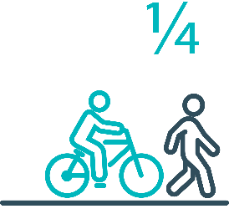

Pedestrians and cyclists are vulnerable and represent one in four serious casualties in our towns and cities

## Targeted infrastructure upgrades in high traffic urban areas

This program provides for delivery of a range of infrastructure safety upgrades to make our towns and cities safer. This will include shoulder sealing, intersection improvements, safety barriers and pavement marking at high traffic areas. This program targets high volume state roads that are not planned for major investment in the short term.

Current situation / comments

This initiative has not yet commenced and will be considered as part of the next action plan.

However, funding allocated to this initiative to date, under the Action Plan, has supported the Road Safety Levy co‑contributions under the Australian Government’s Road Safety Program (RSP). This has taken advantage of the opportunity that Australian Government co-funding has presented for targeted shoulder sealing and junction upgrades across Tasmania, and the upgrade of nearly 600 electronic school zone signs across approximately 220 locations.

|  |  |  |  |  |
| --- | --- | --- | --- | --- |
| Status |  |  |  | Not yet commenced |

## Vulnerable Road User Program

The Vulnerable Road User Program (VRUP) is an established grants program which assists local government with the costs of installing safety improvements in built up areas. The aim of the program is to reduce conflict between vehicles and vulnerable road users - cyclists, pedestrians and motorcyclists.

Additionally, the program has a focus on increasing Safe System knowledge and capacity in local governments. The funding available under the VRUP was increased from $500,000 to $1,000,000 per annum, under the current Action Plan.

Current situation / comments

The Australian Government’s RSP provided valuable additional funding to the VRUP. As a result, three funding rounds were held during FY21. In FY21, 95 applications were received under the VRUP with 71 receiving funding. This includes seven cycling safety-focused projects that all received funding under round three.

The successful projects from FY21 total approximately $11.58 million in value. This includes funding of $4.63 million from the Australian Government’s RSP, $4.70 million from the Road Safety Levy, and $2.25 million from Local Government co-contributions.

As of 31 December 2024, 61 projects from the FY21 rounds have been delivered and three projects are in the acquittal stage. Eight projects from the 71 successful projects, valued at $1,405,000, have been withdrawn.

The 2022–2023 funding round of the VRUP awarded $1.4 million from the Road Safety Levy to 15 successful applicants. For these successful VRUP applications, $1.41 million of funding, alongside nearly $500,000 in co-contributions from councils, has allowed for $1.9 million of infrastructure to be built to protect vulnerable road users. Funded infrastructure treatments include traffic calming measures, electronic speed signage, footpaths, pedestrian refuges, curb ramps and crossing.

As of 31 December 2024, nine of the 2022-23 VRUP projects are complete, one is in the process of delivering works, two projects have been withdrawn and two projects are at the stage of acquittal, assessment of works.

The 2023-24 funding round of the VRUP opened on 4 December 2023 and closed on 23 February 2024. This round had a combined sum of funding approved with the SRRP of $4.68 million.

The VRUP received 31 applications for the 2023-24 round. As of 31 December 2024, the status of the 24 VRUP projects in the 2023-24 round comprised six projects at the stage of finalising plans, three projects have submitted finalised plans (for Traffic Engineering review), 13 projects are in the delivery of works stage and one project is the acquittal stage.

The 2025 round of the VRUP has been delayed. The Road Safety Branch is progressing administrative duties to have the round opened in early 2025.

|  |  |  |  |  |
| --- | --- | --- | --- | --- |
| Status |  |  | On schedule/progressing/low risk |  |

## Community Road Safety Grants Program

The Community Road Safety Grants Program (CRSGP) is an established grants program that aims to build community engagement to address local road safety issues. The program supports local councils, schools, community groups, research institutions and charity organisations to promote road safety at the grass roots level.

**Current situation / comments**

The Road Safety Branch continues to work with funding recipients to ensure project evaluations and acquittals are received from the 2023-24 funding round.

|  |  |  |  |  |
| --- | --- | --- | --- | --- |
| Status |  |  | On schedule/progressing/low risk |  |

## Trial of innovative technologies

This project will include monitoring, investigation and trialling of new and emerging technology based approaches to improving safety for vulnerable road users.

Current situation / comments

This project has not yet commenced and will be considered as part of the mid-term review.

|  |  |  |  |  |
| --- | --- | --- | --- | --- |
| Status |  |  |  | Not yet commenced. |

## Innovative infrastructure treatment demonstrations

This project will investigate, trial and demonstrate innovative Safe System urban infrastructure treatments to improve road safety in our urban areas. We will work with local councils to show how Tasmania’s cities and towns can be improved for the benefit of all road users, particularly cyclists and pedestrians.

Current situation / comments

This project has not yet commenced and will be considered as part of the mid-term review.

|  |  |  |  |  |
| --- | --- | --- | --- | --- |
| Status |  |  |  | Not yet commenced. |



92 young people are seriously injured or killed on our roads every year

## Learner Driver Mentor Program and Driver Mentoring Tasmania

The Learner Driver Mentor Program (LDMP), supported by Driver Mentoring Tasmania (DMT), is a well-established program that supports disadvantaged learner drivers to gain supervised on-road driving hours to gain a licence. DMT supports LDMP providers through peak body support and coordination.

**Current situation / comments**

The LDMP continues to experience strong demand, with over 500 people actively waiting for a place in their local program.

Between 1 October and 31 December 2024, the LDMP provided 4,706 hours of supervised driving and supported 754 learners in obtaining their provisional licenses. On average, 236 learner drivers participated in the program during this period.

The DMT Coordinator, Mr Garry O’Byrne, officially retired at the end of the year after 14 years in the role. Ms Tanya Geddes will serve as Acting DMT Coordinator until the position is reviewed and advertised for the remainder of the Action Plan.

|  |  |  |  |  |
| --- | --- | --- | --- | --- |
| Status |  |  | On schedule/progressing/low risk |  |

## Graduated Licensing System Project

Changes have been made to the Graduated Licensing System (GLS) for drivers to better protect young and novice drivers and improve the licensing pathway. Young drivers are overrepresented in crash statistics and most at risk when they first get their Ps and start driving solo. The changes to the GLS aim to address this risk and improve road safety outcomes for both young and novice drivers.

Current situation / comments

The Tasmanian Government implemented regulatory changes to the GLS on 1 December 2020. Tasmania’s GLS now meets the enhanced model under the national driver GLS framework. The GLS changes were accompanied by a public education campaign explaining the policy changes and how they would apply to current and new learners.

Complementing the policy changes are three digital products that were progressively launched from July 2021.

The Plates Plus learning and assessment platform was designed to improve learner driver education by focusing on developing safe behaviours and attitudes. It is an innovative tool that takes users through a series of interactive exercises to ensure new drivers know the road rules and understand the impact of the fatal five road behaviours.

A public education campaign accompanied the launch of the Plates Plus platform and ran until September 2021. The campaign encouraged take-up by promoting the convenience of the platform, which is accessible from any device connected to the internet.

The Plates Plus logbook app launched in November 2021. For many Tasmanian learners, this will replace the existing hard copy logbook. It provides an easy and efficient way to record supervised driving hours during the learner licensing phase. A public education campaign targeting 15 to 25-year-olds accompanied the launch of the Plates Plus logbook app. To engage with this age group, the campaign focused on selected social media platforms.

The computer-based hazard perception test (HPT) was launched on 7 March 2022. The HPT is a mandatory assessment that has been introduced to the learner licensing pathway. The HPT assesses a learner’s ability to identify and react to safely avoid hazards. It features high-quality 3D clips developed by Austroads in conjunction with the Centre for Automotive Safety Research, using real Australian crash data to identify the most dangerous driving situations for novice drivers.

The HPT was the final product to be delivered under the GLS project.

State Growth contracted the Queensland University of Technology (QUT) Centre for Accident Research and Road Safety – Queensland (CARRS-Q) to undertake an evaluation of the changes over a seven-year period, including crash and offence based analyses and personal experiences of Tasmanian residents. The intermediate phase of the evaluation is currently in progress.

|  |  |
| --- | --- |
| Status | **Complete** |

## Motorcyclist Graduated Licensing System review

The Tasmanian motorcyclist GLS is being reviewed to identify enhancements to ensure novice motorcyclists are as safe as possible on Tasmanian roads.

Current situation / comments

Following initial consideration by the Department of State Growth, the Centre for Automotive Safety Research (CASR) was engaged to conduct a review of the Tasmanian motorcyclist GLS. The findings and recommendations of the review were presented to the RSAC at its May 2022 meeting.

A public consultation process sought feedback on CASR’s recommendations. Feedback was collated and presented to the RSAC at its November 2022 meeting, together with a package of options to amend the motorcyclist GLS. At the RSAC’s request, additional information was provided and considered at its March 2023 meeting. The RSAC endorsed a package of recommended changes to the motorcyclist GLS which the former Minister for Infrastructure and Transport approved. Consideration of the package by the Tasmanian Government was delayed due to the caretaker and election periods and formation of a new Government. In October 2024, the Minister for Transport approved a package of changes to the motorcyclist GLS. Implementation is in progress, with regulatory amendments being prepared.

|  |  |  |  |  |
| --- | --- | --- | --- | --- |
| Status |  |  | On schedule/progressing/low risk |  |

## RYDA program

RYDA is a one-day interactive road safety education program for Year 10-12 students to assist them to respond positively to the challenges and responsibilities of being a driver or passenger. RYDA’s curriculum consists of six sessions, each focusing on critical aspects of road safety, including speed management, distraction avoidance, and the importance of responsible driving. Professional facilitators, including Tasmania Police and experts from road safety organisations, lead the sessions. Rotary volunteers support the program's operations, handling logistics, coordination with schools, and ensuring smooth delivery across six statewide locations.

RYDA has proven to be a transformative experience for students, fostering attitudinal changes towards driving. The program encourages young drivers to think critically about their behaviour on the road, equipping them with the knowledge and skills needed to make safer choices. Additionally, students who participate in RYDA receive a five-hour reduction in the mandatory driving hours required for their learner’s licence, further incentivising participation.

**Current situation / comments**

In 2024, RYDA provided a full day of interactive road safety training designed to prepare young drivers and passengers for the responsibilities of the road. The program engaged 4,484 students through 79 sessions conducted across Tasmania, with 33 sessions in the South, 21 in the North, and 19 in the North-West. The sessions targeted high schools in both urban and regional areas, ensuring equitable access to road safety education statewide.

The winner of the October 2024 RYDA student survey submission was Maggie Hodgman from St Patrick’s College in Launceston. Maggie’s submission reflects the impact of RYDA, commenting that the program gave her confidence and informed her of the factors of road safety aside from the Tasmanian Road Rules, stating that she “took a lot of information out of RYDA and will continue to refer to the skills and strategies” that she learnt.

|  |  |  |  |  |
| --- | --- | --- | --- | --- |
| Status |  |  | On schedule/progressing/low risk |  |

## Driving for Jobs Program

The Driving for Jobs (DfJ) Program aims to support disadvantaged students who would otherwise be unable to enter and progress through the Graduated Driver Licensing System (GLS). The program provides students at selected schools with the opportunity to increase their road safety knowledge whilst also improving their job readiness.  Students undertake a personalised intensive program with a strong road safety focus including professional on-road driving lessons and participation in the Rotary Youth Driver Awareness Program (RYDA).

Current situation / comments

The DfJ Program operates at Jordan River Learning Federation (JRLF) and Claremont College in the South and Launceston and Newstead Colleges in the North.

In 2024, DfJ students undertook 1,633 hours of fully funded driving lessons delivered by RACT, Ls2Ps (South) and NextGen (North) accredited driving instructors. A total of 59 students obtained their learner licence and 50 students obtained their provisional driver licence. 86 students attended the full day RYDA road safety program.

The DfJ Program continues to go from strength to strength with more driving lessons delivered in 2024 than in previous years.

|  |  |  |  |  |
| --- | --- | --- | --- | --- |
| Status |  |  | On schedule/progressing/low risk |  |

## RACT education initiatives

The RACT delivers a range of community and school-based road safety education programs for seniors community groups and primary and secondary students.

**Current situation / comments**

RoadSafe Program

This program focuses on road safety education for primary school students. Within this quarter, RACT delivered six presentations to over 106 students in grades 3-4. These sessions introduced fundamental road safety practices, tailored to younger audiences to ensure long-term retention of safe driving principles.

Ready for the Road Program

Targeting high school students (Years 10-12), this program educates students on the Graduated Licensing System (GLS) and specific rules for L and P plate drivers. In this quarter, the program had seven sessions across the state. These sessions reached over 154 students and were complemented by four practical "Distracted Driving" courses, giving students hands-on experience in managing distractions while driving.

Years Ahead Program

Aimed at senior drivers, this program was delivered six times in this quarter, across Tasmania, engaging 100 participants. The sessions offered road rule updates and safe driving tips, helping seniors maintain their driving skills and knowledge.

|  |  |  |  |  |
| --- | --- | --- | --- | --- |
| Status |  |  | On schedule/progressing/low risk |  |

## Real Mates media campaign

The MAIB-funded Real Mates campaign engages with young men to encourage them to avoid the risks of drink driving by empowering them to speak up and stop a mate from driving after drinking.

Current situation / comments

A new Real Mates campaign was launched at the end of September in line with Grand Final weekend. Planning ahead and ensuring your mates all get home safely after a night out is the focus of the newly revamped campaign. The campaign focuses on the Bro Code and adds new rules around a night out to make sure the whole crew get home safely. The Bro Code, a set of unwritten rules among male friends that emphasises loyalty, respect, and camaraderie, now includes guidelines that encourage friends to ensure one another's safe return home. New Bro Code rules include making plans to get home safely after a night out, allowing a friend to crash at your place, having a designated driver, lending money for rideshares, calling a parent for a ride, and never leaving a friend behind. Anyone who looks out for you—be it a friend, a parent, or even a sibling—can be considered a bro in this context. Statistically, males in the 17 to 25 age group account for about a quarter of all road users involved in crashes where alcohol is a contributing factor over the last five years. Given that rural and regional areas of Tasmania may lack access to Ubers or taxis, having a clear plan is crucial. While the campaign will run on television and radio, if will feature predominantly on social media platforms to specifically target this cohort. The first burst of this campaign will run until the end of December. In 2025, Real Mates will have another burst to coincide with the return of University of Tasmania students. Supporting merchandise for the campaign will also commence being distributed to hospitality venues and clubs statewide by the Tasmanian Hospitality Association and Clubs Tasmania.

|  |  |  |  |  |
| --- | --- | --- | --- | --- |
| Status |  |  | On schedule/progressing/low risk |  |

## Bicycle Network bike education

The Bicycle Network delivers the Ride2School program designed to promote safe cycling habits, road safety awareness, and positive road-sharing behaviour among primary-aged students. Through engaging educational sessions, the program encourages young students to embrace cycling as a safe and sustainable mode of transport.

Current situation / comments

The Ride2School program delivered 56 workshops across Tasmanian primary schools in this quarter, including the engagement of two new schools who have not previously participated in the Ride2School program. Highlights included the continued development of the Learn2Ride program, working with students who have low skills and confidence riding a bike to fast track their skills and development.

|  |  |  |  |  |
| --- | --- | --- | --- | --- |
| Status |  |  | On schedule/progressing/low risk |  |

## Safety around schools

Safety around schools is promoted through designated crossings, lower speed zones, more than 100 school crossing patrol officers and public education. The current Safety around Schools project, including the Love 40 campaign, encourages drivers to lower their speed and keep a look out for children in school zones and around buses.

Current situation / comments

The Love 40 road safety campaign has been run at the start of each school term since 2020. While it has featured on television and radio, its reach has been limited.

To enhance its impact, the department continued working with the advertising agency to refresh the campaign, emphasising the importance of slowing down in school zones, driving safely around school buses, and obeying school crossing patrol officers.

Filming took place at Lindisfarne Primary School in late November 2024, with new digital assets created for social media. The campaign will also expand its reach through extended radio advertising to better target drivers as they approach school zones.

|  |  |  |  |  |
| --- | --- | --- | --- | --- |
| Status |  |  | On schedule/progressing/low risk |  |

## Kidsafe child restraint check program

Kidsafe Tasmania conducts free child restraint checking and training sessions for professionals to ensure young children are safely and lawfully seated and restrained in cars. Kidsafe also distribute and promote educational materials to inform the public of the correct child restraint type for a child’s age and size.

**Current situation / comments**

In 2024, Kidsafe conducted a series of free child restraint checks and provided training sessions for professionals, focusing on empowering communities and improving child passenger safety. Key activities included:

* Child Restraint Checks & Fittings: Free child restraint checking and fitting sessions revealed that nearly all child restraints required adjustments to meet safety standards. Kidsafe's trained professionals ensured that parents left each session with properly fitted restraints and a clear understanding of why correct installation is essential.
* Professional Training Sessions: Kidsafe delivered hands-on training to childcare facilities, special needs schools, and transport services. These sessions equipped caregivers and transport providers with the knowledge and skills needed to correctly install and use child restraints, ensuring children's safety during transit.
* Statewide Education & Awareness Campaigns: Kidsafe Tasmania distributed educational materials across the state, helping parents and caregivers choose the right restraints for different ages and sizes. Timely media campaigns, such as the Buckle Up Every Trip initiative before Easter, highlighted the risks of improper car seat installation and provided practical safety tips for families.

|  |  |  |  |  |
| --- | --- | --- | --- | --- |
| Status |  |  | On schedule/progressing/low risk |  |

## Full Gear motorcycle safety project

The Glenorchy City Council, in partnership with Bucaan House, delivers its successful Full Gear motorcycle safety project (Full Gear), which helps at-risk young motorcycle riders to enter the licensing system and adopt safe riding practices.

**Current situation / comments**

The Glenorchy City Council is preparing to undertake an evaluation of the Full Gear program, focusing on the impact to the community and individual members. A copy of the evaluation report will be tabled for RSAC to review in early 2025.

|  |  |  |  |  |
| --- | --- | --- | --- | --- |
| Status |  |  | On schedule/progressing/low risk |  |

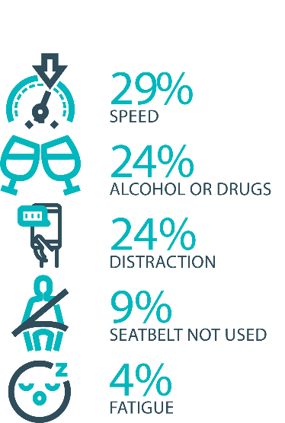

The fatal five behaviours contributing to serious casualties

## Inattention and distraction

Inattention and distraction are concerning causes of serious casualty crashes and may have a far greater impact than current data suggests. There are a number of research projects and enforcement initiatives that are being used to address this issue. This project will include consideration of emerging strategies for tackling distraction, encouraging compliance through enforcement and influencing driver behaviour through public education campaigns.

Current situation / comments

Enforcement

Tasmania Police introduced three unmarked motorcycles to increase the rate of detection and enforcement of illegal phone use whilst driving. These motorcycles operate across all districts and target the low-speed road network and congested traffic conditions, utilising ‘lane filtering’ legislation to full advantage.

The introduction of unmarked motorcycles has proved to be incredibly successful with riders reporting high-level public support and a notable change in driver behaviour. In addition regular operations continue to be conducted which target illegal phone use.

Tasmania Police continues to identify, trial and implement emerging technologies to address speeding, seatbelt, inattention and distraction offences including, improving enforcement of high-risk driving. Technologies such as handheld speed cameras, updated ANPR technology and dash cams are now being trialled and ongoing support is being provided to the Automated Traffic Enforcement Project being led by the Department of State Growth.

Public Education

The *We’re Looking Out for You* road safety campaign will again run at the end of 2024 over the Christmas / New Year period. It was last run in March / April 2024. This campaign focuses on encouraging drivers to reflect on their behaviour during the holiday period, emphasising the importance of getting home safety. With the tagline "We're looking out for you this holiday season." it highlights that getting caught breaking road rules could actually save lives, helping to prevent a catastrophic crash before it occurs.

|  |  |  |  |  |
| --- | --- | --- | --- | --- |
| Status |  |  | On schedule/progressing/low risk |  |

## Safe behaviour campaigns

Targeted media campaigns will continue to educate people about high-risk behaviours and to highlight the dangers of the ‘Fatal Five’.

Current situation / comments

Launched in July 2024, the new **Over is Over** campaign aims to reshape road safety attitudes and challenge the misconception that driving just a few kilometres over the speed limit is acceptable. This campaign underscores the disconnect between current speeding behaviours and historical safety measures, such as mandatory seatbelt use, reduced blood alcohol limits, random breath testing, and restrictions on mobile phone use while driving. Although these regulations faced initial resistance, they have become widely accepted and have significantly improved safety on Tasmanian roads over the past 50 years. The initial phase of the **Over is Over** campaign ran across television, radio, and social media until mid-September 2024. Billboards around the state have also been reskinned to feature the Over is Over campaign and a number of Metro buses around the State also feature this advertising.

The Love40 campaign had another burst at the start of term four in October 2024. Love40 aims to encourage motorists to drive at or below the school zone limit to keep our children safe. A new Love40 campaign will be launched early in 2025.

The ‘You Can’t Beat Tassie Roads’ motorcycle campaign and the Cycling Safety campaign are running at various intervals over the summer/daylight savings period. The motorcycle campaign serves as a reminder for touring motorcyclists, both local and from interstate or overseas, to drive carefully on Tasmanian roads The purpose of this Cycling Safety campaign is to promote mutual respect and safety between cyclists and motorists on shared roads. It emphasises that everyone is accountable for their actions, regardless of their mode of transportation, and encourages road users to support one another to ensure everyone's safe return to their loved ones.

|  |  |  |  |  |
| --- | --- | --- | --- | --- |
| Status |  |  | On schedule/progressing/low risk |  |

## Mandatory Alcohol Interlock Program (MAIP)

The MAIP aims to have repeat and high-level drink driving offenders demonstrate they are able to separate their drinking from driving through the installation of an alcohol interlock in their vehicle. New measures will be introduced to increase participation in the MAIP.

Current situation / comments

Drafting instructions for the revised framework were provided to the Office of Parliamentary Counsel (OPC) in October 2019. Parliamentary priorities, including COIVD-19, caused reprioritisation of OPC work. Drafting instructions were withdrawn from OPC in May 2021, before the first draft of amendments had been received, to enable the new Road User Services’ managers to review the drafting instructions to ensure that they remain current. The revised instructions were re-submitted to OPC on 15 February 2022. Again, Parliamentary priorities slowed the work of OPC. Nonetheless, version 2 of the amendments were received in November 2022. Drafting work has been suspended pending a review to determine whether the proposed amendments will create a best practice program. Road Safety Branch commenced the review in late 2024.

Two approved Providers have signed new contracts; negotiations continue with the third. The contracts expiry has been extended until October 2023 under a new Treasury process. Work commenced on creating new contracts in early February 2023. Crown Law has advised that: (i) the format of the contract must be updated to reflect the new TTCC template; and (ii) we must undertake a full tender process rather than roll the contracts over. This approach will also capture the two intending approved providers. Work continues.

|  |  |  |  |  |
| --- | --- | --- | --- | --- |
| Status | Major delays/on hold/high risk |  |  |  |

## Protective clothing for motorcyclists

Motorcyclists are overrepresented in Tasmania’s road trauma figures. Motorcyclists are vulnerable road users due to a lack of physical protection. Protective clothing can reduce injury severity in the event of a crash. Tasmania is a funding member of MotoCAP. MotoCAP provides safety assessment star ratings for protective clothing and prepares education materials for motorcyclists.

Current situation / comments

In June 2023, an updated public education brochure educating riders on the importance of wearing protective motorcycle gear was re-distributed to Tasmanian retailers, Tasmanian Neighbourhood Houses and AJL training facilities. The brochure reiterates the importance of wearing full gear on every ride and directs motorcyclists to the MotoCAP website to check gear safety ratings before purchase.

|  |  |  |  |  |
| --- | --- | --- | --- | --- |
| Status |  |  | On schedule/progressing/low risk |  |

## Road safety penalties review

For enforcement activities to improve safety on our roads, they need to be backed up with appropriate penalties. Tasmania’s road safety penalties will be reviewed to ensure they are up-to-date and provide an appropriate deterrence to those who break the rules and put themselves and others at risk.

Current situation / comments

The Department previously completed a review of road safety penalties in 2020, which showed that Tasmania was largely consistent with other jurisdictions, except for speeding offence penalties, which were lower.

The results of that review were presented to the Road Safety Advisory Council (RSAC) in November 2020. RSAC recommended not amending penalty values due to the economic impacts of COVID-19 and general parity with other jurisdictions.

Since November 2020, some jurisdictions have implemented higher penalties, which has widened the gap between Tasmania’s penalties and some jurisdictional averages.

The Road Safety Branch (RSB) undertook a review of Tasmanian road safety penalties to compare Tasmanian penalties to the average of other Australian jurisdictions for the fatal five road offences – speed, mobile phones, alcohol and drugs and failure to wear a seatbelt.

The review compared Tasmania’s penalty levels to a ‘jurisdictional average’ (i.e., an average of all other jurisdictions, without inclusion of Tasmania’s penalties) to avoid skewing the average. To ensure that the comparison of monetary penalties considers the differences in earning potential across the jurisdictions, comparisons are being done as a percentage of each jurisdiction’s seasonally adjusted average weekly wage (not a whole dollar value).

A recommendation to consider endorsing amendments to the monetary penalties for offences relating to illegal mobile phone use, seatbelt non-compliance, registration, and speed, was provided to RSAC for review in its May 2023 meeting. RSAC considered the proposal, recommending penalties should not be amended until the effects of the new automatic traffic enforcement program have been considered. RSAC agreed to review penalties again when the evaluation is complete.

|  |  |  |  |  |
| --- | --- | --- | --- | --- |
| Status |  |  | On schedule/progressing/low risk |  |

## Speed enforcement strategy

As one of the primary ‘fatal five’ contributory factors, speeding is directly addressed within the Tasmania Police *Safe Roads Strategy 2024-2026*.

The Strategy directs enhanced speed enforcement strategies and techniques to increase the rate of detection and increase the perception that offending drivers and riders will be caught, through the coordination of high-visibility speed enforcement in high-risk areas across all police districts.

Tasmania Police continues to research and trial new technology to support enforcement activities – the latest efforts involving a supplementary review of ‘In-Motion’ camera technology, where speed cameras are fitted to moving vehicles to support interdiction at the time of or sometime after, offending behaviour. Automatic number plate recognition technology is anticipated to complement the in-motion component, enhancing enforcement efforts even further. Tasmania Police will also continue to support the Department of State Growth in the conduct of the automated speed enforcement program in Tasmania, specifically via intelligence-led advice into camera sites, infringement notice processing and review activities.

The Tasmania Police Kia Stinger have now transitioned to the targeted, BMW highway patrol vehicle. This forms part of strategic efforts to drive down high-risk speeding behaviour across our highway networks, while projecting a high visibility presence. The introduction of these vehicles will be complemented by existing ‘Over is Over’ livery to further augment speed-related messaging. Tasmania Police continue matching different livery designs to specific uses, for example general patrol, high-visibility patrol, and low-profile marked vehicles – all of which are relevant to different methodologies of speed reduction and enforcement.

|  |  |  |  |  |
| --- | --- | --- | --- | --- |
| Status |  |  | On schedule/progressing/low risk |  |

## Enforcement of high-risk behaviours

To reduce high-risk behaviours and increase compliant road user behaviour, State Growth and Tasmania Police will work collaboratively to investigate and introduce new enforcement techniques and technologies to detect high-risk behaviours that address the ‘fatal five’, including mobile phone use, speeding and failure to wear a seatbelt.

Current situation / comments

The Tasmania Police *Safe Roads Strategy 2024-2026* focuses the activities of all police on the fatal five causes of serious and fatal crashes, which are the highest risk driver behaviours: speeding; alcohol and drugs; distraction and inattention; seatbelts; and fatigue.

The strategy includes the analysis of current data that assists in identifying where enforcement activities should be focused according to the highest risk, road safety locations, times and behaviours to achieve a change in driver behaviour. It is anticipated that police efforts will be further refined, via completion of a Road Safety Enforcement Allocation Model (RSEAM) project in tandem with Department of State Growth, which aims to deliver a ‘best practice’ guide for operation police, amongst other tangible benefits.

Tasmania Police actively seeks to create an environment through targeted policing tactics and consistent police messaging, where drivers expect to encounter enforcement activities anywhere on the road network. A specific focus upon the conduct of high-visibility District and Statewide Road Policing Operations underpins this strategy.

|  |  |  |  |  |
| --- | --- | --- | --- | --- |
| Status |  |  | On schedule/progressing/low risk |  |

## Automated Traffic Enforcement Program

Automated Traffic Enforcement (ATE) (i.e. speed cameras) is relatively underutilised as a deterrence and enforcement mechanism in Tasmania. This project investigates proven and emerging camera technologies for use at high-risk locations and across the entire road network.

Current situation / comments

On 30 September 2022, mobile speed camera enforcement services being delivered by Sensys Gatso Australia began issuing Infringement Notice’s to motorists detected speeding.

Currently there are 16 mobile speed camera systems operating in Tasmania being deployed at over 400 unique locations each month. Mobile speed camera deployment locations have been chosen based on crash risk, road safety infrastructure and vehicle operating speeds.

The introduction of the mobile speed camera program has been supported by the new enforcement focus of the ‘Over is Over’ marketing campaign and the development of a program website (speedcameras.tas.gov.au).

The Road User Portal (portal.speedcameras.tas.gov.au) was developed in early 2023 to support enforcement and allow motorists to view their offence images and video. The Road User Portal aims to improve transparency and build confidence in automated traffic enforcement.

In addition to speed enforcement, the Government has allocated an additional $9.3 million over three years to allow for an expansion of enforcement to 16 cameras, provide an additional one year of enforcement, and implement emerging technologies such as mobile phone, seatbelt, and average speed enforcement.

To support the implementation of these emerging technologies, the project team progressed legislative and regulatory amendments in 2022 which have enabled photographic detection devices to be used in the detection and prosecution of mobile phone, seatbelt, and average speed offences.

In August 2023, mobile phone and seatbelt enforcement commenced using four camera systems with approximately 50 deployment per month. The implementation of mobile phone and seatbelt enforcement has been supported by the ‘Click. Store. Go.’ campaign, which encourages positive behaviour change and informs motorists that detection cameras are now live.

An on-road trial of registration enforcement technology commenced in mid-2024.

The project team is progressing work to deliver a trial of mobile average speed enforcement technology.

|  |  |  |  |  |
| --- | --- | --- | --- | --- |
| Status |  |  | On schedule/progressing/low risk |  |

## High-risk motorcycling enforcement

Speed is a factor in at least a quarter of motorcyclist serious casualties. Speed cameras offer no deterrence to motorcyclists, whose numberplates are mounted only on the back. Introduction of rear-facing speed cameras will improve detection and deterrence of speeding. This is being considered as part of the Automated Traffic Enforcement Program.

Current situation / comments

The Tasmania Police Road Safety Strategy 2022-2024 approaches the enforcement of high-risk motorcycle behaviours from several angles. Tasmania Police has:

* worked with the Department of State Growth to re-introduce Automated Mobile Speed Enforcement Cameras that have both a rearward and forward-facing capability to better target and detect high-risk motorcycle behaviour.
* introduced an online public portal for members of the public to upload footage relating to traffic offences they have witnessed. Tasmania Police reviews these submissions and allocate prima facie offences to an officer for investigation and follow-up.
* published the Tasmania Police Road Safety Strategy 2022 – 2024 which provides for increased patrol hours on rural roads which includes many of the popular motorcycle touring routes. The increased patrol hours will be conducted in a mix of covert and overt patrols that will discourage and detect high-risk motorcycle behaviours increasing the perception amongst riders they will be caught anywhere at any time.

|  |  |  |  |  |
| --- | --- | --- | --- | --- |
| Status |  |  | On schedule/progressing/low risk |  |

## Road Rules Awareness

Compliance with Road Rules makes our behaviour on the roads predictable, improving safety for all road users. This initiative will ensure that user-friendly and tailored information resources are developed so that the Road Rules are easily understood and adhered to by all road users.

Current situation / comments

The *Tasmanian* *Road Rules Handbook* and the *Misunderstood Road Rules* series of pamphlets are distributed to Service Tasmania locations when required.

|  |  |  |  |  |
| --- | --- | --- | --- | --- |
| Status | Major delays/on hold/high risk |  | On schedule/progressing/low risk |  |





11 per cent of all serious casualties on our roads are non-Tasmanian residents

## Tourist road safety signage program

This program will see the installation of tourist signage strategically placed across the road network. The signs will provide important road safety information, relevant to the area road users are travelling in. This program will be undertaken in collaboration with stakeholders, local government and State Roads.

Current situation / comments

This program is currently on hold.

|  |  |  |  |  |
| --- | --- | --- | --- | --- |
| Status | On hold |  | On schedule/progressing/low risk |  |

## Responsive electronic signage trial

This project will trial a responsive electronic sign with real time information at regional tourism gateways.

Current situation / comments

This project is currently on hold.

|  |  |  |  |  |
| --- | --- | --- | --- | --- |
| Status | On hold |  |  |  |

## Tourist education materials

A range of education materials developed using images, symbols and multi-lingual material delivered to specific audiences through targeted communications channels. This includes vehicle hangers, brochures, posters, roadside signs, editorial content, film and digital content.

Current situation / comments

Communications materials are being distributed upon request from stakeholders.

|  |  |  |  |  |
| --- | --- | --- | --- | --- |
| Status |  |  | On schedule/progressing/low risk |  |

## Strategic partnerships

Developing strategic partnerships based on synergies with target audiences will enable the effective promotion of road safety messages and education.

Current situation / comments

This project is currently on hold.

|  |  |  |  |  |
| --- | --- | --- | --- | --- |
| Status | On hold |  |  |  |

## Tourist education at gateway entry points

As an island state, we have the opportunity to strategically place messaging at our gateway airports and seaports to reach visitors with important road safety messaging prior to them driving in Tasmania. This includes a range of educational materials, electronic and static signs and billboards.

Current situation / comments

Printed collateral is in stock and digital billboards display road safety messaging at gateway locations.

|  |  |  |  |  |
| --- | --- | --- | --- | --- |
| Status |  |  | On schedule/progressing/low risk |  |

## Stakeholder alliances

Sharing information and collaborating to develop effective strategies and tools to address road safety issues is vital. This project will develop formal and informal stakeholder alliances to encourage input and create opportunities to deliver joint initiatives.

Current situation / comments

This activity is currently on hold.

|  |  |  |  |  |
| --- | --- | --- | --- | --- |
| Status | On hold |  |  |  |





The rate of fatal crashes is four times higher for vehicles 15+ years old than for vehicles made in the last five years

## Australasian New Car Assessment Program (ANCAP)

Tasmania is a funding member of ANCAP. ANCAP plays a vital role in informing consumers about safety performance of new vehicles and advocates for improved vehicle safety design and specification through public education campaigns, advocacy activities and engagement with governments, corporate fleets, the media and consumers. Activities related to ANCAP will include promotion of safer vehicles and options for an annual vehicle fleet report.

Current situation / comments

Tasmania continues to provide funding support to ANCAP. ANCAP has developed a Strategic Plan for 2023-2030. Tasmania has increased its support of ANCAP with funding of up to $85,000 per annum from the Road Safety Levy. ANCAP published 20 new vehicle ratings between 1 October 2024 and 31 December 2024. Each vehicle goes through four crash tests, various crash avoidance tests and other assessments. One vehicle was republished from Euro NCAP and three were tested and published by ANCAP.

|  |  |  |  |  |
| --- | --- | --- | --- | --- |
| Status |  |  | On schedule/progressing/low risk |  |

## Safer cars for young drivers

This project aims to increase awareness of the Used Car Safety Rating database amongst first time car buyers. This could be promoted through education materials and campaigns and may be able to integrate with the GLS online learning platform.

Current situation / comments

This project has not yet commenced and will be considered as part of the Light Vehicle Safety Strategy and through the mid-term review.

|  |  |  |  |  |
| --- | --- | --- | --- | --- |
| Status |  |  |  | Not yet commenced |

## Autonomous vehicle and crash avoidance readiness

This project involves the monitoring and development of safety and autonomous vehicle technologies.

Current situation / comments

A regulatory framework for the use of autonomous vehicles is being considered at a national level and Tasmania is participating in that process.

|  |  |  |  |  |
| --- | --- | --- | --- | --- |
| Status |  |  | On schedule/progressing/low risk |  |

## Workplace driver safety

Vehicle use in road traffic is the most significant contributor to work-related traumatic injury. This project will aim to promote and encourage employers to adopt safe driving policies based on the Worksafe, ‘Vehicles as a workplace’ guide.

Current situation / comments

This project has not yet commenced and will be considered as part of the mid-term review.

|  |  |  |  |  |
| --- | --- | --- | --- | --- |
| Status |  |  |  | Not yet commenced. |

## Light vehicle safety strategy

A light vehicle safety strategy will be developed to provide public education and undertake enforcement activities to enhance the safety standard of Tasmania’s vehicle fleet.

Current situation / comments

A draft light vehicle safety strategy is being developed. The draft strategy aims to accelerate an increase in the number of newer and safer vehicles and removal of older cars from the light vehicle fleet while increasing the safety of the current vehicle fleet.

RSAC will soon consider policy advice on the light vehicle safety strategy.

|  |  |  |  |  |  |
| --- | --- | --- | --- | --- | --- |
| Status |  |  | On schedule/progressing/low risk |  | |
|  | | | | |

|  |  |  |  |
| --- | --- | --- | --- |
| **Funding** | |  |  |
| **Road Safety Levy Overview for the Financial Year 2024/25** | | | |
| As at 31 December 2024 (Quarter 2) | |  |  |
|  |  |  |  |
| **Road Safety Levy Opening Summary** | |  |  |
| Opening Balance as at 01 July 2024 | |  | $28,189,355 |
| Annual Allocation to Road Safety Operations | |  | $2,600,000 |
|  |  |  |  |
| **Revenue Summary** | |  |  |
|  |  | **Forecast (FY25)**  **$** | **Actual (YTD)**  **$** |
| Motor Accident Insurance Board Funding | | 1,560,908 | 959,436 |
| Revenue Inflows from Registrations | | 18,157,313 | 10,138,508 |
|  |  |  |  |
| Funds Available for Distribution | | 47,646,668 | 39,183,427 |
|  |  |  |  |
| **Expenditure Summary** | |  |  |
| **Theme no.** | **Theme** | **Forecast (FY25)**  **$** | **Actual (YTD)**  **$** |
| 1 | Making our Rural Roads Safer | 11,945,032 | 1,744,846 |
| 2 | Improving Safety in our Towns and Cities | 4,147,750 | 693,536 |
| 3 | Saving Young Lives | 3,786,922 | 1,095,806 |
| 4 | Encouraging Safer Road Use^ | 6,834,872 | 1,677,975 |
| 5 | Making Visitors Safer | 263,282 | 69,048 |
| 6 | Improving Safety Through Vehicles and Technology | 2,890,000 | 129,192 |
| 7 | General Support | 699,578 | 328,487 |
|  |  |  |  |
|  |  |  |  |
| **Budget and Expenditure by Category** | | **Forecast (FY25)**  **$** | **Actual (YTD)**  **$** |
| Infrastructure Expenditure | | 15,063,128 | 2,316,556 |
| Policy & Projects Expenditure | | 15,504,309 | 3,422,334 |
|  |  |  |  |
| **Total Expenditure** | | 30,567,437 | 5,738,890 |
|  |  |  |  |
| **Balance as of 31 December 2024** | | 23,441,328 | 33,444,536 |
|  |  |  |  |
| **Forecast Closing Balance of FY25** | | 17,236,266 |  |
|  | |  |  |
| ^includes MAIB expenditure | |  |  |

|  |  |  |  |
| --- | --- | --- | --- |
| **MAIB Funding**  **As at 31 December 2024** | | | |
| **2024/25 Financial Year** | **Budget**  **$** | **Actual (ytd)**  **$** | **Balance**  **$** |
| **Expenditure (State Growth)** |  |  |  |
| Administration & Public Relations | 360,934 | 151,166 | 209,768 |
| Public Education | 1,124,974 | 628,559 | 496,415 |
| Research | 75,000 | 57,454 | 17,546 |
| **Subtotal** | **1,560,908** | **837,179** | **723,729** |
|  | | | |
| **Expenditure (Tasmania Police)** |  |  |  |
| Salaries | 2,299,342 | 1,206,800 | 1,092,542 |
| Operating Expenses | 188,000 | 68,534 | 119,466 |
| Equipment | 507,257 | 52,352 | 454,904 |
| **Subtotal** | **2,994,599** | **1,327,687** | **1,666,912** |
| **Total** | **4,555,507** | **2,164,866** | **2,390,641** |
| **Includes Carried Forward of**  **$153,480 (Police)** | | | |

|  |  |  |
| --- | --- | --- |
| MKBK:Users:roland:My Desk:Business:RG Design:Jobs:DEDTA Jobs:DSG 14034 DSG A4 Document Template:B - Development:Exports:Back Gov Logo.png | Department of State Growth  Road Safety Branch  Towards Zero Action Plan 2020-2024  GPO Box 536 Hobart TAS 7001 Australia | |
| Phone: | 6166 3243 |
| Email: | rsac@stategrowth.tas.gov.au |
| Web: | www.rsac.tas.gov.au |
|  | © State of Tasmania December 2024 | |