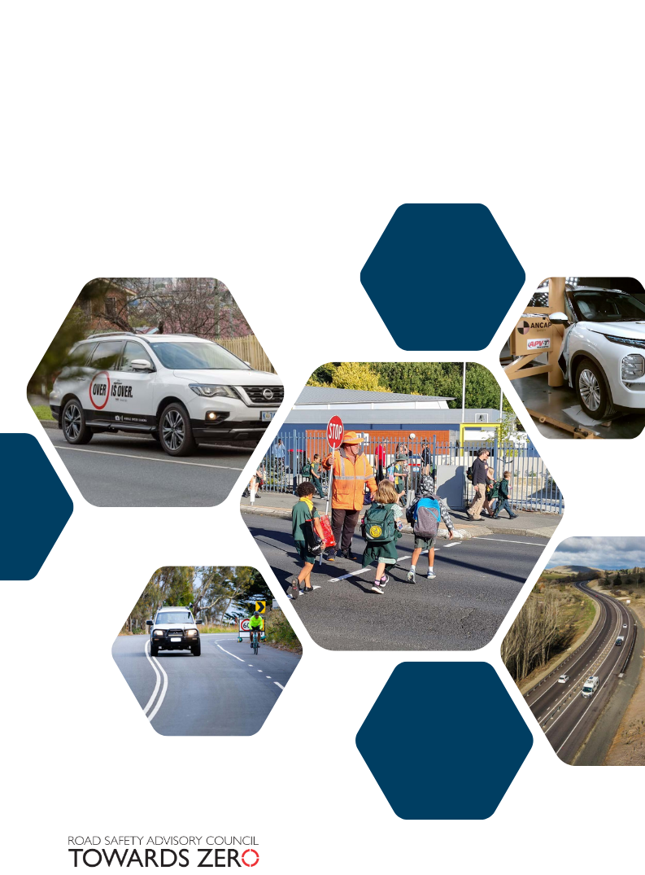

CONSULTATION REPORT

Speed Management Strategy

**Speed Management Strategy – Consultation Report**

**Contents**

Executive summary 3

1. Introduction 4

1.1 Background

1.2 About the Speed Management Strategy

2. Public consultation 4

2.1 Consultation methodology

2.2 Consultation questions

2.3 Response options

3. Consultation results 6

3.1 Respondent demographics

3.2 Consultation responses

3.3 Strategy aim

3.4 Strategy principles

3.5 Action areas

3.6 Outcomes

3.7 Strategy approach

3.8 Local government consultation forum

Next steps 11

Appendix 1 – Proposed Speed Management Strategy Approach 12

Appendix 2 – Consultation Questions 13

*In recognition of the deep history and culture of this island, the Road Safety Advisory Council acknowledges and pays respect to Tasmanian Aboriginal people as the traditional and continuing custodians of lutruwita/Tasmania, and we pay our respects to Elders past and present.***Executive summary**

The Speed Management Strategy (the Strategy) is a commitment under the *Towards Zero Action Plan 2020-2024* and aims to help reduce the number of people seriously injured or killed by supporting safe and appropriate vehicle travel speeds on Tasmanian roads.

The Road Safety Advisory Council (RSAC) led a public consultation process between 10 October and 21 November 2024 seeking feedback on a Speed Management Strategy Consultation Paper, which included a draft Strategy framework. The Paper included ten questions on the proposed Strategy aim, principles, action areas and outcomes, as well as general questions about the Strategy. This report summarises the feedback received as part of this consultation.

There were 81 consultation responses, including written submissions, website responses, survey responses, meeting/telephone, and email contributions. The majority of respondents identified as community members, but also included road managers, road safety experts/researchers, peak body representatives and a category of ‘other’.

Overall, there was strong support for the draft Strategy approach set out in the Consultation Paper. Respondents who provided comment generally agreed with the Strategy’s aim and five principles. Some changes were suggested by respondents, such as clarifying aspects of the principles, particularly relating to the idea of shared responsibility for speed management. For the minority who did not support the Strategy approach, this was often based on the view that vehicle speed is not a key factor in serious casualty crashes or an area for action to improve road safety.

The majority of respondents commenting supported the five action areas proposed in the draft Strategy approach and proposed outcomes. There was very strong support for action on infrastructure and speed limits, with good support for action on enforcement. There was more moderate support for action to engage the community on speed management and for the area of vehicle technology.

Respondents expressed a range of views in relation to the proposed action areas. Common themes included using traffic calming and grade separation to protect vulnerable road users, while others expressed support for a speed limit setting that is consistent, efficient and easily understood, taking a whole of network approach. There was also support for the use of speed limit reduction trials in Tasmania, and calls for 40km/h and lower speed zones in built-up areas. Even among respondents opposing speed changes, there was some support for lowering speed limits in urban areas.

Most responses called for more enforcement generally to address speeding behaviours, but with a focus on ensuring an increase in manual police enforcement. For community engagement, there was an emphasis on ensuring local community input, including from rural areas. In relation to vehicle technology, there was support to provide information and education on the value of vehicle safety features, as well as action to increase adoption of vehicle technology in Tasmania.

A strong theme overall was the view that expanding and strengthening partnerships will help deliver speed management action. Local councils indicated a clear desire for stronger collaboration with the Department of State Growth in achieving safer speeds for their communities, including support for safety and speed limit assessment. Other suggestions included expanding collaboration to include partnerships with health and workplaces sectors.

The RSAC will now consider the feedback provided through this public consultation process, as well as evidence and recommendations made by road safety experts to inform the development of the Speed Management Strategy.

**1. Introduction**

## 1.1 Background

The Tasmanian Government has tasked the Road Safety Advisory Council (RSAC) with developing a Speed Management Strategy (the Strategy). The Strategy is a commitment under the *Towards Zero Action Plan 2020-2024* and it aims to help reduce the number of people seriously injury or killed by supporting safe and appropriate vehicle travel speeds on Tasmanian roads.

Over the last decade since 2013, more than 3,000 people have been either seriously injured or killed on Tasmanian roads. Speed is a major contributor to road trauma, as it is both a leading factor in road crashes and the key determining factor in the outcome for those involved.

Safe speed is one of the four components of the Safe System approach that all Australian jurisdictions have committed to, in the effort to improve road safety. Vehicle speed is the factor that mediates all other Safe System components, as the faster the vehicle speed, the greater the impact, and resulting trauma.

Decades of research in Australia and internationally show that safer vehicle travel speeds across a road network is one of the most effective ways to reduce the number of people seriously injured or killed. Speed management refers to a range of techniques and tools that are designed to achieve safe and appropriate speeds for all road users. Road safety experts have recommended a range of best practice speed management actions that can be implemented to improve road safety in Tasmania.

## 1.2 About the Speed Management Strategy

The RSAC has developed a Speed Management Strategy draft framework that is based on the Safe System model and is informed by extensive evidence and best practice actions. The approach includes a set of draft principles, five key actions areas, and a range of outcomes. The scope of the Strategy approach covers the whole Tasmanian road network, but does not include changes to the statutory, default speeds limits. The proposed timeline for the Strategy is 2025 to 2030.

**2. Public consultation**

## 2.1 Consultation methodology

The RSAC led a consultation process to inform the development of the Strategy. The purpose of the consultation was to provide information to the community about the role of vehicle speed in road safety, introduce the proposed Strategy approach, and provide key stakeholders and the broader community with the opportunity to have their say on the development of the Strategy.

The public consultation process commenced on 10 October 2024 and was open for a period of 6 weeks, closing on 21 November 2024.

The public consultation was advertised and promoted as follows:

* a public notice in the early general news sections of the Mercury, the Examiner and the Advocate on Saturday 12 October 2024
* a letter to more than 200 key stakeholders and community organisations from the Chair of the RSAC, (including 130 display posters with QR codes sent to all Service Tasmania outlets, all RACT offices, each local government office, and all Tasmanian libraries to help promote the consultation)
* a post on the RSAC Facebook page (with a post share on the Roads Tas Facebook page)
* promotion through the RSAC website (including announcement released on 11 October 2024, and links to the consultation website)
* a media release from the RSAC Chair
* two media interviews by the RSAC on ABC radio (on 11 October and 15 October 2024)

A Speed Management Strategy Consultation Paper was developed by the RSAC, with guidance from an RSAC Steering Committee. The Consultation Paper included information about the role of speed in road safety, including in Tasmanian road safety, best practice speed management, and the proposed Strategy approach. It also included 10 questions embedded into the document that sought feedback on the Strategy aim, principles, actions, outcomes, as well as general questions seeking input on the Strategy more broadly. This was supported by a one-page, Consultation Paper summary, which was a highly graphic, easy access document.

The Consultation Paper and support documents are available on the Department of State Growth’s Engage page - <https://engage.stategrowth.tas.gov.au/speed-management-strategy>

These documents were hosted on a consultation website, which was part of the Department of State Growth’s Engage platform. In addition to the consultation document library, the website provided a range of frequently asked questions about the Strategy approach and the consultation. Stakeholders and community members wanting to give feedback were provided with a range of options. They could upload a submission to the website, provide comment through an online feedback form, or complete a survey. The survey included the same ten questions that were included in the Consultation Paper. Further information was requested through the online form and the survey, including participants’ names, email addresses, relationship to road safety, and postcode.

The opportunity to engage in consultation meetings was provided to stakeholders, with meetings being held either in person, online or by phone. A state-wide consultation forum was also held for all Tasmanian local councils on 13 November 2024, in partnership with the Local Government Association of Tasmania. In November, an email was sent to stakeholders and an RSAC Facebook page was posted, as a reminder that the consultation was closing on 21 November 2024, and encouraging consultation responses.

## 2.2 Consultation questions

The Consultation Paper contained ten questions that cover the proposed aim, principles, action areas, and outcomes, as well as general questions about the content and Strategy approach. The consultation questions are included at Appendix 2.

## 2.3 Response options

The ‘Have you say’ page on the consultation website included two modules to allow respondents to provide feedback on the Strategy approach - a dialogue box for comments, and a survey (based on the consultation questions). In addition, respondents could directly upload a written submission via this page or use the consultation email address to either attach a written submission or provide comments.

Both the comments box and the survey asked respondents to provide some demographic information including, first and last name, email address (a required prompt to allow for any post response clarification and follow-up), interest in road safety, organisation, and postcode. Free-text dialogue boxes were provided for all consultation responses to allow for open, unlimited feedback.

Apart from the respondent’s email address, all website comment and survey questions were optional.

**3. Consultation results**

## 3.1 Respondent demographics

The following data provides a summary of demographics for those who responded to the website via submission, comments or the survey. Results are reported for consultation questions.

Figure 1: Consultation respondent category for those providing a website comment, uploading a submission or completing a survey (question ‘interest in road safety’)

The majority of respondents identified as a ‘community member’ (68 per cent), followed by those selecting ‘other’ (16 per cent). ‘Other’ responses include road safety advocate, driver/rider instructor, ex-police officer, community association, professional engineer and business owner. A small proportion of respondents identified themselves as a ‘road manager’ (9 per cent), ‘road safety expert/researcher’ (5 per cent) and ‘peak body representative’ (2 per cent).

Almost all respondents were Tasmanian, except for a research institution in Western Australia, a road safety expert in Victoria, and two community member responses from New South Wales.

## 3.2 Consultation responses

Overall, there were 81 consultation responses, including:

* 28 written submissions
* 35 website responses
* 12 survey responses
* 4 meeting/phone contributions
* 2 email contributions

In addition, there was the opportunity for all local councils to attend a state-wide forum to provide feedback as local road managers. This was held on 13 November 2024 and attended by representatives from 13 councils and the Department of State Growth.

There was also a small number of comments in response to Facebook posts promoting the consultation.

## 3.3 Strategy aim

Of the respondents that commented directly on the aim, the majority (80 per cent) either stated they supported the aim or supported broad aspects of the aim.

A small number of those suggested amendments to the aim. While there were no consistent themes to the feedback, suggestions included that it should be bolder and should include defined targets, while another suggestion was that the aim should include consistent application of speed management across the state road network.

A remainder of respondents (20 per cent) stated that they either did not support the aim specifically, or did not support the focus on speed. The general sentiment of these responses was that vehicle speed is not a leading safety priority compared to driver error, including inattention and poor driver behaviour or lack of skill.

## 3.4 Strategy principles

The majority of respondents (78 per cent) commenting directly on this question either indicated that they supported the principles or supported their broad direction.

There were a range of suggested changes intended to strengthen Strategy principles. The most common suggestion was to define the principle of shared responsibility more clearly, particularly how it relates to differences in accountability. Another suggestion was to make it clear that safe road systems and speeds support all road users.

A remainder of respondents (22 per cent) stated that they either did not support the principles broadly, or did not support specific principles, or that the community should not be consulted on evidence-based safety measures.

## 3.5 Action Areas

**Action Area 1 – Road and roadside infrastructure that supports safe vehicle speeds**

There was strong endorsement from respondents to improving infrastructure to support safe vehicle speeds. A very high proportion of responses (89 per cent) who provided comment on this area either supported or partially supported the approach outlined in Action Area 1.

Feedback on this Action Area included a range of suggestions. Most commonly, respondents suggested specific infrastructure improvements, either to localised parts of the Tasmanian road network, or suggestions to use specific types of designs or upgrades, such as low-cost treatments. There was an emphasis on protecting vulnerable road users, such as pedestrians and motorbike riders, either by separating them more effectively from traffic or creating safer speed environments.

For those making suggestions about the action area itself, this included defining infrastructure more broadly to include active living infrastructure, such as cycleways, and including designs appropriate for urban and suburban environments that support a ‘Movement and Place’ approach.

Others commented that a strategic infrastructure focus is important, including using safety plans and audits, and that State Government lead by risk assessing the whole Tasmanian road network.

Where respondents did not support a focus on infrastructure, the reasons were most commonly related to seeing other factors as more important to improving road safety, such as driver error and the need for more enforcement.

**Action Area 2 – Speed limits that reduce risk and are aligned with the safety level of the network**

The issue of speed limits generated the highest number of responses of all Action Area questions. Of those providing a specific response to this question, 88 per cent supported safer speed limits. This consists of 53 per cent supporting the Strategy approach and 35 per cent calling for speed limit reductions to improve road safety. Among those suggesting speed limit reductions, this included broad categories of speeds, such as speed limits in built up areas or requesting speed reductions for specific roads and streets.

The feedback on this Action Area included the following key themes.

Respondents, including most road managers, stated that the speed limit assessment and setting process needs to be consistent, clear, efficient and easily understood. Responses highlighted that there also needs to be alignment between the Strategy and the *Tasmanian Speed Zoning Guidelines* to help achieve this.

Broadly, there was support for a whole of network approach to speed limit setting, irrespective of state and local area boundaries. Councils also indicated a clear desire for stronger partnership with State Growth in implementing safer speeds for their communities. This includes collaboration and support around safety and speed limit assessment.

One of the strongest themes was the support for lowering speed limits to 40km/h and 30km/h in built-up areas, high-pedestrian zones, and shopping districts. Even among respondents opposing speed changes, there was some support for lowering speed limits in urban areas.

Other suggestions included the use of temporary and variable speed limit changes and signage. An example was side road activated speed signs operating in other jurisdictions – these temporarily reduce the limit on a high-speed main road to support the entry of vehicles from a side road.

The use of speed limit trials was another common suggestion from respondents to support safer speeds. These included pedestrian areas, 30km/h school zones, and establishing a process for the community to initiate speed limit trials.

Respondents also raised the issue of default speed limit changes, with some questioning why the Strategy scope excludes changes to default speed limits, particularly given the impact this would have on outcomes. It was suggested that survey data of community sentiment should be used to identify the level of support for any default speed limit reductions.

While a large majority of respondents supported safer speed limits, there were a small number who opposed speed limit changes, particularly in rural areas, as well as others not answering this question directly, but opposing the focus on speed in the aim of the Strategy.

**Action Area 3 – Enforcement of speed limits to encourage safe road user behaviour**

There was a moderately high level of support for this Action Area to use enforcement of speed limits to encourage safe road user behaviour. For those providing a response to this question, 74 per cent supported the Strategy approach.

Most responses called for more enforcement generally to address speeding behaviours, but with a focus on ensuring an increase in manual police enforcement. Other suggestions included specific enforcement action, such as the introduction of point to point (average speed) automated cameras.

Other respondents suggested that penalties for speeding offences should be reviewed and increased to improve driver behaviours, while another suggestion was for before and after data to evaluate the introduction of speed mitigation and enforcement strategies.

For the remainder who did not directly support enforcement of speed limits, almost all supported enforcement of other driver behaviours, such as inattention and tailgating.

**Action Area 4 – Measures to positively influence community attitudes regarding vehicle speed**

The issue of positively influencing community attitudes regarding vehicle speed had good support among respondents with 64 per cent agreeing with the Strategy approach or the value of community engagement around speed.

Responses included suggestions for a range of approaches, such as needing a multifaceted community engagement approach, ensuring engagement with community champions, local voices, and those with lived experience, and including a focus on rural areas. A common theme was the view that expanding strengthening partnerships with communities and organisations will help deliver speed management action.

Others suggested that any community engagement needs to have consistency in speed management messaging between stakeholders, and that messages include issues such as promoting the benefits of safer speeds, providing information to the community about the use of enforcement revenue, and complementing enforcement efforts with supporting campaigns.

For those not directly supporting the Strategy approach, they suggested that community engagement should target poor driving behaviour and delivering actions like driver training and information to improve competency.

**Action Area 5 – Vehicle technology that supports safe travel speeds**

While this Action Area generated the least number of specific responses, 65 per cent of these respondents either supported the Strategy’s approach or the role for vehicle technology to support safe travel speeds.

Suggested approaches for this action area included providing information and education on the value of vehicle safety features, as well as supporting the adoption of improved vehicle technology in Tasmania. Examples of vehicle technology included the use of phone app technology to assist drivers to comply with posted speed limits.

Some respondents raised the opportunities for technology to be encouraged, particularly for corporate fleet buyers, while also being mindful that technology needs to support older vehicles, given Tasmania has the oldest average vehicle age.

Where respondents did not support the focus on vehicle technology, there was doubt that, as a jurisdiction, Tasmanian can have much impact on this area, or that technology was not advanced enough to be helpful to all drivers, particularly those with older vehicles.

## 3.6 Outcomes

While only a small proportion of respondents provided a specific comment on the proposed Strategy outcomes, of those responding, 72 per cent either showed support or partial support.

For those respondents providing specific comments, a range of additions were suggested. Some responses mentioned that existing outcomes be refined, including outcomes on guidance, support and collaboration for speed management action for local road managers. Other responses made specific suggestions for additional or related outcomes, including for enforcement, speed limits and for community engagement.

Other suggestions were to order the outcomes based on priority of action, link the outcomes more directly to the primary outcome and aim, and to publish the progress against the outcomes.

Where respondents did not agree with the outcomes, this was linked to the same reasons for opposing the primary aim and focus of the draft Strategy framework.

## 3.6 Strategy approach

Consultation questions also asked for feedback on what else should be included in the Speed Management Strategy and sought respondent views of the approach taken in the Strategy more broadly. Just over half (52 per cent) of all respondents provided comment on additional actions and approaches that could be considered in the development of the Strategy. Several key themes emerged among these responses.

A common theme within responses was about partnerships and collaborations. The draft Strategy framework proposes strengthening partnerships with local government and supporting risk identification, and consultation responses from local road managers strongly endorsed this approach. In addition, other consultation responses included expanding partnerships to include health and workplaces.

Some respondents focused on more specific enforcement efforts, including the introduction of remedial programs for repeat speeding offenders and less directly related actions such as the use of red-light cameras. Connected to this was the suggestion that enforcement revenue needed to be hypothecated for dedicated use in improving road safety.

Comments on further vehicle technology actions also emerged in responses to these questions. Suggestions included mandating the use of speed limiting technology, as well as using this option to limit speeds of vehicles in specific, built-up areas (known as ‘geofencing’).

Responses also included that road safety authorities and road managers should show leadership by implementing measures that are best practice and already proven to be effective, and reserving public consultation only for suggestions about ways to best introduce these initiatives.

Although not directly related to speed management, a very common response on the issue of additional actions and approaches was the suggestion that more needed to be done to address a perceived lack of skill and attention among other drivers. The most popular suggestion was to deliver more driver training and education, including improving defensive driving skills. Linked to this was the view that a more restrictive licensing system would also help improve driver skills through more extensive testing, as well as addressing poor driving behaviour.

## 3.7 Local government consultation forum feedback

A local government consultation forum was held on 13 November 2024, in partnership with the Local Government Association of Tasmania. The state-wide forum was attended by representatives from 13 councils and the Department of State Growth. Like the feedback captured through consultation submissions, common themes emerged in the feedback provided by attending local councils about the draft Strategy approach and speed management in Tasmania.

Overall, attendees expressed support for the role a Strategy can play in improving road safety, as well as helping clarify the role local and state governments can play together to achieve safer speeds. Related to this was support for an approach to speed limit setting that takes a whole of network perspective that helps reduce any confusion for road users.

Responses noted that speed limits can be socially and politically sensitive, particularly around the issue of default limits. Attendees expressed that there needs to be ways for the Strategy to help build consensus so that these issues do not undermine a best-practice, technical approach to improving safety on Tasmanian roads and streets. This includes engaging community support for actions to achieve safer speeds.

Responses also supported using a Movement and Place approach to identify risk, guide infrastructure design and undertake speed limit assessments but noted that councils would need support to best use this approach. It was identified that smaller councils, with more limited resources would particularly need support. Related to this was the observation that work was needed to identify and embed a framework for use in Tasmania, including by local councils.

**4. Next steps**

The RSAC will now consider the feedback provided through this public consultation process, as well as evidence and recommendations made by road safety experts. This will be used to inform the development of the Speed Management Strategy.

**Appendix 1 – Proposed Speed Management Strategy Approach**

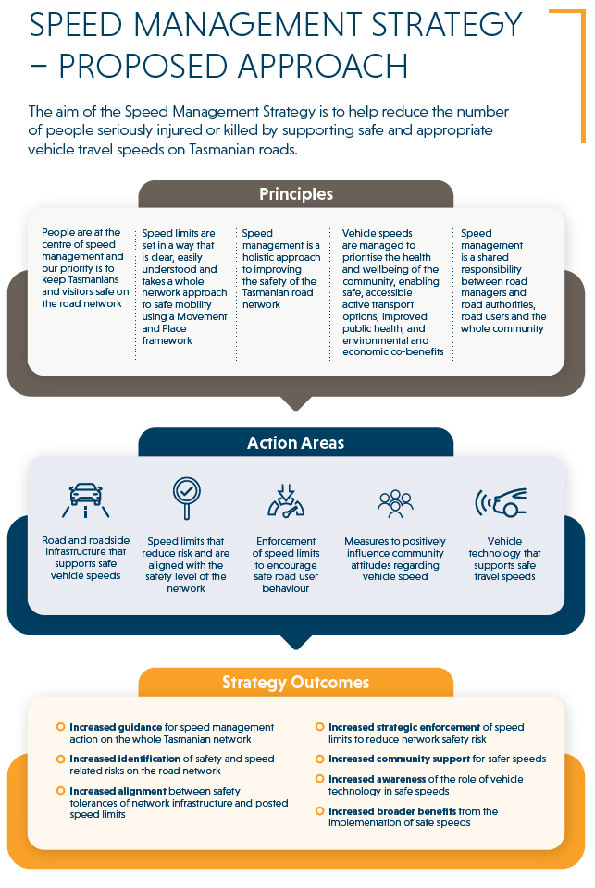

**Appendix 2 – Consultation Questions**

Question 1 – What are your thoughts or comments on the aim of the Strategy?

Question 2 – Are these principles right or are there other best-practice principles that we should consider in our approach to this Strategy?

Question 3 – (Road and roadside infrastructure that supports safe vehicle speeds)

What is your view about this action area? What else should we be considering in this area to support safe vehicle speeds?

Question 4 – (Speed limits that reduce risk and align with the safety level of the road network)

What is your view about this action area? What else should we be considering in this area to reduce risk and align speed limits with the safety level of the network?

Question 5 – (Enforcement of speed limits to encourage safe road user behaviour)

What is your view about this action area? What else should we be considering in this area to encourage safe road user behaviour?

Question 6 – (Measures to positively influence community attitudes regarding vehicle speed)

What is your view about this action area? What else should we be considering in this area to positively influence community attitudes?

Question 7 – (Vehicle technology that supports safe travel speeds)

What is your view about this action area? What else should we be considering in this area to support safe travel speeds through technology?

Question 8 – Are these the right outcomes we should be aiming to achieve or are there other outcomes that we should be considering for the Strategy?

Question 9 – What else should we be including in this Strategy to improve road safety through speed management?

Question 10 – Do you have any other views about the approach we are taking in this Strategy?

Speed Management Strategy

CONSULTATION REPORT

Address: GPO Box 536, Hobart TAS 7001 Australia

Phone: 1800 030 688

Email: [speedmanagement@stategrowth.tas.gov.au](mailto:speedmanagement@stategrowth.tas.gov.au)

© State of Tasmania January 2025

