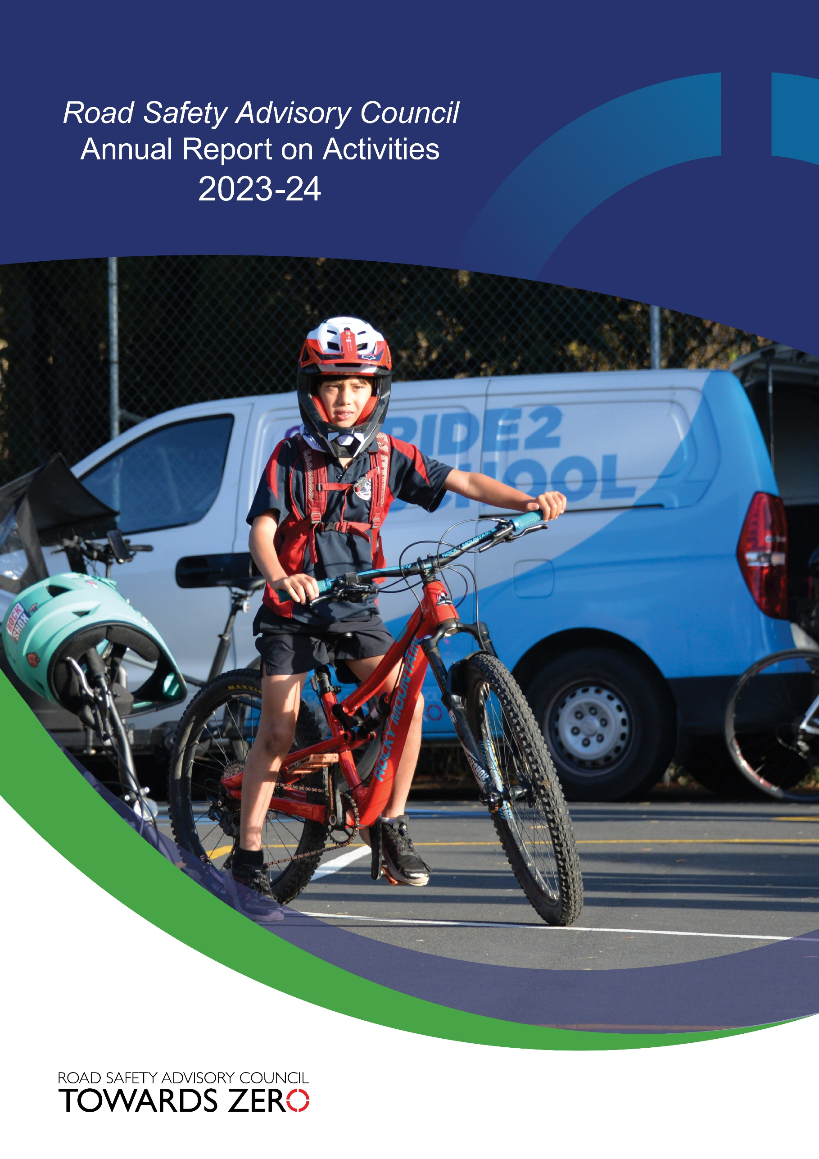

Table of contents
Photo credits and acknowledgements 2
Overview 3
Message from the Chair of the Road Safety Advisory Council 3
About the Road Safety Advisory Council 6
Road Safety Advisory Council membership 7
Road Safety Advisory Council meetings and attendance 8
RSAC Education and Enforcement Sub-Committee (EESC) membership 8
EESC meetings and attendance 9
RSAC and EESC remuneration 9
Serious casualty trends and progress on meeting Towards Zero Strategy targets 10
Thematic Snapshot of the Towards Zero Action Plan 2020-2024 14
Making our rural roads safer 15
Improving safety in our towns and cities 17
Saving young lives 18
Encouraging safer road use 25
Making visitors safer 30
Improving safety through vehicles and technology 31
Road safety levy budget overview 32

Photo credits and acknowledgements
Images used within this report remain the property of the copyright holder. All images are courtesy of the RSAC, Tasmanian Government and its associated projects, ANCAP, Bicycle Network, Scott Glynn and Alastair Bett. Cover photo courtesy of Bicycle Network.
© State of Tasmania October 2024

Overview

Message from the Chair of the Road Safety Advisory Council

As Chair of the Road Safety Advisory Council (RSAC), I am pleased to present the fourth annual report under the five-year Towards Zero Action Plan 2020-2024 (Action Plan). The five-year Action Plan details the 42 road safety initiatives that will gain the greatest reductions in serious injuries and deaths.
Over the life of the Action Plan over $75 million will be invested in road safety, funded from the Road Safety Levy. Annually, the Motor Accidents Insurance Board (MAIB) contributes $4.5 million for the production and evaluation of public education initiatives and to support enforcement activities. Additionally, over the last year the Australian Government has contributed $1.5 million to infrastructure projects delivered through the Road Safety Program.
One of the major undertakings for RSAC over the last year has been to review the Action Plan with a view to extending it to align with the end of the Towards Zero Road Safety Strategy in 2026. We have determined the priorities for road safety funding and the most appropriate initiatives to reduce road trauma. The plan will also include safety performance indicators (SPIs) to complement injury-based data with risk-reduction performance data (leading indicators).
We recognise the impact that road crashes have on individuals and the broader community. In 2023, we had 36 fatalities on our roads and 309 people were seriously injured. Although these figures were down on the previous year, we’re not making the inroads we need to reach our target of fewer than 200 serious casualties by 2026.
The extended Action Plan will continue to focus on the Safe System approach which recognises that our bodies are fragile and not built to withstand the physical force of crashes. We continue to try to reduce the number of crashes on our roads, as well as reducing the severity of crashes should they occur. The Safe System has four pillars which help us to concentrate our efforts in this regard, these being safer roads and roadsides, safer road users, safer vehicles, and safer speeds.
In the last year, to increase compliance with the road rules and to reduce high-risk behaviours, we have extended our automated traffic enforcement program, originally targeting speeding, to include mobile phone and seatbelt detection cameras. We have trialled the detection of unregistered and uninsured vehicles. We have supported local government to improve safety on our urban and rural roads through the Vulnerable Road User Program and the Safer Rural Roads Program. We are currently developing a speed management strategy which will encompass public education, road risk assessments, enforcement, speed limit setting, infrastructure measures and vehicle technologies to encourage safer speeds on the road network. We are also developing a light vehicle safety strategy to accelerate an increase in the number of newer and safer vehicles and the removal of older vehicles in our fleet while also ensuring the current fleet is as safe as it can be.
A highlight for the last year was Tasmania hosting National Road Safety Week for the first time. From 5-12 May a range of events were held across Tasmania with participation from RSAC, the Tasmanian government, councils, sporting clubs, RACT and other key road safety stakeholders. The launch was held at the Tasmanian Museum and Art Gallery showcasing an interactive display featuring ‘Graham’, a lifelike sculpture designed to show how humans would need to evolve to withstand the forces involved in crashes.
RSAC remains firmly committed to working towards its vision of a zero road toll. The commitment of all Tasmanians is also key to driving down road trauma.
I would like to acknowledge and thank RSAC members and those who support the Council’s work for their continued commitment and professionalism to saving lives on Tasmanian roads.
Scott Tilyard
Chair, Road Safety Advisory Council
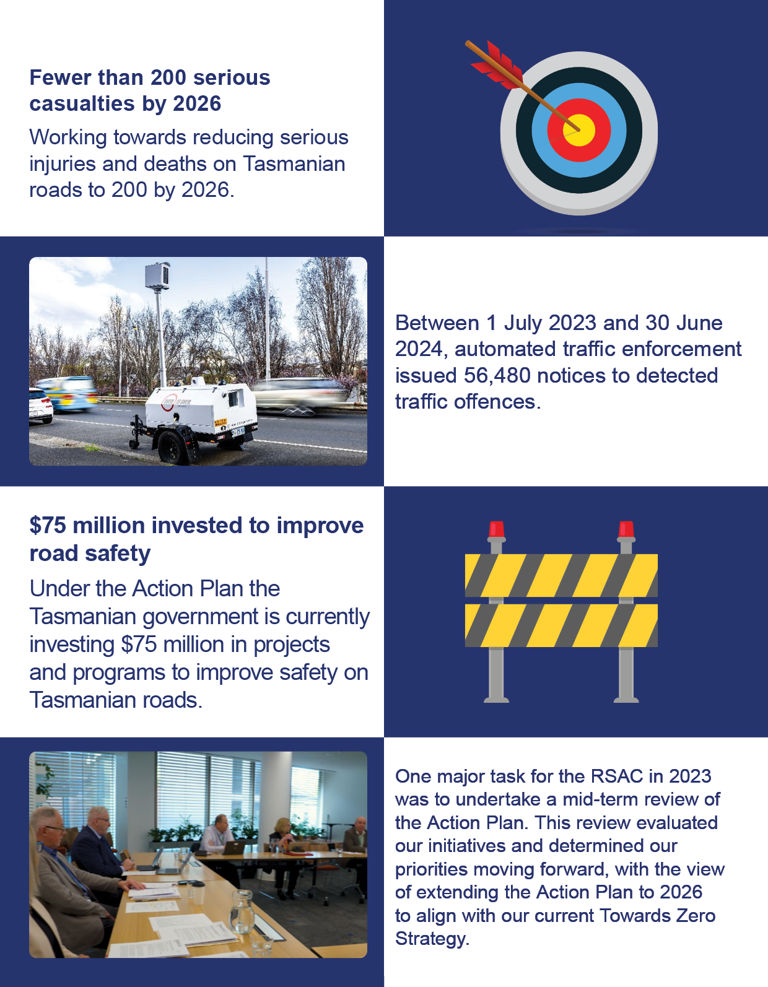

Tasmanian road crash fatalities and key road safety measures
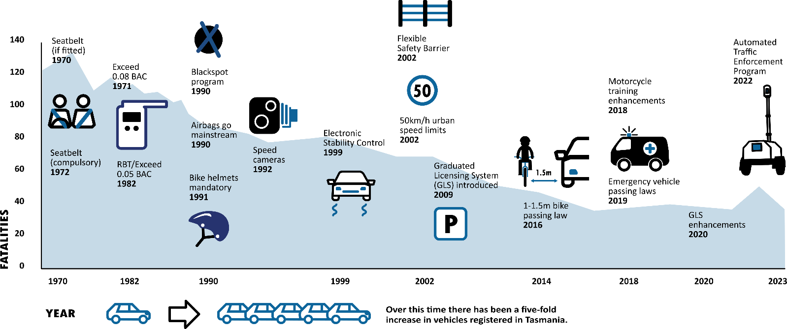

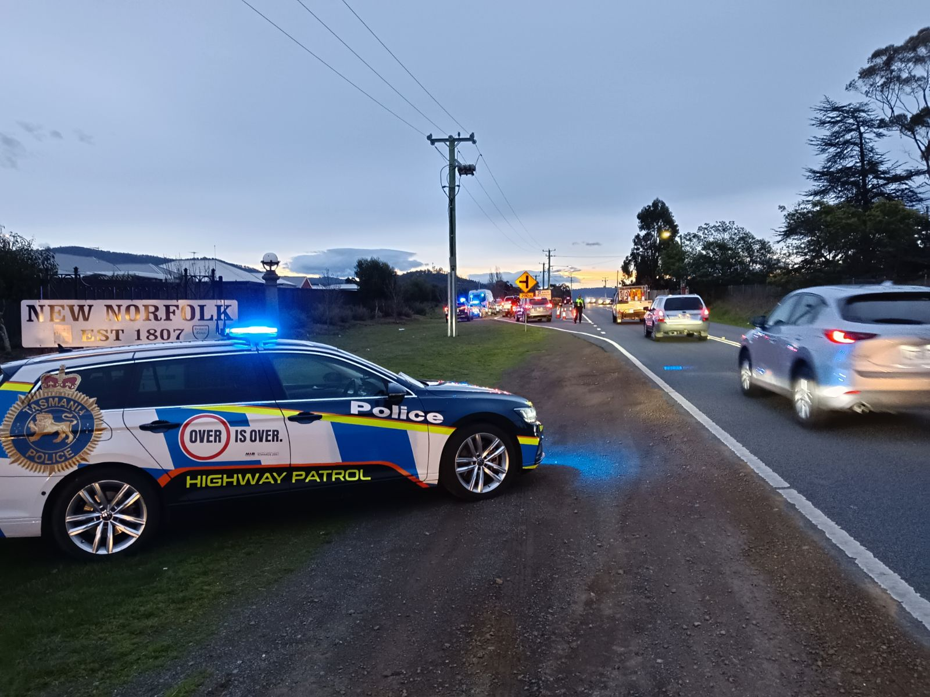
In 2023-2024, Tasmania Police detected 33,259 total traffic offenders including 16,593 high-risk traffic offenders.

About the Road Safety Advisory Council
The Road Safety Advisory Council (RSAC) was established in October 2010 to help shape the future of road safety policy in Tasmania. The RSAC replaced the Tasmanian Road Safety Council and the Road Safety Taskforce and combined their expertise. The RSAC oversees the development and implementation of policy, initiatives, public education, and strategies to reduce serious injuries and deaths on Tasmania’s roads.
Primarily, the RSAC provides strategic direction, oversight and critical assessment of proposed road safety initiatives and campaigns. The RSAC recommends and reports on road safety initiatives to the Minister for Infrastructure and Transport through the Department of State Growth.
The Towards Zero – Tasmanian Road Safety Strategy 2017 – 2026 (Towards Zero Strategy) guides the RSAC’s overall vision, purpose, and approach. The RSAC envisions a Tasmania that is free from serious injuries or deaths from crashes on Tasmanian roads. The Towards Zero Strategy is supported by periodical action plans with the current being the Towards Zero Action Plan 2020-2024 (Action Plan). Annually, around 300 people are seriously injured and killed on Tasmanian roads.
The key target is to reduce annual serious injuries and deaths on Tasmanian roads to fewer than 200 by 2026.
The RSAC’s goals and the Towards Zero Strategy are based on the ‘Safe System’ approach to road safety. The Safe System approach involves a holistic view of the road transport system that includes how roads, travel speeds, vehicles and road users interact with each other. The approach is an inclusive one as it involves all groups of road users, including drivers, motorcyclists, passengers, pedestrians, cyclists, commercial and heavy vehicle drivers.
The Safe System approach has four elements: safe road users, safe roads and roadsides, safe vehicles, and safe speeds. The rationale behind the system is that it recognises that road users will always make mistakes and may have road accidents. However, the road system should be able to accommodate mistakes so that road crashes do not result in death or serious injury.
Sitting within RSAC is the Education and Enforcement Sub-Committee (EESC). The EESC is funded by the Motor Accidents Insurance Board (MAIB). The EESC is responsible for the delivery of public education campaigns, sponsorships and enforcement activities. The EESC provides advice on road safety education and ensures that community road safety and enforcement programs align with the Towards Zero Strategy.
In addition, the EESC reports and makes recommendations to the RSAC by identifying emerging issues from key community stakeholders and contributes to the further development of key road safety strategic directions.

Road Safety Advisory Council membership
The RSAC consists of 10 members appointed by the Minister for Infrastructure and Transport. The member positions are as follows.
- A part-time independent Chair
- The Secretary of the Department of State Growth
- The Secretary of the Department of Police, Fire and Emergency Management
- The CEO (or equivalent) of the Motor Accidents Insurance Board
- The CEO (or equivalent) of the Local Government Association of Tasmania
- A person or people (maximum four) to represent a range of road users whose organisation(s) can demonstrate its major role in and contribution to road safety, including:
  - light and heavy vehicle drivers
  - motorcyclists
  - cyclists
  - pedestrians, and
  - young people
- A person with high-level expertise in road safety research, infrastructure, countermeasures, strategies, and contemporary road safety principles.

The RSAC’s membership as at 30 June 2024






ADRIAN BODNAR
DENISE MCINTYRE
Road Safety Expert
DR BLAIR TURNER
CEO, MAIB
PAUL KINGSTON
Chair, RSAC
SCOTT TILYARD


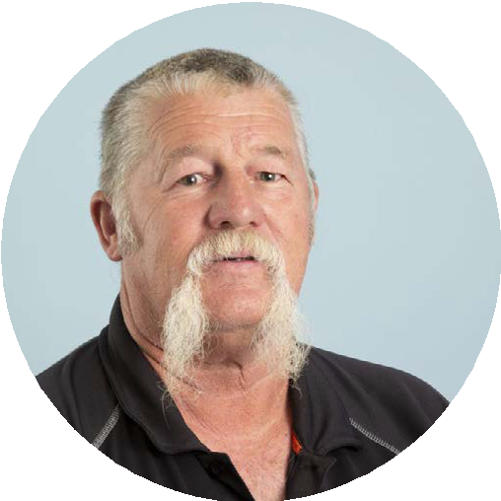
A/Deputy Secretary Transport and Infrastructure, Department of State Growth
Assistant Commissioner Operations Tasmania Police
MICHAEL (MICK) BOYD
MICHELLE HARWOOD
ALISON HETHERINGTON
DION LESTER
CEO RACT and Road User Representative
MARK MUGNAIONI

CEO Local Government Association of Tasmania
Chair Tasmanian Bicycle Council and Road User Representative
Tasmanian Motorcycle Council President
Executive Director of the Tasmanian Transport Association

NB. The Minister for Infrastructure and Transport has appointed the following delegates as representatives on RSAC:
- Denise McIntyre, Acting Deputy Secretary for Craig Limkin, Secretary, Department of State Growth
- Assistant Commissioner Adrian Bodnar for Commissioner Donna Adams, Department of Police, Fire and Emergency Management.

Road Safety Advisory Council meetings and attendance
The RSAC held four meetings in 2023-24, occurring on the following dates.
- 22 August 2023
- 27 November 2023
- 19 March 2024
- 21 May 2024
Out-of-session meetings were also held via email.
The below table outlines the attendance of the RSAC representatives at each of the four meetings occurring in 2023-24. Other observers, presenters or irregular attendees are not included.
Member | 22 August 2023 | 27 November 2023 | 19 March  2024 | 21 May  2024 | Total Meetings Attended
Mr Scott Tilyard |  |  |  |  | 3
Mr Paul Kingston |  |  |  |  | 4
Dr Ian Johnston*  Dr Blair Turner** |  |  |  |  | 4
Mr Gary Swain***  Ms Denise McIntyre |  |  |  |  | 3
Mr Mark Mugnaioni |  |  |  |  | 4
Ms Michelle Harwood |  |  |  |  | 2
Ms Alison Hetherington |  |  |  |  | 4
Mr Mick Boyd |  |  |  |  | 2
Mr Dion Lester |  |  |  |  | 4
Mr Adrian Bodnar |  |  |  |  | 4
*Dr Ian Johnston resigned as Road Safety Expert, attending his last meeting on 22 August 2023.
** Dr Blair Turner commenced as Road Safety Expert on 1 November 2023.
*** Gary Swain resigned as Deputy Secretary Transport and Infrastructure. Denise McIntyre acting in the position from the 19 March 2024 meeting.

RSAC Education and Enforcement Sub-Committee (EESC) membership
Representing | Member
Chair | Mr Paul Kingston  CEO, Motor Accidents Insurance Board (MAIB)
Chair RSAC | Mr Scott Tilyard
Marketing Expert | Mr Rowan Smith
The Department of State Growth | Mr Craig Hoey  Manager Road Safety, the Department of State Growth
The Royal Automobile Club of Tasmania | Mr Ben Hansen  Communications & PR Manager, Royal Automobile Club of Tasmania (RACT)
The Department of Police, Fire and Emergency Management | Mr Adrian Bodnar  Assistant Commissioner Operations, Tasmania Police

EESC meetings and attendance
The EESC held four meetings in 2023-24. The below table outlines the attendance of the EESC members at each of the four meetings occurring in 2023-24. Other observers, presenters or irregular attendees are not included.
Member | 22 August 2023 | 27 November 2023 | 18 March  2024 | 20 May  2024 | Total Meetings Attended
Mr Paul Kingston |  |  |  |  | 4
Mr Scott Tilyard |  |  |  |  | 4
Mr Rowan Smith |  |  |  |  | 4
Mr Craig Hoey |  |  |  |  | 4
Mr Ben Hansen |  |  |  |  | 3
Mr Adrian Bodnar |  |  |  |  | 3

RSAC and EESC remuneration
Council members who received remuneration for the 2023-24 financial year include:
Chair RSAC
- $41,212 per annum
- Out-of-pocket expenses up to $1,600 per annum
Road safety expert
- $2,100 per meeting
- Actual out-of-pocket expenses
Marketing expert
- $642 per meeting
- Actual out-of-pocket expenses.
Council members who are not public officers are entitled to motor vehicle allowances based on a cents-per-kilometre basis, in accordance with Australian Taxation Office guidelines.

Serious casualty trends and progress on meeting Towards Zero Strategy targets
The Towards Zero Strategy sets the key interim target of reducing the number of annual serious casualties on Tasmanian roads to fewer than 200 by 2026. This is an ambitious target of 100 fewer serious casualties per year than the annual average for the period 2012 – 2016 and will move Tasmania towards the long-term goal of zero serious casualties.

Serious Casualites for 2023 – 24 (Serious Injuries and Deaths)
The number of serious casualties in 2023 was 345, a 7.8 per cent increase from 320 in 2022, and a 13.2 per cent increase on the five-year serious casualty average of 304.8 (2018-2022).

Serious Casualties Tasmania – Annual Count, Percentage Split by Quarter and Towards Zero Target
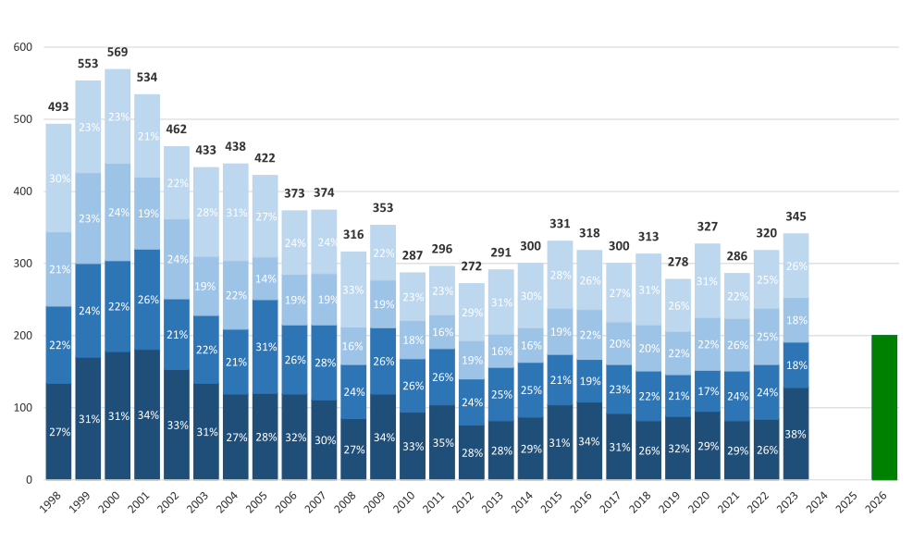

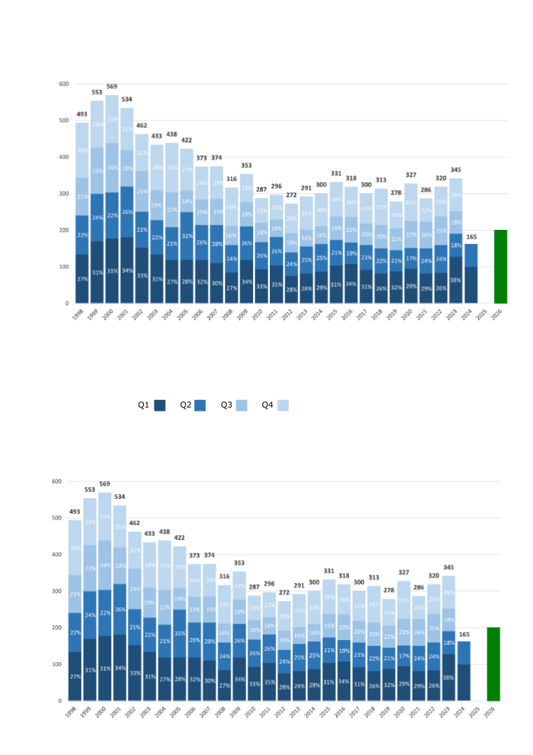

Year-to-Date as at 30 June 2024
There have been 165 serious casualties as at 30 June 2024 (from 1 January 2024), including 10 deaths and 155 serious injuries. This number is 28 fewer than the 193 serious casualties recorded at the same time in 2023, which included 18 deaths and 175 serious injuries and an increase of 2.9 per cent on the five-year average of 160.4 serious casualties.

Serious Casualties Tasmania – Annual Count, Percentage Split by Quarter and Towards Zero Target
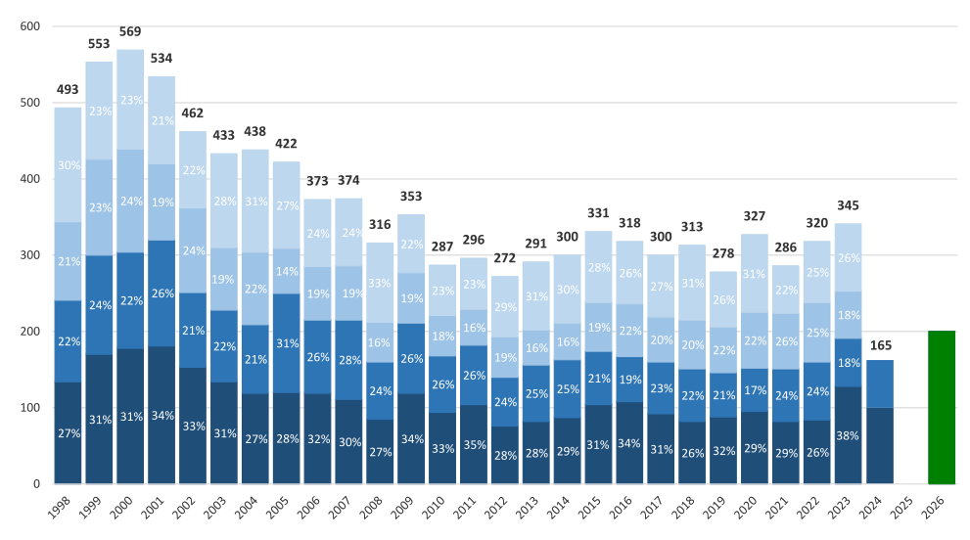

Annual fatalities – Rate per 100,000 population (NT omitted for clarity purposes)
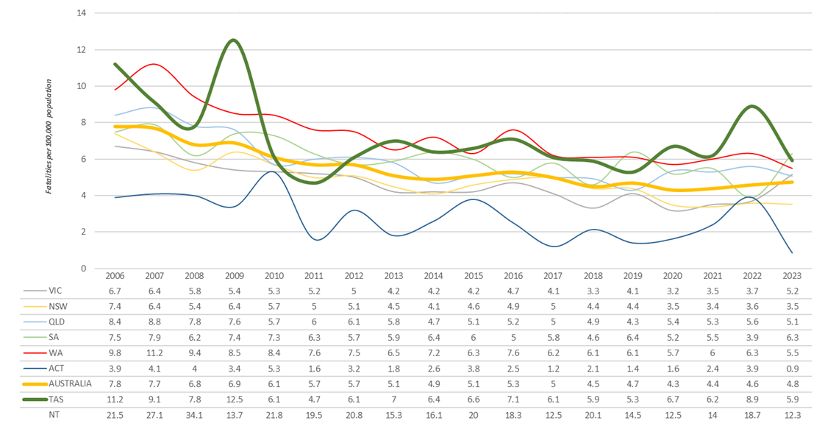

Serious casualties – breakdown by road user type
 | Motorcyclists represented 8 of the 36 deaths on Tasmanian roads in 2023. |  | Two-thirds of deaths on Tasmanian roads in 2023 were vehicle occupants.
 | There were zero deaths and 10 cyclist serious injuries in 2023. |  | 26 of the 36 deaths on Tasmanian roads in 2023 were male, representing approximately three-quarters of the total deaths. In addition, males accounted for 229 of the 345 serious casualties.

Serious casualties – breakdown by crash attributes

Speed zone
The graph below depicts the number of serious casualties occurring quarterly by speed zone. Serious casualties occur more frequently on roads with 100 km/h or higher speed limits and less frequently on roads with 40 km/h or lower speed limits.

Serious Casualties by Quarter by Speed Zone – 12 period moving average

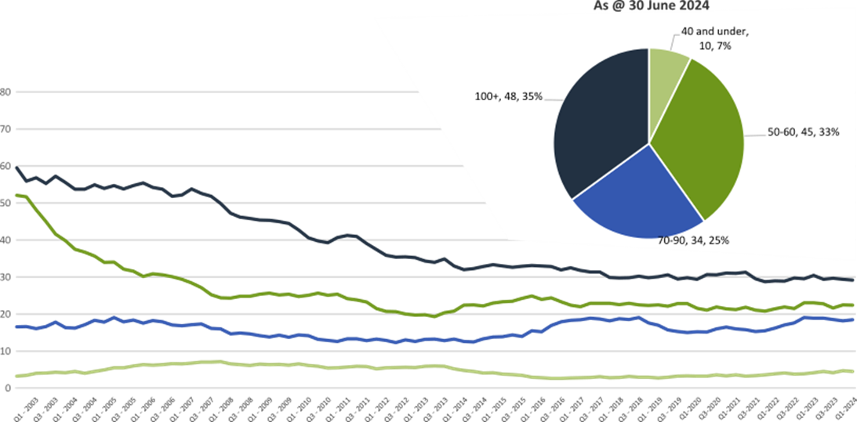
Pie chart excludes serious casualties where speed zone is recorded as ‘not known’

Crash type
The graph below depicts the number of serious casualties occurring quarterly by crash type. The majority of serious casualties occur due to lane departure crashes.

Serious Casualties by Quarter by Crash Type (DCA) – 12 period moving average

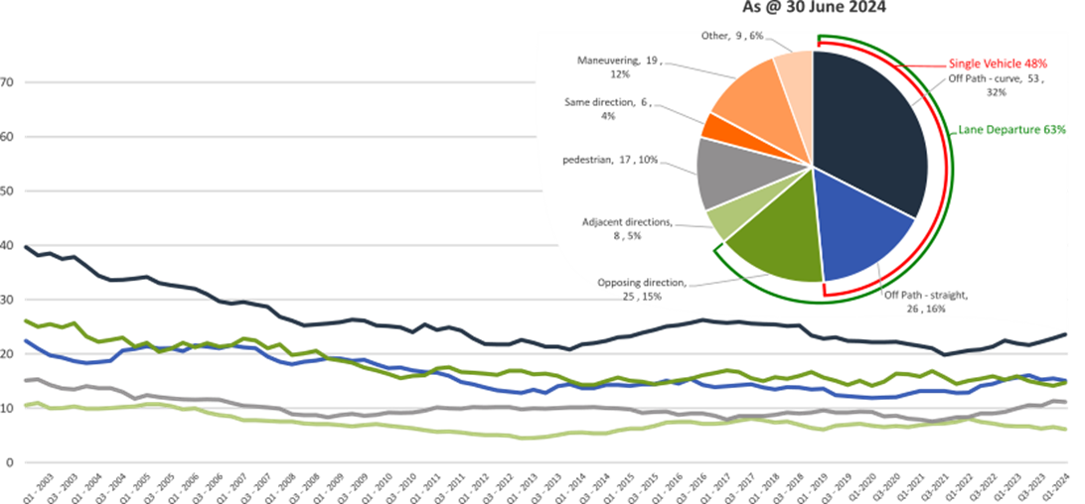
Other includes crash types: on-path (4%), overtaking (1%), and passenger and miscellaneous (1%).
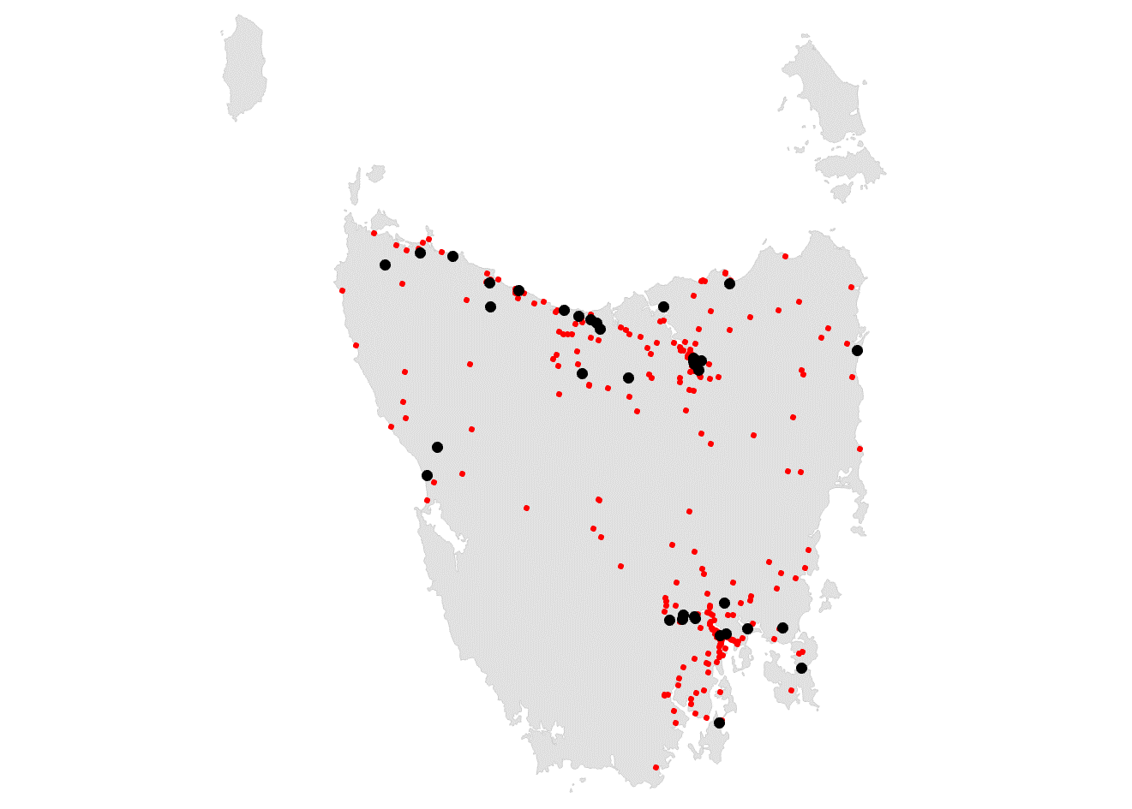

Location
The image (right) depicts
the location of all serious
casualties that occurred
in 2023.
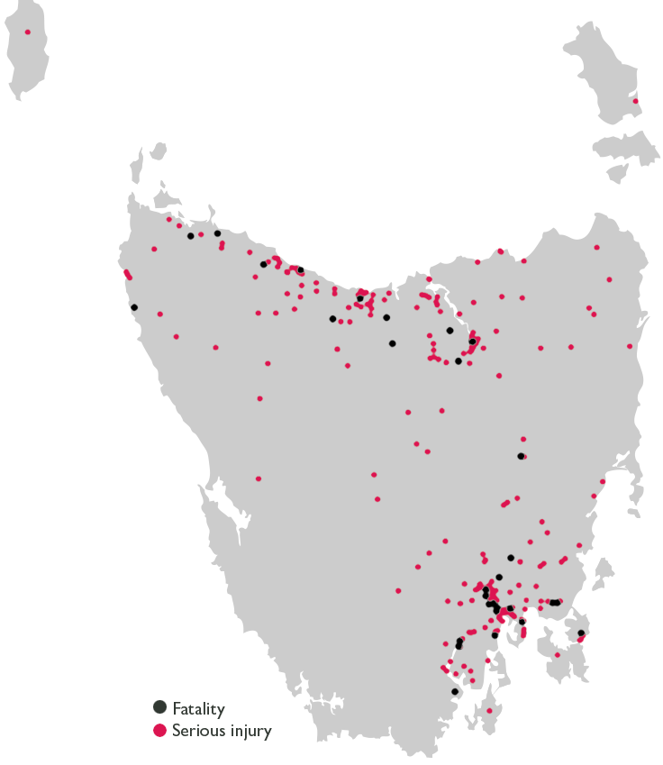

Thematic Snapshot of the Towards Zero Action Plan 2020-2024
Making our rural roads safer |    | Improving safety in our towns and cities | 
Rural road grants program for local government  Motorcyclist safety on rural roads  Safe System knowledge and skills training  Infrastructure upgrades on low volume state roads  Speed moderation and community engagement strategy |  | Targeted infrastructure upgrades in high traffic  urban areas  Community Road Safety Program  Innovative infrastructure treatment demonstrations  Vulnerable Road User Program  Trial of innovative technologies
Saving young lives |  | Encouraging safer road use
Learner Driver Mentor Program and Driver Mentoring Tasmania  Rotary Youth Driver Awareness Program  RACT education initiatives  Bicycle Network bike education  Kidsafe child restraint check program  Develop a Graduated Licensing System for motorcyclists  Graduated Licensing System Project for drivers  Driving for Jobs Program  Real Mates media campaign  Safety around schools  Full Gear motorcycle safety project |  | Inattention and distraction  Mandatory Alcohol Interlock Program  Road safety penalties review  Enforcement of high-risk behaviours  High-risk motorcycling enforcement  Safe behaviour campaigns  Protective clothing for motorcyclists  Speed enforcement strategy  Automated Speed Enforcement Program  Road Rules Awareness
Making visitors safer |  | Improving safety through vehicles and technology | 
Tourist road safety signage program  Tourist education materials  Tourist education at gateway entry points  Responsive electronic signage trial  Strategic partnerships  Stakeholder alliances |  | ANCAP  Autonomous vehicle and crash avoidance readiness  Light vehicle strategy  Safer cars for young drivers  Workplace driver safety

Making our rural roads safer
60 per cent of fatalities in Tasmania occur in rural areas. The Tasmanian Government has committed $20 million into improving the safety of our rural roads.

Summary of initiatives

Establish a rural roads grants program for local government
The Safer Rural Roads Program (SRRP) launched in late 2020 as an infrastructure initiative established under the Action Plan. The SRRP provides opportunities for Tasmanian local governments to apply for grant funding to implement widespread low-cost road safety infrastructure treatments on high-speed rural roads. The program aims to improve road safety outcomes in Tasmania by reducing the number of head-on and run-off-road crashes and to reduce harm when these crashes do happen. Treatment types funded under the SRRP include improved delineation (signs and lines), roadside hazard removal, limited shoulder sealing and safety barriers. Junction upgrades are also eligible for funding under the SRRP.
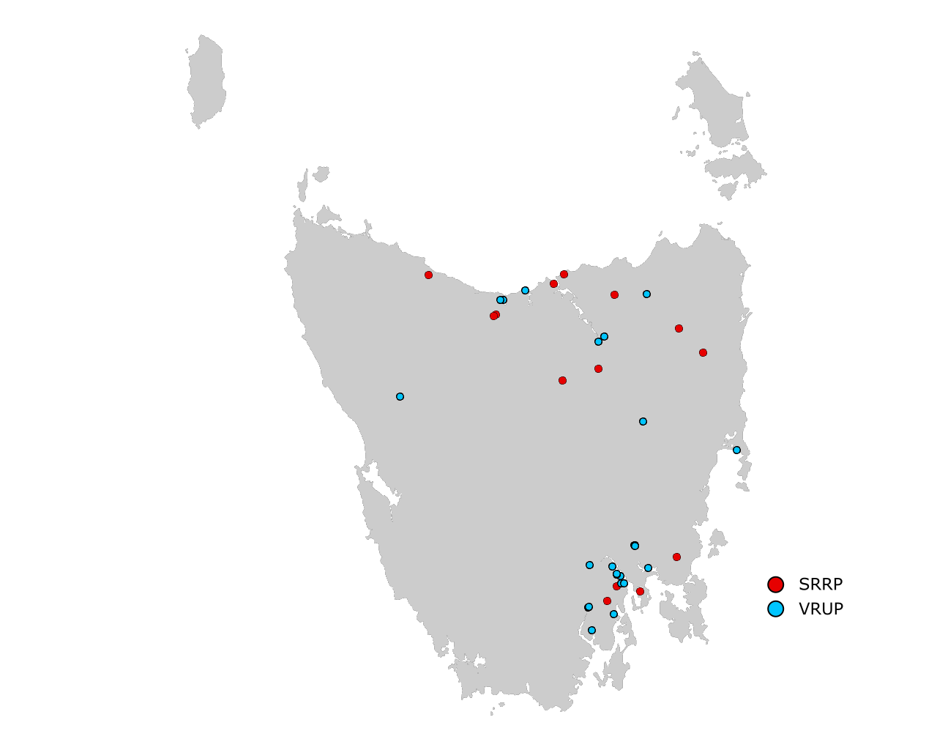
Under the 2023-2024 SRRP funding round – the fourth SRRP round under the Action Plan – 14 projects were supported with $2.1 million of funding. Alongside $1.8 million in co-contributions from councils, this funding will allow $3.9 million in infrastructure to be built to improve safety on rural roads. Funded infrastructure treatments include guardrails, pavement widening, line marking and traffic signage.

The map (right) illustrates the distribution of projects in the 2023-24 round of the Safer Rural Roads Program (SRRP), and the Vulnerable Road Users Program (VRUP).

Conduct infrastructure upgrades on low volume state roads
Under the Action Plan, a Safe System Infrastructure Strategy is being developed to provide for safety improvements on lower volume state roads that are not a priority for significant upgrades in the short to medium term.
The strategy will include a network safety plan to guide future investment under this action. The State has partnered with the Australian Government to deliver a Road Safety Program which delivers low-cost infrastructure treatments including improved delineation (signs and lines), curve treatments, roadside hazard removal, limited shoulder sealing, safety barrier and junction upgrades.

Improve motorcyclist safety on rural roads
Under the Action Plan, regular road safety audits are undertaken on high-risk touring routes across Tasmania. The audit process includes engagement with local motorcyclists to gain a rider’s perspective. Findings are shared with stakeholders to identify behavioural countermeasures as well as infrastructure solutions.
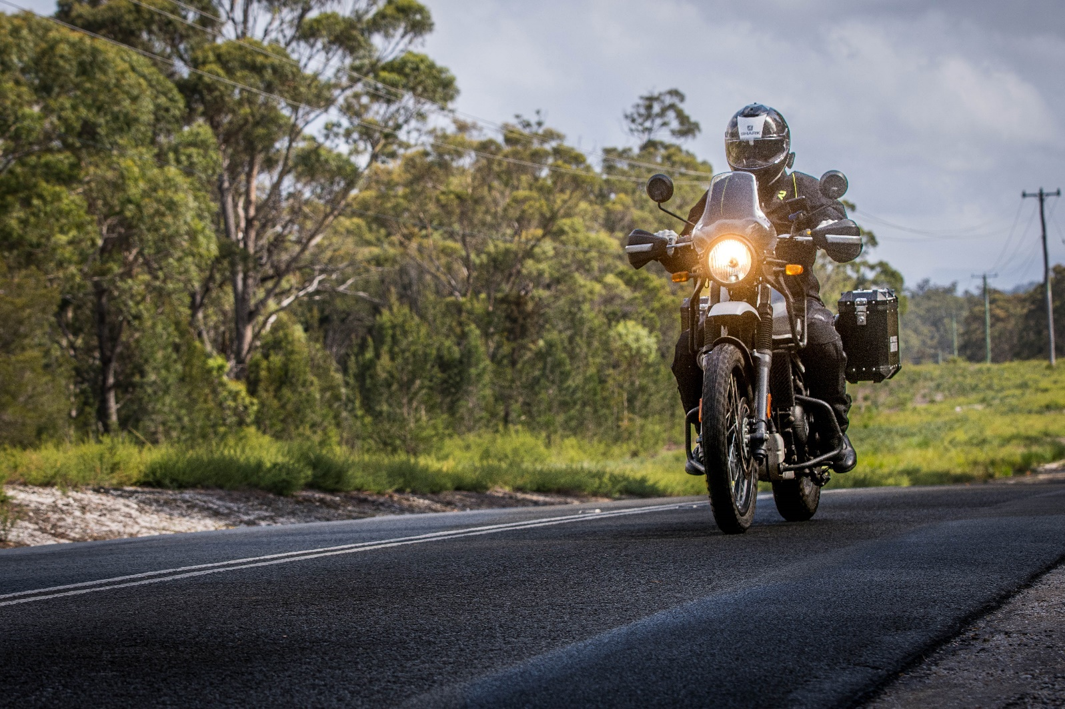
A strategy has also been developed to identify potential priority routes across Tasmania, suitable for conducting motorcycle road safety audits.
In 2023-24, funding up to $400,000 was allocated to carry out low-cost infrastructure treatments to improve road safety for motorcyclists on the Channel Highway, between Margate and Verona Sands, following an audit undertaken in March 2023. In May 2024, the installation of treatments on the Channel Highway were completed.
In March 2024, an audit of the Tasman Highway between St Helens and Scottsdale was completed. A schedule of works is being prepared with works expected to commence in early 2025.

Expand Safe System knowledge and skills
This program aims to improve Safe System knowledge for all those in a position to influence road safety outcomes and support Safe System infrastructure design and speed setting. The program includes technical training sessions, workshops, and forums across Tasmania.
Under the Action Plan, a structured training package has been developed to support the development of Safe System knowledge and skills across local and state government. As part of this package, the an external consultant was engaged to produce an online induction module which will be available to all Transport and Infrastructure state government employees, local government, Tasmania Police and to external consultants on an as-needs basis.
It’s expected that the module will be available by the end of 2024.

Budget summary
Throughout 2023-24, $2.8 million was spent under the ‘Making Rural Roads Safer theme’.
Chart 1 – Making our Rural Roads Safer theme, FY 23/24 Road Safety Levy Expenditure

Improving safety in our towns and cities
Our towns and cities play host to a complex mix of road users from people on foot through to large trucks and buses. The Tasmanian Government has committed to over $31 million in projects and programs to improve road safety in our towns and cities.

Summary of initiatives

Expand the Vulnerable Road User Program
The Vulnerable Road User Program (VRUP) provides opportunities for Tasmanian local governments to apply for grant funding to implement low-cost infrastructure treatments that improve road safety outcomes for vulnerable road users such as pedestrians, cyclists, and motorcyclists. The program aims to improve road safety in Tasmania by reducing the number of crashes that occur between vulnerable road users and vehicles in urban areas and by reducing the level of injury when a crash does occur. Typical infrastructure treatments funded under the VRUP include pedestrian crossing infrastructure (such as median pedestrian refuges and wombat crossings) and off-road shared-use paths to separate vulnerable road users from vehicle traffic.
Under the 2023-2024 VRUP funding round – the fourth VRUP round under the Action Plan – 24 projects were supported with $2.6 million* of funding. Alongside nearly $1.6 million in co-contributions from councils, this funding will allow $4.27 million in infrastructure to be built to protect vulnerable road users. Funded infrastructure treatments include traffic calming measures, footpaths, pedestrian refuges, curb ramps and crossings.

Community Road Safety Grants Program
The Community Road Safety Grants Program (CRSGP) aims to provide community groups across Tasmania with the opportunity to develop and deliver small scale local road safety programs within their communities consistent with the Towards Zero Strategy.
The Government has committed $200,000 annually for five years from the Road Safety Levy, as part of the Action Plan. CRSGP funding is available in two categories: small grants of up to $5,000 and medium/large grants of up to $35,000. To be eligible, projects must address at least one of the Fatal Five road safety behaviours or promote safety for vulnerable road users, while demonstrating a community focus.
In 2023-24, a Funding Assessment Panel recommended funding six projects totalling $80,815.

Conduct infrastructure upgrades on high volume state roads
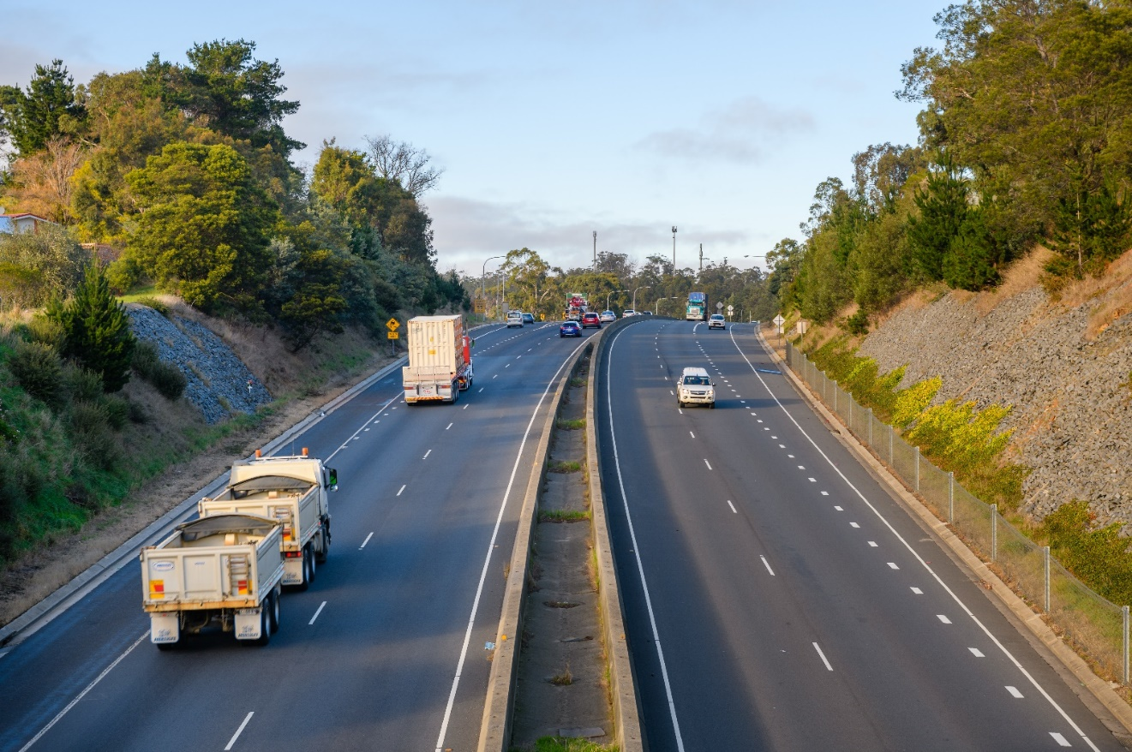
Consistent with its approach on low volume roads the Tasmanian Government is developing a Safe System Infrastructure Strategy that provides for safety improvements on higher volume state roads that are not a priority for significant upgrades in the short to medium term.
The program focuses on low-cost infrastructure treatments including improved delineation (signs and lines), curve treatments, roadside hazard removal, limited shoulder sealing, safety barrier and junction upgrades.
The strategy is being expanded to deliver a network safety plan to guide future investment under this action.

Budget summary
Throughout 2023-24, $2.1 million was expended under the ‘Improving Safety in our Towns and Cities’ theme.
Chart 2 – Improving Safety in our Towns and Cities theme, FY 23/24 Road Safety Levy Expenditure

*Note: $2.6 million in funding was awarded under the 2023-24 round of the VRUP. However, this funding has not been expended in the 2023-24 financial year as grant payments are made in instalments with conditions needing to be met before an instalment can be paid (e.g. finalised plans approved). The $1.1 million expenditure under the 2023-24 financial year is made up of payments made to previous VRUP grants that have completed works.

Saving young lives
Tragically, on average, 78 young road users (17 – 25 years) suffer serious casualties on Tasmanian roads every year. To reduce this harm, the Tasmanian Government committed over $12 million in programs and projects.
Under the Action Plan, there are several programs that aim to promote road safety awareness and save young lives.
Summary of initiatives

Improve the Graduated Licensing System (GLS)
Commenced in 2017, the GLS review’s primary goal was to reduce serious casualties among young road users (17 – 25 years) on Tasmanian roads.
The Tasmanian Government implemented changes to the GLS on 1 December 2020. Tasmania’s GLS now meets the ‘enhanced’ model GLS under the national driver GLS policy framework. The GLS changes were accompanied by a public education campaign explaining the policy changes and how they would apply to current and new learners.
A package of digital products was progressively launched from July 2021 to complement the changes to the GLS.
The Plates Plus online learning and assessment platform was designed to improve learner driver education by focusing on developing safe driving behaviours and attitudes. It is an innovative tool that takes users through a series of interactive exercises to ensure new drivers know the road rules and understand the impact of the fatal five road behaviours. A public education campaign accompanied the launch of the Plates Plus platform and ran until September 2021. The campaign encouraged take-up by promoting the convenience of the platform, which is accessible from any device connected to the internet.
The Plates Plus logbook app was launched in November 2021. The app offers an alternative to the hard copy logbook for those learners who prefer to record their hours digitally. It provides an easy and efficient way to log supervised driving hours during the learner licensing phase. A public education campaign targeting 15 to 25-year-olds accompanied the launch of the Plates Plus logbook app. To engage with this age group, the campaign focused on selected social media platforms.
The computer-based hazard perception test (HPT) was launched in March 2022. The HPT is a mandatory assessment that has been introduced to the learner licensing pathway to ensure novice drivers are able to recognise and respond to avoid various hazards on the road.
The HPT was the final product to be delivered under the GLS project.
As part of the GLS review, the Department of State Growth engaged the Centre for Accident Research and Road Safety - Queensland (CARRS-Q) to conduct a long-term evaluation of the changes. The evaluation will assess the impact of the changes to the GLS on road safety outcomes for young drivers, as well as licensing rates and young drivers’ perceptions of the Tasmanian licensing pathway. The evaluation commenced shortly before implementation of the changes to the GLS and will continue until 2027 (being seven years post-implementation).

Continue the Learner Driver Mentor Program
The Learner Driver Mentor Program (LDMP) is a well-established program that supports disadvantaged learner drivers to gain their on-road supervised driving hours to obtain a licence.
For some learner drivers, accessing a suitable car and/or supervisory driver to gain the required minimum 80 on-road hours is extremely challenging.
Under the LDMP, community based not-for-profit organisations coordinate the matching of disadvantaged learner drivers with volunteers (and vehicles) to gain the minimum supervised driving hours to progress to the provisional stage of the GLS.
For the purposes of participating in a LDMP, a learner driver is considered to meet the disadvantaged criteria if they do not have access to a suitable supervisory driver and/or car, are on a low income and are not able to afford professional driving lessons to gain the minimum hours required to obtain a provisional licence.
For the 2023-24 financial year, $1,203,324.41 was provided to 16 LDMPs and Driver Mentoring Tasmania. The LDMP helped 194 learners attain their provisional licence. The LDMP completed over 17,500 on-road hours, with an average of 220 learners receiving mentoring each month.

Develop an improved Graduated Licensing System (GLS) for motorcyclists
A review of the Tasmanian motorcyclist GLS commenced in 2021 to identify potential enhancements to complement the training and assessment curriculum implemented in 2017.
Motorcycle riders represent more than one in five serious casualties on Tasmanian roads despite motorcycles comprising less than one in 20 registered Tasmanian vehicles. Unlike the national GLS policy framework for drivers, there is no nationally agreed policy framework for motorcycle licensing. In order to assess Tasmania’s motorcyclist GLS and identify options for enhancement, the Centre for Automotive Safety Research (CASR) was engaged to conduct a review of the Tasmanian motorcyclist GLS. The findings and recommendations of the review were presented to RSAC at its May 2022 meeting.
A discussion paper was subsequently prepared and released by the RSAC to guide a public consultation process held during August and September 2022. The public consultation process sought feedback and community sentiment towards CASR’s recommendations. That feedback was then considered by the RSAC together with CASR’s recommendations. The RSAC endorsed a package of recommended changes to the motorcyclist GLS which has been provided to the Minister for Transport for consideration.

Continue to support the RYDA program
RYDA is a nationally developed program that delivers a series of key educational road safety messages to 16–18 year old students, with a focus on laying the foundation for safe road use throughout these students’ lives. The program is delivered by Rotary Clubs of Tasmania over a day via interactive sessions to equip students with personalised strategies and life skills to assist them to respond positively to challenges they face as a driver or passenger. RYDA engages community members and experts to deliver the program to students for local relevance.
RYDA is conducted throughout Tasmania, including regional areas such as Smithton, Huonville, and King Island. Tasmanian road safety statistics highlight the importance of engaging our at-risk regional areas to increase road safety outcomes.
Rotary has reported increased interest in the program since the commencement of the five-bonus learner licence logbook hours for attending the program under the GLS.
RYDA Session | Schools | No. of Students Attending
South | 29 | 2162
Huonville* | 4 | 119
North | 22 | 1129
Smithton* | 2 | 36
North West | 19 | 1038
Total | 69 | 4484
RYDA won the 2023 MAIB Community Road Safety Award, Awards Australia, and is a semi finalist for the Community Awards in 2024.
* The RYDA program is currently delivered in a scaled back version in the Huon Valley and Smithton regions for local schools to attend.
Annual funding of $100,000 pays for venue hire, equipment and the licensing levies per student for attending RYDA.

Continue the Driving for Jobs Program
The Driving for Jobs (DfJ) Program aims to support disadvantaged students who would otherwise be unable to enter and progress through the GLS. The program provides students at selected schools with the opportunity to increase their road safety knowledge whilst also improving their job readiness. Students undertake a road safety focussed learning program, including professional on-road driving lessons and participation in the RYDA Program.
The DfJ Program operates at Jordan River Learning Federation and Claremont College in the South and Launceston and Newstead Colleges in the North. For the school year 2023, 191 students engaged with the program which resulted in 1,264 hours of fully funded driving lessons being delivered from accredited driving schools. A total of 52 students obtained their learner or provisional licence.
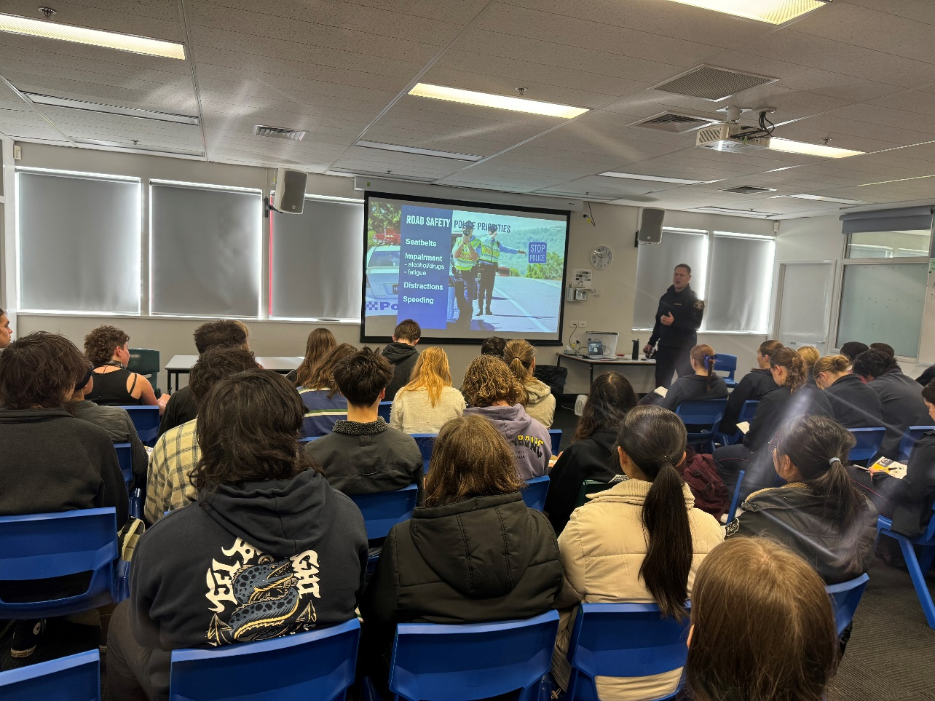

Provide funding for the RACT education initiatives
The RACT is provided with $100,000 annually to deliver a suite of road safety education programs.
Misunderstood Road Rules
Misunderstood Road Rules explores road rules that are commonly misunderstood by Tasmanian drivers. For the 2023-24 financial year, the RACT provided 30 ‘Misunderstood Road Rules’ presentations to 429 older drivers.
Ready for the Road
Ready for the Road is an interactive education session suitable for students in grade 10 - 12. It outlines the processes of getting your licence and sparks discussion with students about safe driving tips, vehicle safety and other factors to consider when owning a vehicle, such as insurance.
For the 2023-24 financial year, the RACT provided 34 Ready for the Road presentations and an additional 14 Distracted Driving practical driving lessons. A total of 1,533 students participated in both the programs across the state.
YIPPEE! and RACT RoadSafe
Yippee has been developed to encourage children to think about safe ways to travel in the car and when crossing the road. Each student will then get to take home their own copy of a rhyming storybook to share with their family. For the 2023-24 financial year, 238 Yippee! sessions were delivered.
RoadSafe is for primary school teachers to explore road rules and road safety with their Grade 3 and 4 students. It uses a range of learning tools to work through four learning modules including how to be a safe passenger, how to be safe when riding a bike, scooter or skateboard and what the road signs are telling us. For the 2023-24 financial year, the RACT provided 93 RoadSafe presentations at primary schools to 2,022 students.

Continue the Real Mates media campaign
The Real Mates campaign is now in its 12th year, with a new revamped campaign due to be launched in September 2024.
The campaign is funded by the MAIB and targets males aged 17 to 25 years old, encouraging them to take a stand against drink driving by empowering them to intervene and prevent a mate from driving after drinking. This age group is specifically targeted as they are disproportionately involved in serious and fatal crashes where alcohol is a contributing factor.
Now in its fourth year, the Real Mates sponsorship of the North West Football League (NWFL) Colts continues to reinforce the campaign’s message in this region.
In 2023, the campaign aired on television in September, strategically focusing on the AFL finals and grand final to effectively reach the target demographic. It was also aired on television in December 2023 and early 2024, played during the airing of the Big Bash League. Additionally, the Real Mates message has been prominently featured at Blundstone Arena during Hobart Hurricanes matches.

Support Bicycle Network Tasmania
The Bicycle Network delivers the Ride2School program to schools across Tasmania. Ride2School is for primary aged students and focuses on safe cycling, road safety and positive road sharing behaviour.
The Ride2School program continues to have a positive impact in Tasmanian primary schools, with over 110 Bicycle Education workshops completed across the state during the 2023-24 financial year.
Ride2School has implemented successful initiatives such as community group ride activities, specific transport, trail riding and mountain biking skills and programs based on the environment and facilities available to individual schools.
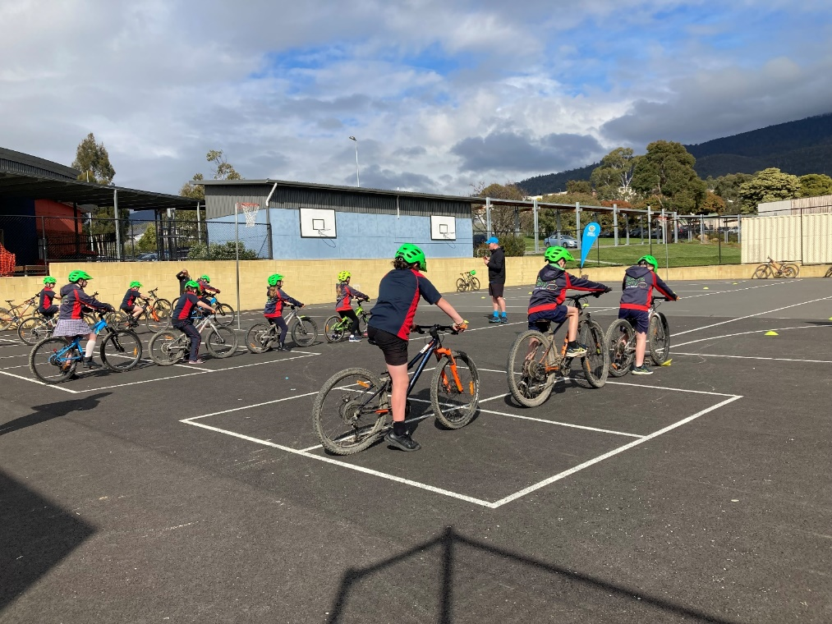
The positive trend of schools having greater access to bike riding facilities either within their own grounds or the local community continues to be a growth area for the Ride2School program.
The most effective strategies for promotion of the Ride2School program in Tasmania continues to be through digital sources such as online newsletters through the Department for Education, Children and Young People, Bicycle Network’s own social media, newsletters and website, local media coverage from special projects and event days and the all-important word of mouth between teachers and staff across schools.
Bicycle Network won the 2023 Healthy Tasmania and Wellbeing award, Awards Australia, for the Ride2School program.
Keep school children safe on the roads
Safety around schools is promoted through designated crossings, lower speed zones, more than 100 school crossing patrol officers and public education. The Safety around Schools project, including the Love 40 campaign, encourages drivers to reduce their speed and keep a look out for children in school zones and around buses.
‘Back to School’ 2024, was launched at East Launceston Primary School on Monday, 5 February 2024 by the Deputy Premier, Michael Ferguson . This was complemented by the Love 40 campaign on television, radio and social media, before and after the commencement of Term One. Love 40 was screened again at the commencement of each school term.

Support Kidsafe child restraint checks
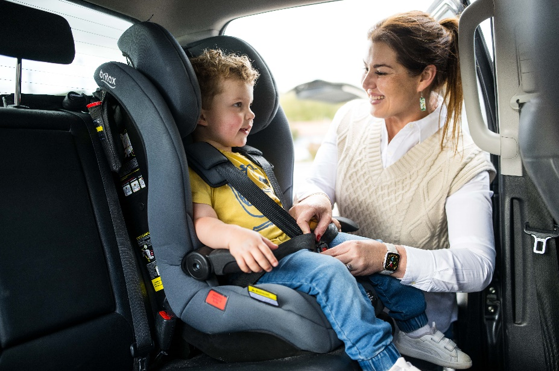
Kidsafe Tasmania conducts free child restraint checking sessions to ensure that young children are safely and lawfully seated and restrained in cars. Kidsafe also distributes educational materials to inform the community of the correct child restraint type for a child’s age and size.
Kidsafe continues to provide free child restraint checks and education with a trained child restraint fitter at community organisations and via outreach services. Free training is provided to professionals regarding regulatory requirements and good practice approaches to child restraints.
Kidsafe continues to distribute easy-to-read hardcopy restraint guides, which are provided to parents and carers to encourage the correct purchase of restraints suitable to a child's height and weight.
Kidsafe was a finalist in the 2023 MAIB Community Road Safety Award, Awards Australia.

Encourage safe and legal motorcycle riding
The Glenorchy City Council (GCC), in partnership with Bucaan House, delivered its successful Full Gear motorcycle safety program, which helps young motorcycle riders enter the licensing system and to adopt safe riding practices.
In 2023-24, the GCC delivered three Full Gear Programs to a total of 20 participants. A new partnership with Karadi Aboriginal Corporation has been developed to target Aboriginal youth and facilitate safe motorcycle licensing.

Budget summary
Throughout 2023-24, $2.8 million was spent under the ‘Saving Young Lives’ theme.
Chart 3 – Saving Young Lives theme, FY 23/24 Road Safety Levy Expenditure

Encouraging safer road use
Each road user has a responsibility to use roads in ways that are safe for those around them.
The Tasmanian Government has committed over $4 million to improve road user behaviour.

Summary of initiatives

Investigate strategies to address inattention and distraction
Inattention and distraction are concerning causes of serious casualty crashes and may have a far greater impact than available data suggests.
Enforcement activity and public education aims to build awareness of the dangers of inattention and distraction for all road users.
Public education
The second phase of the Click.Store.Go public education campaign was launched in August 2023, informing motorists that speed, mobile phone and seat belt detection cameras were live and infringement notices would now be issued. Click.Store.Go. aims to reduce road trauma by increasing community awareness of the dangers of distraction when driving and supports the introduction of mobile phone and seatbelt detection cameras in Tasmania. The campaign is supported by TV, radio, press, digital and outdoor advertising.

Police officer enforcement
Tasmania Police continues to utilise both overt and covert methodologies to detect and enforce inattention and distraction amongst drivers. 3,129 drivers were detected committing ‘inattentive driving’ offences during 2023-24. Social media messaging and regular engagement with traditional media outlets consistently highlights the increased risks of drivers being involved in serious and fatal crashes whilst distracted, as one of the ‘Fatal Five’ risk factors.
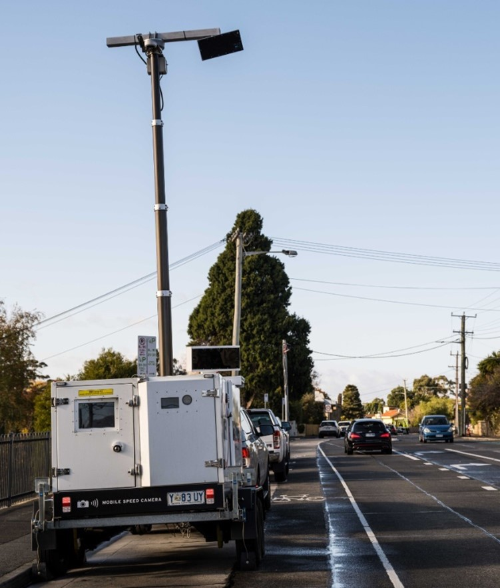
This messaging is reinforced by state-wide and local traffic operations, many of which are conducted alongside other road safety partners, such as the National Heavy Vehicle Regulator and State Growth Transport Safety and Investigation Officers.

Automated traffic enforcement
Automated traffic enforcement continued to operate mobile speed camera activities throughout 2023-24 including:
- 36,095 enforcement hours
- 5,379 enforcement sessions, and
- 50,881 Infringement Notices.
In August 2023 emerging technology used to automatically detect illegal mobile phone and seatbelt non-compliance was introduced. Throughout 2023-24 the following mobile phone and seatbelt enforcement occurred:
- 7,997 enforcement hours
- 364 enforcement sessions
- 3,196 seatbelt related Infringement Notices, and
- 1,499 mobile phone related Infringement Notices.
In the first half of 2024, automated registration enforcement technology underwent on-road testing and system integration. Registration enforcement is expected to commence in early 2024-25.

Promote safe behaviours through campaigns
Targeted media campaigns continued to inform road users about high-risk behaviours and to highlight the dangers of the ‘Fatal Five’.
The Road Safety Starts with Me campaign ran throughout July and August 2023 across social media, cinema and digital billboards. This campaign encourages the community to think about the role they play in making Tasmanian roads safe and how they can be a safer or more courteous road user.
The social media campaign Drive to the Conditions continued to run throughout July and August 2023, encouraging drivers to be aware of changing road and weather conditions and to slow down where necessary.
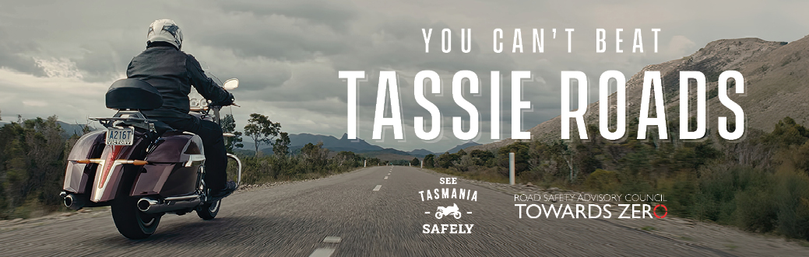
Road Torque aired on Monday nights on Seven Tasmania’s nightly news in July and early August 2023. Detecting distraction with new camera technologies, the North West Football League spreading the Real Mates message in this region, Beyond Loss, Car Seat Safety and a trip to ANCAP’s Crash Lab featured in this year’s episodes.

Bursts of the Love 40 campaign, promoting safety around schools and 40 km/h speed limits in school zones, featured at the beginning of each school term for a week on television, radio and social media.
In August 2023, the second phase of the ‘Click.Store.Go.’ campaign launched, notifying motorists that speed and seatbelt cameras were now active, with fines being issued. The campaign, backed by TV, radio, press, digital, and outdoor ads, aims to reduce road trauma by raising awareness of the dangers of driving distractions and supporting the introduction of mobile phone and seatbelt detection cameras in Tasmania.
The Over is Over campaign, targeting the dangers of speeding, featured on television and radio throughout September and October 2023, ahead the launch of the new Over is Over Campaign in July 2024.
The Rule 79A campaign, reminding motorists to slow down to 40 km/h when passing emergency vehicles like police, fire, ambulances and emergency roadside assistance vehicles, featured on TV, radio and socials between September and December 2023.
A Real Mates September burst was scheduled to coincide with 2023 AFL Finals and Grand Finals, reinforcing the message about the consequences of you or your mate drink driving. The schedule was designed to reach as many of the target audience as possible across a four-week period utilising television and social media.
The cyclist safety campaign, ‘Let’s Have Each Other’s Back’, ran again between October and December 2023 to coincide with Daylight Savings and a change in weather seeing more cyclists on the road.
The campaign was a reminder for both drivers and cyclists to be aware of their surroundings and the safety of each other. This featured on television and socials.
A new enforcement campaign was launched in the week prior to Christmas, urging people to make sure they get home safely over the busy holiday season. The campaign highlighted the fact that police could be anywhere and everywhere, and if you are doing the wrong thing, you will be caught. The campaign featured on TV Radio and Socials with further bursts over Easter and the Anzac Day Weekend.
‘You Can’t Beat Tassie Roads’ was run for a four-week period over January and February 2024. The campaign provides a few simple tips and rules that will help keep both motorcyclists and their pillion riders safe when riding on Tasmanian roads.
For the first time, Tasmania was the host state for National Road Safety Week, which took place from the 5 to 12 May 2024. Daily events were held around the State in line with the daily themes which highlighted the ongoing impact of road trauma on communities while promoting ways to reduce this toll. Each year around 1200 Australians are killed and more than 40,000 people seriously injured as a result of road crashes. This year’s theme was All Road Safety is Local – Drive So Others Survive.
Tasmanian landmarks were lit up yellow and community grants were made available to all Tasmanian councils so that they could hold their own National Road Safety Week events. The AFL Game in Launceston between Hawthorn and St Kilda was a Road Safety Round, with road safety advertisements and interviews featured as part of the game. The North West Football League also held a Road Safety Round as part of the week.

Promote protective clothing for motorcyclists
Motorcyclists are significantly over-represented in Tasmania’s road trauma figures. One of the reasons for this is that riders are more likely to be injured in a crash due to a lack of physical protection.
Under the Action Plan work continues to reduce the risks to motorcyclists through a range of actions, including supporting the work of MotoCAP to promote the use of protective clothing and promoting safe gear through an educational brochure.
MotoCAP provides safety assessment star ratings for protective clothing and prepares education materials for motorcyclists. Protective clothing can reduce injury severity in the event of a crash. The brochure reiterates the importance of wearing full gear on every ride and directs motorcyclists to the MotoCAP website to check gear safety ratings before purchase.
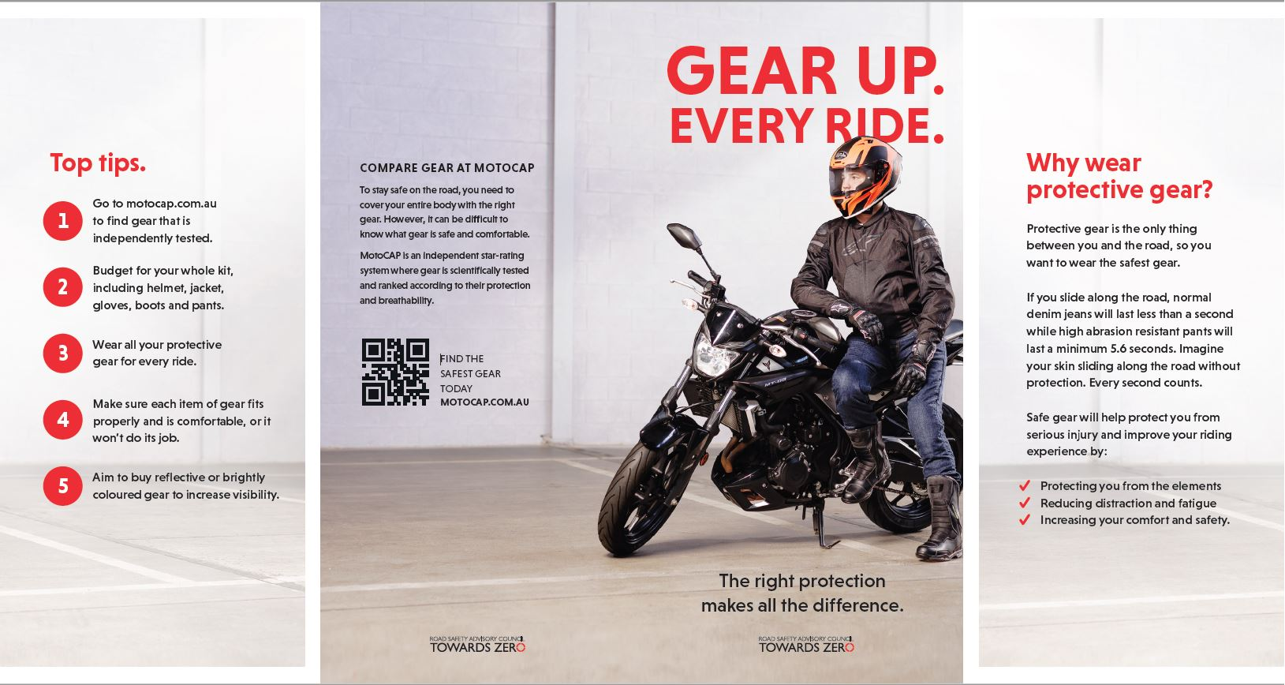

Ensure participation in the Mandatory Alcohol Interlock Program
The Mandatory Alcohol Interlock Program (MAIP) aims to have repeat and high-level drink driving offenders demonstrate that they can separate their drinking from driving through the installation of an alcohol interlock in their vehicle. Participation rates are less than optimal as participants often seek exemption from the obligation to have an interlock installed on the grounds of severe hardship. Amendments are being sought to the regulatory framework to clarify the exemption framework available to participants. Regulatory clarification will also enable diligent assessment of exemption claims.

Implement a new speed enforcement strategy
Speed enforcement remains one of the key priorities for Tasmania Police in its aim to improve driver behaviour through traffic enforcement. During 2023-2024, Tasmania Police charged 18,388 motorists for speeding, 10,439 of those motorists were speeding in excess of 15 kilometres above the posted speed limit, and 580 of those travelling in excess of 30km/h above the limit.
Tasmania Police continues to implement programs to increase its capability to monitor, interdict and prosecute those who speed excessively and place themselves and others at risk. This includes the partnership with State Growth on the automated speed enforcement project.

Improve enforcement of high-risk behaviours
In 2023-2024, Tasmania Police detected 16,593 high-risk traffic offenders. The introduction of new highway patrol vehicles, and the piloting of several new enforcement tools, has demonstrated Tasmania Police’s commitment to targeting offenders who place themselves and others in harm’s way.
In total, Tasmania Police prosecuted 33,259 traffic offenders in 2023-24 which included:
- 780 motorists for not wearing their seatbelt
- 1,408 motorists for using a mobile phone whilst driving
- 3,562 motorists for disqualified, suspended or unlicensed driving
- 3,421 motorists for drink and drug driving; and
- 137 motorists for dangerous or reckless driving.

Investigate an enhanced automated speed enforcement strategy
Automated speed enforcement has been relatively underutilised as a deterrence and enforcement mechanism in Tasmania. The Automated Traffic Enforcement Project investigates proven and emerging speed camera technologies for use at high-risk locations and across the entire road network.
In addition, in March 2023 funding was approved to develop a Road Safety Enforcement Allocation Model (RSEAM) which seeks to provide guidance on the optimal mix and level of various traffic enforcement activities including automated speed enforcement. RSEAM will inform the development of a whole of government approach to road safety enforcement in Tasmania and any future investment by the Tasmanian Government.
In May 2024, a formal request for tender was released to develop RSEAM with contract award and development to commence in early 2024-2025.

Continue to promote the Road Rules
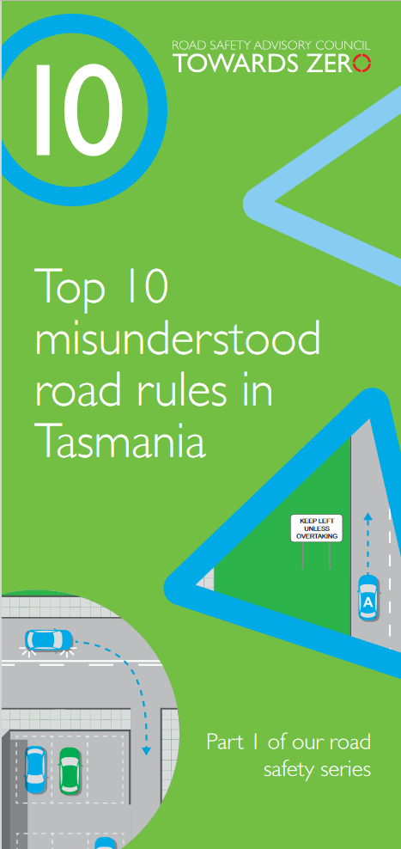
Compliance with the Road Rules makes road user behaviour predictable, improves traffic flow and most importantly, improves safety outcomes for all road users.
Road Rules enquiries are regularly received and responses provided critical information and clarification to community members.
User-friendly and tailored resources are developed for existing and new Road Rules that come into effect so that the rules are easily understood and adhered to by all road users.
Resources, including the Tasmanian Road Rules Handbook, Top Ten Misunderstood Road Rules and the Five More Misunderstood Road Rules pamphlet are promoted on the RSAC website and distributed to Service Tasmania locations when required.

Budget summary
Throughout 2023-24, $3.1 million was spent under the ‘Encouraging Safer Road Use’ theme.
Chart 4 – Encouraging Safer Road Use theme, FY23/24 Expenditure
Note:
1) Includes funding from the Motor Accident Insurance Board (MAIB) towards road safety campaigns and public education.
2) Automated Speed Enforcement Program – the above figure only includes Road Safety Levy expenditure.

Making visitors safer
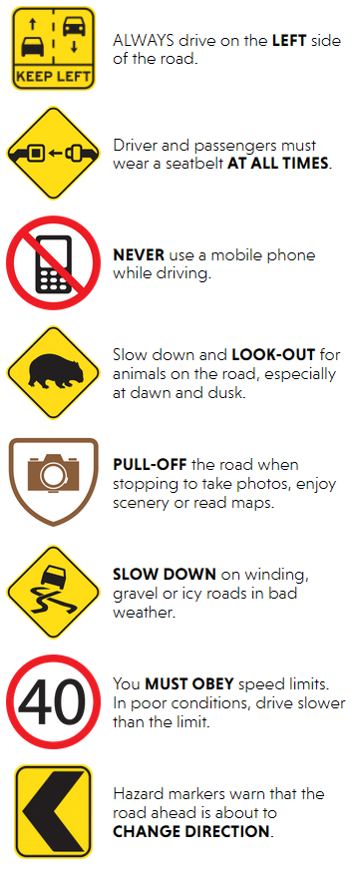
11 per cent of all serious casualties on Tasmanian roads are non-Tasmanian residents. The Tasmanian Government has committed $2 million to initiatives to support the education and safety of visiting road users including interstate drivers and riders, international drivers and for others new to Tasmania such as students and seasonal workers.

Summary of initiatives

Develop effective and engaging education materials
A range of education materials are distributed to make visiting road users safer. The multi-lingual education material has been delivered to the international visitor audience through targeted communication channels. These include vehicle hangers, brochures, posters, roadside signs, editorial content, film, and digital content. Communications materials continue to be distributed upon request from stakeholders.

Attract visitors’ attention by focusing activity on gateway entry points
Being an island state, Tasmania has the unique advantage of strategically placing essential road safety messages at its gateway airports and seaports to reach visitors before they drive in Tasmania. This includes a range of educational materials, electronic and static signs, and billboards. Printed collateral is available and digital billboards display road safety messaging at gateway locations.

Budget summary
Throughout 2023-24, $87,767 was expended under the ‘Making Visitors Safer’ theme.
Chart 5 – Making Visitors Safer theme, FY 23/24 Road Safety Levy Expenditure

Improving safety through vehicles and technology
Advances in vehicle design and technology are helping to prevent crashes from occurring and better protecting all road users in Tasmania. The Tasmanian Government has committed over $3 million to support and encourage Tasmanians to drive safer vehicles.

Summary of initiatives

Continue to support ANCAP
Tasmania has the oldest vehicle fleet in Australia. This is concerning because the rate of fatal crashes per registered vehicle is four times higher for vehicles aged 15 years or older than for vehicles aged five years old or less.
Tasmania is a member of the Australasian New Car Assessment Program (ANCAP). ANCAP plays a vital role in informing consumers of the differences in the safety performance of new vehicles entering the Australasian vehicle fleet. Furthermore, ANCAP also advocates for improved vehicle safety design and specification through public education campaigns, advocacy activities and engagement with governments, corporate fleets, the media and consumers.

Develop a Light Vehicle Safety Strategy
Tasmania has the oldest vehicle fleet in the country with an average age of around 13 years. This means more time and resources must be expended maintaining the roadworthiness of Tasmania’s older vehicles and that many Tasmanians are not benefiting from the latest vehicle safety features.
A light vehicle safety strategy is currently being developed to improve the crashworthiness and roadworthiness of the Tasmanian light vehicle fleet.
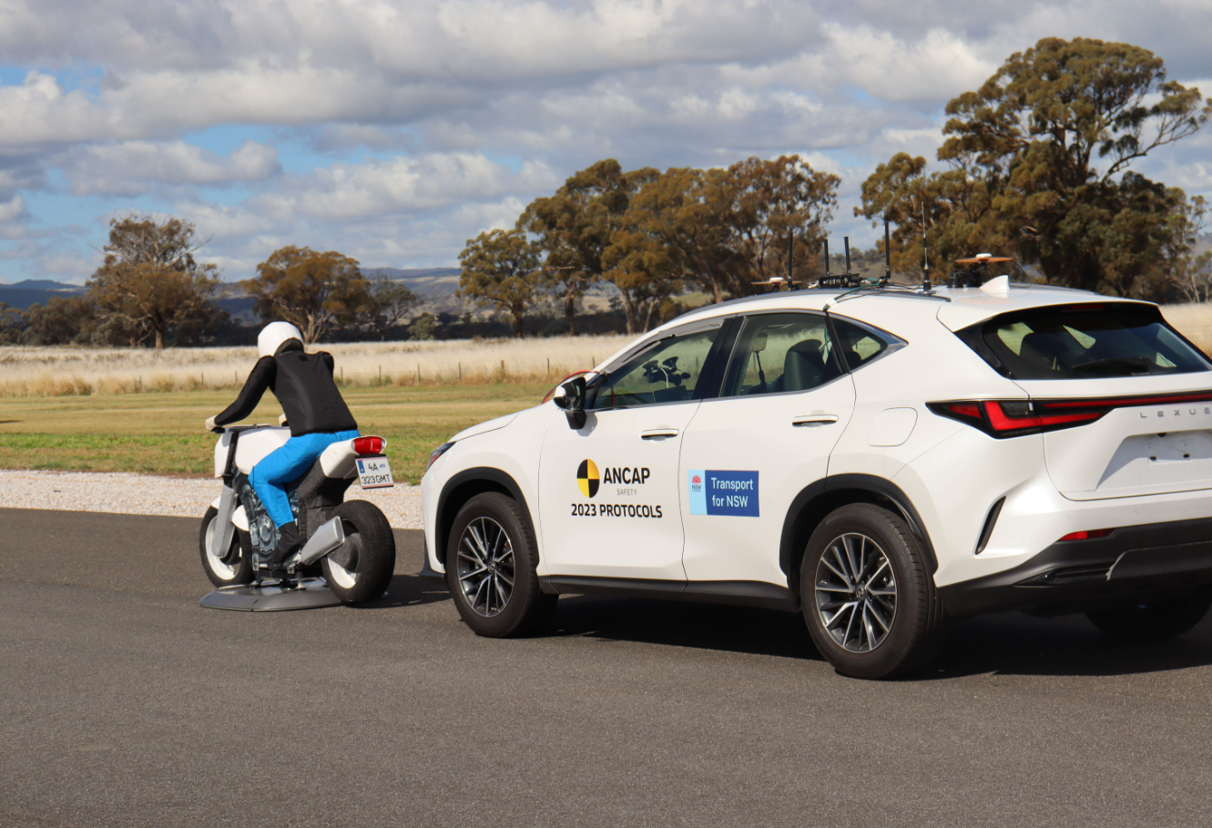
The strategy aims to accelerate an increase in the number of newer and safer vehicles and removal of older cars from the light vehicle fleet while increasing the safety of the current vehicle fleet.

Monitor developments in vehicle technology
Modern vehicles are increasingly equipped with technology that can improve safety. New features help drivers to adhere to the speed limit, minimise blind spots, reduce distraction and monitor signs of driver fatigue. Vehicles with crash avoidance technologies can alert the driver to potential hazards, give the driver more control in emergency situations and act autonomously to prevent a collision. These types of vehicle technology are evolving rapidly and have the potential to greatly reduce road trauma.
The aim of this initiative is to monitor autonomous vehicle and crash avoidance readiness in Tasmania to ensure that Tasmanian infrastructure and laws are compatible with emerging technologies. The regulation of autonomous vehicles is being considered at a national level, and Tasmania is participating in this process.

Budget summary
Throughout 2023-24 $81,781 was expended under the ‘Improving Safety Through Vehicles and Technology’ theme.
Chart 6 – Improving Safety Through Vehicles and Technology theme, FY 23/24 Road Safety Levy Expenditure

Road safety levy budget overview

Funding
Road safety initiatives in Tasmania are funded through collection of the Road Safety Levy, funding from the Motor Accidents Insurance Board (MAIB) and from the Australian Government’s Road Safety program (RSP).

The Road Safety Levy
The delivery of initiatives under the Action Plan are largely funded by the Road Safety Levy which supports the Towards Zero – Tasmanian Road Safety Strategy 2017-2026, as the primary road safety funding source through to 2026.
The Road Safety Levy applies to all eligible registered vehicles with general access to the road network. The Road Safety Levy is collected from vehicle registrations and is to be expended for the purposes of road safety. The Road Safety Levy raises around $15 million per annum and increases relative to Hobart CPI.

Approved budget for FY 2023-24
The RSAC approved the 2023-24 Action Plan budget on 30 May 2023. On the advice of the RSAC, the Minister for Infrastructure and Transport approved the budget on 20 June 2023.
At the start of 2023-24, approximately $22.2 million was available from the road safety levy to expend on road safety in Tasmania. Throughout the year approximately $18.5 million was collected from registrations.
In 2023-24, a total of $11.4 million was collectively expended from Road Safety Levy and MAIB funding. This saw over $4.1 million spent on infrastructure improvements across Tasmania and nearly $7.3 million (including MAIB contributions) spent on the delivery of road safety policy and projects.
At 30 June 2024, the Road Safety Levy recorded a balance of approximately $28.2 million.
The following table provides a detailed financial summary of 2023-24 revenue and expenditure.

Revenue and Expenditure for the Financial Year 2023-24
Road Safety Levy Opening Summary |  |  | $
Opening Balance as at 01 July 2023 |  |  | 22,209,096
Annual Allocation to Road Safety Operations |  |  | 2,600,000

Revenue Summary
 |  | Forecast (FY24)  $ | Actual  $
Motor Accidents Insurance Board Funding |  | 1,476,423 | 1,454,499
Revenue Inflows from Registrations |  | 15,787,990 | 18,510,194
Funds Available for Distribution |  | 36,826,964 | 39,573,789

Expenditure Summary
Theme no. | Theme | Forecast (FY24)  $ | Actual  $
1 | Making our Rural Roads Safer | 6,951,744 | 2,789,521
2 | Improving Safety in our Towns and Cities | 9,061,899 | 2,063,966
3 | Saving Young Lives | 3,362,189 | 2,765,332
4 | Encouraging Safer Road Use^ | 4,549,117 | 3,018,969
5 | Making Visitors Safer | 200,391 | 87,768
6 | Improving Safety Through Vehicles and Technology | 1,821,781 | 81,781
7 | General Support | 794,578 | 577,097
Budget and Expenditure by Category |  | Forecast (FY24)  $ | Actual  $
Infrastructure Expenditure* |  | 15,103,934 | 4,083,382
Policy & Projects Expenditure* |  | 11,667,765 | 7,301,052
Total Expenditure |  | 26,741,699 | 11,343,239
Balance as of 30 June 2024 |  | 10,131,810 | 28,230,550
Forecast Closing Balance of FY24 |  | 10,025,101
Note: ^The above includes MAIB expenditure
**Includes four ceasing activities not categorised by Action Plan 2020-24 themes.

Note: The underspend in FY 23/24 is predominately due to delayed expenditure relating to infrastructure projects. These projects are expected to be delivered in in following financial years.

MAIB Funding as at 30 June 2024
2023/24 Financial Year | Budget  $ | Actual (YTD)  $ | Balance  $
Expenditure (State Growth)
Administration & Public Relations | 320,673 | 337,864 | (17,191)
Public Education | 1,090,750 | 1,091,835 | (1,085)
Research | 65,000 | 24,800 | 40,200
Subtotal | 1,476,423 | 1,454,499 | 21,924
Expenditure (Tasmania Police)
Salaries | 2,263,072 | 2,221,650 | 41,422
Operating Expenses | 188,000 | 89,916 | 98,084
Equipment | 609,177 | 595,203 | 13,974
Subtotal | 3,060,249 | 2,906,769 | 153,480
Total | 4,536,672 | 4,361,268 | 175,404
Includes Carried Forward of
- $41,521 (State Growth)
- $274,839 (Police)

List of Acronyms
Action Plan | Towards Zero Action Plan 2020 - 2024
ANCAP | Australian New Car Assessment Program
ASE | Automated Speed Enforcement
CEO | Chief Executive Officer
CRSG | Community Road Safety Grants
DfJ | Driving for Jobs
GLS | Graduated Licensing System
HPT | Hazard Perception Test
ITS | Intelligent Transport System
JRLF | Jordan River Learning Federation
LDMP | Learner Driver Mentor Program
MAIB | Motor Accidents Insurance Board
MAIP | Mandatory Alcohol Interlock Program
RSAC | Road Safety Advisory Council
RSP | Road Safety Program
RYDA | Rotary Youth Driver Awareness
SRRP | Safer Rural Roads Program
State Growth | The Department of State Growth
Towards Zero Strategy | Towards Zero - Tasmanian Road Safety Strategy 2017-2026
VRUP | Vulnerable Road User Program


Road Safety Advisory Council  Department of State Growth | GPO Box 536 Hobart  Tas 7001 Australia  Phone: 1800 030 688  Email: rsac@stategrowth.tas.gov.au  Web: rsac.tas.gov.au

See Towards Zero Strategy at https://www.rsac.tas.gov.au/about-us/towards-zero-strategy/
See Action Plan at https://www.rsac.tas.gov.au/about-us/towards-zero-strategy/
Issued Infringement Notices includes notices that have been reduced to caution including: 1,591 speed, 136 mobile phone and 362 seatbelt caution notices.
Issued Infringement Notices do not include offences being heard in the Magistrates Court (i.e., court hearing requested of defendant or high-speed offences that Tasmania Police have taken immediate actions to charge the individual).

