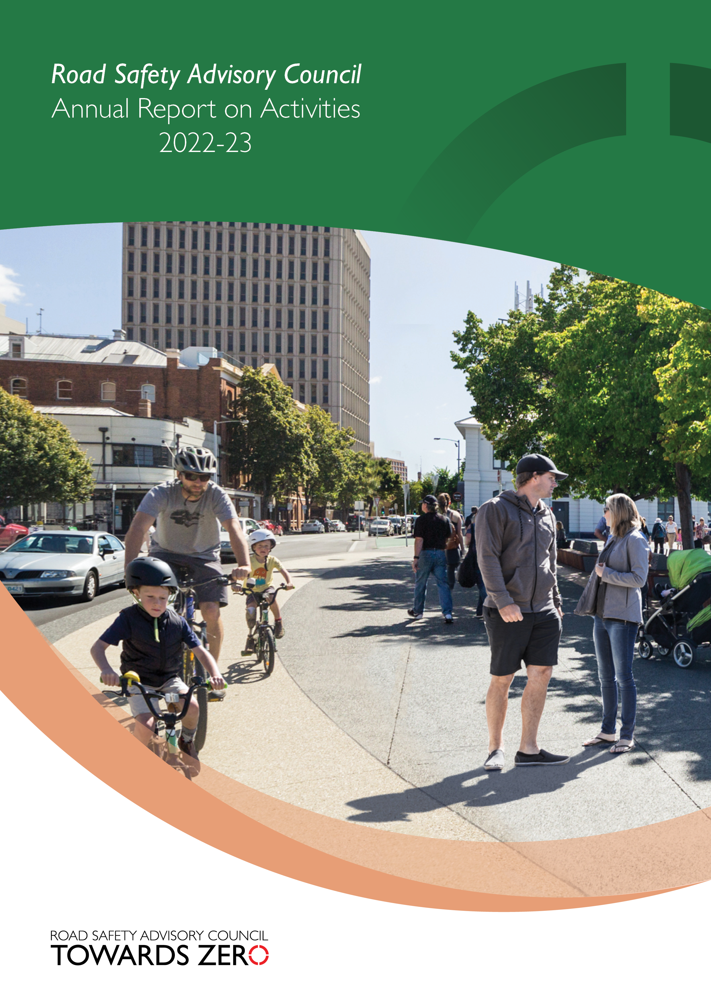

Table of contents
Photo credits and acknowledgements 2
Overview 3
Message from the Chair of the Road Safety Advisory Council 3
About the Road Safety Advisory Council 6
Road Safety Advisory Council membership 7
Road Safety Advisory Council meetings and attendance 8
RSAC Education and Enforcement Sub-Committee (EESC) membership 8
EESC meetings and attendance 9
RSAC and EESC remuneration 9
Serious casualty trends and progress on meeting Towards Zero Strategy targets 10
Thematic Snapshot of the Towards Zero Action Plan 2020-2024 14
Making our rural roads safer 15
Improving safety in our towns and cities 17
Saving young lives 19
Encouraging safer road use 25
Making visitors safer 30
Improving safety through vehicles and technology 31
Road safety levy budget overview 33

Photo credits and acknowledgements
Images used within this report remain the property of the copyright holder. All images are courtesy of the RSAC, Tasmanian Government and its associated projects. Cover photo courtesy of City of Hobart.
© State of Tasmania October 2023

© State of Tasmania August 2023

Overview

Message from the Chair of the Road Safety Advisory Council
As Chair of the Road Safety Advisory Council (RSAC), I am pleased to present the third annual report under the five-year Towards Zero Action Plan 2020-2024. The five-year Action Plan details the 42 road safety initiatives that will gain the greatest reductions in serious injuries and deaths. The Action Plan is based on the best-practice Safe System approach to road safety and targets our highest risk road safety areas. The selection of initiatives and programs was informed by extensive community engagement, stakeholder consultations, and independent research and modelling.
Over the life of the Action Plan over $75 million will be invested in road safety, funded from the Road Safety Levy. Annually, the Motor Accidents Insurance Board (MAIB) contributes $4.5 million for the production and evaluation of public education initiatives and to support enforcement activities. Additionally, over the last year the Australian Government has contributed $1.5 million to infrastructure projects delivered through the Road Safety Program.
One of the major undertakings for RSAC over the last year has been to commence a mid-term review of the Towards Zero Strategy and Action Plan as they have reached the halfway point of their terms. The mid-term review will allow us to understand the current road safety environment in Tasmania and to best direct road safety resources to reduce serious injuries and deaths on Tasmanian roads.
In 2022, we had 51 fatalities on our roads and 266 people were seriously injured. This was the highest number of deaths on our roads in more than a decade. The human cost of road trauma is devastating for individuals, families, friends, and communities, and has a significant impact on first responders.
In response to the increase in lives lost on Tasmanian roads RSAC held public regional road safety forums around the state in August 2022. The forums were well-attended and it was heartening to see so many community members engaged in discussions about how to make our roads safer. On 25 October 2022 the Government received the final report from the Legislative Council Select Committee Inquiry into Road Safety in Tasmania. The ideas from the forums and the Inquiry will also feed into the mid-term review.
Another major project has seen the introduction of mobile speed cameras on our roads again. Speed remains a major factor in road trauma, impacting both the severity and likelihood of a crash. Over time, the automated traffic enforcement program is expected to reduce fatal and serious injuries by up to 20 per cent, equating to six lives saved, and 54 serious injuries prevented each year. As at the end of June 2023, we have 16 mobile speed cameras operating on the road network.
We are extending our automated traffic enforcement program to include mobile phone and seatbelt detection cameras. Inattentiveness and distraction take our focus away from the complex task of driving and put us at risk of crashing. Not wearing a seatbelt, or wearing a seatbelt incorrectly, dramatically increases our risk of dying in the event of a crash.
We never want to see so many lives lost in a single year again. Our hopes for a reduction in deaths and serious injuries has not been realised in the last decade, with the level of progress plateauing. When we set our 10 year short-term target for fewer than 200 serious casualties by 2026, we knew it was ambitious, but it is now looking unachievable. However, we are firmly committed to working towards this target and through our projects, programs, policies, education and enforcement we will continue to tackle the road toll and I implore all Tasmanians to act responsibly and join us in the road safety effort.
I would like to acknowledge and thank RSAC members and those who support the Council’s work for their commitment and professionalism during what was a challenging year for road safety in our State.

Scott Tilyard
Chair, Road Safety Advisory Council
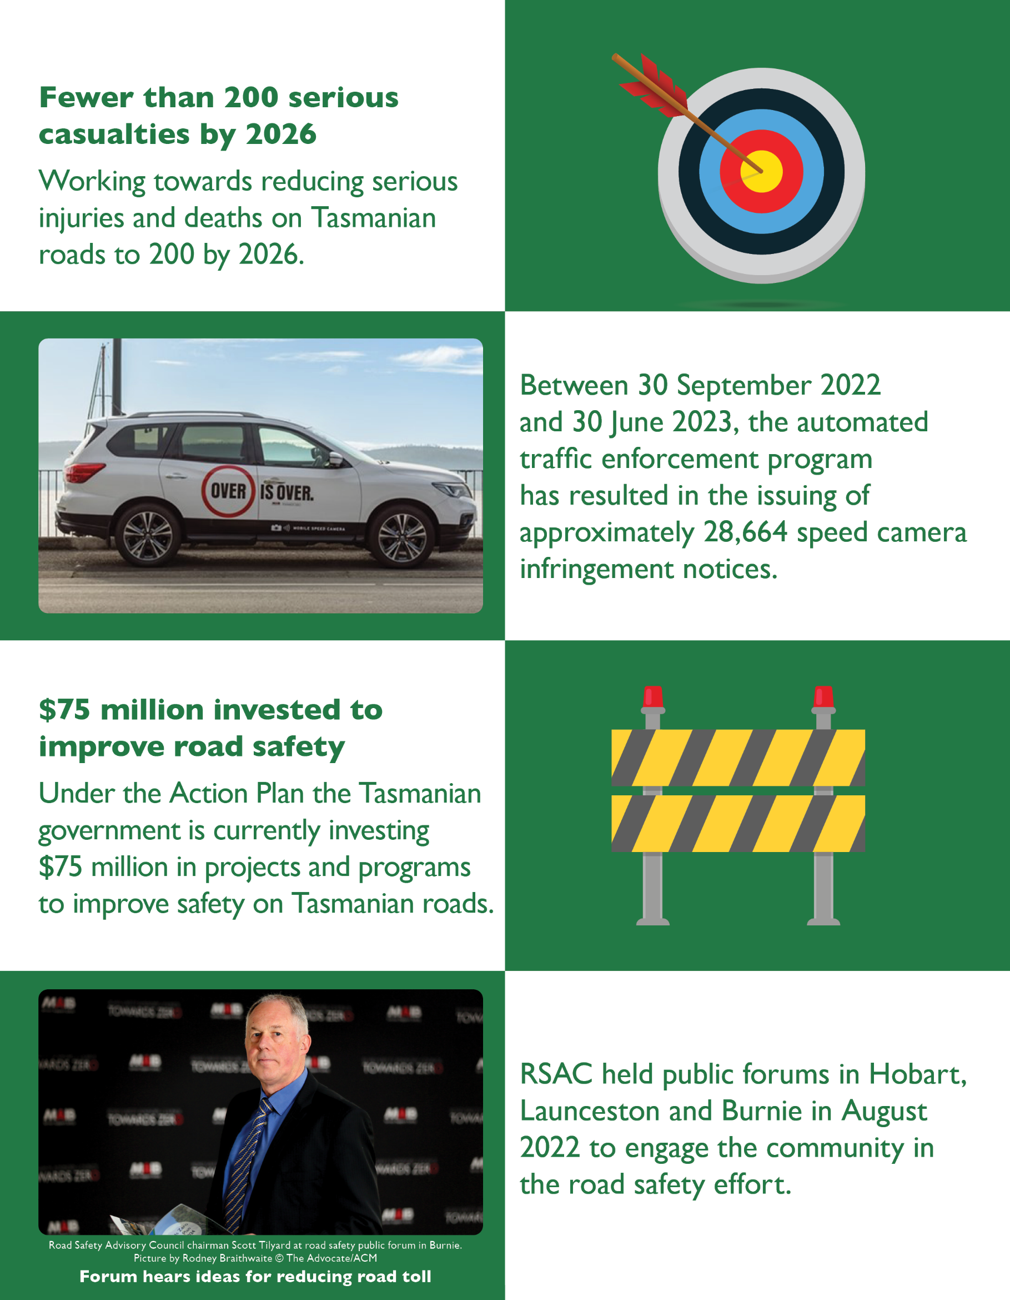

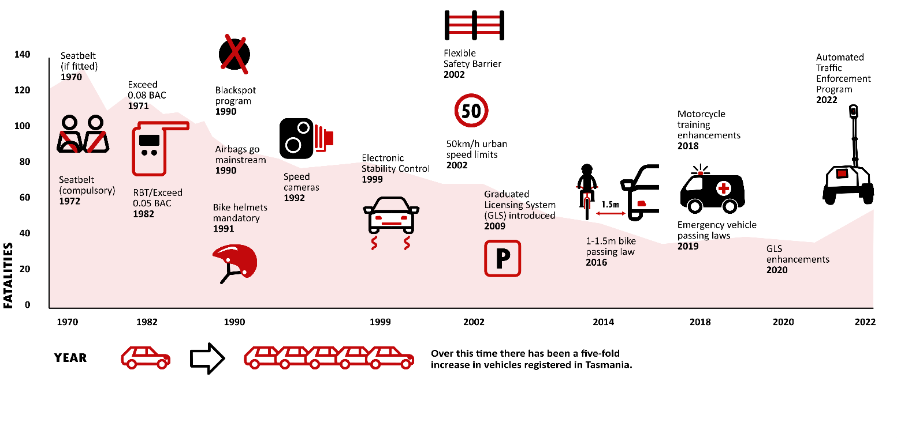
Tasmanian road crash fatalities and key road safety measures

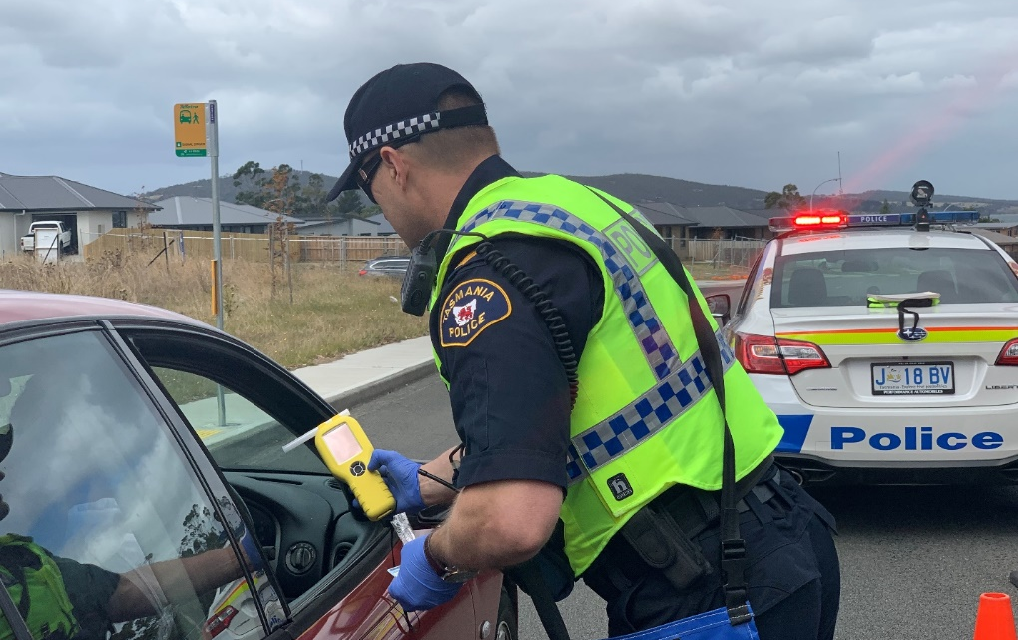
In 2022-2023, Tasmania Police detected 39,378 total traffic offenders including 18,173 high-risk traffic offenders.

About the Road Safety Advisory Council
The Road Safety Advisory Council (RSAC) was established in October 2010 to help shape the future of road safety policy in Tasmania. The RSAC replaced the Tasmanian Road Safety Council and the Road Safety Taskforce and combined their expertise. The RSAC oversees the development and implementation of policy, initiatives, public education, and strategies to reduce serious injuries and deaths on Tasmania’s roads.
Primarily, the RSAC provides strategic direction, oversight and critical assessment of proposed road safety initiatives and campaigns. The RSAC recommends and reports on road safety initiatives to the Minister for Infrastructure and Transport through the Department of State Growth.
The Towards Zero – Tasmanian Road Safety Strategy 2017 – 2026 (Towards Zero Strategy) guides the RSAC’s overall vision, purpose and approach. The RSAC envisions a Tasmania that is free from serious injuries or deaths from crashes on Tasmanian roads. The Towards Zero Strategy is supported by periodical action plans with the current being the Towards Zero Action Plan 2020-2024 (Action Plan). Annually, around 300 people are seriously injured and killed on Tasmanian roads.
The key target is to reduce annual serious injuries and deaths on Tasmanian roads to fewer than 200 by 2026.
The RSAC’s work goals and the Towards Zero Strategy are based on the ‘Safe System’ approach to road safety. The Safe System approach involves a holistic view of the road transport system that includes how roads, travel speeds, vehicles and road users interact with each other. The approach is an inclusive one as it involves all groups of road users, including drivers, motorcyclists, passengers, pedestrians, cyclists, commercial and heavy vehicle drivers.
The Safe System approach has four elements: safe road users, safe roads and roadsides, safe vehicles and safe speeds. The rationale behind the system is that it recognises that road users will always make mistakes and may have road accidents. However, the road system should be able to accommodate mistakes so that road crashes do not result in death or serious injury.
Sitting within RSAC is the Education and Enforcement Sub-Committee (EESC). The EESC is funded by the Motor Accidents Insurance Board (MAIB). The EESC is responsible for the delivery of public education campaigns, sponsorships and enforcement activities. The EESC provides advice on road safety education and ensures that community road safety and enforcement programs align with the Towards Zero Strategy.
In addition, the EESC reports and makes recommendations to the RSAC by identifying emerging issues from key community stakeholders and contributes to the further development of key road safety strategic directions.

Road Safety Advisory Council membership
The RSAC consists of 10 members appointed by the Minister for Infrastructure and Transport. The member positions are as follows.
- A part-time independent Chair
- The Secretary of the Department of State Growth
- The Secretary of the Department of Police, Fire and Emergency Management
- The CEO (or equivalent) of the Motor Accidents Insurance Board
- The CEO (or equivalent) of the Local Government Association of Tasmania
- A person or people (maximum four) to represent a range of road users whose organisation(s) can demonstrate its major role in and contribution to road safety, including:
  - light and heavy vehicle drivers
  - motorcyclists
  - cyclists
  - pedestrians, and
  - young people
- A person with high-level expertise in road safety research, infrastructure, countermeasures, strategies, and contemporary road safety principles.

The RSAC’s membership as at 30 June 2023
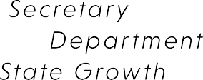
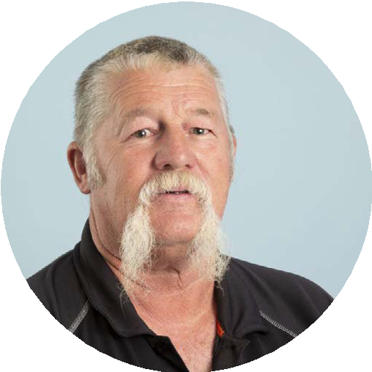
ADRIAN BODNAR

NB. The Minister for Infrastructure and Transport has appointed the following delegates as representatives on RSAC:
- Gary Swain, Deputy Secretary for Kim Evans, Secretary, Department of State Growth
- Assistant Commissioner Adrian Bodnar for Commissioner Donna Adams, Department of Police, Fire and Emergency Management.

Road Safety Advisory Council meetings and attendance
The RSAC held four meetings in 2022-23, occurring on the following dates.
- 23 August 2022
- 22 November 2022
- 28 March 2023
- 30 May 2023
The below table outlines the attendance of the RSAC representatives at each of the four meetings occurring in 2022-23. Other observers, presenters or irregular attendees are not included.
Member | 23 August 2022 | 22 November 2022 | 28 March  2023 | 30 May  2023 | Total Meetings Attended
Mr Scott Tilyard |  |  |  |  | 4
Mr Paul Kingston |  |  |  |  | 4
Dr Ian Johnston |  |  |  |  | 3
Mr Gary Swain* |  |  |  |  | 4
Mr Mark Mugnaioni |  |  |  |  | 3
Ms Michelle Harwood |  |  |  |  | 3
Ms Alison Hetherington |  |  |  |  | 4
Mr Mick Boyd |  |  |  |  | 3
Mr Dion Lester |  |  |  |  | 2
Mr Jonathan Higgins**  Mr Adrian Bodnar*** |  |  |  |  | 4
*Acting Deputy Secretary, Denise McIntyre attended the 23 August 2022 meeting.
**Acting Assistant Commissioner Stuart Wilkinson attended the 23 August 2022 meeting.
***Assistant Commissioner Operations Adrian Bodnar commenced as the RSAC Tasmania Police representative from November 2022.

RSAC Education and Enforcement Sub-Committee (EESC) membership
Representing | Member
Chair | Mr Paul Kingston  CEO, Motor Accidents Insurance Board (MAIB)
Chair RSAC | Mr Scott Tilyard
Marketing Expert | Mr Rowan Smith
The Department of State Growth | Mr Craig Hoey  Manager Road Safety, the Department of State Growth
The Royal Automobile Club of Tasmania | Mr Ben Hansen  Communications & PR Manager, Royal Automobile Club of Tasmania (RACT)
The Department of Police, Fire and Emergency Management | Mr Jonathan Higgins to December 2022  Mr Adrian Bodnar from January 2023  Assistant Commissioner, Tasmania Police

EESC meetings and attendance
The EESC held four meetings in 2022-23. The below table outlines the attendance of the EESC members at each of the four meetings occurring in 2022-23. Other observers, presenters or irregular attendees are not included.
Member | 23 August 2022 | 22 November 2022 | 28 March  2023 | 30 May  2023 | Total Meetings Attended
Mr Paul Kingston |  |  |  |  | 4
Mr Scott Tilyard |  |  |  |  | 4
Ms Suzi Watral /  Mr Rowan Smith |  |  |  |  | 4
Mr Craig Hoey |  |  |  |  | 4
Mr Ben Hansen |  |  |  |  | 3
Mr Jonathan Higgins /  Mr Adrian Bodnar |  |  |  |  | 4
NB. Jonathan Higgins was the Tasmania Police representative on the EESC up until 23 August 2022 and Adrian Bodnar commenced as the Tasmania Police representative from 22 November 2022.
NB. Suzi Watral was the Marketing Expert representative on the EESC up until 22 November 2022 and Rowan Smith commenced as the Marketing Expert representative from 28 March 2023.

RSAC and EESC remuneration
Council members who received remuneration for the 2022-23 financial year include:
Chair RSAC
- $41,212 per annum
- Out-of-pocket expenses up to $1,600 per annum
Road safety expert
- $1,500 per meeting
- Actual out-of-pocket expenses
Marketing expert
- $642 per meeting
- Actual out-of-pocket expenses.
Council members who are not public officers are entitled to motor vehicle allowances based on a cents-per-kilometre basis, in accordance with Australian Taxation Office guidelines.

Serious casualty trends and progress on meeting Towards Zero Strategy targets
The Towards Zero Strategy sets the key interim target of reducing the number of annual serious casualties on Tasmanian roads to fewer than 200 by 2026. This is an ambitious target of 100 fewer serious casualties per year than the annual average for the period 2012 – 2016 and will move Tasmania towards the long-term goal of zero serious casualties.

Serious Casualites for 2022 – 23 (Serious Injuries and Deaths)
The number of serious casualties in 2022 was 317, a 12.8 per cent increase from 286 in 2021, and a 7.2 per cent decrease on the five-year serious casualty average of 300.8 (2017-2021).

Serious Casualties Tasmania – Annual Count, Percentage Split by Quarter and Towards Zero Target

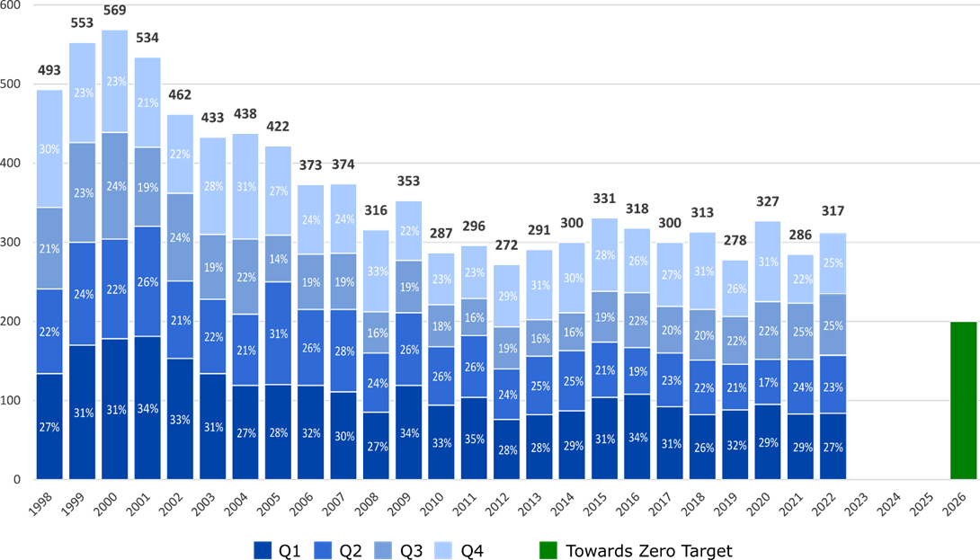

Year-to-Date as at 30 June 2023
There have been 191 serious casualties as at 30 June 2023 (from 1 January 2023), including 17 deaths and 174 serious injuries. This number is 32 more than the 159 serious casualties recorded at the same time last year, which includes 30 deaths and 129 serious injuries and an increase of 27.1 per cent on the five-year average of 150.2 serious casualties.

Serious Casualties Tasmania – Annual Count, Percentage Split by Quarter and Towards Zero Target
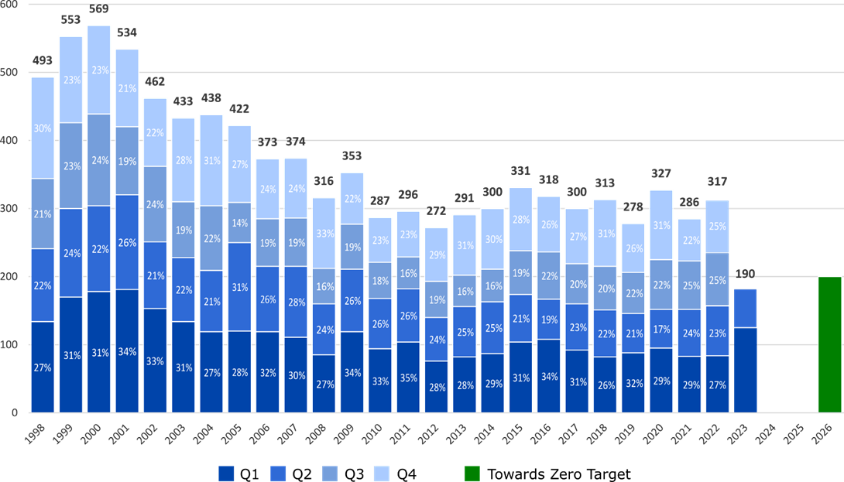

Annual fatalities – Rate per 100,000 population (NT omitted for clarity purposes)
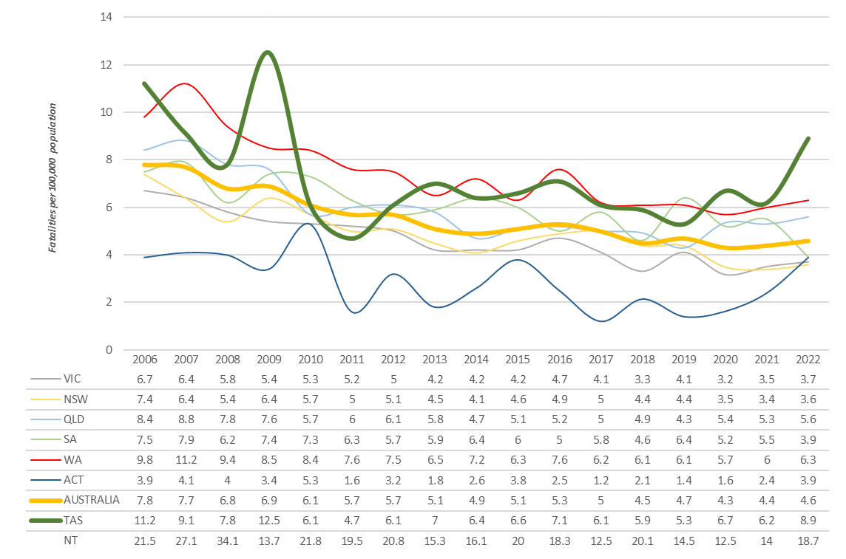

Serious casualties – breakdown by road user type
 | Motorcyclists represented 10 of the 51 deaths on Tasmanian roads in 2022. |  | Two-thirds of deaths on Tasmanian roads in 2022 were vehicle occupants.
 | There was one death and eight cyclist serious injuries in 2022. |  | 39 of the 51 deaths on Tasmanian roads in 2022 were male, representing approximately three-quarters of the total deaths. In addition, males accounted for 232 of the 317 serious casualties.

Serious casualties – breakdown by crash attributes

Speed zone
The graph below depicts the number of serious casualties occurring quarterly by speed zone. Serious casualties occur more frequently on roads with 100 km/h or higher speed limits and less frequently on roads with 40 km/h or lower speed limits.

Serious Casualties by Quarter by Speed Zone – 12 period moving average

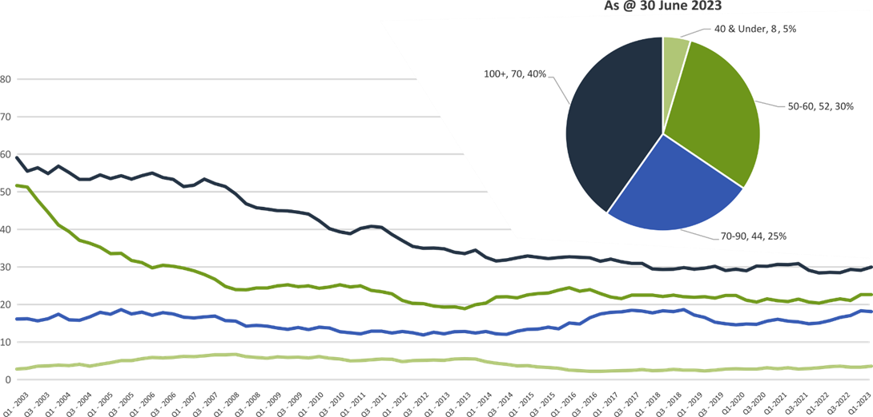
Pie chart excludes serious casualties where speed zone is recorded as ‘not known’

Crash type
The graph below depicts the number of serious casualties occurring quarterly by crash type. The majority of serious casualties occur due to lane departure crashes.

Serious Casualties by Quarter by Crash Type (DCA) – 12 period moving average

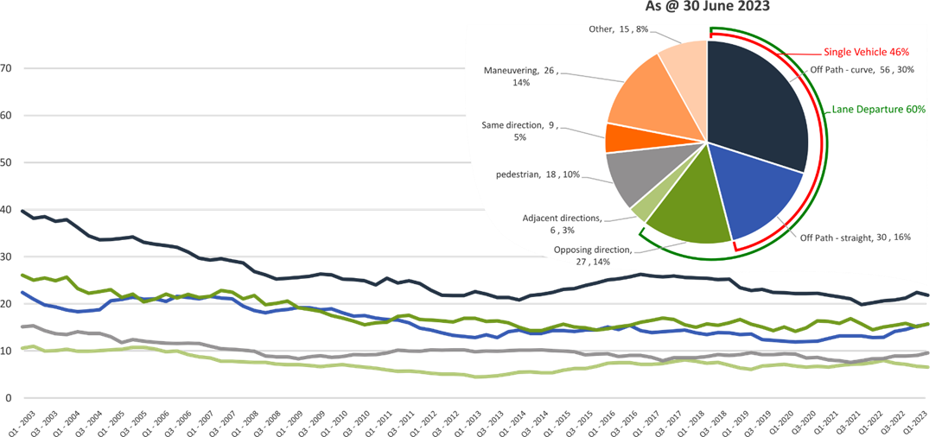
Other includes crash types: overtaking (5%), on-path (2%), and passenger and miscellaneous (1%).
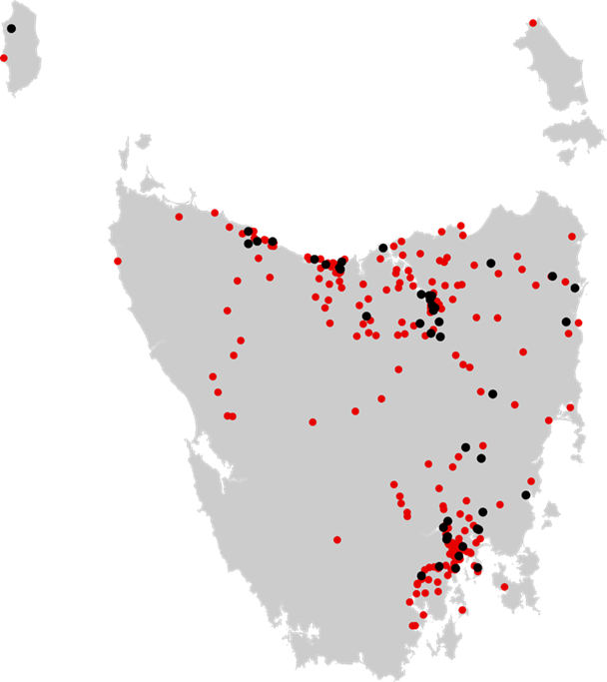

Location
The image (right) depicts
the location of all serious
casualties that occurred
in 2022.

Thematic Snapshot of the Towards Zero Action Plan 2020-2024
Making our rural roads safer |  | Improving safety in our towns and cities
Rural road grants program for local government  Motorcyclist safety on rural roads  Safe System knowledge and skills training  Infrastructure upgrades on low volume state roads  Speed moderation and community engagement strategy |  | Targeted infrastructure upgrades in high traffic  urban areas  Community Road Safety Program  Innovative infrastructure treatment demonstrations  Vulnerable Road User Program  Trial of innovative technologies
Saving young lives |  | Encouraging safer road use
Learner Driver Mentor Program and Driver Mentoring Tasmania  Rotary Youth Driver Awareness Program  RACT education initiatives  Bicycle Network bike education  Kidsafe child restraint check program  Develop a Graduated Licensing System for motorcyclists  Graduated Licensing System Project for drivers  Driving for Jobs Program  Real Mates media campaign  Safety around schools  Full Gear motorcycle safety project |  | Inattention and distraction  Mandatory Alcohol Interlock Program  Road safety penalties review  Enforcement of high-risk behaviours  High-risk motorcycling enforcement  Safe behaviour campaigns  Protective clothing for motorcyclists  Speed enforcement strategy  Automated Speed Enforcement Program  Road Rules Awareness
Making visitors safer |  | Improving safety through vehicles and technology
Tourist road safety signage program  Tourist education materials  Tourist education at gateway entry points  Responsive electronic signage trial  Strategic partnerships  Stakeholder alliances |  | ANCAP  Autonomous vehicle and crash avoidance readiness  Light vehicle strategy  Safer cars for young drivers  Workplace driver safety

Making our rural roads safer
60 per cent of fatalities in Tasmania occur in rural areas. The Tasmanian Government is currently investing over
$20 million into improving the safety of our rural roads.

Summary of initiatives

Establish a rural roads grants program for local government
The Safer Rural Roads Program (SRRP) launched in late 2020 as an infrastructure initiative established under the Action Plan. The SRRP provides opportunities for Tasmanian local governments to apply for grant funding to implement widespread low-cost road safety infrastructure treatments on high-speed rural roads. The program aims to improve road safety outcomes in Tasmania by reducing the number of head-on and run-off-road crashes and to reduce harm when these crashes do happen. Treatment types funded under the SRRP include improved delineation (signs and lines), roadside hazard removal, limited shoulder sealing and safety barriers. Junction upgrades are also eligible for funding under the SRRP.
Under the 2022–2023 SRRP funding round – the third SRRP round under the Action Plan – 18 projects were supported with $3.2 million of funding. Alongside $1.6 million in co-contributions from councils, this funding will allow $4.8 million in infrastructure to be built to improve safety on rural roads. Funded infrastructure treatments include guardrails, pavement widening, line marking and traffic signage.
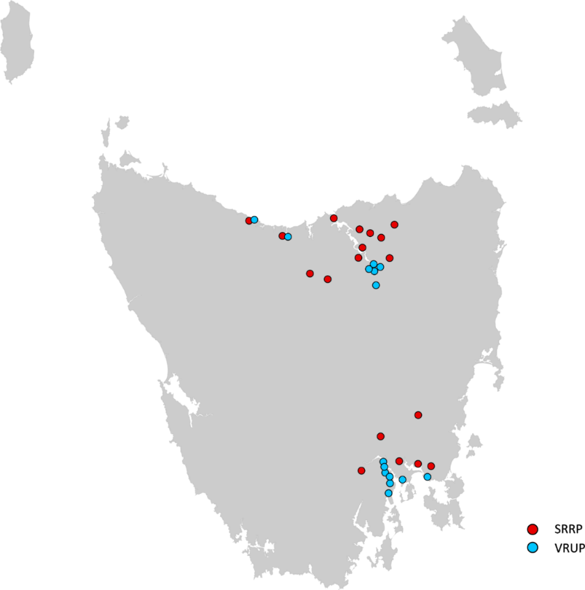
The Road Safety Branch continues to work with local governments that were awarded SRRP grants in previous rounds, noting some projects have experienced delays including impacts associated with supply chain and market constraints.

Map illustrating the distribution of projects in the 2022-2023 round of the Safer Rural Roads Program (SRRP), and the Vulnerable Road Users Program (VRUP).

Conduct infrastructure upgrades on low volume state roads
The Safe System Infrastructure Strategy provides for safety improvements on lower volume state roads that are not a priority for significant upgrades in the short to medium term. The program focuses on low-cost infrastructure treatments including improved delineation (signs and lines), curve treatments, roadside hazard removal, limited shoulder sealing, safety barrier and junction upgrades. The strategy is being expanded to deliver a network safety plan to guide future investment under this action.

Improve motorcyclist safety on rural roads
The Tasmanian Government conducts regular road safety audits on high-risk touring routes across Tasmania. The audit process includes engagement with local motorcyclists to gain a ‘rider’s’ perspective. Findings are shared with stakeholders to identify behavioural countermeasures as well as infrastructure solutions.
In 2022-23, funding up to $350 000 was allocated for State Growth to carry out low-cost infrastructure treatments to improve road safety for motorcyclists on Lake Leake Road, following an audit undertaken in 2018. In March 2023, the installation of treatments on Lake Leake Road were completed.
On 6 March 2023, an audit of the Channel Highway between Margate and Verona Sands was completed. A schedule of works is being prepared with works to commence in late 2023.
State Growth is also currently developing a strategy for future motorcycle road safety audits. This strategy will identify potential priority routes across Tasmania, suitable for conducting further motorcycle road safety audits.

Expand Safe System knowledge and skills
This program aims to improve Safe System knowledge for all those in a position to influence road safety outcomes and support Safe System infrastructure design and speed setting. The program includes technical training sessions, workshops, and forums across Tasmania.
On 7 March 2023, State Growth provided a Safe System principles training session to provide 25 employees of State Growth and Tasmania Police with advanced Safe System knowledge.
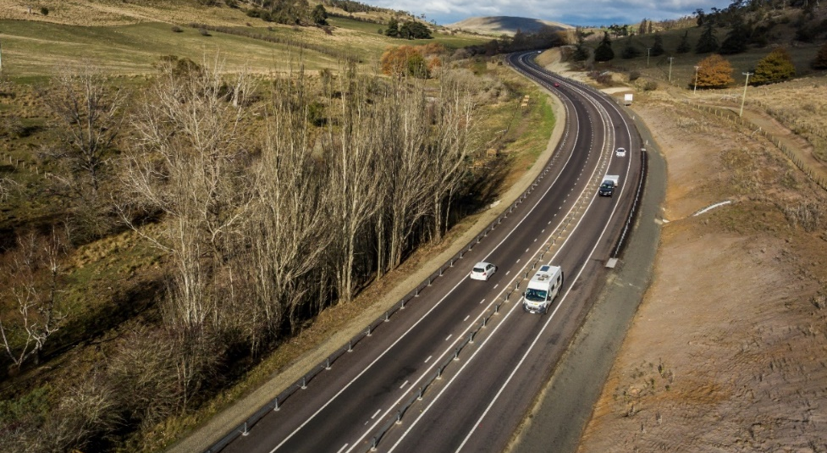
State Growth is considering options to develop a structured training package to support the development of Safe System knowledge and skills across local and state government. In June 2023, State Growth conducted consultation of the framework with stakeholders within the Transport and Infrastructure Group, Tasmania Police, and local government. State Growth is refining the training framework before development is progressed.

Budget summary
Throughout 2022-23, $1.6 million was spent under the ‘Making Rural Roads Safer theme’.
Chart 1 – Making our Rural Roads Safer theme, FY 22/23 Road Safety Levy Expenditure
*note: includes correction of expenditure from the Vulnerable Road User Program to the Cycling Safety Infrastructure Program.

Improving safety in our towns and cities
Tasmania’s population is growing, and our towns and cities are busier than ever. The Tasmanian Government is investing over $31 million in projects and programs to improve road safety in our towns and cities.

Summary of initiatives

Expand the Vulnerable Road User Program
The Vulnerable Road User Program (VRUP) provides opportunities for Tasmanian local governments to apply for grant funding to implement low-cost infrastructure treatments that improve road safety outcomes for vulnerable road users such as pedestrians, cyclists and motorcyclists. The program aims to improve road safety in Tasmania by reducing the number of crashes that occur between vulnerable road users and vehicles in urban areas and by reducing the level of injury when a crash does occur. Typical infrastructure treatments funded under the VRUP include pedestrian crossing infrastructure (such as median pedestrian refuges and wombat crossings) and off-road shared-use paths to separate vulnerable road users from vehicle traffic.
Under the 2022–2023 VRUP funding round – the fourth VRUP round under the Action Plan – 15 projects were supported with $1.4 million of funding. Alongside nearly $500,000 in co-contributions from councils, this funding will allow $1.9 million in infrastructure to be built to protect vulnerable road users. Funded infrastructure treatments include traffic calming measures, electronic speed signage, footpaths, pedestrian refuges, curb ramps and crossings.
The Road Safety Branch continues to work with local governments that were awarded VRUP grants in previous rounds, noting some projects have experienced delays including impacts associated with supply chain and market constraints.

Community Road Safety Grants Program
The Community Road Safety Grants Program (CRSGP) aims to provide community groups across Tasmania with the opportunity to develop and deliver small scale local road safety programs within their communities consistent with the Towards Zero Strategy.
The Government has committed $200,000 annually for five years from the Road Safety Levy, as part of the Action Plan. CRSGP funding is available in two categories: small grants of up to $5,000 and medium/large grants of up to $35,000. To be eligible, projects must address at least one of the Fatal Five road safety behaviours or promote safety for vulnerable road users, while demonstrating a community focus.
Out of the 2022–23 CRSGP funding round, a total of 13 projects have been funded and are currently underway.
Several medium/large grants were awarded to support delivery of the Full Gear program, which helps eligible young motorcycle riders enter the licensing system and to adopt safe riding practices.
Additionally, grants were awarded to several schools to conduct road safety initiatives, such as promoting the correct use of seatbelts and the acquisition of a mobile radar speed feedback sign for supporting speed reductions and awareness around the school.
The remaining projects include an innovative social media campaign educating children and parents on safe road user behaviours and speed awareness programs.

Conduct infrastructure upgrades on high volume state roads
Consistent with its approach on low volume roads the Tasmanian Government is developing a Safe System Infrastructure Strategy that provides for safety improvements on higher volume state roads that are not a priority for significant upgrades in the short to medium term.
The program focuses on low-cost infrastructure treatments including improved delineation (signs and lines), curve treatments, roadside hazard removal, limited shoulder sealing, safety barrier and junction upgrades.
The strategy is being expanded to deliver a network safety plan to guide future investment under this action.

Budget summary
Throughout 2022-23, $3.9 million was expended under the ‘Improving Safety in our Towns and Cities’ theme.
Chart 2 – Improving Safety in our Towns and Cities theme, FY 22/23 Road Safety Levy Expenditure
Note: The Vulnerable Road User Program (VRUP) is omitted for clarity purposes – expenditure was corrected from the VRUP to projects under the Cycling Safety Infrastructure Program (see Making our Rural Roads Safer section).

Saving young lives
Tragically, on average, 92 young road users (17 – 25 years) suffer serious casualties on Tasmanian roads every year.
To reduce this harm, the Tasmanian Government is investing over $12 million in programs and projects.
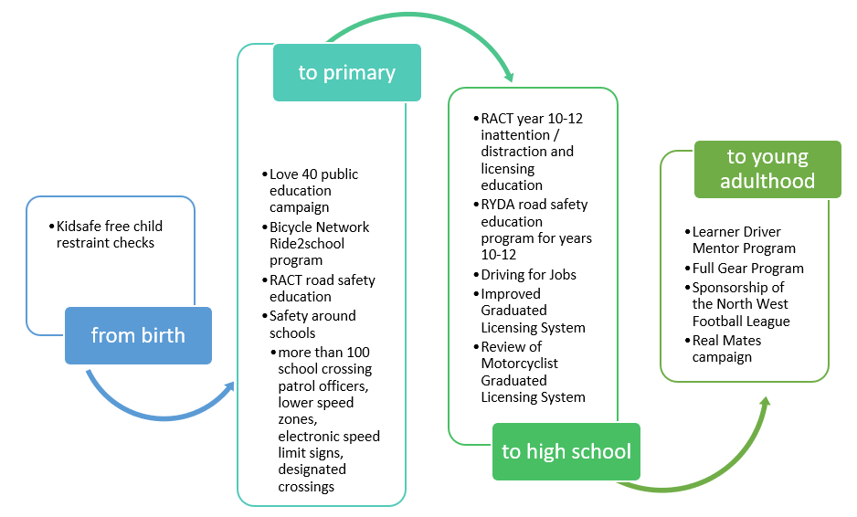
Under the Action Plan, there are a number of programs that aim to promote road safety awareness and save young lives.
Summary of initiatives

Improve the Graduated Licensing System (GLS)
Commenced in 2017, the GLS review’s primary goal is to reduce serious casualties among young road users (17 – 25 years) on Tasmanian roads.
The Tasmanian Government implemented changes to the GLS on 1 December 2020. Tasmania’s GLS now meets the ‘enhanced’ model GLS under the national driver GLS policy framework. The GLS changes were accompanied by a public education campaign explaining the policy changes and how they would apply to current and new learners.
A package of digital products was progressively launched from July 2021 to complement the changes to the GLS.
The Plates Plus online learning and assessment platform was designed to improve learner driver education by focusing on developing safe driving behaviours and attitudes. It is an innovative tool that takes users through a series of interactive exercises to ensure new drivers know the road rules and understand the impact of the fatal five road behaviours. A public education campaign accompanied the launch of the Plates Plus platform and ran until September 2021. The campaign encouraged take-up by promoting the convenience of the platform, which is accessible from any device connected to the internet.
The Plates Plus logbook app was launched in November 2021. The app offers an alternative to the hard copy logbook for those learners who prefer to record their hours digitally. It provides an easy and efficient way to log supervised driving hours during the learner licensing phase. A public education campaign targeting 15 to 25-year-olds accompanied the launch of the Plates Plus logbook app. To engage with this age group, the campaign focused on selected social media platforms.
The computer-based hazard perception test (HPT) was launched on 7 March 2022. The HPT is a mandatory assessment that has been introduced to the learner licensing pathway to ensure novice drivers are able to recognise and respond to avoid various hazards on the road.
The HPT was the final product to be delivered under the GLS project.

Continue the Learner Driver Mentor Program
The Learner Driver Mentor Program (LDMP) is a well-established program that supports disadvantaged learner drivers to gain their on-road supervised driving hours to obtain a licence.
For some learner drivers, accessing a suitable car and/or supervisory driver to gain the required minimum 80 on-road hours is extremely challenging.
Under the Learner Driver Mentor Program (LDMP), community based not-for-profit organisations coordinate the matching of disadvantaged learner drivers with volunteers (and vehicles) to gain the minimum supervised driving hours to progress to the provisional stage of the GLS.
For the purposes of participating in a LDMP, a learner driver is considered to meet the disadvantaged criteria if they do not have access to a suitable supervisory driver and/or car, are on a low income and are not able to afford professional driving lessons to gain the minimum hours required to obtain a provisional licence.
Under the Action Plan, funding of $1 million was allocated to the LDMP (including DMT) from the Road Safety Levy (Levy) for the 2022-23 financial year. As in previous years, requested funding well exceeded the annual allocation. Individual programs are operating without margin and the program scale would need to be reduced in order to meet the budgeted allocation.
For the 2022-23 financial year, the total funding allocated was $1,149 887 to support a viable state-wide program.

Develop an improved Graduated Licensing System (GLS) for motorcyclists
A review of the Tasmanian motorcyclist GLS commenced in 2021 to identify potential enhancements to complement the training and assessment curriculum implemented in 2017.
Motorcycle riders represent more than one in five serious casualties on Tasmanian roads despite motorcycles comprising less than one in 20 registered Tasmanian vehicles. Unlike the national GLS policy framework for drivers, there is no nationally agreed policy framework for motorcycle licensing. In order to assess Tasmania’s motorcyclist GLS and identify options for enhancement, the Centre for Automotive Safety Research (CASR) was engaged to conduct a review of the Tasmanian motorcyclist GLS. The findings and recommendations of the review were presented to RSAC at its May 2022 meeting.
A discussion paper was subsequently prepared and released by the RSAC to guide a public consultation process held during August and September 2022. The public consultation process sought feedback and community sentiment towards CASR’s recommendations. That feedback was then considered by the RSAC together with CASR’s recommendations. The RSAC endorsed a package of recommended changes to the motorcyclist GLS which has been provided to the Minister for Infrastructure and Transport for consideration.

Continue to support the RYDA program
RYDA is a nationally developed program that delivers a series of key educational road safety messages to 16–18 year old students, with a focus on laying the foundation for safe road use throughout these students’ lives. The program is delivered by Rotary Clubs of Tasmania over a day via interactive sessions to equip students with personalised strategies and life skills to assist them to respond positively to challenges they face as a driver or passenger. RYDA engages community members and experts to deliver the program to students for local relevance.
RYDA is conducted throughout Tasmania, including regional areas such as Smithton, Huonville and King Island. Tasmanian road safety statistics highlight the importance of engaging our at-risk regional areas to increase road safety outcomes.

Rotary has reported increased interest in the program since the commencement of the five-bonus learner licence logbook hours for attending the program under the GLS.
RYDA Session | Schools | No. of Students Attending
South | 26 | 1871
Huonville | 4 | 110
North | 20 | 1212
Smithton | 2 | 36
North West | 17 | 958
Total | 69 | 4187
Annual funding of $100,000 pays for venue hire, equipment and the licensing levies per student for attending RYDA.

Continue the Driving for Jobs Program
The Driving for Jobs (DfJ) Program aims to support disadvantaged students who would otherwise be unable to enter and progress through the GLS. The program provides students at selected schools with the opportunity to increase their road safety knowledge whilst also improving their job readiness. Students undertake a road safety focussed learning program, including professional on-road driving lessons and participation in the RYDA Program.
The DfJ Program operates at Jordan River Learning Federation and Claremont College in the South. It operates at Launceston and Newstead Colleges in the North. For the school year 2022, 203 students engaged with the program which resulted in 925 hours of fully funded driving lessons being delivered from accredited driving schools. A total of 37 students obtained their learner licence and 28 students gained their P1 licence.
The delivery of fully funded driving lessons to students in 2022 did not commence until term two due to the impact of Covid-19 on school operations and difficulties in obtaining a driving school.

Provide funding for the RACT education initiatives
The RACT is provided with $100,000 annually to deliver a suite of road safety education programs.
Misunderstood Road Rules
Misunderstood Road Rules explores road rules that are commonly misunderstood by Tasmanian drivers. For the 2022-23 financial year, the RACT provided 32 ‘Misunderstood Road Rules’ presentations to 613 older drivers.
Ready for the Road
Ready for the Road is an interactive education session suitable for students in grade 10 - 12. It outlines the processes of getting your licence and sparks discussion with students about safe driving tips, vehicle safety and other factors to consider when owning a vehicle, such as insurance. For the 2022-23 financial year, the RACT provided nine Ready for the Road presentations to 219 students throughout Tasmania.
YIPPEE! and RACT RoadSafe
Yippee has been developed to encourage children to think about safe ways to travel in the car and when crossing the road. Each student will then get to take home their own copy of a rhyming storybook to share with their family.
RoadSafe is for primary school teachers to explore road rules and road safety with their Grade 3 and 4 students. It uses a range of learning tools to work through four learning modules including how to be a safe passenger, how to be safe when riding a bike, scooter or skateboard and what the road signs are telling us.
For the 2022-23 financial year, the RACT provided 36 RoadSafe presentations at primary schools to 1,491 students and delivered the Yipee program at 71 schools to 2,320 students.

Continue the Real Mates media campaign
A new iteration of Real Mates was developed and launched in September 2022 to coincide with AFL finals.
MAIB funded the Real Mates campaign throughout 2022–23 with the campaign running across television in September 2022, December 2022, January 2023 and May 2023 and across social media in December 2022, January 2023, and April 2023.
The campaign uses humour and engages with young men to persuade them to avoid the risks of drink driving by encouraging them to speak up and stop a mate from driving after drinking.
The Real Mates sponsorship of the North West Football League (NWFL) colts and the Hobart Hurricanes saw the promotion of the Real Mates message around the North West from March 2023 and at Blundstone Arena from December 2022 to March 2023.

Support Bicycle Network Tasmania
The Bicycle Network delivers the Ride2School program to schools across Tasmania. Ride2School is for primary aged students and focuses on safe cycling, road safety and positive road sharing behaviour.
The Ride2School program continues to have a positive impact in Tasmanian primary schools, with a further 115 Bicycle Education workshops completed across the state during the 2022/23 Financial Year.

Throughout the 2022-23 Financial Year, the Ride2School Tasmania Bicycle Education program has continued to grow despite increasing cost pressures.

Ride2School has implemented successful initiatives such as community group ride activities, specific transport, trail riding and mountain biking skills and programs based on the environment and facilities available to individual schools.

The positive trend of schools having greater access to bike riding facilities either within their own grounds or the local community continues to be a growth area for the Ride2School program.

The most effective strategies for promotion of the Ride2School program in Tasmania continues to be through digital sources such as online newsletters through the Department for Children and Young People, Bicycle Network’s own social media, newsletters and website, local media coverage from special projects and event days and the all-important word of mouth between teachers and staff across schools.

Keep school children safe on the roads
Safety around schools is promoted through designated crossings, lower speed zones, more than 100 school crossing patrol officers and public education. The Safety around Schools project, including the Love 40 campaign, encourages drivers to reduce their speed and keep a look out for children in school zones and around buses.
‘Back to School’ 2023, was launched at Riverside Primary School on Thursday, 2 February 2023 by the Deputy Premier, Michael Ferguson and Scott Tilyard, Chair, RSAC. This was complemented by the Love 40 campaign on television, radio and social media before and after the commencement of Term One. Love 40 was again screened at the commencement of each school term.

Support Kidsafe child restraint checks
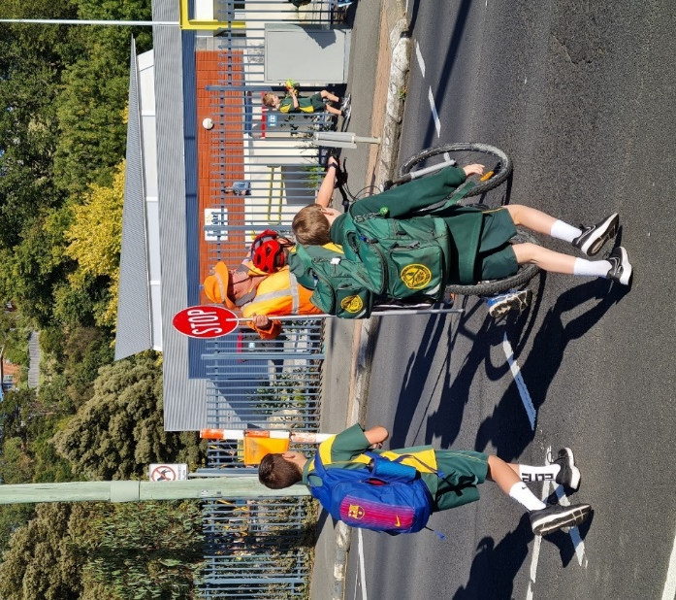
Kidsafe Tasmania conducts free child restraint checking sessions to ensure that young children are safely and lawfully seated and restrained in cars. Kidsafe also distributes educational materials to inform the community of the correct child restraint type for a child’s age and size.
Kidsafe continues to provide free child restraint checks and education with a trained child restraint fitter at community organisations and via outreach services. Free training is provided to professionals regarding regulatory requirements and good practice approaches to child restraints.
Kidsafe has developed complementary easy-to-read hardcopy restraint guides, which are provided to parents and carers to encourage the correct purchase of restraints suitable to a child's height and weight.

Encourage safe and legal motorcycle riding
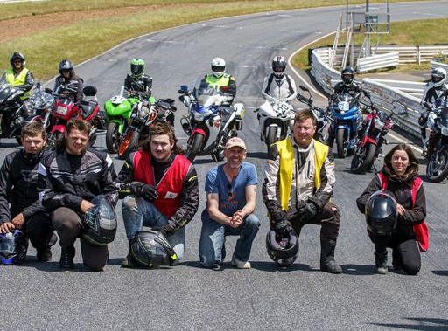
The Glenorchy City Council (GCC), in partnership with Bucaan House, delivered its successful Full Gear motorcycle safety program, which helps young motorcycle riders enter the licensing system and to adopt safe riding practices.
In 2022-23, the GCC delivered three Full Gear Programs to a total of 20 participants. The program was delivered to five participants in Chigwell, seven participants in Smithton and eight participants in Clarendon Vale. Of the 20 participants, 16 received their learner licence.

Budget summary
Throughout 2022-23, $2.4 million was spent under the ‘Saving Young Lives’ theme.
Chart 3 – Saving Young Lives theme, FY 22/23 Road Safety Levy Expenditure

Encouraging safer road use
Each road user has a responsibility to use roads in ways that are safe for those around them. In 2020-21 the Tasmanian Government committed over $4 million to improve road user behaviour.

Summary of initiatives

Investigate strategies to address inattention and distraction
Inattention and distraction are concerning causes of serious casualty crashes and may have a far greater impact than available data suggests.
Enforcement activity and public education aims to build awareness of the dangers of inattention and distraction for all road users.
Public education
The distraction campaign ‘Don’t Drive Blind’ was rerun from December 2022 until March 2023. This campaign pre-empted the introduction of the new mobile phone and seatbelt detection cameras and campaign.
Phase one of the ‘Click. Store. Go’ campaign launched in April 2023 to inform the community that mobile phone and seatbelt detection cameras are coming to Tasmania, with phase two scheduled for later in 2023.

Police officer enforcement
Tasmania Police continues to utilise both overt and covert means to detect and enforce inattention and distraction amongst drivers. Social media messaging and regular engagement with traditional media outlets consistently highlights the increased risks of drivers being involved in serious and fatal crashes whilst distracted.
This messaging is reinforced by state-wide and local traffic operations, many of which are conducted alongside other road safety partners, such as National Heavy Vehicle Regulator and State Growth Transport Safety and Investigation Officers.

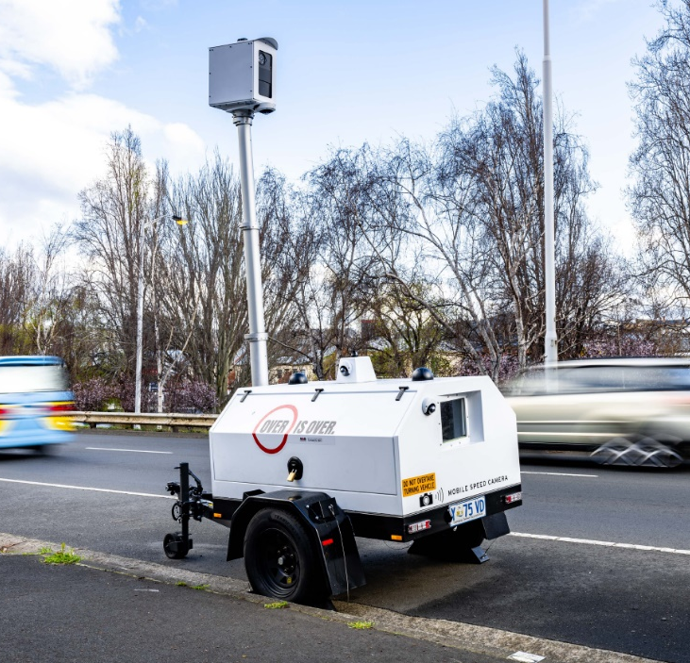
Automated distracted driver enforcement
In addition to mobile speed enforcement, the project to implement automated distracted driver enforcement (mobile phone and seatbelt) commenced with on-road testing commencing in April 2023.
As of 30 June 2023, Sensys Gatso Australia had completed multiple deliverables required to implement distracted driver enforcement in Tasmania including retrofitting suitable camera technology onto existing mobile speed cameras, on-road system testing, training of multiple camera operators and critical software integration.

Promote safe behaviours through campaigns
Targeted media campaigns continued to inform road users about high-risk behaviours and to highlight the dangers of the ‘Fatal Five’.
A new iteration of the ‘Real Mates’ campaign was launched in September 2022 in line with the AFL finals aiming to reduce serious casualties among Tasmanian males aged between 17 and 25, particularly where alcohol is a crash factor.
A new cycling safety campaign was launched in October 2022 to encourage road users to look after and look out for each other on the road.
Road Torque aired on Monday nights on Seven Tasmania’s nightly news in July and early August 2022. The five road safety segments featured Plates Plus, winter driving tips, school safety, truck safety and a behind the scenes look at the new phase of the ‘Real Mates’ campaign.
In preparation for the introduction of mobile phone and seatbelt detection cameras in Tasmania, the new ‘Click. Store. Go.’ public education campaign was launched in April 2023. The first phase of the campaign informed the community that the detection cameras were coming to Tasmania, and if not wearing a seatbelt correctly or illegally using their phone, drivers would be caught. A second phase of the campaign will be launched in August 2023 to let the community know that the cameras are live.
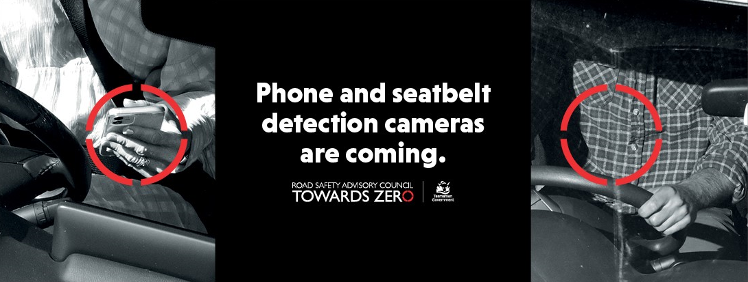
‘Click. Store. Go.’ aims to reduce road trauma by increasing community awareness of the dangers of distraction when driving and supports the introduction of mobile phone and seatbelt detection cameras in Tasmania. The campaign is supported by TV, radio, press, digital and outdoor advertising.

National Road Safety Week (NRSW) took place from 14 to 21 May, 2023. The week incorporates daily national themes with activities in Tasmania and interstate highlighting the impact that road trauma has on our communities while promoting ways to reduce this toll The ‘Road Safety Starts With Me’ campaign was launched alongside NRSW, asking Tasmanians to consider their driving behaviour and the role they play in making our roads safe. Buildings and landmarks across the state were lit in yellow to mark the week.

Promote protective clothing for motorcyclists
Motorcyclists are significantly over-represented in Tasmania’s road trauma figures. One of the reasons for this is that riders are more likely to be injured in a crash due to a lack of physical protection.
The Tasmanian Government continues to work to reduce the risks to motorcyclists through a range of actions, including supporting the work of MotoCAP to promote the use of protective clothing. MotoCAP provides safety assessment star ratings for protective clothing and prepares education materials for motorcyclists. Protective clothing can reduce injury severity in the event of a crash.
In June 2023, an updated public education brochure educating riders on the importance of wearing protective motorcycle gear was distributed to Tasmanian retailers, Tasmanian Neighbourhood Houses and AJL training facilities. The brochure reiterates the importance of wearing full gear on every ride and directs motorcyclists to the MotoCAP website to check gear safety ratings before purchase.
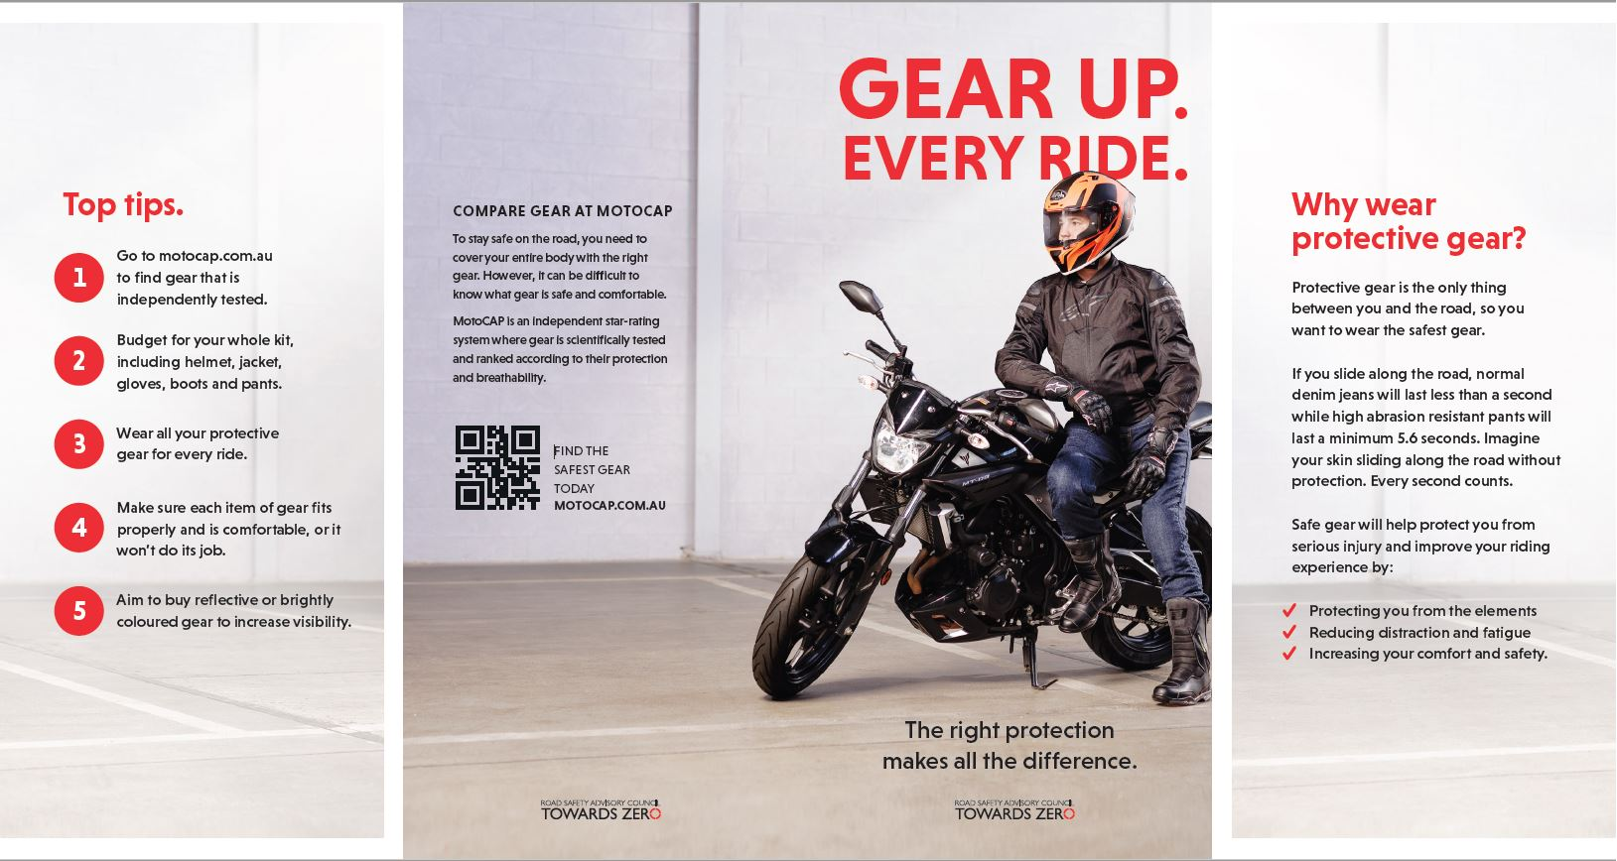

Ensure participation in the Mandatory Alcohol Interlock Program
The Mandatory Alcohol Interlock Program (MAIP) aims to have repeat and high-level drink driving offenders demonstrate that they can separate their drinking from driving through the installation of an alcohol interlock in their vehicle. Participation rates are less than optimal as participants often seek exemption from the obligation to have an interlock installed on the grounds of severe hardship. Amendments are being sought to the regulatory framework to clarify the exemption framework available to participants. Regulatory clarification will also enable diligent assessment of exemption claims.

Implement a new speed enforcement strategy
Speed enforcement remains one of the key priorities for Tasmania Police in its aim to improve driver behaviour through traffic enforcement. During 2022-2023 Tasmania Police charged 23,515 motorists for speeding. 11,310 of those motorists were speeding in excess of 15 kilometres above the posted speed limit with 747 of those travelling in excess of 30km/h above the limit.
Tasmania Police continues to implement programs to increase its capability to monitor, interdict and prosecute those who speed excessively and place themselves and others at risk. This includes the partnership with State Growth on the automated speed enforcement project.

Improve enforcement of high-risk behaviours
In 2022-2023, Tasmania Police detected 18,173 high-risk traffic offenders. An enhanced traffic policing restructure, the introduction of new highway patrol vehicles, and the piloting of several new enforcement tools has demonstrated Tasmania Police’s commitment to targeting offenders who place themselves and others in harm’s way.
In total, Tasmania Police prosecuted 39 378 traffic offenders in 2022-23 which included:
- 817 motorists for not wearing their seatbelt
- 1,731 motorists for using a mobile phone whilst driving
- 3,592 motorists for disqualified, suspended or unlicensed driving
- 3,615 motorists for drink and drug driving; and
- 120 motorists for dangerous or reckless driving.

Investigate an enhanced automated speed enforcement strategy
Automated speed enforcement has been relatively underutilised as a deterrence and enforcement mechanism in Tasmania. This project investigates proven and emerging speed camera technologies for use at high-risk locations and across the entire road network.
During 2022-23 over 400 mobile speed camera on-site assessments for camera suitability were conducted and resulted in the approval of 379 unique camera locations on all types of roads around Tasmania.
On 30 September 2022, mobile speed camera enforcement commenced using eight mobile speed cameras and a mix of highly visible (overt) trailers and more covert vehicles.
The level of mobile speed camera enforcement was progressively increased from an annualised rate of 20,000 enforcement hours (eight mobile speed cameras) to 35,000 enforcement hours (14 mobile speed cameras) on 26 June 2023.
Throughout 2022-23 mobile speed cameras were deployed 2,360 times delivering 16, 620 enforcement hours at over 357 unique camera locations including approximately:
- 860 trailer deployments (13,410 enforcement hours), and
- 1, 500 vehicle deployments (3,210 enforcement hours).
Mobile speed camera operations in 2022-23 resulted in the issuing of 28, 664 Photographic Detection Device Infringement Notices with approximately 4,400 relating to speeding offences where the posted speed-limit was exceeded by 15km/h or more.

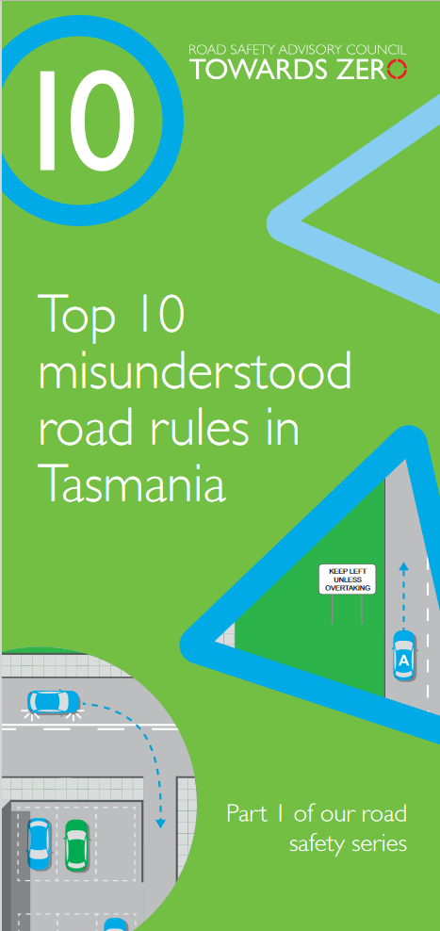
Continue to promote the Road Rules
Compliance with the Road Rules makes road user behaviour predictable, improves traffic flow and most importantly, improves safety outcomes for all road users. In 2022-23, 44 enquiries about the Road Rules were received and responses provided critical information and clarification to community members.
User-friendly and tailored resources are developed for existing and new Road Rules that come into effect so that the rules are easily understood and adhered to by all road users. Resources, including the Tasmanian Road Rules Handbook, Top Ten Misunderstood Road Rules and the Five More Misunderstood Road Rules pamphlet are distributed to Service Tasmania locations when required.

Budget summary
Throughout 2022-23, $3.6 million was spent under the ‘Encouraging Safer Road Use’ theme.
Chart 4 – Encouraging Safer Road Use theme, FY 22/23 Expenditure
Note: 1) Includes funding from the Motor Accident Insurance Board (MAIB) towards road safety campaigns and public education.
2) Automated Speed Enforcement Program – the above figure only includes Road Safety Levy expenditure.

Making visitors safer
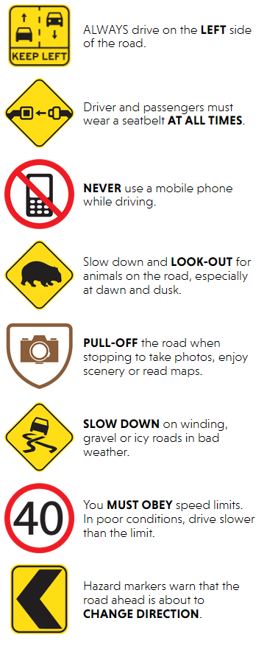
11 per cent of all serious casualties on Tasmanian roads are non-Tasmanian residents. The Tasmanian Government is investing $2 million in initiatives to support the education and safety of visiting road users including interstate drivers and riders, international drivers and for others new to Tasmania such as students and seasonal workers.

Summary of initiatives

Develop effective and engaging education materials
A range of education materials are distributed to make visiting road users safer. The multi-lingual education material has been delivered to the international visitor audience through targeted communication channels. These include vehicle hangers, brochures, posters, roadside signs, editorial content, film, and digital content. Communications materials continued to be distributed upon request from stakeholders.

Attract visitors’ attention by focusing activity on gateway entry points
Being an island state, Tasmania has the unique advantage of strategically placing essential road safety messages at its gateway airports and seaports to reach visitors before they drive in Tasmania. This includes a range of educational materials, electronic and static signs, and billboards. Printed collateral is available and digital billboards display road safety messaging at gateway locations.

Budget summary
Throughout 2022-23, $75,050 was expended under the Making Visitors Safer theme.
Chart 5 – Making Visitors Safer theme, FY 22/23 Road Safety Levy Expenditure

Improving safety through vehicles and technology
Advances in vehicle design and technology are helping to prevent crashes from occurring and better protecting all road users in Tasmania. The Tasmanian Government is committing over $3 million to support and encourage Tasmanians to drive safer vehicles.

Summary of initiatives

Continue to support ANCAP
Tasmania has the oldest vehicle fleet in Australia. This is concerning because the rate of fatal crashes per registered vehicle is four times higher for vehicles aged 15 years or older than for vehicles aged five years old or less.
Tasmania is a member of the Australasian New Car Assessment Program (ANCAP). ANCAP plays a vital role in informing consumers of the differences in the safety performance of new vehicles entering the Australasian vehicle fleet. Furthermore, ANCAP also advocates for improved vehicle safety design and specification through public education campaigns, advocacy activities and engagement with governments, corporate fleets, the media and consumers.

Develop a Light Vehicle Safety Strategy
Tasmania has the oldest vehicle fleet in the country with an average age of around 13 years. This means more time and resources must be expended maintaining the roadworthiness of Tasmania’s older vehicles and that many Tasmanians are not benefiting from the latest vehicle safety features.
A light vehicle safety strategy is currently being developed to improve the crashworthiness and roadworthiness of the Tasmanian light vehicle fleet.
The strategy aims to accelerate an increase in the number of newer and safer vehicles and removal of older cars from the light vehicle fleet while increasing the safety of the current vehicle fleet.

Monitor developments in vehicle technology
Modern vehicles are increasingly equipped with technology that can improve safety. New features help drivers to adhere to the speed limit, minimise blind spots, reduce distraction and monitor signs of driver fatigue. Vehicles with crash avoidance technologies can alert the driver to potential hazards, give the driver more control in emergency situations and act autonomously to prevent a collision. These types of vehicle technology are evolving rapidly and have the potential to greatly reduce road trauma.
The aim of this initiative is to monitor autonomous vehicle and crash avoidance readiness in Tasmania to ensure that Tasmanian infrastructure and laws are compatible with emerging technologies. The regulation of autonomous vehicles is being considered at a national level, and Tasmania is participating in this process.

Budget summary
Throughout 2022-23, $12,869 was expended under the Improving Safety through Vehicles and Technology theme. This supported activities of ANCAP. Other deliverables under this theme are being developed.

Road safety levy budget overview

Funding
Road safety initiatives in Tasmania are funded through collection of the Road Safety Levy, funding from the Motor Accidents Insurance Board (MAIB) and from the Australian Government’s Road Safety program (RSP).

The Road Safety Levy
The delivery of initiatives under the Action Plan are largely funded by the Road Safety Levy which supports the Towards Zero – Tasmanian Road Safety Strategy 2017-2026, as the primary road safety funding source through to 2026.
The Road Safety Levy applies to all eligible registered vehicles with general access to the road network. The Road Safety Levy is collected from vehicle registrations and is to be expended for the purposes of road safety. The Road Safety Levy raises around $15 million per annum and increases relative to Hobart CPI.

Approved budget for FY 2022-23
The RSAC approved the 2022-23 Action Plan budget on 24 May 2022. On the advice of the RSAC, the Minister for Infrastructure and Transport approved the budget on 17 October 2022.
At the start of 2022-23, approximately $17.3 million was available from the road safety levy to expend on road safety in Tasmania. Throughout the year approximately $17.5 million was collected from registrations.
In 2022-23, a total of $11.4 million was collectively expended from Road Safety Levy and MAIB funding. This saw over $4.1 million spent on infrastructure improvements across Tasmania and nearly $7.3 million (including MAIB contributions) spent on the delivery of road safety policy and projects.
At 30 June 2023, the Road Safety Levy recorded a balance of approximately $22.1 million.
The table below provides a detailed financial summary of 2022-23 revenue and expenditure.

Revenue and Expenditure for the Financial Year 2022-23

Road Safety Levy Opening Summary
Opening Balance as at 01 July 2022 |  |  | $ 17,344,616
Annual Allocation to Road Safety Operations |  |  | $ 2,600,000

Revenue Summary
 |  | Forecast (FY23) | Actual
Motor Accidents Insurance Board Funding |  | $ 1,360,044 | $ 1,323,523
Revenue Inflows from Registrations |  | $ 15,281,957 | $ 17,456,716
Funds Available for Distribution |  | $ 31,386,617 | $ 33,524,855

Expenditure Summary
Theme no. | Theme | Forecast (FY22) | Actual
1 | Making our Rural Roads Safer | $ 2,295,898 | $ 1,644,645
2 | Improving Safety in our Towns and Cities | $ 2,261,893 | $ 2,927,906
3 | Saving Young Lives | $ 3,141,552 | $ 2,430,380
4 | Encouraging Safer Road Use | $ 4,033,977 | $ 3,645,917
5 | Making Visitors Safer | $ 125,441 | $ 75,000
6 | Improving Safety Through Vehicles and Technology | $ 692,869 | $ 12,869
7 | General Support | $ 744,491 | $ 655,619
Budget and Expenditure by Category |  | Forecast (FY22) | Actual
Infrastructure Expenditure* |  | $ 4,127,464 | $ 4,121,274
Policy & Projects Expenditure* |  | $ 9,489,863 | $ 7,271,113
Total Expenditure |  | $ 13,617,327 | $ 11,392,387
Balance as of 30 June 2023 |  | $ 17,353,133 | $ 22,132,469
Forecast Closing Balance of FY23 |  | $ 17,769,290
Note: The above includes MAIB expenditure.
*Includes allocations to ‘ceasing activities’ from the Towards Zero Action Plan 2017-2019

MAIB Funding as at 30 June 2023
2022/23 Financial Year | Budget  $ | Actual (ytd)  $ | Balance  $
Expenditure (State Growth)
Administration & Public Relations | 341,920 | 301,709 | 40,211
Public Education | 963,124 | 960,442 | 2,682
Research | 60,000 | 61,372 | (1,372)
Subtotal | 1,365,044 | 1,323,523 | 41,521
Expenditure (Tasmania Police)
Salaries | 2,140,451 | 2,137,838 | 2,613
Operating Expenses | 188,000 | 177,690 | 10,310
Equipment | 816,222 | 583,089 | 233,133
Subtotal | 3,144,673 | 2,898,618 | 246,054
Total | 4,509,717 | 4,222,141 | 287,575
Includes Carried Forward of
- -$41,723 (State Growth)
- $413,879 (Police)

List of Acronyms
Action Plan | Towards Zero Action Plan 2020 - 2024
ANCAP | Australian New Car Assessment Program
ASE | Automated Speed Enforcement
CEO | Chief Executive Officer
CRSG | Community Road Safety Grants
DfJ | Driving for Jobs
GLS | Graduated Licensing System
HPT | Hazard Perception Test
ITS | Intelligent Transport System
JRLF | Jordan River Learning Federation
LDMP | Learner Driver Mentor Program
MAIB | Motor Accidents Insurance Board
MAIP | Mandatory Alcohol Interlock Program
RSAC | Road Safety Advisory Council
RSP | Road Safety Program
RYDA | Rotary Youth Driver Awareness
SRRP | Safer Rural Roads Program
State Growth | The Department of State Growth
Towards Zero Strategy | Towards Zero - Tasmanian Road Safety Strategy 2017-2026
VRUP | Vulnerable Road User Program

Road Safety Advisory Council  Department of State Growth | GPO Box 536 Hobart  Tas 7001 Australia  Phone: 1800 030 688  Email: rsac@stategrowth.tas.gov.au  Web: rsac.tas.gov.au

See Towards Zero Strategy at https://www.rsac.tas.gov.au/about-us/towards-zero-strategy/
See Action Plan at https://www.rsac.tas.gov.au/about-us/towards-zero-strategy/

