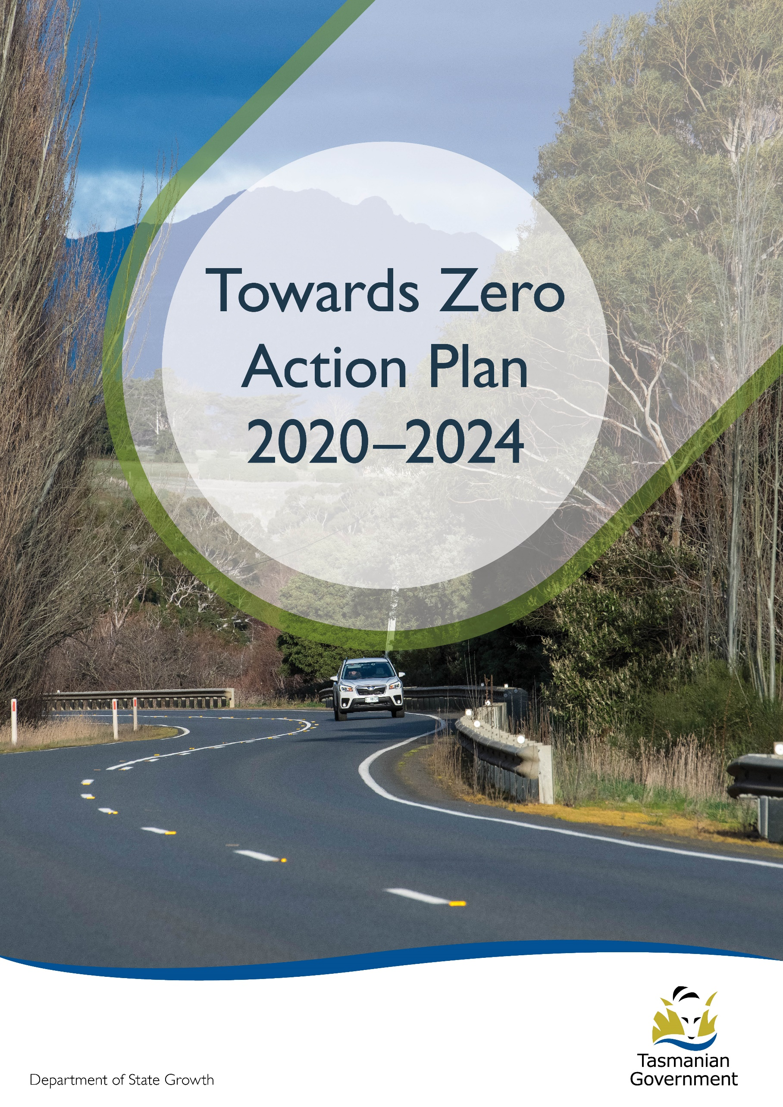
driving
Quarterly Progress Report to RSAC as at 30 June 2023
Contents
Progress on meeting Towards Zero Strategy targets 3
Serious Casualties 3
Fatalities 3
2023 YTD 3
Serious Casualties Tasmania – Annual Count, Percentage Split by Quarter and Towards Zero Target 3
Annual fatalities – Rate per 100,000 population 4
Progress on meeting MAIB targets 5
Fatalities – 12 Month Rolling Total 5
Total Serious Claims – 12 Month Rolling Total 5
Statistics 6
Serious Casualties by Quarter by Age Group – 12 period moving average 6
Serious Casualties by Quarter by Sex – 12 period moving average 6
6
Serious Casualties by Quarter by Road User Type – 12 period moving average 7
Serious Casualties by Quarter by Speed Zone – 12 period moving average 7
Serious Casualties by Quarter by Crash Type (DCA) – 12 period moving average 8
Serious Casualties by Quarter by Urban/Non-Urban – 12 period moving average 8
Serious Casualty locations to 30 June 2023 (Black = Fatality, Red = Serious Injury) 9
Key themes and priority actions 2020-2024 10
Funding of key themes 10
Project status report 11
Progress on key themes 12
Rural roads grants program for local government 12
Infrastructure upgrades on low volume State roads 13
Motorcyclist safety on rural roads 13
Speed moderation and community engagement strategy 14
Safe system knowledge and skills training 14
Targeted infrastructure upgrades in high traffic urban areas 15
Vulnerable Road User Program 15
Community Road Safety Grants Program 16
Trial of innovative technologies 17
Innovative infrastructure treatment demonstrations 17
Learner Driver Mentor Program and Driver Mentoring Tasmania 18
Graduated Licensing System Project 19
Motorcyclist Graduated Licensing System review 19
Rotary Youth Driver Awareness Program (RYDA) 20
Driving for Jobs Program 20
RACT education initiatives 21
Real Mates media campaign 21
Bicycle Network bike education 21
Safety around schools 22
Kidsafe child restraint check program 22
Full Gear motorcycle safety project 22
Inattention and distraction 23
Safe behaviour campaigns 24
Mandatory Alcohol Interlock Program (MAIP) 24
Protective clothing for motorcyclists 25
Road safety penalties review 25
Speed enforcement strategy 25
Enforcement of high-risk behaviours 26
Automated Traffic Enforcement Program 27
High-risk motorcycling enforcement 27
Road Rules Awareness 28
Tourist road safety signage program 29
Responsive electronic signage trial 29
Tourist education materials 29
Strategic partnerships 30
Tourist education at gateway entry points 30
Stakeholder alliances 30
Australasian New Car Assessment Program (ANCAP) 31
Safer cars for young drivers 31
Autonomous vehicle and crash avoidance readiness 32
Workplace driver safety 32
Light vehicle safety strategy 32

Progress on meeting Towards Zero Strategy targets
The key interim target for the Towards Zero – Tasmanian Road Safety Strategy 2017-2026 (Towards Zero Strategy) is to reduce the number of annual serious injuries and deaths on Tasmanian roads to fewer than 200 by 2026. This is an ambitious target of 100 fewer serious casualties per year than for the period 2012-2016 (annual average) and will move us towards the long-term goal of zero serious casualties on Tasmanian roads.

Serious Casualties
The number of serious casualties in 2022 was 317, compared to 286 in 2021, a 10.8 per cent increase. The 2022 figure of 317 is a 5.4 per cent increase on the five year serious casualty average of 300.8 (2017-2021).

Fatalities
In 2022, there were 51 fatalities on Tasmanian roads which is 15 more than the number recorded in 2021. The figure of 51 fatalities in 2022 is a 52.7 per cent increase on the five-year fatality average of 33.4 (2017-2021).

2023 YTD
There have been 188 serious casualties (17 fatalities and 171 serious injuries) to 30 June 2023, 29 more than the number recorded at the same time in 2022 (30 fatalities and 129 serious injuries) and an increase of 23.8 per cent on the five year average of 151.8 serious casualties.

Serious Casualties Tasmania – Annual Count, Percentage Split by Quarter and Towards Zero Target
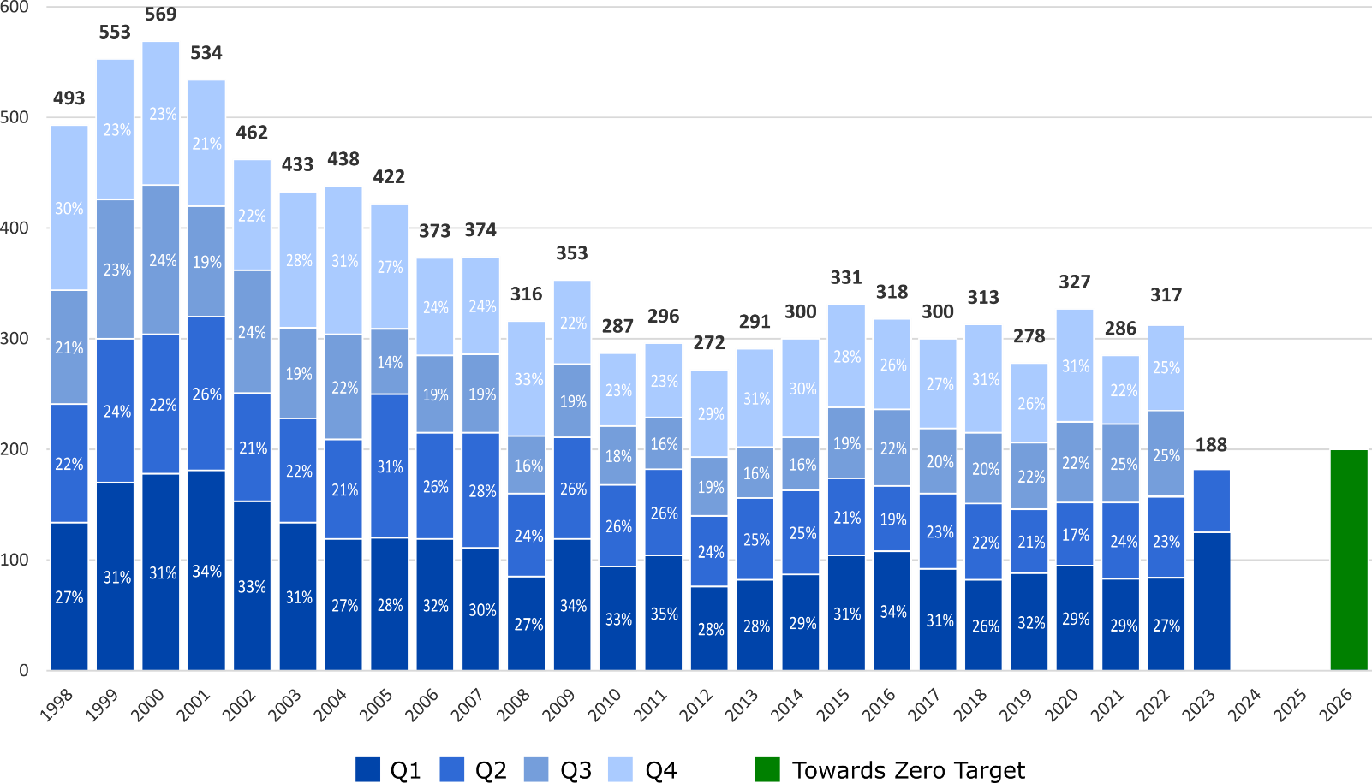

Annual fatalities – Rate per 100,000 population

Note: NT omitted from chart for clarity purposes.

Progress on meeting MAIB targets
Motor Accidents Insurance Board (MAIB) injury statistics show the number of fatalities and the level of claims for serious injuries on our roads.
Various claim reduction targets are specified in the Memorandum of Understanding between the Department of State Growth (State Growth) and the MAIB. Progress against high level targets is shown below, expressed as 12 month moving totals

Fatalities – 12 Month Rolling Total
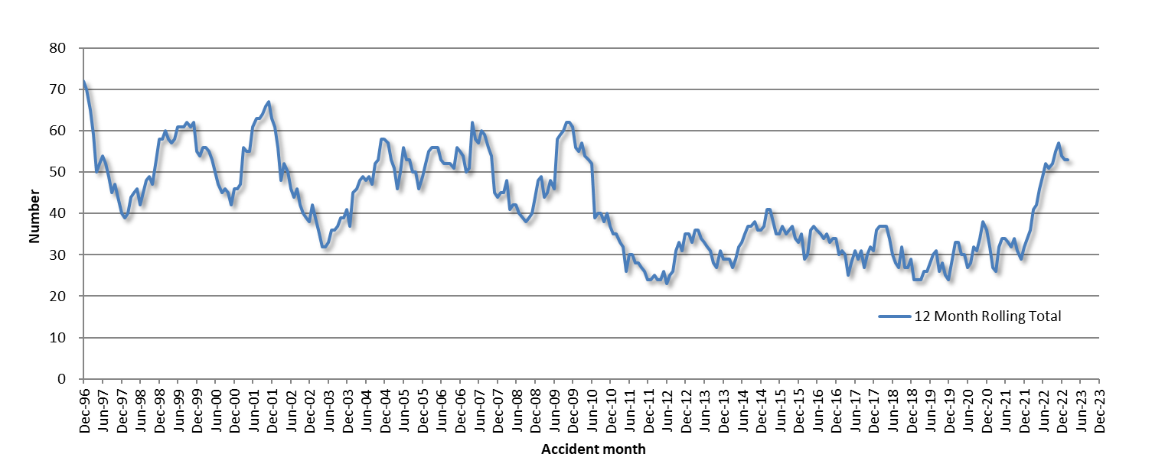

Total Serious Claims – 12 Month Rolling Total
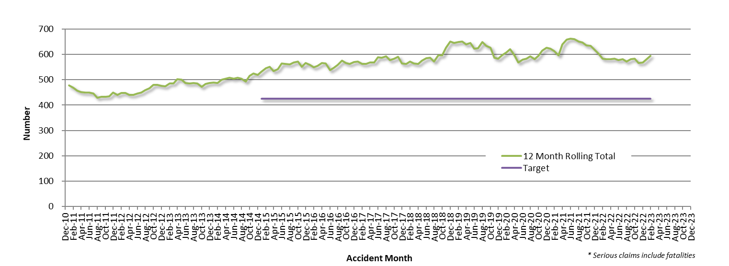

Statistics

Serious Casualties by Quarter by Age Group – 12 period moving average
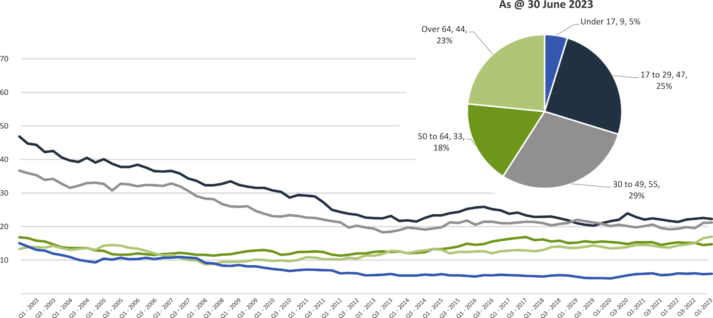

Serious Casualties by Quarter by Sex – 12 period moving average
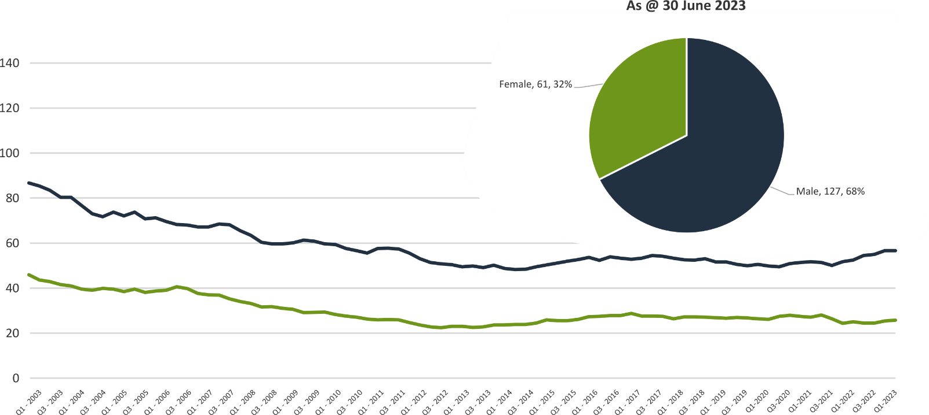

Serious Casualties by Quarter by Road User Type – 12 period moving average
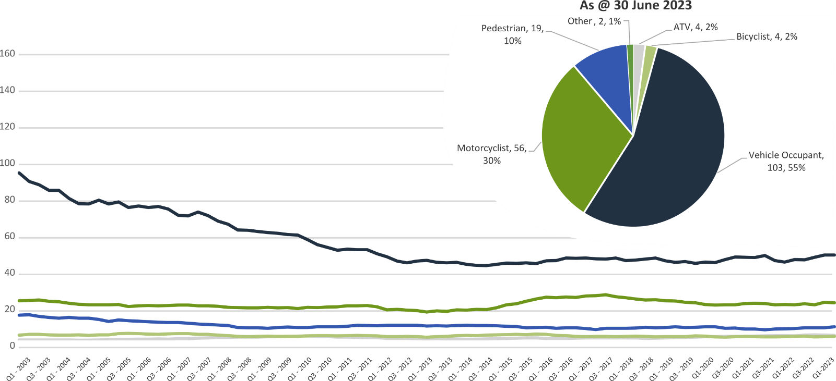

Serious Casualties by Quarter by Speed Zone – 12 period moving average
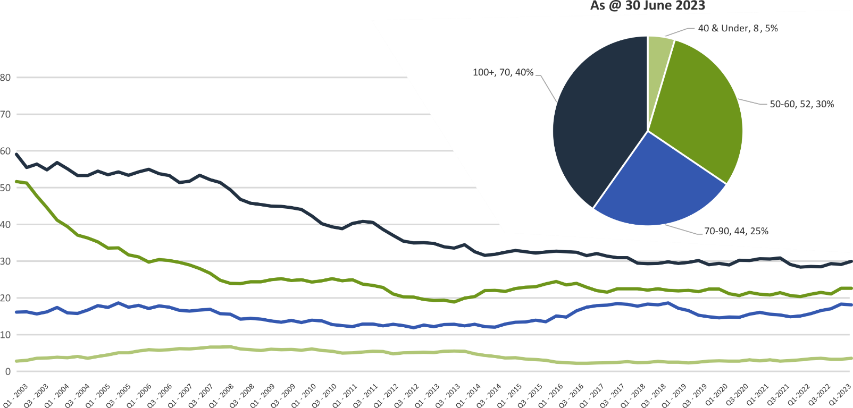

Pie chart excludes serious casualties where speed zone is recorded as ‘not known’

Serious Casualties by Quarter by Crash Type (DCA) – 12 period moving average
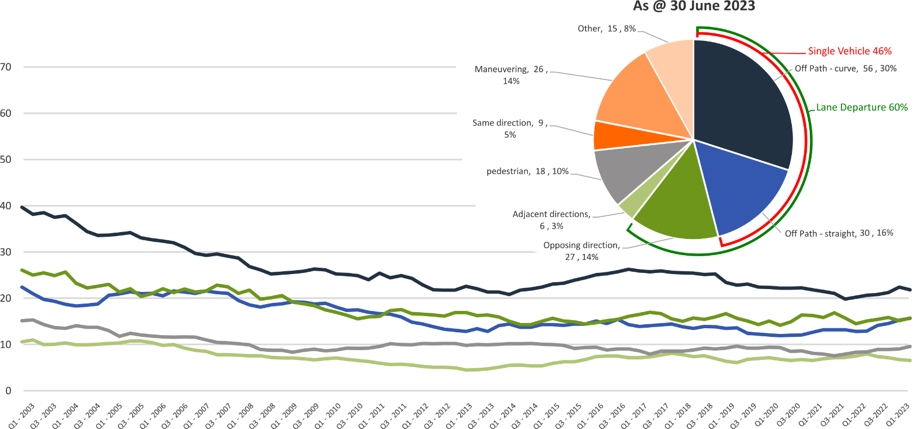

Other includes crash types: overtaking (5%), on-path (2%), & passenger and miscellaneous (1%).

Serious Casualties by Quarter by Urban/Non-Urban – 12 period moving average
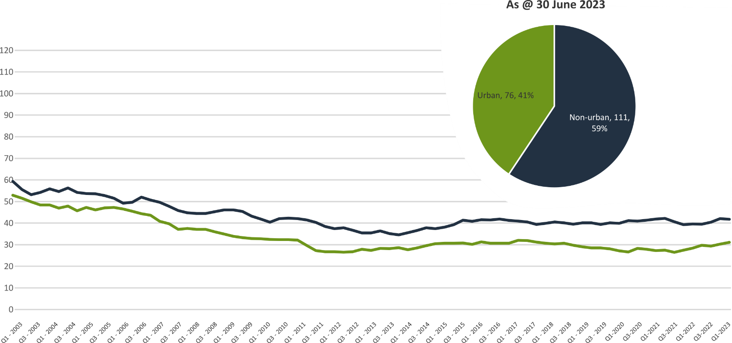

Based on the Australian Bureau of Statistics’ ‘significant urban area’ geographic definition.

Serious Casualty locations to 30 June 2023 (Black = Fatality, Red = Serious Injury)
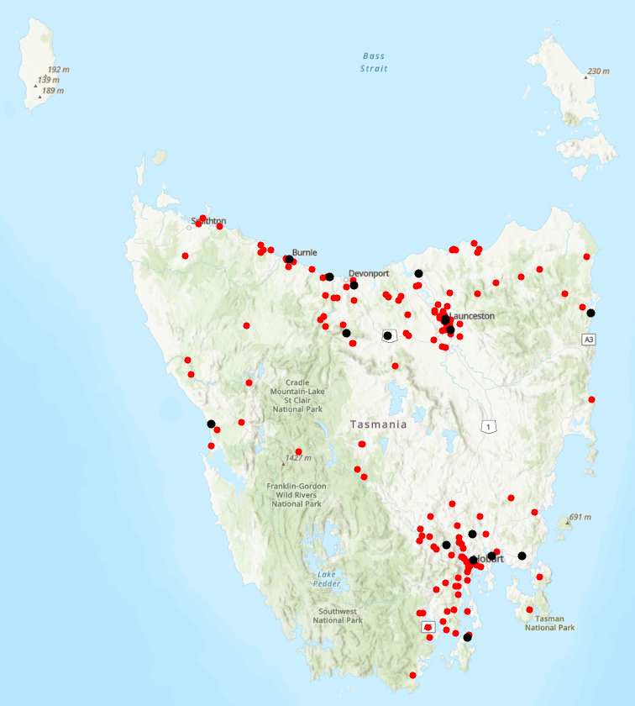

Key themes and priority actions 2020-2024
The Quarterly Progress Report details progress on key themes and priority actions under the Towards Zero Action Plan 2020-2024 and the Towards Zero – Tasmanian Road Safety Strategy 2017-2026.
The progress report should be read in conjunction with the Action Plan and understood in the context of the Towards Zero Strategy. These documents are available at: www.towardszero.tas.gov.au

Funding of key themes
Over $20 million Over $31 million
Over $12 million Over $4 million

$2 million Over $3 million

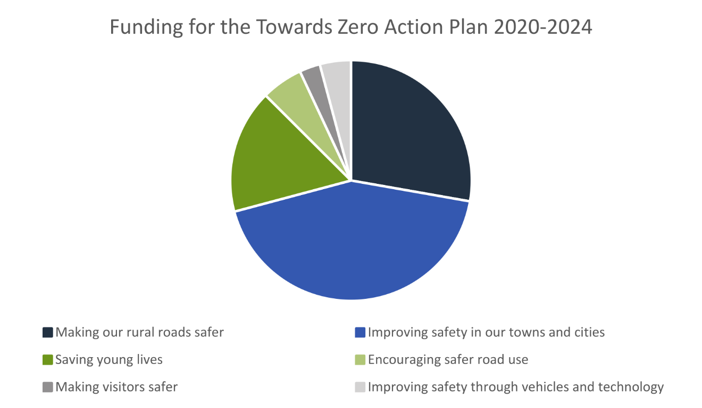

Project status report
Making our rural roads safer
Rural road grants program for local government | On schedule |  | Infrastructure upgrades on low volume State roads | On schedule
Motorcyclist safety on rural roads | On schedule |  | Speed moderation and community engagement strategy | On schedule
Safe system knowledge and skills training | On schedule
Improving safety in our cities and towns
Targeted infrastructure upgrades in high traffic urban areas | Not yet commenced |  | Vulnerable Road User Program | On schedule
Community Road Safety Program | On schedule |  | Trial of innovative technologies | Not yet commenced
Innovative infrastructure treatment demonstrations | Not yet commenced
Saving young lives
Learner Driver Mentor Program and Driver Mentoring Tasmania | On schedule |  | Graduated Licensing System Project for drivers | Complete
Rotary Youth Driver Awareness Program | On schedule |  | Driving for Jobs Program | On schedule
RACT education initiatives | On schedule |  | Real Mates media campaign | On schedule
Bicycle Network bike education | On schedule |  | Safety around schools | On schedule
Kidsafe child restraint check program | On schedule |  | Full Gear motorcycle safety project | On schedule
Develop a Graduated Licensing System for motorcyclists | On schedule
Encouraging safer road use
Inattention and distraction | On schedule |  | Safe behaviour campaigns | On schedule
Mandatory Alcohol Interlock Program | Major delays |  | Protective clothing for motorcyclists | On schedule
Road safety penalties review | On schedule |  | Speed enforcement strategy | On schedule
Enforcement of high-risk behaviours | On schedule |  | Automated Traffic Enforcement Program | On schedule
High-risk motorcycling enforcement | On schedule |  | Road Rules Awareness | On schedule
Making visitors safer
Tourist road safety signage program | On hold |  | Responsive electronic signage trial | On hold
Tourist education materials | Limited activity |  | Strategic partnerships | On hold
Tourist education at gateway entry points | Limited activity |  | Stakeholder alliances | On hold
Improving safety through vehicles and technology
ANCAP | On schedule |  | Safer cars for young drivers | Not yet commenced
Autonomous vehicle and crash avoidance readiness | On schedule |  | Workplace driver safety | Not yet commenced
Light vehicle safety strategy | On schedule

Progress on key themes
Progress on key themes is reported as:
Status | Major delays/on hold/high risk | Delayed/some issues/medium risk | On schedule/progressing/low risk | Not yet commenced

60 per cent of fatalities occur in rural areas

Rural roads grants program for local government
The Safer Rural Roads Program (SRRP) provides funding to councils to implement infrastructure treatments on rural road corridors to reduce lane departure crashes and the harm when they do occur. An allocation of $10 million was made to the SRRP to be administered over five funding rounds of $2 million for the life of the Action Plan.
Current situation / comments
The Australian Government’s Road Safety Program (RSP) is a $3 billion Commonwealth Budget commitment. Under the RSP, Tasmania has been notionally allocated up to $66 million in funding for small-scale road safety infrastructure projects, to be delivered over five 6-month funding tranches.
The RSP provided valuable additional funding to the SRRP. As a result, two funding rounds were held during the 2020–2021 financial year (FY21).
In FY21, 61 applications were received under the SRRP with 59 receiving funding. The successful projects from FY21 total approximately $10 million in value. This includes funding of $5.88 million from the Australian Government’s RSP, $2.45 million from the Road Safety Levy, and $1.64 million from Local Government co-contributions.
As of 30 June 2023, 55 projects from the FY21 program rounds have been delivered, two projects are in progress and two projects are experiencing delays.
During 2022, State Growth undertook a review of the SRRP. This review enabled State Growth to identify opportunities for program improvements which were implemented in preparation for the 2022–2023 funding round.
The 2022–2023 funding round for the SRRP opened on 16 January 2023 and closed on 17 March 2023. It made available $3.68 million from the Road Safety Levy for successful applicants. The SRRP Assessment Committee recommended all 18 applications for funding with all 18 being progressed for funding.
For these approved SRRP applications, $3.2 million of funding, alongside $1.6 million in co-contributions from councils, will allow for $4.8 million of infrastructure to be built to improve safety on rural roads. Funded infrastructure treatments include guardrails, pavement widening, line marking and traffic signage.
Grant Deeds and initial payments are currently being issued as applicants submit their finalised plans. Approved works are expected to commence in 2023.
Status | risk |  | On schedule/progressing/low risk

Infrastructure upgrades on low volume State roads
This program will provide funding for lower volume State roads, where cost effective treatments such as shoulder sealing, pavement markings, curve warnings, road side hazard removal and safety barriers will achieve maximum value for money.
Current situation / comments
In 2022-23, this program of works has supported Road Safety Levy co-contributions under Tranche 1 and 3 of the Australian Government’s RSP. This has taken advantage of the opportunity that Australian Government co-funding has presented for targeted shoulder sealing and junction upgrades across Tasmania.
Status |  |  | On schedule/progressing/low risk

Motorcyclist safety on rural roads
Road safety audits will be conducted on high risk touring routes across Tasmania. This program will involve local motorcyclists and a safe system approach will inform audits. Findings will be shared with stakeholders to identify countermeasures that go beyond typical infrastructure solutions.
Current situation / comments
Safe System motorcycle road safety audits
Funding up to $350,000 was allocated in 2022-23 for State Growth to carry out low-cost infrastructure treatments to improve road safety for motorcyclists on Lake Leake Road. These works follow from an audit of Lake Leake Road undertaken in 2018. In March 2023, installation of treatments on Lake Leake Road were completed.
An audit of the Channel Highway between Margate and Verona Sands was completed on 6 March 2023. A scope of works is being prepared and will be presented to the RSAC at the November 2023 meeting for funding consideration from the Road Safety Levy.
State Growth is developing a strategy for future motorcycle road safety audits to identify potential routes in Tasmania. This strategy was scheduled for delivery in 2022, but due to resource constraints it is now planned for delivery in November 2023. Future audits will be selected in consultation with the Tasmanian Motorcycle Council and the motorcycling community involved in past audits, taking crash data and route popularity into account.
Status |  |  | On schedule/progressing/low risk

Speed moderation and community engagement strategy
Speed moderation requires a holistic strategy encompassing public education, road risk assessments, enforcement, speed limit setting, speed limit mapping and technology, KPIs and evaluation. This project will involve community engagement to inform and build support for action on safer speeds. A significant ongoing coordination effort will be required to support the strategy.
Current situation / comments
At its November 2022 meeting, the RSAC endorsed a high-level strategic approach to the development of a speed management strategy. State Growth is progressing the development and implementation of the strategy, with recruitment currently underway for a project officer role to deliver the strategy.
It is anticipated that the first phase of the project will gather data, information, and community sentiment to inform the development of a comprehensive public education campaign.
Status |  |  | On schedule/progressing/low risk

Safe system knowledge and skills training
This initiative aims to improve Safe System knowledge for all those in a position to influence road safety outcomes. The initiative will focus on Safe System infrastructure design, including appropriate speed setting, and will consist of technical training sessions, workshops and forums across Tasmania.
Current situation / comments
Safe System knowledge and capacity building has been considered within the review of the Safer Rural Roads and Vulnerable Road User programs. As part of this review, State Growth investigated how stronger support can be provided to enable local government to achieve Safe System infrastructure treatments. As part of this review, State Growth also reviewed the tools utilised through these programs to understand how local government officers apply Safe System principles and treatments in practice.
State Growth is now considering options for future training opportunities to support the development of Safe System knowledge and skills across local and state government. State Growth is conducting consultation with stakeholders within the Transport and Infrastructure Group, Tasmania Police, and local government, to obtain feedback on a proposed training package . Once complete, State Growth will engage with the Australian Road Research Board to review the proposed training package before providing the strategy to the RSAC for consideration in November 2023.
State Growth also recently provided a Safe System principles training session on 7 March 2023, to provide 25 employees of State Growth and Tasmania Police with advanced Safe System knowledge.
Status |  |  | On schedule/progressing/low risk

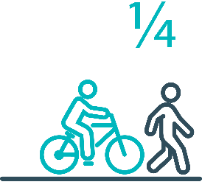

Pedestrians and cyclists are vulnerable and represent
one in four serious casualties in our towns and cities

Targeted infrastructure upgrades in high traffic urban areas
This program provides for delivery of a range of infrastructure safety upgrades to make our towns and cities safer. This will include shoulder sealing, intersection improvements, safety barriers and pavement marking at high traffic areas. This program targets high volume state roads that are not planned for major investment in the short term.
Current situation / comments
This initiative has not yet commenced and will be considered as part of the mid-term review.
However, funding allocated to this initiative to date, under the Action Plan, has supported the Road Safety Levy co-contributions under Tranche 1 and 3 of the Australian Government’s RSP. This has taken advantage of the opportunity that Australian Government co-funding has presented for targeted shoulder sealing and junction upgrades across Tasmania, and the upgrade of nearly 600 electronic school zone signs across approximately 220 locations.
Approximately $260,000 also supported local road pavement marking in 2022-23.
Status |  |  |  | Not yet commenced

Vulnerable Road User Program
The Vulnerable Road User Program (VRUP) is an established grants program which assists local government with the costs of installing safety improvements in built up areas. The aim of the program is to reduce conflict between vehicles and vulnerable road users - cyclists, pedestrians and motorcyclists.
Additionally, the program has a focus on increasing Safe System knowledge and capacity in local governments. The funding available under the VRUP was increased from $500,000 to $1,000,000 per annum, under the current Action Plan.
Current situation / comments
The Australian Government’s Road Safety Program (RSP) provided valuable additional funding to the VRUP. As a result, three funding rounds were held during FY21. In FY21, 95 applications were received under the VRUP with 71 receiving funding. This includes seven cycling safety-focused projects that all received funding under round three.
The successful projects from FY21 total approximately $11.58 million in value. This includes funding of $4.63 million from the Australian Government’s RSP, $4.70 million from the Road Safety Levy, and $2.25 million from Local Government co-contributions.
As of 30 June 2023, 54 projects from the FY21 rounds have been delivered, four projects are in progress and eight projects are experiencing delays. Five projects from the 71 successful projects, valued at $750 000, have been withdrawn.
During 2022, State Growth undertook a review of the VRUP. This review enabled State Growth to identify opportunities for program improvements which were implemented in preparation for the 2022–2023 funding round.
The 2022–2023 funding round of the VRUP opened on 16 January 2023 and closed on 17 March 2023. It made available $1 million from the Road Safety Levy for successful applicants. 22 applications were received. As the SRRP was undersubscribed, the VRUP Assessment Committee recommended using $406,000 of the unspent SRRP funds to increase the funds available to $1.41 million. The Assessment Committee recommended 15 applications for funding.
The movement of funds between the programs was endorsed by the RSAC and approved by the Minister for Infrastructure and Transport in June 2023. For these approved VRUP applications, $1.41 million of funding, alongside nearly $500,000 in co-contributions from councils, will allow for $1.9 million of infrastructure to be built to protect vulnerable road users. Funded infrastructure treatments include traffic calming measures, electronic speed signage, footpaths, pedestrian refuges, curb ramps and crossing.
Grant Deeds and initial payments are currently being issued as applicants submit their finalised plans. Approved works are expected to commence in 2023.
Status |  |  | On schedule/progressing/low risk

Community Road Safety Grants Program
The Community Road Safety Grants Program (CRSGP) is an established grants program that aims to build community engagement to address local road safety issues. The program supports local councils, schools, community groups, research institutions and charity organisations to promote road safety at the grass roots level.
Current situation / comments
In October 2022, 13 projects received funding under the CRSGP. Vulnerable road users are a key theme across the 13 successful projects, with projects focusing on children, motorcyclists and those from culturally and linguistically diverse backgrounds.
In February 2023, the Lions Club of Deloraine presented a ‘Blind Spot Awareness’ display at the Deloraine Truck N Ute Show through funding provided by the CRSGP.
Mobility and Accessibility for Children in Australia (MACA), who received funding through the CRSGP to provide 40 placements to Tasmanian health professionals in their Transporting Children with Disabilities and Medical Conditions course, have reported a strong demand for their program. A week after the program was launched, MACA had filled 50 per cent of the available places and by the end of April, they had 39 enrolments in the course. MACA are on track to complete their project by December 2023.
The remaining 11 projects are progressing as per their agreed timelines. Two projects will be completed in January 2024, five projects will be completed by the July 2024 and the remaining four will be completed by the end of 2025.
Status |  |  |  | On schedule/progressing/low risk

Trial of innovative technologies
This project will include monitoring, investigation and trialling of new and emerging technology based approaches to improving safety for vulnerable road users.
Current situation / comments
This project has not yet commenced and will be considered as part of the mid-term review.
Status |  |  |  | Not yet commenced.

Innovative infrastructure treatment demonstrations
This project will investigate, trial and demonstrate innovative Safe System urban infrastructure treatments to improve road safety in our urban areas. We will work with local councils to show how Tasmania’s cities and towns can be improved for the benefit of all road users, particularly cyclists and pedestrians.
Current situation / comments
This project has not yet commenced and will be considered as part of the mid-term review.
Status |  |  |  | Not yet commenced.

92 young people are seriously injured or killed on our
roads every year

Learner Driver Mentor Program and Driver Mentoring Tasmania
The Learner Driver Mentor Program (LDMP), supported by Driver Mentoring Tasmania (DMT), is a well-established program that supports disadvantaged learner drivers to gain supervised on-road driving hours to gain a licence. DMT supports LDMP providers through peak body support and coordination.
Current situation / comments
The 2023-24 funding round opened on 14 March 2023 and applications closed on 24 April 2023.
Funding totalling $1,102,438.13 was requested by the 16 existing LDMPs and an application was received from DMT requesting $172,213.41.
On 1 May 2023, a Funding Assessment Panel (the Panel) convened to evaluate the funding applications. The Panel noted that:
- learner and mentor participation had decreased from the previous 12 months. The number of active mentors was noted to be restricting the number of learner drivers achieving a provisional license, partially due to a decrease in mentor numbers post-COVID 19.
- the Hobart Police and Community Youth Club has two new vehicles still on order from the 2022-23 funding round, to replace their 2-star rated vehicles. All other programs have a 4-star or above safety rating
- the important role of the coordinator and the need for strategies to increase program productivity. However, for consistency and to fit within the current budget, program coordination will be limited to no more than 15 hours for a one-vehicle program and 24 hours for a two-vehicle program per week
- seven out of the 16 LDMP programs failed to meet their minimum on-road supervisory hours in the previous funding round. These programs will receive letters acknowledging their underperformance and reinforcing their funding agreement's conditions. The two lowest-performing programs will be funded for six months, with a potential extension of an additional six months if performance improves.
- agreed that the DMT budget was reasonable and an external review of the LDMP will provide direction as to whether the role for DMT is required and at what capacity.
The Panel recommended a total funding allocation of $1,203,324.41 for the 2023-24 financial year, including an allocation of $1,031,111.00 to the LDMP and $172,213,41 to DMT.
Status |  |  | On schedule/progressing/low risk

Graduated Licensing System Project
Changes have been made to the Graduated Licensing System (GLS) for drivers to better protect young and novice drivers and improve the licensing pathway. Young drivers are overrepresented in crash statistics and most at risk when they first get their Ps and start driving solo. The changes to the GLS aim to address this risk and improve road safety outcomes for both young and novice drivers.
Current situation / comments
The Tasmanian Government implemented regulatory changes to the GLS on 1 December 2020. Tasmania’s GLS now meets the enhanced model under the national driver GLS framework. The GLS changes were accompanied by a public education campaign explaining the policy changes and how they would apply to current and new learners.
Complementing the policy changes are three digital products that were progressively launched from July 2021.
The Plates Plus learning and assessment platform was designed to improve learner driver education by focusing on developing safe behaviours and attitudes. It is an innovative tool that takes users through a series of interactive exercises to ensure new drivers know the road rules and understand the impact of the fatal five road behaviours.
A public education campaign accompanied the launch of the Plates Plus platform and ran until September 2021. The campaign encouraged take-up by promoting the convenience of the platform, which is accessible from any device connected to the internet.
The Plates Plus logbook app launched in November 2021. For many Tasmanian learners, this will replace the existing hard copy logbook. It provides an easy and efficient way to record supervised driving hours during the learner licensing phase. A public education campaign targeting 15 to 25-year-olds accompanied the launch of the Plates Plus logbook app. To engage with this age group, the campaign focused on selected social media platforms.
The computer-based hazard perception test (HPT) was launched on 7 March 2022. The HPT is a mandatory assessment that has been introduced to the learner licensing pathway. The HPT assesses a learner’s ability to identify and react to safely avoid hazards. It features high-quality 3D clips developed by Austroads in conjunction with the Centre for Automotive Safety Research, using real Australian crash data to identify the most dangerous driving situations for novice drivers.
The HPT was the final product to be delivered under the GLS project.
Status | Complete

Motorcyclist Graduated Licensing System review
The Tasmanian motorcyclist GLS is being reviewed to identify enhancements to ensure novice motorcyclists are as safe as possible on Tasmanian roads.
Current situation / comments
Following initial consideration by the Department of State Growth, the Centre for Automotive Safety Research (CASR) was engaged to conduct a review of the Tasmanian motorcyclist GLS. The findings and recommendations of the review were presented to the RSAC at its May 2022 meeting.
A public consultation process run in August and September sought feedback on CASR’s recommendations. Feedback was collated and presented to the RSAC at its November 2022 meeting, together with a package of options to amend the motorcyclist GLS. At the RSAC’s request, additional information was provided and considered at its March 2023 meeting. The RSAC endorsed a package of recommended changes to the motorcyclist GLS for consideration by the Minister for Infrastructure and Transport. These recommendations are currently being considered.
Status |  |  | On schedule/progressing/low risk

Rotary Youth Driver Awareness Program (RYDA)
RYDA is a one-day interactive road safety education program for Year 10-12 students to assist them to respond positively to the challenges and responsibilities of being a driver or passenger. Every year 4000 students take part in a series of practical demonstrations and learn valuable road safety lessons from expert presenters and volunteers. RYDA is delivered by Rotary Tasmania.
Current situation / comments
The RYDA program is yet to commence for 2023. Due to building construction at the Royal Hobart Showgrounds, the location for the Hobart RYDA program has been moved to Claremont College and is scheduled for August 2023. The North and North-West programs will follow shortly after.
Status |  |  | On schedule/progressing/low risk

Driving for Jobs Program
The Driving for Jobs (DfJ) Program aims to support disadvantaged students who would otherwise be unable to enter and progress through the Graduated Driver Licensing System (GLS). The program provides students at selected schools with the opportunity to increase their road safety knowledge whilst also improving their job readiness. Students undertake a personalised intensive program with a strong road safety focus including professional on-road driving lessons and participation in the Rotary Youth Driver Awareness Program.
Current situation / comments
The DfJ Program operates at Jordan River Learning Federation (JRLF) and Claremont College in the South. It operates at Launceston and Newstead Colleges in the North.
Program capacity is being increased for the second half of 2023 at three locations (excluding JRLF) due to a budget underspend. This will assist with unmet demand through an increase in driving lessons.
In 2022, 203 students engaged with the program which resulted in 925 hours of fully funded driving lessons being delivered from accredited driving instructors. A total of 37 students obtained their learner licence and 28 students obtained their provisional driver licence. The program performance is comparable with 2021 data where the program operated for all four terms.
Status |  |  | On schedule/progressing/low risk

RACT education initiatives
The RACT delivers a range of community and school-based road safety education programs for seniors community groups and primary and secondary students. This includes a program for Year 10-‍12 students focused on the dangers of distraction and inattention, and a program to teach students how to progress through the GLS and about the specific rules that apply to L and P plate drivers. Sessions for seniors include safe driving tips and road rule reminders.
Current situation / comments
The RACT have reported a positive increase in educational opportunities, due to the remainder of COVID restrictions being eased in schools and community settings.
For the 2022-23 financial year, the RACT delivered a total of 32 Misunderstood Road Rules presentations (Years Ahead) presentations throughout the 12-month period to a combined total of 613 older drivers. Ready for the Road presentation (including Distracted Driving) were conducted at nine schools and colleges, to a total of 219 students. The primary school road safety education program, RoadSafe, was delivered at 36 schools, to a total of 1491 students, and the early childhood Yippee! Program was delivered at 71 primary schools, to a total of 2320 students.
Status |  |  | On schedule/progressing/low risk

Real Mates media campaign
The MAIB-funded Real Mates campaign engages with young men to encourage them to avoid the risks of drink driving by empowering them to speak up and stop a mate from driving after drinking.
Current situation / comments
A new iteration of Real mates was launched on the 5 September 2022. This is the eighth iteration of the real mates campaign, the new campaign shows how a Real Mate can and should help their mates make the right decision to avoid the very real consequences of driving after drinking. The key campaign message is remind your mates what’s at stake.
The campaign ran across social media in April 2023 and television in June 2023, with another burst planned for September 2023.
The Real Mates sponsorship of the North West Football League commenced in March 2023 and will continue until September 2023, highlighting the Real Mates message in the North West of Tasmania.
Status |  |  | On schedule/progressing/low risk

Bicycle Network bike education
The Bicycle Network delivers the Ride2School program to primary schools across Tasmania. Ride2School focuses on raising awareness for primary-aged students in safe cycling, road safety and positive road sharing behaviour.
Current situation / comments
Ride2School has exceeded its target of 110 bicycle education workshops within Tasmanian primary schools for the 2022-23 financial year.
Highlights include a comprehensive bike education program over three weeks at Lindisfarne North Primary School, an extensive Ride2School program at Dodges Ferry Primary School including four days of bike education, an ActiveMaps program and work with the local council to improve infrastructure.
The Bicycle Network has collaborated with the Clarence City Council to deliver an adult bike education program Back to support families to ride together in the community.
Status |  |  | On schedule/progressing/low risk

Safety around schools
Safety around schools is promoted through designated crossings, lower speed zones, more than 100 school crossing patrol officers and public education. The current Safety around Schools project, including the Love 40 campaign, encourages drivers to lower their speed and keep a look out for children in school zones and around buses.
Current situation / comments
Following a successful launch at Riverside Primary school in February 2023, the safety arounds schools’ program, including the Love 40 campaign has continued at the commencement of each school term.
Transport Inspectors and Tasmania Police have assisted with proactive high visibility speed enforcement and compliance activities around school zones and in response to incident reports from School Crossing Patrol Officers.
Status |  |  | On schedule/progressing/low risk

Kidsafe child restraint check program
Kidsafe Tasmania conducts free child restraint checking sessions and training sessions for professionals to ensure young children are safely and lawfully seated and restrained in cars. Kidsafe also distribute and promote educational materials to inform the public of the correct child restraint type for a child’s age and size.
Current situation / comments
Kidsafe continues to educate, train, and provide child restraint checks to the Tasmanian community. For the 2022-23 financial year, Kidsafe has:
- conducted approximately 50-60 free restraint checks per month
- conducted two general education sessions per month
- delivered approximately 2,000 promotional bags containing child restraint safety information
- published two newsletters including child restraint and road safety tips
- appeared on the 2023 Road Torque series.
Kidsafe continues to undertake additional project work funded under the Community Road Safety Grants Program.
Status |  |  | On schedule/progressing/low risk

Full Gear motorcycle safety project
The Glenorchy City Council, in partnership with Bucaan House, delivers its successful Full Gear motorcycle safety project (Full Gear), which helps at-risk young motorcycle riders to enter the licensing system and adopt safe riding practices.
Current situation / comments
On 18 May 2023, the Glenorchy City Council, in partnership with the Clarendon Vale Neighbourhood Centre, held a celebration for eight graduates of the Full Gear program with RSAC Chair, Scott Tilyard, and the Minister for Infrastructure and Transport, Michael Ferguson, in attendance.
The demand for the Full Gear program continues to grow across Tasmania, as demonstrated by the 2022-23 Community Road Safety Program funding round in which four applications were received to run the Full Gear program from Brighton, Devonport, Circular Head and Launceston Councils. Devonport and Circular Head Councils were successful in receiving funding to conduct pilot programs in their areas.
Status |  |  | On schedule/progressing/low risk

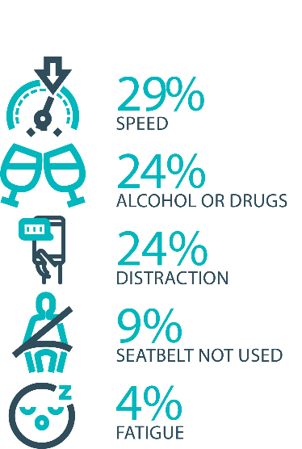

The fatal five behaviours contributing to serious
casualties

Inattention and distraction
Inattention and distraction are concerning causes of serious casualty crashes and may have a far greater impact than current data suggests. There are a number of research projects and enforcement initiatives that are being used to address this issue. This project will include consideration of emerging strategies for tackling distraction, encouraging compliance through enforcement and influencing driver behaviour through public education campaigns.
Current situation / comments
Enforcement
Tasmania Police introduced three unmarked motorcycles to increase the rate of detection and enforcement of illegal phone use whilst driving. These motorcycles operate across all districts and target the low-speed road network and congested traffic conditions, utilising ‘lane filtering’ legislation to full advantage.
In an agency first, the riders are also fitted with helmet cameras to capture the offence, an initiative that has effectively nullified disputes. The introduction of unmarked motorcycles has proved to be incredibly successful with riders reporting high-level public support and a notable change in driver behaviour. In addition, regular operations continue to be conducted which target illegal phone use.
Tasmania Police continue to identify, trial and implement emerging technologies to address speeding, seatbelt, inattention and distraction offences including, improving enforcement of high-risk driving. Technologies such as hand-held speed cameras, updated ANPR technology and dash cams are now being trialled and ongoing support is being provided to the Automated Traffic Enforcement Project being led by the Department of State Growth.
Public Education
The first phase of the ‘Click. Store. Go’ campaign launched in April 2023 to support the introduction of mobile phone and seatbelt detection cameras, letting drivers know these cameras will soon be operational in Tasmania.
The second phase of the ‘Click. Store. Go’ campaign is scheduled to launch in August 2023, letting drivers know mobile phone and seatbelt cameras are now live.
Status |  |  | On schedule/progressing/low risk

Safe behaviour campaigns
Targeted media campaigns will continue to educate people about high-risk behaviours and to highlight the dangers of the ‘Fatal Five’.
Current situation / comments
The Over is Over campaign continued to run on radio, social media and outdoor billboards in April 2023, highlighting the dangers of speeding.
The ‘Road Safety Starts with Me’ campaign launched in May 2023. This campaign encourages the community to think about the role they play in making Tasmanian roads safe and how they can be a safer and more courteous road user.
A new social media campaign ‘Drive to the conditions’ launched in June 2023, encouraging drivers to be aware of changing road and weather conditions and to slow down when necessary.
The Love40 campaign had another burst at the start of term two in April 2023. Love40 aims to encourage motorists to drive at or below the school zone limit to keep our children safe.

Status |  |  | On schedule/progressing/low risk

Mandatory Alcohol Interlock Program (MAIP)
The MAIP aims to have repeat and high-level drink driving offenders demonstrate they are able to separate their drinking from driving through the installation of an alcohol interlock in their vehicle. New measures will be introduced to increase participation in the MAIP.
Current situation / comments
Drafting instructions for the revised framework were provided to the Office of Parliamentary Counsel (OPC) in October 2019. Parliamentary priorities, including COIVD-19, caused reprioritisation of OPC work. Drafting instructions were withdrawn from OPC in May 2021, before the first draft of amendments had been received, to enable the new Road User Services’ managers to review the drafting instructions to ensure that they remain current. The revised instructions were re-submitted to OPC on 15 February 2022. Again, Parliamentary priorities slowed the work of OPC. Nonetheless, version 2 of the amendments were received in November 2022, and work continues with OPC.
Two approved Providers have signed new contracts; negotiations continue with the third. The contracts expiry has been extended until October 2023 under a new Treasury process. Work commenced on creating new contracts in early February 2023. Crown Law has advised that: (i) the format of the contract must be updated to reflect the new TTCC template; and (ii) we must undertake a full tender process rather than roll the contracts over. This approach will also capture the two intending approved providers.

Status | Major delays/on hold/high risk

Protective clothing for motorcyclists
Motorcyclists are overrepresented in Tasmania’s road trauma figures. Motorcyclists are vulnerable road users due to a lack of physical protection. Protective clothing can reduce injury severity in the event of a crash. Tasmania is a funding member of MotoCAP. MotoCAP provides safety assessment star ratings for protective clothing and prepares education materials for motorcyclists.
Current situation / comments
In June 2023, an updated public education brochure educating riders on the importance of wearing protective motorcycle gear was re-distributed to Tasmanian retailers, Tasmanian Neighbourhood Houses and AJL training facilities. The brochure reiterates the importance of wearing full gear on every ride and directs motorcyclists to the MotoCAP website to check gear safety ratings before purchase.
Status |  |  | On schedule/progressing/low risk

Road safety penalties review
For enforcement activities to improve safety on our roads, they need to be backed up with appropriate penalties. Tasmania’s road safety penalties will be reviewed to ensure they are up-to-date and provide an appropriate deterrence to those who break the rules and put themselves and others at risk.
Current situation / comments
The Department previously completed a review of road safety penalties in 2020, which showed that Tasmania was largely consistent with other jurisdictions, except for speeding offence penalties, which were lower.
The results of that review were presented to the Road Safety Advisory Council (RSAC) in November 2020. RSAC recommended not amending penalty values due to the economic impacts of COVID-19 and general parity with other jurisdictions. RSAC agreed to review penalties again towards the end of the current Action Plan which concludes on 31 December 2024.
Since November 2020, some jurisdictions have implemented higher penalties, which has widened the gap between Tasmania’s penalties and some jurisdictional averages.
The Road Safety Branch (RSB) undertook a review of Tasmanian road safety penalties to compare Tasmanian penalties to the average of other Australian jurisdictions for the fatal five road offences – speed, mobile phones, alcohol and drugs and failure to wear a seatbelt.
The review compared Tasmania’s penalty levels to a ‘jurisdictional average’ (i.e., an average of all other jurisdictions, without inclusion of Tasmania’s penalties) to avoid skewing the average. To ensure that the comparison of monetary penalties considers the differences in earning potential across the jurisdictions, comparisons are being done as a percentage of each jurisdiction’s seasonally adjusted average weekly wage (not a whole dollar value).
A recommendation to consider endorsing amendments to the monetary penalties for offences relating to illegal mobile phone use, seatbelt non-compliance, registration, and speed, was provided to RSAC for review in its May 2023 meeting. RSAC considered the proposal and will provide advice to the Minister for Infrastructure and Transport for consideration.
Status |  |  | On schedule/progressing/low risk

Speed enforcement strategy
Speed is one of the fatal five offences addressed within the Tasmania Police Road Safety Strategy 2022-2024.
The strategy directs enhanced speed enforcement strategies and techniques to increase the rate of detection and increase the perception that offending drivers and riders will be caught through the coordination of high-visibility speed enforcement in high-risk areas across all police districts.
With regard to speed cameras, Tasmania Police has conducted several technology trials, including in-motion camera technology, where speed cameras are fitted to moving vehicles, and of mobile point-to-point speed detection, where average speed enforcement utilises two vehicles fitted with automatic numberplate recognition technology. In addition, Tasmania Police is working with the Department of State Growth to introduce future automated speed enforcement in Tasmania.
Tasmania Police has implemented a Strategic Asset Management Plan (SAMP) for all speed detection devices. The SAMP provides for continual review of new and emerging technologies, includes provisions for regular replacement and upgrade of equipment and importantly supports long-term financial planning and budgeting. In line with the SAMP, Tasmania Police’s Southern Road and Public Order Services is also trialling a rear-facing radar on a patrol vehicle.
Tasmania Police has completed the implementation of new vehicle livery across the fleet to include the introduction of ‘Over is Over’ campaign mark-ups on selected traffic enforcement cars and motorcycles. Tasmania Police continue matching different livery designs to specific uses, for example general patrol, high-visibility patrol, and low-profile marked vehicles – all of which are relevant to different methodologies of speed reduction and enforcement. The introduction of unmarked highway patrol cars has also proven to be very successful and complements the use of overt policing tactics well.
Tasmania Police recently updated the marked police motorcycle fleet with new livery for these bikes being implemented to heighten the visibility of police on the road network.

Status |  |  | On schedule/progressing/low risk

Enforcement of high-risk behaviours
To reduce high-risk behaviours and increase compliant road user behaviour, State Growth and Tasmania Police will work collaboratively to investigate and introduce new enforcement techniques and technologies to detect high-risk behaviours that address the ‘fatal five’, including mobile phone use, speeding and failure to wear a seatbelt.
Current situation / comments
Tasmania Police Road Safety Strategy 2022-2024, focuses on the fatal five causes of serious and fatal crashes, which are the highest risk driver behaviours: speeding; alcohol and drugs; distraction and inattention; seatbelts; and fatigue.
The strategy includes the analysis of current data that assists to identify where enforcement activities should be focused according to the highest risk, road safety locations, times and behaviours to achieve a change in driver behaviour.
Tasmania Police has now completed a program of sending traffic policing subject matter experts to various jurisdictions around the country in order to foster closer relationships and identify opportunities for enhancing road safety activities within Tasmania. Reports from these SME’s are now being examined to identify opportunities for Tasmania Police into the future.
Status |  |  | On schedule/progressing/low risk

Automated Traffic Enforcement Program
Automated Traffic Enforcement (ATE) (i.e. speed cameras) is relatively underutilised as a deterrence and enforcement mechanism in Tasmania. This project investigates proven and emerging camera technologies for use at high-risk locations and across the entire road network.
Current situation / comments
On 30 September 2022, mobile speed camera enforcement services being delivered by Sensys Gatso Australia commenced issues Infringement Notice’s to motorists detected speeding.
Currently there are ten (10) mobile speed camera systems operating in Tasmania delivering up to 25 000 enforcement hours via a minimum at over 225 unique locations each month. Mobile speed camera deployments are based on crash risk, road safety infrastructure and vehicle operating speeds. Once fully operating, community suggested locations will be considered where there is a clear road safety benefit.
The introduction of the mobile speed camera program has been supported by the new enforcement focus of the ‘Over is Over’ marketing campaign and the development of a separate program website (speedcameras.tas.gov.au).
In addition to speed enforcement and as part of the 2022-23 State Budget, the Government allocated an additional $9.3 million over three years to extend enforcement services for an additional one year and implement emerging technologies such as mobile phone, seatbelt, and average speed enforcement.
To support the implementation of these emerging technologies, the project team has progressed legislative and regulatory amendments which will enable photographic detection devices to be used in detecting and prosecuting mobile phone, seatbelt, and average speed offences. Legislative amendments were passed by the Tasmanian Parliament in November 2022 and subsequent amendments to subordinate legislation are expected to be finalised in Q2 of 2023.
The implementation of additional enforcement technologies will be supported by educational campaigns and State Growth is developing a supporting educational campaign for mobile phone and seatbelt enforcement technology to be introduced in Q2 or Q3 of 2023.
Status |  |  | On schedule/progressing/low risk

High-risk motorcycling enforcement
Speed is a factor in at least a quarter of motorcyclist serious casualties. Speed cameras offer no deterrence to motorcyclists, whose numberplates are mounted only on the back. Introduction of rear-facing speed cameras will improve detection and deterrence of speeding. This is being considered as part of the Automated Traffic Enforcement Program.
Current situation / comments
The Tasmania Police Road Safety Strategy 2022-2024 approaches the enforcement of high-risk motorcycle behaviours from several angles. Tasmania Police has:
- worked with the Department of State Growth to re-introduce Automated Mobile Speed Enforcement Cameras that have both a rearward and forward-facing capability to better target and detect high-risk motorcycle behaviour.
- introduced an online public portal for members of the public to upload footage relating to traffic offences they have witnessed. Tasmania Police review these submissions and allocate prima facie offences to an officer for investigation and follow-up.
- published the Tasmania Police Road Safety Strategy 2022 – 2024 which provides for increased patrol hours on rural roads which includes many of the popular motorcycle touring routes. The increased patrol hours will be conducted in a mix of covert and overt patrols that will discourage and detect high-risk motorcycle behaviours increasing the perception amongst riders they will be caught anywhere at any time.
Status |  |  | On schedule/progressing/low risk

Road Rules Awareness
Compliance with Road Rules makes our behaviour on the roads predictable, improving safety for all road users. This initiative will ensure that user-friendly and tailored information resources are developed so that the Road Rules are easily understood and adhered to by all road users.
Current situation / comments
The Tasmanian Road Rules Handbook and the Misunderstood Road Rules series of pamphlets are distributed to Service Tasmania locations when required.

Status | Major delays/on hold/high risk |  | On schedule/progressing/low risk

11 per cent of all serious casualties on our
roads are non-Tasmanian residents

Tourist road safety signage program
This program will see the installation of tourist signage strategically placed across the road network. The signs will provide important road safety information, relevant to the area road users are travelling in. This program will be undertaken in collaboration with stakeholders, local government and State Roads.
Current situation / comments
This program is currently on hold.
Status | On hold |  | On schedule/progressing/low risk

Responsive electronic signage trial
This project will trial a responsive electronic sign with real time information at regional tourism gateways.
Current situation / comments
This project is currently on hold.
Status | On hold

Tourist education materials
A range of education materials developed using images, symbols and multi-lingual material delivered to specific audiences through targeted communications channels. This includes vehicle hangers, brochures, posters, roadside signs, editorial content, film and digital content.
Current situation / comments
Communications materials are being distributed upon request from stakeholders.
Status |  | Limited activity

Strategic partnerships
Developing strategic partnerships based on synergies with target audiences will enable the effective promotion of road safety messages and education.
Current situation / comments
This project is currently on hold.
Status | On hold

Tourist education at gateway entry points
As an island state, we have the opportunity to strategically place messaging at our gateway airports and seaports to reach visitors with important road safety messaging prior to them driving in Tasmania. This includes a range of educational materials, electronic and static signs and billboards.
Current situation / comments
Printed collateral is in stock and digital billboards display road safety messaging at gateway locations.
Status |  | Limited activity

Stakeholder alliances
Sharing information and collaborating to develop effective strategies and tools to address road safety issues is vital. This project will develop formal and informal stakeholder alliances to encourage input and create opportunities to deliver joint initiatives.
Current situation / comments
This activity is currently on hold.
Status | On hold

The rate of fatal crashes is four times higher for vehicles 15+ years old than for vehicles made in the last five years

Australasian New Car Assessment Program (ANCAP)
Tasmania is a funding member of ANCAP. ANCAP plays a vital role in informing consumers about safety performance of new vehicles and advocates for improved vehicle safety design and specification through public education campaigns, advocacy activities and engagement with governments, corporate fleets, the media and consumers. Activities related to ANCAP will include promotion of safer vehicles and options for an annual vehicle fleet report.
Current situation / comments
Tasmania continues to provide funding support to ANCAP. ANCAP has developed a new Strategic Plan for 2023-2030. ANCAP is proposing a significant increase in operating budget to support the new plan, resulting in an increased funding ask from funding bodies including Tasmania.
ANCAP met with RSAC and Department representatives in early March 2023 to discuss ANCAP’s Strategic Plan and proposed funding request. Further details regarding the current funding model, particularly the Tasmanian funding contribution, were discussed at the briefing. In late March 2023, RSAC discussed ANCAP’s proposed increase in funding from Tasmania. RSAC endorsed the increased funding request of up to $85 000 per annum from the Road Safety Levy.

Status |  |  | On schedule/progressing/low risk

Safer cars for young drivers
This project aims to increase awareness of the Used Car Safety Rating database amongst first time car buyers. This could be promoted through education materials and campaigns and may be able to integrate with the GLS online learning platform.
Current situation / comments
This project has not yet commenced and will be considered as part of the Light Vehicle Safety Strategy and through the mid-term review.
Status |  |  |  | Not yet commenced

Autonomous vehicle and crash avoidance readiness
This project involves the monitoring and development of safety and autonomous vehicle technologies.
Current situation / comments
The regulation of autonomous vehicles is being considered at a national level and Tasmania is participating in that process.
Status |  |  | On schedule/progressing/low risk

Workplace driver safety
Vehicle use in road traffic is the most significant contributor to work-related traumatic injury. This project will aim to promote and encourage employers to adopt safe driving policies based on the Worksafe, ‘Vehicles as a workplace’ guide.
Current situation / comments
This project has not yet commenced and will be considered as part of the mid-term review.
Status |  |  |  | Not yet commenced.

Light vehicle safety strategy
A light vehicle safety strategy will be developed to provide public education and undertake enforcement activities to enhance the safety standard of Tasmania’s vehicle fleet.
Current situation / comments
A draft light vehicle safety strategy is being developed. The draft strategy aims to accelerate an increase in the number of newer and safer vehicles and removal of older cars from the light vehicle fleet while increasing the safety of the current vehicle fleet.
In May 2023, RSAC approved an amended suite of 19 actions to consider under the light vehicle safety strategy. The Road Safety Branch has determined three actions require considerable work. These are: a seasonal roadworthiness communications campaign, the proposed introduction of a ‘risk-based’ periodic inspection program, and a financial incentive program to assist young drivers to purchase safer vehicles (it is noted these proposals complement several associated actions).
Status |  |  | On schedule/progressing/low risk

Funding
Road Safety Levy Overview for the Financial Year 2022/23
As at 30 June 2023 (Quarter 4)
Road Safety Levy Opening Summary
Opening Balance as at 01 July 2022 |  |  | $ 17,344,616
Annual Allocation to Road Safety Operations |  |  | $ 2,600,000
Revenue Summary
 |  | Forecast (FY23) | Actual (Y.T.D.)
Motor Accident Insurance Board Funding |  | $ 1,360,044 | $ 1,323,523
Revenue Inflows from Registrations |  | $ 15,281,957 | $ 17,456,716
Funds Available for Distribution |  | $ 31,386,617 | $ 33,524,855
Expenditure Summary
Theme no. | Theme | Forecast (FY23) | Actual (Y.T.D.)
1 | Making our Rural Roads Safer | $ 2,295,898 | $ 1,644,645
2 | Improving Safety in our Towns and Cities | $ 2,261,893 | $ 2,927,906
3 | Saving Young Lives | $ 3,141,552 | $ 2,430,380
4 | Encouraging Safer Road Use^ | $ 4,033,977 | $ 3,645,917
5 | Making Visitors Safer | $ 125,441 | $ 75,050
6 | Improving Safety Through Vehicles and Technology | $ 692,869 | $ 12,869
7 | General Support | $ 744,491 | $ 655,619
Budget and Expenditure by Category |  | Forecast (FY23) | Actual (Y.T.D.)
Infrastructure Expenditure* |  | $ 4,127,464 | $ 4,121,274
Policy & Projects Expenditure* |  | $ 9,489,863 | $ 7,271,113
Total Expenditure |  | $ 13,617,327 | $ 11,392,387
Balance as of 30 June 2023 |  | $ 17,353,133 | $ 22,132,469
Forecast Closing Balance of FY23 |  | $ 17,769,290
*Includes four ceasing activities not categorised by Action Plan 2020-24 themes
^includes MAIB expenditure

MAIB Funding
As at 30 June 2023

2021/22 Financial Year | Budget  $ | Actual (ytd)  $ | Balance  $
Expenditure (State Growth)
Administration & Public Relations | 341,920 | 301,709 | 40,211
Public Education | 963,124 | 960,442 | 2,682
Research | 60,000 | 61,372 | (1,372)
Subtotal | 1,365,044 | 1,323,523 | 41,521
Expenditure (Tasmania Police)
Salaries | 2,140,451 | 2,137,838 | 2,613
Operating Expenses | 188,000 | 177,690 | 10,310
Equipment | 816,222 | 583,089 | 233,133
Subtotal | 3,144,673 | 2,898,618 | 246,054
Total | 4,509,717 | 4,222,141 | 287,575
Includes Carried Forward of
-$41,723 (State Growth)
$413,879 (Police)

Department of State Growth
Road Safety Branch
Towards Zero Action Plan 2020-2024

GPO Box 536
Hobart TAS 7001 Australia
 | Phone: | 6166 3243
 | Email: | rsac@stategrowth.tas.gov.au
 | Web: | www.rsac.tas.gov.au
 | © State of Tasmania June 2023

