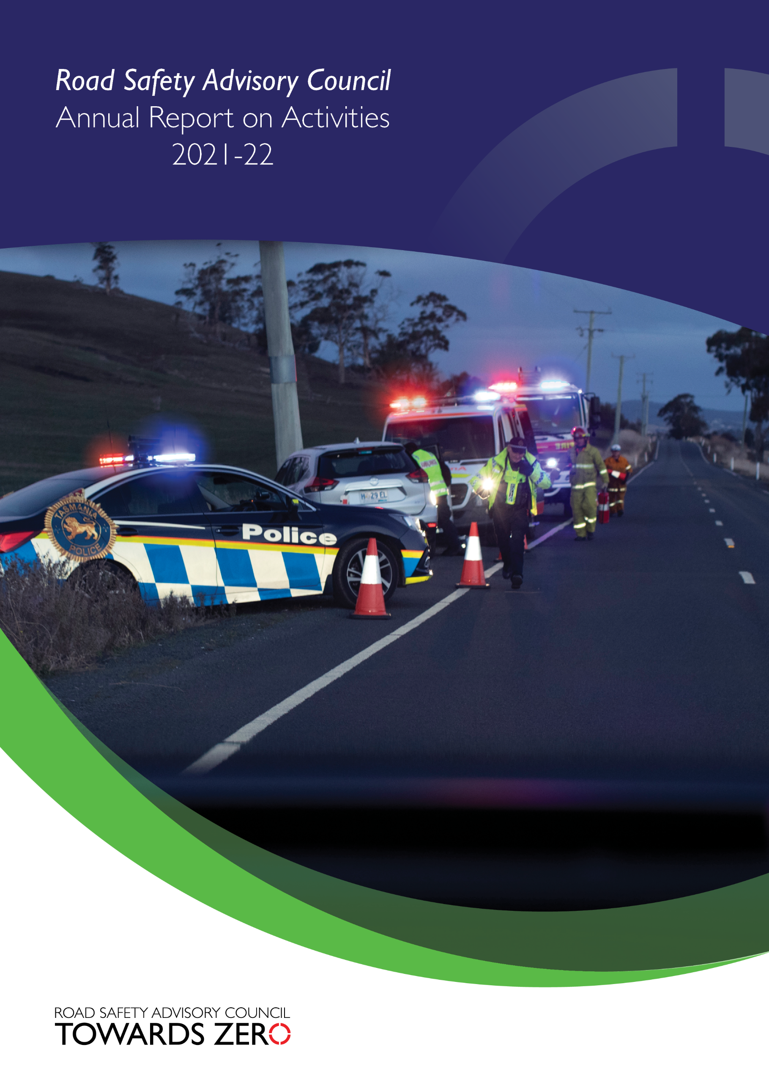

Table of contents
Photo credits and acknowledgements 2
Overview 3
Message from the Chair of the Road Safety Advisory Council 3
About the Road Safety Advisory Council 6
Road Safety Advisory Council membership 7
Road Safety Advisory Council meetings and attendance 8
RSAC Education and Enforcement Sub-Committee (EESC) membership 8
EESC meetings and attendance 9
RSAC and EESC remuneration 9
Serious casualty trends and progress on meeting Towards Zero Strategy targets 10
Thematic Snapshot of the Towards Zero Action Plan 2020-2024 14
Making our rural roads safer 15
Improving safety in our towns and cities 18
Saving young lives 20
Encouraging safer road use 25
Making visitors safer 30
Improving safety through vehicles and technology 31
Road safety levy budget overview 33

Photo credits and acknowledgements
Images used within this report remain the property of the copyright holder. All images are courtesy of the RSAC, Tasmanian Government and its associated projects.
© State of Tasmania December 2022

Overview

Message from the Chair of the Road Safety Advisory Council
As Chair of the Road Safety Advisory Council (RSAC), I am pleased to present the second annual report under the five-year Towards Zero Action Plan 2020-2024. The five-year Action Plan details the 42 road safety initiatives that will gain the greatest reductions in serious injuries and deaths. The Action Plan is based on the best-practice Safe System approach to road safety and targets our highest risk road safety areas. The selection of initiatives and programs was informed by extensive community engagement, stakeholder consultations, and independent research and modelling.
The Action Plan represents a road safety investment of over $75 million, funded from the Road Safety Levy and a $6.5 million contribution from the Motor Accidents Insurance Board (MAIB) for the production and evaluation of public education initiatives. In addition, over the last year the Australian Government has contributed $15.8 million to infrastructure projects through the Road Safety Program.
In 2022, the Towards Zero Strategy and Action Plan reached the halfway point of their terms. A new decade-long National Strategy was released in 2021, consisting of nine priorities and eight enabling actions. A National Action Plan is being finalised.
A mid-term review is being undertaken to understand the current road safety environment in Tasmania and to assess our progress to date and the scale of the challenges ahead to achieve our goals, assess how Tasmania’s current road safety strategy and actions align to our new National Strategy and National Action Plan, to consider what new opportunities, if any, are available to best utilise road safety resources to reduce serious injuries and deaths on Tasmanian roads and to confirm the direction for Tasmanian road safety policy for the remaining term of the Action Plan and more broadly, the Towards Zero Strategy.
Another major project will see the introduction of mobile speed cameras on our roads again. Speed is the single largest factor in road trauma, impacting both the severity and likelihood of a crash. Speed cameras reduce the speed of passing vehicles, and because cameras can be anywhere anytime, they act as a deterrent and reduce speeding across the whole road network. Mobile speed cameras have been proven to reduce speeds and the risk of crashing. Speed cameras save lives.
In 2021, we had 35 fatalities on our roads and 250 people were seriously injured. We’ve seen a tragic start to 2022 and at 30 June 2022, 30 people had lost their lives and our roads and 127 had been seriously injured.
It’s absolutely heartbreaking that we continue to see these deadly crashes, which are nearly always preventable. Every fatal crash is tragic and deprives family, friends and their communities of someone they love.
Unfortunately, there’s a combination of factors that feature frequently and prominently in serious casualty crashes and while the RSAC is always working to raise awareness of the ‘fatal five’ (speeding, distraction, driving under the influence of alcohol or drugs, fatigue or failure to wear seatbelts), it seems the messages don’t seem to be getting through and some people continue to engage in risky driving behaviour.
Although there are challenges, the Council remains firmly committed to providing Government with an evidence-based response to our road safety problem. As a Council, we are working towards our vision that no one is seriously injured or killed as a result of a crash on our roads. I am sure that all Tasmanians share that vision but to achieve it we must all take more personal responsibility as road users.
Scott Tilyard
Chair, Road Safety Advisory Council

Fewer than 200 serious
casualties by 2026
Working towards reducing serious injuries and deaths on Tasmanian roads to 200 by 2026.
$75 million invested to improve road safety
Under the Action Plan the Tasmanian government is currently investing $75 million in projects and programs to improve safety on Tasmanian roads.
A major project has been underway to reduce the number of speed related crashes through the introduction of mobile speed cameras on Tasmanian roads.
Commencement of the Over is Over public education campaign to support the introduction of mobile speed cameras in Tasmania.

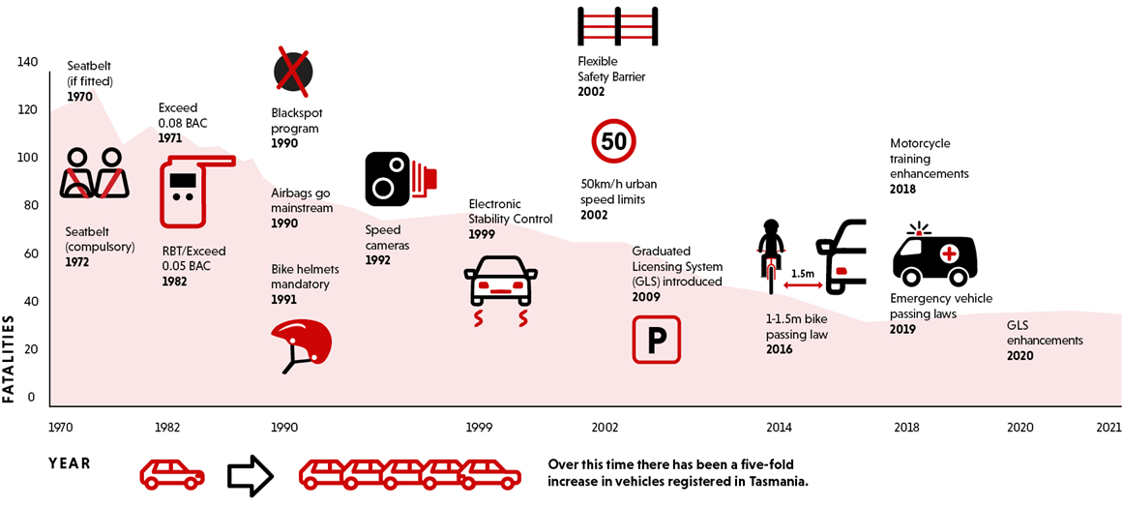
Tasmanian road crash fatalities and key road safety measures

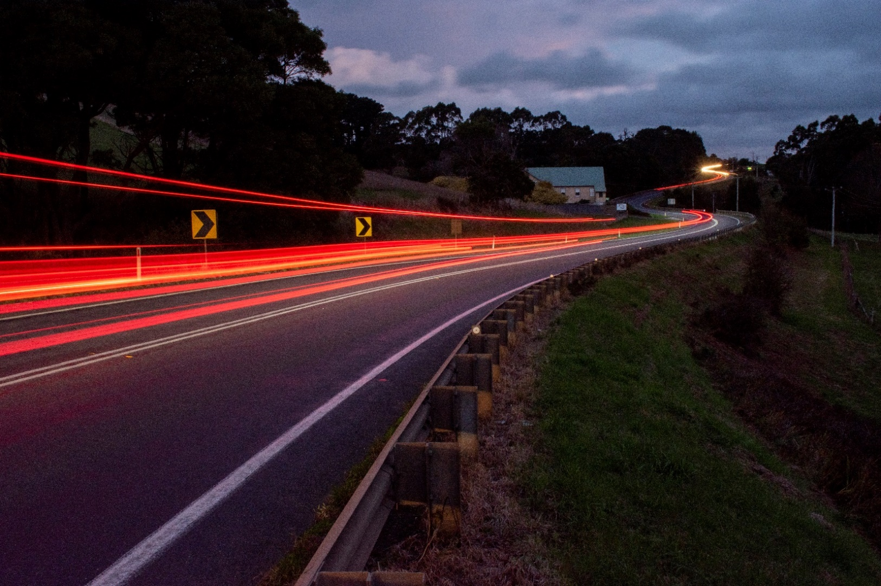
In 2021-2022, Tasmania Police detected 29 588 high-risk traffic offenders. This figure exceeded the operational performance target of 28 000, set for the financial year 2021-2022.

About the Road Safety Advisory Council
The Road Safety Advisory Council (RSAC) was established in October 2010 to help shape the future of road safety policy in Tasmania. The RSAC replaced the Tasmanian Road Safety Council and the Road Safety Taskforce and combined their expertise. The RSAC oversees the development and implementation of policy, initiatives, public education, and strategies to reduce serious injuries and deaths on Tasmania’s roads.
Primarily, the RSAC provides strategic direction, oversight and critical assessment of proposed road safety initiatives and campaigns. The RSAC recommends and reports on road safety initiatives to the Minister for Infrastructure and Transport through the Department of State Growth.
The Towards Zero – Tasmanian Road Safety Strategy 2017 – 2026 (Towards Zero Strategy) guides the RSAC’s overall vision, purpose and approach. The RSAC envisions a Tasmania that is free from serious injuries or deaths from crashes on Tasmanian roads. The Towards Zero Strategy is supported by periodical action plans with the current being the Towards Zero Action Plan 2020-2024 (Action Plan). Annually, around 300 people are seriously injured and killed on Tasmanian roads. The key target is to reduce annual serious injuries and deaths on Tasmanian roads to fewer than 200 by 2026.
The RSAC’s work goals and the Towards Zero Strategy are based on the ‘Safe System’ approach to road safety. The Safe System approach involves a holistic view of the road transport system that includes how roads, travel speeds, vehicles and road users interact with each other. The approach is an inclusive one as it involves all groups of road users, including drivers, motorcyclists, passengers, pedestrians, cyclists, commercial and heavy vehicle drivers. The Safe System approach has four elements: safe road users, safe roads and roadsides, safe vehicles and safe speeds. The rationale behind the system is that it recognises that road users will always make mistakes and may have road accidents. However, the road system should be able to accommodate mistakes so that road crashes do not result in death or serious injury.
Sitting within RSAC is the Education and Enforcement Sub-Committee (EESC). The EESC is funded by the Motor Accidents Insurance Board (MAIB). The EESC is responsible for the delivery of public education campaigns, sponsorships and enforcement activities. The EESC provides advice on road safety education and ensures that community road safety and enforcement programs align with the Towards Zero Strategy. In addition, the EESC reports and makes recommendations to the RSAC by identifying emerging issues from key community stakeholders and contributes to the further development of key road safety strategic directions.

Road Safety Advisory Council membership
The RSAC consists of 10 members appointed by the Minister for Infrastructure and Transport. The member positions are as follows.
- A part-time independent Chair
- The Secretary of the Department of State Growth
- The Secretary of the Department of Police, Fire and Emergency Management
- The CEO (or equivalent) of the Motor Accidents Insurance Board
- The CEO (or equivalent) of the Local Government Association of Tasmania
- A person or people (maximum four) to represent a range of road users whose organisation(s) can demonstrate its major role in and contribution to road safety, including:
  - light and heavy vehicle drivers
  - motorcyclists
  - cyclists
  - pedestrians, and
  - young people
- A person with high-level expertise in road safety research, infrastructure, countermeasures, strategies, and contemporary road safety principles.

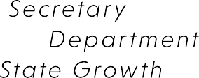
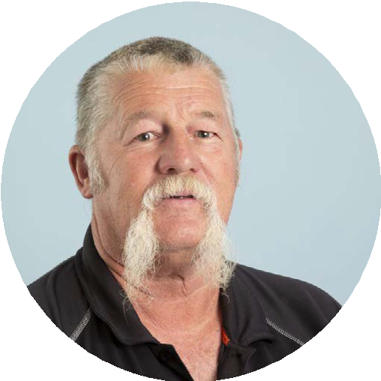
The RSAC’s membership as at 30 June 2022
NB. The Minister for Infrastructure and Transport has appointed the following delegates as representatives on RSAC:
- Gary Swain, Deputy Secretary for Kim Evans, Secretary, Department of State Growth
- Assistant Commissioner Jonathan Higgins for Commissioner Darren Hine, Department of Police, Fire and Emergency Management.

Road Safety Advisory Council meetings and attendance
The RSAC held four meetings in 2021-22, occurring on the following dates.
- 17 August 2021
- 16 November 2021
- 22 March 2022
- 24 May 2022
The below table outlines the attendance of the RSAC representatives at each of the four meetings occurring in 2021-22. Other observers, presenters or irregular attendees are not included.
Member | 17 August 2021 | 16 November 2021 | 22March  2022 | 24 May  2022 | Total Meetings Attended
Mr Scott Tilyard |  |  |  |  | 4
Mr Paul Kingston |  |  |  |  | 4
Dr Ian Johnston |  |  |  |  | 4
Mr Gary Swain |  |  |  |  | 4
Mr Mark Mugnaioni |  |  |  |  | 3
Ms Michelle Harwood |  |  |  |  | 4
Ms Alison Hetherington |  |  |  |  | 4
Mr Paul Bullock / Mr Mick Boyd |  |  |  |  | 4
Mr Dion Lester |  |  |  |  | 2
Mr Jonathan Higgins |  |  |  |  | 4
NB. Mr Paul Bullock resigned from his position as President Tasmanian Motorcycle Council (TMC) on 21 August 2021and Mr Mick Boyd was appointed President of the TMC and motorcyclist representative on RSAC from 21 August 2021.

RSAC Education and Enforcement Sub-Committee (EESC) membership
Representing | Member
Chair | Mr Paul Kingston  CEO, Motor Accidents Insurance Board (MAIB)
Chair RSAC | Mr Scott Tilyard
Marketing Expert | Suzi Watral
The Department of State Growth | Mr Craig Hoey  Manager Road Safety, the Department of State Growth
The Royal Automobile Club of Tasmania | Ms Anita Busch / Amira Vaatstra  Royal Automobile Club of Tasmania (RACT)
The Department of Police, Fire and Emergency Management | Mr Jonathan Higgins  Assistant Commissioner, Tasmania Police

EESC meetings and attendance
The EESC held four meetings in 2021-22. The below table outlines the attendance of the EESC members at each of the four meetings occurring in 2021-22. Other observers, presenters or irregular attendees are not included.
Member | 17 August 2021 | 16 November 2021 | 22March  2022 | 24 May  2022 | Total Meetings Attended
Mr Paul Kingston |  |  |  |  | 4
Mr Scott Tilyard |  |  |  |  | 4
Ms Suzi Watral |  |  |  |  | 4
Mr Craig Hoey |  |  |  |  | 4
Ms Anita Busch / Amira Vaatstra |  |  |  |  | 2
Mr Jonathan Higgins |  |  |  |  | 4
NB. Anita Busch attended the EESC meetings to 21 August 2021 and Amira Vaastra commenced as the RACT representative from 21 August 2021.

RSAC and EESC remuneration
Council members who received remuneration for the 2020-21 financial year include:
Chair RSAC
- $41 212 per annum
- Out-of-pocket expenses up to $1 600 per annum
Road safety expert
- $1 500 per meeting
- Actual out-of-pocket expenses
Marketing expert
- $642 per meeting
- Actual out-of-pocket expenses.
Council members who are not public officers are entitled to motor vehicle allowances based on a cents-per-kilometre basis, in accordance with Australian Taxation Office guidelines.

Serious casualty trends and progress on meeting Towards Zero Strategy targets
The Towards Zero Strategy sets the key interim target of reducing the number of annual serious casualties on Tasmanian roads to fewer than 200 by 2026. This is an ambitious target of 100 fewer serious casualties per year than the annual average for the period 2012 – 2016 and will move Tasmania towards the long-term goal of zero serious casualties.

Serious Casualites for 2021 – 22 (Serious Injuries and Deaths)
The number of serious casualties in 2021 was 285, a 12.8 per cent decrease from 327 in 2020, and a 7.2 per cent decrease on the five-year serious casualty average of 307.2 (2016-2020).

Serious Casualties Tasmania – Annual Count, Percentage Split by Quarter and Towards Zero Target

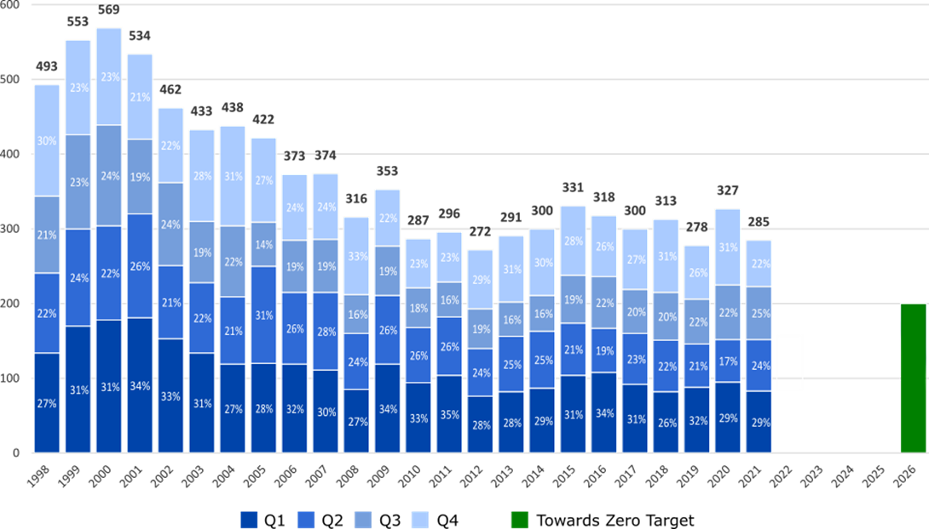

Year-to-Date as at 30 June 2022
There have been 157 serious casualties as at 30 June 2022 (from 1 January 2022), including 30 deaths and 127 serious injuries. This number is 5 more than the 152 serious casualties recorded at the same time last year, which includes 13 deaths and 139 serious injuries and an increase of 3.2 per cent on the five-year average of 152.2 serious casualties.

Serious Casualties Tasmania – Annual Count, Percentage Split by Quarter and Towards Zero Target

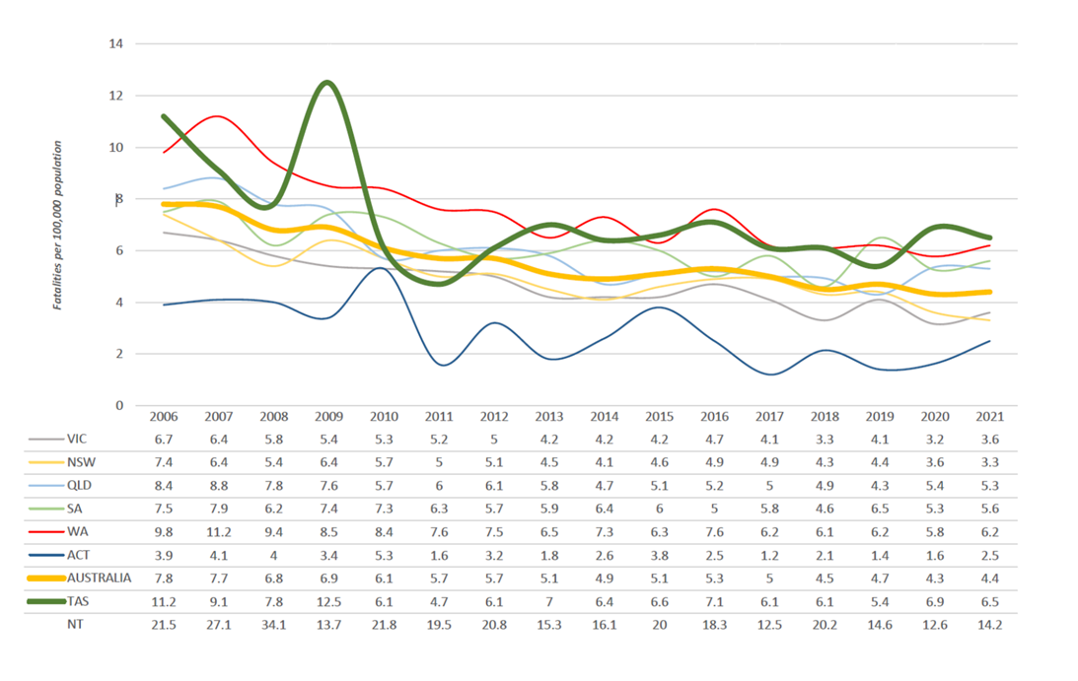
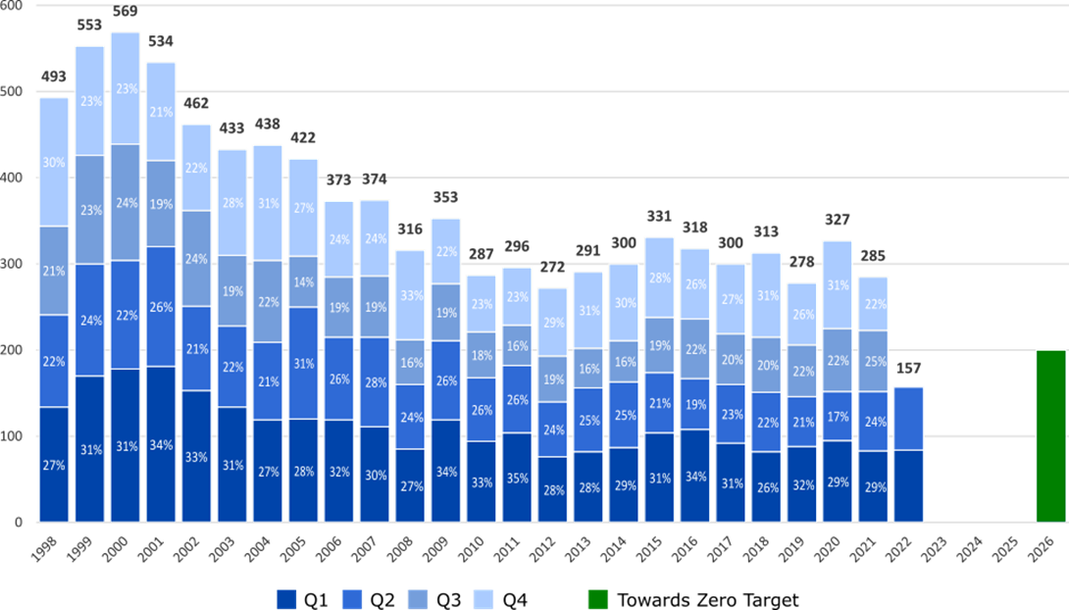

DeathsIn 2021, there were 35 deaths on Tasmanian roads, three fewer than the 38 deaths recorded in 2020, and a 4.8
per cent increase on the five-year fatalities average of 33.4 for the period 2016-2020.

Annual fatalities – Rate per 100,000 population (NT omitted for clarity purposes)

Serious casualties – breakdown by road user type
 | Motorcyclists represented nine of the 35 deaths on Tasmanian roads in 2021. |  |  | Over 60 per cent of deaths on Tasmanian roads in 2021 were vehicle occupants.
 | There was one death and eight cyclist serious injuries in 2021. |  | 27 of the 35 deaths on Tasmanian roads in 2021 were male, representing approximately three-quarters of the total deaths. In addition, males accounted for 199 of the 285 serious casualties.

Serious casualties – breakdown by crash attributes

Speed zone
The graph below depicts the number of serious casualties occurring quarterly by speed zone. Serious casualties occur more frequently on roads with 100 km/h or higher speed limits and less frequently on roads with 40 km/h or lower speed limits.

Serious Casualties by Quarter by Speed Zone – 12 period moving average
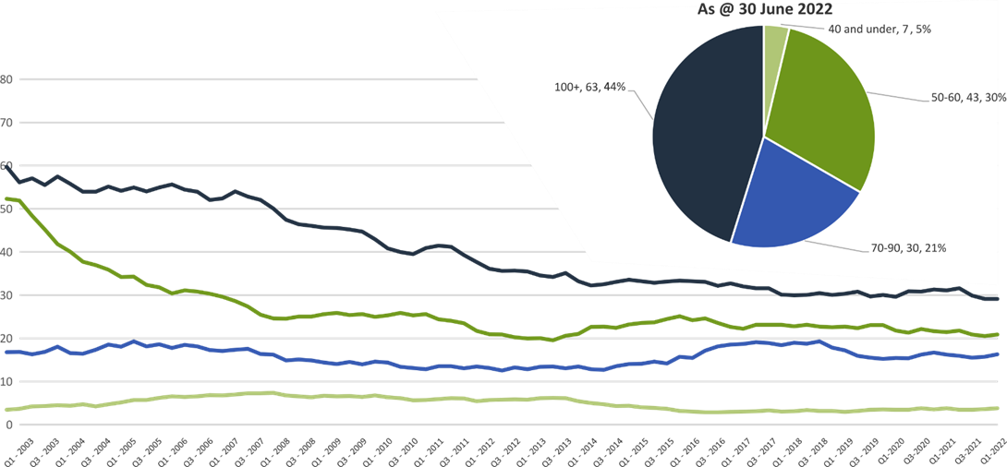
Pie chart excludes serious casualties where speed zone is recorded as ‘not known’

Crash type
The graph below depicts the number of serious casualties occurring quarterly by crash type. The majority of serious casualties occur due to lane departure crashes.

Serious Casualties by Quarter by Crash Type (DCA) – 12 period moving average

Other includes crash types: on-path (6%), overtaking (1%) and passenger and miscellaneous (1%).
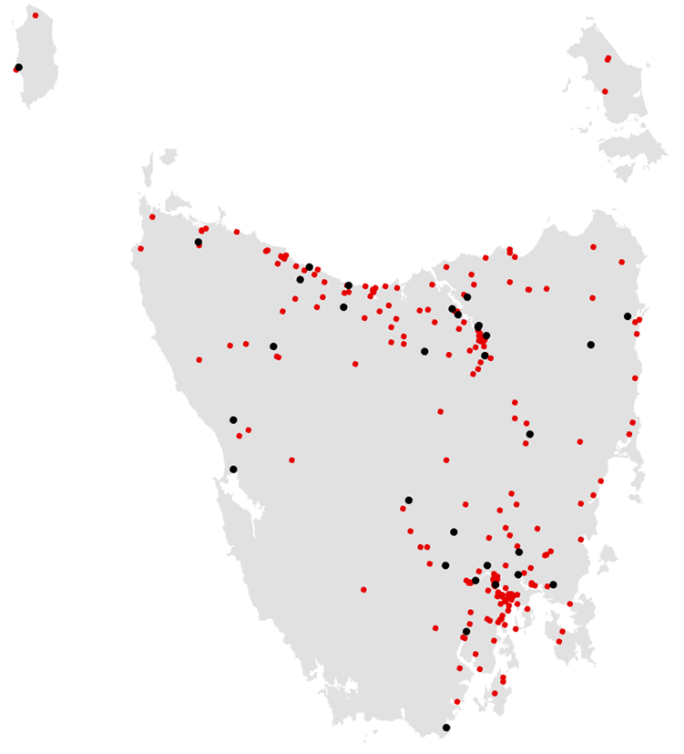

Location
The image (right) depicts
the location of all serious
casualties that occurred
in 2021.

Thematic Snapshot of the Towards Zero Action Plan 2020-2024
Making our rural  roads safer |  | Improving safety in our towns and cities
Rural road grants program for local government  Motorcyclist safety on rural roads  Safe System knowledge and skills training  Infrastructure upgrades on low volume state roads  Speed moderation and community engagement strategy |  | Targeted infrastructure upgrades in high traffic  urban areas  Community Road Safety Program  Innovative infrastructure treatment demonstrations  Vulnerable Road User Program  Trial of innovative technologies
Saving young lives |  | Encouraging safer road use
Learner Driver Mentor Program and Driver Mentoring Tasmania  Rotary Youth Driver Awareness Program  RACT education initiatives  Bicycle Network bike education  Kidsafe child restraint check program  Develop a Graduated Licensing System for motorcyclists  Graduated Licensing System Project for drivers  Driving for Jobs Program  Real Mates media campaign  Safety around schools  Full Gear motorcycle safety project |  | Inattention and distraction  Mandatory Alcohol Interlock Program  Road safety penalties review  Enforcement of high-risk behaviours  High-risk motorcycling enforcement  Safe behaviour campaigns  Protective clothing for motorcyclists  Speed enforcement strategy  Automated Speed Enforcement Program  Road Rules Awareness
Making visitors safer |  | Improving safety through vehicles and technology
Tourist road safety signage program  Tourist education materials  Tourist education at gateway entry points  Responsive electronic signage trial  Strategic partnerships  Stakeholder alliances |  | ANCAP  Autonomous vehicle and crash avoidance readiness  Light vehicle strategy  Safer cars for young drivers  Workplace driver safety

Making our rural roads safer
60 per cent of fatalities in Tasmania occur in rural areas. The Tasmanian Government is currently investing over
$20 million into improving the safety of our rural roads.

Summary of initiatives

Establish a rural roads grants program for local government
The Safer Rural Roads Program (SRRP) launched in late 2020 and is a new infrastructure initiative under the Action Plan. The SRRP assists local government to address road safety issues on council owned high speed rural roads including unsealed roads. The SRRP provides funding to councils to implement infrastructure treatments on rural road corridors to reduce lane departure crashes and to reduce the harm when such crashes do happen. The SRRP has a mass action focus and provides funding to councils to implement low-cost infrastructure treatments. These include improved delineation (signs and lines), roadside hazard removal, limited shoulder sealing and safety barriers. Junction upgrades are also eligible for funding under the SRRP.
Under the 2020-2021 rounds of the SRRP, projects were supported by considerable co-funding under the Australian Government’s Road Safety Program (RSP). This led to 59 projects being delivered concurrently under the program and the delivery of these projects has continued into 2021-2022.
With many projects being impacted by supply chain and market constraints, further rounds of the SRRP in 2021-2022 were postponed to 2022-2023. This ensured that local government could action projects already in progress under the program and impacts did not extend to additional projects at this time.

Conduct infrastructure upgrades on low volume state roads
The Safe System Infrastructure Strategy provides for safety improvements on lower volume state roads that are not a priority for significant upgrades in the short to medium term. The program focuses on low-cost infrastructure treatments including improved delineation (signs and lines), curve treatments, roadside hazard removal, limited shoulder sealing, safety barrier and junction upgrades.
In 2021-2022, we saw the continued delivery of level crossing surface and sight lines improvements which were supported under the Australian Government’s RSP. We also saw the continued delivery of upgrades to several heavy vehicle rest stops.

Improve motorcyclist safety on rural roads
The Tasmanian Government conducts regular road safety audits on high-risk touring routes across Tasmania. The audit process includes engagement with local motorcyclists to gain a ‘rider’s’ perspective. Findings are shared with stakeholders to identify behavioural countermeasures as well as infrastructure solutions.
Funding up to $350 000 has been allocated for State Growth to carry out low-cost infrastructure treatments to improve road safety for motorcyclists on Lake Leake Road. A delivery schedule for these works has been scoped with works scheduled to be completed in late 2022.
State Growth is also currently developing a strategy for future motorcycle road safety audits. This strategy will identify potential priority routes across Tasmania, suitable for conducting further motorcycle road safety audits.

Expand Safe System knowledge and skills
This program aims to improve Safe System knowledge for all those in a position to influence road safety outcomes and support Safe System infrastructure design and speed setting. The program includes technical training sessions, workshops, and forums across Tasmania.
In June, funding of $5 095 was provided to support the City of Hobart in delivering a road safety workshop. The workshop brought together road safety research experts, local government, and State Growth and trialled an approach for sharing experiences and knowledge and provided networking opportunities and a platform to hear the latest in Safe System research and risk assessment tools.
This workshop approach was well received and is being considered by State Growth for future capacity building sessions. Safe System knowledge and capacity building is also being considered within the review of the Safer Rural Roads and Vulnerable Road User programs. As part of these reviews, State Growth is investigating how stronger support can be provided to enable local government to achieve Safe System infrastructure treatments.
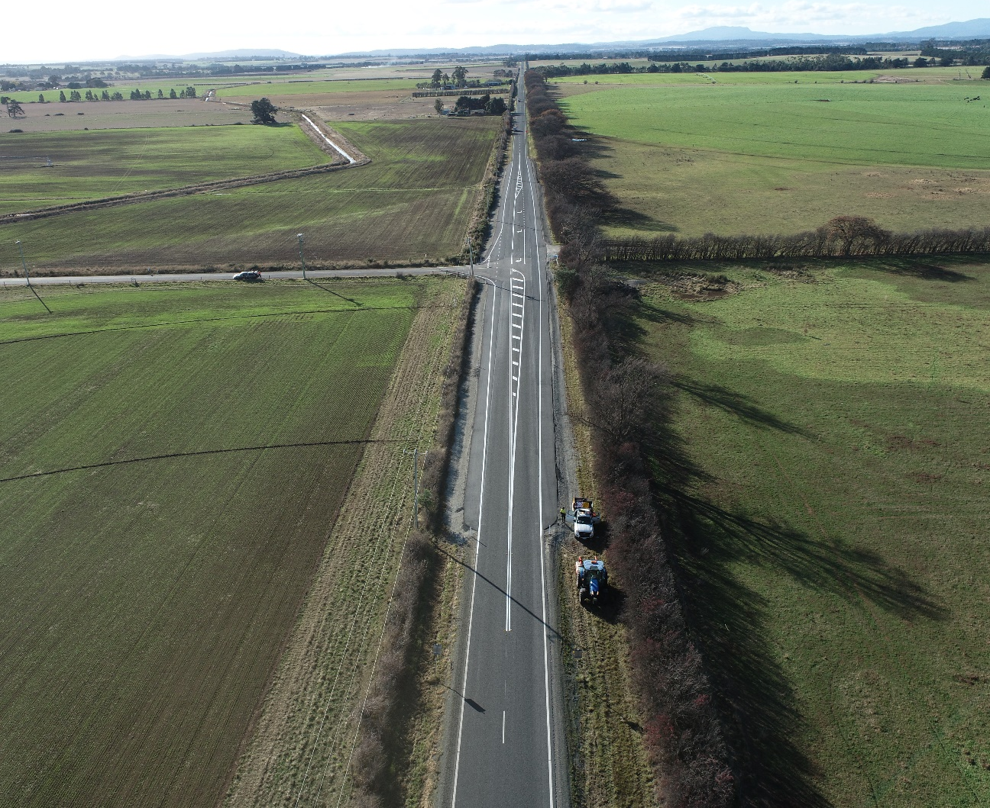
Reducing the likehood and severity of junction crashes is a key focus for improving safety on rural roads. The provision of deceleration, acceleration lanes and turning lanes are proven to reduce crash occurrence and/or crash severity.

Budget summary
Throughout 2021-22, $2.7 million was spent under the ‘Making Rural Roads Safer theme’.
Chart 1 – Making our Rural Roads Safer theme, FY 21/22 Road Safety Levy Expenditure

Improving safety in our towns and cities
Tasmania’s population is growing, and our towns and cities are busier than ever. The Tasmanian Government is investing over $31 million in projects and programs to improve road safety in our towns and cities.

Summary of initiatives

Expand the Vulnerable Road User Program
The Vulnerable Road User Program (VRUP) enables local governments to apply for funding for small-scale infrastructure treatments to improve road safety for vulnerable road users, such as pedestrians, cyclists and motorcyclists. The program aims to improve safety at conflict points such as crossings and provide infrastructure to separate pedestrians and cyclists from motorised traffic.
Typical infrastructure treatments include the installation of pedestrian crossing infrastructure (such as median pedestrian refuges and wombat crossings) and the construction of off-road shared-use paths to separate vulnerable road users from vehicle traffic.
Under the 2020-2021 rounds of the VRUP, projects were supported by considerable co-funding under the Australian Government’s RSP. This led to 71 projects being delivered concurrently under the program and the delivery of these projects has continued into 2021-2022.
Consistent with the SRRP, many of the VRUP projects were impacted by supply chain and market constraints and therefore further rounds of the VRUP in 2021-2022 were postponed to 2022-2023. This ensured that local government could action projects already in progress under the program and impacts did not extend to additional projects.

Community Road Safety Grants Program
The Community Road Safety Grants Program (CRSGP) aims to provide community groups across Tasmania with the opportunity to develop and deliver small scale local road safety programs within their communities consistent with the Towards Zero Strategy.
Funded programs include educational programs targeted at learner driver behaviours, child restraint safety, motorcycle learners’ programs and road safety messages aimed at vulnerable road users.

Conduct infrastructure upgrades on high volume state roads
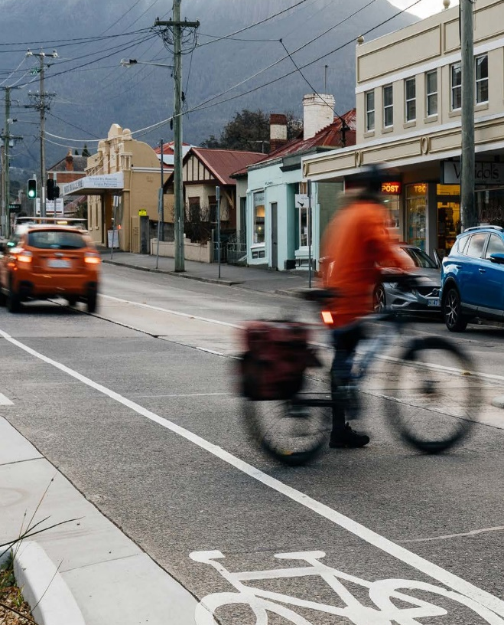
The Safe System Infrastructure Strategy provides for safety improvements on higher volume state roads that are not a
priority for significant upgrades in the short to medium term.
The program focuses on low-cost infrastructure treatments including improved delineation (signs and lines),
curve treatments, roadside hazard removal, limited
shoulder sealing, safety barrier and junction upgrades.
In 2021-2022, we saw the continued delivery of shoulder sealing upgrades to Railton Main Road. The package of works on Railton Main Road included a one metre sealed shoulder with a half-metre unsealed verge, basic right turn treatments
at several junctions and safety barrier installations at identified roadside hazards.
We also saw the delivery of pavement marking works on
local roads across Tasmania.

Budget summary
Throughout 2021-22, $7.2 million was expended under the ‘Improving Safety in our Towns and Cities’ theme.
Chart 2 – Improving Safety in our Towns and Cities theme, FY 21/22 Road Safety Levy Expenditure
Note: The Vulnerable Road User Program (VRUP) is omitted for clarity purposes - resulting from transfers between the Road Safety Levy and funding provided under the Australian Government’s Road Safety Program.

Saving young lives
Tragically, on average, 92 young road users (17 – 25 years) suffer serious casualties on Tasmanian roads every year.
To reduce this harm, the Tasmanian Government is investing over $12 million in programs and projects.
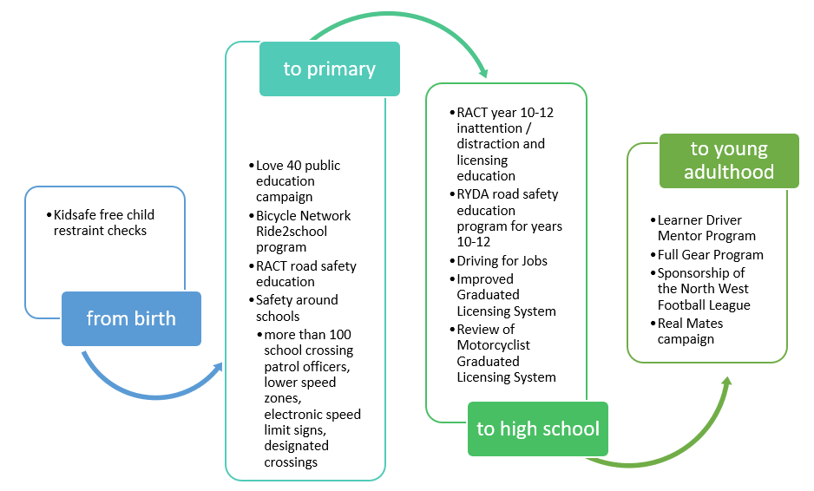
Under the Action Plan, there are a number of programs that aim to promote road safety awareness and save young lives.

Summary of initiatives

Improve the Graduated Licensing System (GLS)
Commenced in 2017, the GLS review’s primary goal is to reduce serious casualties for young road users (17 – 25 years) on Tasmanian roads. The project enhanced the Tasmanian GLS to include internationally recognised best practice measures.
The Tasmanian Government implemented regulatory changes to the GLS on 1 December 2020. Tasmania’s GLS now meets the ‘enhanced’ model under the national driver GLS policy framework. The GLS changes were accompanied by a public education campaign explaining the policy changes and how they would apply to current and new learners.
Complementing the policy changes are three digital products that were progressively launched from July 2021.
The Plates Plus online learning and assessment platform was designed to improve learner driver education by focusing on developing safe behaviours and attitudes. It is an innovative tool that takes users through a series of interactive exercises to ensure new drivers know the road rules and understand the impact of the fatal five road behaviours. As of 30 June 2022, more than 12 000 people had successfully completed the Plates Plus course since its launch on 8 July 2021.
A public education campaign accompanied the launch of the Plates Plus platform and ran until September 2021. The campaign encouraged take-up by promoting the convenience of the platform, which is accessible from any device connected to the internet.
The Plates Plus logbook app launched in November 2021. For many Tasmanian learners, this will replace the existing hard copy logbook. It provides an easy and efficient way to record supervised driving hours during the learner licensing phase. A public education campaign targeting 15 to 25-year-olds accompanied the launch of the Plates Plus logbook app. To engage with this age group, the campaign focused on selected social media platforms. As of 30 June 2022, the logbook app had been downloaded over 7 000 times (across both Apple and Android devices).
The computer-based hazard perception test (HPT) was launched on 7 March 2022. The HPT is a mandatory assessment that has been introduced to the learner licensing pathway. As of 30 June 2022, over 4 000 people had successfully completed the HPT.
The HPT was the final product to be delivered under the GLS project.

Expand the Learner Driver Mentor Program
The Learner Driver Mentor Program (LDMP) is a well-established program that supports disadvantaged learner drivers to gain their on-road supervised driving hours to obtain a licence.
The LDMP continues to have strong demand. From July 2021 to June 2022, the LDMPs assisted 3 043 participants with learner driver sessions, at an average of 254 participants per month. Participants completed an average of 1 671 on-road hours per month, totalling 20 048 supervised on-road hours. Of these participants, 191 individuals achieved their P1 driver licence, resulting in increased access for participants to their communities, services and places of employment, study or training.
Driver Mentoring Tasmania, the peak body for LDMPs, has progressed the rollout of an information technology platform across all LDMPs, which will greatly improvement data collection, more detailed information on supervisory sessions, and vehicle use. Data collected through this new IT system will inform performance reporting and evaluation.

Develop an improved Graduated Licensing System (GLS) for motorcyclists
A review of the Tasmanian motorcyclist GLS commenced in 2021 to identify potential enhancements to complement the training and assessment curriculum that was implemented in 2017.
The review has two purposes: to ensure motorcyclists are as safe as possible during the novice licensing period and after graduating to a full licence, and secondly to facilitate people entering and progressing through the motorcycle licensing system.
Motorcycle riders represent more than one in five serious casualties on Tasmanian roads despite motorcycles comprising less than one in 20 registered Tasmanian vehicles. There is not yet a nationally agreed policy framework for motorcycle licensing. In order to assess Tasmania’s motorcyclist GLS and identify options for enhancement, the findings of the review will be presented to the RSAC in 2022.
Following initial consideration by the Department of State Growth, the Centre for Automotive Safety Research (CASR) was engaged to conduct a review of the Tasmanian motorcyclist GLS. The findings and recommendations of the review were presented to RSAC at its May 2022 meeting. A discussion paper will be prepared by the Department to guide a public consultation process during August and September 2022.
The public consultation process will seek community feedback on CASR’s recommendations. Feedback will be collated and presented to RSAC at its November meeting, together with a package of options to amend the motorcyclist GLS. This will enable RSAC to provide advice to the Tasmanian Government to improve safety outcomes for young and novice motorcyclists.

Continue to support the Rotary Youth Driver Awareness Program (RYDA)
RYDA is a one-day road safety education program for students in year 10 – 12. RYDA makes these students aware of the significant responsibility that comes with being a driver or passenger. Rotary Tasmania organises and delivers RYDA and every year 4000 students take part in practical demonstrations and learn valuable road safety lessons from expert presenters and volunteers.
Rotary has reported increased interest in the program since the commencement of the five-bonus learner licence logbook hours for attending the program under the GLS.

Continue the Driving for Jobs Program
The Driving for Jobs (DfJ) Program supports disadvantaged students who would otherwise be unable to enter and progress through the GLS. The program provides students at selected schools with the opportunity to increase their road safety knowledge whilst also improving their job readiness. Students undertake a road safety focussed learning program, including professional on-road driving lessons and participation in the RYDA Program.
The DfJ Program operates at Jordan River Learning Federation (JRLF) in the South and expanded to Claremont College in term four 2021. It operates at Launceston and Newstead Colleges in the North. For the school year 2021, 238 students engaged with the program which resulted in 967 hours of fully funded driving lessons being delivered from accredited driving schools. A total of 49 students obtained their learner licence and 34 students gained their P1 licence.
The delivery of fully funded driving lessons to students in 2022 did not commence until term two due to the impact of Covid-19 on school operations and difficulties in obtaining a driving school. During term two 2022, 164 students engaged with the program which resulted in 413 hours of fully funded driving lessons. A total of 18 students obtained their learner licence and 8 students gained their P1 licence.

Provide funding for the RACT education initiatives
The RACT delivers a range of in-class road safety education programs. These include a program for students in years 10 – 12 and focuses on the dangers of distraction and inattention. The program also teaches students how to progress through the GLS and about the specific rules that apply to L and P plate drivers.

Continue the Real Mates media campaign
MAIB funded the Real Mates campaign in 2021–22. The campaign uses humour and engages with young men to encourage them to avoid the risks of drink driving by encouraging them to speak up and stop a mate from driving after drinking.
The Real Mates sponsorship of Vibestown and the Hobart Hurricanes saw the promotion of the Real Mates message at three summer music festivals in Hobart and Launceston and Blundstone Arena from December 2021 to March 2022.
A new iteration of Real Mates is in development and will be launched in September 2022 to coincide with AFL finals.

Support Bicycle Network Tasmania
The Bicycle Network delivers the Ride2School program to schools across Tasmania. Ride2School is for primary aged students and focuses on safe cycling, road safety and positive road sharing behaviour.
The Ride2School program in Tasmania continues to have a positive impact in schools, despite some challenges still remaining through the pandemic. During the 2021-2022 financial year, a total of 90 Bicycle Education workshops were completed across the state.
There was a mix of new and currently engaged schools taking up the program, including new initiatives where Bicycle Education workshops were run with the Migrant Resource Centre in Launceston and a school holiday care program in Richmond during the October school holiday period.

Keep school children safe on the roads
Safety around schools is promoted through designated crossings, lower speed zones, more than 100 school crossing patrol officers and public education. The Safety around Schools project, including the Love 40 campaign, encourages drivers to reduce their speed and keep a look out for children in school zones and around buses.
‘Back to School’ 2022, was launched at St Thomas More’s Catholic Primary School on 1 February 2022 by the Deputy Premier and Scott Tilyard, Chair, Road Safety Advisory Council. This was complemented by the Love 40 campaign on television, radio and social media before and after the commencement of Term 1. Love 40 was again screened at the commencement of the following school terms.

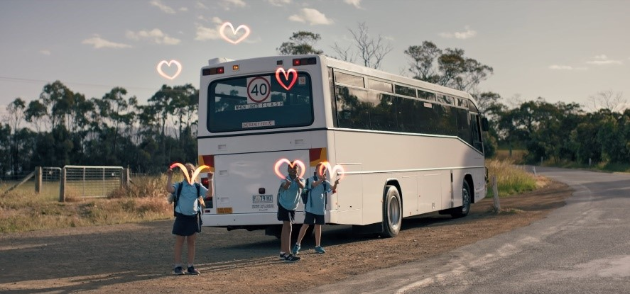

Support Kidsafe child restraint checks
Kidsafe Tasmania conducts free child restraint checking sessions to ensure that young children are safely and lawfully seated and restrained in cars. Kidsafe also distributes educational materials to inform the community of the correct child restraint type for a child’s age and size.
Kidsafe continues to provide free child restraint checks and education with a trained child restraint fitter at community organisations and via outreach services. Free training is provided to professionals regarding regulatory requirements and good practice approaches to child restraints.
Kidsafe has developed complementary easy-to-read hardcopy restraint guides, which are provided to parents and carers to encourage the correct purchase of restraints suitable to a child's height and weight.

Encourage safe and legal motorcycle riding
The Glenorchy City Council (GCC), in partnership with Bucaan House, delivered its successful Full Gear motorcycle safety project, which helps young motorcycle riders enter the licensing system and to adopt safe riding practices.
Full Gear - GCC conducted the Full Gear program in March 2022, with an additional session to be held in August 2022. The Full Gear – GCC Coordinator assisted with expansion of pilot programs in New Norfolk and Bridgewater. Reporting for the 2021-22 financial year is due in November 2022.
Full Gear has been expanded to include a southern P plates program for 2022. A Skills Day is scheduled for November with learner riders and mentors from Tasmania Police.

Budget summary
Throughout 2021-22, $2.1 million was spent under the ‘Saving Young Lives’ theme.
Chart 3 – Saving Young Lives theme, FY 21/22 Road Safety Levy Expenditure

Note: Payment of $250 000 to the Driving for Jobs Program will be paid in August 2022 (FY 2022-2023).

Encouraging safer road use
Each road user has a responsibility to use roads in ways that are safe for those around them. In 2020-21 the Tasmanian Government committed over $4 million to improve road user behaviour.

Summary of initiatives

Investigate strategies to address inattention and distraction
Inattention and distraction are concerning causes of serious casualty crashes and may have a far greater impact than available data suggests.
Enforcement activity and public education aims to build awareness of the dangers of inattention and distraction for all road users.
Public education
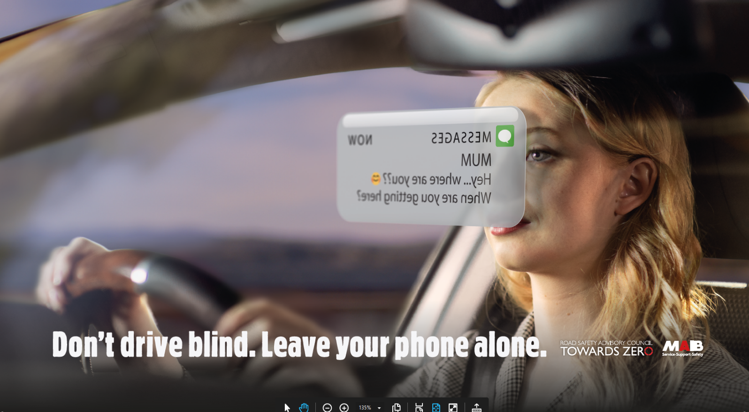
The distraction campaign ‘Don’t Drive Blind’ continued through 2021-22. This was accompanied by social media throughout the campaign.

Enforcement
Tasmania Police continues to utilise both overt and covert means to detect and enforce inattention and distraction amongst drivers. Social media messaging and regular engagement with traditional media outlets consistently highlight the increased risks of drivers being involved in serious and fatal crashes whilst distracted. This coupled with our ‘Enough is Enough’ campaign continues to send a strong message regarding Tasmania Police’s commitment towards securing safer roads for all road users.

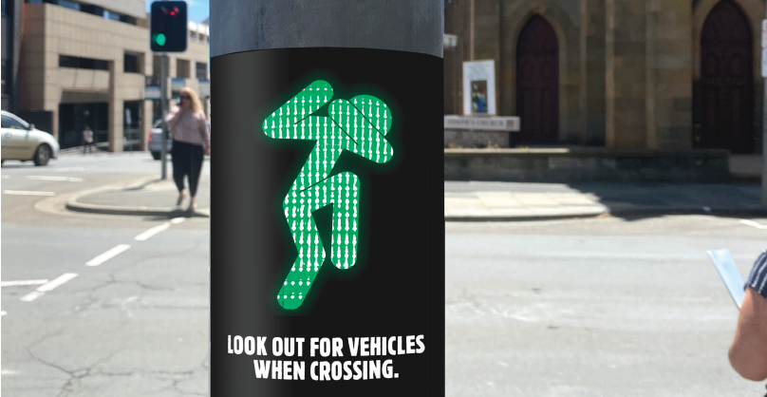
Promote safe behaviours through campaigns
Targeted media campaigns continued to inform road users about high-risk behaviours and to highlight the dangers of the ‘Fatal Five’. A pedestrian safety campaign was launched on 1 September 2021 to encourage both pedestrians and drivers to look out for each other on the road.
A motorcycle safety campaign was launched on 10 October 2021 to inform riders on the risks when riding and the importance of riding safely. The campaign is supported by TV, social media, and posters in pubs and venues on popular motorcycle touring routes.
In preparation for the introduction of enhanced speed enforcement in Tasmania the new ‘Over is Over’ public education campaign was launched in December 2021. The first phase of the campaign challenged motorists to rethink their attitudes to speeding and showed how exceeding the speed limit even by a few kilometres can lead to unintended negative consequences. A second phase of the campaign launched in June 2022 to coincide with the implementation of the new mobile speed camera program and serves as a reminder to drivers and riders that the law is the law and speeding will no longer be ignored.
Over is Over aims to reduce road trauma by highlighting the dangers of speeding and supporting the re-introduction of mobile speed cameras in Tasmania. The campaign is supported by TV, radio, press, digital and outdoor advertising.
On 1 December 2019, the Tasmanian Government introduced a new road rule, Rule 79A of the Road Rules 2019. The introduction of Rule 79A makes it an offence for drivers to pass a stationary or slow-moving emergency vehicle displaying a flashing red, blue or magenta light or sounding an alarm, at speeds greater than 40 km/h. In 2021-22 amendments to Rule 79A were approved to:
- require drivers to slow to 40km/h when passing roadside assistance service vehicles displaying a flashing amber light
- clarify drivers must slow to 40km/h when passing vehicles in accordance with the rule on high-speed roads (above 80km/h) unless it is not practicable
- create offences for the rules contained in 79A.
A new campaign was also developed to educate the community about changes to this Road Rule.
Promote protective clothing for motorcyclists
Motorcyclists are significantly over-represented in Tasmania’s road trauma figures. One of the reasons for this is that riders are more likely to be injured in a crash due to a lack of physical protection. The Tasmanian Government continues to work to reduce the risks to motorcyclists through a range of actions, including supporting the work of MotoCAP to promote the use of protective clothing. MotoCAP provides safety assessment star ratings for protective clothing and prepares education materials for motorcyclists. Protective clothing can reduce injury severity in the event of a crash.
In 2021-22, several thousand public education brochures advising of clothing safety ratings for motorcycle wear were distributed to motorcycle retailers and relevant stakeholders across the state.
A redraft of the successful brochure has commenced to update references to global safety standards and changes in best practice.
Ensure participation in the Mandatory Alcohol Interlock Program
The Mandatory Alcohol Interlock Program (MAIP) aims to have repeat and high-level drink driving offenders demonstrate that they can separate their drinking from driving through the installation of an alcohol interlock in their vehicle. Participation rates are less than optimal as participants often seek exemption from the obligation to have an interlock installed on the grounds of severe hardship. Amendments are being sought to the regulatory framework to clarify the exemption framework available to participants. Regulatory clarification will also enable diligent assessment of exemption claims.
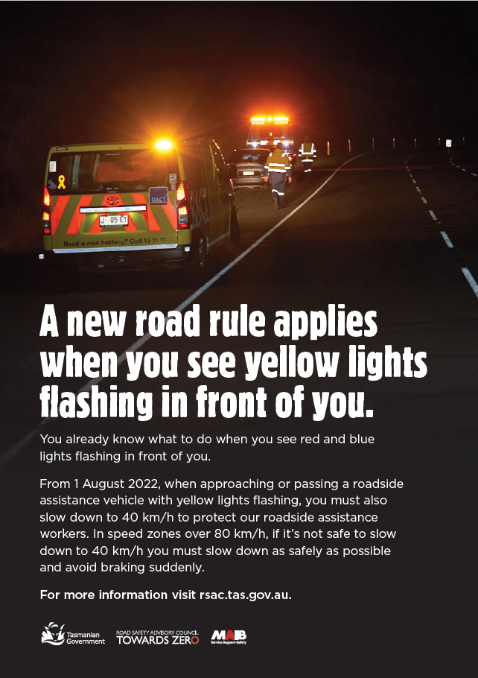
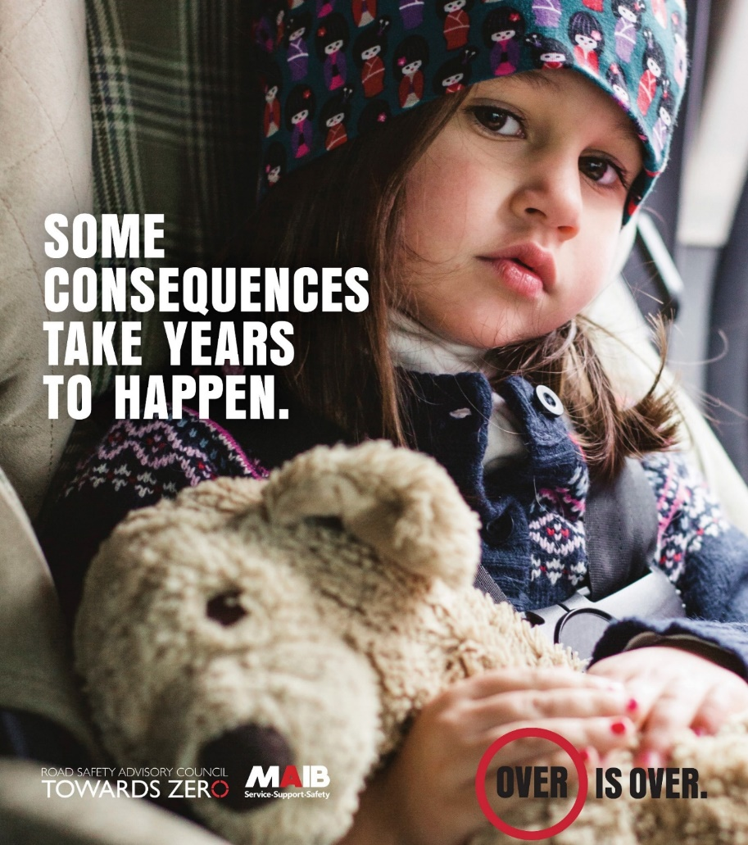

Implement a new speed enforcement strategy
Speed enforcement remains one of the key priorities for Tasmania Police in its aim to improve driver behaviour through traffic enforcement. During 2021-22 Tasmania Police charged 34 450 motorists for speeding. 21 456 of those motorists were speeding in excess of 15 kilometres above the posted speed limit with 1 014 of those travelling in excess of 30km/h above the limit.
Tasmania Police conducted a restructure of its traffic enforcement capability during 2021-22 which, coupled with its partnership with State Growth on the automated speed enforcement project, has seen a substantial increase in Tasmania Police’s capability to monitor, interdict and prosecute those who speed excessively and place themselves and others at risk.
Improve enforcement of high-risk behaviours
In 2021-22, Tasmania Police detected 29 588 high-risk traffic offenders. Coupled with the traffic policing restructure and the introduction of the new highway patrol vehicles, Tasmania Police is committed to targeting those who place themselves and others in harm‘s way.
In total, Tasmania Police prosecuted 52 009 traffic offenders in 2021-22 which included:
- 1 108 motorists for not wearing their seatbelt
- 2 326 motorists for using a mobile phone whilst driving
- 3 687 motorists for disqualified, suspended or unlicensed driving
- 3 786 motorists for drink and drug driving; and
- 105 motorists for dangerous or reckless driving.
Investigate an enhanced automated speed enforcement strategy
Automated Speed Enforcement (ASE) is relatively underutilised as a deterrence and enforcement mechanism in Tasmania. This project investigates proven and emerging speed camera technologies for use at high-risk locations and across the entire road network.
Network analysis and modelling were undertaken to determine camera locations that would provide the greatest effect on reducing crashes on our roads.
In September 2021, a formal Request for Tender was undertaken to identify a suitable supplier of mobile speed camera enforcement services and on 30 May 2022 Sensys Gatso Australia was contracted to provide mobile speed camera enforcement services for a minimum period of two years.
Enforcement services being provided by Sensys Gatso Australia include a minimum of 20 000 speed enforcement hours using eight mobile speed cameras. Additional services including mobile phone, seatbelt and average speed enforcement are to be considered over the course of Sensys Gatso Australia’s contacted period.
As of 30 June 2022, Sensys Gatso Australia had completed multiple deliverables under the required projects Transition-In activities including: recruitment and training of camera operators; roadside camera testing; establishing operational offices in both Hobart and Launceston; and delivering four mobile speed cameras to Tasmania.

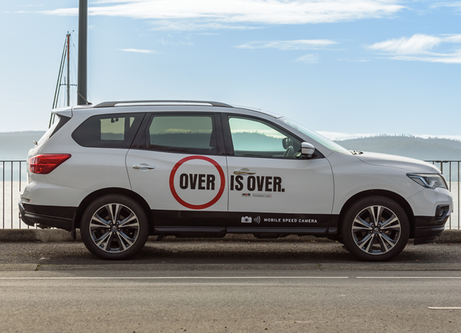
Continue to promote
the Road Rules
Compliance with Road Rules makes road user behaviour predictable and improves safety for all road users. User-friendly and tailored resources are developed for existing and new Road Rules that come into effect so that the rules are easily understood and adhered to by all road users. Resources, including the Tasmanian Road Rules Handbook, Top Ten Misunderstood Road Rules and the Five More Misunderstood Road Rules pamphlet are distributed to Service Tasmania locations when required.

Budget summary
Throughout 2021-22, $2.1 million was spent under the ‘Encouraging Safer Road Use’ theme.
Chart 4 – Encouraging Safer Road Use theme, FY 21/22 Expenditure
Note: Includes funding from the Motor Accident Insurance Board (MAIB) towards road safety campaigns and public education.

Making visitors safer
11 per cent of all serious casualties on Tasmanian roads are non-Tasmanian residents. The Tasmanian Government is investing $2 million in initiatives to support the education and safety of visiting road users including interstate drivers and riders, international drivers and for others new to Tasmania such as students and seasonal workers.

Summary of initiatives

Develop effective and engaging education materials
A range of education materials has been developed aiming to make visiting road users safer. The multi-lingual education material has been delivered to the international visitor audience through targeted communication channels. These include vehicle hangers, brochures, posters, roadside signs, editorial content, film, and digital content. Communications materials continued to be distributed upon request from stakeholders.

Attract visitors’ attention by focusing activity on gateway entry points
Being an island state, Tasmania has the unique advantage of strategically placing essential road safety messages at its gateway airports and seaports to reach visitors before they drive in Tasmania. This includes a range of educational materials, electronic and static signs, and billboards. Printed collateral is available and digital billboards display road safety messaging at gateway locations.

Budget summary
Throughout 2021-22, $157 000 was expended under the Making Visitors Safer theme.
Chart 5 – Making Visitors Safer theme, FY 21/22 Road Safety Levy Expenditure
Improving safety through vehicles and technology
Advances in vehicle design and technology are helping to prevent crashes from occurring and better protecting all road users in Tasmania. The Tasmanian Government is committing over $3 million to support and encourage Tasmanians to drive safer vehicles.

Summary of initiatives

Continue to support ANCAP
Tasmania has the oldest vehicle fleet in Australia. This is concerning because the rate of fatal crashes per registered vehicle is four times higher for vehicles aged 15 years or older than for vehicles aged five years old or less.
Tasmania is a member of the Australasian New Car Assessment Program (ANCAP). ANCAP plays a vital role in informing consumers of the differences in the safety performance of new vehicles entering the Australasian vehicle fleet. Furthermore, ANCAP also advocates for improved vehicle safety design and specification through public education campaigns, advocacy activities and engagement with governments, corporate fleets, the media and consumers.

Develop a Light Vehicle Safety Strategy
Tasmania has the oldest vehicle fleet in the country with an average age of 12.8 years. This means more time and resources must be expended maintaining the roadworthiness of Tasmania’s older vehicles and that many Tasmanians are not benefiting from the latest vehicle safety features.
A light vehicle safety strategy is currently being developed to improve the crashworthiness and roadworthiness of the Tasmanian light vehicle fleet.
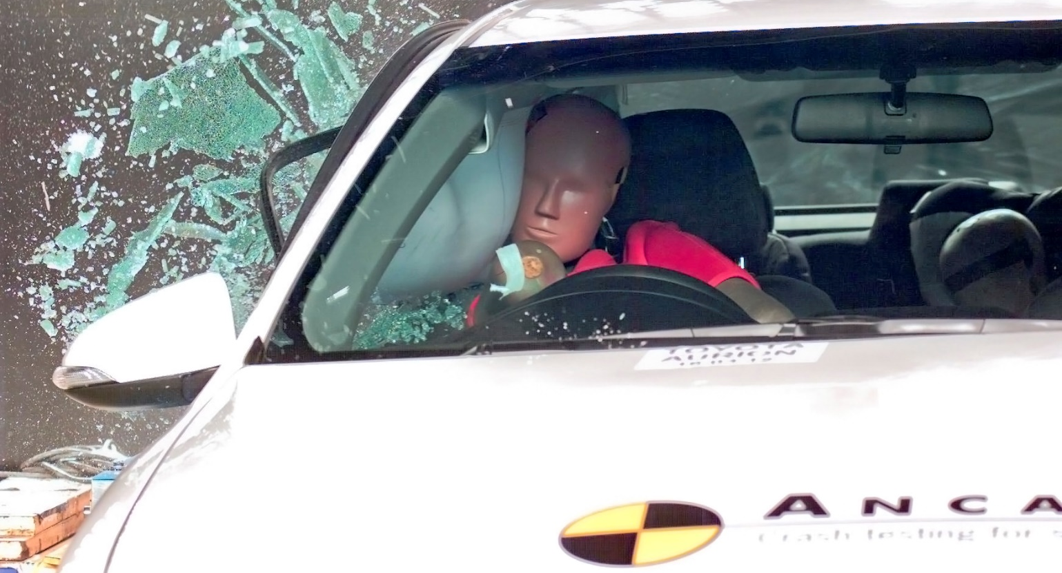
The strategy aims to accelerate an increase in the number of newer and safer vehicles and removal of older cars from the light vehicle fleet while increasing the safety of the current vehicle fleet.

Monitor developments in vehicle technology
Modern vehicles are increasingly equipped with technology that can improve safety. New features help drivers to adhere to the speed limit, minimise blind spots, reduce distraction and monitor signs of driver fatigue. Vehicles with crash avoidance technologies can alert the driver to potential hazards, give the driver more control in emergency situations and act autonomously to prevent a collision. These types of vehicle technology are evolving rapidly and have the potential to greatly reduce road trauma.
The aim of this initiative is to monitor autonomous vehicle and crash avoidance readiness in Tasmania to ensure that Tasmanian infrastructure and laws are compatible with emerging technologies. The regulation of autonomous vehicles is being considered at a national level, and Tasmania is participating in this process.

Budget summary
Throughout 2021-22, $12 245 was expended under the Improving Safety through Vehicles and Technology theme. This supported activities of ANCAP. Other deliverables under this theme are being developed.
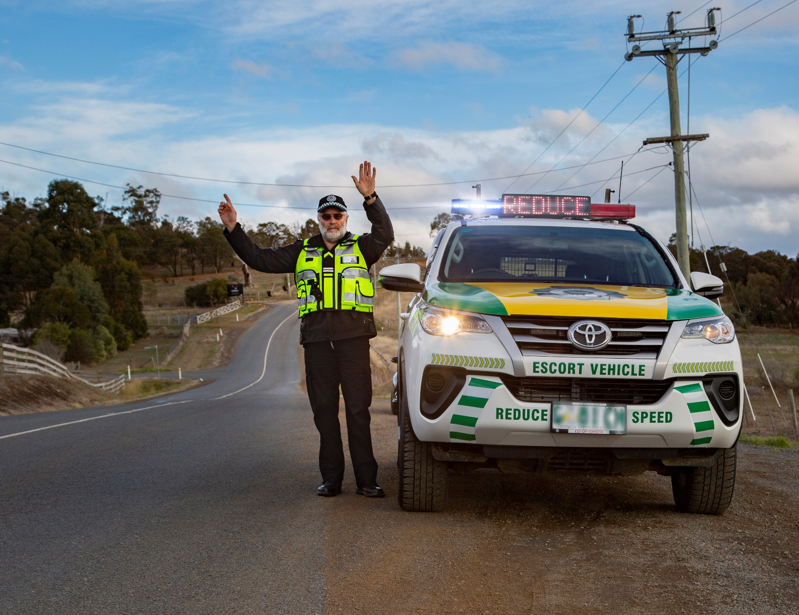

Road safety levy budget overview

Funding
Road safety initiatives in Tasmania are funded through collection of the Road Safety Levy, funding from the Motor Accidents Insurance Board (MAIB) and from the Australian Government’s Road Safety program (RSP).

The Road Safety Levy
The delivery of initiatives under the Action Plan are largely funded by the Road Safety Levy which supports the Towards Zero – Tasmanian Road Safety Strategy 2017-2026, as the primary road safety funding source through to 2026.
The Road Safety Levy applies to all eligible registered vehicles with general access to the road network. The Road Safety Levy is collected from vehicle registrations and is to be expended for the purposes of road safety. The Road Safety Levy raises around $15 million per annum and increases relative to Hobart CPI.

Approved budget for FY 2021-22
The RSAC approved the 2021-22 Action Plan budget on 18 May 2021. On the advice of RSAC, the Minister for Infrastructure and Transport approved the budget on 20 June 2021.
At the start of 2021-22, approximately $17 million was available from the road safety levy to expend on road safety in Tasmania. Throughout the year approximately $16.3 million was collected from registrations.
In 2021-22, a total of $14.9 million was collectively expended from road safety levy and MAIB funding. This saw nearly $9.7 million spent on infrastructure improvements across Tasmania and over $5.2 million spent on the delivery of road safety policy and projects.
At 30 June 2022, the road safety levy recorded a balance of approximately $17.3 million.
The table below provides a detailed financial summary of 2021-22 revenue and expenditure.

Additional Expenditure
The Minister for Infrastructure and Transport approved $250 000 from the Road Safety Levy for a public safety education campaign to support the introduction of personal mobility devices as of December 2021.

Revenue and Expenditure for the Financial Year 2021-22

Road Safety Levy Opening Summary
Opening Balance as at 01 July 2021 |  |  | $ 17,013,469
Annual Allocation to Road Safety Operations |  |  | $ 2,600,000

Revenue Summary
 |  | Forecast (FY22) | Actual (Y.T.D.)
Motor Accidents Insurance Board Funding |  | $ 1,300,000 | $ 1,528,521
Revenue Inflows from Registrations |  | $ 14,875,906 | $ 16,300,008
RSP Funding |  | $ 19,025,000 | $ 15,800,000
Funds Available for Distribution |  | $ 30,589,375 | $ 32,241,998

Expenditure Summary
Theme no. | Theme | Forecast (FY22) | Actual (Y.T.D.)
1 | Making our Rural Roads Safer | $ 3,371,975 | $ 2,701,913
2 | Improving Safety in our Towns and Cities | $ 9,311,480 | $ 7,151,042
3 | Saving Young Lives | $ 2,893,830 | $ 2,081,191
4 | Encouraging Safer Road Use^ | $ 2,142,665 | $ 2,138,147
5 | Making Visitors Safer | $ 705,617 | $ 156,520
6 | Improving Safety Through Vehicles and Technology | $ 175,510 | $ 12,245
7 | General Support | $ 929,821 | $ 656,323
Budget and Expenditure by Category |  | Forecast (FY22) | Actual (Y.T.D.)
Infrastructure Expenditure* |  | $ 12,638,476 | $ 9,650,215
Policy & Projects Expenditure* |  | $ 7,090,415 | $ 5,247,167
Total Expenditure |  | $ 19,728,892 | $ 14,897,382
Balance as of 30 June 2022 |  | $ 10,860,483 | $ 17,344,616
Forecast Closing Balance of FY22 |  | $ 10,860,483
Note: The above includes MAIB expenditure.
*Includes allocations to ‘ceasing activities’ from the Towards Zero Action Plan 2017-2019
MAIB Funding as at 30 June 2022
2021/22 Financial Year | Budget  $ | Actual (ytd)  $ | Balance  $
Expenditure (State Growth)
Administration & Public Relations | 368 116 | 259 366 | 108 750
Public Education | 958 682 | 1 555 452 | (596 860)
Research | 160 000 | 113 703 | 46 297
Subtotal | 1 486 798 | 1 528 521 | (41 723)
Expenditure (Tasmania Police)
Salaries | 2 032 291 | 1 986 288 | 46 003
Operating Expenses | 188 000 | 111 637 | 76 363
Equipment | 539 708 | 248 195 | 291 513
Subtotal | 2 759 999 | 2 346 119 | 413 879
Total | 4 246 797 | 3 874 640 | 372 156
Includes Carried Forward of
- $107 614 (State Growth)
- $82 749 (Police)

List of Acronyms
Action Plan | Towards Zero Action Plan 2020 - 2024
ANCAP | Australian New Car Assessment Program
ASE | Automated Speed Enforcement
CEO | Chief Executive Officer
CRSG | Community Road Safety Grants
DfJ | Driving for Jobs
GLS | Graduated Licensing System
HPT | Hazard Perception Test
ITS | Intelligent Transport System
JRLF | Jordan River Learning Federation
LDMP | Learner Driver Mentor Program
MAIB | Motor Accidents Insurance Board
MAIP | Mandatory Alcohol Interlock Program
RSAC | Road Safety Advisory Council
RSP | Road Safety Program
RYDA | Rotary Youth Driver Awareness
SRRP | Safer Rural Roads Program
State Growth | The Department of State Growth
Towards Zero Strategy | Towards Zero - Tasmanian Road Safety Strategy 2017-2026
VRUP | Vulnerable Road User Program
Road Safety Advisory Council  Department of State Growth | GPO Box 536 Hobart  Tas 7001 Australia  Phone: 1800 030 688  Email: rsac@stategrowth.tas.gov.au  Web: rsac.tas.gov.au

See Towards Zero Strategy at https://www.rsac.tas.gov.au/about-us/towards-zero-strategy/
See Action Plan at https://www.rsac.tas.gov.au/about-us/towards-zero-strategy/

