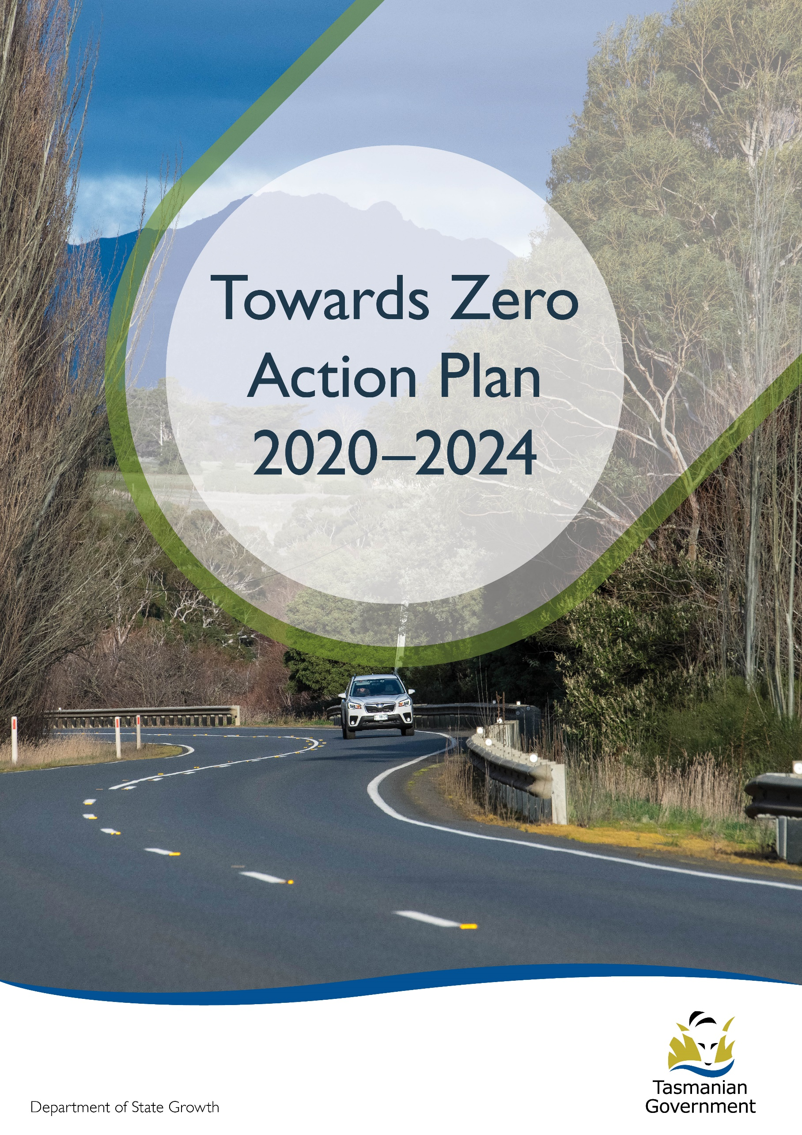
Quarterly Progress Report to RSAC as at 31 December 2022
Contents
Progress on meeting Towards Zero Strategy targets 3
Serious Casualties 3
Fatalities 3
Fatalities Tasmania – Annual Count – 2022, 2021 and 5-Year Average (2017-21) 3
Serious Casualties Tasmania – Annual Count, Percentage Split by Quarter and Towards Zero Target 4
Progress on meeting MAIB targets 6
Fatalities – 12 Month Rolling Total 6
Total Serious Claims – 12 Month Rolling Total 6
Statistics 7
Serious Casualties by Quarter by Age Group – 12 period moving average 7
Serious Casualties by Quarter by Sex – 12 period moving average 7
7
Serious Casualties by Quarter by Road User Type – 12 period moving average 8
Serious Casualties by Quarter by Speed Zone – 12 period moving average 8
Serious Casualties by Quarter by Crash Type (DCA) – 12 period moving average 9
Serious Casualties by Quarter by Urban/Non-Urban – 12 period moving average 9
Serious Casualty locations to 31 December 2022 (Black = Fatality, Red = Serious Injury) 10
Key themes and priority actions 2020-2024 11
Funding of key themes 11
Project status report 12
Progress on key themes 13
Rural roads grants program for local government 13
Infrastructure upgrades on low volume State roads 14
Motorcyclist safety on rural roads 14
Speed moderation and community engagement strategy 15
Safe system knowledge and skills training 15
Targeted infrastructure upgrades in high traffic urban areas 17
Vulnerable Road User Program 17
Community Road Safety Grants Program 18
Trial of innovative technologies 18
Innovative infrastructure treatment demonstrations 19
Learner Driver Mentor Program and Driver Mentoring Tasmania 20
Graduated Licensing System Project 20
Motorcyclist Graduated Licensing System review 21
Rotary Youth Driver Awareness Program (RYDA) 21
Driving for Jobs Program 22
RACT education initiatives 22
Real Mates media campaign 23
Bicycle Network bike education 23
Safety around schools 23
Kidsafe child restraint check program 23
Full Gear motorcycle safety project 24
Inattention and distraction 25
Safe behaviour campaigns 26
Mandatory Alcohol Interlock Program (MAIP) 26
Protective clothing for motorcyclists 27
Road safety penalties review 27
Speed enforcement strategy 28
Enforcement of high-risk behaviours 28
Automated Traffic Enforcement Program 29
High-risk motorcycling enforcement 29
Road Rules Awareness 30
Tourist road safety signage program 31
Responsive electronic signage trial 31
Tourist education materials 31
Strategic partnerships 32
Tourist education at gateway entry points 32
Stakeholder alliances 32
Australasian New Car Assessment Program (ANCAP) 33
Safer cars for young drivers 33
Autonomous vehicle and crash avoidance readiness 33
Workplace driver safety 34
Light vehicle safety strategy 34

Progress on meeting Towards Zero Strategy targets
The key interim target for the Towards Zero – Tasmanian Road Safety Strategy 2017-2026 (Towards Zero Strategy) is to reduce the number of annual serious injuries and deaths on Tasmanian roads to fewer than 200 by 2026. This is an ambitious target of 100 fewer serious casualties per year than for the period 2012-2016 (annual average) and will move us towards the long-term goal of zero serious casualties on Tasmanian roads.

Serious Casualties
The number of serious casualties in 2022 was 314, compared to 286 in 2021, a 9.8 per cent increase. The 2022 figure of 314 is a 4.4 per cent increase on the five year serious casualty average of 300.8 (2017-2021).

Fatalities
In 2022, there were 51 fatalities on Tasmanian roads which is 16 more than the number recorded in 2021. The figure of 51 fatalities in 2022 is a 53.6 per cent increase on the five-year fatality average of 33.2 (2017-2021).

Fatalities Tasmania – Annual Count – 2022, 2021 and 5-Year Average (2017-21)
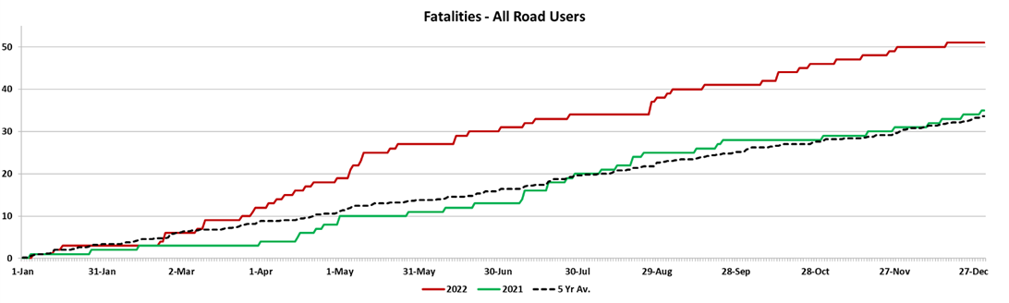

Serious Casualties Tasmania – Annual Count, Percentage Split by Quarter and Towards Zero Target
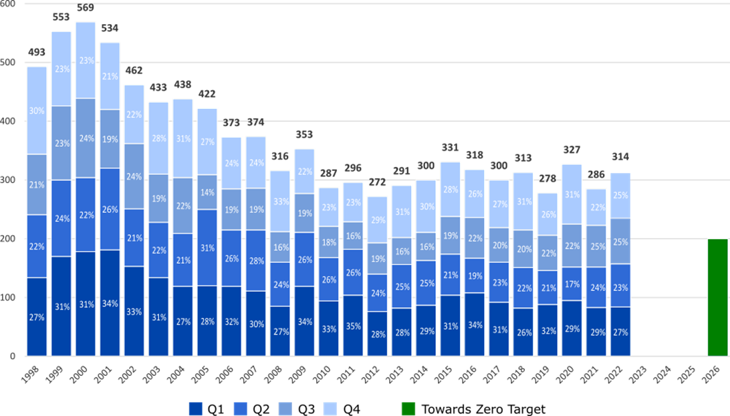
Annual fatalities – Rate per 100,000 population
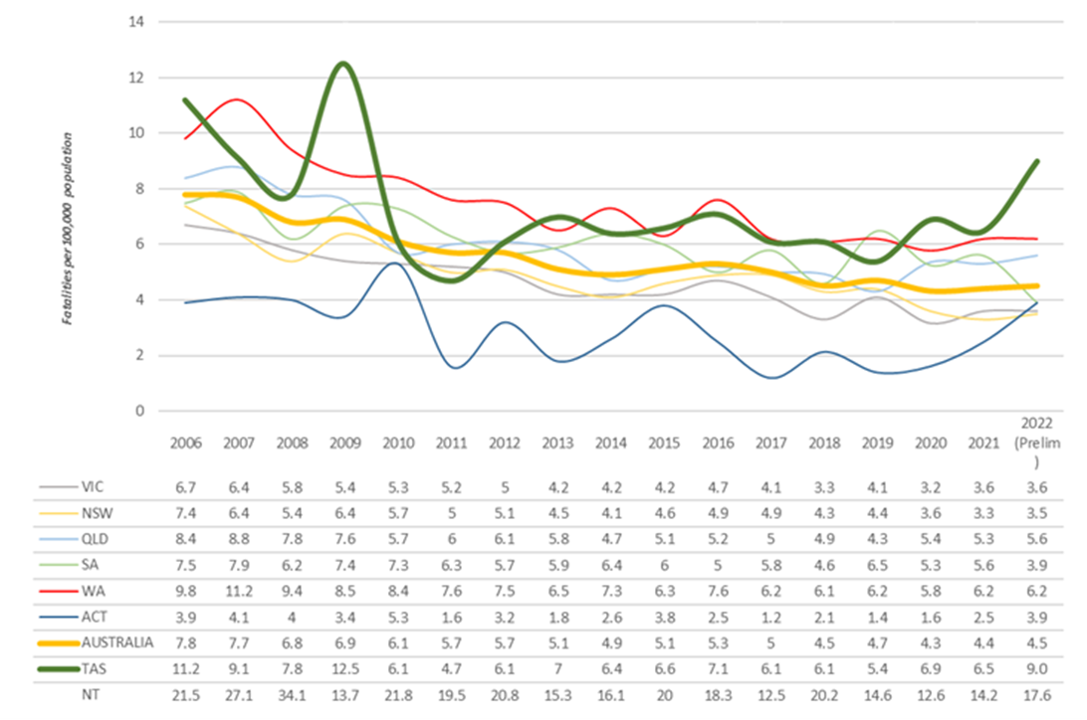

Note: NT omitted from chart for clarity purposes.

Progress on meeting MAIB targets
Motor Accidents Insurance Board (MAIB) injury statistics show the number of fatalities and the level of claims for serious injuries on our roads.
Various claim reduction targets are specified in the Memorandum of Understanding between the Department of State Growth (State Growth) and the MAIB. Progress against high level targets is shown below, expressed as 12 month moving totals

Fatalities – 12 Month Rolling Total
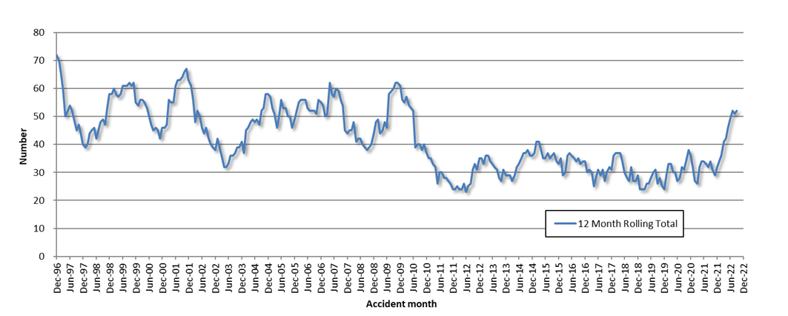

Total Serious Claims – 12 Month Rolling Total
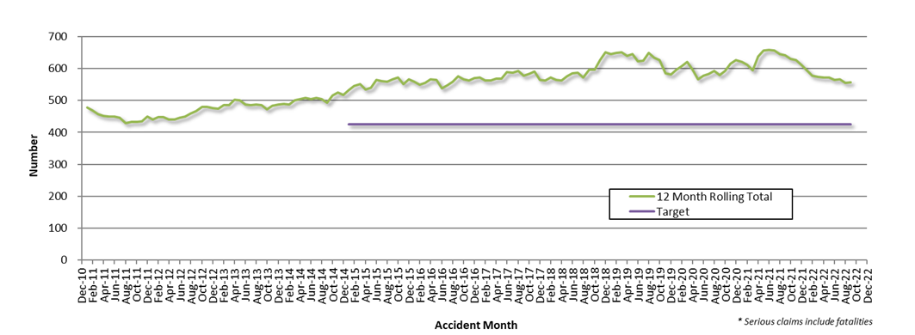

Statistics

Serious Casualties by Quarter by Age Group – 12 period moving average

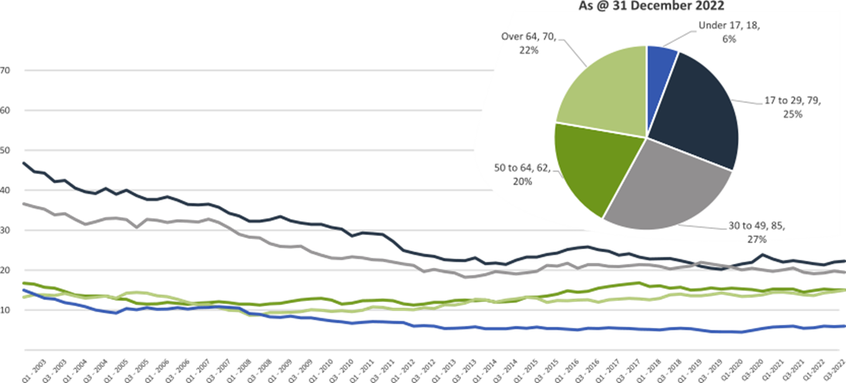

Serious Casualties by Quarter by Sex – 12 period moving average
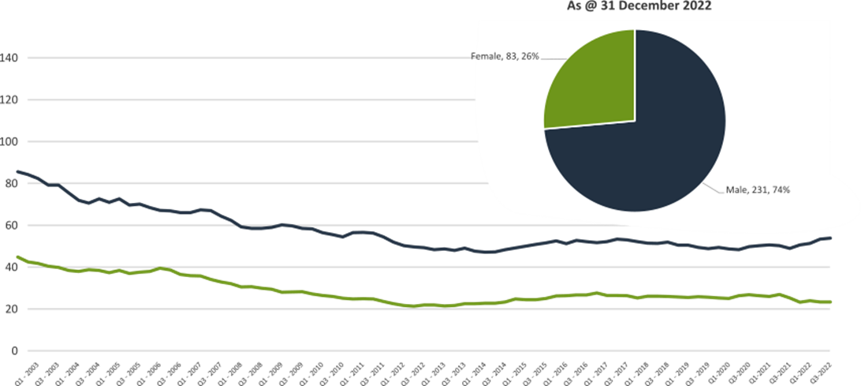

Serious Casualties by Quarter by Road User Type – 12 period moving average
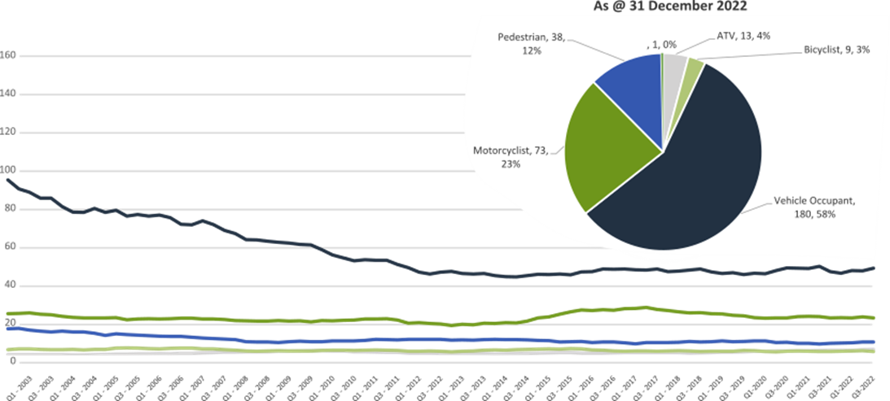

Serious Casualties by Quarter by Speed Zone – 12 period moving average
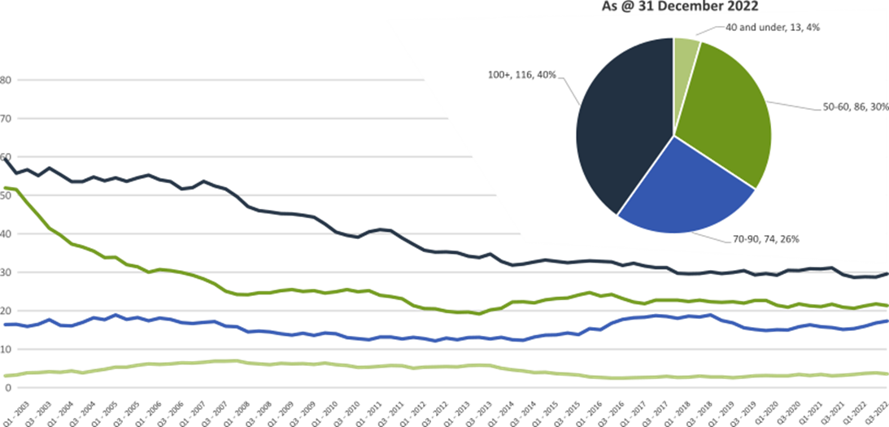

Pie chart excludes serious casualties where speed zone is recorded as ‘not known’

Serious Casualties by Quarter by Crash Type (DCA) – 12 period moving average
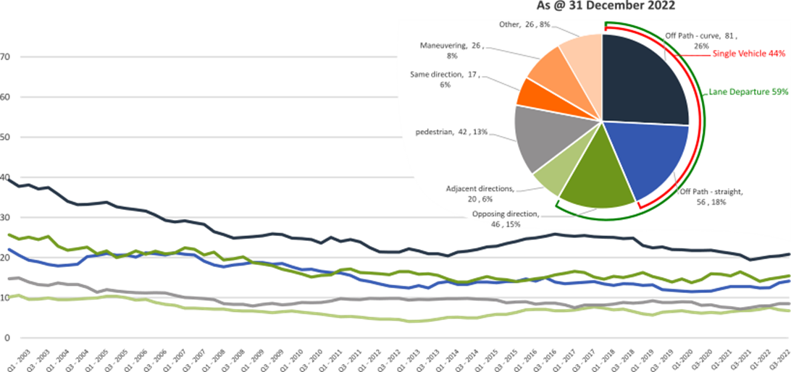

Other includes crash types: on-path (5%), overtaking (1%) & passenger and miscellaneous (2%).

Serious Casualties by Quarter by Urban/Non-Urban – 12 period moving average
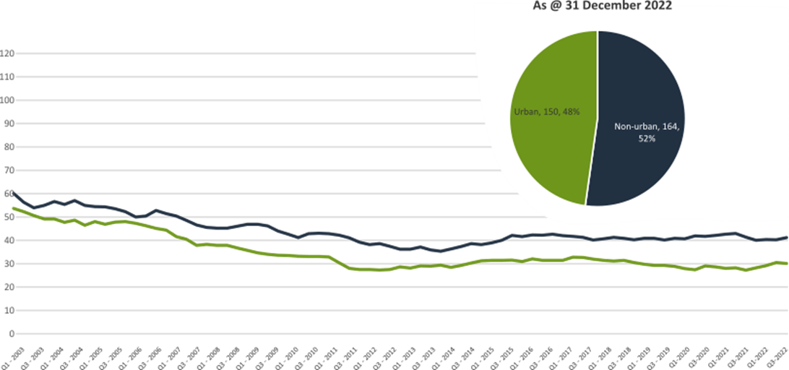

Based on the Australian Bureau of Statistics’ ‘significant urban area’ geographic definition.

Serious Casualty locations to 31 December 2022 (Black = Fatality, Red = Serious Injury)
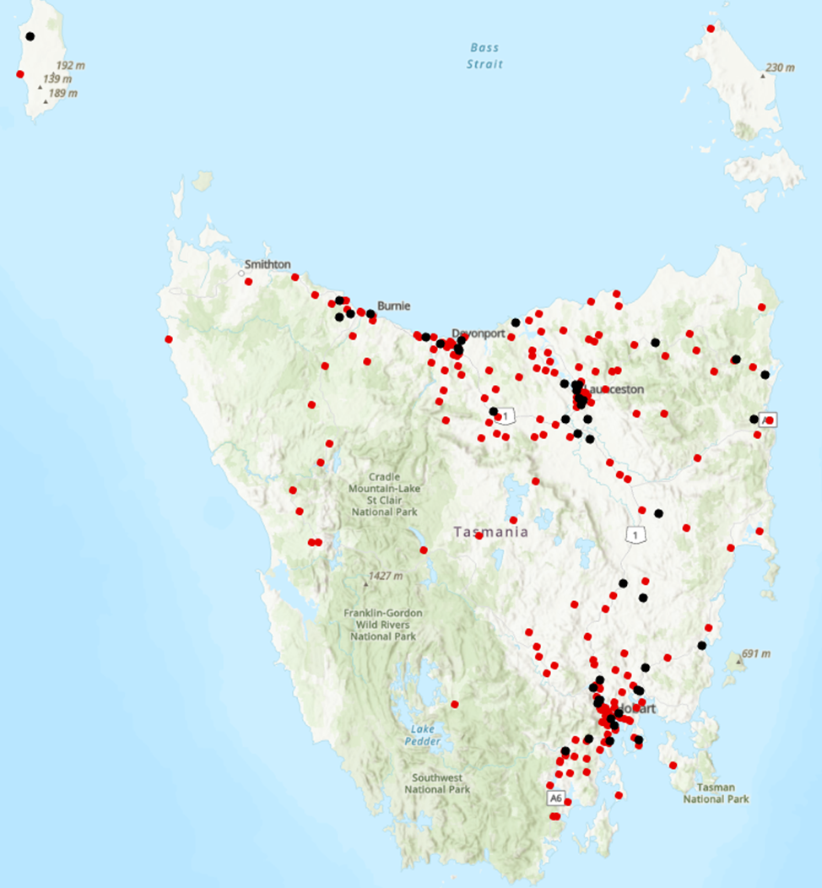

Key themes and priority actions 2020-2024
The Quarterly Progress Report details progress on key themes and priority actions under the Towards Zero Action Plan 2020-2024 and the Towards Zero – Tasmanian Road Safety Strategy 2017-2026.
The progress report should be read in conjunction with the Action Plan and understood in the context of the Towards Zero Strategy. These documents are available at: www.towardszero.tas.gov.au

Funding of key themes
Over $20 million Over $31 million
Over $12 million Over $4 million

$2 million Over $3 million

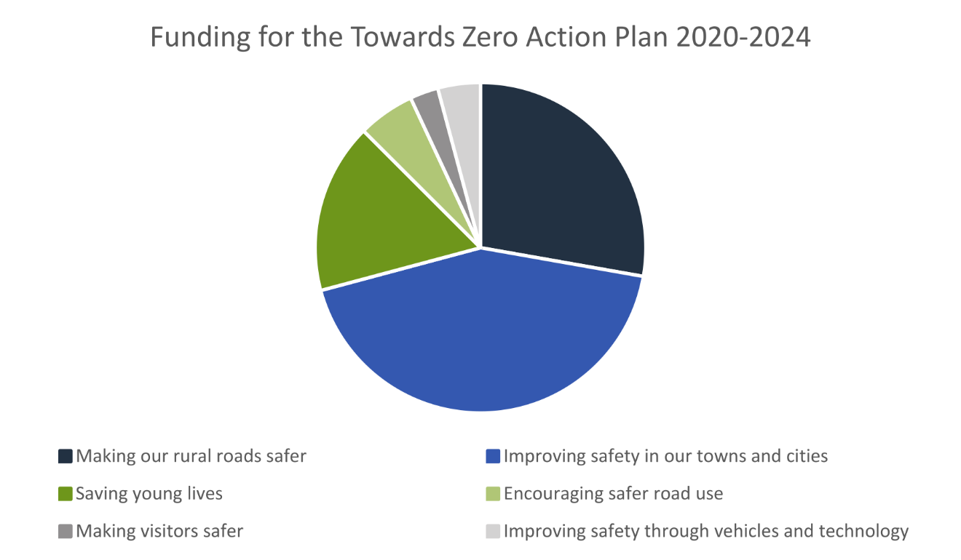

Project status report
Making our rural roads safer
Rural road grants program for local government | On schedule |  | Infrastructure upgrades on low volume State roads | On schedule
Motorcyclist safety on rural roads | On schedule |  | Speed moderation and community engagement strategy | On schedule
Safe system knowledge and skills training | On schedule
Improving safety in our cities and towns
Targeted infrastructure upgrades in high traffic urban areas | Not yet commenced |  | Vulnerable Road User Program | On schedule
Community Road Safety Program | On schedule |  | Trial of innovative technologies | Not yet commenced
Innovative infrastructure treatment demonstrations | Not yet commenced
Saving young lives
Learner Driver Mentor Program and Driver Mentoring Tasmania | On schedule |  | Graduated Licensing System Project for drivers | Complete
Rotary Youth Driver Awareness Program | On schedule |  | Driving for Jobs Program | On schedule
RACT education initiatives | On schedule |  | Real Mates media campaign | On schedule
Bicycle Network bike education | On schedule |  | Safety around schools | On schedule
Kidsafe child restraint check program | On schedule |  | Full Gear motorcycle safety project | On schedule
Develop a Graduated Licensing System for motorcyclists | On schedule
Encouraging safer road use
Inattention and distraction | On schedule |  | Safe behaviour campaigns | On schedule
Mandatory Alcohol Interlock Program | Major delays |  | Protective clothing for motorcyclists | On schedule
Road safety penalties review | Complete |  | Speed enforcement strategy | On schedule
Enforcement of high-risk behaviours | On schedule |  | Automated Traffic Enforcement Program | On schedule
High-risk motorcycling enforcement | On schedule |  | Road Rules Awareness | On schedule
Making visitors safer
Tourist road safety signage program | On hold |  | Responsive electronic signage trial | On hold
Tourist education materials | Limited activity |  | Strategic partnerships | On hold
Tourist education at gateway entry points | Limited activity |  | Stakeholder alliances | On hold
Improving safety through vehicles and technology
ANCAP | On schedule |  | Safer cars for young drivers | Not yet commenced
Autonomous vehicle and crash avoidance readiness | On schedule |  | Workplace driver safety | Not yet commenced
Light vehicle safety strategy | On schedule

Progress on key themes
Progress on key themes is reported as:
Status | Major delays/on hold/high risk | Delayed/some issues/medium risk | On schedule/progressing/low risk | Not yet commenced

60 per cent of fatalities occur in rural areas

Rural roads grants program for local government
The Safer Rural Roads Program (SRRP) provides funding to councils to implement infrastructure treatments on rural road corridors to reduce lane departure crashes and the harm when they do occur. An allocation of $10 million was made to the SRRP to be administered over five funding rounds of $2 million for the life of the Action Plan.
Comments
The Australian Government’s Road Safety Program (RSP) is a $3 billion Commonwealth Budget commitment. Under the RSP, Tasmania has been notionally allocated up to $66 million in funding for small-scale road safety infrastructure projects, to be delivered over five 6-month funding tranches.
The RSP provided valuable additional funding to the SRRP. As a result, two funding rounds were held during the 2020-2021 financial year (FY21).
In FY21, 61 applications were received under the SRRP with 59 receiving funding. The successful projects from FY21 total approximately $10 million in value. This includes funding of $5.88 million from the Australian Government’s RSP, $2.45 million from the Road Safety Levy, and $1.64 million from Local Government co-contributions.
As of 31 December 2022, 51 projects from the FY21 program rounds have been delivered, five projects are in progress and three projects are experiencing delays. There have been no withdrawn projects.
The 2022-23 funding round for the SRRP is scheduled for 16 January 2023 and will make available $3.68 million from the Road Safety Levy for successful applicants. The round will close on the 17 March 2023 with the commencement of works expected in late 2023.
During 2022, State Growth undertook a review of the SRRP. This review enabled State Growth to identify opportunities for program improvements which were implemented in preparation for the 2022-23 funding round. These improvements aim to enhance technical support, implement a structured framework for training opportunities, and make the delivery of the programs more efficient and client focused.
Status | risk |  | On schedule/progressing/low risk

Infrastructure upgrades on low volume State roads
This program will provide funding for lower volume State roads, where cost effective treatments such as shoulder sealing, pavement markings, curve warnings, road side hazard removal and safety barriers will achieve maximum value for money.
Current situation / comments
At the commencement of the Action Plan $6.95 million was committed for infrastructure improvements on the Railton Main Road. $450 000 supported the design and development stage of works and $6.5 million provided funding for works in the delivery stage.
This package of works included a one metre sealed shoulder with a half-metre unsealed verge, basic right turn treatments at several junctions and safety barrier installations at identified roadside hazards. The Railton Main Road upgrades have now been completed.
This program has also supported the Road Safety Levy co-contributions under Tranche 1 and 3 of the Australian Government’s RSP. This has taken advantage of the opportunity that Australian Government co-funding has presented for targeted shoulder sealing and junction upgrades across Tasmania.
Status |  |  | On schedule/progressing/low risk

Motorcyclist safety on rural roads
Road safety audits will be conducted on high risk touring routes across Tasmania. This program will involve local motorcyclists and a safe system approach will inform audits. Findings will be shared with stakeholders to identify countermeasures that go beyond typical infrastructure solutions.
Current situation / comments
Safe System motorcycle road safety audits
Two audits have been completed and funding allocated. The Central Highlands Council was provided with a grant deed up to $200 000 to undertake works on Hollow Tree Road. Works have now been completed.
Funding up to $350 000 has been allocated for State Growth to carry out low-cost infrastructure treatments to improve road safety for motorcyclists on Lake Leake Road. A delivery schedule for these has been scoped with works scheduled to commence in 2022. Some delivery delays have been experienced. The works were scheduled to commence in 2022. However, this has been delayed to 2023 due to contractor issues.
The Channel Highway between Margate and Verona Sands has been identified as the location for the next audit, which is planned for March 2023.
State Growth is developing a strategy for future motorcycle road safety audits to identify potential routes in Tasmania. This strategy was scheduled for delivery in 2022, but due to resource constraints it is now planned for delivery in 2023.

Status |  |  | On schedule/progressing/low risk

Speed moderation and community engagement strategy
Speed moderation requires a holistic strategy encompassing public education, road risk assessments, enforcement, speed limit setting, speed limit mapping and technology, KPIs and evaluation. This project will involve community engagement to inform and build support for action on safer speeds. A significant ongoing coordination effort will be required to support the strategy.
Current situation / comments
At its November 2022 meeting, the RSAC endorsed a high-level strategic approach to the development of a speed management strategy. State Growth is progressing work on this deliverable with a view to commencing the information gathering phase in early 2023.
Status |  |  | On schedule/progressing/low risk

Safe system knowledge and skills training
This initiative aims to improve Safe System knowledge for all those in a position to influence road safety outcomes. The initiative will focus on Safe System infrastructure design, including appropriate speed setting, and will consist of technical training sessions, workshops and forums across Tasmania.
Current situation / comments
Safe System knowledge and capacity building has been considered within the review of the Safer Rural Roads and Vulnerable Road User programs. As part of this review, State Growth investigated how stronger support can be provided to enable local government to achieve Safe System infrastructure treatments. As part of this review, State Growth also reviewed the tools utilised through these programs to understand how local government officers apply Safe System principles and treatments in practice.
State Growth is now considering options for future training opportunities to support the development of Safe System knowledge and skills across local and state government, including a model that directly supports the Safer Rural Roads and Vulnerable Road User programs.
Funding of $5 600 was provided to support the City of Hobart in delivering a road safety workshop in June 2022. The workshop brought together road safety research experts, local government, and State Growth and trialled an approach for sharing experiences and knowledge, and provided networking opportunities and a platform to hear the latest in Safe System research and risk assessment tools. This workshop approach is being considered by State Growth for future capacity building sessions.
Funding of $10 520 was provided to the Tasmanian Bicycle Council to facilitate online training sessions for Tasmanian engineers and planners in designing Safe System compliant cycling lanes/paths.
Additionally, funding of $12 260 has supported Safe System professional capacity building.
State Growth is planning a Safe System principles training session for 7 March 2023 to provide 25 employees of State Growth and Tasmania Police with advanced Safe System knowledge.
Status |  |  | On schedule/progressing/low risk

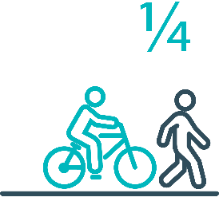

Pedestrians and cyclists are vulnerable and represent
one in four serious casualties in our towns and cities

Targeted infrastructure upgrades in high traffic urban areas
This program provides for delivery of a range of infrastructure safety upgrades to make our towns and cities safer. This will include shoulder sealing, intersection improvements, safety barriers and pavement marking at high traffic areas. This program targets high volume state roads that are not planned for major investment in the short term.
Current situation / comments
This initiative has not yet commenced and will be considered as part of the mid-term review.
However, funding allocated to this initiative to date, under the Action Plan, has supported the Road Safety Levy co-contributions under Tranche 1 and 3 of the Australian Government’s RSP. This has taken advantage of the opportunity that Australian Government co-funding has presented for targeted shoulder sealing and junction upgrades across Tasmania, and the upgrade of nearly 600 electronic school zone signs across approximately 220 locations.
Approximately $430 000 supported local road pavement marking in FY22 to improve delineation at over 300 locations across Tasmania.
Status |  |  |  | Not yet commenced

Vulnerable Road User Program
The Vulnerable Road User Program (VRUP) is an established grants program which assists local government with the costs of installing safety improvements in built up areas. The aim of the program is to reduce conflict between vehicles and vulnerable road users - cyclists, pedestrians and motorcyclists.
Additionally, the program has a focus on increasing Safe System knowledge and capacity in local governments. The funding available under the VRUP was increased from $500 000 to $1 000 000 per annum, under the current Action Plan.
Current situation / comments
The Australian Government’s RSP has provided valuable additional funding to the VRUP. As a result, three funding rounds were held during FY21. In FY21, 95 applications were received under the VRUP with 71 receiving funding. This includes seven cycling safety-focused projects that all received funding under round three.
The successful projects from FY21 total approximately $11.6 million in value. This includes funding of $4.6 million from the Australian Government’s RSP, $4.7 million from the Road Safety Levy, and $2.3 million from Local Government co-contributions.
As of 31 December 2022, 49 projects from the FY21 rounds have been delivered, eight projects are in progress and nine projects are experiencing delays. Five projects from the 71 successful projects, valued at $750 000, have been withdrawn.
The 2022-23 funding round of the VRUP is scheduled to open on 16 January 2023 and will make available $1 million from the Road Safety Levy for successful applicants. The round will close on the 17 March 2023 with the commencement of works expected in late 2023.
During 2022, State Growth undertook a review of the VRUP. This review enabled State Growth to identify opportunities for program improvements which were implemented in preparation for the 2022-23 funding round. These improvements aim to enhance technical support, implement a structured framework for training opportunities, and make the delivery of the programs more efficient and client focused.
Status |  |  | On schedule/progressing/low risk

Community Road Safety Grants Program
The Community Road Safety Grants Program (CRSGP) is an established grants program that aims to build community engagement to address local road safety issues. The program supports local councils, schools, community groups, research institutions and charity organisations to promote road safety at the grass roots level.
Current situation / comments
The CRSGP opened on 23 September and closed on 24 October 2022. Advertisements were placed in the three local newspapers, online and emails were sent to all local government contacts and community groups.
The 2022–23 CRSG funding round attracted a total of 20 applications from community organisations, schools and local governments, with a total funding request of $440 130. The panel recommended 13 projects for funding totalling $199 152.
Vulnerable road users has been a key theme this year, with projects focusing on children, motorcyclists, and those from culturally and linguistically diverse backgrounds. The 2022-23 round will fund an innovative social media project aimed at educating children and parents on safe road user behaviours, speed awareness programs in Clarence, Georgetown and Dodges Ferry, heavy vehicle awareness displays at the Deloraine Truck and Ute Show and pilots of the successful Full Gear Motorcycle Program in Devonport and Circular Head.
Status |  |  | On schedule/progressing/low risk

Trial of innovative technologies
This project will include monitoring, investigation and trialling of new and emerging technology based approaches to improving safety for vulnerable road users.
Current situation / comments
This project has not yet commenced and will be considered as part of the mid-term review.
Status |  |  |  | Not yet commenced.

Innovative infrastructure treatment demonstrations
This project will investigate, trial and demonstrate innovative Safe System urban infrastructure treatments to improve road safety in our urban areas. We will work with local councils to show how Tasmania’s cities and towns can be improved for the benefit of all road users, particularly cyclists and pedestrians.
Current situation / comments
This project has not yet commenced and will be considered as part of the mid-term review.
Status |  |  |  | Not yet commenced.

92 young people are seriously injured or killed on our
roads every year

Learner Driver Mentor Program and Driver Mentoring Tasmania
The Learner Driver Mentor Program (LDMP), supported by Driver Mentoring Tasmania (DMT), is a well-established program that supports disadvantaged learner drivers to gain supervised on-road driving hours to gain a licence. DMT supports LDMP providers through peak body support and coordination.
Current situation / comments
LDMPs continue to operate throughout Tasmania, producing upward of 1 700 hours of on-road supervised driving each month.
The Road safety branch has been working with coordinators to develop a suite of policies and procedures that will in the safety of the program and increase program outcomes.
The 2023-24 funding round will open on 6 March 2023 and will close on 3 April 2023.
Status |  |  | On schedule/progressing/low risk

Graduated Licensing System Project
Changes have been made to the Graduated Licensing System (GLS) for drivers to better protect young and novice drivers and improve the licensing pathway. Young drivers are overrepresented in crash statistics and most at risk when they first get their Ps and start driving solo. The changes to the GLS aim to address this risk and improve road safety outcomes for both young and novice drivers.
Current situation / comments
The Tasmanian Government implemented regulatory changes to the GLS on 1 December 2020. Tasmania’s GLS now meets the enhanced model under the national driver GLS framework. The GLS changes were accompanied by a public education campaign explaining the policy changes and how they would apply to current and new learners.
Complementing the policy changes are three digital products that were progressively launched from July 2021.
The Plates Plus learning and assessment platform was designed to improve learner driver education by focusing on developing safe behaviours and attitudes. It is an innovative tool that takes users through a series of interactive exercises to ensure new drivers know the road rules and understand the impact of the fatal five road behaviours.
A public education campaign accompanied the launch of the Plates Plus platform and ran until September 2021. The campaign encouraged take-up by promoting the convenience of the platform, which is accessible from any device connected to the internet.
The Plates Plus logbook app launched in November 2021. For many Tasmanian learners, this will replace the existing hard copy logbook. It provides an easy and efficient way to record supervised driving hours during the learner licensing phase. A public education campaign targeting 15 to 25-year-olds accompanied the launch of the Plates Plus logbook app. To engage with this age group, the campaign focused on selected social media platforms.
The computer-based hazard perception test (HPT) was launched on 7 March 2022. The HPT is a mandatory assessment that has been introduced to the learner licensing pathway. The HPT assesses a learner’s ability to identify and react to safely avoid hazards. It features high-quality 3D clips developed by Austroads in conjunction with the Centre for Automotive Safety Research, using real Australian crash data to identify the most dangerous driving situations for novice drivers.
The HPT was the final product to be delivered under the GLS project.
Status | Complete

Motorcyclist Graduated Licensing System review
The Tasmanian motorcyclist GLS is being reviewed to identify enhancements to ensure novice motorcyclists are as safe as possible on Tasmanian roads.
Current situation / comments
Following initial consideration by the Department of State Growth, the Centre for Automotive Safety Research (CASR) was engaged to conduct a review of the Tasmanian motorcyclist GLS. The findings and recommendations of the review were presented to the RSAC at its May 2022 meeting.
A public consultation process run in August and September sought feedback on CASR’s recommendations. Feedback was collated and presented to the RSAC at its November 2022 meeting, together with a package of options to amend the motorcyclist GLS. At the RSAC’s request, additional information is being prepared.. This additional information will enable RSAC to provide advice to the Tasmanian Government to improve safety outcomes for young and novice motorcyclists.
Status |  |  | On schedule/progressing/low risk

Rotary Youth Driver Awareness Program (RYDA)
RYDA is a one-day interactive road safety education program for Year 10-12 students to assist them to respond positively to the challenges and responsibilities of being a driver or passenger. Every year 4000 students take part in a series of practical demonstrations and learn valuable road safety lessons from expert presenters and volunteers. RYDA is delivered by Rotary Tasmania.
Current situation / comments
RYDA has concluded for the 2022 school year, with sessions being conducted in the all major regions of Tasmania. RYDA is still seeking alternate accommodation for Hobart sessions in 2023 due to redevelopment of the Hobart Showgrounds.
Rotary is well positioned to continue successful delivery of the RYDA program in 2023.
Status |  |  | On schedule/progressing/low risk

Driving for Jobs Program
The Driving for Jobs (DfJ) Program aims to support disadvantaged students who would otherwise be unable to enter and progress through the Graduated Driver Licensing System (GLS). The program provides students at selected schools with the opportunity to increase their road safety knowledge whilst also improving their job readiness. Students undertake a personalised intensive program with a strong road safety focus including professional on-road driving lessons and participation in the Rotary Youth Driver Awareness Program.
Current situation / comments
The DfJ Program operates at Jordan River Learning Federation (JRLF) and Claremont College in the South. It operates at Launceston and Newstead Colleges in the North.
The delivery of fully funded driving lessons to students in 2022 did not commence until term two due to the impact of Covid-19 on school operations and difficulties in obtaining a driving school. Participation numbers at JRLF were low and the program was restructured to include year 10 students to assist with recruitment and retention. At the Steering Committee meeting in October 2022 it ws determined to continue the program at JRLF in 2023 and to closely monitor engagement. Participation numbers at the other three locations remain very strong with options being examined in early 2023 to utilise budget underspend by increasing capacity at Claremont College and potentially Launceston College to meet unmet demand.
In 2022, 203 students engaged with the program which resulted in 925 hours of fully funded driving lessons being delivered from accredited driving instructors. A total of 37 students obtained their learner licence and 28 students obtained their provisional driver licence. The program performance is comparable with 2021 data where the program operated for all four terms.
Status |  |  | On schedule/progressing/low risk

RACT education initiatives
The RACT delivers a range of community and school-based road safety education programs for seniors community groups and primary and secondary students. This includes a program for Year 10-‍12 students focused on the dangers of distraction and inattention, and a program to teach students how to progress through the GLS and about the specific rules that apply to L and P plate drivers. Sessions for seniors include safe driving tips and road rule reminders.
Current situation / comments
The Road Safety Branch continues to monitor the partnership's outcomes with the RACT.
Status |  |  | On schedule/progressing/low risk

Real Mates media campaign
The MAIB-funded Real Mates campaign engages with young men to encourage them to avoid the risks of drink driving by empowering them to speak up and stop a mate from driving after drinking.
Current situation / comments
A new iteration of Real mates was launched on the 5 September 2022. This is the eighth iteration of the real mates campaign, the new campaign shows how a Real Mate can and should help their mates make the right decision to avoid the very real consequences of driving after drinking. The key campaign message is remind your mates what’s at stake.
The campaign ran across television and social media in December 2022, and will continue into January 2023. Further burst are planned for April and May 2023.
The Real Mates sponsorship of the Hobart Hurricanes commenced in November 2022, highlighting the Real Mates message at Blundstone Arena and local cricket clubs.
Status |  |  | On schedule/progressing/low risk

Bicycle Network bike education
The Bicycle Network delivers the Ride2School program to primary schools across Tasmania. Ride2School focuses on raising awareness for primary-aged students in safe cycling, road safety and positive road sharing behaviour.
Current situation / comments
The Road Safety Branch continue to monitor the outcomes of the partnership with the Bicycle Network.
Status |  |  | On schedule/progressing/low risk

Safety around schools
Safety around schools is promoted through designated crossings, lower speed zones, more than 100 school crossing patrol officers and public education. The current Safety around Schools project, including the Love 40 campaign, encourages drivers to lower their speed and keep a look out for children in school zones and around buses.
Current situation / comments
Back to School was launched at Riverside Primary School on 2 February 2023. Radio and television advertising commenced a week prior to school returning for 2023, in order to altert motorists of children’s movements. Transport Inspectors and Tasmania Police conducted high visibility enforcement activities during the first week of school to slow traffic in and around school zones and buses.
Status |  |  | On schedule/progressing/low risk

Kidsafe child restraint check program
Kidsafe Tasmania conducts free child restraint checking sessions and training sessions for professionals to ensure young children are safely and lawfully seated and restrained in cars. Kidsafe also distribute and promote educational materials to inform the public of the correct child restraint type for a child’s age and size.
Current situation / comments
Kidsafe continue to deliver free child restraint checks and professional development for child carers as part of their funding agreement.
Status |  |  | On schedule/progressing/low risk

Full Gear motorcycle safety project
The Glenorchy City Council, in partnership with Bucaan House, delivers its successful Full Gear motorcycle safety project (Full Gear), which helps at-risk young motorcycle riders to enter the licensing system and adopt safe riding practices.
Current situation / comments
The Full Gear program has continued within the Glenorchy municipality, with the project officer working with interested councils to establish networks for the successful implementation of the program in other municipalities.
Status |  |  | On schedule/progressing/low risk

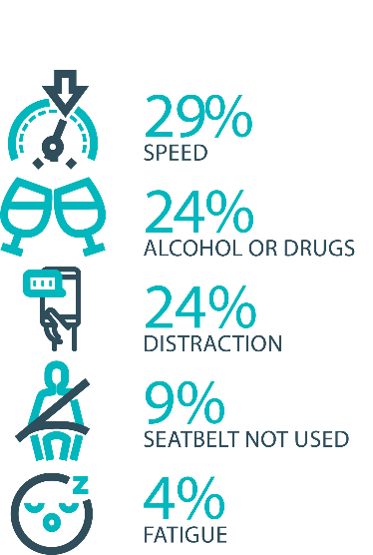

The fatal five behaviours contributing to serious
casualties

Inattention and distraction
Inattention and distraction are concerning causes of serious casualty crashes and may have a far greater impact than current data suggests. There are a number of research projects and enforcement initiatives that are being used to address this issue. This project will include consideration of emerging strategies for tackling distraction, encouraging compliance through enforcement and influencing driver behaviour through public education campaigns.
Current situation / comments
Enforcement
Tasmania Police introduced three unmarked motorcycles to increase the rate of detection and enforcement of illegal phone use whilst driving. These motorcycles operate across all districts and target the low speed road network and congested traffic conditions, utilising ‘lane filtering’ legislation to full advantage.
In an agency first, the riders are also fitted with helmet cameras to capture the offence, an initiative that has effectively nullified disputes. The introduction of unmarked motorcycles has proved to be incredibly successful with riders reporting high-level public support and a notable change in driver behaviour.
Tasmania Police continue to identify, trial and implement emerging technologies to address speeding, seatbelt, inattention and distraction offences including, improving enforcement of high-risk driving. Future use of technologies such as hand held speed cameras and updated ANPR technology is now being considered in conjunction with the Automated Traffic Enforcement Project being led by the Department of State Growth.
Public Education
In December 2022 the Road Safety Advisory Council (RSAC) relaunched their ‘Leave your phone alone. Don’t drive blind’ campaign on television and social media to highlight the dangers of illegal phone use while driving. This will support the introduction of the detection cameras to come.
In preparation for the introduction of mobile phone and seatbelt detection technology in Tasmania a new public education campaign is being developed and is due to be launched in March 2023. The pre-enforcement ‘education’ phase will begin in March 2023 with the launch of the seatbelt/mobile phone detection camera campaign. The first iteration of the new campaign will warn road users that detection cameras will soon be operating in Tasmania and make them consider the consequences of illegal phone use and seatbelt noncompliance. The second enforcement phase will coincide with the detection cameras commencing enforcement in May 2023. This phase of the ‘Click. Stow. Go’ campaign will inform road users that detection cameras are now operating in Tasmania, and they will be issued with a fine and demerit points if they are caught.

Status |  |  | On schedule/progressing/low risk

Safe behaviour campaigns
Targeted media campaigns will continue to educate people about high-risk behaviours and to highlight the dangers of the ‘Fatal Five’.
Current situation / comments
Over is Over continues to run on radio, social media and outdoor billboards highlighting the dangers of speeding. .
A new cycling safety campaign ‘Let’s have each other’s backs, because we all have someone to get back to’ was launched on 5 October 2022 and ran until December 2022. This campaign, which was a collaborative effort with the Tasmanian Bicycle Council aimedto improve safety for cyclists by encouraging respect and understanding between all road users.
The Love40 campaign had another burst at the start of term four in October 2022. Love40 aims to encourage motorists to drive at or below the school zone limit to keep our children safe.
Status |  |  | On schedule/progressing/low risk

Mandatory Alcohol Interlock Program (MAIP)
The MAIP aims to have repeat and high-level drink driving offenders demonstrate they are able to separate their drinking from driving through the installation of an alcohol interlock in their vehicle. New measures will be introduced to increase participation in the MAIP.
Current situation / comments
Drafting instructions for the revised framework were provided to the Office of Parliamentary Counsel (OPC) in October 2019. Parliamentary priorities, including COIVD-19, caused reprioritisation of OPC work. Drafting instructions were withdrawn from OPC in May 2021, before the first draft of amendments had been received, to enable the new Road User Services’ managers to review the drafting instructions to ensure that they remain current. The revised instructions were re-submitted to OPC on 15 February 2022. Again, Parliamentary priorities slowed the work of OPC. Nonetheless, version 2 of the amendments were received in November 2022, and work continues with OPC.
Two approved Providers have signed new contracts; negotiations continue with the third. The contracts expiry has been extended until October 2023 under a new Treasury process. Work will commence on creating new contracts in the near future, because no further extension options are available.
Two more parties have indicated their desire to become approved providers. Negotiations with them will commence when their applications are complete.
Status | Major delays/on hold/high risk

Protective clothing for motorcyclists
Motorcyclists are overrepresented in Tasmania’s road trauma figures. Motorcyclists are vulnerable road users due to a lack of physical protection. Protective clothing can reduce injury severity in the event of a crash. Tasmania is a funding member of MotoCAP. MotoCAP provides safety assessment star ratings for protective clothing and prepares education materials for motorcyclists.
Current situation / comments
An existing public education brochure educating riders on the importance of wearing protective motorcycle gear is currently being updated . Once produced it will be re-distributed to Tasmanian retailers and AJL training facilities. The brochure will reiterate the importance of wearing full gear on every ride and direct motorcyclists to the MotoCAP website to check gear safety ratings before purchase.
Status |  |  | On schedule/progressing/low risk

Road safety penalties review
For enforcement activities to improve safety on our roads, they need to be backed up with appropriate penalties. Tasmania’s road safety penalties will be reviewed to ensure they are up-to-date and provide an appropriate deterrence to those who break the rules and put themselves and others at risk.
Current situation / comments
On 7 September 2022, the House of Assembly passed the Vehicle and Traffic (Driver Distraction and Speed Enforcement) Amendment Bill 2022, which will enable the photographic detection of mobile phone, seatbelt, registration and average speed offences.
On 8 September 2022, the Minister for Infrastructure and Transport requested that the Department of State Growth (the Department) prepare an issues brief detailing the penalties associated with the above offences and comparing them with other jurisdictions.
The Department previously completed a review of road safety penalties in 2020, which showed that Tasmania was largely consistent with other jurisdictions, except for speeding offence penalties, which were lower.
The results of that review were presented to the Road Safety Advisory Council (RSAC) in November 2020. RSAC recommended not amending penalty values due to the economic impacts of COVID-19 and general parity with other jurisdictions. RSAC agreed to review penalties again towards the end of the current Action Plan which concludes on 31 December 2024.
Since November 2020, some jurisdictions have implemented higher penalties, which has widened the gap between Tasmania’s penalties and some jurisdictional averages.
Currently, the Road Safety Branch (RSB) is undertaking a review of Tasmanian road safety penalties to compare Tasmanian penalties to the average of other Australian jurisdictions for the fatal five road offences – speed, mobile phones, alcohol and drugs and failure to wear a seatbelt.
The review is comparing Tasmania’s penalty levels to a ‘jurisdictional average’ (i.e., an average of all other jurisdictions, without inclusion of Tasmania’s penalties) to avoid skewing the average. To ensure that the comparison of monetary penalties considers the differences in earning potential across the jurisdictions, comparisons are being done as a percentage of each jurisdiction’s seasonally adjusted average weekly wage (not a whole dollar value).

Status | Complete

Speed enforcement strategy
Speed is one of the fatal five offences addressed within the Tasmania Police Road Safety Strategy 2022-2024.
The strategy directs enhanced speed enforcement strategies and techniques to increase the rate of detection and increase the perception that offending drivers and riders will be caught through the coordination of high-visibility speed enforcement in high-risk areas across all police districts.
With regard to speed cameras, Tasmania Police has conducted several technology trials, including in-motion camera technology, where speed cameras are fitted to moving vehicles, and of mobile point-to-point speed detection, where average speed enforcement utilises two vehicles fitted with automatic numberplate recognition technology. In addition, Tasmania Police is working with the Department of State Growth to introduce future automated speed enforcement in Tasmania.
Tasmania Police has implemented a Strategic Asset Management Plan (SAMP) for all speed detection devices. The SAMP provides for continual review of new and emerging technologies, includes provisions for regular replacement and upgrade of equipment and importantly supports long-term financial planning and budgeting. In line with the SAMP, Tasmania Police’s Southern Road and Public Order Services is also trialling a rear-facing radar on a patrol vehicle.
Tasmania Police has further developed the new vehicle livery across the fleet to include the introduction of ‘Over is Over’ campaign mark-ups on selected traffic enforcement cars and motorcycles. Tasmania Police continue matching different livery designs to specific uses, for example general patrol, high-visibility patrol, and low-profile marked vehicles – all of which are relevant to different methodologies of speed reduction and enforcement. The strategy has also seen the introduction of unmarked highway patrol cars which have proved to be very successful and complement the use of overt policing tactics well.
Tasmania Police recently updated the marked police motorcycle fleet with new livery for these bikes being implemented to heighten the visibility of police on the road network.

Status |  |  | On schedule/progressing/low risk

Enforcement of high-risk behaviours
To reduce high-risk behaviours and increase compliant road user behaviour, State Growth and Tasmania Police will work collaboratively to investigate and introduce new enforcement techniques and technologies to detect high-risk behaviours that address the ‘fatal five’, including mobile phone use, speeding and failure to wear a seatbelt.
Current situation / comments
Tasmania Police Road Safety Strategy 2022-2024, focuses on the fatal five causes of serious and fatal crashes, which are the highest risk driver behaviours: speeding; alcohol and drugs; distraction and inattention; seatbelts; and fatigue.
The strategy includes the analysis of current data that assists to identify where enforcement activities should be focused according to the highest risk, road safety locations, times and behaviours to achieve a change in driver behaviour.
Status |  |  | On schedule/progressing/low risk

Automated Traffic Enforcement Program
Automated Traffic Enforcement (ATE) (i.e. speed cameras) is relatively underutilised as a deterrence and enforcement mechanism in Tasmania. This project investigates proven and emerging camera technologies for use at high-risk locations and across the entire road network.
Current situation / comments
On 30 September 2022, Sensys Gatso Australia commenced delivery of mobile speed camera enforcement servies and Infringement Notice’s have since been issued by the Department of Police, Fire and Emergency Management to motorists detected speeding.
Sensys Gatso will deliver a minimum of 20,000 enforcement hours per annum via a minimum of eight mobile speed cameras. Additional increases in enforcement hours are expected throughout 2023 however the final level of enforcement is yet to be determined.
In addition and as part of the 2022-23 State Budget, the Government allocated an additional $9.3 million over three years to extend enforcement services for an additional one year and implement emerging technologies such as mobile phone, seatbelt, and average speed enforcement.
To support the implementation of these emerging technologies, the project team has progressed legislative and regulatory amendments which will enable photographic detection devices to be used in detecting and prosecuting mobile phone, seatbelt, and average speed offences. Legislative amendments were passed by the Tasmanian Parliament in October 2022 (yet to be proclaimed) and supporting amendments to relevant regulations are in the final stages of drafting.
Camera are deployed at locations identified through an analysis of crash history/risk, an infrastructure rating assessment and vehicle operating speeds. State Growth has published a mobile speed camera website (www.speedcameras.tas.gov.au) which includes functionality to allow members of the community to suggest potential camera locations. Community suggestions will be considered where there is a clear road safety benefit.
The introduction of the ATE program has been supported by a new enforcement focus of the ‘Over is Over’ marketing campaign and the development of a separate program website (speedcameras.tas.gov.au). The implementation of additional enforcement technologies (i.e., mobile phone and seatbelt detection devices) will be supported by educational capaigns.
Stage One of the mobile speed camera signage programs has been completed with Stage Two expected to be completed in 2022-23.
Status |  |  | On schedule/progressing/low risk

High-risk motorcycling enforcement
Speed is a factor in at least a quarter of motorcyclist serious casualties. Speed cameras offer no deterrence to motorcyclists, whose numberplates are mounted only on the back. Introduction of rear-facing speed cameras will improve detection and deterrence of speeding. This is being considered as part of the Automated Traffic Enforcement Program.
Current situation / comments
The Tasmania Police Road Safety Strategy 2022-2024 approaches the enforcement of high-risk motorcycle behaviours from several angles. Tasmania Police has:
- worked with the Department of State Growth to re-introduce Automated Mobile Speed Enforcement Cameras that have both a rearward and forward-facing capability to better target and detect high-risk motorcycle behaviour.
- introduced an online public portal for members of the public to upload footage relating to traffic offences they have witnessed. Tasmania Police review these submissions and allocate prima facie offences to an officer for investigation and follow-up.
- published the Tasmania Police Road Safety Strategy 2022 – 2024 which provides for increased patrol hours on rural roads which includes many of the popular motorcycle touring routes. The increased patrol hours will be conducted in a mix of covert and overt patrols that will discourage and detect high-risk motorcycle behaviours increasing the perception amongst riders they will be caught anywhere at any time.
Status |  |  | On schedule/progressing/low risk

Road Rules Awareness
Compliance with Road Rules makes our behaviour on the roads predictable, improving safety for all road users. This initiative will ensure that user-friendly and tailored information resources are developed so that the Road Rules are easily understood and adhered to by all road users.
Current situation / comments
The Tasmanian Road Rules Handbook and the Misunderstood Road Rules series of pamphlets are distributed to Service Tasmania locations when required.

Status | Major delays/on hold/high risk |  | On schedule/progressing/low risk

11 per cent of all serious casualties on our
roads are non-Tasmanian residents

Tourist road safety signage program
This program will see the installation of tourist signage strategically placed across the road network. The signs will provide important road safety information, relevant to the area road users are travelling in. This program will be undertaken in collaboration with stakeholders, local government and State Roads.
Current situation / comments
This program is currently on hold.
Status | On hold |  | On schedule/progressing/low risk

Responsive electronic signage trial
This project will trial a responsive electronic sign with real time information at regional tourism gateways.
Current situation / comments
This project is currently on hold.
Status | On hold

Tourist education materials
A range of education materials developed using images, symbols and multi-lingual material delivered to specific audiences through targeted communications channels. This includes vehicle hangers, brochures, posters, roadside signs, editorial content, film and digital content.
Current situation / comments
Communications materials are being distributed upon request from stakeholders.
Status |  | Limited activity

Strategic partnerships
Developing strategic partnerships based on synergies with target audiences will enable the effective promotion of road safety messages and education.
Current situation / comments
This project is currently on hold.
Status | On hold

Tourist education at gateway entry points
As an island state, we have the opportunity to strategically place messaging at our gateway airports and seaports to reach visitors with important road safety messaging prior to them driving in Tasmania. This includes a range of educational materials, electronic and static signs and billboards.
Current situation / comments
Printed collateral is in stock and digital billboards display road safety messaging at gateway locations.
Status |  | Limited activity

Stakeholder alliances
Sharing information and collaborating to develop effective strategies and tools to address road safety issues is vital. This project will develop formal and informal stakeholder alliances to encourage input and create opportunities to deliver joint initiatives.
Current situation / comments
This activity is currently on hold.
Status | On hold

The rate of fatal crashes is four times higher for vehicles 15+ years old than for vehicles made in the last five years

Australasian New Car Assessment Program (ANCAP)
Tasmania is a funding member of ANCAP. ANCAP plays a vital role in informing consumers about safety performance of new vehicles and advocates for improved vehicle safety design and specification through public education campaigns, advocacy activities and engagement with governments, corporate fleets, the media and consumers. Activities related to ANCAP will include promotion of safer vehicles and options for an annual vehicle fleet report.
Current situation / comments
Tasmania continues to support ANCAP with funding of $12 500 per annum. ANCAP has developed a new Strategic Plan for 2023-2030. ANCAP is proposing a significant increase in operating budget to support the new plan, resulting in an increased funding ask from funding bodies including Tasmania. ANCAP is meeting with RSAC and Department representatives in early March 2023 to discuss ANCAP’s Strategic Plan and proposed funding request. Further details regarding the current funding model, particulary the Tasmanian funding contribution, is a matter for discussion at the proposed briefing.
Status |  |  | On schedule/progressing/low risk

Safer cars for young drivers
This project aims to increase awareness of the Used Car Safety Rating database amongst first time car buyers. This could be promoted through education materials and campaigns and may be able to integrate with the GLS online learning platform.
Current situation / comments
This project has not yet commenced and will be considered as part of the Light Vehicle Safety Strategy and through the mid-term review.
Status |  |  |  | Not yet commenced

Autonomous vehicle and crash avoidance readiness
This project involves the monitoring and development of safety and autonomous vehicle technologies.
Current situation / comments
The regulation of autonomous vehicles is being considered at a national level and Tasmania is participating in that process.
Status |  |  | On schedule/progressing/low risk

Workplace driver safety
Vehicle use in road traffic is the most significant contributor to work-related traumatic injury. This project will aim to promote and encourage employers to adopt safe driving policies based on the Worksafe, ‘Vehicles as a workplace’ guide.
Current situation / comments
This project has not yet commenced and will be considered as part of the mid-term review.
Status |  |  |  | Not yet commenced.

Light vehicle safety strategy
A light vehicle safety strategy will be developed to provide public education and undertake enforcement activities to enhance the safety standard of Tasmania’s vehicle fleet.
Current situation / comments
A draft light vehicle safety strategy is being developed. The draft strategy aims to accelerate an increase in the number of newer and safer vehicles and removal of older cars from the light vehicle fleet while increasing the safety of the current vehicle fleet.
The suite of actions has been informed by:
- An analysis of externally published data to gather insights into the light vehicle fleet in Tasmania
- An analysis of Tasmanian crash data to generate any new insights into light vehicle road safety issues
- An analysis of the international literature on the effectiveness of known policy options (e.g., roadworthiness inspections; financial incentives)
- An examination of international and national light vehicle policy contexts, including local stakeholders
- Scenario economic modelling of the costs of roadworthy inspection schemes in Tasmania.
The draft strategy will be provided to RSAC at its March 2023 meeting to seek feedback and views on the proposed direction and actions.
It should be noted that the proposed LVSS scope does not include vehicles as a workplace or advanced technologies, which would provide greater alignment with the National Road Safety Strategy. Workplace driver safety is being progressed as a separate project under the Action Plan.
It is also recognised that none of the proposed actions are currently funded or resourced. Further, several of the proposed initiatives commit key stakeholders to actions that are yet to be discussed or agreed to. Further consultation with key stakeholders is taking place in early March 2023, and discussions with other government agencies will be undertaken once the proposed direction and initiatives of the draft LVSS have been considered by RSAC.

Status |  |  |  | On schedule/progressing/low risk
Funding
Road Safety Levy Overview for the Financial Year 2022/23
As at 31 December 2022 (Quarter 2)
Road Safety Levy Opening Summary
Opening Balance as at 01 July 2022 |  |  | $ 17,344,616
Annual Allocation to Road Safety Operations |  |  | $ 2,600,000
Revenue Summary
 |  | Forecast (FY23) | Actual (Y.T.D.)
Motor Accident Insurance Board Funding |  | $ 1,300,000 | $ 560,873
Revenue Inflows from Registrations |  | $ 15,281,957 | $ 8,476,528
RSP Funding |  | $ 2,600,000 | $ -
Funds Available for Distribution |  | $ 33,926,573 | $ 23,782,017
Expenditure Summary
Theme no. | Theme | Forecast (FY23) | Actual (Y.T.D.)
1 | Making our Rural Roads Safer | $ 2,295,898 | $ 1,349,671
2 | Improving Safety in our Towns and Cities | $ 3,402,542 | -$ 166,992
3 | Saving Young Lives | $ 2,961,540 | $ 1,997,205
4 | Encouraging Safer Road Use | $ 5,859,649 | $ 1,564,464
5 | Making Visitors Safer | $ 125,441 | $ 35,437
6 | Improving Safety Through Vehicles and Technology | $ 692,869 | $ 12,869
7 | General Support | $ 700,041 | $ 344,108
Budget and Expenditure by Category |  | Forecast (FY23) | Actual (Y.T.D.)
Infrastructure Expenditure* |  | $ 5,268,113 | $ 1,167,652
Policy & Projects Expenditure* |  | $ 11,091,072 | $ 3,969,110
Total Expenditure |  | $ 16,359,185 | $ 5,136,761
Balance as of 31 December 2022 |  | $ 15,506,002 | $ 18,645,256
Forecast Closing Balance of FY23 |  | $ 17,567,388
*Includes four ceasing activites not categorised by Action Plan 2020-24 themes
MAIB Funding
As at 31 December 2022

2021/22 Financial Year |  |  | Budget  $ |  | Actual (ytd)  $ | Balance  $
Expenditure (State Growth)
Administration & Public Relations |  |  | 340 920 |  | 148 247 | 192 673
Public Education |  |  | 963 124 |  | 385 721 | 577 403
Research |  |  | 60 000 |  | 26 905 | 33 095
Subtotal |  |  | 1 364 044 |  | 560 873 | 803 171
Expenditure (Tasmania Police)
Salaries |  |  | 2 140 451 |  | 1 048 286 | 1 092 165
Operating Expenses |  |  | 188 000 |  | 65 323 | 122 677
Equipment |  |  | 816 222 |  | 268 932 | 547 290
Subtotal |  |  | 3 144 673 |  | 1 382 541 | 1 762 131
Total |  |  | 4 508 717 |  | 1 943 414 | 2 565 302
Includes Carried Forward of
-$42 723 (State Growth)
$413 879 (Police)

Department of State Growth
Road Safety Branch
Towards Zero Action Plan 2020-2024

GPO Box 536
Hobart TAS 7001 Australia
 | Phone: | 6166 3243
 | Email: | rsac@stategrowth.tas.gov.au
 | Web: | www.rsac.tas.gov.au
 | © State of Tasmania June 2022

