

Development of an Improved Graduated Licensing System for Motorcyclists

Discussion Paper

Table of Contents

Glossary 3

1 Introduction 4

Background 4

Why now? 4

About the Review 5

Scope and purpose 6

Next steps 7

2 Motorcycle riding in Tasmania 8

Motorcycle crashes in Tasmania 8

Motor Accidents Insurance Board (MAIB) motorcycle claims 8

Novice and young rider safety 10

Vulnerability of motorcyclists 12

Lack of protection 12

Vehicle and road factors 12

Motorcyclist visibility 13

Young and inexperienced riders 13

3 Graduated Licensing 14

Elements of graduated licensing 14

4 Motorcycle training and assessment in Tasmania 15

Enhanced motorcycle training and assessment 15

5 Current Tasmanian motorcyclist GLS 16

Learner stage restrictions 17

P1 stage restrictions 17

P2 Stage restrictions 17

Minimum age and tenure at each licensing stage 18

6 Recommended changes to the motorcyclist GLS to improve safety outcomes 19

Age of entry 21

Recommendation 22

Minimum tenure during learner licensing phase 22

Recommendation 23

Hazard Perception Test 23

Recommendation 23

Carriage of pillion passengers 23

Recommendation 24

Night-time curfew 24

Recommendation 25

Towing 25

Recommendation 25

Use of mobile phones or other communication devices 25

Recommendation 26

Maximum speed restrictions 26

Recommendation 27

Learner Approved Motorcycle Scheme 27

Recommendation 28

7 What will happen next? 28

References 29

Appendix 1 30

Full Gear Motorcycle Training Program 30

Motorcycle Road Safety Audits 31

Motorcycle safety campaigns 31

MotoCAP 32

# Glossary

|  |  |
| --- | --- |
| Term | Meaning within Discussion Paper |
| Fatality | Where a person dies up to 30 days after being involved in a crash |
| Motorcyclist | In the context of injury and fatality statistics, **motorcyclist** includes pillion passengers |
| Novice motorcyclist | A learner, P1 or P2 motorcyclist who has not previously held a full motorcycle licence (either in Tasmania or elsewhere) |
| Off path on curve | Describes a crash that occurred when a vehicle was travelling on a curved road and left the correct lane |
| Off path on straight | Describes a crash that occurred where a vehicle was travelling on a straight section of road but left the correct lane |
| Serious casualty | Collective fatalities and serious injuries resulting from a crash |
| Serious injury | Where a person is admitted to hospital for 24 hours or more after a crash |
| Vehicles same direction | Describes a crash between multiple vehicles travelling in the same direction |
| Vehicles from opposing direction | Describes a crash between more than one vehicle approaching from opposite directions |

# 1 Introduction

## Background

The *Towards Zero Tasmanian Road Safety Strategy 2017-2026* (Strategy) sets out the Government’s long-term goal of zero serious casualties on Tasmanian roads. The Strategy sets an ambitious short-term target of fewer than 200 serious casualties annually by 2026. When the Strategy was launched, around 300 people were killed and injured on Tasmanian roads each year.

Tasmania is not on track to achieve its 2026 target. In 2021 there were 277 serious casualties on Tasmanian roads, including 35 fatalities. Although this was less than the 327 serious casualties in 2020, Tasmania’s downward trend in fatalities and serious injuries has plateaued over the last decade, as shown by the graph below.

Graph showing number of fatalities and serious injuries on Tasmanian roads annually, broken down by quarter. There were 493 total fatalities and serious injuries in 1998 (the first year recorded in the graph), and 281 total fatalities and serious injuries in 2021 (the last full year in the graph). There have been 148 fatalities and serious injuries in the first and second quarters of 2022 (combined).



## Why now?

The *Towards Zero Action Plan 2020-2024* (Action Plan) is the second under the Strategy. It focuses on initiatives that will achieve the greatest reduction in serious injuries and deaths on our roads and was developed following significant analysis of Tasmanian crash data.

Developing an improved graduated licensing system (GLS) for motorcyclists is one of 42 key deliverables under the Action Plan.

The Tasmanian Government has adopted a ‘Safe System’ approach to road safety to achieve its vision of zero fatalities and serious injuries. The Safe System acknowledges that the human body is vulnerable, and that people make mistakes. It makes allowances for inevitable human error by creating a holistic road safety system where all elements work together so that if people are involved in a crash they won’t be killed or seriously injured.

Safe road users are a key element of the Safe System. Motorcyclists are extremely vulnerable road users because they have very little to protect them in the event of a crash. As set out in a 2018 report prepared for Austroads, Woolley et al. noted that ‘[t]he vulnerability of the human body in combination with non-survivable operational speeds means that an effective infrastructure solution is difficult to achieve’ (at 8). The authors note that although some infrastructure treatments improve safety outcomes for motorcyclists (such as rub rails), they fall well short of the aspirations of a Safe System. For this reason, it is critical to ensure that the other elements of the transport system are able to compensate.

A robust motorcyclist GLS is an effective way to ensure that motorcyclists are as safe as possible during the novice licensing stages, as well as embedding safe behaviours and attitudes for a lifetime of safe riding. Approximately one third of all serious casualties on Tasmanian roads during 2021 were motorcyclists, despite motorcycles only comprising approximately five per cent of the registered vehicles in Tasmania. (More detailed analysis of Tasmanian motorcycle crash data is set out in Section 2.)

Developing an improved motorcyclist GLS is expected to reduce road trauma during the novice licensing phase and embed behaviours and attitudes to prepare motorcyclists for a lifetime of safe riding. Nevertheless, it is only one aspect of rider safety and additional countermeasures focused on motorcycle safety will be required to achieve our goal of zero fatalities and serious injuries. A summary of other motorcycle safety projects and programs being progressed by the Tasmanian Government under the Action Plan is set out in Appendix 1.

While all Australian jurisdictions have some form of motorcyclist GLS in place, there is not yet an agreed national motorcyclist GLS framework as exists for drivers (Transport for New South Wales 2014). Strengthening graduated licensing arrangements for motorcycle riders is identified as a priority action under the *National Road Safety Strategy 2021-30* and as a result, a national framework may be agreed over the course of the next ten years. However, Tasmania should not defer consideration of amendments to its motorcyclist GLS until a national policy position is reached given the number of motorcycle fatalities and serious injuries on our roads.

Because Tasmania is not on track to achieve its interim goal of less than 200 serious casualties on our roads by 2026 and because motorcyclists continue to be overrepresented in our road trauma statistics, this review is being progressed as a priority.

## About the Review

To deliver on the Tasmanian Government’s commitment under the Action Plan, a review of the motorcyclist GLS commenced in 2021. The review seeks to identify potential enhancements to the motorcyclist GLS to reduce road trauma among young and novice riders.

The preliminary stages of the review involved:

* a jurisdictional comparison between the licensing arrangements in place in Tasmania and other Australian states and territories
* comparison of the current Tasmanian motorcyclist GLS and the enhanced driver GLS introduced in Tasmania from December 2020
* analysis of Tasmanian motorcycle crash data, and
* analysis of Tasmanian licensing and registration data.

The University of Adelaide’s Centre forAutomotive Safety Research (CASR) was engaged to conduct a review of the Tasmanian motorcyclist GLS and provide independent, expert advice. CASR was selected to conduct the review because of its expertise in road safety.

Matthew Baldock, who led the review, has significant experience in the field of novice motorcyclist safety and graduated licensing arrangements for motorcyclists. Matthew led a 2018 review of the South Australian motorcyclist GLS that resulted in amendments being introduced in 2021.

Engaging an independent expert also ensured that the review is based on current evidence, Australian and international data and literature, and a strong understanding of the complex safety issues faced by motorcyclists.

## Scope and purpose

This Discussion Paper has been prepared on behalf of the Road Safety Advisory Council (RSAC). It provides an opportunity for members of the public to have a say on a range of possible changes to the current Tasmanian motorcyclist GLS. The possible changes included are based on CASR’s recommendations.

The recommendations made by CASR can be loosely grouped into three categories:

* recommendations based on clear evidence
* recommendations based on safety principles
* recommendations based on equity between novice drivers and novice motorcyclists.

The scope of this Discussion Paper includes the licensing requirements for the legal operation of motorcycles on Tasmanian roads (in particular, preconditions and minimum tenure for each novice licensing phase, and conditions or restrictions that apply during each novice licensing phase).

The following are not within the scope of this Discussion Paper:

* the requirement to pass the Motorcycle Driver Knowledge Test (DKT) before being eligible to apply for a learner motorcycle licence
* the content and structure of the motorcycle training and assessment curriculum introduced in Tasmania in 2017
* unlicensed motorcycle riding
* returning and non-novice rider safety.

In 2017, the Tasmanian Government adopted the newly introduced Victorian training and assessment regime. It is relatively new and has not yet been evaluated, and changes to the content and timing are beyond the scope of the current review. Nevertheless, the training has been considered where relevant to evaluating individual recommendations (including the minimum learner period). For completeness, the content and structure of the training and assessment is set out at page 15.

In preparing this Discussion Paper, particular consideration has been given to any discrepancies between the current motorcyclist GLS and the recently enhanced driver GLS. As noted by CASR, riding a motorcycle is considerably more challenging and complex than driving a car, and involves a much higher risk of serious injury or death in the event of a crash (Baldock 2022).

Motorcyclists are most likely to be involved in a serious casualty crash during the learner licensing period. In comparison, drivers are most likely to be involved in a crash during the P1 licensing period, when they are first able to drive independently (see graphs at page 11).

Given that motorcyclists are more vulnerable than drivers and passengers in cars, it would seem that protective restrictions applying to novice motorcyclists should be consistent with those applying to novice drivers during the equivalent licensing period as minimum. Ideally, however, the motorcyclist GLS should contain more protective restrictions than the equivalent stage of the driver GLS to reduce inexperienced riders’ exposure to risk. This is because motorcyclists are so much more vulnerable than drivers. Elements of graduated licensing are discussed further in Section 3 below, and the vulnerability of motorcyclists is discussed in Section 2.

In the absence of an agreed national GLS framework for motorcyclists, the licensing arrangements in other jurisdictions can be useful to inform discussions about whether particular elements or components should be introduced in Tasmania. Where relevant, this Discussion Paper notes whether recommendations are in place in other jurisdictions.

Tasmanian crash data and licensing and registration data has been included in this Discussion Paper. However, it should be noted that the total number of motorcycle crashes is relatively small in Tasmania. As a result, annual variations in total crash numbers can significantly affect crash rates and give the appearance of substantial reductions or increases. Because the total crash numbers are so volatile, it is more useful and accurate to review data over a longer time period, and to also consider best practice in terms of novice motorcyclist safety.

It should also be noted that the Tasmanian crash data provided to CASR prior to the preparation of its recommendations covered the ten years from 2011 to 2020. The crash data used in this Discussion Paper covers the ten years from 2012 to 2021. Although there are slight variations in total numbers and percentages between this Discussion Paper and CASR’s report, these are not significant and do not affect the recommendations made by CASR.

## Next steps

Following conclusion of the public consultation period, feedback will be collated and provided to the RSAC together with options for consideration. The RSAC will then provide advice to the Tasmanian Government on whether changes to the motorcyclist GLS can be expected to reduce road trauma among motorcyclists.

# 2 Motorcycle riding in Tasmania

The annual number of learner motorcycle licences in Tasmania has decreased since 2012, with an accelerated decrease from around 2017. The below graph sets out the number of learner motorcycle licences as of 31 December of each year from 2012-2021.

The decrease in new learner licences coincided with the introduction of the new training and assessment curriculum, which was rolled out progressively across Tasmania from July 2017. As can be seen from the above graph, learner licensure rates declined slightly in the years prior to 2017.

Nevertheless, the total number of motorcycle licences in Tasmania (all categories combined) continues to increase (from 48 026 on 31 December 2021 to 57 816 on 28 February 2022). The number of registered motorcycles has similarly increased (from 17 227 on 31 December 2021 to 21 458 on 28 February 2022).

## Motorcycle crashes in Tasmania

From 2012 to 2021, between two and 11 motorcyclists were killed every year on Tasmanian roads, with a total of 72 motorcycle riders killed. The most common crash type (all severities) over this period was ‘off path on curve’ (accounting for approximately 30% of cases). The second and third most common crash types were a combination of ‘off path on straight’ and ‘vehicles same direction’. Motorcyclist fatalities and serious injuries were most commonly a result of ‘off path on curve’ (37%) crashes followed by ‘off path on straight’ and ‘vehicles from opposing direction’.

Of all motorcycle riders involved in crashes between 2012 and 2021, 58.86% (2 252) were in single-vehicle crashes, and 39.02% involved one other vehicle. The remainder of crashes involved multiple other vehicles. In comparison, 26.4% of light vehicle crashes over the same time period were single-vehicle crashes.

## Motor Accidents Insurance Board (MAIB) motorcycle claims

The estimated rate of claims received by the MAIB for motorcyclists decreased from 13.6 claims per 1 000 registered vehicles in the 2019-20 financial year to 12.2 claims per 1 000 registered vehicles in 2020-21 (a decrease of 10.3 per cent). This decrease is broadly consistent with the reduction in claim rates for all vehicle classes.

The below table sets out the number of motorcycle claims for the 2012-2021 period (as at 31 December 2021):

|  |  |  |  |  |  |  |  |  |  |  |  |  |
| --- | --- | --- | --- | --- | --- | --- | --- | --- | --- | --- | --- | --- |
| **Motorcycle Claims in Tasmania** | | | | | | | | | | | | |
|  | 2012 | 2013 | 2014 | 2015 | 2016 | 2017 | 2018 | 2019 | 2020 | 2021 | Total Claims | %Total Claims |
| Full | 124 | 143 | 143 | 132 | 115 | 140 | 121 | 127 | 122 | 146 | 1,313 | 47.9% |
| Novice L | 63 | 70 | 89 | 71 | 71 | 64 | 37 | 38 | 33 | 25 | 561 | 20.5% |
| Novice P1 | 19 | 32 | 39 | 29 | 28 | 35 | 21 | 9 | 14 | 8 | 234 | 8.5% |
| Novice P2 | 15 | 19 | 27 | 34 | 25 | 26 | 23 | 14 | 16 | 15 | 214 | 7.8% |
| Learner (previously held a full licence) | - | - | - | - | - | - | - | - | 1 | - | 1 | 0.0% |
| Restricted | - | - | - | - | - | - | - | - | 1 | - | 1 | 0.0% |
| Tas Unknown | 6 | 5 | 7 | 2 | 7 | 2 | 10 | - | 2 | 4 | 45 | 1.6% |
| Unlicensed | 13 | 14 | 19 | 17 | 11 | 14 | 19 | 20 | 22 | 12 | 161 | 5.9% |
| Mainland | 6 | 13 | 9 | 9 | 7 | 4 | 8 | 6 | 11 | 4 | 77 | 2.8% |
| Mainland Unlicensed | - | - | - | - | - | - | - | - | - | - | - | 0.0% |
| Not Required (Pillion or Other) | 12 | 17 | 7 | 27 | 11 | 13 | 14 | 10 | 14 | 11 | 136 | 5.0% |
| GRAND TOTAL | 258 | 313 | 340 | 321 | 275 | 298 | 253 | 224 | 236 | 225 | 2,743 | 100.0% |
| Novice Riders | 97 | 121 | 155 | 134 | 124 | 125 | 81 | 61 | 64 | 48 | 1,010 | 36.8% |

This table excludes mainland registered vehicles rejected for scheduled benefits and no common law applicable claims that are finalised with no costs paid.

It should be noted that the claims data for 2021 is not yet complete, as claims can take up to 12 months to be lodged. It can therefore be expected that the claims for the 2021 year will be higher than as set out in the above table. It should also be noted that the claims numbers above have not been adjusted in any way to reflect the number of each type of motorcycle licence issued each year. However, it can be seen that the reduction in claims for novice motorcyclists correlates with the drop off in learner licences from 2017 (as set out in the graph at page 8).

Although the MAIB claims data is useful in understanding claims trends, it does not include all motorcycle crashes. As with all MAIB claims, a portion of the claims submitted to the MAIB each year are rejected because the rider was unlicensed or uninsured at the time of the crash (in 2020‑21, 22% of claims by motorcyclists were rejected). As such, there is some discrepancy between the MAIB motorcycle claims data and the Tasmanian motorcycle crash data. The Tasmanian motorcycle crash data captures the total motorcycle crash rates more comprehensively.

Motorcyclists are much more likely to have crashes resulting in MAIB claims and are more likely to suffer more serious injuries from crashes than other road users. As a result, MAIB claims costs per registered motorcycle are three times higher than for motor cars and light vehicles.

## Novice and young rider safety

Over the ten-year period between 2012 and 2021, there were between 11 and 30 novice motorcyclist serious casualties each year in Tasmania, with an average of 20.2 serious casualties per year.

The total number of novice motorcyclist serious casualties annually over the last ten years has been relatively volatile. There has been a slight downward trend over the last ten years. However, in the ten years prior to 2012, there was an average of 15.5 novice motorcyclist serious casualties each year, so the last ten years has seen a relatively significant increase.

It should also be noted that the reduction in total serious injuries in the below graph correlates with the reduction in novice motorcycle licence types issued in Tasmania since 2017.

Tasmania’s motorcycle crash data shows that novice motorcyclists are involved in a higher per-licence crash rate than full licence holders.

In the ten years between 2012 and 2021, learner motorcyclists were in more casualty crashes than any other licence type. Provisional licence holders were involved in significantly fewer casualty crashes, while full licence holders were involved in the least casualty crashes:

This is consistent with evidence that motorcyclists are most at risk during the learner licensing period. In comparison, the learner licensing period is when car drivers are least likely to be in a casualty crash:

P1 drivers, who were in more casualty crashes per 1 000 licences than any other licence types, were still in significantly fewer casualty crashes per 1 000 licences than learner motorcyclists (21.6 per 1 000 P1 drivers compared to 33.7 per 1 000 learner motorcyclists).

The higher casualty crash frequency for novice motorcyclists highlights the need for additional protective restrictions to be in place for novice motorcyclists than novice drivers, particularly during the learner licensing phase.

Of the 3 857 motorcyclist riders involved in crashes in Tasmania between 2012 and 2021, 69 (1.8%) were killed and 704 (18.3%) were seriously injured. Learner licence holders accounted for 735 (19.1%) of these. Learners are significantly overrepresented in crashes: despite comprising only 3.8% of licence holders, learners account for 19.1% of crashes. Conversely, fully licensed riders comprise 89.7% of licences but account for 44.3% of crashes. These statistics have been drawn from Tasmanian crash data over the 2012-2021 period and point-in-time licensing data from 2016.

With respect to age, 15.8% of crash-involved motorcyclists over the ten-year period 2012 to 2021 were teenagers (between the ages of 16 and 19 inclusive). Approximately one in seven (14.6%) of their crashes resulted in fatal or serious injuries.

Tasmania’s motorcycle crash data shows that novice riders are involved in more crashes during hours of darkness than fully licensed riders. Among fully licensed riders, 8.3% of crashes occurred during hours of darkness. Conversely, 18.4% of learner rider crashes, 19% of P1 rider crashes, and 14.5% of P2 rider crashes were during hours of darkness.

It should be noted that it is difficult to draw firm conclusions about the reasons for the above figures without understanding rider exposure.

## Vulnerability of motorcyclists

Motorcyclists are overrepresented in Tasmanian road trauma, accounting for around one third of serious casualties during 2021 despite motorcycles only comprising approximately five per cent of the registered vehicle fleet.

Motorcyclists are far more likely to be killed or seriously injured than drivers or passengers in a car. This is due to a number of factors as set out below.

### Lack of protection

Motorcyclists have very little protection in the event of a collision with other vehicles, road infrastructure, roadside vegetation, or the road surface.

Cars are designed to absorb the energy generated by a crash and are fitted with protective features such as seatbelts and airbags. Modern cars are becoming increasingly crash-worthy with features such as airbags and crumple zones, and are increasingly able to avoid crashes altogether because of the introduction of features such as collision avoidance systems.

Even older cars without modern safety features offer protection in a crash because of the metal structure of the vehicle around the driver and passengers. In comparison, a motorcycle rider is largely unprotected from the force and deceleration caused by a crash.

### Vehicle and road factors

Motorcycles are inherently less stable than cars because they are on two wheels rather than four. This means that riding a motorcycle requires significantly more input from a rider to ensure that the motorcycle remains upright. Correction of an error without losing control can be more difficult when riding a motorcycle than it is when driving a car. As a result, a minor lapse in concentration can have much more severe consequences for a motorcyclist than a driver. Motorcyclists are more likely to be destabilised by poor or unexpected road surfaces and hazards such as:

* oil, debris, wildlife, or roadkill
* uneven road surfaces or gravel roads
* water or ice.

### Motorcyclist visibility

Motorcycles are less conspicuous than other vehicles because of their small size. They can also be less visible due to low light, weather conditions, and the colour of the bike, rider clothing and helmet. Research suggests other road users may not see motorcyclists because they are small, because they represent a low threat in the traffic environment, or because they are easily obscured by other traffic or road infrastructure (Baldock and Hutchinson 2010).

### Young and inexperienced riders

Each of the above issues is compounded for inexperienced motorcyclists because they are learning to ride a motorcycle. For those who do not have a driver’s licence, they are also learning the road rules at the same time.

It is well established that developmental factors predispose young road users to greater crash risk. As noted by Senserrick and Williams (2015), changes to the frontal cortex during the middle adolescent years coincide with typical minimum ages for driving. The frontal cortex is associated with impulse control, emotional arousal and anticipating consequences, which are all crucial for safe driving and do not develop fully until the early to mid-20s. Senserrick and Williams (2015) also note evidence that young drivers are more prone to experiencing daytime fatigue and more susceptible to distractions. While discussed specifically in the context of young drivers, these impacts would affect young motorcyclists equally.

# 3 Graduated Licensing

A robust GLS is proven to be an effective measure to reduce crash risk for novice road users.

The overarching principle of a graduated approach to licensing is to ensure that new drivers or riders gain experience under lower risk conditions before progressing to an unrestricted licence (Christie 2014). Restrictions are greatest while in the earliest licensing phase and are gradually lifted as the driver or rider progresses through the licensing system.

A 2015 Austroads paper on graduated licensing components noted that, among young novice drivers, it is well established that crash and fatality numbers are lower in jurisdictions with stronger graduated licensing arrangements (Senserrick and Williams). The paper cites a 2010 analysis of US fatality data that found a 30% lower fatality crash rate among 15-17-year-old drivers where the graduated licensing system was rated as ‘good’ rather than ‘poor’ (McCartt et al. 2010). Despite the inherent differences between riding a motorcycle and driving a car, these findings can be expected to apply equally to young motorcyclists.

Senserrick and Williams went on to note that it is challenging to quantify the effect of specific components of GLS given that multiple requirements and restrictions are generally introduced simultaneously. Further, a GLS operates as a holistic system, and it is difficult to isolate the effect of individual elements.

In the motorcycling context, the purpose of restrictions is to limit exposure to risk factors for inexperienced riders while they develop skills and competence. Restrictions should be designed to ensure that riders encounter more challenging riding conditions only once they have developed the requisite skills. Restrictions should be lifted as the rider progresses through the licensing system and is ready to ride without the restriction in place. The protective effects of a rigorous GLS are not limited to novice motorcyclists; they establish riding behaviours and attitudes for a lifetime of safe riding.

## Elements of graduated licensing

Although licensing arrangements for both drivers and motorcyclists vary somewhat between jurisdictions, all include the following elements:

* more than one novice licensing stage (e.g. learner licensing stage)
* a minimum age to be eligible for each licensing phase
* a minimum tenure during each licensing phase
* some form of mandatory training and/or assessment to obtain a learner licence and then to progress to subsequent licensing phases
* restrictions or conditions that are most stringent during the learner phase and are lifted as the motorcyclist progresses through the licensing regime.

# 4 Motorcycle training and assessment in Tasmania

## Enhanced motorcycle training and assessment

In 2017, the Tasmanian Government introduced an enhanced motorcycle training and assessment regime in consultation with the Tasmanian Motorcycle Council. The new regime was based on the best-practice training and assessment program developed in Victoria. It is comprised of the Pre-Learner Course, the Check Ride, and the Pre-Provisional Test.

The Pre-Learner Course is delivered over two consecutive days. It includes a theory component, on-range coaching, and an on-road assessment. It covers basic riding skills, motorcycle operation, road-craft tactics, riding gear, motorcycle knowledge, manoeuvring skills, steering, cornering, emergency braking, and safe riding strategies. To progress to the second day, riders must successfully complete the on-range assessment component. To be eligible for a learner licence, riders must pass the on-road assessment at the end of the second day. The on-road component is run in groups of five or six.

The Check Ride is a mandatory half-day course that includes an off-road review of braking, steering and low speed manoeuvring skills, and an on-road coaching ride. The Check Ride reinforces safe riding skills and behaviours which are taught in the Pre-Learner Course. The Check Ride must be passed at least 28 days before sitting the Pre-Provisional Test.

The Pre-Provisional Test includes an off-road and on-road assessment of motorcycle riding skills. Riders must demonstrate the safe motorcycle riding skills and behaviours required to obtain a P1 licence.

The training and assessment course introduced in 2017 has not yet been evaluated to determine whether it has improved road safety outcomes for novice motorcyclists. Although the total number of learner motorcyclists involved in serious casualty crashes has been on a general downward trajectory since 2015 (see graph at page 10), the number of learner motorcycle licences has also decreased over that time (see graph at page 8), so the novice crash rate has remained relatively stable.

# 5 Current Tasmanian motorcyclist GLS

Graphic of current motorcycle  licensing pathway. Eligibility requirements and applicable restrictions are as set out in full in this section. 

The Tasmanian motorcyclist GLS is comprised of three novice licensing phases before a rider can obtain a full motorcycle licence: Learner, P1, and P2. The current motorcyclist licensing pathway is shown below.

In 2017, Tasmania adopted the newly introduced Victorian training and assessment curriculum for novice motorcyclists in its entirety. The content of the new curriculum is set out above at page 15. As noted, the training and assessment curriculum is beyond the scope of this review.

## Learner stage restrictions

The following restrictions apply to riders during the learner licence phase:

* they must display clearly visible L-plates on the rear of their motorcycle (L plates must have the letter “L” in black lettering on a yellow background)
* they may only ride a learner approved motorcycle (being a motorcycle that has an engine capacity of 660cc or less, a power-to-weight ratio not exceeding 150 kilowatts to one tonne, and is approved by the Registrar)
* they are restricted to riding a motorcycle with an automatic transmission if they completed their Pre-Learner Course on one
* they may not travel over 80km/h
* they must have zero blood alcohol content
* they may not carry a passenger (either pillion or in a side car) unless the passenger is being carried for the purposes of giving instructions to the learner pursuant to regulation 12(5) of the Vehicle and Traffic (Driver Licensing and Vehicle Registration) Regulations 2021
* they may not lane filter
* they are subject to a reduced demerit point threshold (a learner or provisional motorcycle licence is liable to suspension if the rider accumulates four or more demerit points in any 12-month period and they have never held a full licence, or a total of 12 or more demerit points in any three-year period, as set out in section 24 of the Vehicle and Traffic Act 1999).

## P1 stage restrictions

The following restrictions apply to riders during the P1 licence phase:

* they must display clearly visible P-plates on the rear of their motorcycle (P1 plates must be the letter “P” in red lettering on a white background)
* they must have zero blood alcohol content
* they may only ride a learner approved motorcycle unless they have previously held a P2 or full motorcycle licence
* they are restricted to riding a motorcycle with an automatic transmission if they completed their Pre-Provisional Test on one
* they may not travel over 80 km/h
* they may not carry a passenger (either pillion or in a side car)
* they may not lane filter
* they are subject to a reduced demerit point threshold (a learner or provisional motorcycle licence is liable to suspension if the rider accumulates four or more demerit points in any 12-month period and they have never held a full licence, or a total of 12 or more demerit points in any three-year period, as set out in section 24 of the Vehicle and Traffic Act 1999).

## P2 Stage restrictions

The following restrictions apply to riders during the P2 licence phase:

* they must display clearly visible P-plates on the rear of their motorcycle (P2 plates must have the letter “P” in green lettering on a white background)
* they must have zero blood alcohol content
* they are restricted to riding a motorcycle with an automatic transmission unless permitted to ride a motorcycle with a manual transmission during the learner or P1 licence phase
* they may not lane filter
* they are subject to a reduced demerit point threshold (a learner or provisional motorcycle licence is liable to suspension if the rider accumulates four or more demerit points in any 12-month period and they have never held a full licence, or a total of 12 or more demerit points in any three-year period, as set out in section 24 of the Vehicle and Traffic Act 1999).

Novice motorcyclists are currently permitted to use mobile phones in the same circumstances as fully licensed motorcyclists. That is, they may not use a mobile phone while their motorcycle is moving or stationary (but not parked) except in the circumstances set out in rule 300(1) of the Road Rules 2019. In summary, these exceptions allow the use of a mobile phone while riding as long as the phone is operated handsfree.

In contrast, learner and P1 drivers are not permitted to interact with a mobile phone in any way while driving. This means they can only use a mobile phone to play music or for GPS functions if it is set up before they commence driving.

## Minimum age and tenure at each licensing stage

A person is eligible for a learner motorcycle licence at 16 years and 6 months old. Novice learners (riders who have never held a full Australian motorcycle licence or a foreign licence equivalent to a full motorcycle licence) must hold their learner motorcycle licence for a continuous period of at least six months.

Non-novice learners are learners who have previously held a motorcycle licence that has been expired for more than five years (or cancelled), or learners who are applying to transfer an expired overseas licence. Non-novice learners must wait at least 28 days after completing their Pre-Learner Course before undertaking the Check Ride. They must then wait at least 28 days before attempting the Pre-Provisional Test.

A P1 licence must be held for a continuous period of 12 months before the rider can progress to a P2 licence. If a rider’s P1 licence is cancelled or suspended or they commit a ‘restart offence’, they will have to recommence the 12-month period again.

A P2 licence must be held for a continuous period of between 12 and 24 months, depending on the rider’s age at the time of issue:

|  |  |
| --- | --- |
| Age at date of P2 licence issue | Minimum continuous P2 period |
| Under 23 | Two years from date of issue |
| 23-25 | One year from date of issue or until they turn 25 (whichever is longer) |
| 25 or over | One year from date of issue |

# 6 Recommended changes to the motorcyclist GLS to improve safety outcomes

The model motorcyclist GLS below incorporates all changes recommended by CSAR.

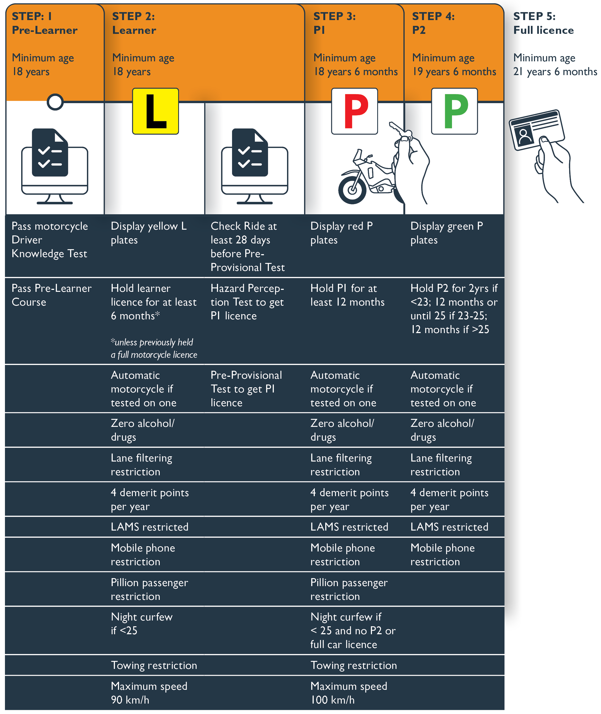

As noted above, CASR considered all elements that apply during the novice licensing stages in each Australian jurisdiction. CASR does not recommend the following countermeasures for inclusion in the Tasmanian motorcyclist GLS at this time:

* a longer minimum learner licensing phase
* mandatory on-road supervision for learners
* a mandatory number of hours of riding experience during the learner licensing phase
* a longer minimum P1 or P2 licensing phase
* a requirement that novice riders wear a high-visibility vest
* additional mandatory protective clothing requirements for novice riders (noting that all riders must wear helmets that comply with the *Road Rules 2019*).

CASR also does not recommend altering the following restrictions that currently apply to novice motorcyclists:

* the requirement to display distinctive L and P plates
* the zero blood alcohol concentration that applies to novice motorcyclists
* the requirement for riders to be tested on a manual motorcycle before being licensed to ride one
* the lane filtering ban during the novice licensing phases.

CASR has recommended nine changes to the Tasmanian motorcyclist GLS to improve safety outcomes for young and novice riders. The rationale for each recommended change is considered in this chapter.

## Age of entry

Currently, the minimum age at which a learner motorcycle licence can be obtained in Tasmania is 16 years and 6 months old.

In its report, CASR notes research that indicates younger motorcycle riders (whether new or fully licensed) are involved in more crashes per distance travelled than older riders. This suggests that age itself is a factor in crash risk, irrespective of experience. In particular, the author cites study from the United States that followed over 40 000 newly licensed motorcyclists and found riders aged under 25 had the highest crash risk (Balusu et al. 2020), and a New Zealand study that found riders over 25 had less than half the crash risk of those aged 15 to 19 (Mullin et al. 2000).

In its 2019 evaluation of the NSW motorcyclist GLS, Transport for NSW (TfNSW) identified that one of the best practice elements of a motorcyclist GLS was having an older rather than a younger minimum age to obtain a learner motorcycle licence. In particular, TfNSW identified that the minimum age to obtain a learner motorcycle licence should not be younger than the minimum provisional driving age.

In Tasmania, the minimum age at which a driver can obtain a learner licence is 16, and the minimum age to progress to a provisional licence and drive unsupervised is 17. As noted above, the minimum age to obtain a learner motorcycle licence in Tasmania is 16 years and 6 months old (at which point they are permitted to ride solo).

The current age difference may appear to indicate that Tasmania already has an older threshold age to enter motorcycle licensing than driver licensing, but motorcyclists are permitted to ride independently as soon as they are granted a learner licence at 16 and 6 months. Conversely, drivers are not permitted to drive independently until they obtain their P1 licence at a minimum age of 17. This means that there is a discrepancy between the car and motorcycle licensing pathways in terms of the earliest age of independent travel.

The minimum age to obtain a learner motorcycle licence varies quite significantly between Australian jurisdictions. The minimum age in Tasmania (16 and 6 months) is the third youngest in the country:

|  |  |  |  |  |  |  |  |  |
| --- | --- | --- | --- | --- | --- | --- | --- | --- |
| Jurisdiction | NT | WA | TAS | ACT | NSW | QLD | SA | VIC |
| Minimum age – learner licence | 16 | 16 | 16 and 6 months | 16 and 9 months | 16 and 9 months | 17 | 18* | 18 |
| Minimum age – solo riding | 16 | 17 | 16 and 6 months | 16 and 9 months | 16 and 9 months | 17 years and 3 months | 18 | 18 |

*\* Exceptions apply: 17 if the person holds a provisional car licence; 16 if they live in regional SA but they may only travel for specified purposes (including work and education).*

Although Tasmania has the third youngest minimum age to obtain a learner licence, it has the second youngest minimum age for solo riding.

The minimum age to obtain a learner motorcycle licence in WA is 16, but novice learners in that state must be supervised during the entire learner period. In WA, motorcyclists are not permitted to ride independently until they progress to an ‘R-E class’ licence at 17 (this is comparable to a P1 licence in Tasmania).

### Recommendation

In its report, CASR recommends that the minimum age to obtain a learner motorcycle licence in Tasmania be raised to 17 at a minimum, but preferably 18.

Raising the minimum age to obtain a learner licence to 17 would mean that novice motorcyclists and novice drivers are permitted to travel independently from the same age, bringing the motorcyclist GLS into alignment with the current driver GLS.

Raising the age to 18 would deliver greater safety benefits by delaying exposure for 18 months. This would bring Tasmania into alignment with Victoria and South Australia.

Raising the minimum age to obtain a learner licence would impact the minimum age at which a rider can progress to a P1, P2 and full motorcycle licence as follows:

|  |  |  |  |
| --- | --- | --- | --- |
|  | Minimum P1 age | Minimum P2 age | Minimum full licence age |
| Minimum learner age of 17 | 17 years and 6 months | 18 years and 6 months | 20 years and 6 months |
| Minimum learner age of 18 | 18 years and 6 months | 19 years and 6 months | 21 years and 6 months |

This recommendation is based on:

* clear evidence, and
* equity between drivers and motorcyclists.

## Minimum tenure during learner licensing phase

The minimum tenure during the learner licensing phase ensures learners have sufficient time to accumulate experience and skills under GLS conditions (Christie 2014). In its best practice review of motorcycle GLS, TfNSW found that there was some degree of evidence supporting a longer (95 + days) rather than a shorter (less than 95 days) minimum learner period.

Currently, the minimum tenure during the learner motorcycle licence phase in Tasmania is six months. In its report, CASR noted that the six-month minimum tenure supports the current training format and timing, noting that the Check Ride is ideally undertaken a minimum of five months after the Pre-Learner Course to reinforce safe riding skills and behaviours.

Non-novice learners are not required to hold their learner licence for six months. A non-novice learner is a learner who has previously held a full motorcycle licence that has been expired for more than five years or has been cancelled or is transferring an expired overseas licence.

A non-novice motorcyclist must wait at least 28 days after passing the Pre-Learner Test before completing the Check Ride, and then another 28 days before attempting the Pre-Provisional Test (effectively an 8-week minimum tenure).

### Recommendation

It is recommended that the six-month minimum tenure for learner licence holders apply to all learners, irrespective of previous licences held. This would support the combined effectiveness of the Pre-Learner Course, the Check Ride, and the Pre-Provisional Test.

This recommendation is based on safety principles.

## Hazard Perception Test

The ability to identify and react to safely avoid hazards is a critical skill for both drivers and motorcyclists.

Computer-based hazard perception tests (HPTs) present simulated driving or riding scenarios and require an individual to scan the scene and respond when a hazard emerges or to indicate when they would react to safely avoid a hazard. They provide a safe and controlled environment to assess hazard perception abilities and allow learners to improve their judgement.

In his *Discussion Paper on Elements of Graduated Licensing Systems for Motorcycle Riders* (2014), Christie found that hazard perception is an essential skill, noting that research suggests that poorly developed hazard perception is linked with crash involvement, particularly among novice drivers.

The HPT is a component of the ‘exemplar’ model of the Australian GLS Policy Framework for drivers (TfNSW 2014). Within the last decade, most Australian jurisdictions have introduced computer-based HPTs as a mandatory element of the licensing pathway for novice drivers and, more recently, novice motorcyclists (both Queensland and Western Australia require the successful completion of a motorcycle-specific HPT).

In March 2022, Tasmania introduced a computer-based HPT as a mandatory assessment in the driver licensing pathway. The HPT must be passed before a learner is eligible to sit their practical driving assessment to progress to a P1 licence.

### Recommendation

CASR recommends introducing a motorcycle-specific HPT to the Tasmanian licensing pathway.

CASR recommends that the HPT should be required between the Check Ride and the Pre-Provisional Test, and notes that the motorcycle-specific HPT clips it developed in conjunction with Austroads present scenarios from the perspective of a motorcycle rider and would be suitable.

This recommendation is based on:

* safety principles
* equity between novice motorcyclists and drivers.

## Carriage of pillion passengers

All Australian jurisdictions prohibit learner motorcyclists from carrying pillion passengers apart from Tasmania and Western Australia. In Tasmania, learner motorcyclists are permitted to carry pillion passengers if the passenger is being carried for the purpose of instructing the learner (in addition, the supervisor must have held a motorcycle licence, other than a learner licence, for a continuous period of 3 years). In Western Australia, learners are required to be accompanied by a supervisory rider as a pillion passenger, in a sidecar, or on another motorcycle. In Queensland, learner riders must also be supervised at all times, but the supervisor is not permitted to be carried as a pillion passenger (supervisors must be seated in a sidecar or supervise from a safe distance on another motorcycle or in another vehicle).

During the P1 licensing phase (or the first 12 month following the learner phase for those jurisdictions that don’t use the ‘P1 terminology), most jurisdictions have pillion passenger restrictions.

In its report, CASR notes that carrying a pillion passenger makes balancing a motorcycle more challenging, may result in distraction, and increase the potential for risk taking behaviour to be encouraged. Carrying pillion passengers not only increases crash risk, but also the injury risk in the event of a crash (Baldock 2022).

In a 2019 review of motorcycle licensing, TfNSW found that restricting carriage of pillion passengers during the novice licensing stages is an element of a best practice motorcyclist GLS.

### Recommendation

CASR recommends that learners should no longer be permitted to carry pillion passengers for the purpose of providing instruction. It should be noted that this would not prevent learners from being accompanied by a compliant supervisor in a sidecar.

This recommendation is based on safety principles.

## Night-time curfew

Night-time restrictions aim to reduce the risk of fatalities or serious injuries to inexperienced riders by prohibiting riding during specific night-time hours.

Tasmanian motorcycle crash data from 2011-2020 shows that young riders are over-represented in night-time crashes: of the crashes that occurred between 12:00 am and 5:00 am, 43% involved riders aged between 16 and 25 years old.

In reviewing relevant evidence and literature, CASR noted that it is well-established that night-time riding involves a higher crash risk, and a higher risk of more severe injuries if involved in a crash. This is likely due to multiple factors, including:

* higher levels of alcohol use by riders and other road users;
* reduced visibility (both in terms of the motorcyclist being seen by other road users and the motorcyclist’s ability to see hazards); and
* sleepiness.

In its 2019 review of motorcycle GLS, TfNSW identified night-time restrictions for novice riders as a ‘best-practice’ component of a motorcyclist GLS.

Night-time restrictions for novice motorcyclists are in place in South Australia and Western Australia between 12:00 am and 5:00 am (although exemptions apply).

### Recommendation

CASR recommends that Tasmania introduce a night-time restriction between 12:00 am and 5:00 am for learner and P1 licence holders under the age of 25, with an exception for P1 licence holders who hold a P2 or full car driver’s licence.

This recommendation is based on evidence.

## Towing

Towing restrictions aim to improve safety outcomes for novice riders by eliminating the additional demands that towing places on inexperienced riders.

There is little to no evidence that towing is a contributory factor in novice motorcycle crashes in Tasmania, but CASR notes that towing trailers is likely to increase risk to inexperienced novice riders and a ban is unlikely to disadvantage many novice motorcyclists.

Towing restrictions currently apply to novice motorcyclists in four Australian jurisdictions:

* ACT (learners and first 12 months of provisional licence)
* NSW (learner and P1 licence holders)
* Victoria (learner and provisional licence holders)
* SA (learners).

### Recommendation

CASR recommends introducing a towing ban for learner and P1 licence holders.

This recommendation is based on:

* safety principles, and
* equity between novice motorcyclists and drivers.

## Use of mobile phones or other communication devices

Under the current Tasmanian motorcyclist GLS, novice riders are subject only to the mobile phone restriction that applies to fully licensed riders and drivers: in summary, they are only permitted to use their mobile phone while riding to make or receive audio calls or as a driver’s aid, and the phone must either be secured in a mounting affixed to their motorcycle or be used hands-free.

As a result of changes to the driver GLS introduced in 2020, Tasmanian learner and P1 drivers are subject to a more comprehensive ban on the use of mobile phones: they are not permitted to interact with a mobile phone at all while driving (including via handsfree means such as Bluetooth). This means that they can use GPS functions or listen to music only if they set it up before they start driving, and they must pull over and park if they want to interact with their phone at all.

This change sought to eliminate mobile phones as a source of distraction in novice drivers. As a result of this change, there is a clear discrepancy between the rules that apply to novice motorcyclists and those that apply to novice drivers.

Although there is less research on the impact of mobile phone use on motorcyclists than car drivers, CASR notes in its report that studies have observed mobile phone use at the time of crash among hospitalised riders, and a higher risk of crash involvement linked to self-reported phone use while riding (Doan and Hobday 2019; Truong et al. 2019).

Western Australia is the only Australian jurisdiction that does not ban mobile phone use for novice riders. Many jurisdictions have bans for novice riders, but exemptions permit hands-free use. TfNSW’s best practice review identified a ban on all mobile phone for all novice riders as a ‘best practice’ component of a motorcyclist GLS.

### Recommendation

CASR recommends banning all mobile phone use for learner and provisional riders (including Bluetooth and handsfree). This would permit use of phones for music and GPS only if set up before a motorcyclist starts riding and does not interact with their phone at all while riding.

This recommendation is based on:

* safety principles, and
* equity between novice motorcyclists and drivers.

## Maximum speed restrictions

Maximum speed restrictions during the novice licensing phase set a maximum permissible speed in addition to the applicable posted speed limit. Maximum novice speed restrictions are a common countermeasure because of the link between travel speed and crash risk.

Under the current Tasmanian motorcyclist GLS, learner and P1 licence holders are subject to a novice maximum speed of 80km/h (in addition to posted speed limits).

As a result of changes to the driver GLS introduced in 2020, novice drivers are currently subject to additional speed restrictions depending on the novice licence type held. Leaner drivers may not drive over 90km/h and P1 drivers may not drive over 100km/h. P2 licence holders are not subject to additional novice speed restrictions. These changes were introduced to allow learner drivers to develop driving skills at a higher speed whilst in a supervised environment (for learners) and whilst subject to other protective restrictions (for both learners and P1 licence holders).

The Australian GLS Policy Framework notes that, in the context of novice drivers, there is not a great deal of available research on the value of reduced speed restrictions, and that it has been suggested novice speed restrictions result in speed differentials between novice and fully licensed drivers that could increase crash risk (TfNSW 2014). The Framework goes on to note that some jurisdictions that have increased novice speed restrictions in recent years have seen no increase in crashes. Nevertheless, the Framework acknowledges that a lack of evidence does not necessarily mean that a countermeasure is ineffective.

In his 2014 discussion paper dealing with graduated licensing elements for motorcyclists, Christie noted that “no strong scientific evidence shows that restricting novice riders or drivers to limits below that for other road users reduces crashes” and in fact, evidence suggests crash risk among all road users increases with greater differentials between individual vehicle speeds and the stream speed of the traffic (35). The paper concludes that restricting the speed limit for novice riders below the stream speed is not best practice, particularly in zones 100km/h and above.

The applicable maximum speed limits (that apply in addition to posted speed limits) for learner motorcyclists in Australian jurisdictions are as follows:

|  |  |  |  |  |  |  |  |  |
| --- | --- | --- | --- | --- | --- | --- | --- | --- |
|  | TAS | ACT | NSW | NT | Qld | SA | Vic | WA |
| Learner | 80km/h | - | 90km/h | 80km/h | - | 100 km/h | - | 100 km/h |
| P1 | 80 km/h | - | 90 km/h | 100km/h unless holds full driver’s licence | - | 100km/h unless holds full driver’s licence | - | - |
| P2 | - | - | 100 km/h | (no P2 phase) | - | (no P2 phase) | - | - |

Tasmania is the only jurisdiction that restricts P1 licence holders to a maximum of 80km/h. In NSW, P1 licence holders are limited to 90km/h, and in NT and SA, P2 licence holders are limited to 100km/h unless they also hold a full driver’s licence (in which case, they are not subject to an additional speed limit).

NSW is the only jurisdiction that imposes an additional speed limit for P2 licence holders (100km/h).

### Recommendation

CASR recommends that the maximum speed restriction applying to learner and P1 motorcyclists be raised in alignment with novice drivers. The maximum speeds for each licence category would be as follows:

* learner motorcyclists: 90km/h
* P1 motorcyclists: 100km/h.

This recommendation is based on:

* evidence, and
* equity between novice motorcyclists and drivers.

## Learner Approved Motorcycle Scheme

The Learner Approved Motorcycle Scheme (LAMS) prevents novice motorcyclists from riding high-powered motorcycles to reduce crash risk among this cohort.

Transport for NSW maintains a list of approved LAMS motorcycles, which must have a maximum power-to-weight ratio of 150 kilowatts per tonne. Most motorcycles with an engine capacity below 260cc and all motorcycles built before 1960 with an engine capacity of less than 660cc are approved under the scheme.

In its report, CASR notes studies showing a correlation between high-powered motorcycles and both crash rates and injury severity. CASR does acknowledge that motorcycle types are self-selected, and that riders who choose a higher-powered motorcycle may be more likely to ride in a way that affects their crash risk.

In Tasmania, learner motorcyclists must ride a LAMS motorcycle. P1 licence holders must ride a LAMS motorcycle unless they previously held a P2 or full motorcycle licence. P2 licence holders are not limited to a LAMS motorcycle.

Tasmania is the only Australian jurisdiction that permits P2 licence holders to ride non-LAMS motorcycles. All other Australian jurisdictions have adopted LAMS criteria for the entire novice licensing phase (noting that the ACT permits some motorcycles with an engine capacity greater than 660cc as long as the power to weight ratio is under 150 kW/tonne).

### Recommendation

CASR recommends extending the LAMS requirement to the P2 licensing phase. This would bring us into alignment with most Australian states and territories.

CASR does note that Austroads is currently reviewing LAMS to ensure that it provides optimal safety outcomes for novice motorcycle riders. CASR recommends that Tasmania note any possible implications for the LAMS system arising from that review.

This recommendation is based on safety principles.

# 7 What will happen next?

This Discussion Paper has been prepared to promote discussion about options to improve the Tasmanian motorcyclist GLS.

Once your views have been heard, RSAC will make a recommendation to the Tasmanian Government to develop an improved motorcyclist GLS. Legislative changes may be required to introduce some recommended changes. If required, a regulatory impact statement will be prepared in accordance with the *Subordinate Legislation Act 1992.*

# References

Baldock, MJR Hutchinson, T 2010 [Motorcycling in South Australia: knowledge gaps for research](http://casr.adelaide.edu.au/publications/list/?id=1184), Report CASR 075, University of Adelaide Centre for Automotive Safety Research, Adelaide, SA.

Baldock, MRJ 2022 Recommendations for a graduated licensing system for motorcyclists in Tasmania, Report CASR 198, University of Adelaide Centre for Automotive Safety Research, Adelaide, SA.

Balusu, SK Mannering, F Pinjari, A 2020 [Hazard based duration analysis of the time between motorcyclists’ initial training and their first crash](https://www.sciencedirect.com/science/article/abs/pii/S2213665720300336?via%3Dihub), *Analytic Methods in Accident Research,* 28, cited in Baldock M R J 2022 Recommendations for a graduated licensing system for motorcyclists in Tasmania, Report CASR 198, University of Adelaide Centre for Automotive Safety Research, Adelaide, SA.

Christie, R 2014 [A discussion paper on elements of graduated licensing systems for motorcycle riders](https://austroads.com.au/publications/road-safety/ap-r469-14), (AP-R469-14). Sydney: Austroads, 10.

Doan, HTN Hobday, MB 2019 [Characteristics and severity of motorcycle crashes resulting in hospitalization in Ho Chi Minh City, Vietnam](https://www.tandfonline.com/doi/full/10.1080/15389588.2019.1643460), *Traffic Injury and Prevention*, 20, 732-737 cited in Baldock, MRJ 2022 Recommendations for a Graduated Licensing System for Motorcyclists in Tasmania, Report CASR 198, University of Adelaide Centre for Automotive Safety Research, Adelaide, SA.

McCartt, AT Teoh, ER Fields, M Braitman, KA Hellinga, LA 2010 [Graduated licensing laws and fatal crashes of teenage drivers: a national study](https://www.tandfonline.com/doi/abs/10.1080/15389580903578854), *Traffic Injury Prevention*, 11: 240-248.

Mullin, B Jackson, R Langley, J Norton, R 2000 [Increasing age and experience: are both protective against motorcycle injury? A case control study](https://www.ncbi.nlm.nih.gov/pmc/articles/PMC1730576/), *Injury Prevention* 6, 32-35 cited in Baldock, MRJ 2022 Recommendations for a Graduated Licensing System for Motorcyclists in Tasmania, Adelaide: Centre for Automotive Safety Research.

Senserrick, TM Williams, AF 2015 [Summary of literature of the effective components of graduated driver licensing systems](https://austroads.com.au/publications/road-safety/ap-r476-15/media/AP-R476-15_Literature_Review_of_Effective_Components_of_Graduated_Licensing_Schemes.pdf), Austroads AP-R476-15

TfNSW 2019 [*Evaluation of the NSW motorcycle graduated licensing scheme*](https://roadsafety.transport.nsw.gov.au/downloads/motorcycle-graduated-licensing-scheme-report.pdf)*,* Report prepared by the Centre for Road Safety, New South Wales Government.

TfNSW 2014 [*Australian graduated licensing scheme: policy framework*](https://roadsafety.transport.nsw.gov.au/downloads/gls.pdf), Report prepared by the Centre for Road Safety, New South Wales Government.

Truong, LT Nguyen, HTT de Gruyter, C 2019 [Mobile phone use while riding a motorcycle and crashes among university students](https://www.tandfonline.com/doi/abs/10.1080/15389588.2018.1546048?journalCode=gcpi20), *Traffic Injury Prevention* 20(2), 204-210 cited in Baldock, MRJ 2022 Recommendations for a graduated licensing system for motorcyclists in Tasmania, Report CASR 198, University of Adelaide Centre for Automotive Safety Research, Adelaide, SA.

Woolley, J Stokes, C Turner, B Jurewicz, C 2018 [Towards safe system infrastructure: a compendium of current knowledge](https://austroads.com.au/publications/road-safety/ap-r560-18), Austroads AP-R560-18

# Appendix 1

The following projects and programs are being progressed under the Action Plan to improve safety outcomes for motorcyclists:

### Full Gear Motorcycle Training Program

The Full Gear motorcycle training program (Full Gear) was launched by the Glenorchy City Council and Bucaan Community House in 2017 in response to community concern about unlicensed and dangerous riding on local streets.

Full Gear was co-designed by young people. It provides comprehensive motorcycle safety education to 16-24-year-olds and aims to reduce dangerous and illegal riding behaviours. Full Gear covers the cost of the mandatory pre-learner course (a common barrier to entering the licensing pathway for many young people). Full Gear also provides $400 towards the cost of motorcycle safety equipment such as a helmet and gloves.

Over $50 000 is provided annually to fund the Full Gear motorcycle training program over the life of the Action Plan.

A group of people standing astride motorcycles wearing high visibility vests with their hands in the air. 
In early 2022, an additional Community Road Safety Grant was awarded to the City of Launceston, in partnership with the Starting Point Neighbourhood House and the Northern Suburbs Community Centre, to run a trial expansion of Full Gear in the north of the state. The Launceston program will be run across two sites: Mac’s Community Shed in Ravenswood and King Billy Shed in Rocherlea.

*Full Gear Motorcycle Training Program participants.*

### Motorcycle Road Safety Audits

Motorcycle Road Safety Audits are being undertaken on popular motorcycle touring routes that have been identified by the Department of State Growth.

Motorcycle Road Safety Audits holistically incorporate the Safe System approach to road safety with local knowledge to improve safety outcomes for motorcyclists on rural Tasmanian roads. This is achieved by identifying and considering key crash types that result in fatal and serious injury, undertaking crash force analysis, and identifying key vulnerable road user risks to align audit findings and countermeasures with Safe System principles. The auditing process engages local stakeholders and motorcyclists to better understand road user perspectives. This transfer of road safety knowledge between stakeholders works to create a safer road system by sharing local knowledge in conjunction with the identification of effective infrastructure treatments and behavioural focused initiatives.

Following a ‘Safe System’ audit, upgrade works were completed on Hollow Tree Road in late 2021. The Central Highlands Council was engaged to complete the works, which included road surface repairs, installation of improved barriers and rub rails, chevron and hazard warning signage, culvert endwall protection and advisory speed signage.

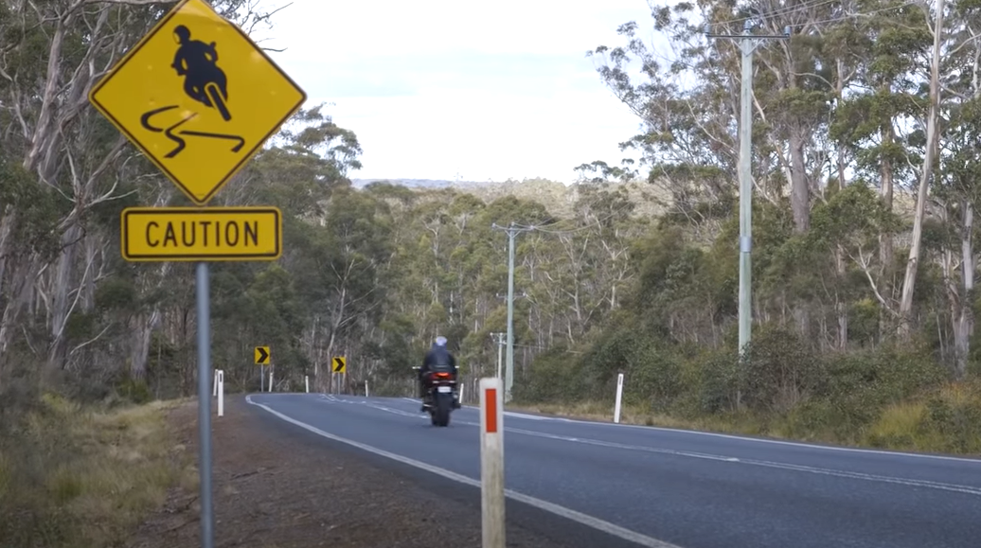Infrastructure and signage improvements on Lake Leake Road are currently underway following a motorcycle safety audit.

*Lake Leake Road motorcycle safety audit.*

### Motorcycle safety campaigns

Ongoing media and public education campaigns continue to focus on the safety of motorcyclists.

This includes the ‘You can’t beat Tassie roads’ campaign, which launched in Spring 2021. This campaign urges motorcyclists to be prepared for all road conditions when riding on Tasmanian roads. Riders are reminded that they are likely to encounter sudden changes in weather conditions, slippery wet or icy roads, loose gravel, and roadkill.

This campaign was developed in consultation with the Tasmanian Motorcycle Council.

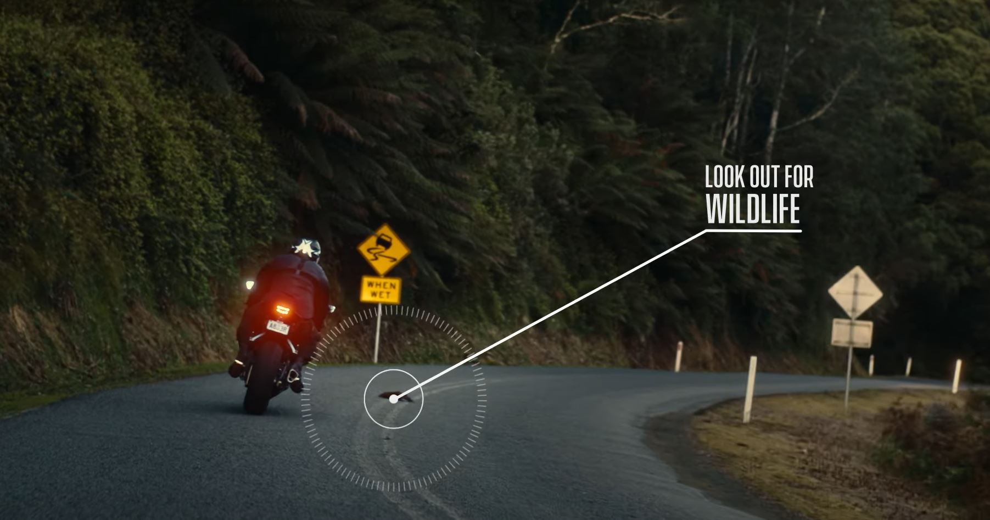Motorcycle safety campaigns complement motorcycle elements of the Tourist Road Safety Strategy, including online safety material and touring maps (<https://www.rsac.tas.gov.au/visitingdrivers/>). These resources are aimed at interstate motorcyclists and have been distributed via the Spirit of Tasmania and motorcycle-related social media networks.

*‘You can’t beat Tassie roads’ motorcycle safety campaign.*

### MotoCAP

Tasmania continues to support the Motorcycle Clothing Assessment Program (MotoCAP), an independent, free resource supported by governments and private road safety organisations across Australia and New Zealand. MotoCAP tests motorcycle protective clothing using rigorous, scientific methods to provide ratings for motorcyclists to choose the right gear with the best protection and breathability for their ride.

The right protective gear can greatly reduce the likelihood of permanent injuries from a crash and shorten hospital recovery times. With the right gear, riders experience a more comfortable ride, with less distraction, fatigue and dehydration.

Riders are best protected when their whole body is covered with abrasion resistant materials, with added impact protection for the joints. Riders wearing protective motorcycle clothing, especially when fitted with impact protection, are less likely to have any injuries in a crash, while those who are injured are less likely to be hospitalised. Unfortunately, studies show that up to 30 per cent of motorcycle clothing fails in crashes.

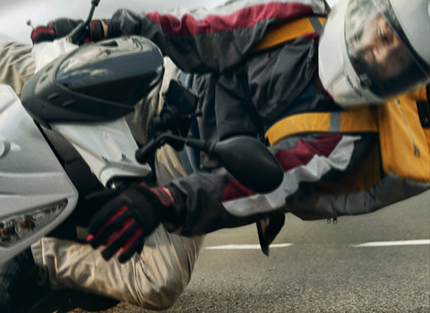Until now, riders have had little information on choosing the best products to protect them from injury if they crash. Nor could retailers or manufacturers compare the performance of their products to others in the market.

**Road Safety Advisory Council**

**Department of State Growth**

GPO Box 536 Hobart

Tas 7001 Australia

Phone: 1800 030 688

Email: [rsac@stategrowth.tas.gov.au](mailto:rsac@stategrowth.tas.gov.au)

Web: [rsac.tas.gov.au](http://www.rsac.tas.gov.au)

© State of Tasmania July 2022