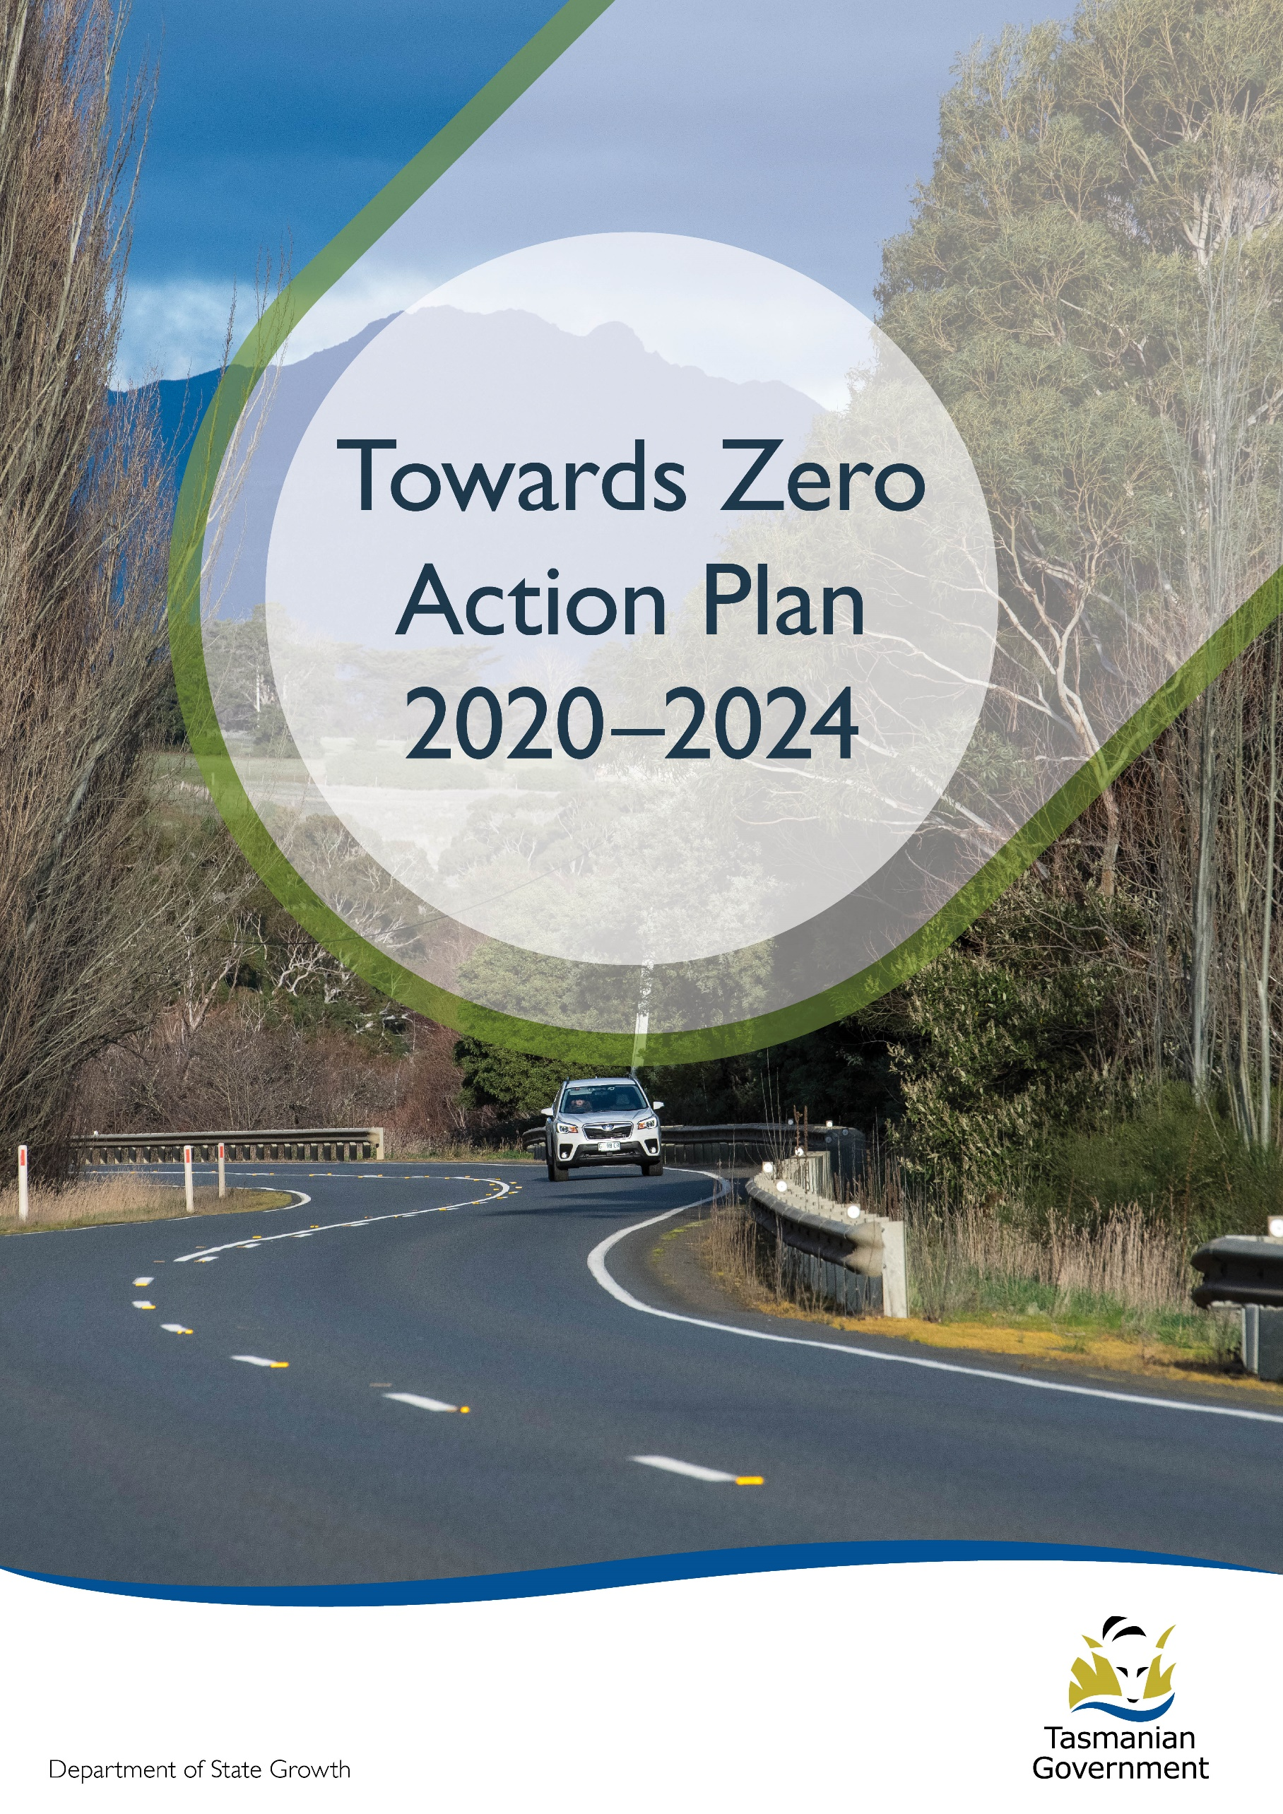
Quarterly Progress Report to RSAC as at 30 June 2022
Contents
Progress on meeting Towards Zero Strategy targets 3
Serious Casualties 3
Fatalities 3
2022 YTD 3
Fatalities Tasmania – Annual Count – 2022 (to 30 June), 2021 and 5-Year Average (2017-21) 3
Serious Casualties Tasmania – Annual Count, Percentage Split by Quarter and Towards Zero Target 4
Annual fatalities – Rate per 100,000 population 5
Progress on meeting MAIB targets 6
Fatalities – 12 Month Rolling Total 6
Total Serious Claims – 12 Month Rolling Total 6
Statistics 7
Serious Casualties by Quarter by Age Group – 12 period moving average 7
Serious Casualties by Quarter by Sex – 12 period moving average 7
7
Serious Casualties by Quarter by Road User Type – 12 period moving average 8
Serious Casualties by Quarter by Speed Zone – 12 period moving average 8
Serious Casualties by Quarter by Crash Type (DCA) – 12 period moving average 9
Serious Casualties by Quarter by Urban/Non-Urban – 12 period moving average 9
Serious Casualty locations to 30 June 2022 (Black = Fatality, Red = Serious Injury) 10
Key themes and priority actions 2020-2024 11
Funding of key themes 11
Project status report 12
Progress on key themes 13
Rural roads grants program for local government 13
Infrastructure upgrades on low volume State roads 14
Motorcyclist safety on rural roads 15
Speed moderation and community engagement strategy 15
Safe system knowledge and skills training 15
Targeted infrastructure upgrades in high traffic urban areas 17
Vulnerable Road User Program 17
Community Road Safety Grants Program 18
Trial of innovative technologies 19
Innovative infrastructure treatment demonstrations 19
Learner Driver Mentor Program and Driver Mentoring Tasmania 16
Graduated Licensing System Project 16
Motorcyclist Graduated Licensing System review 17
Rotary Youth Driver Awareness Program (RYDA) 17
Driving for Jobs Program 18
RACT education initiatives 18
Real Mates media campaign 18
Bicycle Network bike education 19
Safety around schools 19
Kidsafe child restraint check program 19
Full Gear motorcycle safety project 20
Inattention and distraction 21
Safe behaviour campaigns 22
Mandatory Alcohol Interlock Program (MAIP) 22
Protective clothing for motorcyclists 22
Road safety penalties review 23
Speed enforcement strategy 23
Enforcement of high-risk behaviours 24
Automated Traffic Enforcement Program 24
High-risk motorcycling enforcement 25
Road Rules Awareness 25
Tourist road safety signage program 26
Responsive electronic signage trial 26
Tourist education materials 26
Strategic partnerships 27
Tourist education at gateway entry points 27
Stakeholder alliances 27
Australasian New Car Assessment Program (ANCAP) 28
Safer cars for young drivers 28
Autonomous vehicle and crash avoidance readiness 28
Workplace driver safety 29
Light vehicle safety strategy 29

Progress on meeting Towards Zero Strategy targets
The key interim target for the Towards Zero – Tasmanian Road Safety Strategy 2017-2026 (Towards Zero Strategy) is to reduce the number of annual serious injuries and deaths on Tasmanian roads to fewer than 200 by 2026. This is an ambitious target of 100 fewer serious casualties per year than for the period 2012-2016 (annual average) and will move us towards the long-term goal of zero serious casualties on Tasmanian roads.

Serious Casualties
The number of serious casualties in 2021 was 281, compared to 327 in 2020, a 14.1 per cent decrease. The 2021 figure of 281 is an 8.5 per cent decrease on the five year serious casualty average of 307.2 (2016-2020).

Fatalities
In 2021, there were 35 fatalities on Tasmanian roads which is three less than the number recorded in 2020. The figure of 35 fatalities in 2021 is a 4.8 per cent increase on the five-year fatality average of 33.4 (2016-2020).

2022 YTD
There have been 148 serious casualties (30 fatalities and 118 serious injuries) to 30 June 2022, 3 fewer than the number recorded at the same time last year (13 fatalities and 138 serious injuries) and a decrease of 2.1 per cent on the five year average of 151.2 serious casualties.
While the number of serious casualties recorded to the end of June in 2021 and 2022 is broadly consistent (151 v 148), 2022 has seen a more than doubling in fatalities (30) when compared to 2021 (13).

Fatalities Tasmania – Annual Count – 2022 (to 30 June), 2021 and 5-Year Average (2017-21)
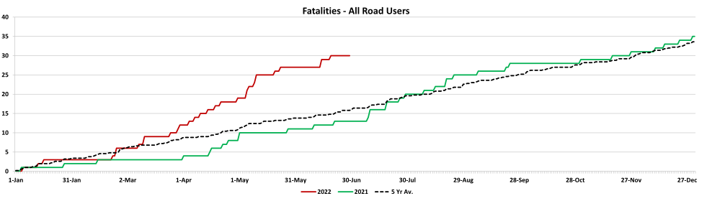

Serious Casualties Tasmania – Annual Count, Percentage Split by Quarter and Towards Zero Target
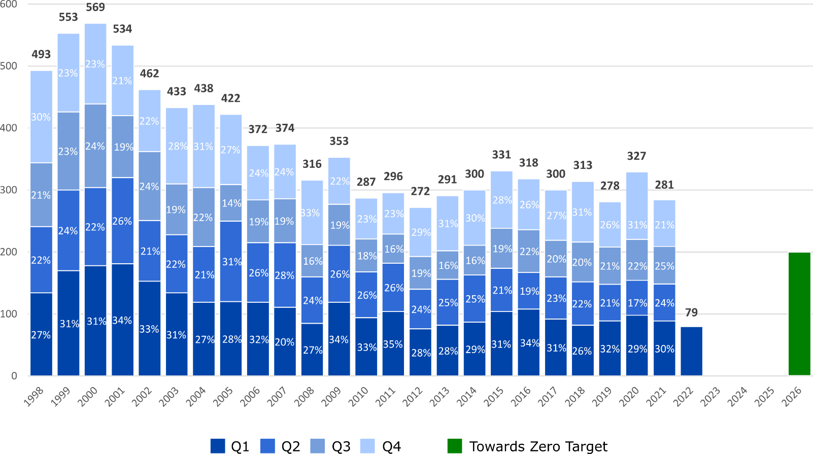

Annual fatalities – Rate per 100,000 population
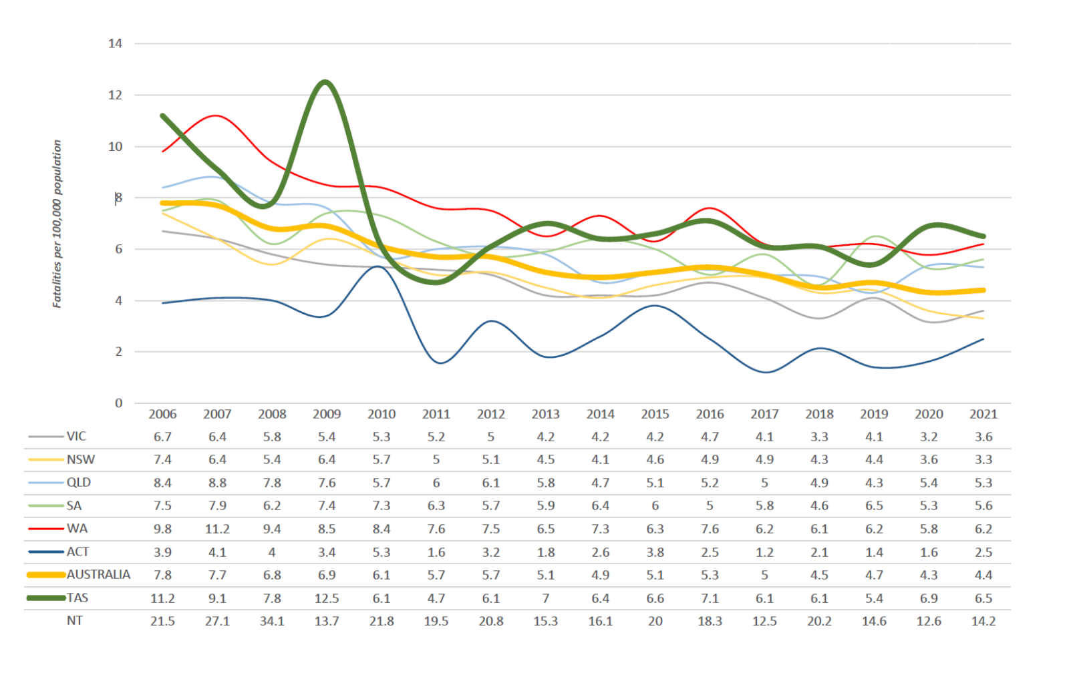
Note: NT omitted from chart for clarity purposes.

Progress on meeting MAIB targets
Motor Accidents Insurance Board (MAIB) injury statistics show the number of fatalities and the level of claims for serious injuries on our roads.
Various claim reduction targets are specified in the Memorandum of Understanding between the Department of State Growth (State Growth) and the MAIB. Progress against high level targets is shown below, expressed as 12 month moving totals

Fatalities – 12 Month Rolling Total
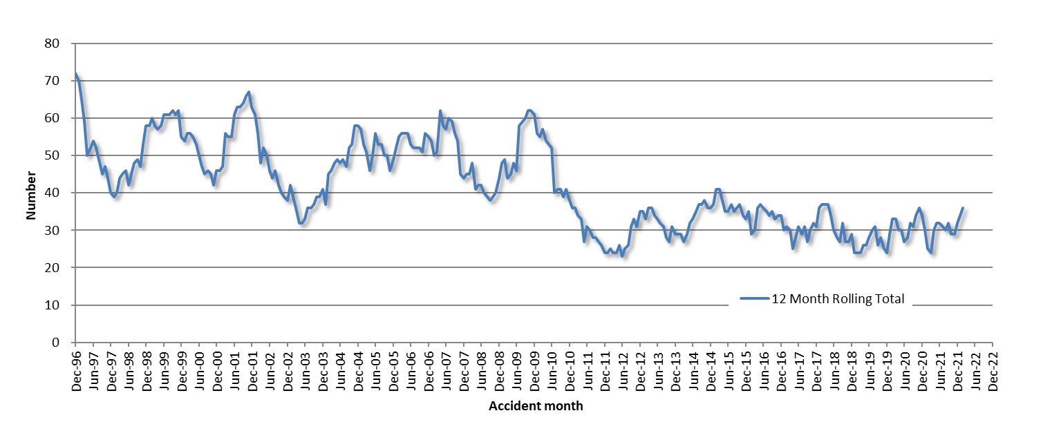

Total Serious Claims – 12 Month Rolling Total
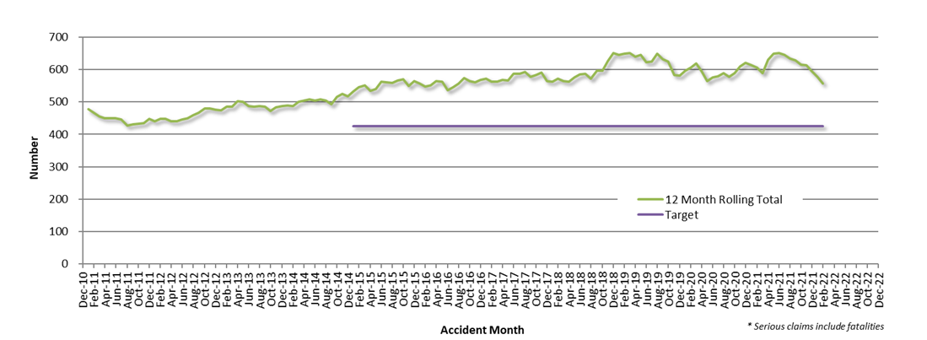

Statistics

Serious Casualties by Quarter by Age Group – 12 period moving average

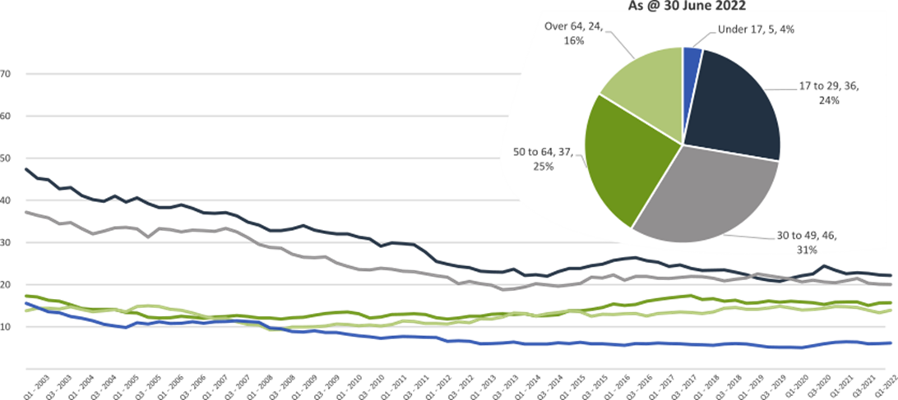

Serious Casualties by Quarter by Sex – 12 period moving average
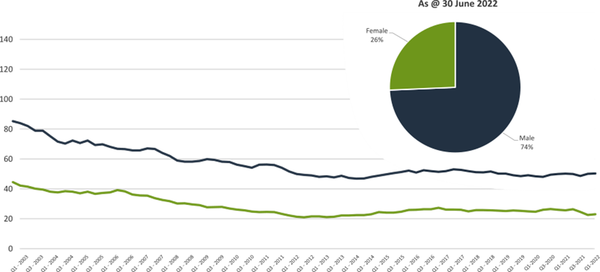

Serious Casualties by Quarter by Road User Type – 12 period moving average
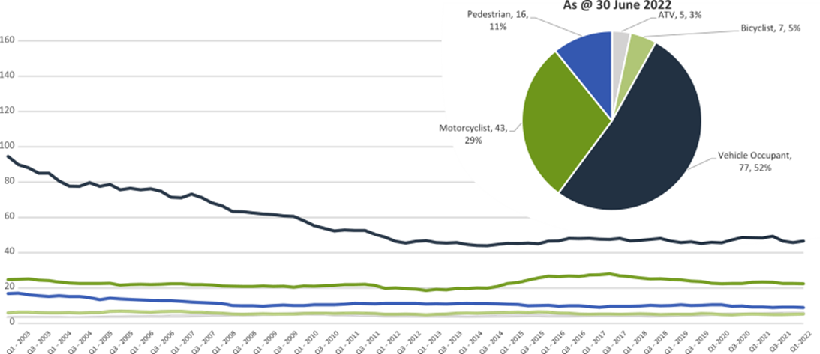

Serious Casualties by Quarter by Speed Zone – 12 period moving average

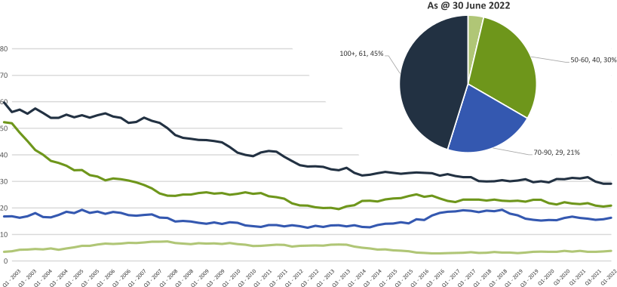

Pie chart excludes serious casualties where speed zone is recorded as ‘not known’

Serious Casualties by Quarter by Crash Type (DCA) – 12 period moving average
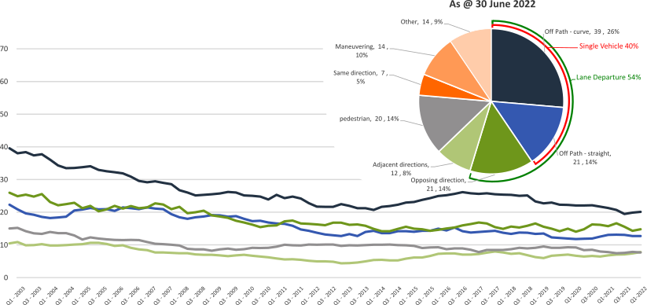

Other includes crash types: on-path (7%), overtaking (1%) & Passenger and Miscellaneous (1%).

Serious Casualties by Quarter by Urban/Non-Urban – 12 period moving average
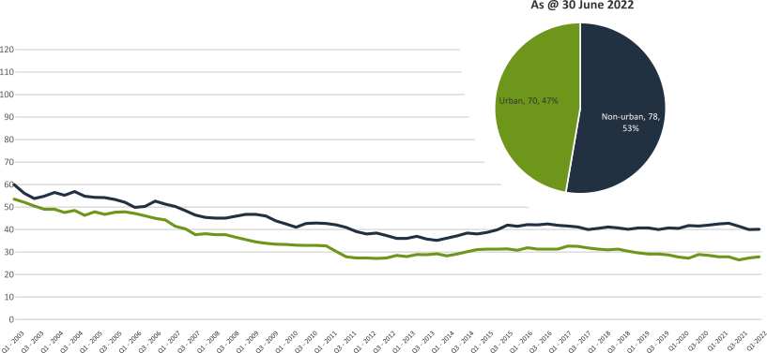

Based on the Australian Bureau of Statistics’ ‘significant urban area’ geographic definition.

Serious Casualty locations to 30 June 2022 (Black = Fatality, Red = Serious Injury)
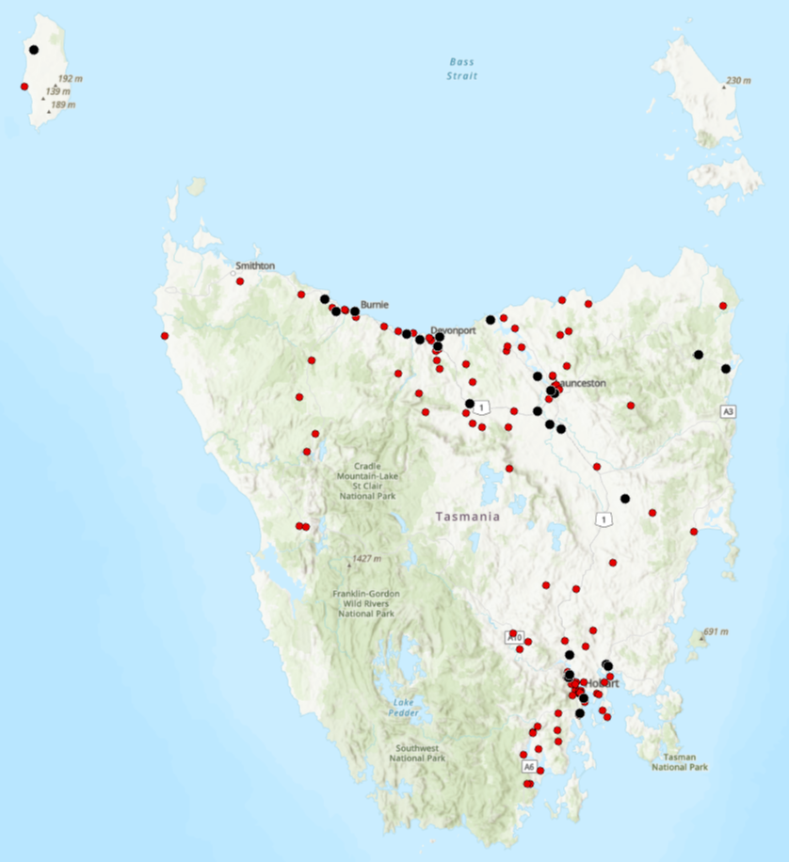

Key themes and priority actions 2020-2024
The Quarterly Progress Report details progress on key themes and priority actions under the Towards Zero Action Plan 2020-2024 and the Towards Zero – Tasmanian Road Safety Strategy 2017-2026.
The progress report should be read in conjunction with the Action Plan and understood in the context of the Towards Zero Strategy. These documents are available at: www.towardszero.tas.gov.au

Funding of key themes
Over $20 million Over $31 million
Over $12 million Over $4 million

$2 million Over $3 million

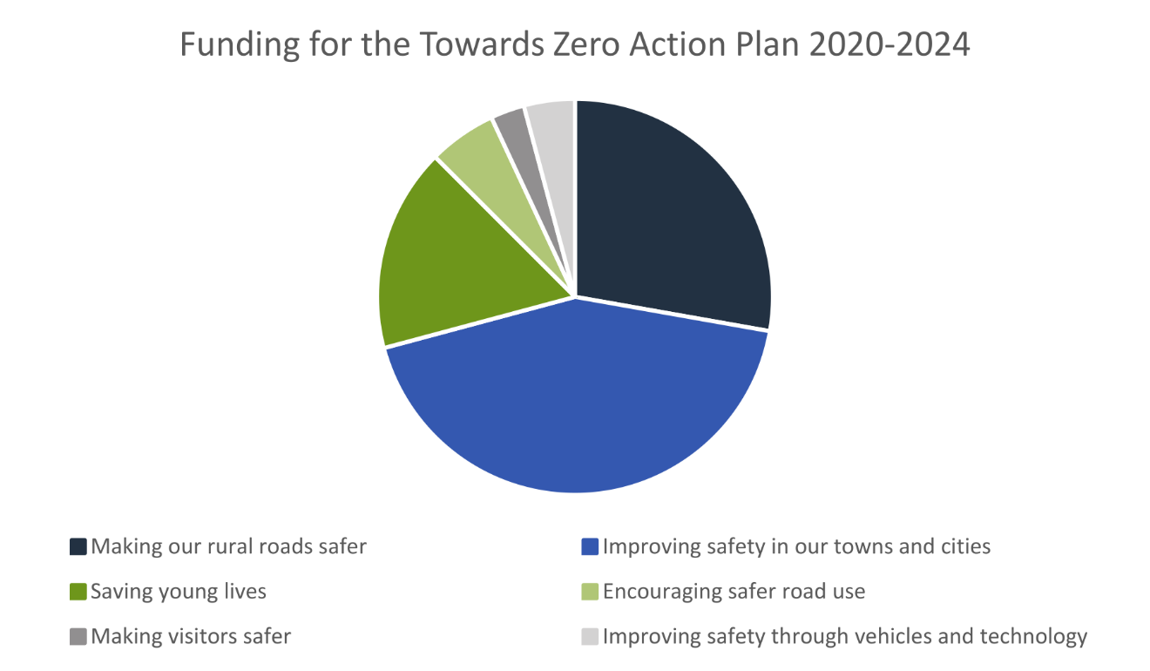

Project status report
Making our rural roads safer
Rural road grants program for local government | On schedule |  | Infrastructure upgrades on low volume State roads | On schedule
Motorcyclist safety on rural roads | On schedule |  | Speed moderation and community engagement strategy | Not yet commenced
Safe system knowledge and skills training | On schedule
Improving safety in our cities and towns
Targeted infrastructure upgrades in high traffic urban areas | Not yet commenced |  | Vulnerable Road User Program | On schedule
Community Road Safety Program | On schedule |  | Trial of innovative technologies | Not yet commenced
Innovative infrastructure treatment demonstrations | Not yet commenced
Saving young lives
Learner Driver Mentor Program and Driver Mentoring Tasmania | On schedule |  | Graduated Licensing System Project for drivers | Complete
Rotary Youth Driver Awareness Program | On schedule |  | Driving for Jobs Program | On schedule
RACT education initiatives | On schedule |  | Real Mates media campaign | On schedule
Bicycle Network bike education | On schedule |  | Safety around schools | On schedule
Kidsafe child restraint check program | On schedule |  | Full Gear motorcycle safety project | On schedule
Develop a Graduated Licensing System for motorcyclists | On schedule
Encouraging safer road use
Inattention and distraction | On schedule |  | Safe behaviour campaigns | On schedule
Mandatory Alcohol Interlock Program | Major delays |  | Protective clothing for motorcyclists | On schedule
Road safety penalties review | Complete |  | Speed enforcement strategy | On schedule
Enforcement of high-risk behaviours | On schedule |  | Automated Traffic Enforcement Program | On schedule
High-risk motorcycling enforcement | On schedule |  | Road Rules Awareness | On schedule
Making visitors safer
Tourist road safety signage program | On hold |  | Responsive electronic signage trial | On hold
Tourist education materials | Limited activity |  | Strategic partnerships | On hold
Tourist education at gateway entry points | Limited activity |  | Stakeholder alliances | On hold
Improving safety through vehicles and technology
ANCAP | On schedule |  | Safer cars for young drivers | Not yet commenced
Autonomous vehicle and crash avoidance readiness | On schedule |  | Workplace driver safety | Not yet commenced
Light vehicle safety strategy | On schedule

Progress on key themes
Progress on key themes is reported as:
Status | Major delays/on hold/high risk | Delayed/some issues/medium risk | On schedule/progressing/low risk | Not yet commenced

60 per cent of fatalities occur in rural areas

Rural roads grants program for local government
The Safer Rural Roads Program (SRRP) provides funding to councils to implement infrastructure treatments on rural road corridors to reduce lane departure crashes and the harm when they do occur. An allocation of $10 million was made to the SRRP to be administered over five funding rounds of $2 million for the life of the Action Plan.
Comments
The Australian Government’s Road Safety Program (RSP) is a $3 billion Commonwealth Budget commitment. Under the RSP, Tasmania has been notionally allocated up to $66 million in funding for small-scale road safety infrastructure projects, to be delivered over five 6-month funding tranches.
Under tranche one of the RSP (1 January 2021 to 30 June 2021), $33.3 million in funding was allocated to Tasmania. To secure this funding, the Tasmanian Government was required to make a co-contribution of $12.3 million.
The RSP provided valuable additional funding to the SRRP. As a result, two funding rounds were held during the 2020-2021 financial year (FY21).
In FY21, 61 applications were received under the SRRP with 59 receiving funding.
The successful projects from FY21 total approximately $10 million in value. This includes funding of $5.88 million from the Australian Government’s RSP, $2.45 million from the Road Safety Levy, and $1.64 million from Local Government co-contributions.
Note: the figures reported in the Quarterly Progress Report to 31 March 2022, contained a transcription error for the amount contributed by the Road Safety Levy and the total value. This has been corrected.
Summary of applications made under the SRRP in FY21
Round | Applications | Number of projects awarded funding | Total amount awarded | Total value of awarded projects
SRRP 2020-21 R1 | 44 | 42 | $5.5 million | $6.1 million
SRRP 2020-21 R2 | 17 | 17 | $2.8 million | $3.9 million
Total | 61 | 59 | $8.3 million | $10 million
Status of successful applications from SRRP rounds in FY21
Round | Number of projects awarded funding | Complete | In progress | Delayed | Withdrawn
SRRP 2020-21 R1 | 42 | 28 | 5 | 9 | -
SRRP 2020-21 R2 | 17 | 9 | 5 | 3 | -
Total | 59 | 37 (+9) | 10 (-11) | 12 (+2) | -
As of 30 June 2022, 37 projects from the FY21 program rounds have been delivered, 10 projects are in progress and 12 projects are experiencing delays. There has been no withdrawn projects.
With the release of the new National Road Safety Strategy 2021-2030 (NRSS) identifying new national direction, the current demand for civil construction, and with several SRRP projects currently in progress, State Growth has delayed the next round of the SRRP to 2023. State Growth will utilise 2022 to undertake a review of the SRRP. This review will enable State Growth to identify and implement opportunities for improvement, as well as action administrative efficiencies that have been identified following the delivery of the SRRP in FY21.
Status | risk |  | On schedule/progressing/low risk

Infrastructure upgrades on low volume State roads
This program will provide funding for lower volume State roads, where cost effective treatments such as shoulder sealing, pavement markings, curve warnings, road side hazard removal and safety barriers will achieve maximum value for money.
Current situation / comments
At the commencement of the Action Plan $6.95 million was committed for infrastructure improvements on the Railton Main Road. $450 000 supported the design and development stage of works and $6.5 million provided funding for works in the delivery stage.
This package of works included a one metre sealed shoulder with a half-metre unsealed verge, basic right turn treatments at several junctions and safety barrier installations at identified roadside hazards. The Railton Main Road upgrades have now been completed.
This program has also supported the Road Safety Levy co-contributions under Tranche 1 and 3 of the Australian Government’s RSP. This has taken advantage of the opportunity that Australian Government co-funding has presented for targeted shoulder sealing and junction upgrades across Tasmania.
Status |  |  | On schedule/progressing/low risk

Motorcyclist safety on rural roads
Road safety audits will be conducted on high risk touring routes across Tasmania. This program will involve local motorcyclists and a safe system approach will inform audits. Findings will be shared with stakeholders to identify countermeasures that go beyond typical infrastructure solutions.
Current situation / comments
Safe System motorcycle road safety audits
Two audits have been completed and funding allocated. The Central Highlands Council was provided with a grant deed up to $200 000, to undertake works on Hollow Tree Road. Works have now been completed.
Funding up to $350 000 has been allocated for State Growth to carry out low-cost infrastructure treatments to improve road safety for motorcyclists on Lake Leake Road. A delivery schedule for these works is currently being scoped with works scheduled to commence in 2022, with delivery of works likely to be completed in 2022.
State Growth is developing a strategy for future motorcycle road safety audits. This strategy will be delivered in 2022, and will identify potential routes in Tasmania to conduct further motorcycle road safety audits.
Status |  |  | On schedule/progressing/low risk

Speed moderation and community engagement strategy
Speed moderation requires a holistic strategy encompassing public education, road risk assessments, enforcement, speed limit setting, speed limit mapping and technology, penalties, KPIs and evaluation. This project will involve community engagement to inform and build support for action on safer speeds. A significant ongoing coordination effort will be required to support the strategy.
Current situation / comments
This project has not yet commenced and will be considered as part of the mid-term review.
Status |  |  |  | Not yet commenced

Safe system knowledge and skills training
This initiative aims to improve Safe System knowledge for all those in a position to influence road safety outcomes. The initiative will focus on Safe System infrastructure design, including appropriate speed setting, and will consist of technical training sessions, workshops and forums across Tasmania.
Current situation / comments
Safe System knowledge and capacity building is being considered within the review of the Safer Rural Roads and Vulnerable Road User programs. As part of these reviews, State Growth is investigating how stronger support can be provided to enable local government to achieve Safe System infrastructure treatments.
As part of this review, State Growth will also review the tools utilised through these programs to further support and encourage local government to apply Safe System principles and treatments in practice.
Funding of $5 600 was provided to support the City of Hobart in delivering a road safety workshop in June 2022. The workshop brought together road safety research experts, local government, and State Growth and trialled an approach for sharing experiences and knowledge, and provided networking opportunities and a platform to hear the latest in Safe System research and risk assessment tools. This workshop approach is being considered by State Growth for future capacity building sessions.
Funding of $10 520 was provided to the Tasmanian Bicycle Council to facilitate online training sessions for Tasmanian engineers and planners in designing Safe System compliant cycling lanes/paths.
Additionally, funding of $12 260 has supported Safe System professional capacity building.
Status |  |  | On schedule/progressing/low risk

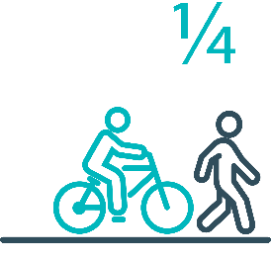

Pedestrians and cyclists are vulnerable and represent
one in four serious casualties in our towns and cities

Targeted infrastructure upgrades in high traffic urban areas
This program provides for delivery of a range of infrastructure safety upgrades to make our towns and cities safer. This will include shoulder sealing, intersection improvements, safety barriers and pavement marking at high traffic areas. This program targets high volume state roads that are not planned for major investment in the short term.
Current situation / comments
This initiative has not yet commenced and will be considered as part of the mid-term review.
However, funding allocated to this initiative to date, under the Action Plan, has supported the Road Safety Levy co-contributions under Tranche 1 and 3 of the Australian Government’s RSP. This has taken advantage of the opportunity that Australian Government co-funding has presented for targeted shoulder sealing and junction upgrades across Tasmania, and the upgrade of nearly 600 electronic school zone signs across approximately 220 locations.
Approximately $430 000 supported local road pavement marking in FY22 to improve delineation at over 300 locations across Tasmania.
Status |  |  |  | Not yet commenced

Vulnerable Road User Program
The Vulnerable Road User Program (VRUP) is an established grants program which assists local government with the costs of installing safety improvements in built up areas. The aim of the program is to reduce conflict between vehicles and vulnerable road users - cyclists, pedestrians and motorcyclists.
Additionally, the program has a focus on increasing Safe System knowledge and capacity in local governments. The funding available under the VRUP was increased from $500 000 to $1 000 000 per annum, under the current Action Plan.
Current situation / comments
The Australian Government’s RSP has provided valuable additional funding to the VRUP. As a result, three funding rounds were held during FY21. In FY21, 95 applications were received under the VRUP with 71 receiving funding. This includes seven cycling safety-focused projects that all received funding under round three.
The successful projects from FY21 total approximately $11.6 million in value. This includes funding of $4.6 million from the Australian Government’s RSP, $4.7 million from the Road Safety Levy, and $2.3 million from Local Government co-contributions.
Summary of applications made under the VRUP in FY21
Round | Applications | Number of projects awarded funding | Total amount awarded | Total value of awarded projects
VRUP 2020-21 R1 | 28 | 20 | $831 941 | $1.3 million
VRUP 2020-21 R2 | 42 | 26 | $3.2 million | $4.2 million
VRUP 2020-21 R3 | 25 | 25 | $5.3 million | $6.1 million
Total | 95 | 71 | $9.3 million | $11.6 million
Status of successful applications from VRUP rounds in FY21
Round | Number of projects awarded funding | Complete | In progress | Delayed | Withdrawn
VRUP 2020-21 R1 | 20 | 17 | - | 1 | 2
VRUP 2020-21 R2 | 26 | 13 | 5 | 5 | 3
VRUP 2020-21 R3 | 25 | 9 | 8 | 8 | -
Total | 71 | 39 (+12) | 13 (-18) | 14 (+4) | 5 (+2)
As of 30 June 2022, 39 projects have been delivered, 13 projects are in progress and 14 projects are experiencing delays. Five projects from the 71 successful projects, valued at $750 000, have been withdrawn.
With the release of the new NRSS identifying new national direction, the current demand for civil construction, and with several VRUP projects currently in progress, State Growth has decided to delay the next round of the VRUP to 2023. Alongside the review of the SRRP, State Growth will review of the VRUP. This review will enable State Growth to identify and implement opportunities for improvement, as well as action administrative efficiencies that have been identified following the delivery of the VRUP in FY21.
Status |  |  | On schedule/progressing/low risk

Community Road Safety Grants Program
The Community Road Safety Grants Program (CRSGP) is an established grants program that aims to build community engagement to address local road safety issues. The program supports local councils, schools, community groups, research institutions and charity organisations to promote road safety at the grass roots level.
Current situation / comments
The Road Safety Branch continues to monitor the progress of projects that have received funding under the CRSGP. Due to different project dates, the majority of evaluation reports will be received over the next 2-3 quarters. Positive community feedback was received for a regional project delivered in Zeehan focused on child safety on main roads, which finished in April 2022.
Status |  |  | On schedule/progressing/low risk

Trial of innovative technologies
This project will include monitoring, investigation and trialling of new and emerging technology based approaches to improving safety for vulnerable road users.
Current situation / comments
This project has not yet commenced and will be considered as part of the mid-term review.
Status |  |  |  | Not yet commenced.

Innovative infrastructure treatment demonstrations
This project will investigate, trial and demonstrate innovative Safe System urban infrastructure treatments to improve road safety in our urban areas. We will work with local councils to show how Tasmania’s cities and towns can be improved for the benefit of all road users, particularly cyclists and pedestrians.
Current situation / comments
This project has not yet commenced and will be considered as part of the mid-term review.
Status |  |  |  | Not yet commenced.

92 young people are seriously injured or killed on our
roads every year

Learner Driver Mentor Program and Driver Mentoring Tasmania
The Learner Driver Mentor Program (LDMP), supported by Driver Mentoring Tasmania (DMT), is a well-established program that supports disadvantaged learner drivers to gain supervised on-road driving hours to gain a licence. DMT supports LDMP providers through peak body support and coordination.
Current situation / comments
DMT has continued to rollout the program evaluation system called YLOO, which provides live data updates on supervisory sessions and vehicle use. This data will inform reporting and evaluation processes.
The 2022-23 funding applications were assessed recently, with recommendations put forward by the Funding Assessment Panel that all 16 applicants who were previously approved for 2021-22 continue to be funded for 2022-23. Approval processes are underway to inform successful 2022-23 applicants.
Status |  |  | On schedule/progressing/low risk

Graduated Licensing System Project
Changes are being made to the Graduated Licensing System (GLS) for drivers to better protect young and novice drivers and improve the licensing pathway. Young drivers are overrepresented in crash statistics and most at risk when they first get their Ps and start driving solo. The changes to the GLS aim to address this risk and improve road safety outcomes for both young and novice drivers.
Current situation / comments
The Tasmanian Government implemented regulatory changes to the GLS on 1 December 2020. Tasmania’s GLS now meets the enhanced model under the national driver GLS framework. The GLS changes were accompanied by a public education campaign explaining the policy changes and how they would apply to current and new learners.
Complementing the policy changes are three digital products that were progressively launched from July 2021.
The Plates Plus learning and assessment platform was designed to improve learner driver education by focusing on developing safe behaviours and attitudes. It is an innovative tool that takes users through a series of interactive exercises to ensure new drivers know the road rules and understand the impact of the fatal five road behaviours. As of 4 July 2022, over 12 000 people had successfully completed the Plates Plus course since its launch on 8 July 2021.
A public education campaign accompanied the launch of the Plates Plus platform and ran until September 2021. The campaign encouraged take-up by promoting the convenience of the platform, which is accessible from any device connected to the internet.
The Plates Plus logbook app launched in November 2021. For many Tasmanian learners, this will replace the existing hard copy logbook. It provides an easy and efficient way to record supervised driving hours during the learner licensing phase. A public education campaign targeting 15 to 25-year-olds accompanied the launch of the Plates Plus logbook app. To engage with this age group, the campaign focused on selected social media platforms.
The computer-based hazard perception test (HPT) was launched on 7 March 2022. The HPT is a mandatory assessment that has been introduced to the learner licensing pathway. As on 4 July 2022, over 4 000 people had successfully completed the HPT.
The HPT assesses a learner’s ability to identify and react to safely avoid hazards. It features high-quality 3D clips developed by Austroads in conjunction with the Centre for Automotive Safety Research, using real Australian crash data to identify the most dangerous driving situations for novice drivers.
The HPT was the final product to be delivered under the GLS project.
Status | Complete

Motorcyclist Graduated Licensing System review
The Tasmanian motorcyclist GLS is being reviewed to identify enhancements to ensure novice motorcyclists are as safe as possible on Tasmanian roads.
Current situation / comments
Following initial consideration by the Department of State Growth, the Centre for Automotive Safety Research (CASR) was engaged to conduct a review of the Tasmanian motorcyclist GLS. The findings and recommendations of the review were presented to RSAC at its May 2022 meeting. A discussion paper is being prepared by the Department, and will be used for a public consultation process that will commence in early August.
The public consultation process will seek community feedback on CASR’s recommendations. Feedback will be collated and presented to RSAC at its November meeting, together with a package of options to amend the motorcyclist GLS. This will enable RSAC to provide advice to the Tasmanian Government to improve safety outcomes for young and novice motorcyclists.
Status |  |  | On schedule/progressing/low risk

Rotary Youth Driver Awareness Program (RYDA)
RYDA is a one-day interactive road safety education program for Year 10-12 students to assist them to respond positively to the challenges and responsibilities of being a driver or passenger. Every year 4000 students take part in a series of practical demonstrations and learn valuable road safety lessons from expert presenters and volunteers. RYDA is delivered by Rotary Tasmania.
Current situation / comments
2022 RYDA sessions commenced in May, with almost 900 students from 11 schools participating in the north-west. Negotiations for alternate accommodations for 2023 due to site redevelopment are continuing with the Department of Education. In FY22, almost 200 students participated regionally from Smithton, Huonville and King Island, out of almost 4 500 students statewide, continuing the focus on engaging at-risk regional communities to increase road safety outcomes.

Status |  |  | On schedule/progressing/low risk

Driving for Jobs Program
The Driving for Jobs (DfJ) Program aims to support disadvantaged students who would otherwise be unable to enter and progress through the Graduated Driver Licensing System (GLS). The program provides students at selected schools with the opportunity to increase their road safety knowledge whilst also improving their job readiness. Students undertake a personalised intensive program with a strong road safety focus including professional on-road driving lessons and participation in the Rotary Youth Driver Awareness Program.
Current situation / comments
The DfJ Program operates at Jordan River Learning Federation (JRLF) in the South and expanded to Claremont College in term four 2021. It operates at Launceston and Newstead Colleges in the North. During 2021, 238 students engaged with the program which resulted in 967 hours of fully funded driving lessons being delivered from accreited driving schools. A total of of 49 students obtained their learner licence and 34 students gained their P1 licence.
The delivery of fully funded driving lessons to students in 2022 did not commence until term two due to the impact of Covid-19 on school operations and difficulties in obtaining a driving school. Participation numbers at JRLF are currently very low and this issue will be discussed at the Steering Committee in August 2022. Participation numbers at the other three locations remain viable.
Status |  |  | On schedule/progressing/low risk

RACT education initiatives
The RACT delivers a range of community and school-based road safety education programs for seniors community groups and primary and secondary students. This includes a program for Year 10-‍12 students focused on the dangers of distraction and inattention, and a program to teach students how to progress through the GLS and about the specific rules that apply to L and P plate drivers. Sessions for seniors include safe driving tips and road rule reminders.
Current situation / comments
The Road Safety Branch continues to monitor the partnership's outcomes with the RACT.
Status |  |  | On schedule/progressing/low risk

Real Mates media campaign
The MAIB-funded Real Mates campaign engages with young men to encourage them to avoid the risks of drink driving by empowering them to speak up and stop a mate from driving after drinking.
Current situation / comments
The Real Mates sponsorship of Vibestown and the Hobart Hurricanes saw the promotion of the Real Mates message at three summer music festivals in Hobart and Launceston and Blundstone Arena from December 2021 to March 2022.
A new iteration of Real mates is in development and will be launched in September 2022 to coincide with AFL finals.
Status |  |  | On schedule/progressing/low risk

Bicycle Network bike education
The Bicycle Network delivers the Ride2School program to primary schools across Tasmania. Ride2School focuses on raising awareness for primary-aged students in safe cycling, road safety and positive road sharing behaviour.

Current situation / comments
The Road Safety Branch continue to monitor the outcomes of the partnership with the Bicycle Network.
Status |  |  | On schedule/progressing/low risk

Safety around schools
Safety around schools is promoted through designated crossings, lower speed zones, more than 100 school crossing patrol officers and public education. The current Safety around Schools project, including the Love 40 campaign, encourages drivers to lower their speed and keep a look out for children in school zones and around buses.
Current situation / comments
The Hon Michael Fergusson MP relaunched the Love 40 campaign at Saint Thomas Moores Primary School, Launceston in Term 1 2022. TVC, radio and digital media continued for two weeks at the commencement of Term 1 to promote the importance of slowing down in school zones and around school buses. Further promotion is planned at the beginning of each school term for 2022.
Status |  |  | On schedule/progressing/low risk

Kidsafe child restraint check program
Kidsafe Tasmania conducts free child restraint checking sessions and training sessions for professionals to ensure young children are safely and lawfully seated and restrained in cars. Kidsafe also distribute and promote educational materials to inform the public of the correct child restraint type for a child’s age and size.
Current situation / comments
Kidsafe continues to provide free child restraint checks and education with a trained child restraint fitter at community organisations and via outreach services. Free training is provided to professionals regarding regulatory requirements and good practice approaches to child restraints. The complementary easy-to-read restraint guides developed by Kidsafe are provided to parents and carers to encourage the correct purchase of restraints suitable to a child's height and weight.

Status |  |  | On schedule/progressing/low risk

Full Gear motorcycle safety project
The Glenorchy City Council, in partnership with Bucaan House, delivers its successful Full Gear motorcycle safety project (Full Gear), which helps at-risk young motorcycle riders to enter the licensing system and adopt safe riding practices.
Current situation / comments
Full Gear held a successful course with highly engaged participants in March 2022, with upcoming sessions in August. Full Gear has been expanded to include a southern P plates program for 2022, with a Skills Day scheduled for November with learner riders and buddy mentors. Full Gear is also being trialled in Launceston this year, with the first presentation for participants held in June. The Glenorchy Project Officer continues to provide support to staff to ensure a core focus on road safety and consistency in the project objectives and principles.
Status |  |  | On schedule/progressing/low risk

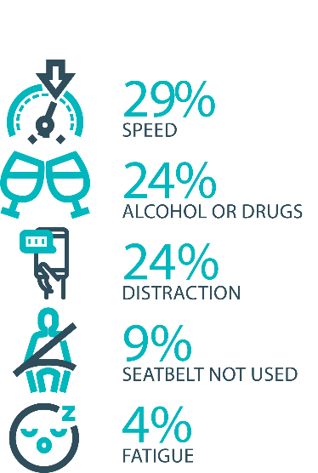

The fatal five behaviours contributing to serious
casualties

Inattention and distraction
Inattention and distraction are concerning causes of serious casualty crashes and may have a far greater impact than current data suggests. There are a number of research projects and enforcement initiatives that are being used to address this issue. This project will include consideration of emerging strategies for tackling distraction, encouraging compliance through enforcement and influencing driver behaviour through public education campaigns.
Current situation / comments
Enforcement
Tasmania Police introduced three unmarked motorcycles to increase the rate of detection and enforcement of illegal phone use whilst driving. These motorcycles operate across all districts and target the low speed road network and congested traffic conditions, utilising ‘lane filtering’ legislation to full advantage.
In an agency first, the riders are also fitted with helmet cameras to capture the offence, an initiative that has effectively nullified disputes. The introduction of unmarked motorcycles has proved to be incredibly successful with riders reporting high-level public support and a notable change in driver behaviour.
Tasmania Police continue to identify, trial and implement emerging technologies to address speeding, seatbelt, inattention and distraction offences including, improving enforcement of high-risk driving. The technology is combined with speed detection and Automated Number Plate Recognition capabilities. Future use of such technology is now being considered as part of the Automated Traffic Enforcement Project being led by the Department of State Growth.

Status |  |  | On schedule/progressing/low risk

Safe behaviour campaigns
Targeted media campaigns will continue to educate people about high-risk behaviours and to highlight the dangers of the ‘Fatal Five’.
Current situation / comments
In preparation for the introduction of enhanced speed enforcement in Tasmania a new public education campaign ‘Over is Over’ was launched in December 2021.
The first phase of the campaign challenges motorists to rethink their attitudes to speeding and shows how exceeding the speed limit even by ‘a few kilometres’ can lead to unintended negative consequences.
A second phase of the campaign launched in June 2022 to coincide with the implementation of the new mobile speed camera program and serves as a reminder to drivers and riders that the law is the law and speeding will no longer be ignored.
Over is Over aims to reduce road trauma by highlighting the dangers of speeding and will support the re-introduction of mobile speed cameras. The campaign is supported by TV, radio, press, digital and outdoor advertising.
Status |  |  | On schedule/progressing/low risk

Mandatory Alcohol Interlock Program (MAIP)
The MAIP aims to have repeat and high-level drink driving offenders demonstrate they are able to separate their drinking from driving through the installation of an alcohol interlock in their vehicle. New measures will be introduced to increase participation in the MAIP.
Current situation / comments
Drafting instructions for the revised framework were provided to the Office of Parliamentary Counsel (OPC) in October 2019. Parliamentary priorities, including COIVD-19, caused reprioritisation of OPC work. Drafting instructions were withdrawn from OPC in May 2021, before the first draft of amendments had been received, to enable the new Road User Services’ managers to review the drafting instructions to ensure that they remain current. The revised instructions were re-submitted to OPC on 15 February 2022.
Two approved Providers have signed new contracts; negotiations continue with the third. The contracts expire in October 2022; work will commence on creating new contracts in the near future.
Status | Major delays/on hold/high risk

Protective clothing for motorcyclists
Motorcyclists are overrepresented in Tasmania’s road trauma figures. Motorcyclists are vulnerable road users due to a lack of physical protection. Protective clothing can reduce injury severity in the event of a crash. Tasmania is a funding member of MotoCAP. MotoCAP provides safety assessment star ratings for protective clothing and prepares education materials for motorcyclists.
Current situation / comments
Tasmania contributes around $8 000 per annum to participate in and support the activities of MotoCAP. In early 2021, several thousand public education brochures advising of clothing safety ratings for motorcycle wear were sent out to motorcycle retailers and relevant stakeholders across the state.
Status |  |  | On schedule/progressing/low risk

Road safety penalties review
For enforcement activities to improve safety on our roads, they need to be backed up with appropriate penalties. Tasmania’s road safety penalties will be reviewed to ensure they are up-to-date and provide an appropriate deterrence to those who break the rules and put themselves and others at risk.
Current situation / comments
Tasmania’s road safety penalties have been reviewed and updated and inter-jurisdictional analysis has been completed. Findings were submitted to RSAC for noting at its November 2020 meeting. RSAC determined that current penalties are appropriate and penalties will be reviewed towards the end of the current Action Plan.
Status | Complete

Speed enforcement strategy
Speed is one of the fatal five offences addressed within the Tasmania Police Road Safety Strategy 2022-2024.
The strategy directs enhanced speed enforcement strategies and techniques to increase the rate of detection and increase the perception that offending drivers and riders will be caught through the coordination of high-visibility speed enforcement in high-risk areas across all police districts.
With regard to speed cameras, Tasmania Police has conducted several technology trials, including in-motion camera technology, where speed cameras are fitted to moving vehicles, and of mobile point-to-point speed detection, where average speed enforcement utilises two vehicles fitted with automatic numberplate recognition technology. In addition, Tasmania Police is working with the Department of State Growth to introduce future automated speed enforcement in Tasmania.
Tasmania Police has implemented a Strategic Asset Management Plan (SAMP) for all speed detection devices. The SAMP provides for continual review of new and emerging technologies, includes provisions for regular replacement and upgrade of equipment and importantly supports long-term financial planning and budgeting. In line with the SAMP, Tasmania Police’s Southern Road and Public Order Services is also trialling a rear-facing radar on a patrol vehicle.
Tasmania Police has further developed the new vehicle livery across the fleet to include the introduction of ‘Over is Over’ campaign mark-ups on selected traffic enforcement cars and motorcycles. Tasmania Police continue matching different livery designs to specific uses, for example general patrol, high-visibility patrol, and low-profile marked vehicles – all of which are relevant to different methodologies of speed reduction and enforcement. The strategy has also seen the introduction of unmarked highway patrol cars which have proved to be very successful and complement the use of overt policing tactics well.
Tasmania Police recently updated the marked police motorcycle fleet with new livery for these bikes being implemented to heighten the visibility of police on the road network.

Status |  |  | On schedule/progressing/low risk

Enforcement of high-risk behaviours
To reduce high-risk behaviours and increase compliant road user behaviour, State Growth and Tasmania Police will work collaboratively to investigate and introduce new enforcement techniques and technologies to detect high-risk behaviours that address the ‘fatal five’, including mobile phone use, speeding and failure to wear a seatbelt.
Current situation / comments
Tasmania Police Road Safety Strategy 2022-2024, focuses on the fatal five causes of serious and fatal crashes, which are the highest risk driver behaviours: speeding; alcohol and drugs; distraction and inattention; seatbelts; and fatigue.
The strategy includes the analysis of current data that assists to identify where enforcement activities should be focused according to the highest risk, road safety locations, times and behaviours to achieve a change in driver behaviour.
Status |  |  | On schedule/progressing/low risk

Automated Traffic Enforcement Program
Automated Traffic Enforcement (ATE) (i.e. speed cameras) is relatively underutilised as a deterrence and enforcement mechanism in Tasmania. This project investigates proven and emerging camera technologies for use at high-risk locations and across the entire road network.
Current situation / comments
On 30 May 2022, the Deputy Premier and Minister for Infrastructure and Transport (Deputy Premier) signed a contract with Sensys Gatso Australia to deliver mobile speed camera enforcement services in Tasmania.
Sensys Gatso will deliver 20,000 enforcement hours via a minimum of eight mobile speed cameras with speed enforcement expected to commence in September 2022.
In addition and as part of the 2022-23 State Budget, the Government allocated an additional $9.3 million over three years to extend enforcement services for an additional one year and implement emerging technologies such as mobile phone, seatbelt, and average speed enforcement.
To support the implementation of these emerging technologies, the project team has progressed legislative and regulatory amendments which will enable photographic detection devices to be used in detecting and prosecuting mobile phone, seatbelt, and average speed offences. Legislative amendments are currently before the Tasmanian Parliament.
Camera deployments will be based on crash risk, an infrastructure rating assessment and vehicle operating speeds. Once full operating, community suggested locations will be considered where there is a clear road safety benefit.
The introduction of the ATE program has be supported by a new enforcement focus of the ‘Over is Over’ marketing campaign and the development of a separate program website.
Stage One of the mobile speed camera signage programs has been completed with Stage Two expected to be completed in 2022-23.
Status |  |  | On schedule/progressing/low risk

High-risk motorcycling enforcement
Speed is a factor in at least a quarter of motorcyclist serious casualties. Speed cameras offer no deterrence to motorcyclists, whose numberplates are mounted only on the back. Introduction of rear-facing speed cameras will improve detection and deterrence of speeding. This is being considered as part of the Automated Traffic Enforcement Program.
Current situation / comments
The Tasmania Police Road Safety Strategy 2022-2024 approaches the enforcement of high-risk motorcycle behaviours from several angles. Tasmania Police has:
- worked with the Department of State Growth to re-introduce Automated Mobile Speed Enforcement Cameras that have both a rearward and forward-facing capability to better target and detect high-risk motorcycle behaviour.
- introduced an online public portal for members of the public to upload footage relating to traffic offences they have witnessed. Tasmania Police review these submissions and allocate prima facie offences to an officer for investigation and follow-up.
- published the Tasmania Police Road Safety Strategy 2022 – 2024 which provides for increased patrol hours on rural roads which includes many of the popular motorcycle touring routes. The increased patrol hours will be conducted in a mix of covert and overt patrols that will discourage and detect high-risk motorcycle behaviours increasing the perception amongst riders they will be caught anywhere at any time.
Status |  |  | On schedule/progressing/low risk

Road Rules Awareness
Compliance with Road Rules makes our behaviour on the roads predictable, improving safety for all road users. This initiative will ensure that user-friendly and tailored information resources are developed so that the Road Rules are easily understood and adhered to by all road users.
Current situation / comments
The Tasmanian Road Rules Handbook and the Misunderstood Road Rules series of pamphlets are distributed to Service Tasmania locations when required.

Status | Major delays/on hold/high risk |  | On schedule/progressing/low risk

11 per cent of all serious casualties on our
roads are non-Tasmanian residents

Tourist road safety signage program
This program will see the installation of tourist signage strategically placed across the road network. The signs will provide important road safety information, relevant to the area road users are travelling in. This program will be undertaken in collaboration with stakeholders, local government and State Roads.
Current situation / comments
This program is currently on hold.
Status | On hold |  | On schedule/progressing/low risk

Responsive electronic signage trial
This project will trial a responsive electronic sign with real time information at regional tourism gateways.
Current situation / comments
This project is currently on hold.
Status | On hold

Tourist education materials
A range of education materials developed using images, symbols and multi-lingual material delivered to specific audiences through targeted communications channels. This includes vehicle hangers, brochures, posters, roadside signs, editorial content, film and digital content.
Current situation / comments
Communications materials are being distributed upon request from stakeholders.
Status |  | Limited activity

Strategic partnerships
Developing strategic partnerships based on synergies with target audiences will enable the effective promotion of road safety messages and education.
Current situation / comments
This project is currently on hold.
Status | On hold

Tourist education at gateway entry points
As an island state, we have the opportunity to strategically place messaging at our gateway airports and seaports to reach visitors with important road safety messaging prior to them driving in Tasmania. This includes a range of educational materials, electronic and static signs and billboards.
Current situation / comments
Printed collateral is in stock and digital billboards display road safety messaging at gateway locations.
Status |  | Limited activity

Stakeholder alliances
Sharing information and collaborating to develop effective strategies and tools to address road safety issues is vital. This project will develop formal and informal stakeholder alliances to encourage input and create opportunities to deliver joint initiatives.
Current situation / comments
This activity is currently on hold.
Status | On hold

The rate of fatal crashes is four times higher for vehicles 15+ years old than for vehicles made in the last five years

Australasian New Car Assessment Program (ANCAP)
Tasmania is a funding member of ANCAP. ANCAP plays a vital role in informing consumers about safety performance of new vehicles and advocates for improved vehicle safety design and specification through public education campaigns, advocacy activities and engagement with governments, corporate fleets, the media and consumers. Activities related to ANCAP will include promotion of safer vehicles and options for an annual vehicle fleet report.
Current situation / comments
Tasmania continues to support ANCAP with funding of $12 500 per annum.
Status |  |  | On schedule/progressing/low risk

Safer cars for young drivers
This project aims to increase awareness of the Used Car Safety Rating database amongst first time car buyers. This could be promoted through education materials and campaigns and may be able to integrate with the GLS online learning platform.
Current situation / comments
This project has not yet commenced and will be considered as part of the Light Vehicle Safety Strategy and through the mid-term review.
Status |  |  |  | Not yet commenced

Autonomous vehicle and crash avoidance readiness
This project involves the monitoring and development of safety and autonomous vehicle technologies.
Current situation / comments
The regulation of autonomous vehicles is being considered at a national level and Tasmania is participating in that process.
Status |  |  | On schedule/progressing/low risk

Workplace driver safety
Vehicle use in road traffic is the most significant contributor to work-related traumatic injury. This project will aim to promote and encourage employers to adopt safe driving policies based on the Worksafe, ‘Vehicles as a workplace’ guide.
Current situation / comments
This project has not yet commenced and will be considered as part of the mid-term review.
Status |  |  |  | Not yet commenced.

Light vehicle safety strategy
A light vehicle safety strategy will be developed to provide public education and undertake enforcement activities to enhance the safety standard of Tasmania’s vehicle fleet.
Current situation / comments
A draft light vehicle safety strategy is being developed. The draft strategy aims to accelerate an increase in the number of newer and safer vehicles and removal of older cars from the light vehicle fleet while increasing the safety of the current vehicle fleet.
The draft strategy will be provided to RSAC at its August 2022 meeting to seek feedback and views on the proposed direction and actions.
Status |  |  | On schedule/progressing/low risk

Funding
Road Safety Levy Overview for the Financial Year 2021/22
As at 30 June 2022 (Quarter 4)
Road Safety Levy Opening Summary
Opening Balance as at 01 July 2021 |  |  | $ 17,013,469
Annual Allocation to Road Safety Operations |  |  | $ 2,600,000
Revenue Summary
 |  | Forecast (FY22) | Actual (Y.T.D.)
Motor Accident Insurance Board Funding |  | $ 1,300,000 | $ 1,528,521
Revenue Inflows from Registrations |  | $ 14,875,906 | $ 16,300,008
RSP Funding |  | $ 19,025,000 | $ 24,975,000
Funds Available for Distribution |  | $ 30,589,375 | $ 32,241,998
Expenditure Summary
Theme no. | Theme | Forecast (FY22) | Actual (Y.T.D.)
1 | Making our Rural Roads Safer | $ 3,371,975 | $ 2,701,913
2 | Improving Safety in our Towns and Cities | $ 9,311,480 | $ 7,151,042
3 | Saving Young Lives | $ 2,893,830 | $ 2,081,191
4 | Encouraging Safer Road Use | $ 2,142,665 | $ 2,138,147
5 | Making Visitors Safer | $ 705,617 | $ 156,520
6 | Improving Safety Through Vehicles and Technology | $ 175,510 | $ 12,245
7 | General Support | $ 929,821 | $ 656,323
Budget and Expenditure by Category |  | Forecast (FY22) | Actual (Y.T.D.)
Infrastructure Expenditure |  | $ 12,638,476 | $ 9,650,215
Policy & Projects Expenditure |  | $ 7,090,415 | $ 5,247,167
Total Expenditure |  | $ 19,728,892 | $ 14,897,382
Balance as of 30 June 2022 |  | $ 10,860,483 | $ 17,344,616
Forecast Closing Balance of FY22 |  | $ 10,860,483
Note: Expenditure include MAIB expenditure

MAIB Funding
As at 30 June 2022

2021/22 Financial Year | Budget  $ | Actual (ytd)  $ | Balance  $
Expenditure (State Growth)
Administration & Public Relations | 368 116 | 259 366 | 108 750
Public Education | 958 682 | 1 555 452 | (596 860)
Research | 160 000 | 113 703 | 46 297
Subtotal | 1 486 798 | 1 528 521 | (41 723)
Expenditure (Tasmania Police)
Salaries | 2 032 291 | 1 986 288 | 46 003
Operating Expenses | 188 000 | 111 637 | 76 363
Equipment | 539 708 | 248 195 | 291 513
Subtotal | 2 759 999 | 2 346 119 | 413 879
Total | 4 246 797 | 3 874 640 | 372 156
Includes Carried Forward of
$107 614 (State Growth)
$82 749 (Police)

Department of State Growth
Road Safety Branch
Towards Zero Action Plan 2020-2024

GPO Box 536
Hobart TAS 7001 Australia
 | Phone: | 6166 3243
 | Email: | rsac@stategrowth.tas.gov.au
 | Web: | www.rsac.tas.gov.au
 | © State of Tasmania June 2022

