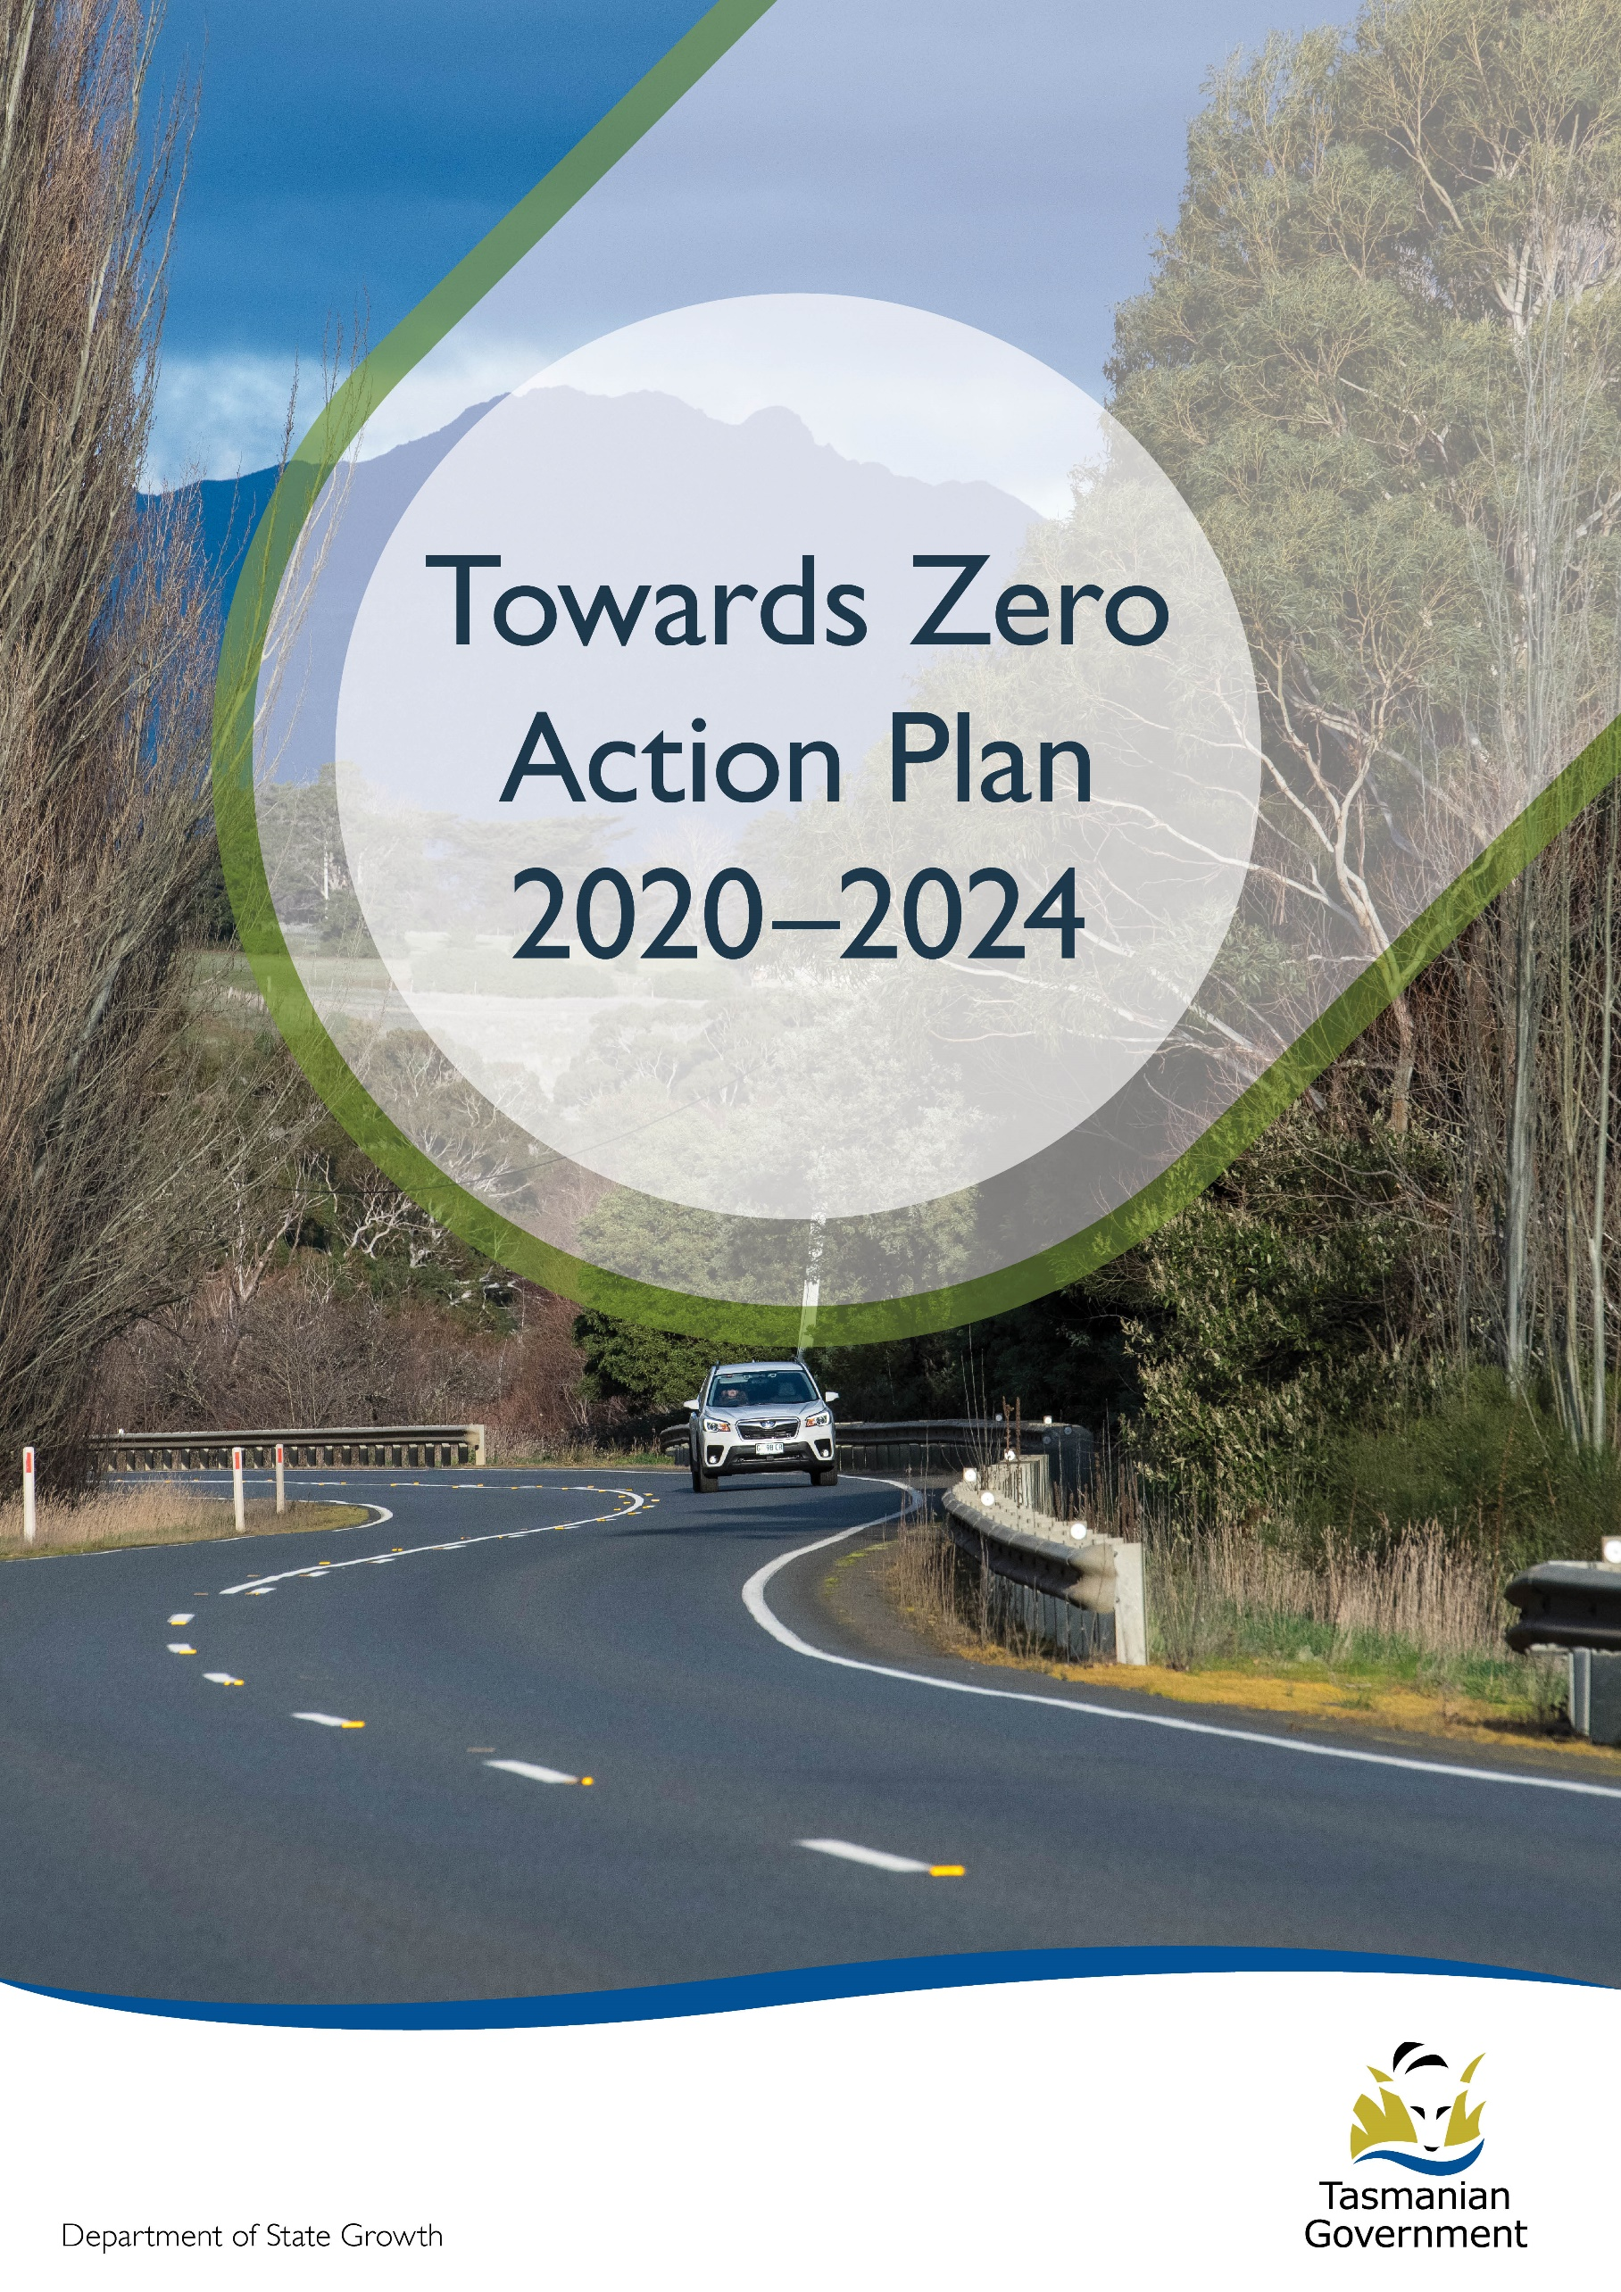
Quarterly Progress Report to RSAC as at 31 March 2022
Contents
Progress on meeting Towards Zero Strategy targets 3
Serious Casualties 3
Fatalities 3
2022 YTD 3
Serious Casualties Tasmania – Annual Count, Percentage Split by Quarter and Towards Zero Target 3
Annual fatalities – Rate per 100,000 population 4
Progress on meeting MAIB targets 5
Fatalities – 12 Month Rolling Total 5
Total Serious Claims – 12 Month Rolling Total 5
Statistics 6
Serious Casualties by Quarter by Age Group – 12 period moving average 6
Serious Casualties by Quarter by Sex – 12 period moving average 6
6
Serious Casualties by Quarter by Road User Type – 12 period moving average 7
Serious Casualties by Quarter by Speed Zone – 12 period moving average 7
Serious Casualties by Quarter by Crash Type (DCA) – 12 period moving average 8
Serious Casualties by Quarter by Urban/Non-Urban – 12 period moving average 8
Serious Casualty locations to 31 March 2022 (Black = Fatality, Red = Serious Injury) 9
Key themes and priority actions 2020-2024 10
Funding of key themes 10
Project status report 11
Progress on key themes 12
Rural roads grants program for local government 12
Infrastructure upgrades on low volume State roads 13
Motorcyclist safety on rural roads 13
Speed moderation and community engagement strategy 13
Safe system knowledge and skills training 14
Targeted infrastructure upgrades in high traffic urban areas 15
Vulnerable Road User Program 15
Community Road Safety Grants Program 16
Trial of innovative technologies 17
Innovative infrastructure treatment demonstrations 17
Learner Driver Mentor Program and Driver Mentoring Tasmania 16
Graduated Licensing System Project 16
Motorcyclist Graduated Licensing System review 17
Rotary Youth Driver Awareness Program (RYDA) 17
Driving for Jobs Program 18
RACT education initiatives 18
Real Mates media campaign 18
Bicycle Network bike education 19
Safety around schools 19
Kidsafe child restraint check program 19
Full Gear motorcycle safety project 20
Inattention and distraction 21
Safe behaviour campaigns 22
Mandatory Alcohol Interlock Program (MAIP) 22
Protective clothing for motorcyclists 22
Road safety penalties review 23
Speed enforcement strategy 23
Enforcement of high-risk behaviours 23
Automated Traffic Enforcement Program 24
High-risk motorcycling enforcement 24
Road Rules Awareness 25
Tourist road safety signage program 26
Responsive electronic signage trial 26
Tourist education materials 26
Strategic partnerships 27
Tourist education at gateway entry points 27
Stakeholder alliances 27
Australasian New Car Assessment Program (ANCAP) 28
Safer cars for young drivers 28
Autonomous vehicle and crash avoidance readiness 28
Workplace driver safety 29
Light vehicle strategy 29

Progress on meeting Towards Zero Strategy targets
The key interim target for the Towards Zero – Tasmanian Road Safety Strategy 2017-2026 (Towards Zero Strategy) is to reduce the number of annual serious injuries and deaths on Tasmanian roads to fewer than 200 by 2026. This is an ambitious target of 100 fewer serious casualties per year than for the period 2012-2016 (annual average) and will move us towards the long-term goal of zero serious casualties on Tasmanian roads.

Serious Casualties
The number of serious casualties in 2021 was 281, compared to 327 in 2020, a 14.1 per cent decrease. The 2021 figure of 281 is an 8.5 per cent decrease on the five year serious casualty average of 307.2 (2016-2020).

Fatalities
In 2021, there were 35 fatalities on Tasmanian roads which is three less than the number recorded in 2020. The figure of 35 fatalities in 2021 is a 4.8 per cent increase on the five year fatalities average of 33.4 (2016-2020).

2022 YTD
There have been 79 serious casualties (12 fatalities and 67 serious injuries) to 31 March 2022, 4 fewer than the number recorded at the same time last year (3 fatalities and 80 serious injuries) and a decrease of 10.2 per cent on the five year average of 88 serious casualties.

Serious Casualties Tasmania – Annual Count, Percentage Split by Quarter and Towards Zero Target
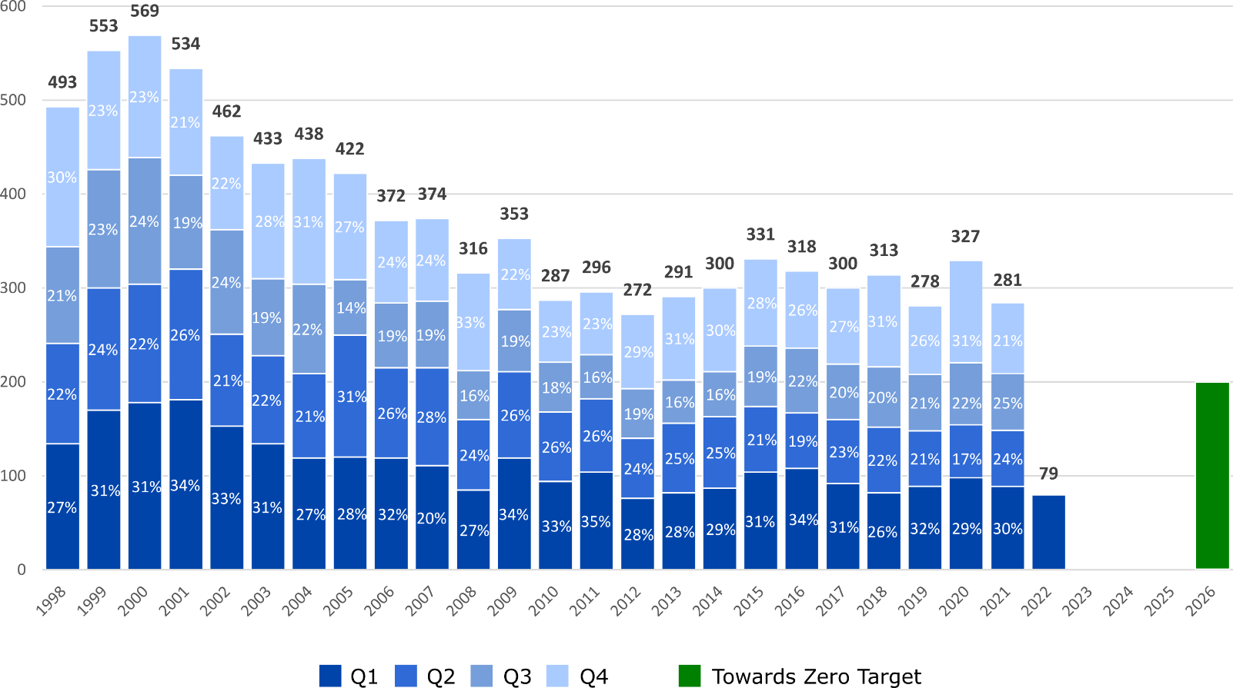

Annual fatalities – Rate per 100,000 population
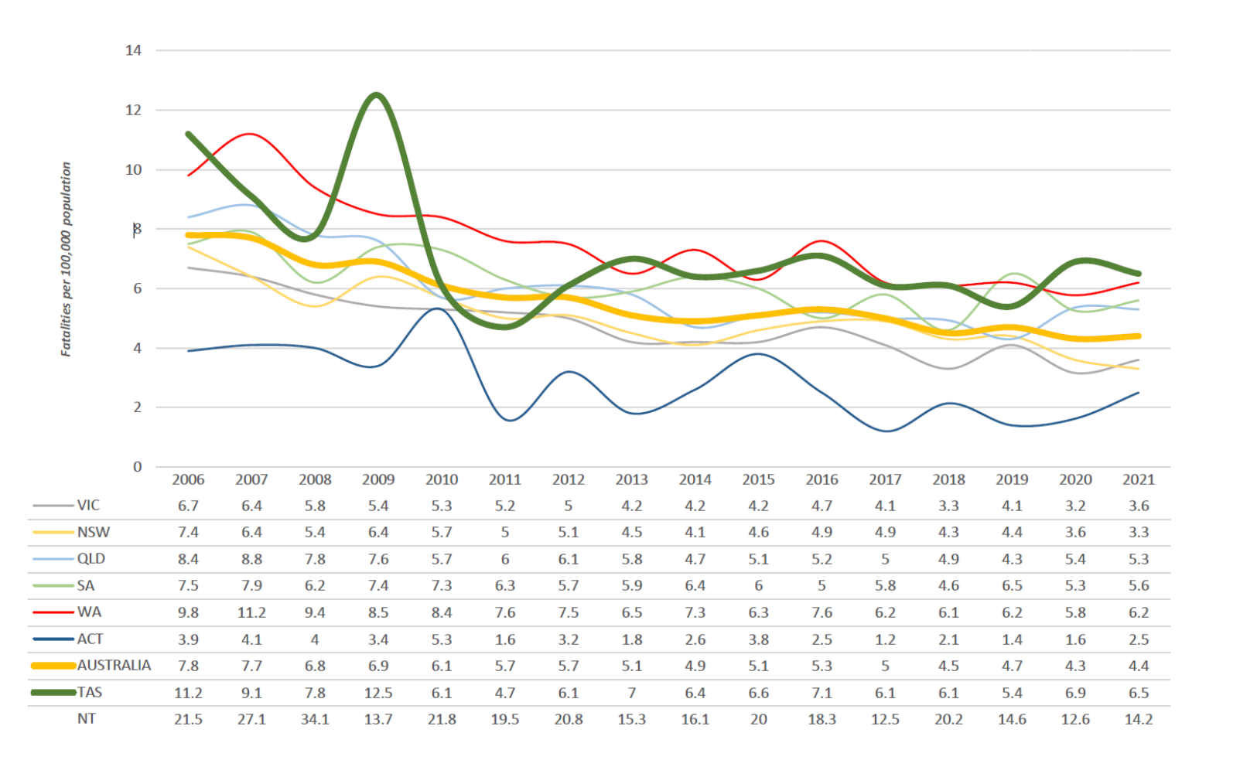
Note: NT omitted from chart for clarity purposes.

Progress on meeting MAIB targets
Motor Accidents Insurance Board (MAIB) injury statistics show the number of fatalities and the level of claims for serious injuries on our roads.
Various claim reduction targets are specified in the Memorandum of Understanding between the Department of State Growth (State Growth) and the MAIB. Progress against high level targets is shown below, expressed as 12 month moving totals

Fatalities – 12 Month Rolling Total
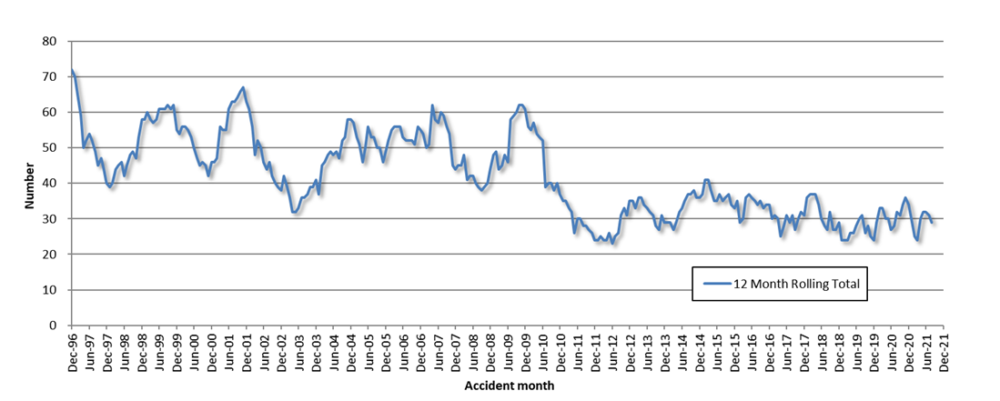

Total Serious Claims – 12 Month Rolling Total
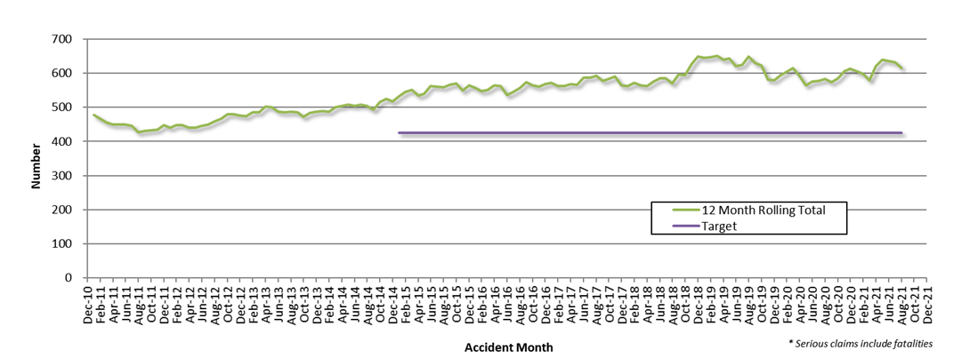

Statistics

Serious Casualties by Quarter by Age Group – 12 period moving average
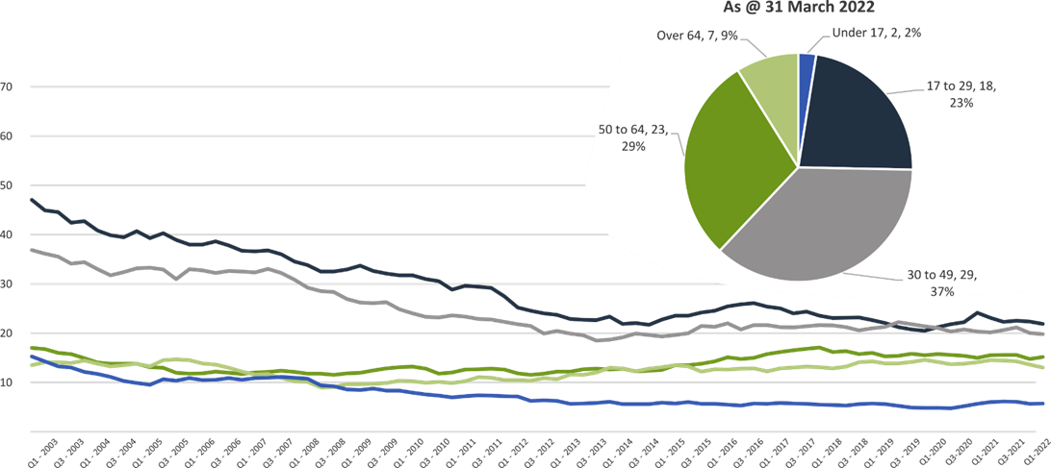

Serious Casualties by Quarter by Sex – 12 period moving average
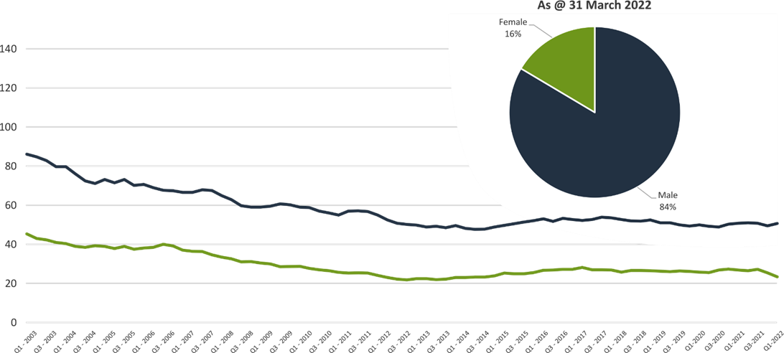

Serious Casualties by Quarter by Road User Type – 12 period moving average
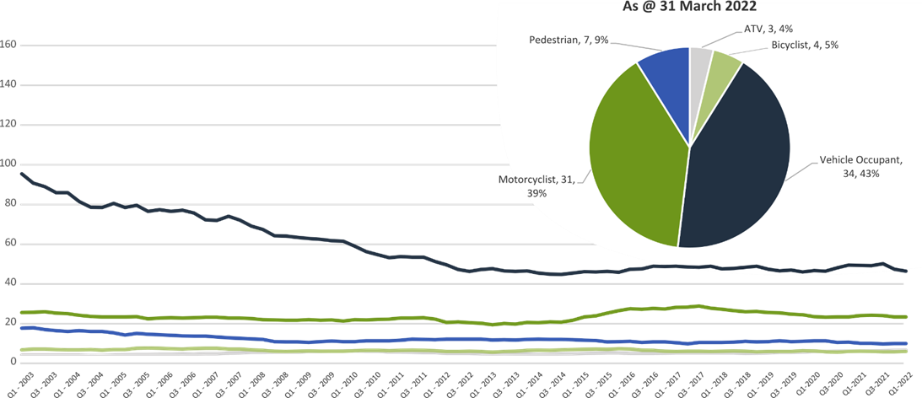

Serious Casualties by Quarter by Speed Zone – 12 period moving average
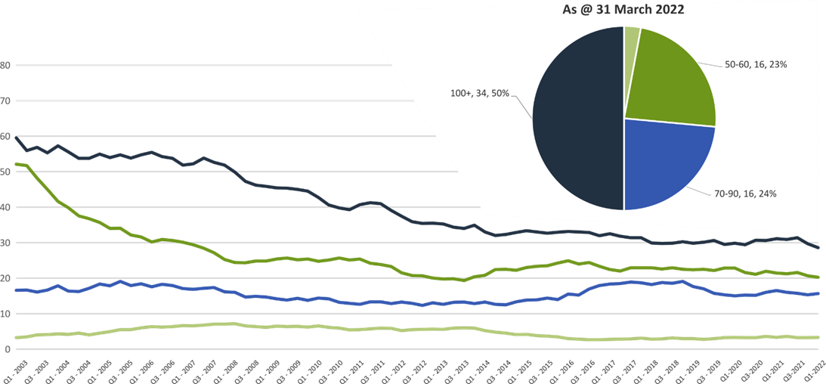

Pie chart excludes serious casualties where speed zone is recorded as ‘not known’

Serious Casualties by Quarter by Crash Type (DCA) – 12 period moving average
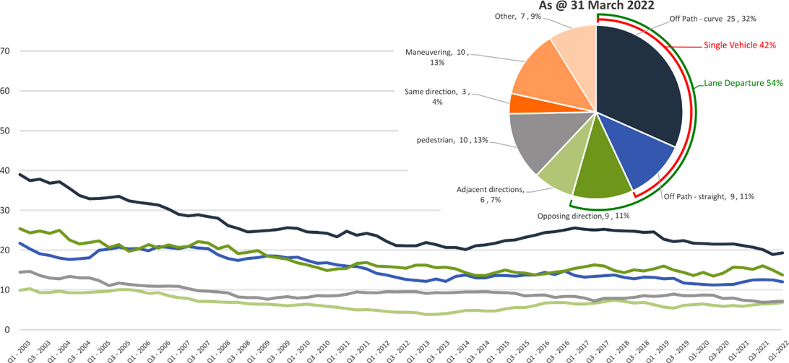

Other includes crash types: on-path (4%), overtaking (3%) & Passenger and Miscellaneous (4%).

Serious Casualties by Quarter by Urban/Non-Urban – 12 period moving average
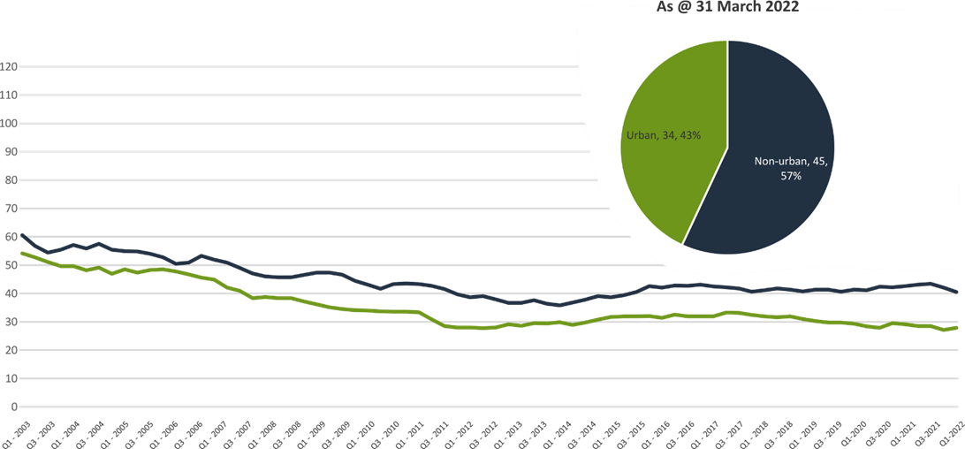

Based on the Australian Bureau of Statistics’ ‘significant urban area’ geographic definition.

Serious Casualty locations to 31 March 2022 (Black = Fatality, Red = Serious Injury)
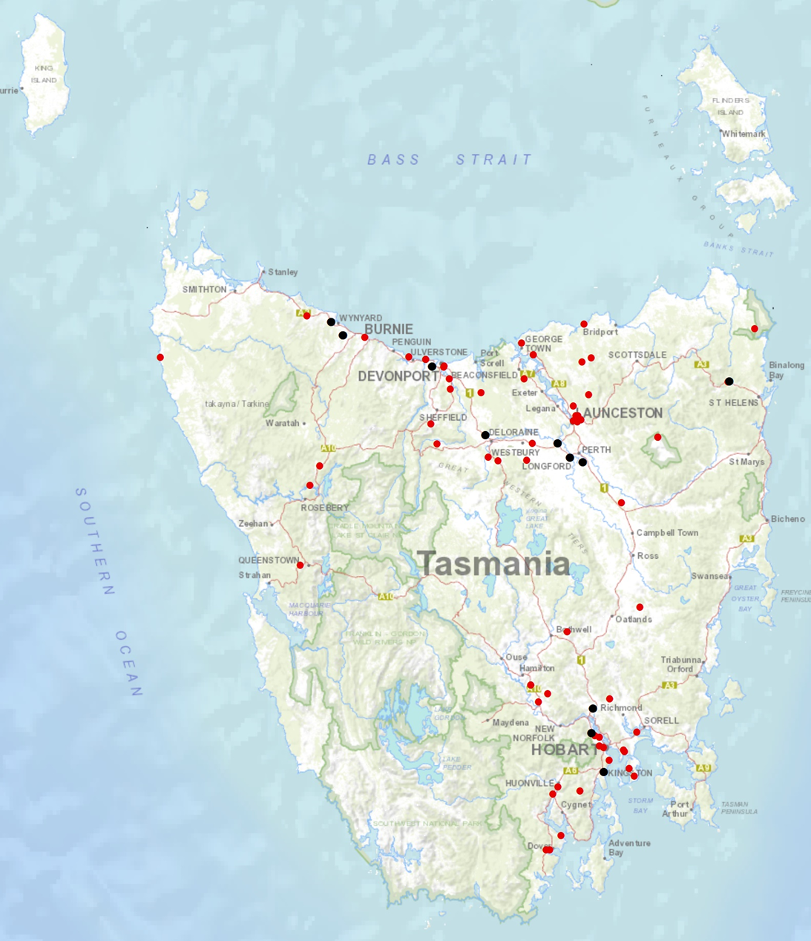

Key themes and priority actions 2020-2024
The Quarterly Progress Report details progress on key themes and priority actions under the Towards Zero Action Plan 2020-2024 and the Towards Zero – Tasmanian Road Safety Strategy 2017-2026.
The progress report should be read in conjunction with the Action Plan and understood in the context of the Towards Zero Strategy. These documents are available at: www.towardszero.tas.gov.au

Funding of key themes
Over $20 million Over $31 million
Over $12 million Over $4 million

$2 million Over $3 million

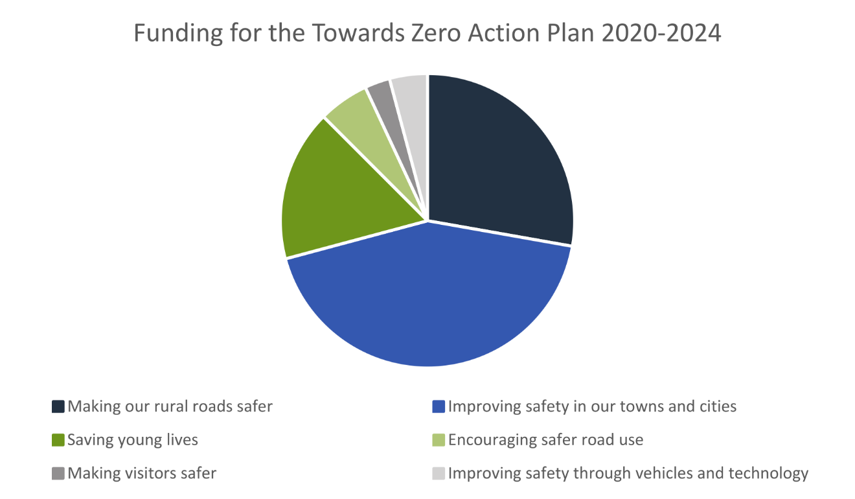

Project status report
Making our rural roads safer
Rural road grants program for local government | On schedule |  | Infrastructure upgrades on low volume State roads | On schedule
Motorcyclist safety on rural roads | On schedule |  | Speed moderation and community engagement strategy | Not yet commenced
Safe system knowledge and skills training | On schedule
Improving safety in our cities and towns
Targeted infrastructure upgrades in high traffic urban areas | Not yet commenced |  | Vulnerable Road User Program | On schedule
Community Road Safety Program | On schedule |  | Trial of innovative technologies | Not yet commenced
Innovative infrastructure treatment demonstrations | Not yet commenced
Saving young lives
Learner Driver Mentor Program and Driver Mentoring Tasmania | On schedule |  | Graduated Licensing System Project for drivers | Complete
Rotary Youth Driver Awareness Program | On schedule |  | Driving for Jobs Program | On schedule
RACT education initiatives | On schedule |  | Real Mates media campaign | On schedule
Bicycle Network bike education | On schedule |  | Safety around schools | On schedule
Kidsafe child restraint check program | On schedule |  | Full Gear motorcycle safety project | On schedule
Develop a Graduated Licensing System for motorcyclists | On schedule
Encouraging safer road use
Inattention and distraction | On schedule |  | Safe behaviour campaigns | On schedule
Mandatory Alcohol Interlock Program | Major delays |  | Protective clothing for motorcyclists | On schedule
Road safety penalties review | Complete |  | Speed enforcement strategy | On schedule
Enforcement of high-risk behaviours | On schedule |  | Automated Traffic Enforcement Program | On schedule
High-risk motorcycling enforcement | Not yet commenced |  | Road Rules Awareness | On schedule
Making visitors safer
Tourist road safety signage program | On hold |  | Responsive electronic signage trial | On hold
Tourist education materials | Limited activity |  | Strategic partnerships | On hold
Tourist education at gateway entry points | Limited activity |  | Stakeholder alliances | On hold
Improving safety through vehicles and technology
ANCAP | On schedule |  | Safer cars for young drivers | Not yet commenced
Autonomous vehicle and crash avoidance readiness | On schedule |  | Workplace driver safety | Not yet commenced
Light vehicle safety strategy | On schedule

Progress on key themes
Progress on key themes is reported as:
Status | Major delays/on hold/high risk | Delayed/some issues/medium risk | On schedule/progressing/low risk | Not yet commenced

60 per cent of fatalities occur in rural areas

Rural roads grants program for local government
The Safer Rural Roads Program (SRRP) provides funding to councils to implement infrastructure treatments on rural road corridors to reduce lane departure crashes and the harm when they do occur. An allocation of $10 million was made to the SRRP to be administered over five funding rounds of $2 million for the life of the Action Plan.
Comments
The Australian Government’s Road Safety Program (RSP) is a $3 billion Commonwealth Budget commitment. Under the RSP, Tasmania has been notionally allocated up to $66 million in funding for small-scale road safety infrastructure projects, to be delivered over five 6-month funding tranches.
Under tranche one of the RSP (1 January 2021 to 30 June 2021), $33.3 million in funding was allocated to Tasmania. To secure this funding, the Tasmanian Government was required to make a co-contribution of $12.3 million.
The RSP provided valuable additional funding to the SRRP. As a result, two funding rounds were held during the 2020-2021 financial year (FY21).
In FY21, 61 applications were received under the SRRP with 59 receiving funding.
The successful projects from FY21 total approximately $11.4 million in value. This includes funding of $5.8 million from the Australian Government’s RSP, $3.8 million from the Road Safety Levy, and $1.7 million from Local Government co-contributions.
As of 31 March 2022, 28 projects at a total value of $4.5 million have been delivered, 21 projects valued at $5.5 million are in progress and 10 projects valued at $1.4 million are experiencing delays.
With the release of the new National Road Safety Strategy 2021-2030 (NRSS) identifying new national direction, the current demand for civil construction, and with several SRRP projects currently in progress, State Growth has decided to delay the next round of the SRRP to 2023.
State Growth will utilise 2022 to undertake a review of the SRRP. This review will enable State Growth to identify and implement opportunities for improvement, as well as action administrative efficiencies that have been identified following the delivery of the SRRP in FY21.
Status | risk |  | On schedule/progressing/low risk

Infrastructure upgrades on low volume State roads
This program will provide funding for lower volume State roads, where cost effective treatments such as shoulder sealing, pavement markings, curve warnings, road side hazard removal and safety barriers will achieve maximum value for money.
Current situation / comments
$6.95 million has been committed for infrastructure improvements on the Railton Main Road. $450 000 is required for the design and development stage and $6.5 million required for works in the delivery stage.
Status |  |  | On schedule/progressing/low risk

Motorcyclist safety on rural roads
Road safety audits will be conducted on high risk touring routes across Tasmania. This program will involve local motorcyclists and a safe system approach will inform audits. Findings will be shared with stakeholders to identify countermeasures that go beyond typical infrastructure solutions.
Current situation / comments
Safe System motorcycle road safety audits
Two audits have been completed and funding allocated. The Central Highlands Council was provided with a grant deed up to $200 000, to undertake works on Hollow Tree Road. Works have now been completed.
Funding up to $350 000 has been allocated for State Growth to carry out low-cost infrastructure treatments to improve road safety for motorcyclists on Lake Leake Road. A delivery schedule for these works is currently being scoped with works scheduled to commence in 2022.
State Growth is developing a strategy for future motorcycle road safety audits. This strategy will be delivered in 2022, and will identify potential routes in Tasmania to conduct further motorcycle road safety audits.
Status |  |  | On schedule/progressing/low risk

Speed moderation and community engagement strategy
Speed moderation requires a holistic strategy encompassing public education, road risk assessments, enforcement, speed limit setting, speed limit mapping and technology, penalties, KPIs and evaluation. This project will involve community engagement to inform and build support for action on safer speeds. A significant ongoing coordination effort will be required to support the strategy.
Current situation / comments
This project has not yet commenced and will be considered as part of the mid-term review.
Status |  |  |  | Not yet commenced

Safe system knowledge and skills training
This initiative aims to improve Safe System knowledge for all those in a position to influence road safety outcomes. The initiative will focus on Safe System infrastructure design, including appropriate speed setting, and will consist of technical training sessions, workshops and forums across Tasmania.
Current situation / comments
Safe System knowledge and capacity building is being considered within the review of the Safer Rural Roads and Vulnerable Road User programs. As part of these reviews, State Growth is investigating how stronger support can be provided to enable local government to achieve Safe System infrastructure treatments.
As part of this review, State Growth will also review the tools utilised through these programs to further support and encourage local government to apply Safe System principles and treatments in practice.
Funding of $10 520 has been provided to the Tasmanian Bicycle Council to facilitate online training sessions for Tasmanian engineers and planners in designing Safe System compliant cycling lanes/paths.
Additionally, funding of $12 260 has supported Safe System professional capacity building.
Status |  |  | On schedule/progressing/low risk

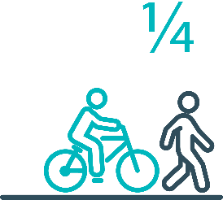

Pedestrians and cyclists are vulnerable and represent
one in four serious casualties in our towns and cities

Targeted infrastructure upgrades in high traffic urban areas
This program provides for delivery of a range of infrastructure safety upgrades to make our towns and cities safer. This will include shoulder sealing, intersection improvements, safety barriers and pavement marking at high traffic areas. This program targets high volume state roads that are not planned for major investment in the short term.
Current situation / comments
This project has not yet commenced and will be considered as part of the mid-term review.
Status |  |  |  | Not yet commenced

Vulnerable Road User Program
The Vulnerable Road User Program (VRUP) is an established grants program which assists local government with the costs of installing safety improvements in built up areas. The aim of the program is to reduce conflict between vehicles and vulnerable road users - cyclists, pedestrians and motorcyclists.
Additionally, the program has a focus on increasing Safe System knowledge and capacity in local governments. The funding available under the VRUP was increased from $500 000 to $1 000 000 per annum, under the current Action Plan.
Current situation / comments
The Australian Government’s RSP has provided valuable additional funding to the VRUP. As a result, three funding rounds were held during FY21. In FY21, 95 applications were received under the VRUP with 71 receiving funding. This includes seven cycling safety-focused projects that all received funding under round three.
The successful projects from FY21 total approximately $11.6 million in value. This includes funding of $4.6 million from the Australian Government’s RSP, $4.7 million from the Road Safety Levy, and $2.3 million from Local Government co-contributions.
Summary of applications made under the VRUP in FY21
Round | Applications | Number of projects awarded funding | Total amount awarded | Total value of awarded projects
VRUP 2020-21 R1 | 28 | 20 | $831 941 | $1.3 million
VRUP 2020-21 R2 | 42 | 26 | $3.2 million | $4.2 million
VRUP 2020-21 R3 | 25 | 25 | $5.3 million | $6.1 million
Total | 95 | 71 | $9.3 million | $11.6 million
Status of successful applications from VRUP rounds in FY21
Round | Number of projects awarded funding | Complete | In progress | Delayed | Withdrawn
VRUP 2020-21 R1 | 20 | 16 | 3 | - | 1
VRUP 2020-21 R2 | 26 | 9 | 10 | 5 | 2
VRUP 2020-21 R3 | 25 | 2 | 18 | 5 | -
Total | 71 | 27 | 31 | 10 | 3
As of 31 March 2022, 27 projects have been delivered, 31 projects are in progress and 10 projects are experiencing delays. Three projects from the 71 successful projects, valued at $344 828, have been withdrawn.
With the release of the new NRSS identifying new national direction, the current demand for civil construction, and with several VRUP projects currently in progress, State Growth has decided to delay the next round of the VRUP to 2023.
Alongside the review of the SRRP, State Growth will review of the VRUP. This review will enable State Growth to identify and implement opportunities for improvement, as well as action administrative efficiencies that have been identified following the delivery of the VRUP in FY21.
Status |  |  | On schedule/progressing/low risk

Community Road Safety Grants Program
The Community Road Safety Grants Program (CRSGP) is an established grants program that aims to build community engagement in addressing local road safety issues. The program supports local councils, schools, community groups, research institutions and charity organisations to promote road safety at the grass roots level.
Current situation / comments
The Road Safety Branch continues to monitor the progress of projects that have received funding under the CRSGP.
Project evaluation reports have been received for the 2020-21 funding round and a report for Council is being prepared.
Status |  |  | On schedule/progressing/low risk

Trial of innovative technologies
This project will include monitoring, investigation and trialling of new and emerging technology based approaches to improving safety for vulnerable road users.
Current situation / comments
This project has not yet commenced and will be considered as part of the mid-term review.
Status |  |  |  | Not yet commenced.

Innovative infrastructure treatment demonstrations
This project will investigate, trial and demonstrate innovative Safe System urban infrastructure treatments to improve road safety in our urban areas. We will work with local councils to show how Tasmania’s cities and towns can be improved for the benefit of all road users, particularly cyclists and pedestrians.
Current situation / comments
This project has not yet commenced and will be considered as part of the mid-term review.
Status |  |  |  | Not yet commenced.

92 young people are seriously injured or killed on our
roads every year

Learner Driver Mentor Program and Driver Mentoring Tasmania
The Learner Driver Mentor Program (LDMP), supported by Driver Mentoring Tasmania (DMT) is a well-established program that supports disadvantaged learner drivers to gain their on-road supervised driving hours to gain a licence.
Current situation / comments
DMT recently received a grant from MAIB to introduce a program evaluation system called YLOO.
YLOO facilitates online booking of supervisory driving sessions, but also provides live updates of the following:
- number of supervisory sessions
- length of each session and the kilometres travelled
- number of supervisory hours each learner is receiving and each mentor is giving
- length of time learners and mentors participate in the program each week, month and year
- number of Provisional Plates achieved
- age profile of learners
- demographics of participants.
This data will be used for reporting purposes and will form part of an overall evaluation of the LDMP to assess if the LDMP is still meeting its intended outcomes and determine if the funding model is right for Tasmania.
Funding submissions for the 2022-23 financial year open 15 March 2022.
Status |  |  | On schedule/progressing/low risk

Graduated Licensing System Project
Changes are being made to the Graduated Licensing System (GLS) for drivers to better protect young and novice drivers and improve the licensing pathway. Young drivers are overrepresented in crash statistics and most at risk when they first get their Ps and start driving solo. The changes to the GLS aim to address this risk and improve road safety outcomes for both young and novice drivers.
Current situation / comments
The Tasmanian Government implemented policy changes to the GLS on 1 December 2020. Tasmania’s GLS now meets the enhanced model under the national driver GLS framework. The GLS changes were accompanied by a public education campaign explaining the policy changes and how they would apply to current and new learners.
Complementing the policy changes are three digital products that have been progressively launched since July 2021.
The Plates Plus learning and assessment platform was designed to improve learner driver education by focusing on developing safe behaviours and attitudes. It is an innovative tool that takes users through a series of interactive exercises to ensure new drivers know the road rules and understand the impact of the fatal five road behaviours. As of 31 March 2022, over 9,000 people have successfully completed the Plates Plus course since its launch on 8 July 2021.
A public education campaign accompanied the launch of the Plates Plus platform and ran until September 2021. The campaign encouraged take-up by promoting the convenience of the platform, which is accessible from any device connected to the internet.
The Plates Plus logbook app launched in November 2021. For many Tasmanian learners, this will replace the existing hard copy logbook. It provides an easy and efficient way to record supervised driving hours during the learner licensing phase. A public education campaign targeting 15 to 25-year-olds accompanied the launch of the Plates Plus logbook app. To engage with this age group, the campaign focused on selected social media platforms.
The computer-based hazard perception test (HPT) was launched on 7 March 2022. The HPT is a mandatory assessment that has been introduced to the learner licensing pathway. It is also required for some overseas licence conversions.
The HPT assesses a learner’s ability to identify and react to safely avoid hazards. It features high-quality 3D clips developed by Austroads in conjunction with the Centre for Automotive Safety Research, using real Australian crash data to identify the most dangerous driving situations for novice drivers.
The HPT is the final product to be delivered under the GLS project.
Status | Complete

Motorcyclist Graduated Licensing System review
The Tasmanian motorcyclist GLS is being reviewed to identify enhancements to ensure novice motorcyclists are as safe as possible on Tasmanian roads.
Current situation / comments
Following initial consideration by the Department of State Growth, the Centre for Automotive Safety Research (CASR) was engaged to conduct a review of the Tasmanian motorcyclist GLS. The findings and recommendations of the review are being prepared and will be presented to RSAC at its May 2022 meeting.
Status |  |  | On schedule/progressing/low risk

Rotary Youth Driver Awareness Program (RYDA)
RYDA is a one day road safety education program for year 10-12 students making them aware of the significant responsibility that comes with being a driver or passenger. Every year 4000 students take part in practical demonstrations and learn valuable road safety lessons from expert presenters and volunteers. RYDA is delivered by Rotary Tasmania.
Current situation / comments
RYDA will commence in May 2022 with soythern sessions still being conducted out of the Royal Hobart Showgrounds. Due to the redvelopment of the site, alternate accommodation is required for 2023. A suitable cost effective location is being negotiated with the Department of Education.
Status |  |  | On schedule/progressing/low risk

Driving for Jobs Program
The Driving for Jobs (DfJ) Program aims to support disadvantaged students who would otherwise be unable to enter and progress through the Graduated Driver Licensing System (GLS). The program provides students at selected schools with the opportunity to increase their road safety knowledge whilst also improving their job readiness. Students undertake a personalised intensive program with a strong road safety focus including professional on-road driving lessons and participation in the Rotary Youth Driver Awareness Program.
Current situation / comments
The DfJ Program operates at Jordan River Learning Federation (JRLF) in the South and expanded to Claremont College in term four 2021. It operates at Launceston and Newstead Colleges in the North. During 2021, 238 students engaged with the program which resulted in 967 hours of fully funded driving lessons being delivered from accreited driving schools. A total of of 49 students obtained their learner licence and 34 students gained their P1 licence.
The delivery of fully funded driving lessons to students in 2022 has been delayed due to the impact of Covid-19 on school operations and no submissions were received for the Request to Tender to provide driving lessons to the four DfJ schools. The Department of Education has since utilised a direct appointment approach with driving lessons expected to commence in term two 2022.
Status |  |  | On schedule/progressing/low risk

RACT education initiatives
The RACT delivers a range of in-class road safety education programs. This includes a program for years 10-12 students that focuses on the dangers of distraction and inattention. The program also teaches students how to progress through the GLS and about the specific rules that apply to L and P plate drivers.
Current situation / comments
The Road Safety Branch continues to monitor the partnership's outcomes with the RACT.
Status |  |  | On schedule/progressing/low risk

Real Mates media campaign
The MAIB-funded Real Mates campaign uses humour to engage with young men to encourage them to avoid the risks of drink driving by empowering them to speak up and stop a mate from driving after drinking.
Current situation / comments
The Real Mates sponsorship of Vibestown saw the promotion of the Real Mates message at three summer music festivals in Hobart and Launceston from December 2021 to March 2022.
A new iteration of Real mates is in development and will be launched in September 2022 to coincide with AFL finals.
Status |  |  | On schedule/progressing/low risk

Bicycle Network bike education
The Bicycle Network delivers the Ride2School program to schools across Tasmania. Ride2School is for primary aged students and focuses on safe cycling, road safety and positive road sharing behaviour.
Current situation / comments
The Road Safety Branch continue to monitor the outcomes of the partnership with the Bicycle Network.
Status |  |  | On schedule/progressing/low risk

Safety around schools
Safety around schools is promoted through designated crossings, lower speed zones, more than 100 school crossing patrol officers and public education. The current Safety around Schools project, including the Love 40 campaign, encourages drivers to lower their speed and keep a look out for children in school zones and around buses.
Current situation / comments
The Hon Michael Fergusson MP relaunched the Love 40 campaign at Saint Thomas Moores Primary School, Launceston in term one 2022. TVC, radio and digital media continued for two weeks at the commencement of Term 1 to promote the importance of slowing down in school zones and around school buses. Further promotion is planned at the beginning of each school term for 2022.
Status |  |  | On schedule/progressing/low risk

Kidsafe child restraint check program
Kidsafe Tasmania conducts free child restraint checking sessions to ensure that young children are safely and lawfully seated and restrained in cars. Kidsafe also distribute and promote educational materials to inform the public of the correct child restraint type for a child’s age and size.
Current situation / comments
Kidsafe continues to provide free child restraint checks and has recently produced a set of complementary easy to read restraint guides. During restraint checks, hardcopies are provided to parents and carers to encourage the correct purchase of restraints suitable to a child's height and weight. The restraint guides have been designed to fit within a vehicle's glove compartment for easy future reference.
Status |  |  | On schedule/progressing/low risk

Full Gear motorcycle safety project
The Glenorchy City Council, in partnership with Bucaan House, delivers its successful Full Gear motorcycle safety project, which helps young motorcycle riders enter the licensing system and to adopt safe riding practices.
Current situation / comments
The Full Gear project provides funding for a 0.1 FTE project officer to continue the program in Glenorchy and assist with expansion into New Norfolk and Gagebrook. The project officer has commenced planning for a workshop to share facilitation techniques with Neighbourhood House staff, who provide outreach coordination and assistance with the program.
Status |  |  | On schedule/progressing/low risk

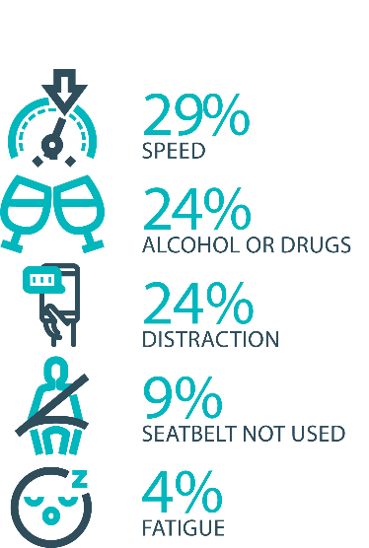

The fatal five behaviours contributing to serious
casualties

Inattention and distraction
Inattention and distraction are concerning causes of serious casualty crashes and may have a far greater impact than current data suggests. There are a number of research projects and enforcement initiatives that are being used to address this issue. This project will include consideration of emerging strategies for tackling distraction, encouraging compliance through enforcement and influencing driver behaviour through public education campaigns.
Current situation / comments
Enforcement
Tasmania Police introduced three unmarked motorcycles to increase the rate of detection and enforcement of illegal phone use whilst driving. These motorcycles operate across all districts and target the low speed road network and congested traffic conditions, utilising ‘lane filtering’ legislation to full advantage.
In an agency first, the riders are also fitted with helmet cameras to capture the offence, an initiative that has effectively nullified disputes. The introduction of unmarked motorcycles has proved to be incredibly successful with riders reporting high-level public support and a notable change in driver behaviour.
Tasmania Police has also conducted a technology demonstration with a commercial provider to test artificial intelligence based automated mobile phone detection. The technology is combined with speed detection and Automated Number Plate Recognition capabilities. Future use of such technology is now being considered as part of the Automated Traffic Enforcement Project being led by the Department of State Growth.

Status |  |  | On schedule/progressing/low risk

Safe behaviour campaigns
Targeted media campaigns will continue to educate people about high-risk behaviours and to highlight the dangers of the ‘Fatal Five’.
Current situation / comments
A motorcycle safety campaign was launched on 10 October 2021. The campaign educated Tasmanian motorcycle riders on the risks when riding and the importance of riding safely. The campaign concept focuses on a 30 second TVC, digital videos, and posters in pubs and venues on popular motorcycle touring routes.
In preparation for the introduction of enhanced speed enforcement in Tasmania a new public education campaign on low level speed was launched in December 2021.
The Over is Over campaign aims to reduce road trauma by highlighting the dangers of speeding and will support the re-introduction of mobile speed cameras. The campaign is supported by TV, radio, press, digital and outdoor advertising.
Status |  |  | On schedule/progressing/low risk

Mandatory Alcohol Interlock Program (MAIP)
The MAIP aims to have repeat and high-level drink driving offenders demonstrate they are able to separate their drinking from driving through the installation of an alcohol interlock in their vehicle. New measures will be introduced to increase participation in the MAIP.
Current situation / comments
Drafting instructions for the revised framework were provided to the Office of Parliamentary Counsel (OPC) in October 2019. Parliamentary priorities, including COIVD-19, caused reprioritisation of OPC work. Drafting instructions were withdrawn from OPC in May 2021, before the first draft of amendments had been received, to enable the new Road User Services’ managers to review the drafting instructions to ensure that they remain current. The revised instructions were re-submitted to OPC on 15 February 2022.
Two approved Providers have signed new contracts; negotiations continue with the third. The contracts expire in October 2022; work will commence on creating new contracts in the near future.
Status | Major delays/on hold/high risk

Protective clothing for motorcyclists
Motorcyclists are overrepresented in Tasmania’s road trauma figures. Motorcyclists are vulnerable road users due to a lack of physical protection. Protective clothing can reduce injury severity in the event of a crash. Tasmania is a funding member of MotoCAP. MotoCAP provides safety assessment star ratings for protective clothing and prepares education materials for motorcyclists.
Current situation / comments
Tasmania contributes around $8 000 per annum to participate in and support the activities of MotoCAP. In early 2021, several thousand public education brochures advising of clothing safety ratings for motorcycle wear were sent out to motorcycle retailers and relevant stakeholders across the state.
Status |  |  | On schedule/progressing/low risk

Road safety penalties review
For enforcement activities to improve safety on our roads, they need to be backed up with appropriate penalties. Tasmania’s road safety penalties will be reviewed to ensure they are up-to-date and provide an appropriate deterrence to those who break the rules and put themselves and others at risk.
Current situation / comments
Tasmania’s road safety penalties have been reviewed and updated and inter-jurisdictional analysis has been completed. Findings were submitted to RSAC for noting at its November 2020 meeting. RSAC determined that current penalties are appropriate and penalties will be reviewed towards the end of the current Action Plan.
Status | Complete

Speed enforcement strategy
Speed enforcement is one of five priority areas within Tasmania Police’s current Road Safety Strategy 2019-2021.
With regard to speed cameras, Tasmania Police has conducted several technology trials, including in-motion camera technology, where speed cameras are fitted to moving vehicles, and of mobile point-to-point speed detection, where average speed enforcement utilises two vehicles fitted with automatic numberplate recognition technology. In addition, Tasmania Police is working with the Department of State Growth to introduce future automated speed enforcement in Tasmania.
Tasmania Police has implemented a Strategic Asset Management Plan (SAMP) for all speed detection devices. The SAMP provides for continual review of new and emerging technologies, includes provisions for regular replacement and upgrade of equipment and importantly supports long-term financial planning and budgeting. In line with the SAMP, Tasmania Police’s Southern Road and Public Order Services is also trialling a rear-facing radar on a patrol vehicle.
Tasmania Police has further developed the new vehicle livery across the fleet to include the introduction of ‘Over is Over’ campaign mark-ups on selected traffic enforcement cars and motorcycles. Tasmania Police continue matching different livery designs to specific uses, for example general patrol, high-visibility patrol, and low-profile marked vehicles – all of which are relevant to different methodologies of speed reduction and enforcement. The strategy has also seen the introduction of unmarked highway patrol cars which have proved to be very successful and complement the use of overt policing tactics well.
Tasmania Police recently updated the marked police motorcycle fleet with new livery for these bikes being implemented to heighten the visibility of police on the road network.
Status |  |  | On schedule/progressing/low risk

Enforcement of high-risk behaviours
To reduce high-risk behaviours and increase compliant road user behaviour, State Growth and Tasmania Police will work collaboratively to investigate and introduce new enforcement techniques and technologies to detect high-risk behaviours that address the ‘fatal five’, including mobile phone use, speeding and failure to wear a seatbelt.
Current situation / comments
Tasmania Police’s Road Policing Strategy focuses on the fatal five causes of serious and fatal crashes, which are the highest risk driver behaviours: speeding; alcohol and drugs; distraction and inattention; seatbelts; and fatigue. The strategy includes several priority areas under each theme and the strategy guides the deployment of operational policing resources.
Status |  |  | On schedule/progressing/low risk

Automated Traffic Enforcement Program
Automated Traffic Enforcement (ATE) (i.e. speed cameras) is relatively underutilised as a deterrence and enforcement mechanism in Tasmania. This project investigates proven and emerging camera technologies for use at high-risk locations and across the entire road network.
Current situation / comments
On 11 September 2021, State Growth released a request for tender (RFT) to identify a suitable service provider to manage a program of mobile speed cameras and supply a compatible infringement adjudication system. During the RFT, Tenders were also required to demonstrate their capability to increase enforcement levels and implement ‘Future Functionalities’ including mobile phone, seatbelt, registration, and average speed enforcement. State Growth is currently in contract negotiations with a Preferred Supplier, and it is expected that these negotiations will be finalised in the second quarter of 2022. Enforcement of speeding offences via mobile speed cameras is expected to commence in September 2022.
The initial stages of the ATE program will provide a caution notice period to ensure the community is provided opportunity to transition to have mobile speed cameras back on Tasmanian roads. This period also provides communications and educational material for the program sufficient time to disseminate in the community.
The project team has finalised a deployment methodology, with the selection of camera locations based on crash risk, an infrastructure rating assessment and vehicle operating speeds. Community suggestions of additional camera locations will be considered once the program is fully established.
The introduction of the ATE program will be supported by a new enforcement focus of the ‘Over is Over’ marketing campaign. Updated signage will be installed at critical locations across the road network and a separate program website will be developed.
The project team is also currently progressing legislative and regulatory amendments required to enable the photographic detection devices to be used in detecting and prosecuting Future Functionalities. A trial of Future Functionality technology is expected to commence in late 2022.
Status |  |  | On schedule/progressing/low risk

High-risk motorcycling enforcement
Speed is a factor in at least a quarter of motorcyclist serious casualties. Speed cameras offer no deterrence to motorcyclists, whose numberplates are mounted only on the back. Introduction of rear-facing speed cameras will improve detection and deterrence of speeding. This is being considered as part of the Automated Traffic Enforcement Program.
Current situation / comments
Tasmania Police investigated rotating the current fixed speed cameras 180 degrees to provide for rear-facing detection (to detect motorcycles). Technology limitations determined this was not a practical solution due to accuracy concerns. Upgrading the technology to support forward and rear-facing and multiple lane detection has now been subsumed into State Growth’s Automated Traffic Enforcement Program.
Status |  |  |  | Not yet commenced

Road Rules Awareness
Compliance with Road Rules makes our behaviour on the roads predictable, improving safety for all road users. This initiative will ensure that user-friendly and tailored information resources are developed so that the Road Rules are easily understood and adhered to by all road users.
Current situation / comments
The Tasmanian Road Rules Handbook and the Misunderstood Road Rules series of pamphlets are distributed to Service Tasmania locations when required.
The Ride with Respect campaign will continue on social media advertising until the end of April 2022 to communicate the rules for personal mobility devices, such as e-scooters and e-skateboards.
Status | Major delays/on hold/high risk |  | On schedule/progressing/low risk

11 per cent of all serious casualties on our
roads are non-Tasmanian residents

Tourist road safety signage program
This program will see the installation of tourist signage strategically placed across the road network. The signs will provide important road safety information, relevant to the area road users are travelling in. This program will be undertaken in collaboration with stakeholders, local government and State Roads.
Current situation / comments
This program is currently on hold.
Status | On hold |  | On schedule/progressing/low risk

Responsive electronic signage trial
This project will trial a responsive electronic sign with real time information at regional tourism gateways.
Current situation / comments
This project is currently on hold.
Status | On hold

Tourist education materials
A range of education materials developed using images, symbols and multi-lingual material delivered to specific audiences through targeted communications channels. This includes vehicle hangers, brochures, posters, roadside signs, editorial content, film and digital content.
Current situation / comments
Communications materials are being distributed upon request from stakeholders.
Status |  | Limited activity

Strategic partnerships
Developing strategic partnerships based on synergies with target audiences will enable the effective promotion of road safety messages and education.
Current situation / comments
This project is currently on hold.
Status | On hold

Tourist education at gateway entry points
As an island state, we have the opportunity to strategically place messaging at our gateway airports and seaports to reach visitors with important road safety messaging prior to them driving in Tasmania. This includes a range of educational materials, electronic and static signs and billboards.
Current situation / comments
Printed collateral is in stock and digital billboards display road safety messaging at gateway locations.
Status |  | Limited activity

Stakeholder alliances
Sharing information and collaborating to develop effective strategies and tools to address road safety issues is vital. This project will develop formal and informal stakeholder alliances to encourage input and create opportunities to deliver joint initiatives.
Current situation / comments
This activity is currently on hold.
Status | On hold

The rate of fatal crashes is four times higher for vehicles 15+ years old than for vehicles made in the last five years

Australasian New Car Assessment Program (ANCAP)
Tasmania is a funding member of ANCAP. ANCAP plays a vital role in informing consumers about safety performance of new vehicles and advocates for improved vehicle safety design and specification through public education campaigns, advocacy activities and engagement with governments, corporate fleets, the media and consumers. Activities related to ANCAP will include promotion of safer vehicles and options for an annual vehicle fleet report.
Current situation / comments
Tasmania continues to support ANCAP with funding of $12 500 per annum.
Status |  |  | On schedule/progressing/low risk

Safer cars for young drivers
This project aims to increase awareness of the Used Car Safety Rating database amongst first time car buyers. This could be promoted through education materials and campaigns and may be able to integrate with the GLS online learning platform.
Current situation / comments
This project has not yet commenced and will be considered as part of the Light Vehicle Safety Strategy and through the mid-term review.
Status |  |  |  | Not yet commenced

Autonomous vehicle and crash avoidance readiness
This project involves the monitoring and development of safety and autonomous vehicle technologies.
Current situation / comments
The regulation of autonomous vehicles is being considered at a national level and Tasmania is participating in that process.
Status |  |  | On schedule/progressing/low risk

Workplace driver safety
Vehicle use in road traffic is the most significant contributor to work-related traumatic injury. This project will aim to promote and encourage employers to adopt safe driving policies based on the Worksafe, ‘Vehicles as a workplace’ guide.
Current situation / comments
This project has not yet commenced and will be considered as part of the mid-term review.
Status |  |  |  | Not yet commenced.

Light vehicle safety strategy
A light vehicle safety strategy will be developed to provide public education and undertake enforcement activities to enhance the safety standard of Tasmania’s vehicle fleet.
Current situation / comments
A draft light vehicle safety strategy is under development. The draft strategy aims to accelerate an increase in the number of newer, safer, and cleaner vehicles and a removal of older cars from the light vehicle fleet while increasing the safety of the current vehicle fleet. A suite of actions centres on information and education to drive public demand for safer cars; financial incentives to support their purchase (with a focus on novice and older drivers); a ‘cash for clunkers’ scheme and changes to the registration of older repairable write-off vehicles to remove older vehicles; and education, potential incentives, and a mandatory roadworthiness inspection to encourage vehicles to be maintained in roadworthy condition.
Further development is required and underway to design the most appropriate and cost effective roadworthiness inspection scheme.
The draft strategy is currently under consultation within the Department of State Growth. Feedback collected during the consulation process will be assessed and used to refine/reshape the draft strategy accordingly. The draft strategy will be provided to RSAC at its May 2022 meeting to seek feedback and views on the proposed direction and actions.
Status |  |  | On schedule/progressing/low risk

Funding
Road Safety Levy Overview for the Financial Year 2021/22
As at 31 March 2022 (Quarter 3)
Road Safety Levy Opening Summary
Opening Balance as at 01 July 2021 |  |  | $ 17,013,469
Annual Allocation to Road Safety Operations |  |  | $ 2,600,000
Revenue Summary
 |  | Forecast (FY22) | Actual (Y.T.D.)
Motor Accident Insurance Board Funding |  | $ 1,300,000 | $ 1,079,568
Revenue Inflows from Registrations |  | $ 16,182,965 | $ 12,009,835
RSP Funding |  | $ 19,025,000 | $ -
Funds Available for Distribution |  | $ 50,921,434 | $ 27,502,872
Expenditure Summary
Theme no. | Theme | Forecast (FY22) | Actual (Y.T.D.)
1 | Making our Rural Roads Safer | $ 5,111,869 | $ 1,525,513
2 | Improving Safety in our Towns and Cities | $ 10,474,316 | $ 6,123,886
3 | Saving Young Lives | $ 2,893,830 | $ 1,943,825
4 | Encouraging Safer Road Use | $ 5,786,729 | $ 1,292,045
5 | Making Visitors Safer | $ 705,617 | $ 71,867
6 | Improving Safety Through Vehicles and Technology | $ 1,225,510 | $ 12,245
7 | General Support | $ 929,821 | $ 501,617
Budget and Expenditure by Category |  | Forecast (FY22) | Actual (Y.T.D.)
Infrastructure Expenditure* |  | $ 15,481,527 | $ 7,451,754
Policy & Projects Expenditure* |  | $ 11,874,160 | $ 4,019,246
Total Expenditure |  | $ 27,355,686 | $ 11,470,999
Balance as of 31 December 2021 |  | $ 7,333,928 | $ 16,031,873
Forecast Closing Balance of FY22 |  | $ 23,565,748
*includes four ceasing activities not categorised by Action Plan 2020-24 themes
^includes MAIB expenditure

MAIB Funding
As at 31 March 2022

2021/22 Financial Year | Budget  $ | Actual (ytd)  $ | Balance  $
Expenditure (State Growth)
Administration & Public Relations | 368 116 | 195 315 | 172 801
Public Education | 958 682 | 780 046 | 178 636
Research | 160 000 | 104 206 | 55 794
Subtotal | 1 486 798 | 1 079 568 | 407 230
Expenditure (Tasmania Police)
Salaries | 2 032 291 | 1 516 269 | 516 023
Operating Expenses | 188 000 | 72 953 | 115 047
Equipment | 539 708 | 244 251 | 295 457
Subtotal | 2 759 999 | 1 833 473 | 926 525
Total | 4 246 797 | 2 913 041 | 1 333 755
Includes Carried Forward of
$107 614 (State Growth)
$82 749 (Police)

Note: the 2020 Fatality count has been revised from 37 to 38 on the basis of a recently released Coronial finding.

