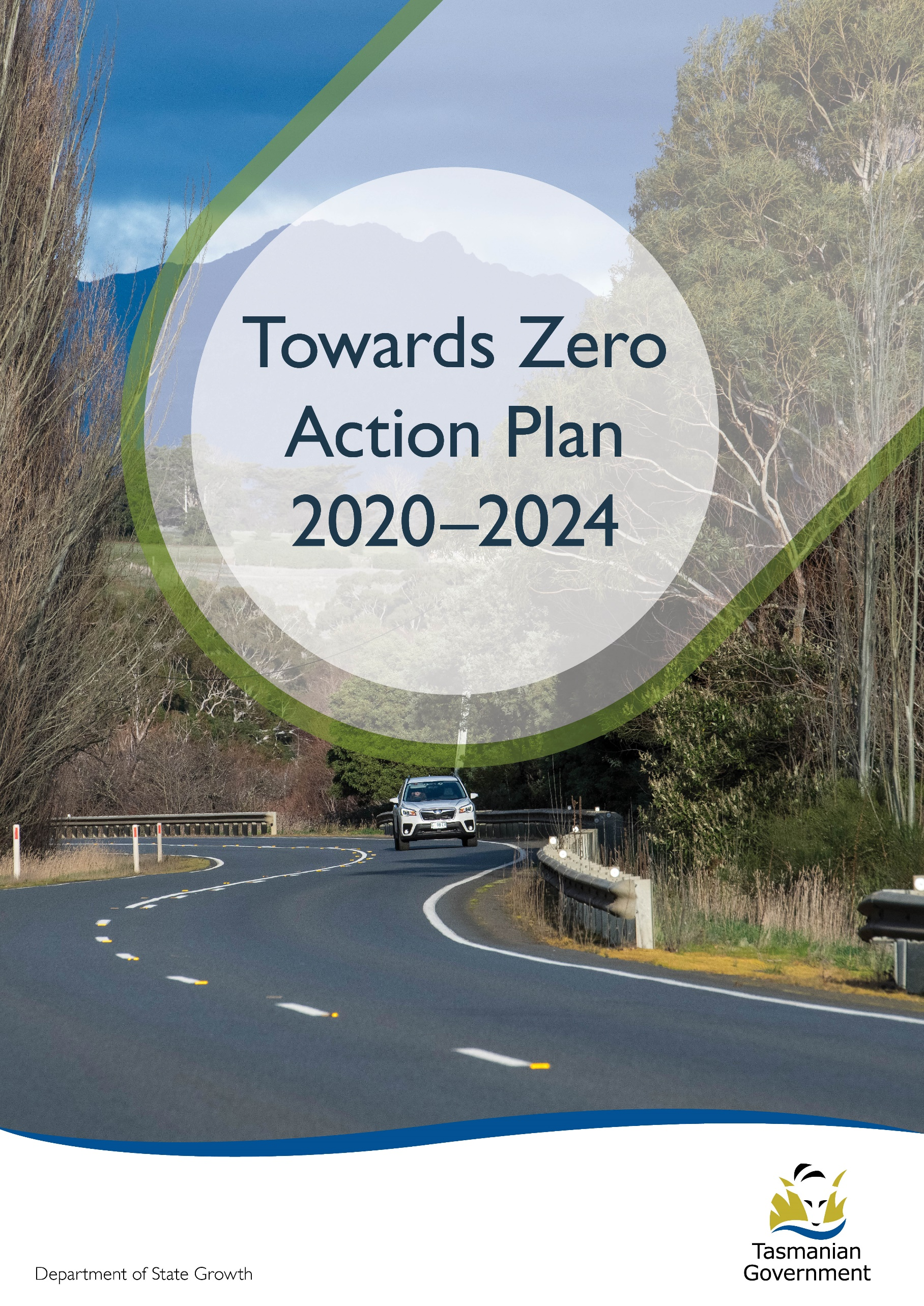
Quarterly Progress Report to RSAC as at 31 March 2020
Contents
Progress on meeting Towards Zero Strategy targets 3
Serious Casualties 3
Fatalities 3
2020 YTD 3
Serious Casualties Tasmania – Annual Count, Percentage Split by Quarter and Towards Zero Target 3
Annual fatalities – Rate per 100,000 population 4
Progress on meeting MAIB targets 5
Fatalities – 12 Month Rolling Total 5
Total Serious Claims – 12 Month Rolling Total 5
Statistics 6
Serious Casualties by Quarter by Age Group – 12 period moving average 6
Serious Casualties by Quarter by Sex – 12 period moving average 6
6
Serious Casualties by Quarter by Road User Type – 12 period moving average 7
Serious Casualties by Quarter by Speed Zone – 12 period moving average 7
Serious Casualties by Quarter by Crash Type (DCA) – 12 period moving average 8
Serious Casualties by Quarter by Urban/Non-Urban – 12 period moving average 8
Serious Casualty locations to 31 March 2020 (Black = Fatality, Red = Serious Injury) 9
Key themes and priority actions 2020-2024 10
Funding of key themes 10
Project status report 11
Progress on key themes 12
Rural roads grants program for local government 12
Infrastructure upgrades on low volume State roads 12
Motorcyclist safety on rural roads 13
Speed moderation and community engagement strategy 13
Safe system knowledge and skills training 13
Targeted infrastructure upgrades in high traffic urban areas 14
Vulnerable Road User Program 14
Community Road Safety Grants Program 14
Trial of innovative technologies 15
Innovative infrastructure treatment demonstrations 15
Learner Driver Mentor Program and Driver Mentoring Tasmania 16
Graduated Licensing System Project 16
Motorcyclist Graduated Licensing System review 17
Rotary Youth Driver Awareness Program (RYDA) 17
Driving for Jobs Program 17
RACT education initiatives 17
Real Mates media campaign 18
Bicycle Network bike education 18
Safety arounds schools 18
Kidsafe child restraint check program 18
Full Gear motorcycle safety project 19
Inattention and distraction 20
Safe behaviour campaigns 21
Mandatory Alcohol Interlock Program (MAIP) 21
Protective clothing for motorcyclists 21
Road safety penalties review 21
Speed enforcement strategy 22
Enforcement of high-risk behaviours 22
Automated Speed Enforcement Program 22
High-risk motorcycling enforcement 23
Road Rules Awareness 23
Tourist road safety signage program 24
Responsive electronic signage trial 24
Tourist education materials 24
Strategic partnerships 25
Tourist education at gateway entry points 25
Stakeholder alliances 25
Australasian New Car Assessment Program (ANCAP) 26
Safer cars for young drivers 26
Autonomous vehicle and crash avoidance readiness 26
Workplace driver safety 27
Light vehicle strategy 27

Progress on meeting Towards Zero Strategy targets
The key interim target for the Towards Zero – Tasmanian Road Safety Strategy 2017-2026 (Towards Zero Strategy) is to reduce the number of annual serious injuries and deaths on Tasmanian roads to fewer than 200 by 2026. This is an ambitious target of 100 fewer serious casualties per year than for the period 2012-2016 (annual average) and will move us towards the long-term goal of zero serious casualties on Tasmanian roads.

Serious Casualties
The number of serious casualties in 2019 was 281, compared to 314 in 2018, a 10.5 per cent decrease. The 2019 figure of 281 is a 10.1 per cent increase on the five year serious casualty average of 312.6 (2014-2018).

Fatalities
In 2019, there were 32 fatalities on Tasmanian roads which is one fewer than the number recorded in 2018. The figure of 32 fatalities in 2019 is a 4.2 per cent decrease on the five year fatalities average of 33.4 (2014-2018).

2020 YTD
There have been 91 serious casualties (15 fatalities and 76 serious injuries) to 31 March 2020, an increase of 7.1 per cent on the same period last year of 85 serious casualties (8 fatalities and 77 serious injuries) and a decrease of 1.9 per cent on the five year average of 92.8 serious casualties.

Serious Casualties Tasmania – Annual Count, Percentage Split by Quarter and Towards Zero Target
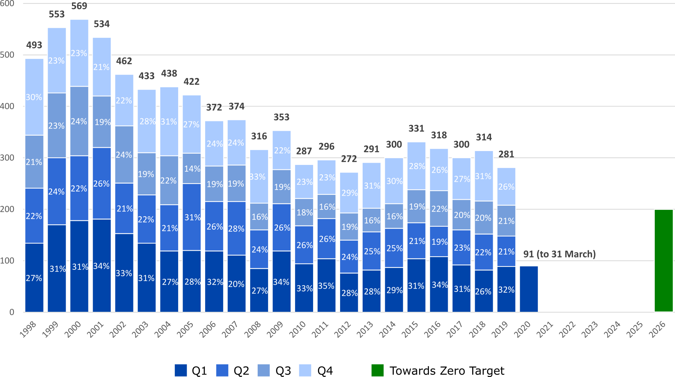

Annual fatalities – Rate per 100,000 population
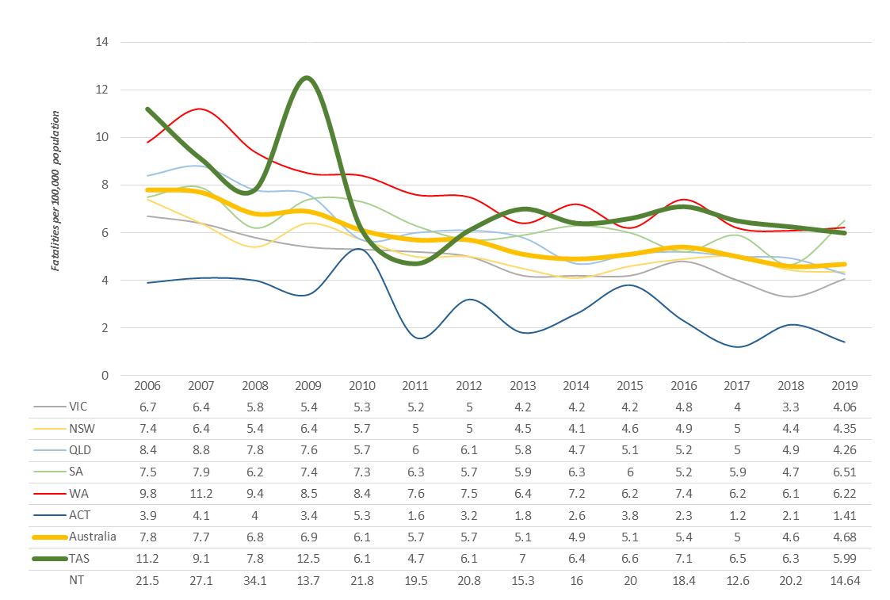

Note: NT omitted from chart for clarity purposes.

Progress on meeting MAIB targets
Motor Accidents Insurance Board (MAIB) injury statistics show the number of fatalities and the level of claims for serious injuries on our roads.
Various claim reduction targets are specified in the Memorandum of Understanding between the Department of State Growth (State Growth) and the MAIB. Progress against high level targets is shown below, expressed as 12 month moving totals

Fatalities – 12 Month Rolling Total
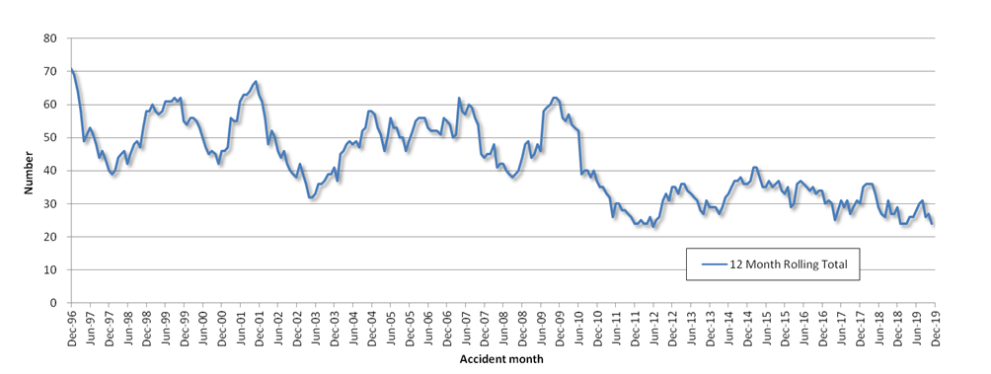

Total Serious Claims – 12 Month Rolling Total
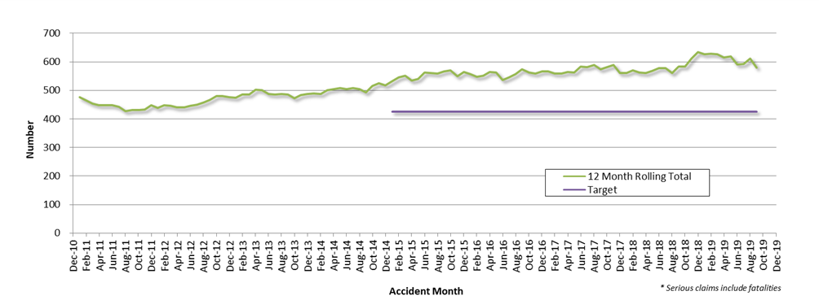

Statistics

Serious Casualties by Quarter by Age Group – 12 period moving average
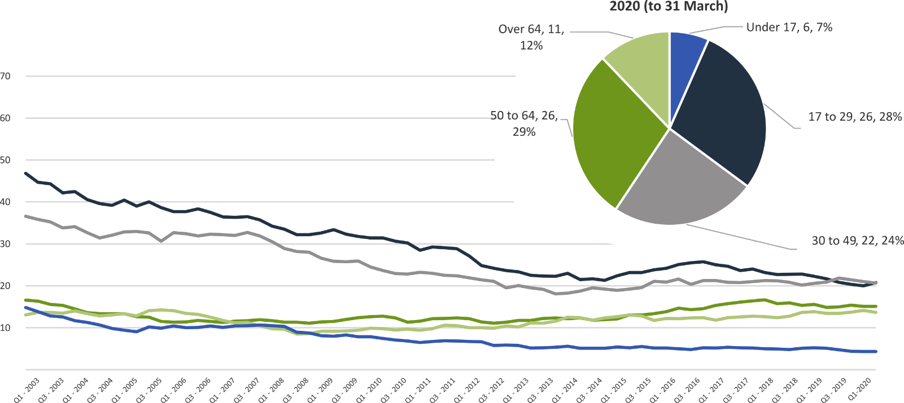

Serious Casualties by Quarter by Sex – 12 period moving average
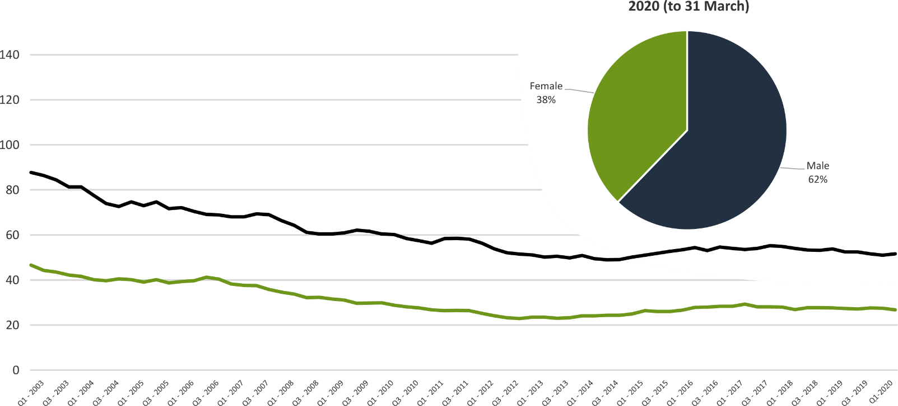

Serious Casualties by Quarter by Road User Type – 12 period moving average

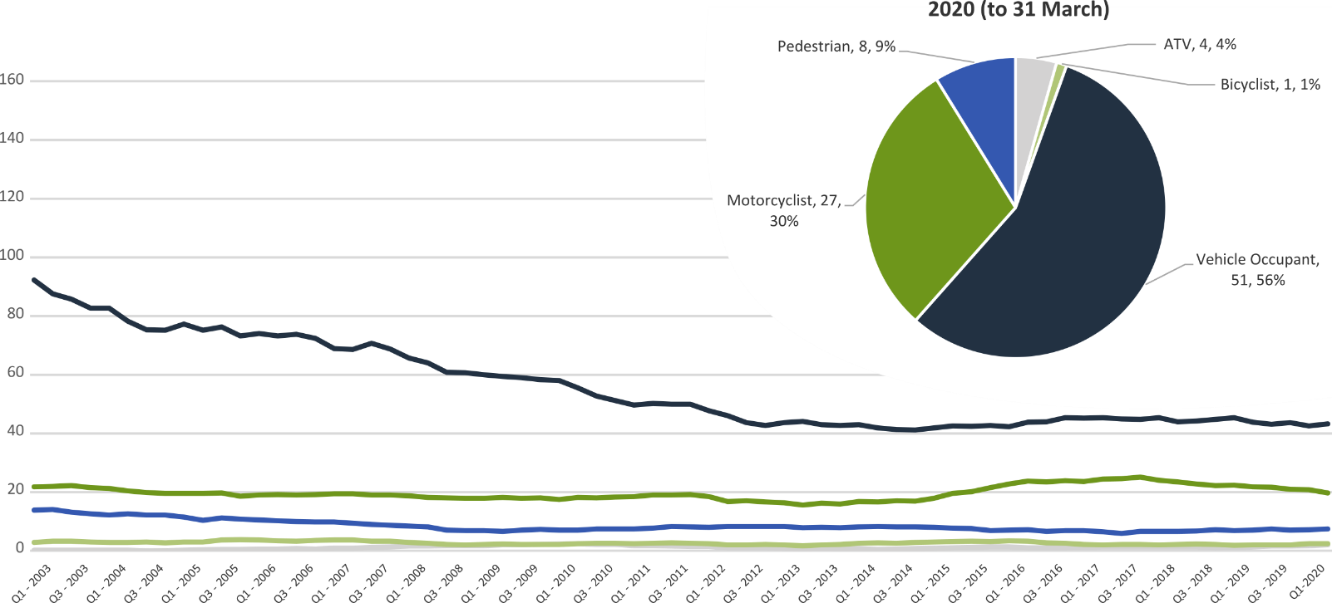

Serious Casualties by Quarter by Speed Zone – 12 period moving average

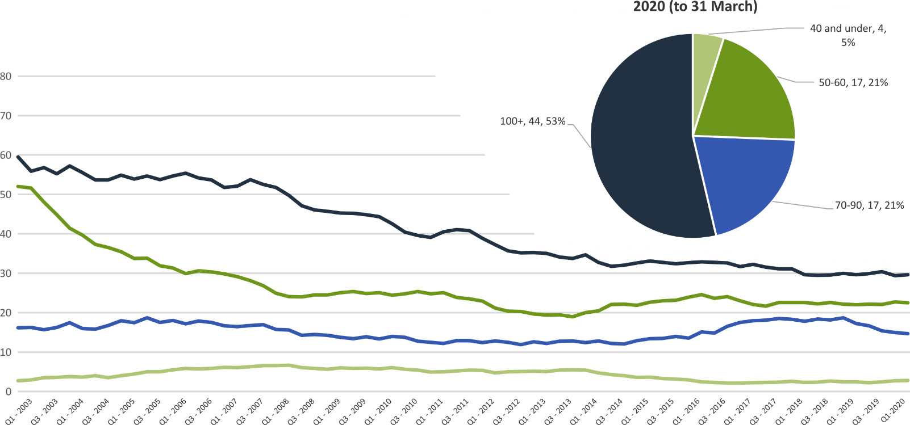

Pie chart excludes serious casualties where speed zone is recorded as ‘not known’

Serious Casualties by Quarter by Crash Type (DCA) – 12 period moving average
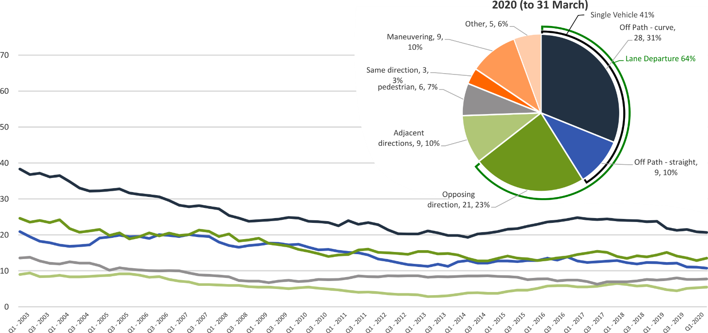

Other includes crash types: on-path (2%), overtaking (2%) & Passenger and Miscellaneous (2%).

Serious Casualties by Quarter by Urban/Non-Urban – 12 period moving average
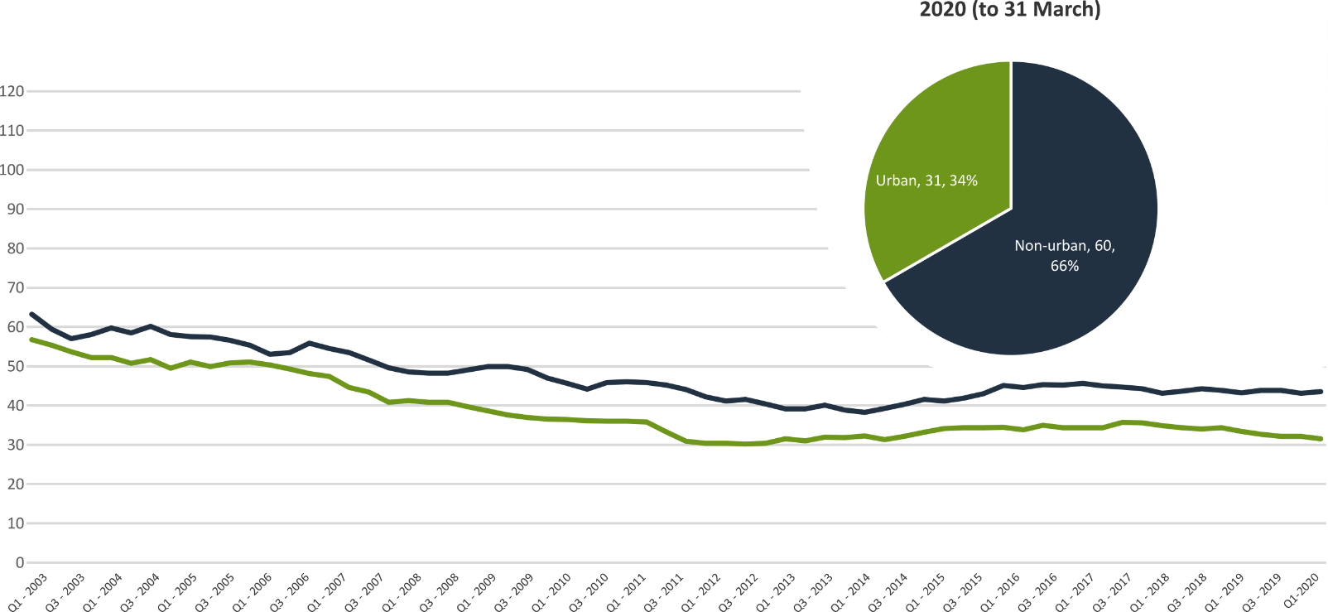

Based on the Australian Bureau of Statistics’ ‘significant urban area’ geographic definition.

Serious Casualty locations to 31 March 2020 (Black = Fatality, Red = Serious Injury)
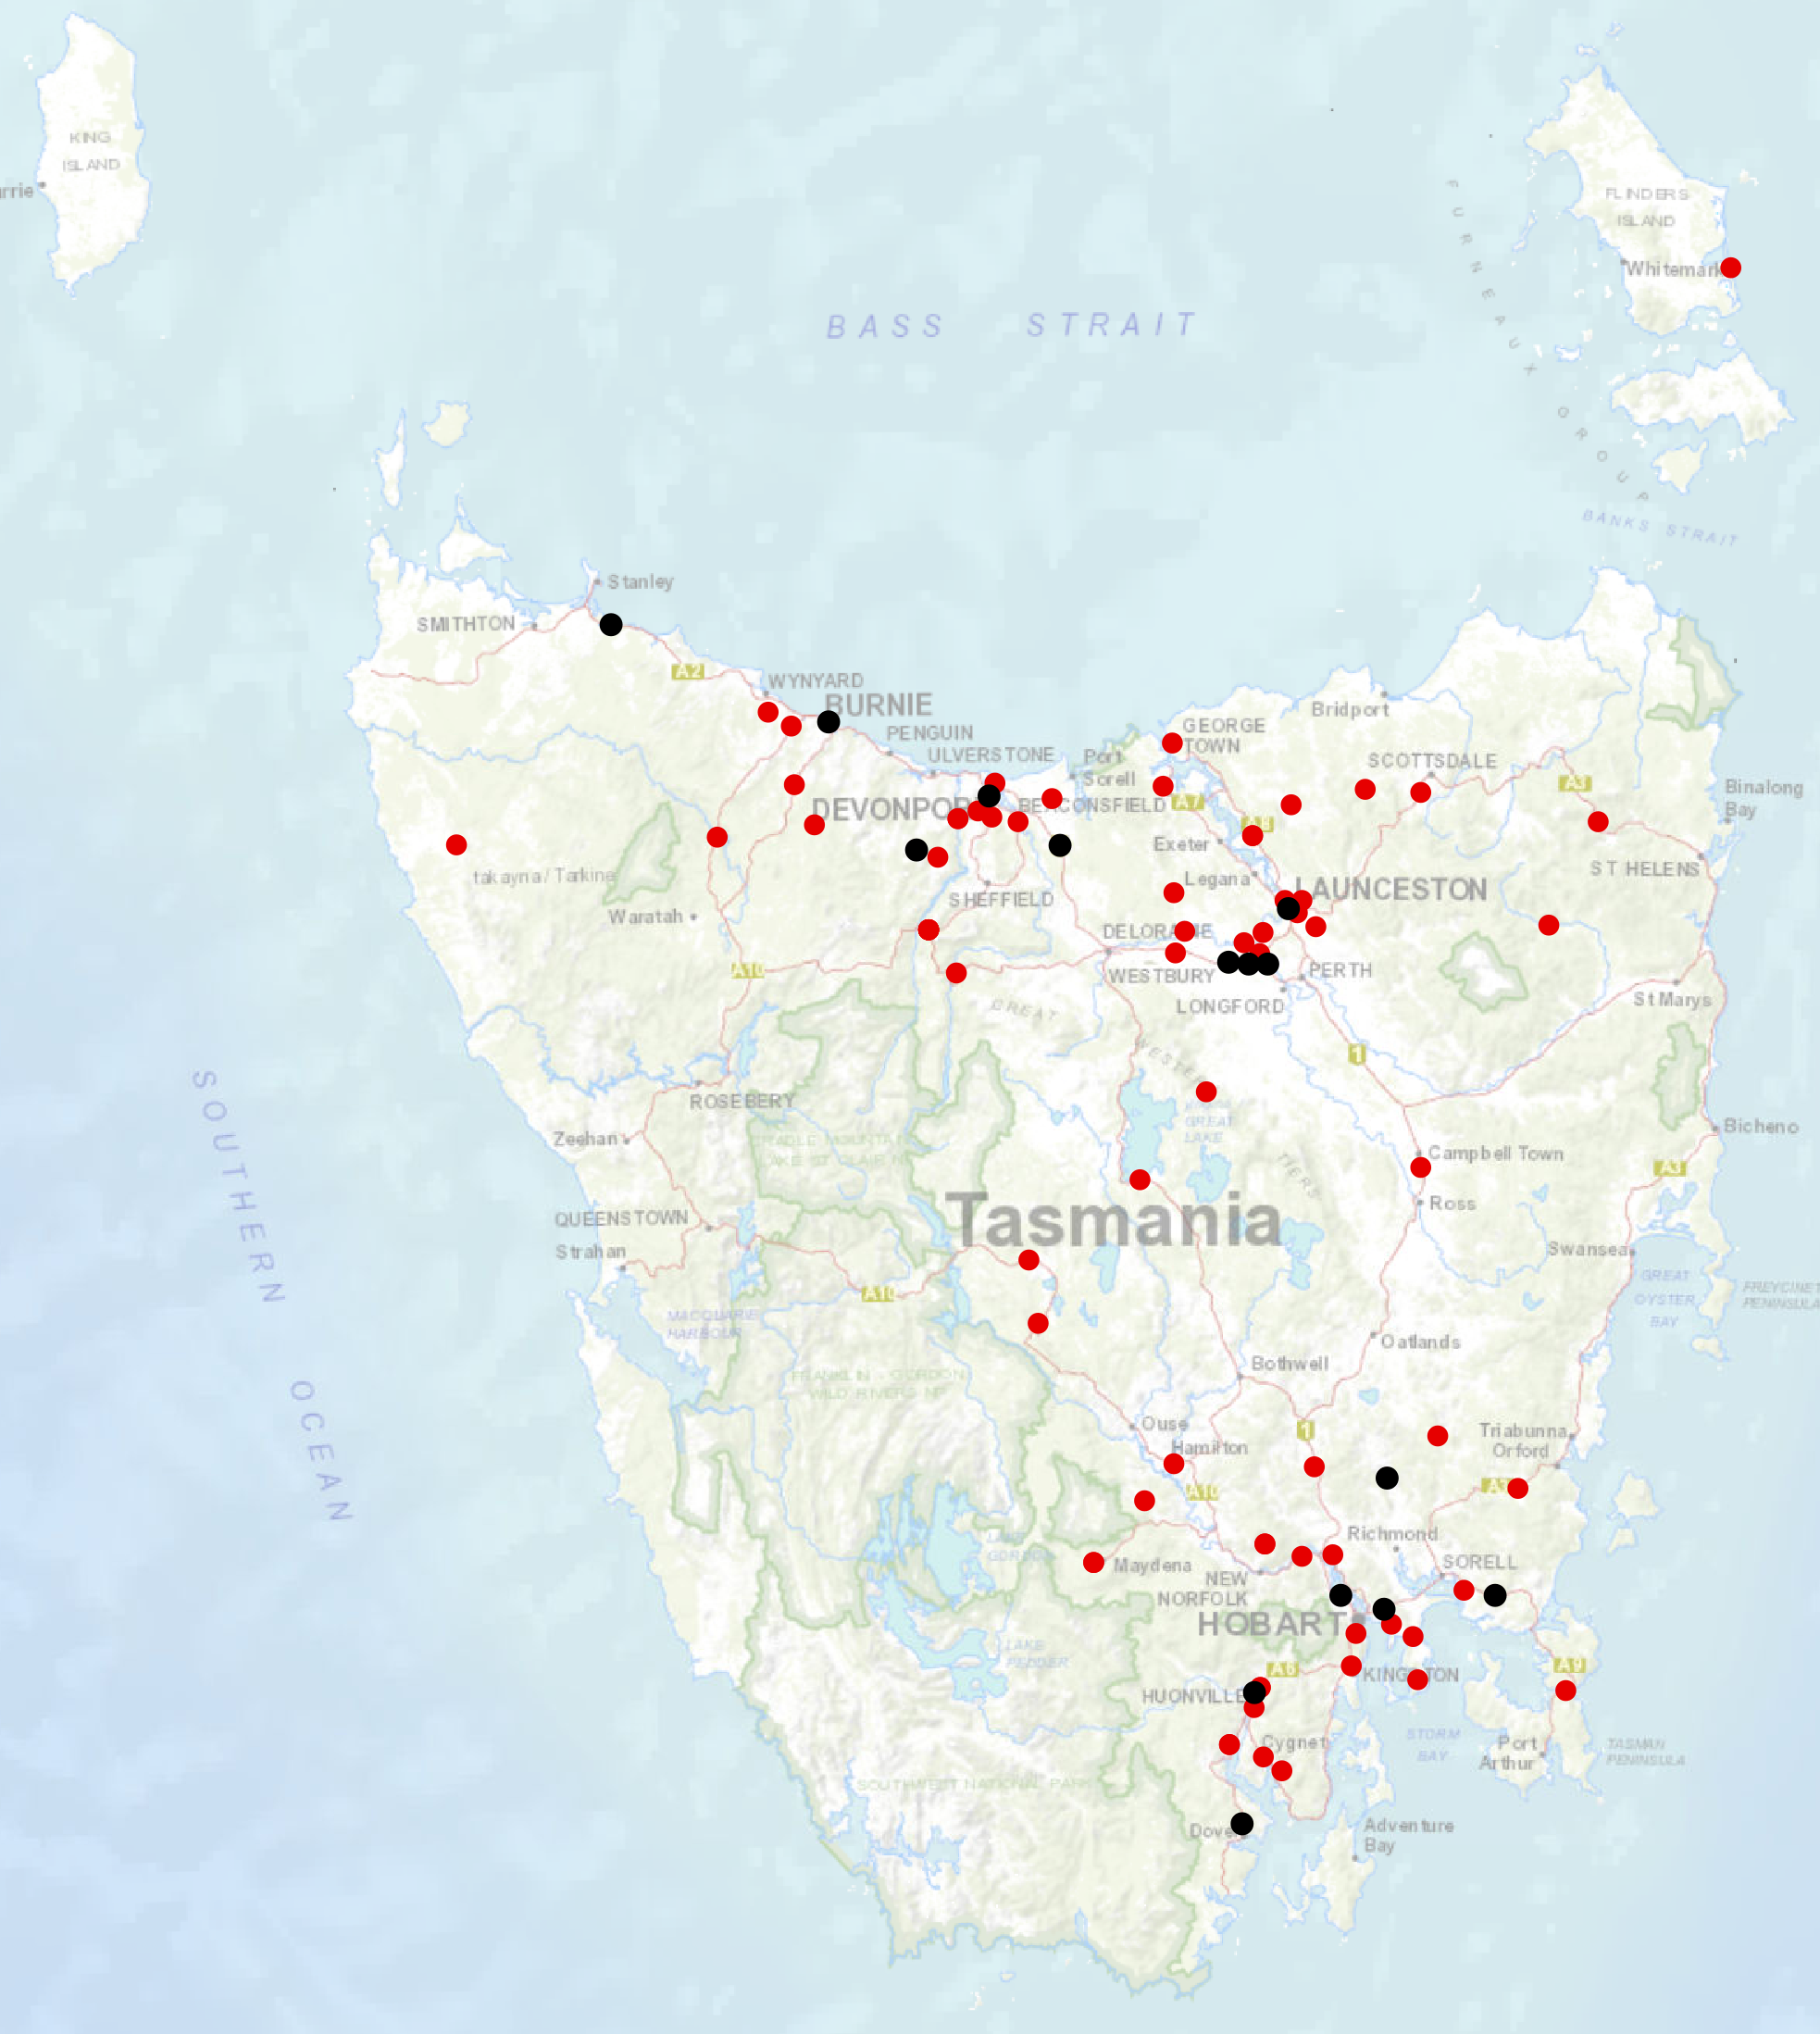

Key themes and priority actions 2020-2024
The Quarterly Progress Report details progress on key themes and priority actions under the Towards Zero Action Plan 2020-2024 and the Towards Zero – Tasmanian Road Safety Strategy 2017-2026.
The progress report should be read in conjunction with the Action Plan and understood in the context of the Towards Zero Strategy. These documents are available at: www.towardszero.tas.gov.au

Funding of key themes
Over $20 million Over $31 million
Over $12 million Over $4 million

$2 million Over $3 million

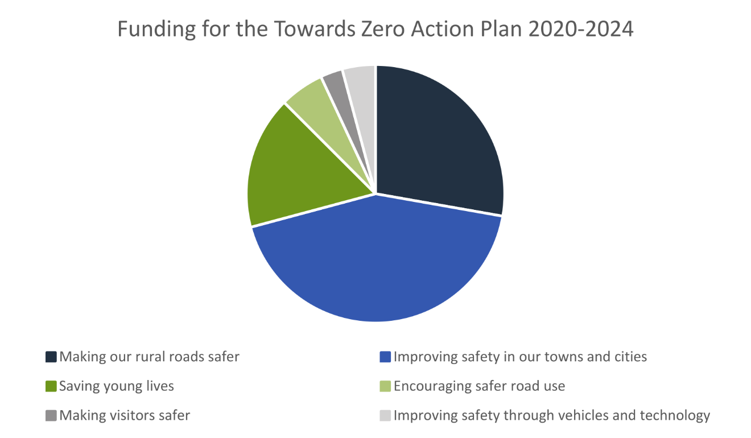

Project status report
Making our rural roads safer
Rural road grants program for local government | Delayed |  | Infrastructure upgrades on low volume State roads | On schedule
Motorcyclist safety on rural roads | On schedule |  | Speed moderation and community engagement strategy | Not yet commenced
Safe system knowledge and skills training | Delayed
Improving safety in our cities and towns
Targeted infrastructure upgrades in high traffic urban areas | Delayed |  | Vulnerable Road User Program | On schedule
Community Road Safety Program | On schedule |  | Trial of innovative technologies | Not yet commenced
Innovative infrastructure treatment demonstrations | Not yet commenced
Saving young lives
Learner Driver Mentor Program and Driver Mentoring Tasmania | Delayed |  | Graduated Licensing System Project for drivers | On schedule
Rotary Youth Awareness Program | On schedule |  | Driving for Jobs Program | Delayed
RACT education initiatives | Delayed |  | Real Mates media campaign | On schedule
Bicycle Network bike education | Delayed |  | Safety around schools | On hold
Kidsafe child restraint check program | On schedule |  | Full Gear motorcycle safety project | Delayed
Develop a Graduated Licensing System for motorcyclists | Not yet commenced
Encouraging safer road use
Inattention and distraction | On schedule |  | Safe behaviour campaigns | On schedule
Mandatory Alcohol Interlock Program | Major delays |  | Protective clothing for motorcyclists | On schedule
Road safety penalties review | On schedule |  | Speed enforcement strategy | On schedule
Enforcement of high-risk behaviours | On schedule |  | Automated Speed Enforcement Program | Delayed
High-risk motorcycling enforcement | Not yet commenced |  | Road Rules Awareness | On schedule
Making visitors safer
Tourist road safety signage program | On schedule |  | Responsive electronic signage trial | On schedule
Tourist education materials | Delayed |  | Strategic partnerships | On schedule
Tourist education at gateway entry points | On hold |  | Stakeholder alliances | Delayed
Improving safety through vehicles and technology
ANCAP | On schedule |  | Safer cars for young drivers | Not yet commenced
Autonomous vehicle and crash avoidance readiness | On schedule |  | Workplace driver safety | Not yet commenced
Light vehicle strategy | Not yet commenced

Progress on key themes
Progress on key themes is reported as:
Status | Major delays/on hold/high risk | Delayed/some issues/medium risk | On schedule/progressing/low risk | Not yet commenced

60 per cent of fatalities occur in rural areas

Rural roads grants program for local government
This grants program will fund councils to implement mass action infrastructure treatments on their high speed rural road corridors to reduce lane departure crashes and lessen the harm when they do occur.
Comments
The first grants funding round under this grants program was planned for 2020, however commencement may be impacted by COVID 19.
Status | risk | Delayed/some issues/medium risk

Infrastructure upgrades on low volume State roads
This program will provide funding for lower volume State roads, where cost effective treatments such as shoulder sealing, pavement markings, curve warnings, road side hazard removal and safety barriers will achieve maximum value for money.
Current situation / comments
$6.95 million has been committed for infrastructure improvements on the Railton Main Road. $450 000 is required for the design and development stage and $6.5 million required for works in the delivery stage. Funding for this project is currently with the Minister for approval.
Status |  |  | On schedule/progressing/low risk

Motorcyclist safety on rural roads
Road safety audits will be conducted on high risk touring routes across Tasmania. This program will involve local motorcyclists and a safe system approach will inform audits. Findings will be shared with stakeholders to identify countermeasure that go beyond typical infrastructure solutions.
Current situation / comments
Safe System motorcycle road safety audit of Hollow Tree Road
Road Safety partnered with the Central Highlands Council to conduct a Safe System motorcycle road safety audit of Hollow Tree Road and a stakeholder workshop on Wednesday 19 February 2020.
The audit and workshop report have been completed. State Growth, Safe System Solutions and the Central Highlands Council have now identified and prioritised a plan of low-cost infrastructure treatments to improve road safety on Hollow Tree Road.
If funding is approved, work will be delivered via a deed with Central Highlands Council. State Roads will provide advice regarding the final scope of works to ensure network consistency and value for money.
Status |  |  | On schedule/progressing/low risk

Speed moderation and community engagement strategy
Speed moderation requires a holistic strategy encompassing public education, road risk assessments, enforcement, speed limit setting, speed limit mapping and technology, penalties, KPIs and evaluation. This project will involve community engagement to inform and build support for action on safer speeds. A significant ongoing coordination effort will be required to support the strategy.
Current situation / comments
To commence 2021.
Status |  |  |  | Not yet commenced

Safe system knowledge and skills training
This program aims to improve Safe System knowledge for all those in a position to influence road safety outcomes and support Safe System infrastructure design and speed setting. It will include technical training sessions, workshops and forums across Tasmania.
Current situation / comments
Workshops are planned for 2020. COVID 19 will impact the delivery of face to face workshops and alternative delivery options are being considered such as virtual or other online methods.
Status | risk | Delayed/some issues/medium risk

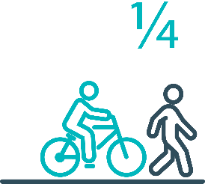

Pedestrians and cyclists are vulnerable and represent
one in four serious casualties in out towns and cities

Targeted infrastructure upgrades in high traffic urban areas
This program provides for delivery of a range of infrastructure safety upgrades to make our towns and cities safer. This will include shoulder sealing, intersection improvements, safety barriers and pavement marking at high traffic areas. By targeting high volume state roads that are not planned for major investment in the short term.
Current situation / comments
Not yet commenced.
Status |  | Delayed/some issues/medium risk

Vulnerable Road User Program
The Vulnerable Road User Program (VRUP) is an established grants program which assists local government with the costs of installing safety improvements in built up areas. The aim of the program is to reduce conflict between vehicles and vulnerable road users - cyclists, pedestrians and motorcyclists.
Current situation / comments
The VRUP was increased from $500 000 per year to $1 000 000 under this Action Plan. The current round was advertised on 14 February 2020 and submissions closed on 15 April 2020.
Status |  |  | On schedule/progressing/low risk

Community Road Safety Grants Program
The Community Road Safety Grants Program (CRSGP) is an established grants program that aims to build community engagement in addressing local road safety issues. The program supports local councils, schools, community groups, research institutions and charity organisations to promote road safety at the grass roots level.
Current situation / comments
The CRSGP 2020 round, with total funding available of $200,000, opened on 14 February 2020 and closed 15 April 2020.
Status |  | Delayed/some issues/medium risk

Trial of innovative technologies
This project will include monitoring, investigation and trialling of new and emerging technology based approaches to improving safety for vulnerable road users.
Current situation / comments
To commence 2021.
Status |  |  |  | Not yet commenced

Innovative infrastructure treatment demonstrations
This project will investigate, trial and demonstrate innovative Safe System urban infrastructure treatments to improve road safety in our urban areas. We will work with local councils to show how Tasmania’s cities and towns can be improved for the benefit of all road users, particularly cyclists and pedestrians.
Current situation / comments
To commence 2021.
Status |  |  |  | Not yet commenced

92 young people are seriously injured or killed on our
roads every year

Learner Driver Mentor Program and Driver Mentoring Tasmania
The Learner Driver Mentor Program (LDMP), supported by Driver Mentoring Tasmania (DMT) is a well-established program that supports disadvantaged learner drivers to gain their on-road supervised driving hours to gain a licence.
Current situation / comments
LDMPs ceased operation in mid-March due to COVID-19. Programs will restart once social distancing and health guidelines allow. The 2020 LDMP grant funding round, with total funding available of $1m, opened on 6 March 2020 and closed on 15 April 2020.
Status |  | Delayed/some issues/medium risk

Graduated Licensing System Project
Changes are being made to the Graduated Licensing System (GLS) for drivers to better protect young and novice drivers and improve the licensing pathway. Young drivers are overrepresented in crash statistics and most at risk when they first get their Ps and start driving solo. The changes to the GLS aim to address this risk, and improve road safety outcomes for both young and novice drivers.
Current situation / comments
The Tasmanian Government has committed to implementing the changes to the GLS by December 2020.
Complementing the GLS regulatory changes will be the new online learning platform, public education campaign and supporting materials and resources. Work commenced on these key deliverables in March 2020. Due to the COVID19 restrictions that also came into effect at this time the GLS Project team has had to work with the external provider to reframe the project activity to ensure progress continues. This has included taking all research activity informing the development of the platform online.
Status |  |  | On schedule/progressing/low risk

Motorcyclist Graduated Licensing System review
This project will evaluate the benefits of a new Graduated Licensing System (GLS) for motorcyclists. This will include greater restrictions on learners, that are gradually lifted as riders acquire skills and experience under conditions that reduce risk.
Current situation / comments
To commence 2022.
Status |  |  |  | Not yet commenced

Rotary Youth Driver Awareness Program (RYDA)
RYDA is a one day road safety education program for year 10-12 students making them aware of the significant responsibility that comes with being a driver or passenger. Every year 4000 students take part in practical demonstrations and learn valuable road safety lessons from expert presenters and volunteers. RYDA is delivered by Rotary Tasmania.
Current situation / comments
RYDA is scheduled towards end of Term 3 and Term 4. There are currently no changes to this as a result of COVID-19 but State Growth will work with Rotary closer to the date to identify any impacts on the program.
Status |  | Delayed/some issues/medium risk

Driving for Jobs Program
The Driving for Jobs (DfJ) Program aims to support disadvantaged students who would otherwise be unable to enter and progress through the Graduated Driver Licensing System (GLS). The program provides students at selected schools with the opportunity to increase their road safety knowledge whilst also improving their job readiness. Students undertake a personalised intensive program with a strong road safety focus including professional on-road driving lessons and participation in the Rotary Youth Driver Awareness Program.
Current situation / comments
Work is underway between the Department of State Growth and Department of Education to formalise the partnership to deliver and expand the Driving for Jobs Program over the next five years (2020-2024). The DfJ program commenced as a pilot at Jordan River Learning Federation where its operation in 2020 has been significantly impacted by Covid-19. Steps are being taken for the program to resume as soon as possible. Work has continued between the agencies including development of a funding agreement and DfJ Program Guidelines, as well as investigation into other suitable schools to expand the program into.
Status |  | Delayed/some issues/medium risk

RACT education initiatives
The RACT delivers a range of in-class road safety education programs. This includes a program for years 10-12 students that focuses on the dangers of distraction and inattention. The program also teaches students how to progress through the GLS and about the specific rules that apply to L and P plate drivers.
Current situation / comments
Education initiatives are being rolled out by the RACT as per their grant deed agreement. It is expected program delivery will be impacted due to COVID-19.
Status |  | Delayed/some issues/medium risk

Real Mates media campaign
The MAIB-funded Real Mates campaign uses humour to engage with young men to encourage them to avoid the risks of drink driving by empowering them to speak up and stop a mate from driving after drinking.
Current situation / comments
The advertising agency is working on a new phase for the campaign, including exploring new ways to promote the message through a third party.
Status |  |  | On schedule/progressing/low risk

Bicycle Network bike education
The Bicycle Network delivers the Ride2School program to schools across Tasmania. Ride2School is for primary aged students and focuses on safe cycling, road safety and positive road sharing behaviour.
Current situation / comments
The Bike Network is focusing on developing program materials while workshops are on hold due to COVID-19. This is in line with their grant deed requirements.
Status |  | Delayed/some issues/medium risk

Safety arounds schools
Safety around schools is promoted through designated crossings, lower speed zones, more than 100 school crossing patrol officers and public education. The current Safety around Schools project, including the Love 40 campaign, encourages drivers to lower their speed and keep a look out for children in school zones and around buses.
Current situation / comments
The Love 40 Campaign was not active for Term 2 due to low student attendance as a result of COVID-19. The situation regarding COVID-19 is being monitored and the campaign will be continued once schools are back to full operations.
Status |  | Delayed/some issues/medium risk

Kidsafe child restraint check program
Kidsafe Tasmania conducts free child restraint checking sessions to ensure that young children are safely and lawfully seated and restrained in cars. Kidsafe also distribute and promote educational materials to inform the public of the correct child restraint type for a child’s age and size.
Current situation / comments
Kidsafe is conducting one-on-one child restraint checks due to COVID-19 and supporting parents and carers with child restraint information.
Status |  |  | On schedule/progressing/low risk

Full Gear motorcycle safety project
The Glenorchy City Council, in partnership with Bucaan House, delivers its successful Full Gear motorcycle safety project which helps young motorcycle riders enter the licensing system and to adopt safe riding practices.
Current situation / comments
The Full Gear program has continued to address dangerous motorcycle riding by young people in the Glenorchy municipality. The program commenced at the beginning of the year with six participants, however Bucaan House is currently closed due to COVID-19 and therefore the safety component is on hold. Participants continue to gain experience on their learner licence until restrictions are lifted.
Status |  | Delayed/some issues/medium risk

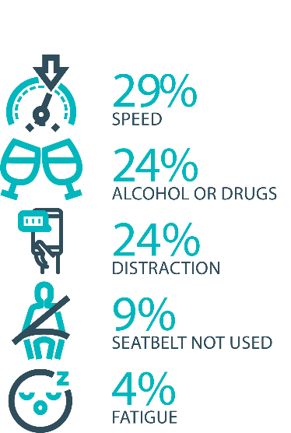

The fatal five behaviours contributing to serious
casualties

Inattention and distraction
Inattention and distraction are concerning causes of serious casualty crashes and may have a far greater impact than current data suggests. There are a number of research projects and enforcement initiatives that are being used to address this issue. This project will include consideration of emerging strategies for tacking distraction, encouraging compliance through enforcement and influencing driver behaviour through public education campaigns.
Current situation / comments
Enforcement
Tasmania Police introduced three unmarked motorcycles to increase the rate of detection and enforcement of illegal phone use whilst driving. These motorcycles operate across all districts and target the low speed road network and congested traffic conditions, utilising ‘lane filtering’ legislation to full advantage.
In an agency first, the riders are also fitted with helmet cameras to capture the offence, an initiative that has effectively nullified disputes. The introduction of unmarked motorcycles has proved to be incredibly successful with riders reporting high-level public support and a notable change in driver behaviour.
Tasmania Police has also conducted a technology demonstration with a commercial provider to test artificial intelligence based automated mobile phone detection. The technology is combined with speed detection and Automated Number Plate Recognition capabilities.
Public education campaigns
The ‘Leave Your Phone Alone’ campaign continues to warn drivers of the dangers of using a mobile phone while driving.
Status |  |  | On schedule/progressing/low risk

Safe behaviour campaigns
Targeted media campaigns will continue to educate people about high-risk behaviours and to highlight the dangers of the ‘Fatal Five’.
Current situation / comments
Market research has been commissioned to evaluate the effectiveness of the Drive Safe/We’ve Been Everywhere campaign used around holiday periods. The research will help inform a replacement campaign.
Status |  |  | On schedule/progressing/low risk

Mandatory Alcohol Interlock Program (MAIP)
The MAIP aims to have repeat and high-level drink driving offenders demonstrate they are able to separate their drinking from driving through the installation of an alcohol interlock in their vehicle. New measures will be introduced to increase participation in the MAIP.
Current situation / comments
Drafting instructions for the revised framework were provided to the Office of Parliamentary Counsel (OPC) in October 2019. Parliamentary priorities caused reprioritisation of OPC work. First draft regulations have not been received by the Department. Two Approved Providers have signed new contracts: negotiations continue with the third.
Status | Major delays/on hold/high risk

Protective clothing for motorcyclists
Motorcyclists are overrepresented in Tasmania’s road trauma figures. Motorcyclists are vulnerable road users due to a lack of physical protection. Protective clothing can reduce injury severity in the event of a crash. Tasmania is a funding member of MotoCAP. MotoCAP provides safety assessment star ratings for protective clothing and prepares education materials for motorcyclists.
Current situation / comments
Tasmania contributes around $8 000 per annum to participate in and support the activities of MotoCAP.
Status |  |  | On schedule/progressing/low risk

Road safety penalties review
For enforcement activities to improve safety on our roads, they need to be backed up with appropriate penalties. Tasmania’s road safety penalties will be reviewed to ensure they are up-to-date and provide an appropriate deterrence to those who break the rules and put themselves and others at risk.
Current situation / comments
Initial analysis has been undertaken comparing Tasmania’s road safety related penalties to those in other jurisdictions.
Status |  |  | On schedule/progressing/low risk

Speed enforcement strategy
Tasmania Police have prepared a speed enforcement strategy and will enact new speed enforcement techniques to increase the rate of detection and enforcement. Tasmania Police record speeding offences, however, there is no general monitoring of speed limit compliance. Improved reporting needs to be developed to better understand the issue of speeding.
Current situation / comments
Speed enforcement is one of five priority areas within Tasmania Police’s current Road Safety Strategy 2019-2021.
With regard to speed cameras, Tasmania Police has conducted several technology trials, including in-motion camera technology, where speed cameras are fitted to moving vehicles, and of mobile point-to-point speed detection, where average speed enforcement utilises two vehicles fitted with automatic numberplate recognition technology. In addition, Tasmania Police is working with the Department of State Growth to consider the future of automated speed enforcement in Tasmania.
Tasmania Police has implemented a Strategic Asset Management Plan (SAMP) for all speed detection devices. The SAMP provides for continual review of new and emerging technologies, includes provisions for regular replacement and upgrade of equipment and importantly supports long-term financial planning and budgeting. In line with the SAMP, Tasmania Police’s Southern Road and Public Order Services is also trialling a rear-facing radar on a patrol vehicle.
Tasmania Police has further implemented a new vehicle livery across the fleet, matching different livery designs to specific uses, for example general patrol, high-visibility patrol, and low-profile marked vehicles – all of which are relevant to different methodologies of speed reduction and enforcement. The strategy has also seen the introduction of unmarked highway patrol cars which have proved to be very successful and complement the use of overt policing tactics well.
Status |  |  | On schedule/progressing/low risk

Enforcement of high-risk behaviours
To reduce high-risk behaviours and increase compliant road user behaviour, State Growth and Tasmania Police will work collaboratively to investigate and introduce new enforcement techniques and technologies to detect high-risk behaviours that address the ‘fatal five’, including mobile phone use, speeding and failure to wear a seatbelt.
Current situation / comments
Tasmania Police’s Road Policing Strategy focuses on the fatal five causes of serious and fatal crashes, which are the highest risk driver behaviours: speeding; alcohol and drugs; distraction and inattention; seatbelts; and fatigue. The strategy includes several priority areas under each theme and the strategy guides the deployment of operational policing resources.
Status |  |  | On schedule/progressing/low risk

Automated Speed Enforcement Program
Speed cameras are relatively underutilised as a deterrence and enforcement mechanism in Tasmania. This project investigates proven and emerging speed camera technologies for use at high-risk locations and across the entire road network.
Current situation / comments
Analysis has been undertaken detailing the potential road safety benefits, expected costs, and projected infringement revenues for consideration by the Automated Speed Enforcement Steering Committee (ASESC). The project has been temporarily paused due to COVID 19.
Status | Major delays/on hold/high risk | Delayed/some issues/medium risk | On schedule/progressing/low risk | Not yet commenced

High-risk motorcycling enforcement
Speed is a factor in at least a quarter of motorcyclist serious casualties. Speed cameras offer no deterrence to motorcyclists, whose numberplates are mounted only on the back. Introduction of rear-facing speed cameras will improve detection and deterrence of speeding. This is being considered as part of the Automated Speed Enforcement project.
Current situation / comments
Tasmania Police investigated rotating the current fixed speed cameras 180 degrees to provide for rear-facing detection (to detect motorcycles). Technology limitations determined this was not a practical solution due to accuracy concerns. Upgrading the technology to support forward and rear-facing and multiple lane detection has now been subsumed into State Growth’s Automated Speed Enforcement Program.
Status |  |  |  | Not yet commenced

Road Rules Awareness
Compliance with Road Rules makes our behaviour on the roads predictable, improving safety for all road users. This initiative will ensure that user-friendly and tailored information resources are developed so that the Road Rules are easily understood and adhered to by all road users.
Current situation / comments
A comprehensive community education campaign communicating the new emergency vehicle passing rule has recently concluded. This included the launch of an education campaign on television and radio, in print media, and on billboards and the back of buses. The campaign ran for a period of seven months and will be subject to an upcoming evaluation.
The Road Rules Handbook, extensively at the end of 2019, and the Five More Misunderstood Road Rules pamphlet, are distributed to Service Tasmania locations.
Status | Major delays/on hold/high risk |  | On schedule/progressing/low risk

11 per cent of all serious casualties on our
roads are non-Tasmanian residents

Tourist road safety signage program
This program will see the installation of tourist signage strategically placed across the road network. The signs will provide important road safety information, relevant to the area road users are travelling in. This program will be undertaken in collaboration with stakeholders, local government and State Roads.
Current situation / comments
The process of installing Tourist road safety signs across the road network continues. This involves the selection of sign locations and confirming messaging in consultation with a range of stakeholders. Signs have been installed on Bruny Island, with sign locations and messaging confirmed in a number of other local government areas. Signs will continue to be installed across the road network, throughout the duration of the Action Plan.
Status |  |  | On schedule/progressing/low risk

Responsive electronic signage trial
This project will trial a responsive electronic sign with real time information at regional tourism gateways.
Current situation / comments
Options are being explored around the most appropriate technology and locations for the responsive electronic signage trial. Installation is planned for 2021-2022.
Status |  |  | On schedule/progressing/low risk

Tourist education materials
A range of education materials developed using images, symbols and multi-lingual material delivered to specific audiences through targeted communications channels. This will include vehicle hangers, brochures, posters, roadside signs, editorial content, film and digital content.
Current situation / comments
The distribution of educational material targeting tourists is currently on hold due to COVID -19. Communications material is being reviewed, refreshed and updated where appropriate. Strategies are in place to utilise stakeholder alliances to develop new content. Commercial and stakeholder distribution networks are currently being reviewed.
Status |  | Delayed/some issues/medium risk

Strategic partnerships
Developing strategic partnerships based on synergies with target audiences will enable the effective promotion of road safety messages and education.
Current situation / comments
Building and maintaining stakeholder alliances is an ongoing and embedded strategy. Progress is being made, this includes continuing to partner with the Spirit of Tasmania, Local Government, industry associations online media companies, and now engaging with Australia’s largest motorcycle retailing, accessories wholesaling company.
Status |  |  | On schedule/progressing/low risk

Tourist education at gateway entry points
As an island state, we have the opportunity to strategically place messaging at our gateway airports and seaports to reach visitors with important road safety messaging prior to them driving in Tasmania. This will include a range of educational materials, electronic and static signs and billboards.
Current situation / comments
Due to the impact of COVID-19, the distribution of collateral and other educational activity including electronic and static signs and billboards at gateway entry points is currently on hold. Printed collateral remains in stock at gateway locations and strategies are in place to phase in distribution activity when travel resumes.
Status | Major delays/on hold/high risk

Stakeholder alliances
Sharing information and collaborating to develop effective strategies and tools to address road safety issues is vital. This project will develop formal and informal stakeholder alliances to encourage input and create opportunities to deliver joint initiatives.
Current situation / comments
Building and maintaining stakeholder alliances is an ongoing and embedded strategy. COVID-19 has resulted in some activity being put on hold, but it has also provided a good opportunity to work more closely with other stakeholders.
Presentations, consultation and workshops with stakeholders are ongoing. Good progress is being made to build and strengthen alliances with stakeholders from across all levels of government, industry associations, special interest groups and individuals. Regular communication and strengthened relationships are now resulting in opportunities to share information, resources and collaborate on road safety initiatives.
Status |  | Delayed/some issues/medium risk

The rate of fatal crashes is four times higher for vehicles 15+ years old than for vehicles made in the last five years

Australasian New Car Assessment Program (ANCAP)
Tasmania is a funding member of ANCAP. ANCAP plays a vital role in informing consumers about safety performance of new vehicles and advocates for improved vehicle safety design and specification through public education campaigns, advocacy activities and engagement with governments, corporate fleets, the media and consumers. Activities related to ANCAP will include promotion of safer vehicles and options for an annual vehicle fleet report.
Current situation / comments
Tasmania continues to support ANCAP with funding of $12 500 per annum.
Status |  |  | On schedule/progressing/low risk

Safer cars for young drivers
This project aims to increase awareness of the Used Car Safety Rating database amongst first time car buyers. This could be promoted through education materials and campaigns and may be able to integrate with the GLS online learning platform.
Current situation / comments
To commence in 2021.
Status |  |  |  | Not yet commenced

Autonomous vehicle and crash avoidance readiness
This project involves the monitoring and development of safety and autonomous vehicle technologies.
Current situation / comments
The regulation of autonomous vehicles is being considered at a national level and Tasmania is participating in that process.
Status |  |  | On schedule/progressing/low risk

Workplace driver safety
Vehicle use in road traffic is the most significant contributor to work-related traumatic injury. This project will aim to promote and encourage employers to adopt safe driving policies based on the Worksafe, ‘Vehicles as a workplace’ guide.
Current situation / comments
To commence 2021.
Status |  |  |  | Not yet commenced.

Light vehicle strategy
A light vehicle strategy will be developed to provide public education and undertake enforcement activities to enhance the safety standard of Tasmania’s vehicle fleet. A scoping paper will be developed, with the strategy considering KPIs and annual reporting.
Current situation / comments
To commence in late 2020.
Status |  |  |  | Not yet commenced

Funding
Road Safety Levy Overview for the Financial Year 2019/20
As at 31 March 2020 (Quarter 3)
Road Safety Levy Opening Summary
Opening Balance as at 01 July 2019 |  |  | $ 19,628,925
Annual Allocation to Road Safety Operations |  |  | $ 2,600,000
Revenue Summary
 |  | Forecast (FY20) | Actual (Y.T.D.)
Motor Accident Insurance Board Funding |  | $ 1,522,482 | $ 1,187,419
Revenue Inflows from Registrations |  | $ 14,000,876 | $ 11,344,418
Funds Available for Distribution |  | $ 32,552,283 | $ 29,560,762
Expenditure Summary
Theme no. | Theme | Forecast (FY20) | Actual (Y.T.D.)
1 | Making our Rural Roads Safer | $ 10,067,689 | $ 2,163,153
2 | Improving Safety in our Towns and Cities | $ 1,547,953 | $ 629,928
3 | Saving Young Lives | $ 2,513,408 | $ 2,181,278
4 | Encouraging Safer Road Use | $ 2,324,807 | $ 1,694,264
5 | Making Visitors Safer | $ 147,000 | $ 33,639
6 | Improving Safety Through Vehicles and Technology | $ 420,000 | $ 12,245
7 | General Support | $ 741,000 | $ 356,796
Budget and Expenditure by Category |  | Forecast (FY20) | Actual (Y.T.D.)
Infrastructure Expenditure* |  | $ 11,554,828 | $ 2,609,532
Policy & Projects Expenditure* |  | $ 6,881,001 | $ 4,794,847
Total Expenditure |  | $ 18,435,829 | $ 7,404,379
Balance as of 31 March 2020 |  | $ 15,225,192 | $ 22,156,383
Forecast Closing Balance of FY20 |  | $ 11,868,021
*Includes four ceasing activities not categorised by Action Plan 2020-24 themes
MAIB Funding

As at 31 March 2020

2019/20 Financial Year | Budget  $ | Actual (ytd)  $ | Balance  $
Expenditure (State Growth)
Administration & Public Relations | 348 360 | 213 822 | 134 538
Public Education | 1 030 387 | 938 503 | 91 884
Research | 143 735 | 35 095 | 108 640
Subtotal | 1 522 482 | 1 187 420 | 335 062
Expenditure (Tasmania Police)
Salaries | 1 975 694 | 1 527 612 | 448 082
Operating Expenses | 182 000 | 204 463 | -22 463
Equipment | 394 000 | 315 247 | 78 753
Subtotal | 2 551 694 | 2 047 322 | 504 372
Total | 4 074 176 | 3 234 742 | 839 434
Includes Carried Forward of
$196 853 (State Growth)
$-54 306 (Police)

