Fewer than 200 serious injuries and deaths on our roads by 2026

Towards Zero Tasmanian Road Safety Strategy 2017–2026

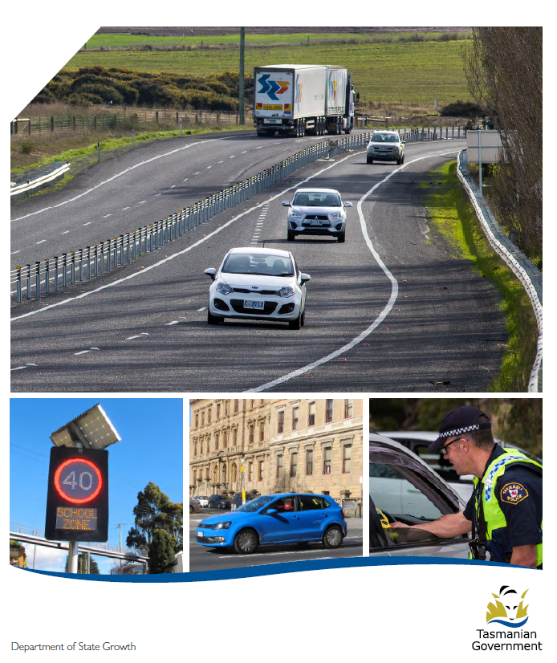

Quarterly Progress Report to RSAC
as at 31 December 2019

Progress on meeting Towards Zero Strategy targets
The key interim target for the Towards Zero – Tasmanian Road Safety Strategy 2017-2026 (Towards Zero Strategy) is to reduce the number of annual serious injuries and deaths on Tasmanian roads to fewer than 200 by 2026. This is an ambitious target of 100 fewer serious casualties per year than for the period 2012-2016 (annual average) and will move us towards the long-term goal of zero serious casualties on Tasmanian roads.
Serious Casualties
The number of serious casualties in 2019 was 283, compared to 314 in 2018, a 9.9 per cent decrease. The 2019 figure of 283 is a 9.5 per cent decrease on the five year serious casualty average of 312.6 (2014-2018).

Fatalities
In 2019, there were 32 fatalities on Tasmanian roads which is one fewer than the number recorded in 2018. The figure of 32 fatalities in 2019 is a 3.6 per cent decrease on the five year fatalities average of 33.2 (2014-2018).
Serious Casualties Tasmania – Annual Count, Percentage Split by Quarter and Towards Zero Target

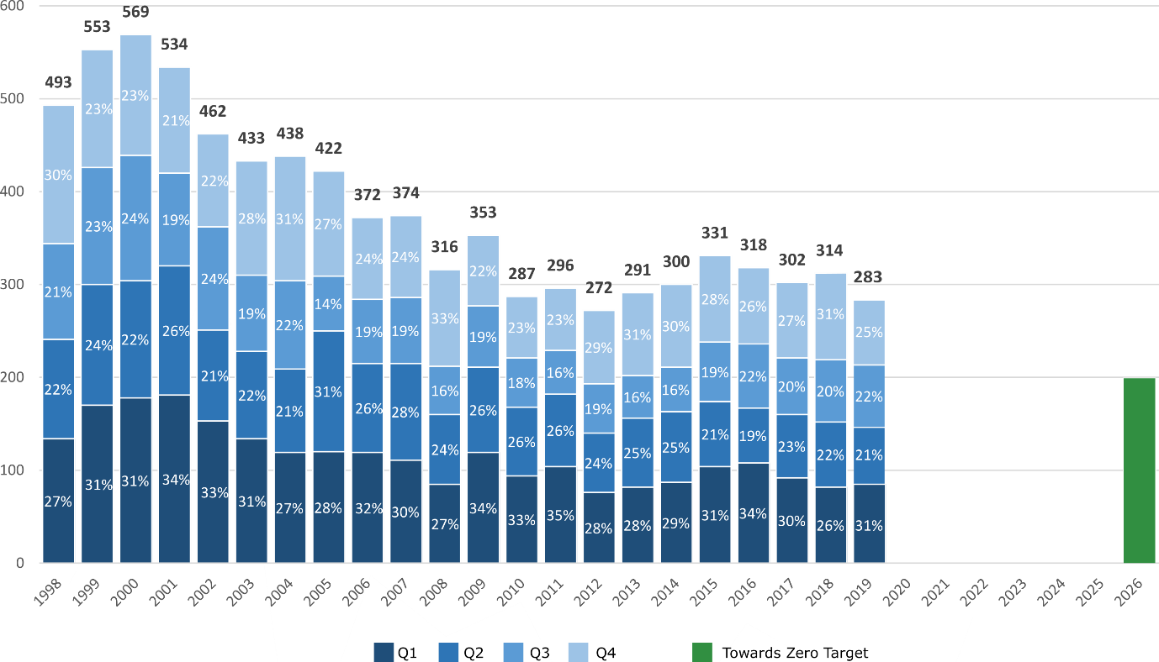

Annual fatalities – Rate per 100,000 population
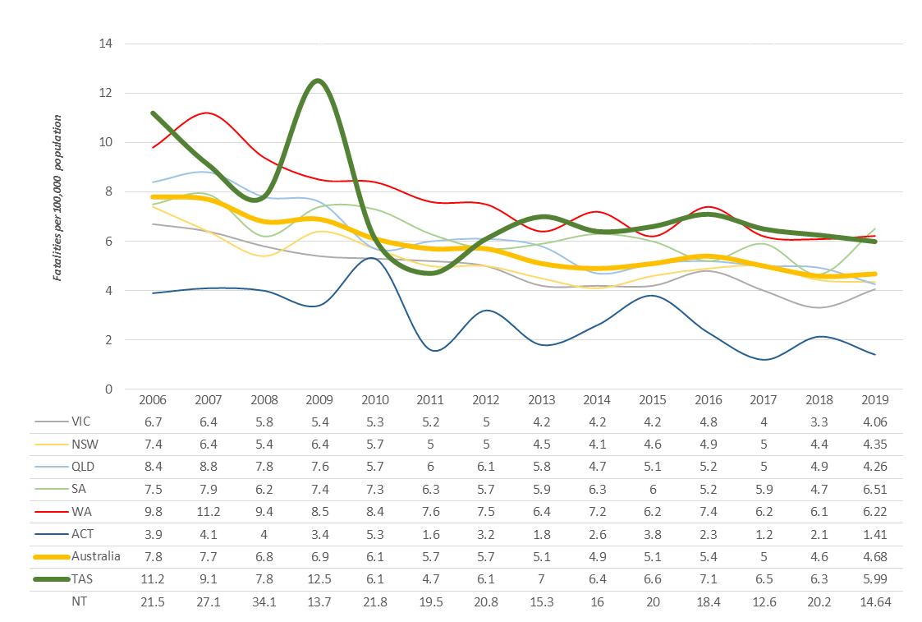
Note: NT omitted from chart for clarity purposes.

Progress on meeting MAIB targets

Motor Accidents Insurance Board (MAIB) injury statistics show the number of fatalities and the level of claims for serious injuries on our roads.
Various claim reduction targets are specified in the Memorandum of Understanding between the Department of State Growth (State Growth) and the MAIB. Progress against high level targets is shown below, expressed as 12 month moving totals.

Fatalities – 12 Month Rolling Total
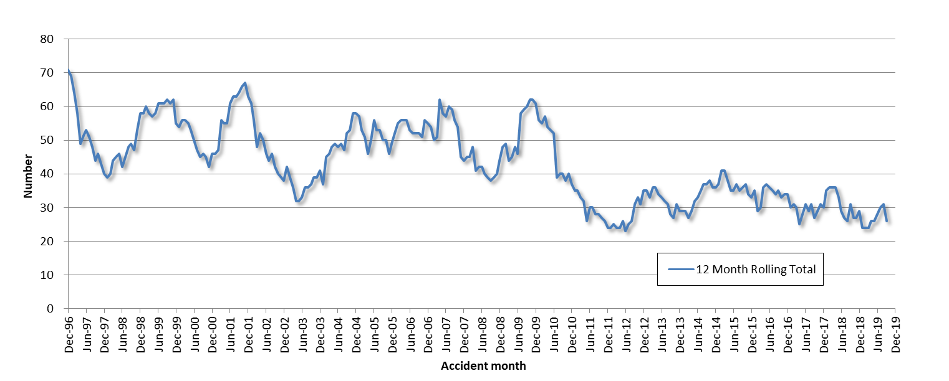

Total Serious Claims – 12 Month Rolling Total
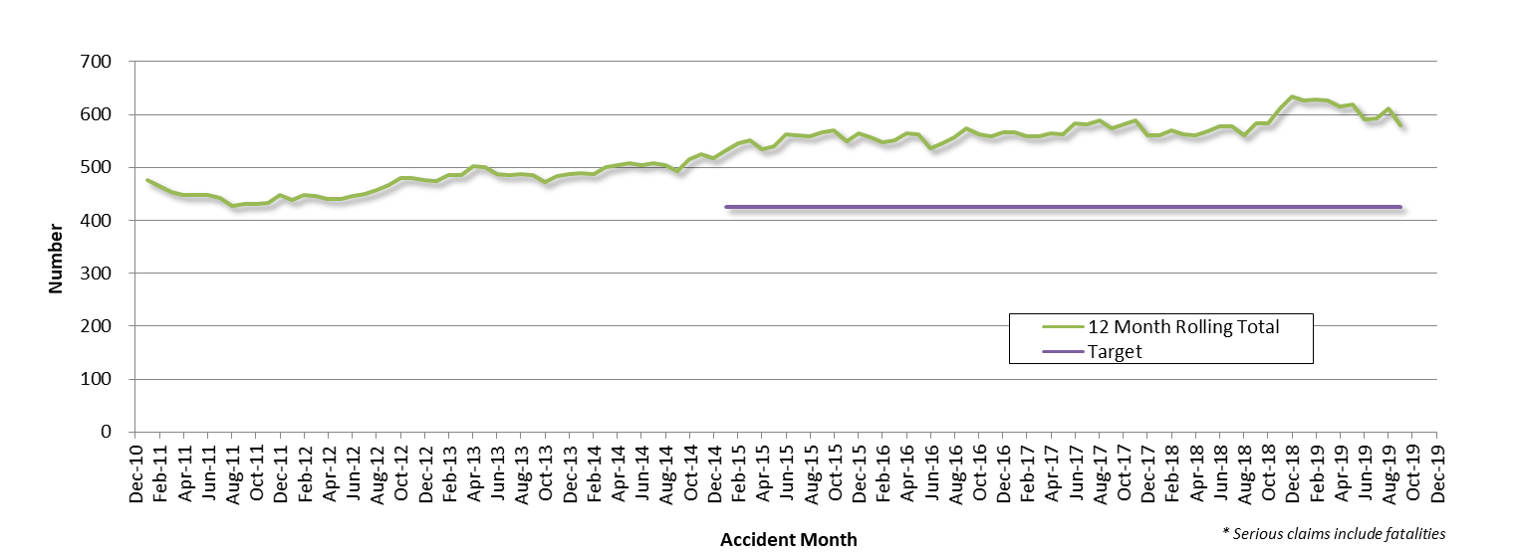

Statistics
Serious Casualties by Quarter by Age Group – 12 period moving average

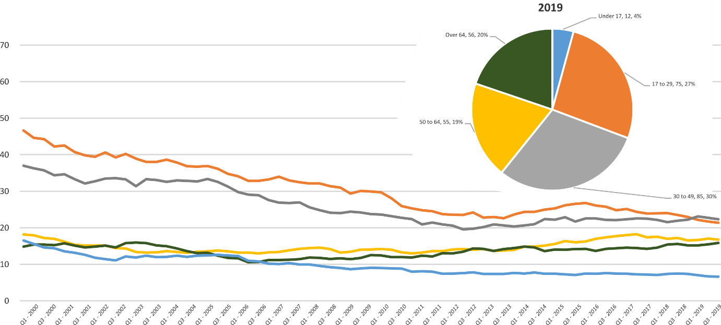

Serious Casualties by Quarter by Sex – 12 period moving average

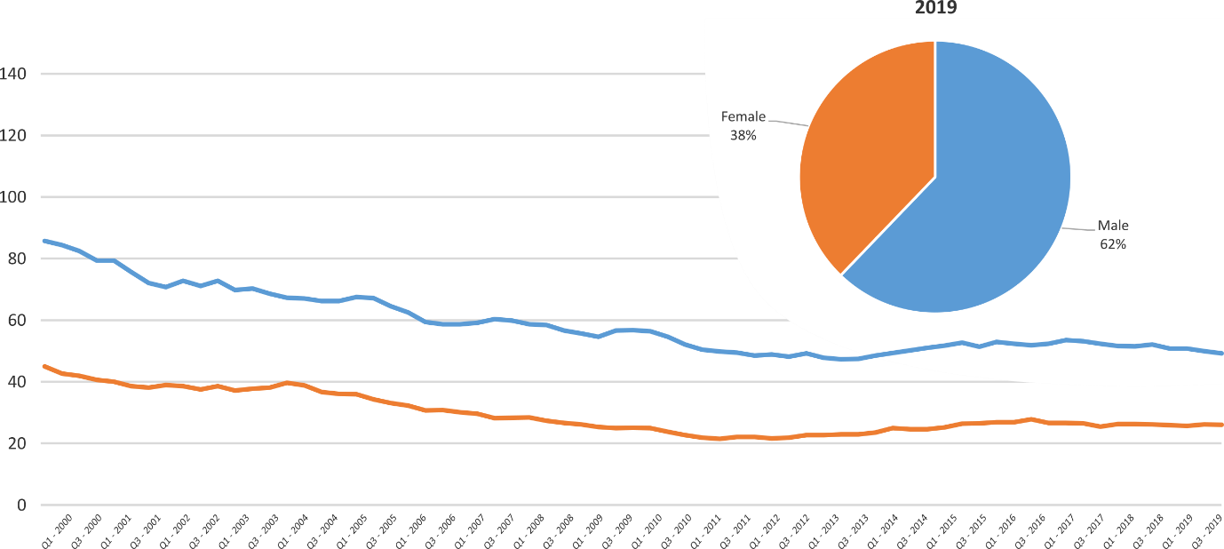

Serious Casualties by Quarter by Road User Type – 12 period moving average

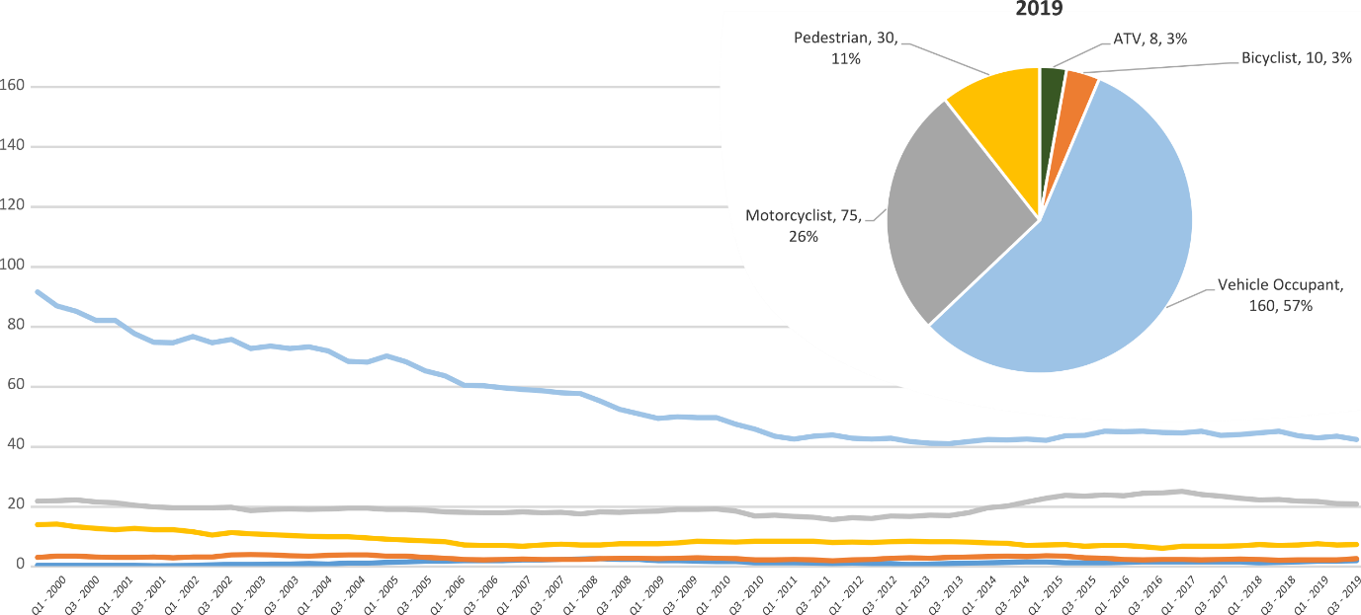

Serious Casualties by Quarter by Speed Zone – 12 period moving average

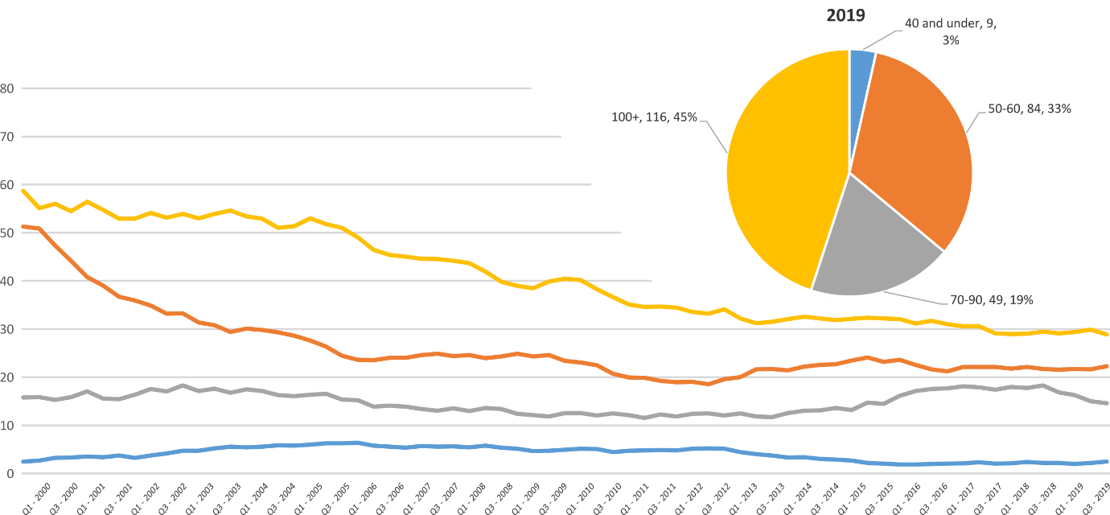

Pie chart excludes serious casualties where speed zone is recorded as ‘not known’

Serious Casualties by Quarter by Crash Type (DCA) – 12 period moving average
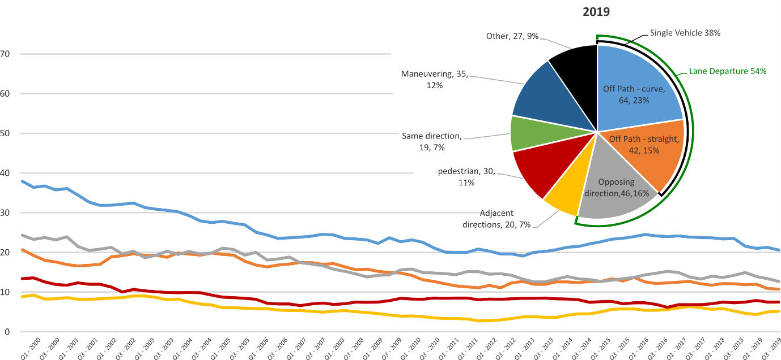

Other includes crash types: on-path (2%) & overtaking (2%).

Serious Casualties by Quarter by Urban/Non-Urban – 12 period moving average
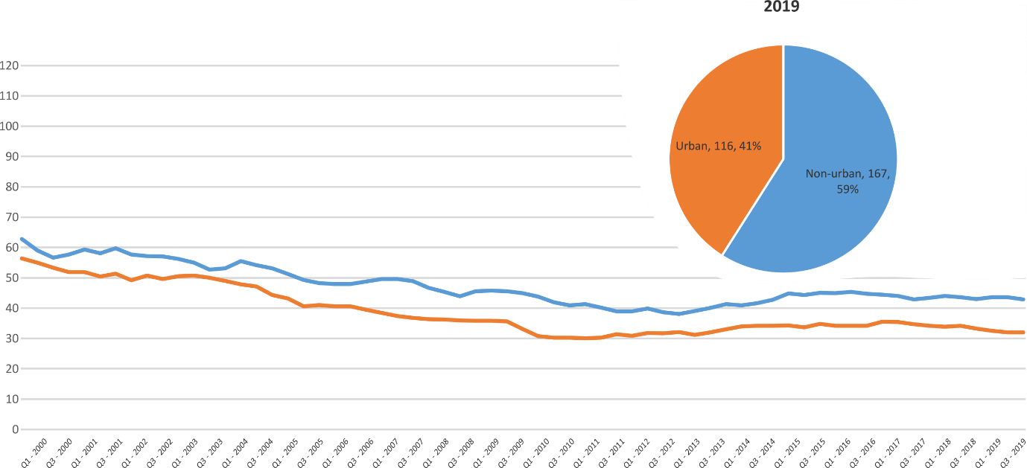
Based on the Australian Bureau of Statistics’ ‘significant urban area’ geographic definition.

Serious Casualty locations 2019 (Black = Fatality, Red = Serious Injury)
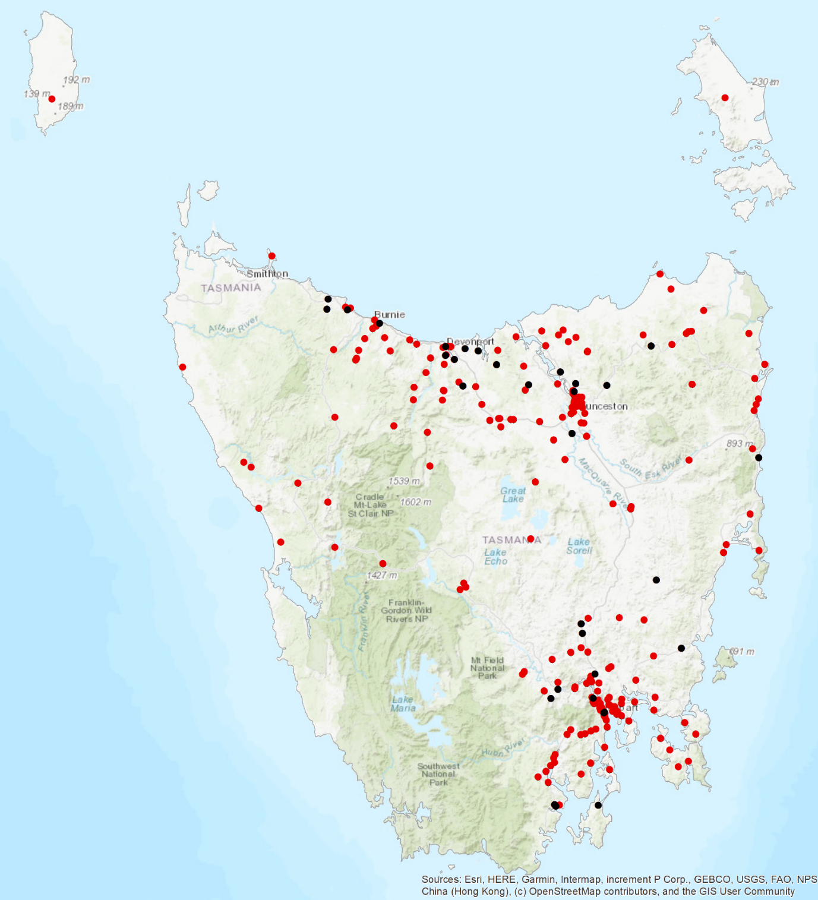

Priority Actions 2017-2019

Safe Road Users

- Improve the Graduated Licensing System to reduce serious casualties for young road users (17-25 year olds).
- Introduce safety initiatives to reduce motorcyclist serious casualties.
- Promote safer road user behaviour through education and enforcement.

Safe Roads and Roadsides
-
- Reduce run-off-road and head-on crashes through improved infrastructure.
- Reduce the severity of intersection crashes through improved infrastructure treatments.
- Embrace safe system thinking in road design.
- Reduce serious casualties through improved delineation such as line marking.

Safe Vehicles

- Improve the star rating of Tasmania’s vehicle fleet to include vehicles with better safety features.
- Increase the number of motorcycles with ABS.

Safe Speeds

- Introduce more appropriate speed limits to reduce serious casualties.
- Increase enforcement through technology to reduce speed related serious casualty crashes.

Progress on projects
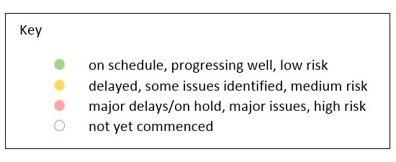
Action Plan 2017-2019
Safe Road Users
Project | Responsibility | Status |  |  | Milestones achieved | Milestones planned |  |  |  |  | Comments |  |  |  | Budget  Life of project  $ |  |  |  |  | YTD  2019/20  $
GLS Implementation  Following on from GLS Review | Road Safety, State Growth |  |  |  | On 5 May 2019 GLS changes were announced. Following this, a pre-awareness campaign commenced including a television commercial and billboards in public carparks – known as ‘strings’.  On 5 July 2019, the Request for Proposal (RFP) closed that sought a business to create a digital platform and public education campaign to support the changes to the GLS.  In October 2019 the Minister launched the ‘Quality Time’ pre-awareness campaign that encourages more on-road supervised driving experience for novice drivers. Printed collateral has been provided to stakeholders to support the campaign.  A Request for Quotation (RFQ) concluded in December 2019 that sought a Consultant to undertake an evaluation package of the GLS changes. TasCoss and YNOT were members of the Evaluation Committee. | The RFP process is expected to be finalised and a contract awarded the first quarter of 2020. There has been a delay in awarding the contract due to other priorities for the Department of State Growth.  Following this, extensive stakeholder engagement workshops will occur (internal and external) to develop the digital platform and associated public education campaign.  Meanwhile, the ‘Quality Time’ pre-awareness campaign will run until June 2020.  The GLS Project Team is progressing a Cabinet package on additional policy changes. The package is scheduled to go to Cabinet in late March 2020, and an announcement will be made in April 2020, contingent on approval.  No suitable quotations were received as part of the RFQ process. Advice is being provided to the S.C on the matter. |  |  |  |  | The Project Team is preparing for the next announcement and developing communication material for the additional policy changes to inform the public and key stakeholders.  The Project Team will also be heavily involved in stakeholder engagement and workshops for the development of the digital platform and public education campaign.  The Project Team will continue to work with the Minister’s Office to keep them informed on implementation progress. |  |  |  | 3 000 000 |  |  |  |  | 251 967
New motorcycle training and assessment program | Registration & Licensing, State Growth |  |  |  | The progressive roll out of the new Motorcycle and Assessment Program concluded 8 January 2018.  A transitional training program has now been implemented in all regions.  The Grant Deed established to fund the transitional arrangements and the financial support model following the financial sustainability review concluded in December 2019.  The new training film demonstrating the safety benefits of the new Program and the top 5 motorcycle crashes has been developed and released.  A communication strategy has been implemented to ensure all existing motorcycle learner licence holders affected by the transitional arrangements are notified. | Finalise the development of the auditing and compliance monitoring framework including the resourcing requirements, structure and governance.  Commence scoping the Longitudinal Study that will look to evaluate the new Program and any potential linkages to crash statistics in the future.  Implementation of the electronic results portal has been trialled and was released to the external provider for a progressive implementation from March 2019. The results portal interacts directly with the Motor Registry System to enable instant result reporting for licencing upgrades and provides real time confirmation of licensing eligibility. |  |  |  |  | Implementation Project complete.  Demand for the new motorcycle training and assessment program is significantly lower than the previous training regime. As at the end of December 2019 in the North and South demand was around 63%, however is significantly less in the North West at 38%, compared to previous years.  The Department is continuing to work with the external service provider to progress with complementary activities to promote future participation in the program. |  |  |  | 810 000 |  |  |  |  | 714 713  (Life of project)
Towards Zero Enforcement Project - Increased enforcement of high-risk behaviours | Tasmania Police |  |  |  | Continued to implement the Road Safety Strategy 2019-21  and Road Safety Project Plan.  Delivered In-Vehicle and In-Motion Speed Enforcement Demonstration (Sensys-Gatso Australia).  Report provided to Automated Speed Enforcement Project (ASEP). Consultants provided demonstration to road safety stakeholders.  Acusensus presented a summary of their Heads-Up demonstration to the ASEP Steering Committee. | Supporting the planning and implementation of Operation Crossroads – the Christmas period road safety plan.
Promote safe behaviours through media campaigns –  Mobile phones | EESC,  Road Safety, State Growth |  |  |  | Launched in conjunction with the Action Plan in December 2019. | Campaign to discourage mobile phone use while driving. |  |  |  |  | Funding approved by EESC. |  |  |  | MAIB funding  $100 000 (excluding media buy)
MAIP Implementation | Road Safety, State Growth |  |  |  | Drafting instructions delivered to OPC in October 2019.  Interim contracts have been sent to providers in October 2019. |  |  |  |  |  | Procurement action completed and Regulations have been finalised.  Revised implementation date is to be determined.  One approved provider has executed the contract while two remain outstanding. |  |  |  | State Growth funded (refer MAIP Transitional Arrangement Project) |  |  |  |  | 83 076
Tourist road safety campaign – Phase 2 (2017-2019) | Road Safety, State Growth |  |  |  | New look and feel has been developed and an update to has been delivered to material in market from November 2018.  New Z-card map produced as the result of feedback from stakeholders and tourists.  Animated outdoor electronic signs operational at Hobart and Launceston Airports. |  |  |  |  |  | Two new animated films in production to be run in Hobart Airport and through stakeholder networks.  New materials have been produced for ‘new to Tasmania’ audiences. The launch date for these materials is yet to be confirmed.  Ongoing engagement with stakeholders including Local Government, industry associations and community groups.  A strategic workshop on visiting motorcyclists is being planned. |  |  |  | 650 000 |  |  |  |  | 172 767
Community Road Safety Grants Program | Road Safety, State Growth |  |  |  | The 2019-20 CRSG Program attracted 23 applications.  The Funding Assessment Panel recommend 12 projects for funding, totalling $198 791.  Successful projects included the purchase of Variable Message Boards, child restraint checks and funding to improve the road safety component of the Driving For Jobs program. | Program improvements have been made for the application process and will be reviewed prior to the planning of the next CRSG round. |  |  |  |  | Next round will open 14 February 2020. |  |  |  | 200 000  p/a |  |  |  |  | 195 956
Learner Driver Mentor Program and Driver Mentoring Tasmania | Road Safety, State Growth |  |  |  | Sixteen organisations were successful for funding under the 2019-20 LDMP funding round totalling $756 424.  Driver Mentoring Tasmania has been allocated $145 120 for the 2019-20 Financial Year.  $100 000 has been allocated for the New Vehicle Replacement Program which will continue to ensure the LDMP fleet has a minimum 4-star ANCAP safety rating. | The Department continues to work with programs and the DMT coordinator to implement business improvements recommended in the 2017 evaluation report. |  |  |  |  | The next round, the 2020-21 LDMP funding round, will open on 28 February 2020. |  |  |  | 1 000 000  p/a |  |  |  |  | 1 087 915
RYDA program | Road Safety, State Growth |  |  |  | Funding of $100 000 has been provided to Rotary to deliver the RYDA program in 2019-20.  RYDA sessions for 2019 were held from 26 August to 6 September. | The Department of State Growth’s Community Road Safety team and Graduated Licensing System team attended RYDA. |  |  |  |  | Funding to be provided in June 2020. |  |  |  | 100 000 |  |  |  |  | 100 000
RACT and Bicycle Network | Road Safety, State Growth |  |  |  | The RACT and Bicycle Network have been provided with $100 000 and $90 000 per annum respectively to deliver a suite of road safety programs and cycling safety education in schools.  Half-yearly activity report from Bicycle Networks has been received. | Yearly activity report from RACT is expected in June 2020. |  |  |  |  | Funding to be provided June 2020. |  |  |  | 190 000 |  |  |  |  | 190 000
Safety around Schools | Road Safety, State Growth |  |  |  | The Love40 campaign was launched on Friday 1 February 2019 and is scheduled to run again at the beginning of each school term.  The iterations of the campaign will continue for three calendar years and planning for 2020 has begun. | The Campaign will again launch on 6 February 2020 for Term 1 of the school year. |  |  |  |  | The campaign encourages drivers to slow down in school zones and around school buses. |  |  |  | $300 000  2019 - 2021 |  |  |  |  | 8 997
Reduced speeds around emergency vehicles | Road Safety, State Growth |  |  |  | Key milestones achieved:  - a survey of emergency service personnel on the risks associated with working by roadsides has been completed  - the Minister approved an additional $100 000 from the Road Safety Levy to continue to promote the new rule/campaign, and to complete an evaluation in 2020. This brings the total budget to $250 000.  - the rule commenced on 1 December 2019 following the successful amendment of the Road Rules 2019.  - the Minister launched the new rule with the emergency services in Launceston;  - the education campaign commenced in September 2019 and will continue until April 2020. | Key remaining milestones:  - to commence the post-implementation evaluation, including both a campaign evaluation and road rule evaluation ($35,000 of new budget). |  |  |  |  | Stage One of the evaluation survey (2019) was funded through the Road Safety Levy, discretionary activities fund. Funding for Stage Two (2020) of the evaluation has been approved as part of the project budget. |  |  |  | $250 000 |  |  |  |  | 153 400
Safe Roads and Roadsides
Project | Responsibility | Status | Milestones achieved |  |  | Milestones planned |  |  | Comments |  |  |  |  | Budget  Life of project  $ |  |  | YTD  2018/19  $
Capacity Building Strategy and Action plan | Road Safety, State Growth |  | In March 2019, RSAC endorsed the funding request of $50 000 to engage a consultant to develop a capacity building strategy to support the Action Plan 2020-24.  In May 2019, a consultant was engaged to undertake the capacity review and develop an action plan.  From June to July 2019, a range of interviews with key influential road safety stakeholders were undertaken.  The consultant has delivered a capacity building review report and action plan in late 2019.  A presentation on the report and action plan was provided to RSAC at the November 2019 meeting. |  |  | The Road Safety Branch will now consider the recommendations of the capacity review and implementation to support the Action Plan 2020-2024. |  |  | The review will inform the work of the Road Safety Branch to build capacity to deliver on priorities identified in the Action Plan 2020-2024. This will include avenues to increase knowledge and technical skills in Tasmania. |  |  |  |  | 50 000 |  |  | Paid from Discretionary Activities Fund
Vulnerable Road User Program (VRUP) | Road Safety,  State Growth |  | On 4 March 2019 applications closed for the VRUP 2019-20 funding round.  20 applications were received with the VRUP Assessment Committee recommending 14 for funding equating to $523 360.  SOC approved successful applications in April.  Advice provided to the Minister on the outcome of the 2019-20 funding round with a supporting media release.  Following this, local councils were advised of result |  |  |  |  |  | A funding allocation for VRUP post 2019-20 has been considered as part of the redevelopment of the next Action Plan for 2020-24 with $ 1000 000 currently allocated per annum.  The Road Safety Branch continues to administer the program, which involves monitoring projects, providing support to council and disbursing funds for competed works.  A new financial structure will enable clear reporting of VRUP expenditure under the Action Plan 2020-24. |  |  |  |  | Allocation of $500 000 + residual of previous rounds for 2020-21 |  |  | N/A  Projects are paid on completion. Year to date figure is not accurate reflection of project value as payment occurs irregularly.
Infrastructure Risk Rating (IRR) Analysis | Road Safety,  State Growth |  | IRR analysis tool has been developed. The Road Safety Branch is procuring speed profile data to integrate into the IRR analysis tool. |  |  | Implementation of Speed profiles into risk analysis of the IRR analysis tool. |  |  | Speed profile data may also inform other initiatives other than just infrastructure treatments.  The procurement of speed profile data is currently delayed due to other procurement priorities of the Department of State Growth |  |  |  |  | 32 537  (residual from 80 000 project budget) |  |  |  | 0
2018-19 pavement marking maintenance program – local government | State Roads, State Growth |  | A significant proportion of the 2018-19 shoulder sealing program has been completed. A small amount of funding remains |  |  | Support local government to optimise the safety performance of road markings (such as through the use of long life, highly visible materials). |  |  | Moving forward under the Action Plan an amount has been allocated to both Low and High volume local pavement marking. |  |  |  |  | 770 000 |  |  |  | 123 384
2018-19 Shoulder sealing program | State Roads, State Growth |  | A small proportion of shoulder sealing projects has progressed.  The remainder of projects will continue to be implemented throughout 2019/20. |  |  | Program of shoulder sealing road safety infrastructure improvements to be undertaken.  Priority sections of key routes to be targeted.  Works expected to continue into 2019-20. |  |  | Funding endorsed by RSAC at August 2018 meeting.  Additional funding of $2 million endorsed by RSAC at its March 2019 meeting. Funding request subsequently approved by the Minister. |  |  |  |  | 9 million |  |  |  | 66 084
School Electronic Speed Limit Signs –replacement | State Roads, State Growth |  |  |  |  | Scope and specification of replacement program to be developed.  Phased replacement of existing signs. |  |  | As noted at the RSAC meeting of 20 August 2019 this project will be managed and funded by the State Roads Division of State Growth. The $100 000 previously endorsed by RSAC for preliminary scoping and design of the replacement program for school electronic speed limit signs is no longer required. |  |  |  |  | 0 |  |  |  | Paid from Discretionary Activities Fund
Safe Vehicles
Project | Responsibility | Status | Milestones achieved |  |  |  | Milestones planned |  |  |  |  | Comments |  |  | Budget  Life of project  $ |  |  |  |  |  | YTD
Government Business Enterprise (GBE) and State Owned Company (SOC) Fleet Review | Road Safety, State Growth |  | Project planning and scoping complete.  Initial desktop analysis of fleet structure complete. Policy options and recommendations drafted.  Engaged with GBE and SOC fleet managers in partnership with Treasury. |  |  |  | Analysis of findings of GBE/SOC fleet feedback.  Policy paper to be finalised. |  |  |  |  | Consideration will be given to this body of work in respect of priorities under the new Action Plan 2020-2024. |  |  | 0 |  |  |  |  |  | NA
Promote vehicle fleet safety standards for commercial fleets | Road Safety, State Growth |  | Road Safety Branch attended the LGAT Conference in July 2018 and promoted Government policy and vehicle safety to attendees.  Road Safety Branch supported the National Road Safety Partnership (NRSPP) to present on the vehicle as a workplace at the 2018 WorkSafe Conference. |  |  |  | Continued collaboration with NRSPP and investigation of opportunities to further promote vehicle fleet safety in the commercial sector. |  |  |  |  | Consideration will be given to this body of work in respect of priorities under the new Action Plan 2020-2024. |  |  | 0 |  |  |  |  |  | NA
ANCAP support | Road Safety, State Growth |  | An ANCAP kiosk has been provided to Motors Pty Ltd on a trial basis. The kiosk will house an I-pad with the ANCAP app installed and will be available for buyers to browse and inform their purchases. The kiosk has been co-branded between the RACT, Tasmanian Government and ANCAP. |  |  |  | The trial is active with next steps to be scoped out. |  |  |  |  | $12 000 per annum provides for a membership subscription to ANCAP for each financial year.  The Department of State Growth is a member alongside other jurisdictions and automotive associations as well as members in New Zealand. |  |  | 12 000 p/a |  |  |  |  |  | 12 254
MOTOCAP | Road Safety,  State Growth |  | The MOTOCAP website launched in September 2018. The Chair of RSAC released a media statement supporting and promoting the website.  A Road Safety Branch representative attended the March 2019 meeting at Deakin University crash test lab in Geelong, VIC.  A demonstration was given of the crash test equipment. Discussion was also had on stakeholder engagement and how to promote the website further.  The website has been updated with additional safety ratings for motorcycle clothing published. |  |  |  | The current contract between State Growth and MOTOCAP expires on 30 June 2020. The next 12 month fee is $8 200.  The Road Safety Branch will continue to actively participate in the group and execute another agreement in the coming months.  MOTOCAP will soon be looking to engage a company to develop a stakeholder and engagement plan. |  |  |  |  | MOTOCAP aims to test 10 per cent of the motorcycle protective clothing market and star rate them on protection and comfort.  Deakin University is the current contractor testing and rating the clothing. |  |  | 8 200 |  |  |  |  |  | 8 200
Safe Speeds
Project | Responsibility | Status |  | Milestones achieved |  |  |  | Milestones planned |  |  |  |  | Comments |  |  | Budget  Life of project  $ |  |  |  |  |  | YTD  $
Development of speed limit setting guidelines | Road Safety, State Growth
Assessment of speed limits on 100km/h roads | Road Safety, State Roads, State Growth
Towards Zero Enforcement Project - Review of point to point (P2P) speed cameras on high risk rural roads | Tasmania Police |  |  | Mobile P2P demonstration complete. Awaiting final report. |  |  |  | Provide report to Automated Speed Enforcement Project (ASEP).  Service provider (Tess) to present to next meeting of ASEP S.C. |  |  |  |  | Project closed. |  |  | 132 000  To review 5 projects |  |  |  |  |  | 32 500
Automated Speed Enforcement Project | Road Safety, State Growth / Tasmania Police |  |  | Consultants (Centre for Automotive Safety Research, CASR) delivered final report on 31 January 2020.  Preliminary business case has been drafted internally. |  |  |  | Steering Committee to consider final report and business case recommendations at next meeting (date TBC). |  |  |  |  |  |  |  | Funded by Road Safety Branch
Reducing Urban Arterial Speed Limits in Tasmania from 60km/h to 50km/h. | Road Safety State Growth |  |  | Project planning and scoping completed. |  |  |  |  |  |  |  |  | Remaining roads are low volume (aside from urban arterials) and may have less community support.  Road safety benefit not immediate, but would be long term.  On hold as not a priority project, but will be progressed as a demonstration of appropriate speeds. |  |  | TBC
Speed Moderation Strategy | Road Safety, State Growth

Other
Project | Responsibility | Status | Milestones achieved | Milestones planned | Comments | Budget  Life of project  $ | YTD  $
RSAC and Towards Zero Strategy support | Road Safety, State Growth |  | Funding for Manager RSAC Secretariat, Chair and Expert sitting fees and operation of RSAC.  Funding to support development and implementation of Strategy and supporting Action Plans. |  |  | Up to 400 000  p/a | 102 256
MAIP Transitional arrangements | Registration & Licensing, State Growth |  | Support for fee waiver. |  |  | 3 300 000 | 2 403 164  Fee Waiver  2 486 241  (Life of project)
Discretionary Activities Fund | Road Safety, State Growth |  | - Activities include:  - Commissioner for Children and Young People event engagement  - Development of the Action Plan 2020-24  - Emergency Vehicles Survey Research  - Grant Delivery Support  - School Speed Signage Trial  - Variable Message Sign (supporting fees) for Local Government  - Cycling and Walking Australia and New Zealand Contribution  - Love 40 Campaign Support  - Safe System Training and Capacity Building Strategic Development  - Support to the Railton Bike Show 2020 |  |  | 250 000 | 113 190

Funding

Road Safety Levy Overview
As at 31 December 2019
2019/20 Financial Year
Opening balance as at 1 July 2019 |  | $19 628 925
Revenue 2019/20 | Forecast (ytd) | Actual (ytd)
Road safety levy collected | $7 000 438 | $7 729 883
Funds available for distribution | $4 000 438 | $5 129 883
Total funds available for distribution | $24 029 363 | $24 758 808
Expenditure |  | Actual (ytd)
Roads and Roadsides |  | $602 958
Policy and Projects |  | $2 611 344
Total Expenditure |  | $3 214 302
Balance | Forecast | Actual as of 31 December 2019
Closing balance | $16 880 561 | $21 544 506
Funding of Expenditure (2019/20)
Remaining allocated funding
Safe Roads and Roadsides | $12 434 280
Policy and Projects | $5 035 679
Total remaining allocated funding | $17 469 959
Remaining unallocated funding
Safe Roads and Roadsides | $0
Policy and Projects | $0
Total remaining unallocated funding | $0

MAIB Funding
As at 31 December 2019
2019/20 Financial Year | Budget  $ | Actual (ytd)  $ | Balance  $
Expenditure (State Growth)
Administration & Public Relations | 348 360 | 145 309 | 203 051
Public Education | 1 030 387 | 540 179 | 490 208
Research | 143 735 | 35 095 | 108 640
Subtotal | 1 522 482 | 720 583 | 801 899
Expenditure (Tasmania Police)
Salaries | 1 942 700 | 1 032 820 | 909 880
Operating Expenses | 182 000 | 171 063 | 10 937
Equipment | 394 000 | 327 135 | 66 865
Subtotal | 2 518 700 | 1 531 018 | 987 682
Total | 4 041 182 | 2 251 601 | 1 789 581
Includes Carried Forward of
$196 853 (State Growth)
$-54 306 (Police)

