Fewer than 200 serious injuries and deaths on our roads by 2026

Towards Zero Tasmanian Road Safety Strategy 2017–2026

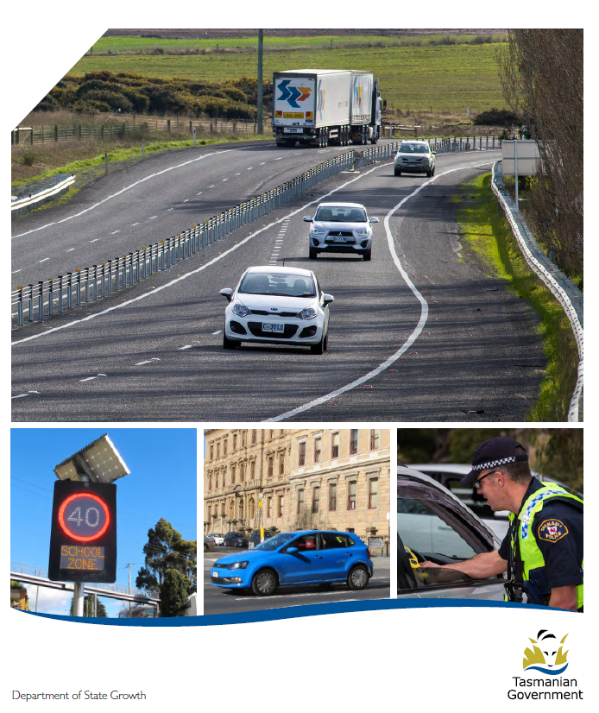

Quarterly Progress Report to RSAC
as at 31 December 2018

Progress on meeting Towards Zero Strategy targets
The key interim target for the Towards Zero – Tasmanian Road Safety Strategy 2017-2026 (Towards Zero Strategy) is to reduce the number of annual serious injuries and deaths on Tasmanian roads to fewer than 200 by 2026. This is an ambitious target of 100 fewer serious casualties per year than for the period 2012-2016 (annual average) and will move us towards the long-term goal of zero serious casualties on Tasmanian roads.
Serious Casualties
The number of serious casualties in 2018 was 311, compared to 303 in 2017, a 2.6 per cent increase. The 2018 figure of 311 is a 0.8 per cent increase on the five year serious casualty average of 308.6 (2013-2017).
Fatalities
In 2018, there were 33 fatalities on Tasmanian roads which is one fewer than the number recorded in 2017. The figure of 33 fatalities in 2018 is a 3.5 per cent decrease on the five year fatalities average of 34.2 (2013-2017).

Serious Casualties Tasmania – Annual Count, Percentage Split by Quarter and Towards Zero Target

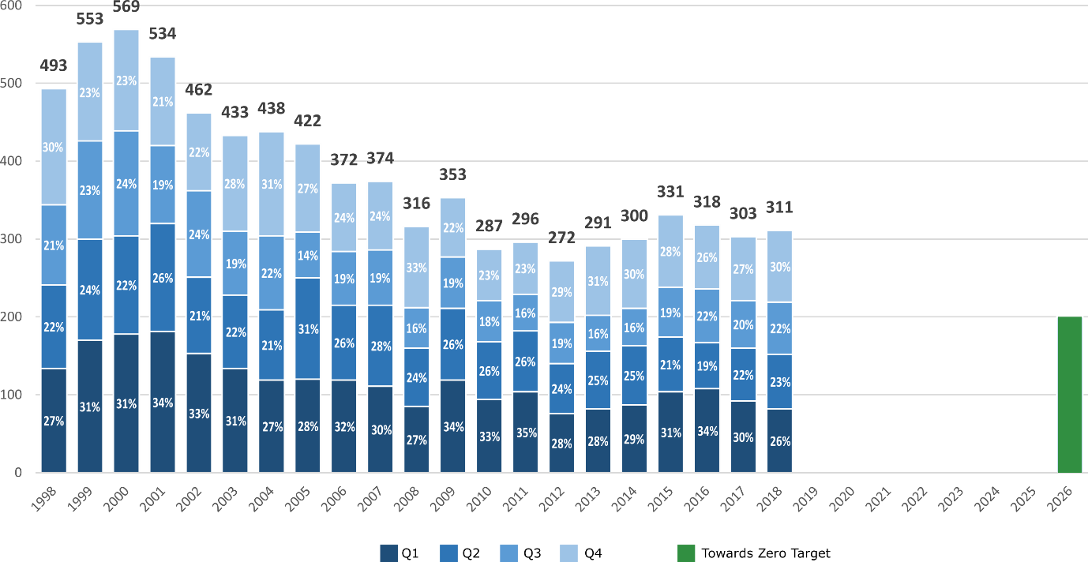

Annual fatalities – Rate per 100,000 population
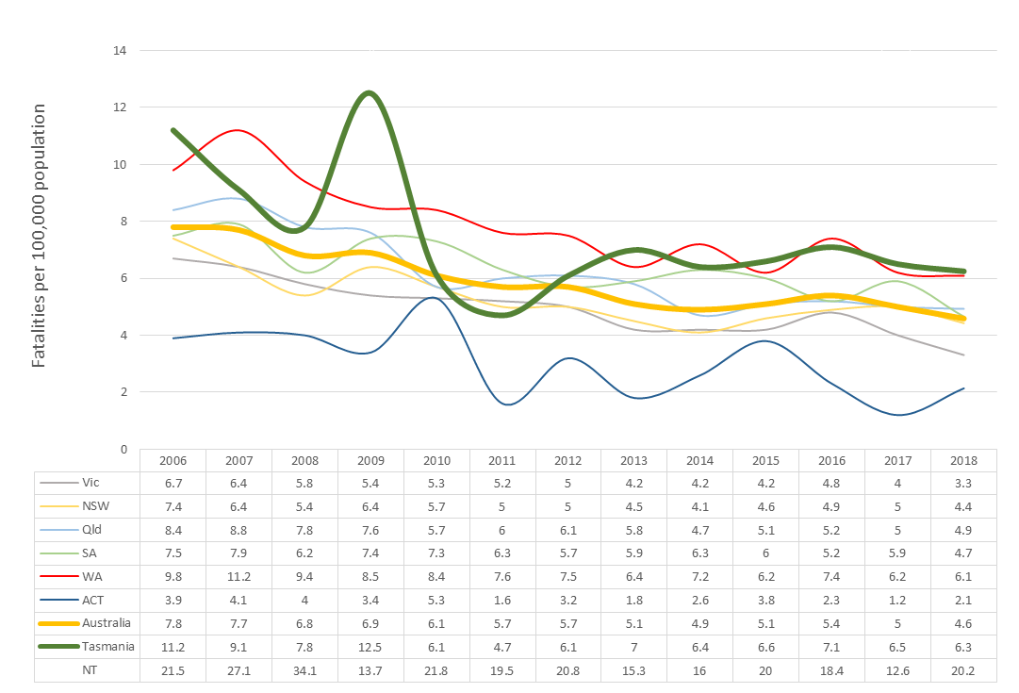
Note: NT omitted from chart for clarity purposes.

Progress on meeting MAIB targets

Motor Accidents Insurance Board (MAIB) injury statistics show the number of fatalities and the level of claims for serious injuries on our roads.
Various claim reduction targets are specified in the Memorandum of Understanding between the Department of State Growth (State Growth) and the MAIB. Progress against high level targets is shown below, expressed as 12 month moving totals.

Fatalities – 12 Month Rolling Total
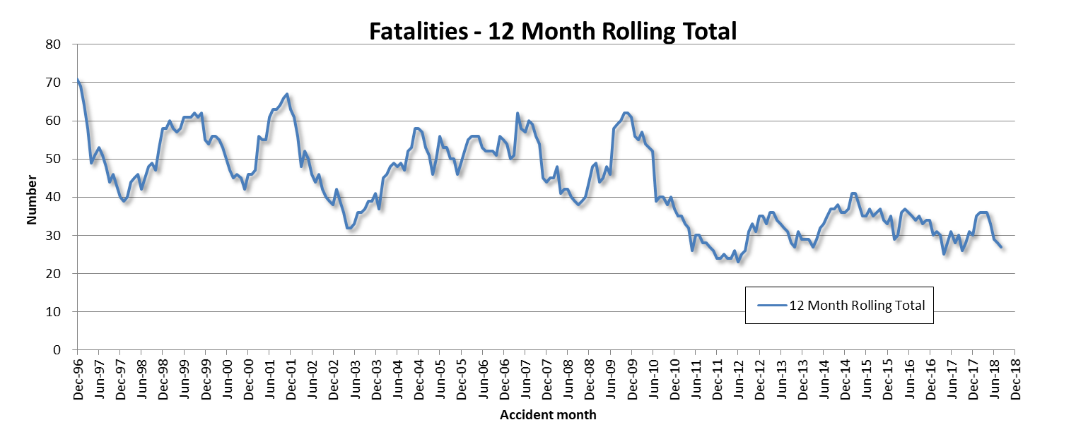

Total Serious Claims – 12 Month Rolling Total
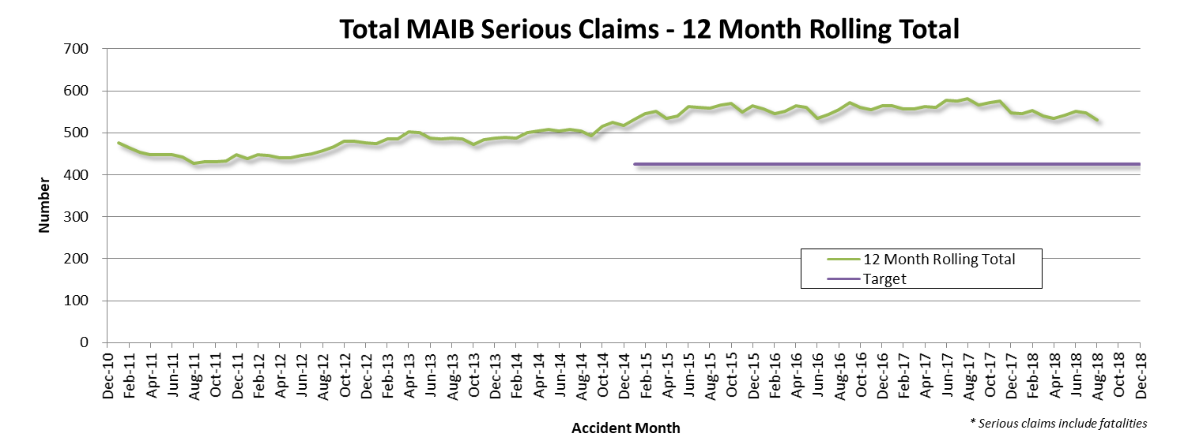

Statistics
Serious Casualties by Quarter by Age Group – 12 period moving average

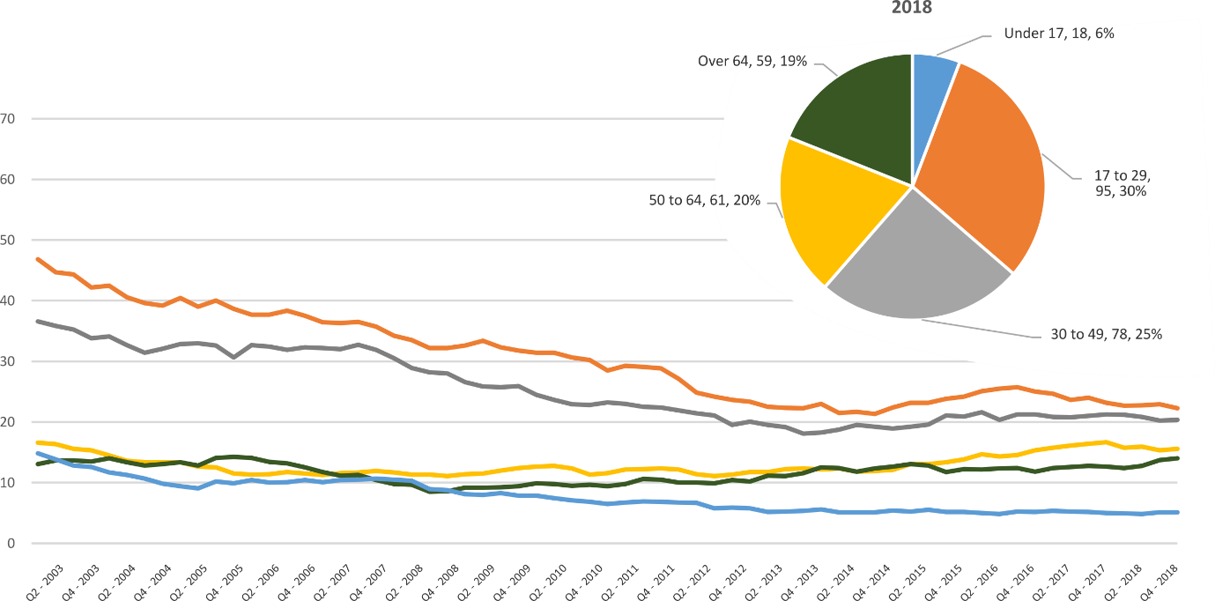

Serious Casualties by Quarter by Gender – 12 period moving average

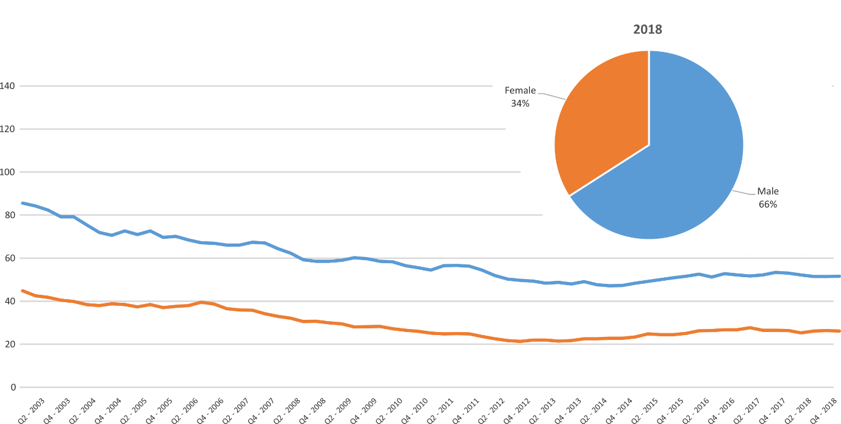

Serious Casualties by Quarter by Road User Type – 12 period moving average

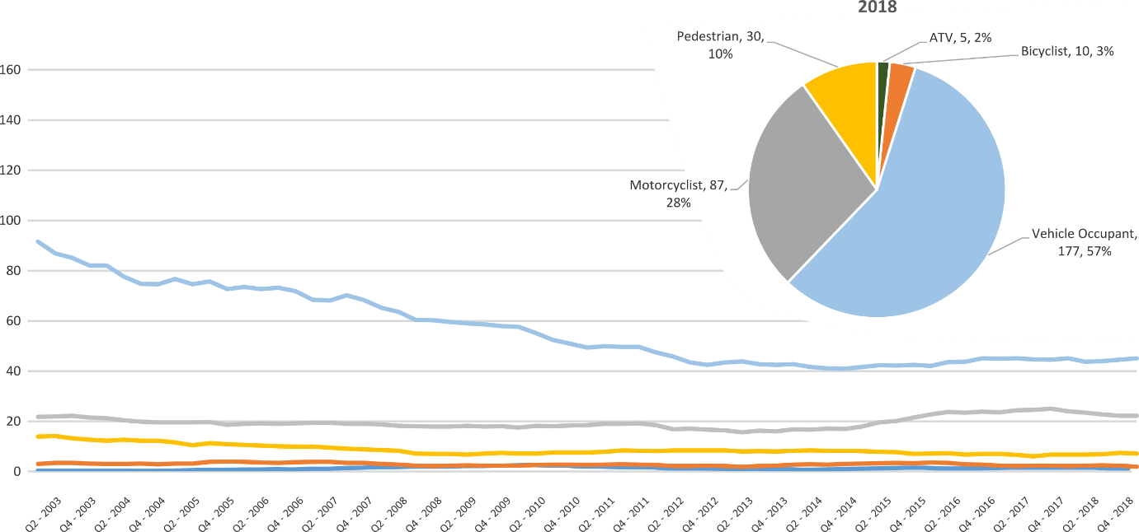

Serious Casualties by Quarter by Speed Zone – 12 period moving average

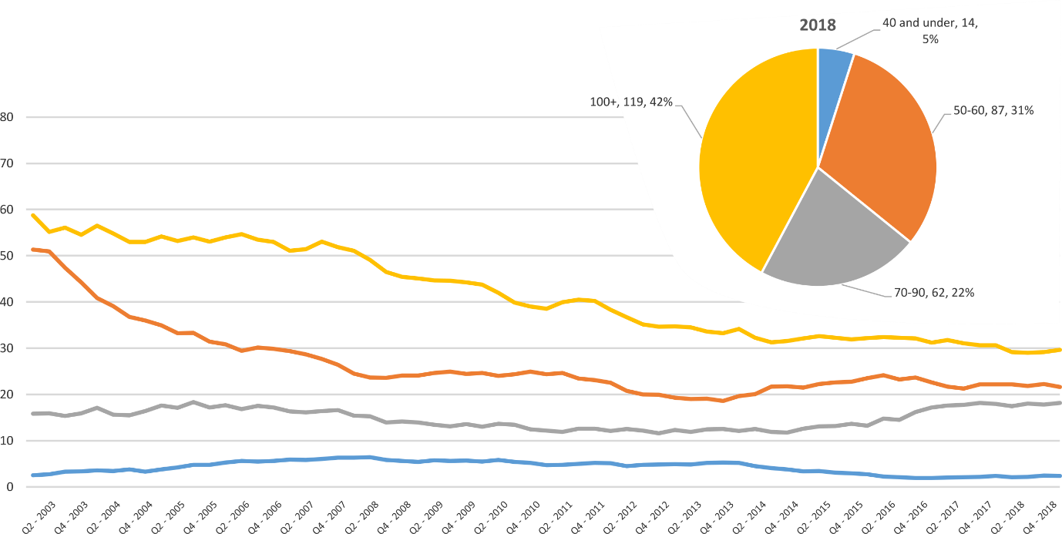
Pie chart excludes serious casualties where speed zone is recorded as ‘not known’

Serious Casualties by Quarter by Crash Type (DCA) – 12 period moving average

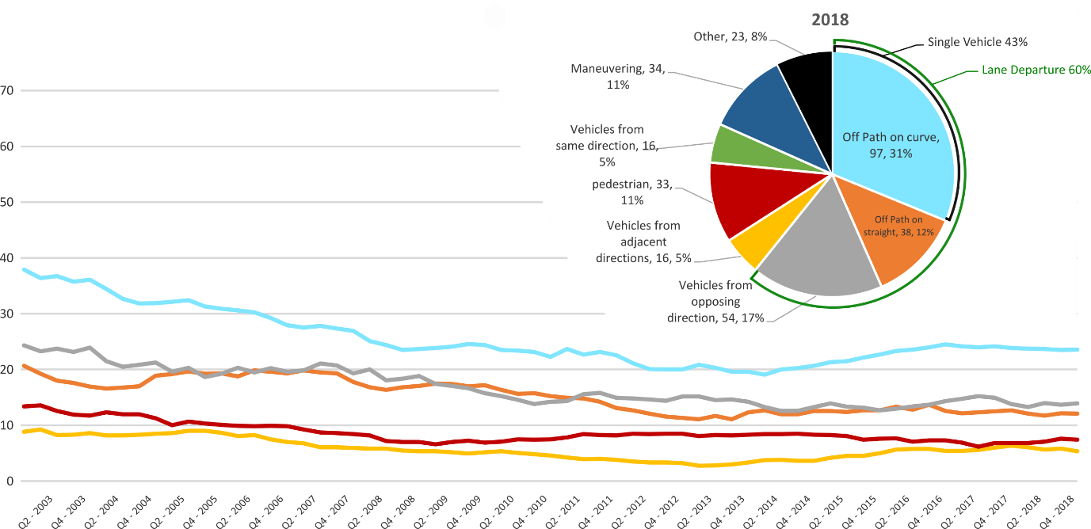
Other includes crash types: on-path (2%), overtaking (6%), passenger & miscellaneous (2%)

Serious Casualties by Quarter by Urban/Non-Urban – 12 period moving average

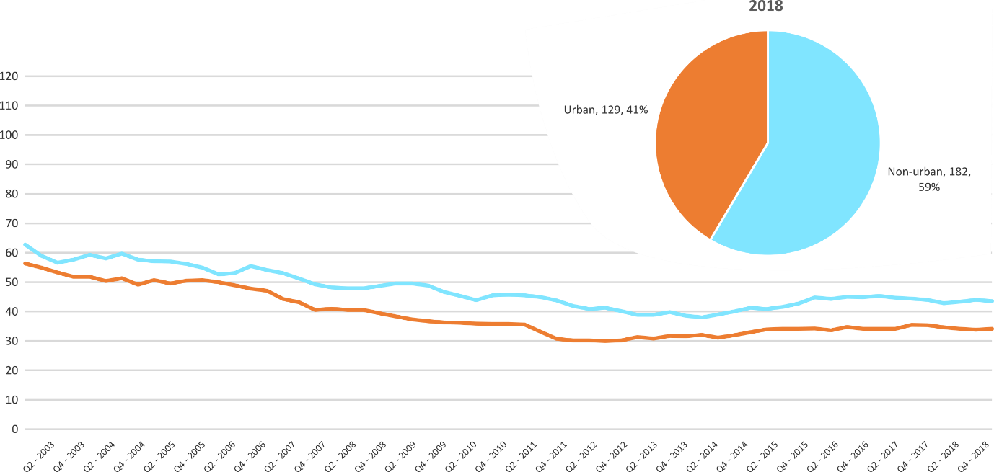
Based on the Australian Bureau of Statistics’ ‘significant urban area’ geographic definition.

Serious Casualty locations 2018 (Black = Fatality, Red = Serious Injury)
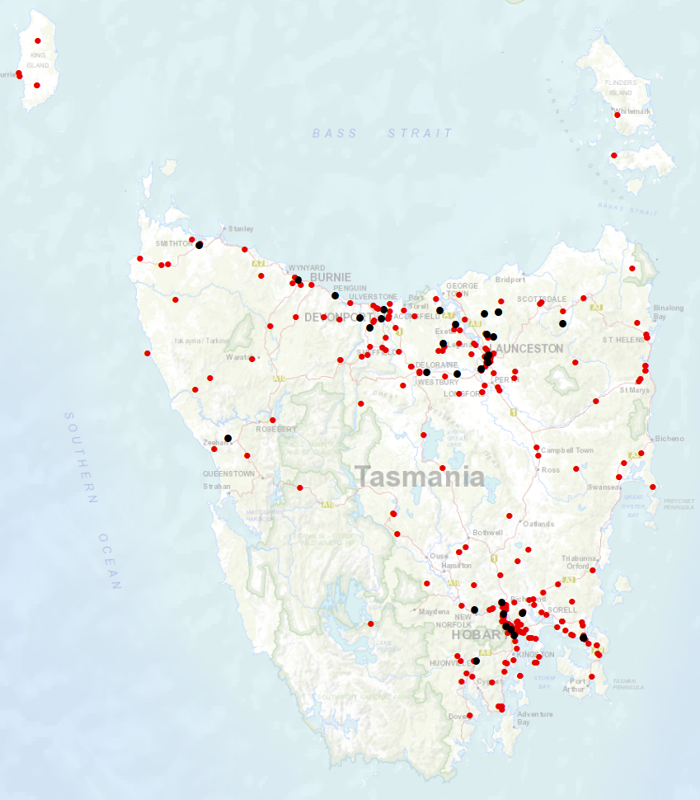

Priority Actions 2017-2019

Safe Road Users

- Improve the Graduated Licensing System to reduce serious casualties for young road users (17-25 year olds).
- Introduce safety initiatives to reduce motorcyclist serious casualties.
- Promote safer road user behaviour through education and enforcement.

Safe Roads and Roadsides

- Reduce run-off-road and head-on crashes through improved infrastructure.
- Reduce the severity of intersection crashes through improved infrastructure treatments.
- Embrace safe system thinking in road design.
- Reduce serious casualties through improved delineation such as line marking.

Safe Vehicles

- Improve the star rating of Tasmania’s vehicle fleet to include vehicles with better safety features.
- Increase the number of motorcycles with ABS.

Safe Speeds

- Introduce more appropriate speed limits to reduce serious casualties.
- Increase enforcement through technology to reduce speed related serious casualty crashes.

Progress on projects
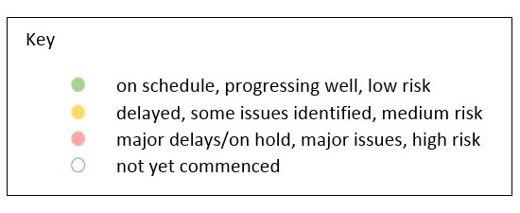
Action Plan 2017-2019
Safe Road Users
Project | Responsibility | Status | Milestones achieved | Milestones planned |  | Comments | Budget  Life of project  $ | YTD  2018/19  $
GLS Implementation  Following on from GLS Review | Road Safety, State Growth |  | Progressing and finalising papers as part of the Process Review.  Request for Proposal (RFP) with Crown Law for review.  Policy changes paper finalised. RSAC endorsement policy changes and peer passenger restrictions.  Consulted with Minister’s office on proposed approach and announcement timeline.  Consultation occurred with YNOT, Service Tasmania, TasCOSS and internal government departments on the policy changes. | Package to be provided to Minister in February 2019 on the policy changes and Cabinet Briefing.  Supporting communication documents to be developed with this package. |  | Implementation and change management will be a major factor in achieving successful outputs and outcomes for the Project.  The Project Team will be starting work on these milestones ahead of schedule to allow for adequate consideration of how policy implementation will be managed.  The Process Review will conclude in January 2019. This aligns with bringing an agency on board in early 2019, and the Government announcement of the new GLS in the first quarter of 2019 (January to March 2019). | 3,000,000 | 39,985  November 2018

New motorcycle training and assessment program | Registration & Licensing, State Growth |  | The progressive roll out of the new Motorcycle and Assessment Program has concluded with the commencement of the Program in the North on 8 January 2018.  A transitional training program has been implemented in all regions.  The new training film demonstrating the safety benefits of the new Program and the top 5 motorcycle crashes has been developed and released.  A communication strategy has been implemented to ensure all existing motorcycle learner licence holders affected by the transitional arrangements are notified. | Finalise the development of the auditing and compliance monitoring framework including the resourcing requirements, structure and governance.  Commence scoping the Longitudinal Study that will look to evaluate the new Program and any potential linkages to crash statistics in the future.  Implementation of the electronic results portal has been trialled and will be implemented by March 2019. The results portal interfaces directly with the Motor Registry System to enable instant result reporting for licencing upgrades and provides real time confirmation of licensing eligibility. | Implementation Project complete.  The Grant Deed established to fund the transitional arrangements is ongoing until end 2019.  Demand for the new motorcycle training and assessment program is significantly lower than the previous training regime. As at the end of December 2018, the average figures state-wide were around 60% compared to previous years, and are slightly improving in the South and North.  An independent financial advisor has been contracted to undertake a comprehensive financial audit to assist the Department to develop a sustainable delivery model. Outcomes of this review are expected in early 2019. | 810,000 | 714,060  (Life of project)

Towards Zero Enforcement Project - Introduce rear-facing automated speed cameras |  | Tasmania Police |  | A cost estimate to reconfigure the existing forward facing speed cameras to rear-facing was complete.  The estimated cost is approximately $50,000 per two sites (with two sites being the minimum per trip).  TasPol is currently drafting a Speed Enforcement Strategy (SES) that will guide future investment in speed enforcement technologies – it may be that fixed cameras are phased out in favour of mobile technologies. | A decision needs to be made in-line with the three following options:  - Maintain the status quo for the foreseeable future,  - Invest and reconfigure, or  - Phase out fixed speed camera detection. | A decision regarding the future use of fixed speed cameras will not be made until the Speed Enforcement Strategy delivered in 2019. | 132,000  To review 5 projects | 0
Towards Zero Enforcement Project - Increased motorcycle-focused enforcement | Tasmania Police |  |  | Draft Motorcycle Enforcement & Engagement Strategy developed. | Nil | 12 month Strategy
Towards Zero Enforcement Project - Increased enforcement of high-risk behaviours | Tasmania Police |  |  | Unmarked motorcycle trial commenced December 2018.  1 x Triumph Tiger 800 and 2 riders.  Southern police district only. | 2 x Interim Performance Reviews  2 x Review of Risk Register | Trial is exceeding expectations. Anecdotal evidence of change in CBD driver behaviour since commencement.  A decision to expand the trial will be made mid-march 2019. Expansion (if approved) will see two more bikes purchased – providing one per district with the bikes rotated between districts.
 |  |  |  | Commenced planning to optimise the use of Automated Number Plate Recognition (ANPR) technology to detect and link number plates with drivers that have previously tested positive for drugs.  Watch-lists based on positive Breath Alcohol Concentration (BAC) detections can be readily generated. In contrast, positive Oral Fluid Test (OFT) watch-lists have to be manually created.  A plan to address gaps will be identified and implemented. | Nil | Project parked due to workload.
Promote safe behaviours through media campaigns | EESC,  Road Safety, State Growth |  |  |  | Update of I’ve Been Everywhere campaign used in holiday periods. New content focus on speeding motorists and motorcyclists. | Funding approved by RSAC in May 2017. | Road Safety Levy funding  $100,000 (excluding media buy)
 | EESC,  Road Safety, State Growth |  |  |  | Campaign to discourage mobile phone use while driving. | Funding approved by EESC. | MAIB funding  $100,000 (excluding media buy)
 | EESC,  Road Safety, State Growth |  |  |  | A new anti-drink-driving Real Mates campaign targeted at men aged between 17 and 25. | Funding approved by EESC. | MAIB funding  $80,000 (excluding media buy)
MAIP Implementation | Road Safety, State Growth |  |  |  | Commence implementation of recommendations. | Working on interim provider contracts.  Obtaining endorsement of policy decisions prior to creating drafting instructions.  Collecting data for financial forecasting. | State Growth funded | 26,846
Distance makes the Difference campaign Stage 2 | Road Safety, State Growth |  |  |  |  | Phase 2 continues to be well received. Outdoor billboards were installed on the Bass Highway at Latrobe and Somerset in early October. A State wide TV advertising campaign also started in early October. All activity is scheduled to conclude in March 2019. | 400,000 | 374,357  (Life of project)
Tourist road safety campaign – Phase 2 (2017-2019) |  | Road Safety, State Growth |  | Visiting drivers’ website launched December 2017. 6 x 15 second films running in Hobart Airport and other key locations. Collateral continues to be distributed. Extending messaging through stakeholder networks. Seasonal worker campaign launched in December 2017.  Workshops with rental car companies took place in May and June 2018. | . | New material has been developed with input from stakeholders for:  - Visiting drivers  - New Tasmanians  - Visiting motorcyclists  The new material includes LED and static signs, two videos and a range of printed collateral.  Distribution and channels continue to grow with the support of stakeholders. | 650,000 | 249,099
Community Road Safety Grants Program |  | Road Safety, State Growth |  | A further $200 000 per annum over three years has been approved to continue the Community Road Safety Grants program (2019-2021). | The next funding round for Community Road Safety Grants will open 1 February and close 22 March 2019. | Following a review of the Community Road Safety Grants program, recommendations for program improvements are currently being implemented. | 200,000  p/a | 134,929
Learner Driver Mentor Program and Driver Mentoring Tasmania |  | Road Safety, State Growth |  | Funding of $1million per annum for the next four years has been approved. This sum includes annual program costs and the implementation of business improvements recommended in the 2017 evaluation report. | The next funding round for LDMPs general program expenses will open 1 March and close 29 March 2019. | The Department continues to work with programs and the DMT coordinator to implement business improvements recommended in the 2017 evaluation report. | 500,000  p/a  702,000 approved for 2017/18. | 988,305
RYDA program |  | Road Safety, State Growth |  | Funding of $75 000 has been provided to Rotary to deliver the RYDA program in 2018-19. A request for a further $25000 per annum has been approved by the Minister to implement program improvements and support a raise in operational costs. | An evaluation of program performance is due in June 2019. Funding will again be provided for the 2019-20 financial year. | A meeting is scheduled for February 2019 to discuss strategic program improvements and develop of an implementation strategy. | 100,000 | 75,000
RACT and Bicycle Network |  | Road Safety, State Growth |  | The RACT and Bicycle Network have been provided with $100 000 and $90 000 per annum respectively to deliver a suite of road safety programs and for cycling safety in schools. | An evaluation of program performance is due in June 2019. Funding will again be provided for the 2019-20 financial year. | A meeting is scheduled for February 2019 to discuss the development of an evaluation strategy. | 190,000 | 90,000
Safety around Schools |  | Road Safety, State Growth |  | On 21 August 2018 RSAC endorsed $300 000 from the Road Safety Levy to develop and implement a Safety around Schools project, following a request from the Minister to review the Back to School campaign.  A Safety around Schools campaign concept has been developed and approved upon internally. | Over the next quarter the campaign will be produced and key stakeholders (including the Department of Education and Tasmania Police) will be consulted on distribution.  The campaign will commence prior to Term 1 2019. | The campaign will have a dual focus over three years: encouraging drivers to slow down in school zones and around school buses, and targeting students to be road safe.  Iterations of the campaign will continue for three calendar years. | $300 000 p.a.  2019 - 2021 | 70,164
Reduced speeds around emergency vehicles |  | Road Safety, State Growth |  | Minister has approved $150,000 for the community education campaign for the new rule.  Drafting instructions have been prepared and sent to OPC (included in the remake of the Road Rules 2009).  Consultation with key stakeholders has commenced.  Communication plan and creative brief have been prepared - creative agency has been engaged.  Evaluation framework has been drafted. | Engagement of expertise to support evaluation (February 2019).  Continued engagement with key stakeholders to participate in and contribute to evaluation and education campaign (February/March 2019).  Key remaining milestones:  - preparation of Cabinet and ExCo material for approval of new road rule  - development and implementation of education campaign  - commence evaluation - collection of data pre-implementation of new rule. |  | $150,000 | -

Safe Roads and Roadsides
Project | Responsibility |  | Status |  | Milestones achieved |  | Milestones planned |  |  | Comments |  |  | Budget  Life of project  $ |  |  | YTD  2018/19  $
Building Road Safety Knowledge in Tasmania –  Safe system thinking in road design | Road Safety, State Growth |  |  |  | Two Safe System Solution training courses were held in Hobart in September 2018:  - 1 X Safe System Approach to Road Safety  - 1 X Safe System Technical Training  Trainings targeted state government, local government and councils and were well attended.  Review of training conducted from 2016 to 2018 completed.  Paper provided to RSAC at November 2018 meeting on the training completed to date. |  | March 2019 RSAC paper prepared requesting funding to support continued capacity building in this space.  Following RSAC’s endorsement, the Road Safety Branch will contract a supplier to plan, develop and deliver a five year plan for Safe System capacity building across the State throughout 2019. |  |  | $50 000 will be sought to support capacity building under Action Plan 2020-24. |  |  | 50, 000 |  |  | 28,526
Pedestrian safety package – Stage 2 | EESC  State Growth |  |  |  |  |  |  |  |  | RSAC has referred consideration of education about pedestrian distraction from mobile phones to the EESC. |  |  | 430,000  (additional 35,000 is available from stage 1 residual) |  |  | 0
Vulnerable Road User Program (VRUP) | Road Safety,  State Growth |  |  |  | The 2018-19 sixth round of VRUP concluded with 16 projects awarded funding.  Advice was provided to local councils on this matter in November 2018.  In December 2018, the Minister approved the funding allocation for 2019-20 VRUP round of $500 000. |  | 2019-20 VRUP round will open in February 2019. Applications close in March 2019.  VRUP grant management system being utilised (SmartyGrants) for 2019-20 round.  The VRUP Guidelines and supporting resources have been revised to consolidate information and clarify the application process for applicants. |  |  | The future funding allocation for VRUP will be considered as part of the redevelopment of the next iteration of the Action Plan. |  |  | 500 000 |  |  | NA  Projects are paid on completion. Year to date figure is not accurate reflection of project value as payment occurs irregularly.
Infrastructure Risk Rating (IRR) Analysis | Road Safety,  State Growth |  |  |  | Development of IRR analysis tool underway. |  | Receipt of IRR analysis tool (~early 2019). |  |  | Funding endorsed by RSAC at August 2018 meeting. Funding subsequently approved by Minister. |  |  | 80 000 |  |  | 14,100
2018-19 pavement marking maintenance program – local government | State Roads, State Growth |  |  |  |  |  | Support local government to optimise the safety performance of road markings (such as through the use of long life, highly visible materials). |  |  | Funding endorsed by RSAC at August 2018 meeting. Additional funding subsequently approved by Minister. Includes up to $90 000 for school crossing pavement marking. |  |  | 770 000 |  |  | 0
2018-19 Shoulder sealing program | State Roads, State Growth |  |  |  |  |  | Program of shoulder sealing road safety infrastructure improvements to be undertaken.  Priority sections of key routes to be targeted.  Works expected to continue into 2019-20. |  |  | Funding endorsed by RSAC at August 2018 meeting. Funding subsequently approved by Minister. |  |  | 7 million |  |  | 0
Safe Vehicles
Project | Responsibility |  | Status |  | Milestones achieved |  |  | Milestones planned |  |  | Comments |  |  | Budget  Life of project  $ |  |  | YTD
Government Vehicle Fleet Safety Policy Review (Stage 2)  Government Business Enterprise (GBE) and State Owned Company (SOC) Fleet Review | Road Safety, State Growth |  |  |  | Project planning and scoping complete.  Initial desktop analysis of fleet structure complete. Policy options and recommendations drafted.  Engaged with Department of Treasury and Finance (Treasury)  Ministerial approved advising of formal engagement with GBE and SOCs via Treasury.  Engaged with GBE and SOC fleet managers in partnership with Treasury. |  |  | Analysis of findings of GBE/SOC fleet feedback.  Policy paper to be finalised. |  |  |  |  |  | 0 |  |  | NA
Government Vehicle Fleet Safety Policy Review (Stage 3)  Promote vehicle fleet safety standards for commercial fleets | Road Safety, State Growth |  |  |  | Road Safety Branch attended the LGAT Conference in July and promoted Government policy and vehicle safety to attendees.  Road Safety Branch has supported the National Road Safety Partnership (NRSPP) to present on the vehicle as a workplace at the 2018 WorkSafe Conference. |  |  | Continued collaboration with NRSPP and investigation of opportunities to further promote vehicle fleet safety in the commercial sector. |  |  | The outcomes of Stage 2 will also inform the approach to Stage 3 of the project and further engagement with commercial fleets. |  |  | 0 |  |  | NA
ANCAP support | Road Safety, State Growth |  |  |  |  |  |  |  |  |  |  |  |  | 12,000 p/a |  |  | 12,088
MotoCAP | Road Safety,  State Growth |  |  |  | The August 2018 meeting was attended in which crash tests were conducted on a range of poor to good quality motorcycle gear.  In September 2018, the MotoCAP website was launched. Media events occurred across Australia supporting the launch.  The Chair of RSAC released a media statement supporting and promoting the website.  In November 2018, State Growth executed its membership agreement with MotoCAP for 12 months.  In December 2018, a number of new rating were launched on the MotoCAP website including pants and gloves. |  |  | The Road Safety Branch will continue to participate in the MotoCAP Focus Group.  MotoCAP will continue to test and rate clothing and expand what is currently available on the website.  A March 2019 meeting will occur at Deakin University crash test lab. |  |  | Moto-CAP aims to crash test clothing and star rate them on protection and comfort.  The clothing rating was developed by Deakin University in conjunction with stakeholders from each state, Road User Services, insurance companies and representatives from New Zealand. |  |  | 8 000 |  |  | 8 000  Funding for each year is based on CPI. No figure confirmed for future funding but will be similar.
Safe Speeds
Project |  | Responsibility |  | Status |  | Milestones achieved |  |  | Milestones planned |  |  | Comments |  |  | Budget  Life of project  $ |  |  | YTD  $
Development of speed limit setting guidelines |  | Road Safety, State Growth
Assessment of speed limits on 100km/h roads |  | Road Safety, State Roads, State Growth
Towards Zero Enforcement Project - Review of point to point (P2P) speed cameras on high risk rural roads |  | Tasmania Police |  |  |  | TasPol currently working with three potential providers of Mobile P2P technology. |  |  | Trial guidelines complete.  Trial sites identified and established.  Trial participants invited.  Trial commenced. |  |  | As this is new technology, current effort seeks to define what makes a suitable site e.g. environmental and engineering constraints.  Only once suitable sites have been identified can a trial commence.  This project is proving challenging as it is ‘cutting edge’ – the project is devising a new enforcement methodology. |  |  | 132,000  To review 5 projects
Reducing Urban Arterial Speed Limits in Tasmania from 60km/h to 50km/h. |  | Road Safety State Growth |  |  |  | Project planning and scoping completed. |  |  |  |  |  | Remaining roads are low volume (aside from urban arterials) and may have less community support.  Road safety benefit not immediate, but would be long term.  On hold as not a priority project, but will be progressed as a demonstration of appropriate speeds. |  |  | TBC
Speed Moderation Strategy |  | Road Safety, State Growth

Other
Project | Responsibility | Status | Milestones achieved | Milestones planned | Comments | Budget  Life of project  $ | YTD  $
RSAC and Towards Zero Strategy support | Road Safety, State Growth |  | Funding for Manager RSAC Secretariat, Senior Project Officer TEB, Chair and Expert sitting fees and operation of RSAC. |  |  | Up to 400,000  p/a | 155,985
MAIP Transitional arrangements | Registration & Licensing, State Growth |  | Support for fee waiver. |  |  | 3,300,000 | 2,290,310  Fee Waiver  2,317,157 (Life of project)
Discretionary Activities Fund | Road Safety, State Growth |  |  |  |  | 250,000
 |  |  | Motorcycle Safety Demonstration Project: Lake Leake Highway |  |  | 25 000 | 22,412

Funding

Road Safety Levy Overview
As at 31 December 2018
2018/19 Financial Year
Opening balance as at 1 July 2018 |  | $12,317,549
Revenue 2018/19 | Proposed | Actual (ytd)
Road safety levy collected | $13,500,000 | $6,994,214
Funds available for distribution | $10,900,000 | $4,394,214
Total funds available for distribution | $23,217,549 | $16,711,763
Expenditure |  | Actual (ytd)
Roads and Roadsides |  | $617,781
Policy and Projects |  | $2,013,468
Total Expenditure |  | $2,631,249
Balance | Forecast | Actual as of 31 December
Closing balance | $20,586,300 | $14,080,514
Funding of Expenditure (2018/19)
Remaining allocated funding
Safe Roads and Roadsides | $7,382,219
Policy and Projects | $4,570,506
Total remaining allocated funding | $11,952,725
Remaining unallocated funding
Safe Roads and Roadsides | $0
Policy and Projects | $8,633,575
Total remaining unallocated funding | $8,633,575

MAIB Funding
As at 31 December 2018
2018/19 Financial Year | Budget  $ | Actual (ytd)  $ | Balance  $
Expenditure (State Growth)
Administration & Public Relations | 336,716 | 138,511 | 198,205
Public Education | 1,150,273 | 369,716 | 780,557
Research | 146,085 | 61,050 | 85,035
Subtotal | 1,633,074 | 569,277 | 1,063,797
Expenditure (Tasmania Police)
Salaries | 1,899,312 | 920,583 | 978,729
Operating Expenses | 186,000 | 118,163 | 199,479
Equipment | 690,469 | 203,012 | 355,815
Subtotal | 2,775,781 | 1,241,758 | 1,534,023
Total | 4,408,855 | 1,811,035 | 2,597,820
Includes Carried Forward of
$333,439 (State Growth)
$429,547 (Police)

