Fewer than 200 serious injuries and deaths on our roads by 2026
ATTACHMENT A
Towards Zero Tasmanian Road Safety Strategy 2017–2026

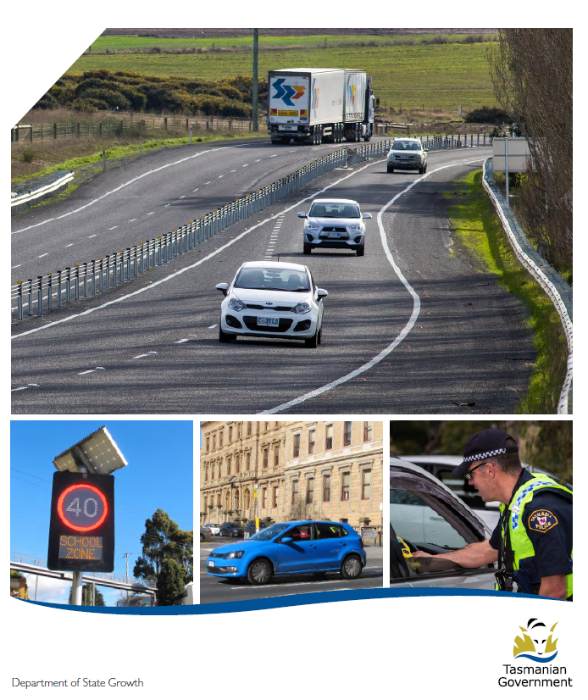

Quarterly Progress Report to RSAC
as at 30 June 2018

Progress on meeting Towards Zero Strategy targets
The key interim target for the Towards Zero – Tasmanian Road Safety Strategy 2017-2026 (Towards Zero Strategy) is to reduce the number of annual serious injuries and deaths on Tasmanian roads to fewer than 200 by 2026. This is an ambitious target of 100 fewer serious casualties per year than for the period 2012-2016 (annual average) and will move us towards the long-term goal of zero serious casualties on Tasmanian roads.
Serious Casualties
The number of serious casualties in 2017 was 303, compared to 318 in 2016, a 4.7 per cent decrease. The 2017 figure of 303 is a 0.2 per cent increase on the five year serious casualty average of 302.4 (2012-2016).
Fatalities
In 2017, there were 34 fatalities on Tasmanian roads which is two fewer than the number recorded in 2016 The figure of 34 fatalities in 2017 is a 1.2 per cent increase on the five year fatalities average of 33.6 (2012-2016).
2018 YTD
There have been 149 serious casualties (17 fatalities and 132 serious injuries) to 30 June 2018, a decrease of 7.4 per cent on the same period last year of 160 serious casualties (16 fatalities and 144 serious injuries) and a decrease of 9.1 per cent on the five year average of 164 serious casualties.

Serious Casualties Tasmania – Annual Count and Towards Zero Target
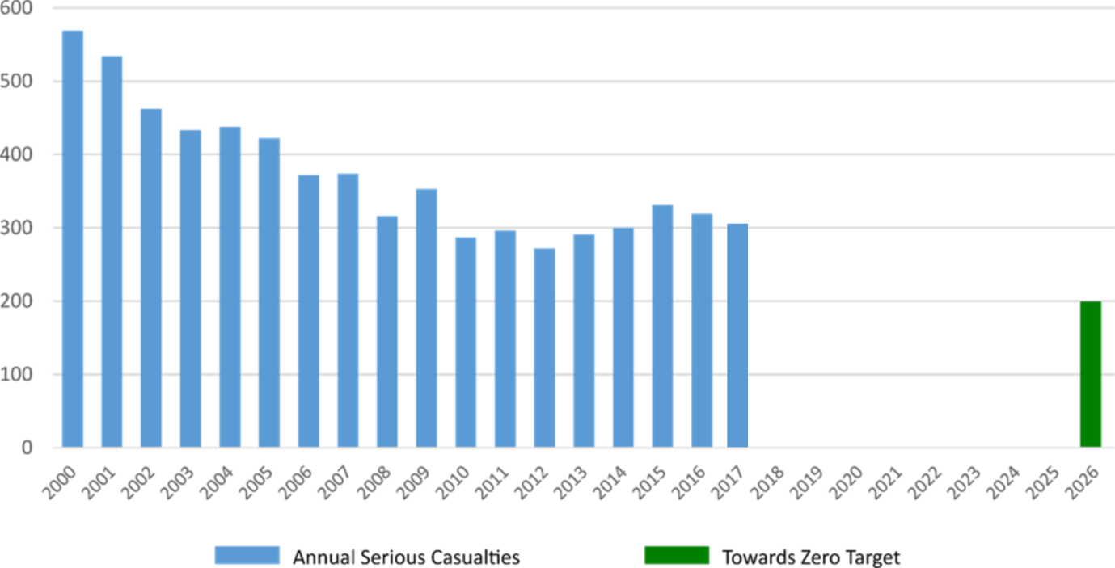
Annual fatalities – Rate per 100,000 population
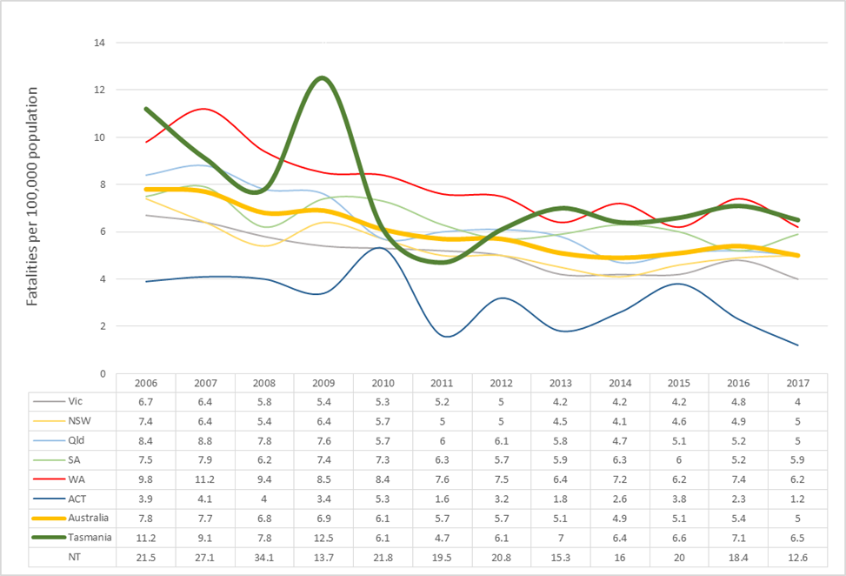
Note: NT omitted from chart for clarity purposes.

Progress on meeting MAIB targets

Motor Accidents Insurance Board (MAIB) injury statistics show the number of fatalities and the level of claims for serious injuries on our roads.
Various claim reduction targets are specified in the Memorandum of Understanding between the Department of State Growth (State Growth) and the MAIB. Progress against high level targets is shown below, expressed as 12 month moving totals.

Fatalities – 12 Month Rolling Total
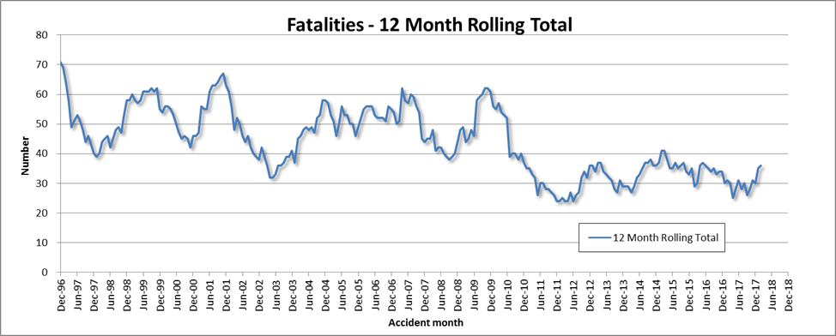

Total Serious Claims – 12 Month Rolling Total
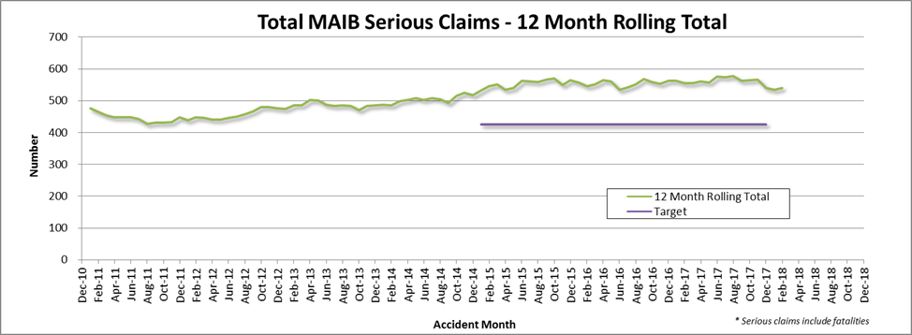

Statistics
Serious Casualties by Quarter by Age Group – 12 period moving average

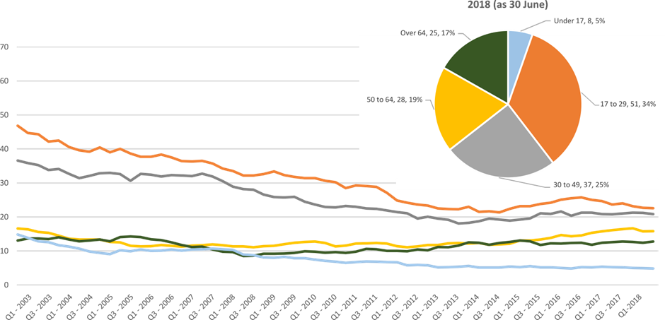

Serious Casualties by Quarter by Gender – 12 period moving average

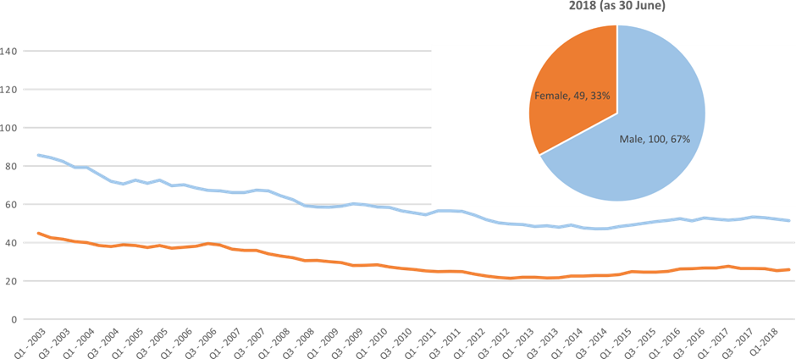

Serious Casualties by Quarter by Road User Type – 12 period moving average

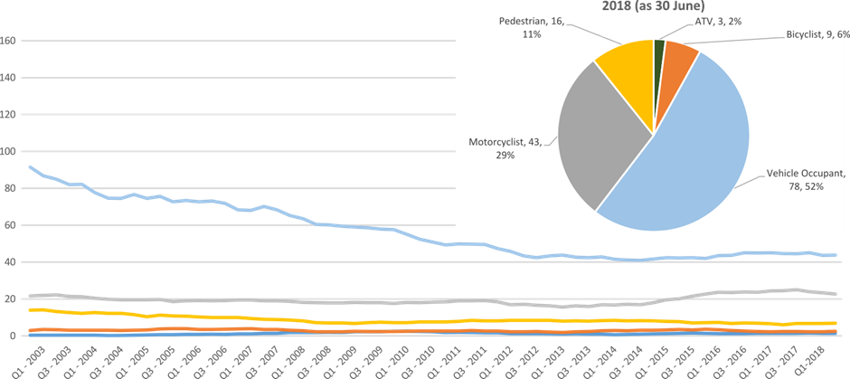

Serious Casualties by Quarter by Speed Zone – 12 period moving average

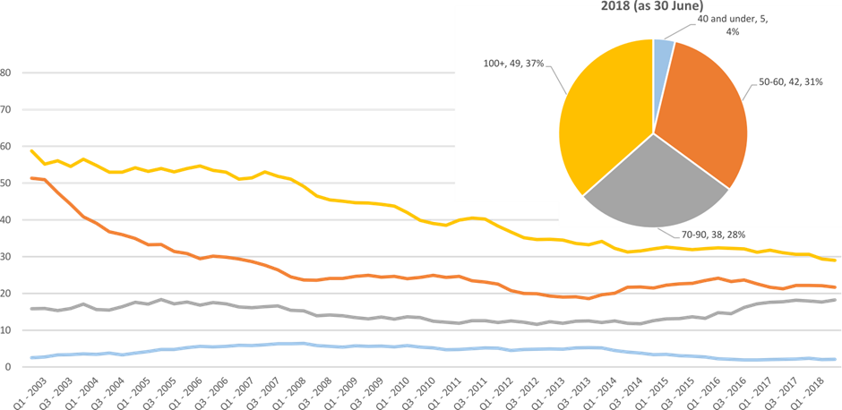
Pie chart excludes serious casualties where speed zone is recorded as ‘not known’

Serious Casualties by Quarter by Crash Type (DCA) – 12 period moving average

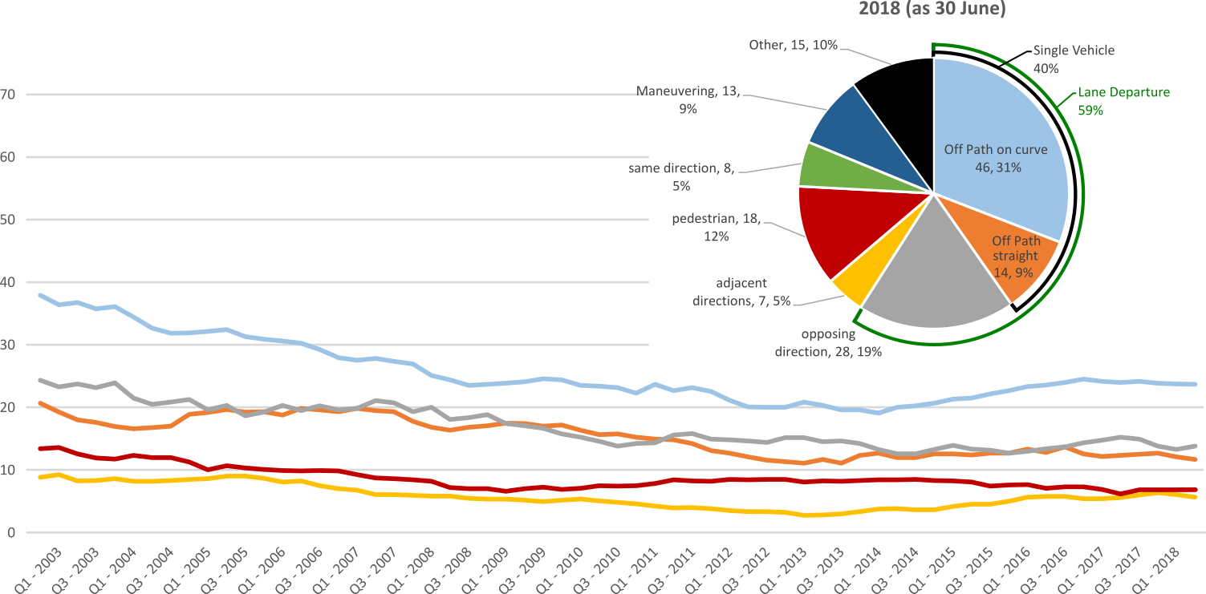
Other includes crash types: on-path (2%), overtaking (6%), passenger & miscellaneous (2%)

Serious Casualties by Quarter by Urban/Non-Urban – 12 period moving average

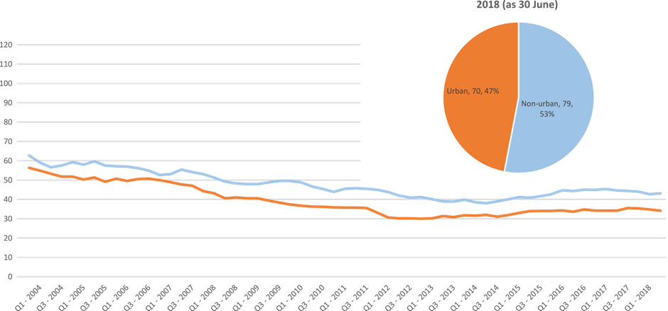
Based on the Australian Bureau of Statistics’ ‘significant urban area’ geographic definition.

Serious Casualty locations as @ 30 June 2018 (Black = Fatality, Red = Serious Injury)
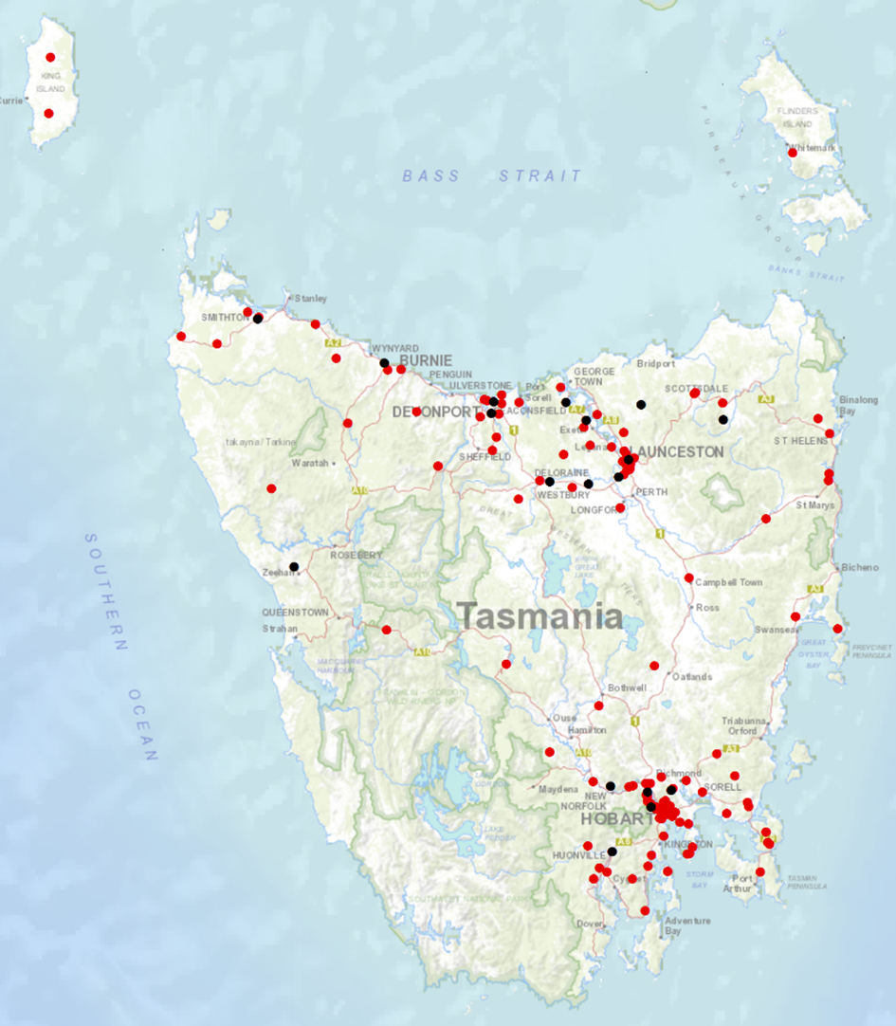

Priority Actions 2017-2019

Safe Road Users

- Improve the Graduated Licensing System to reduce serious casualties for young road users (17-25 year olds).
- Introduce safety initiatives to reduce motorcyclist serious casualties.
- Promote safer road user behaviour through education and enforcement.

Safe Roads and Roadsides

- Reduce run-off-road and head-on crashes through improved infrastructure.
- Reduce the severity of intersection crashes through improved infrastructure treatments.
- Embrace safe system thinking in road design.
- Reduce serious casualties through improved delineation such as line marking.

Safe Vehicles

- Improve the star rating of Tasmania’s vehicle fleet to include vehicles with better safety features.
- Increase the number of motorcycles with ABS.

Safe Speeds

- Introduce more appropriate speed limits to reduce serious casualties.
- Increase enforcement through technology to reduce speed related serious casualty crashes.

Progress on projects
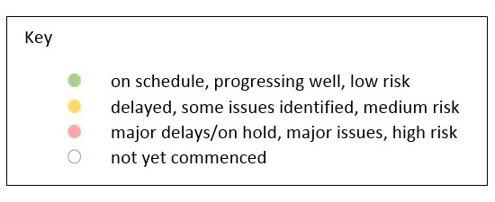
Action Plan 2017-2019
Safe Road Users
Project | Responsibility | Status | Milestones achieved | Milestones planned |  | Comments | Budget  Life of project  $ | YTD  2017/18  $
GLS Implementation  Following on from GLS Review | Road Safety, State Growth |  | On 15 May 2018 the Steering Committee agreed to a process review on the GLS pathway and recruitment of a band 5 Policy Officer to undertake this task.  The successful applicant will commence on 30 July 2018. | A tender package is currently being progressed to contract an agency to develop a best practice educational communication package that will include:  - Educational strategy framework  - Digital platform and tools  - Branding and content development  - Public education campaign; and  - Stakeholder engagement  A process review of the GLS pathway will shortly be conducted of the current processes and functions. This will identify opportunities to improve efficiencies when updating the GLS. |  | Current focus of the project is on the tender package to bring a consultant on board in early 2019.  The project team is working towards delivering the Government’s commitment as announced in May 2018, First Year Agenda, to enable the announcement of the new GLS in the first quarter of 2019 (January to March 2019). | 3,000,000 | 5,766
New motorcycle training and assessment program | Registration & Licensing, State Growth |  | The progressive roll out of the new Motorcycle and Assessment Program has concluded with the commencement of the Program in the North on 8 January 2018.  A transitional training program has been implemented in all regions.  The new training film demonstrating the safety benefits of the new Program and the top 5 motorcycle crashes has been developed and released.  A communication strategy has been implemented to ensure all existing motorcycle learner licence holders affected by the transitional arrangements are notified. | Finalise the development of the auditing and compliance monitoring framework and resourcing structure.  Commence scoping the Longitudinal Study that will look to evaluate the new Program and any potential linkages to crash statistics in the future.  Implementation of the electronic results portal has been delayed until the last quarter of 2018. The results portal interfaces directly with the Motor Registry System to enable instant result reporting for licencing upgrades and provides real time confirmation of licensing eligibility. |  | Implementation Project complete.  The Grant Deed established to fund the transitional arrangements is ongoing until end 2019. | 810,000 | 711,888  (Life of project)
Protective gear for motorcyclists | Road Safety, State Growth |  | The Motorcycle Protective Gear video and supporting collateral has now been incorporated into the new Motorcycle Training and Assessment Program. Every learner will watch the video and receive a supporting brochure.  Additional collateral has been distributed State-wide to motorcycle retailers. |  |  | Project complete. | 75,000 | 39,965
Towards Zero Enforcement Project - Introduce rear-facing automated speed cameras | Tasmania Police |  | Cost estimate to reconfigure some cameras to rear-facing still underway.  PM met with technology providers regarding the reintroduction of mobile speed cameras that can include rear-facing functionality. | Submit costing to RSAC for consideration.  Can’t be progressed until trial of Mobile P2P technology is tested (if approved by Corporate Management Group (CMG) |  |  | 132,000  To review 5 projects | 132,000
Towards Zero Enforcement Project - Increased motorcycle-focused enforcement | Tasmania Police |  | Major review of MRS, TIN and Crash Data Manager data (5yr data).  Benchmarking presentation completed.  Workshops performed with two Districts | Southern Workshop scheduled July 25 |  | Key deliverable will be 12 month Motorcycle Enforcement Strategy. Basic document with a suite of enforcement activities scheduled across a 12 month program. Activities will be tailored to each District. Seeking innovative and alternative enforcement activities.
Towards Zero Enforcement Project - Increased enforcement of high-risk behaviours | Tasmania Police |  | Proposal to trial unmarked police motorcycles provided to CMG for consideration. | To be determined if approved by CMG |  | Proposal is for two unmarked motorcycles to be trialled for 12 months to enforce high-risk road behaviours in slow moving and/or stationary traffic in urban areas. This will complement the Rural Road Policing Strategy.
Promote safe behaviours through media campaigns | EESC,  Road Safety, State Growth |  |  | Long-term enforcement campaign to complement Police media activity during holiday periods launched in December. |  | Funding approved by RSAC in May. | Road Safety Levy funding  $100,000 (excluding media buy)
 | EESC,  Road Safety, State Growth |  |  | A new anti-drink-driving Real Mates campaign targeted at men aged between 17 and 25. |  | Funding approved by EESC. | MAIB funding  $
Building Road Safety Knowledge in Tasmania –  Community engagement | Road Safety, State Growth |  | The Young Driver Symposium: a public forum focused on the overrepresentation of young drivers in road trauma in Road Safety Week.  Community Road Safety Grants presentations for councils and key stakeholders. |  |  | Project Complete. | $50,000  Includes Safe System thinking in road design | 45,107

Safe Roads and Roadsides
Project | Responsibility | Status | Milestones achieved | Milestones planned | Comments | Budget  Life of project  $ | YTD  2017/18  $
Flexible barrier installation program | State Roads, State Growth |  |  | Scoping and planning phase to identify suitable projects and locations underway. Identify sections of roads for treatment; scope and develop project plan. |  | 7.5 million
Audi-tactile line marking program | State Roads, State Growth |  |  | Scoping and planning phase to identify suitable projects and locations underway. Identify sections of roads for treatment; scope and develop project plan.
Shoulder sealing program | State Roads, State Growth |  |  | Scoping and planning phase to identify suitable projects and locations underway. Identify sections of roads for treatment; scope and develop project plan.
Improved delineation on high risk roads | State Roads, State Growth |  |  | Scoping and planning phase to identify suitable projects and locations underway. Identify sections of roads for treatment; scope and develop project plan.
Intersection treatment program | State Roads, State Growth |  |  | Scoping and planning phase to identify suitable projects and locations underway. Identify sections of roads for treatment; scope and develop project plan.
Building Road Safety Knowledge in Tasmania –  Safe system thinking in road design | Road Safety, State Growth |  | Safe System Solution training courses held in Burnie and Launceston, including:  - 2 X Safe System Principles Courses  - 1 X Safe System Application Course)  Trainings targeted engineers and councils. | Three Safe System training to be held in Hobart in September, including:  - Safe System Approach to Road Safety  - Safe System Technical Training  - Making Roads Motorcycle Friendly.  Trainings targeted at engineers, councils, and government. | The $50,000 noted above for Building Road Safety Knowledge in Tasmania – Community Engagement falls within this program.  Funding approved by RSAC in March 2018 meeting.  Minute to the Minister approved in May 2018. |  | 45,107

Safe Vehicles
Project | Responsibility | Status | Milestones achieved | Milestones planned | Comments | Budget  Life of project  $ | YTD
Increase the number of motorcycles with ABS | Road Safety, State Growth |  |  |  | ADR being introduced at a national level. May undertake
Government Vehicle Fleet Safety Policy Review (Stage 1) | Road Safety, State Growth |  | Policy was endorsed by Cabinet and effective as of 1 July 2018.  The Government policy was promoted at the Local Government Association of Tasmania (LGAT) Conference in July 2018. | An article is being prepared for the RACT Journeys from the RSAC Chair on the new policy and to promote the uptake of 5-star ANCAP rated vehicles. | Stage 1 of the project is now complete.  As opportunities arise, the policy will continue to be promoted. | 0 | NA
Government Vehicle Fleet Safety Policy Review (Stage 2)  Government Business Enterprise (GBE) and State Owned Company (SOC) Fleet Review | Road Safety, State Growth |  | Project planning and scoping complete.  Initial desktop analysis of fleet structure complete. Policy options and recommendations drafted.  Engagement with Department of Treasury and Finance (Treasury) underway.  A Minute to the Minister was prepared advising of formal engagement with GBE and SOCs via Treasury. | Engagement with GBE and SOC fleet managers to occur in August 2018 in partnership with Treasury.  Policy paper to be finalised late 2018. |  | 0 | NA
Government Vehicle Fleet Safety Policy Review (Stage 3)  Promote vehicle fleet safety standards for commercial fleets | Road Safety, State Growth |  | Road Safety Branch will attended the LGAT Conference in July and promote Government policy and vehicle safety to attendees. |  | The outcomes of Stage 2 will inform the approach to Stage 3 of the project and further engagement with commercial fleets. | 0 | NA
Safe Speeds
Project | Responsibility | Status | Milestones achieved | Milestones planned | Comments | Budget  Life of project  $ | YTD  $
Development of speed limit setting guidelines | Road Safety, State Growth
Assessment of speed limits on 100km/h roads | Road Safety, State Roads, State Growth
Towards Zero Enforcement Project - Review of point to point (P2P) speed cameras on high risk rural roads | Tasmania Police |  | PM met with providers of Mobile P2P technology in Victoria and Sydney. | Submit proposal to CMG to trial Mobile P2P in Tasmania – this would be highly innovative for an Australian jurisdiction. | Should the technology prove itself, it will be incorporated in to a future proposal to reintroduce Mobile Speed Cameras. | 132,000  To review 5 projects | 132,000
Towards Zero Enforcement Project - Increased fixed speed cameras in urban areas | Tasmania Police | N/A | Project closed | Project closed. | RSAC endorsed the recommendation that no new sites be established.
Reducing Urban Arterial Speed Limits in Tasmania from 60km/h to 50km/h. | Road Safety State Growth |  | Project planning and scoping completed. |  | Remaining roads are low volume (aside from urban arterials) and may have less community support.  Road safety benefit not immediate, but would be long term.  On hold as not a priority project, but will be progressed as a demonstration of appropriate speeds. | TBC

Road Safety Work Program
Safe Road Users
Project | Responsibility | Status | Milestones achieved | Milestones planned |  | Comments | Budget  Life of project  $ | YTD  $
MAIP Review | Road Safety, State Growth |  | MAIP Review Report signed off by Steering Committee | Commence implementation of recommendations. |  | Recruitment of Fixed-Term Band 5 Policy Officer to progress implementation of MAIP Review recommendations currently underway. | State Growth funded | 0
Distance makes the Difference campaign Stage 2 | Road Safety, State Growth |  |  |  |  | Phase 2 continues to be well received. Good audience engagement through a managed Youtube campaign. Also TV, radio and bus back advertising.  The campaign is scheduled to run through until March 2019. | 400,000 | 315,060
Implementation of minimum passing distance legislation | Road Safety, State Growth |  | Legislation commenced on 27 September 2017. | Complete.

Project | Responsibility | Status | Milestones achieved | Milestones planned |  |  | Comments | Budget  Life of project  $ | YTD  $
Tourist road safety campaign – Phase 2 (2017-2019) | Road Safety, State Growth |  | Visiting drivers’ website launched December 2017. 6 x 15 second films running in Hobart Airport and other key locations. Collateral continues to be distributed. Extending messaging through stakeholder networks. Seasonal worker campaign launched in December 2017.  Workshops with rental car companies took place in May and June 2018. | Release of two new motorcycle films and updated Enjoy your ride guide in late September/early October 2018.  Updated international tourist and New to Tasmania material to be released in late September/early October 2018. |  |  | Good progress continues to be made with stakeholders.  Distribution channels continue to grow following productive meetings with stakeholders.  Feedback from stakeholders on the new website and other initiatives underway has been very positive. | 650,000 | 156,259
Community Road Safety Grants Program | Road Safety, State Growth |  | Community Road Safety Grants open 23rd March. This will be the final round of funding under the original Election commitment on $200,000 per year over three years. | Community Road Safety Grants open 23 March 2018 and close 20 April 2018.  Funds will be delivered to successful applicants before the end of the financial year. |  |  | Most acquittals from previous funding rounds are due and a report will be completed for RSAC at a later date. | 200,000  p/a | 190,297
Learner Driver Mentor Program and Driver Mentoring Tasmania | Road Safety, State Growth |  | Funding was delivered to 16 LDMPs for 2017 - 2018.  An evaluation of the LDMP and DMT programs was conducted in November 2017. Recommendations from the evaluation will inform ongoing delivery of LDMP program beyond 2018. | Funding under the LDMP will continue on an annual basis for the next four years. |  |  | The Department continues to work with the DMT coordinator to address the systemic challenges suggested in the evaluation report. | 500,000  p/a  702,000 approved for 2017/18. | 692,442
Learner Driver Mentor Program evaluation | Road Safety, State Growth |  | An evaluation of the LDMP and DMT programs was conducted in November 2017. Recommendations from the evaluation will inform ongoing delivery of LDMP program beyond 2018. | The Department is working to re-define the role of the DMT coordinator to address the systemic challenges faced by LDMPs listed in the evaluation report. |  |  | The Department is working to re-define the role of the DMT coordinator to address the systemic challenges faced by LDMPs listed in the evaluation report. | 50,000 | 45,761
RYDA program | Road Safety, State Growth |  | RYDA has submitted a funding proposal for the sum of $75,000 per annum. A deed has been executed and funding will be made payable for the 2018-19 financial year. | Opportunities for engagement with stakeholders to fill gaps in program delivery is scheduled for July 2018. |  |  | RSE have recently changed several components of the RYDA program. Rotary are currently exploring avenues for the professional delivery of these components. | 75,000 | 0
RACT and Bicycle Network | Road Safety, State Growth |  | The RACT and Bicycle Network submitted an application for funding to deliver a suite of road safety education initiatives across the State. | A deed will be executed for funding the RACT and Bicycle Network for 4 years. Acquittals and program evaluations are due annually before annual funding is released. |  |  | Under the partnership with the RACT, the delivery of road safety programs throughout Tasmania include:  - RoadSafe program for primary school students;  - The interactive workshop ‘Dangers of Distraction’ delivered to high schools;  - Presentation of the Years Ahead program to older drivers throughout Tasmania; and  - CarFit sessions for maturing drivers throughout Tasmania.  The Bicycle Network will deliver:  - A Ride2School program for primary school children; and  - A new bicycle safety program for Year 7 to 9 high school students.
Pedestrian safety package – Stage 1: Pedestrian Countdown Timers (PCTs) Trial | State Roads, State Growth |  | All Launceston sites operating January 2018. |  | Final payments to be made next quarter. |  |  | 70,000 | 35,252
Pedestrian safety package – Stage 2 | State Roads  State Growth |  |  |  |  | RSAC has referred consideration of education about pedestrian distraction from mobile phones to the EESC. |  | 430,000 | 0
Vulnerable Road User Program  2013-2017 | State Roads, State Growth |  | Two of the four outstanding projects completed – to be paid next quarter. |  | Final two projects to be completed next quarter. |  |  | 2,500,000 | 1,892,793
Vulnerable Road User Program  2017-2022 | State Roads  State Growth |  | One project underway.  Grant deeds in process for three projects. |  | Projects’ design plans to be finalised next quarter for 11 projects. |  |  | 2,500,000 | 0
Esk Main Road shoulder sealing, edge line marking and safety improvements | State Roads, State Growth |  |  |  | Final seal and line marking to be done 2018-19 construction season. | Overly high contract prices received; after site inspection State Roads decided to delay final seal to 2018-19 construction year to include in reseal program in order to get better pricing. |  | 5,860,000 | 5,085,666
Lyell Highway, south of Hamilton shoulder sealing | State Roads, State Growth |  | Final seal and line marking completed – to be paid next quarter. |  |  |  |  | 1,272,000) | 1,097,696
Lyell Highway Ouse to Strickland Road | State Roads  State Growth |  | Construction started early January. |  | Construction be completed by end April. |  |  | $4,000,000 | 2,458,753
Midland Highway Safety Improvements | State Roads, State Growth |  | Projects progressing on the 10 year infrastructure upgrade. |  | Continuation of projects. |  |  | 20,000,000 | 14,115,733

Safe Vehicles
Project | Responsibility | Status | Milestones achieved | Milestones planned | Comments | Budget  Life of project  $ | YTD  $
ANCAP support | Road Safety, State Growth |  |  |  |  | 12,000 p/a | 11,851

Safe Speeds
N/A. There are no current Safe Speed projects under the Road Safety Work Program.

Other
Project | Responsibility | Status | Milestones achieved | Milestones planned | Comments | Budget  Life of project  $ | YTD  $
RSAC and Towards Zero Strategy support | Road Safety, State Growth |  | Funding for Manager RSAC Secretariat, Senior Project Officer TEB, Chair and Expert sitting fees and operation of RSAC. |  |  | Up to 400,000  p/a | 295,554
MAIP Transitional arrangements | Registration & Licensing, State Growth |  | Recruit of Fixed-Term Band 5 Policy Officer to progress implementation of MAIP Review recommendations currently underway. |  |  | 3,300,000 | 2,268,834  (Life of project)
Lane filtering for motorcyclists | Road Safety, State Growth |  | Legislation commenced on 29 January 2018. | Complete |  | 30,000 | 32,245
Discretionary Activities Fund | Road Safety, State Growth |  | Redevelopment of RSAC Website |  |  | 250,000 | 5,500
 |  |  | Road Torque |  |  |  | 30,662
 |  |  | Safe System Infrastructure Workshop |  |  |  | 35,505
 |  |  | Road Safety Week |  |  |  | 12,796
 |  |  | Capacity Building |  |  |  | 0
 |  |  | LDMP Evaluation |  |  |  | 45,761
 |  |  |  |  |  |  | 175,331
 |  |  | Motorcycle Safety Demonstration Project: Lake Leake Highway |  |  | 25 000 | NA

Funding

Road Safety Levy Overview
As at 30 June 2018
2017/18 Financial Year | Proposed budget  $ | Actual (ytd)  $
Opening balance (as at 1 July 2017) |  | 14,367,364
Revenue 2017/18
Road safety levy collected | 13,500,000 | 13,948,443
Funds available for distribution | 10,900,000 | 11,348,443
Total funds available for distribution | 25,267,364 | 25,715,807
Expenditure
Roads and Roadsides |  | 3,792,392
Policy and Projects |  | 3,191,561
Total Expenditure |  | 6.983,953
Balance |  | 18,731,854
Allocated funding
Safe Roads and Roadsides |  | 7,000,000
Policy and Projects |  | 3,564,439
Total allocated funding |  | 10,564,439
Unallocated funding
Safe Roads and Roadsides |  | 500,000
Policy and Projects |  | 7,667,415
Unallocated funding balance |  | 8,167,415

MAIB Funding
As at 30 June 2018
2017/18 Financial Year | Budget  $ | Actual (ytd)  $ | Balance  $
Expenditure (State Growth)
Administration & Public Relations | 272,022 | 260,215 | 11,807
Public Education | 934,276 | 693,748 | 240,528
Research | 111,004 | 29,900 | 81,104
Subtotal | 1,317,302 | 983,863 | 333,439
Expenditure (Tasmania Police)
Salaries | 1,853,259 | 1,823,279 | 29,980
Operating Expenses | 293,006 | 163,551 | 129,455
Equipment | 888,646 | 795,132 | 93,514
Subtotal | 3,034,911 | 2,781,962 | 252,949
Total | 4,352,213 | 3,765,825 | 586,388
Includes Carried Forward of
$ 43,150 (State Growth)
$429,547 (Police)

Correspondence received from the Coroner on 13 June 2018 advised that a motor vehicle-related death in Evandale, on 22 June 2017, was the result of natural causes. As per reporting guidelines this death has been removed from the road toll revising the previously reported figure for 2017 of 35 to 34.

