Fewer than 200 serious injuries and deaths on our roads by 2026
Towards Zero Tasmanian Road Safety Strategy 2017–2026

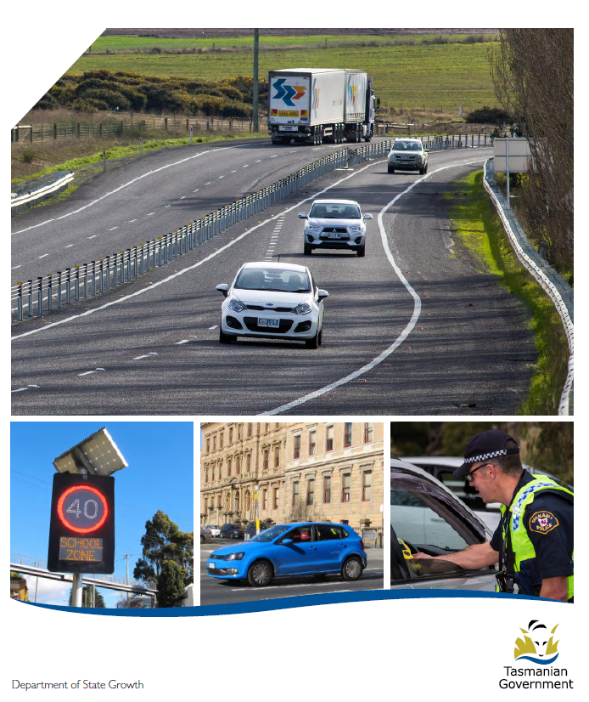

Quarterly Progress Report to RSAC
as at 31 March 2018

Progress on meeting Towards Zero Strategy targets
The key interim target for the Towards Zero – Tasmanian Road Safety Strategy 2017-2026 (Towards Zero Strategy) is to reduce the number of annual serious injuries and deaths on Tasmanian roads to fewer than 200 by 2026. This is an ambitious target of 100 fewer serious casualties per year than for the period 2012-2016 (annual average) and will move us towards the long-term goal of zero serious casualties on Tasmanian roads.
Serious Casualties
The number of serious casualties in 2017 was 303, compared to 318 in 2016, a 4.7 per cent decrease. The 2017 figure of 303 is a 0.2 per cent increase on the five year serious casualty average of 302.4 (2012-2016).
Fatalities
In 2017, there were 35.fatalities on Tasmanian roads which is one fewer than the number recorded in 2016 The figure of 35 fatalities in 2017 is a 4.2 per cent increase on the five year fatalities average of 33.6 (2012-2016).
2018 YTD
There have been 79 serious casualties (12 fatalities and 67 serious injuries) to 31 March 2018, a decrease of 14.1 per cent on the same period last year of 92 serious casualties (5 fatalities and 87 serious injuries) and a decrease of 16.5 per cent on the five year average of 94.6 serious casualties.

Serious Casualties Tasmania – Annual Count and Towards Zero Target
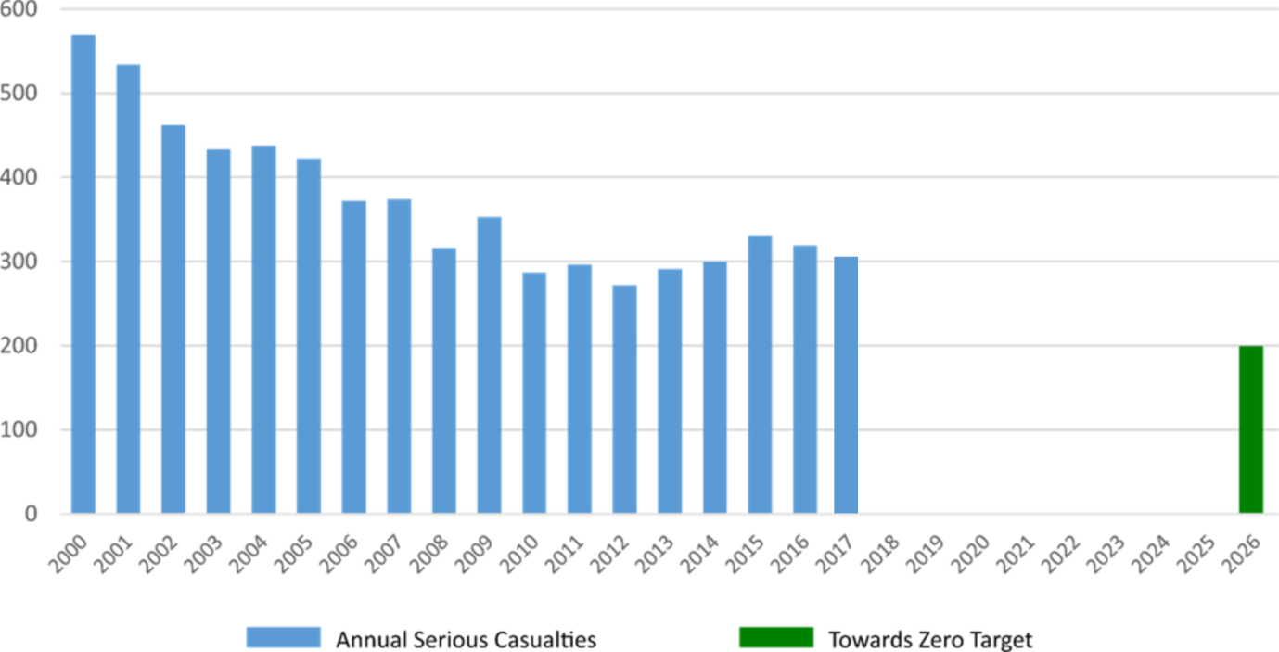
Annual fatalities – Rate per 100,000 population

Note: NT omitted from chart for clarity purposes.

Progress on meeting MAIB targets

Motor Accidents Insurance Board (MAIB) injury statistics show the number of fatalities and the level of claims for serious injuries on our roads.
Various claim reduction targets are specified in the Memorandum of Understanding between the Department of State Growth (State Growth) and the MAIB. Progress against high level targets is shown below, expressed as 12 month moving totals.

Fatalities – 12 Month Rolling Total
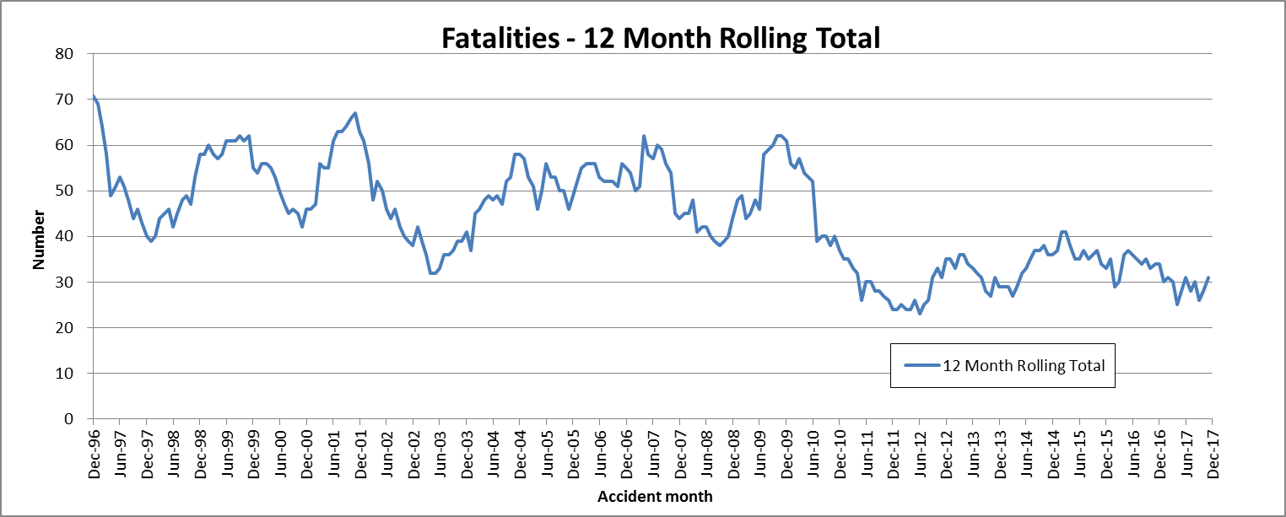

Total Serious Claims – 12 Month Rolling Total
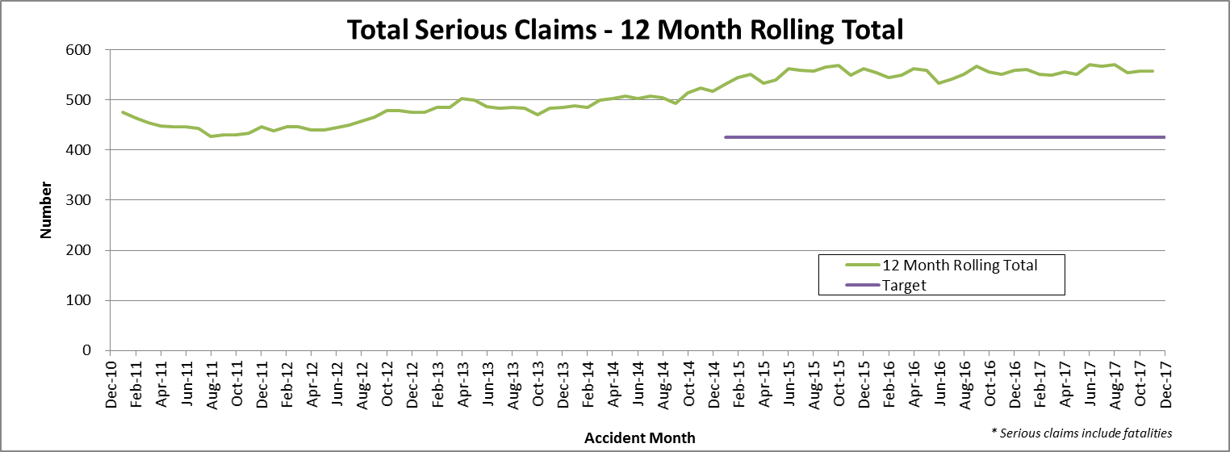

Statistics
Serious Casualties by Quarter by Age Group – 12 period moving average

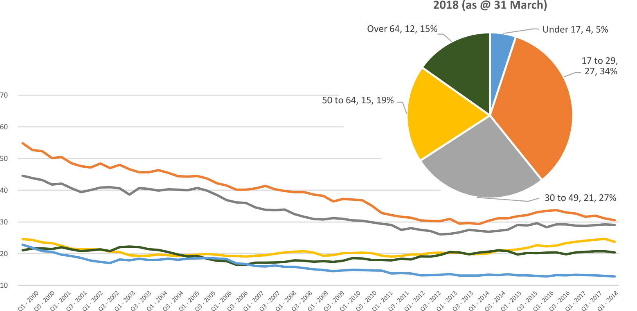

Serious Casualties by Quarter by Gender – 12 period moving average

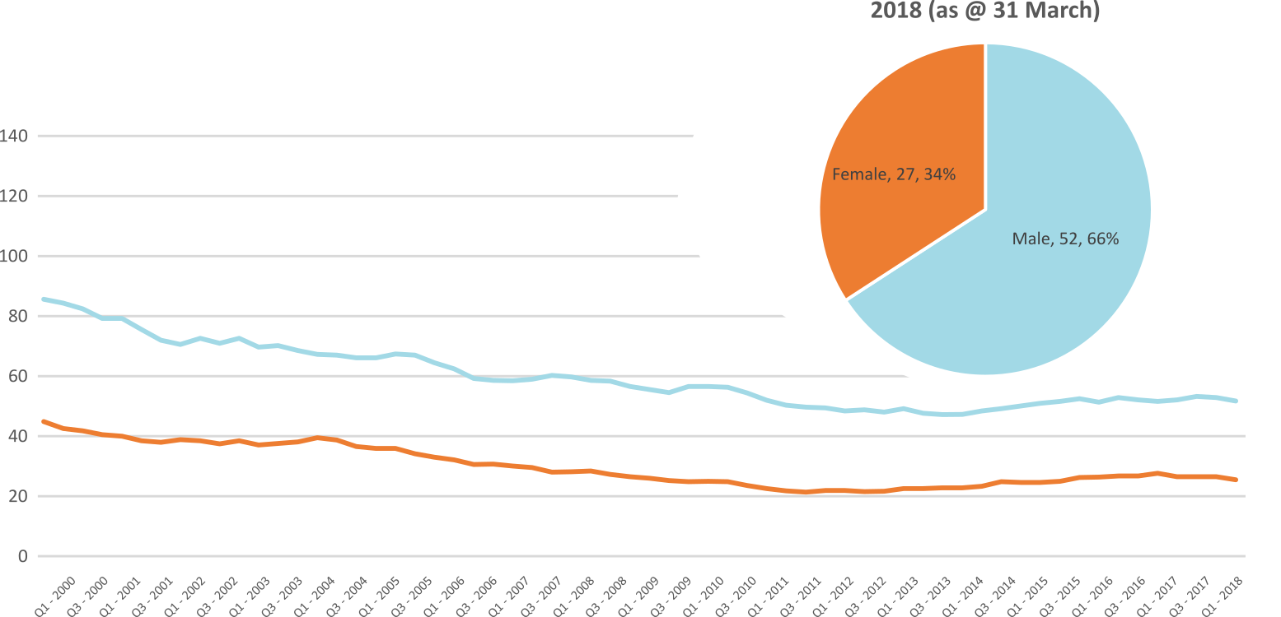

Serious Casualties by Quarter by Road User Type – 12 period moving average

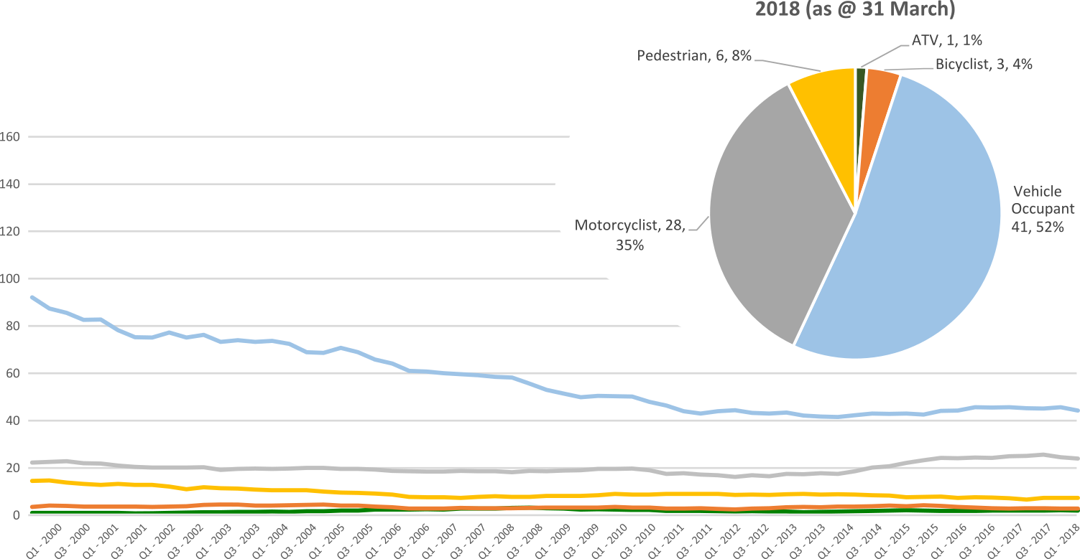

Serious Casualties by Quarter by Speed Zone – 12 period moving average

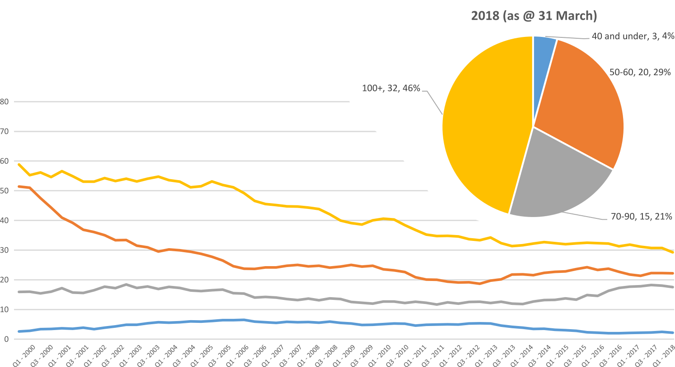
Pie chart excludes serious casualties where speed zone is recorded as ‘not known’

Serious Casualties by Quarter by Crash Type (DCA) – 12 period moving average

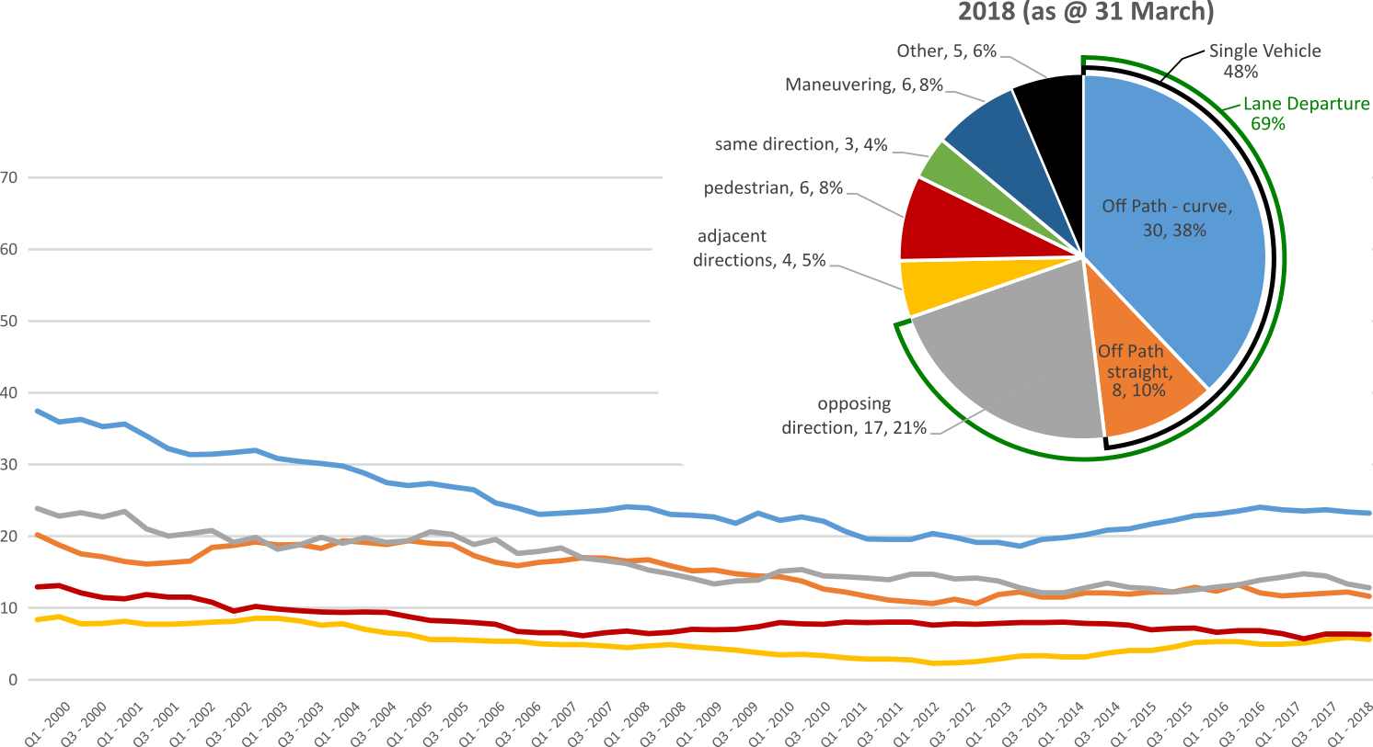
Other includes crash types: on-path (1.3%), overtaking (2.5%), passenger & miscellaneous (2.5%)

Serious Casualties by Quarter by Urban/Non-Urban – 12 period moving average

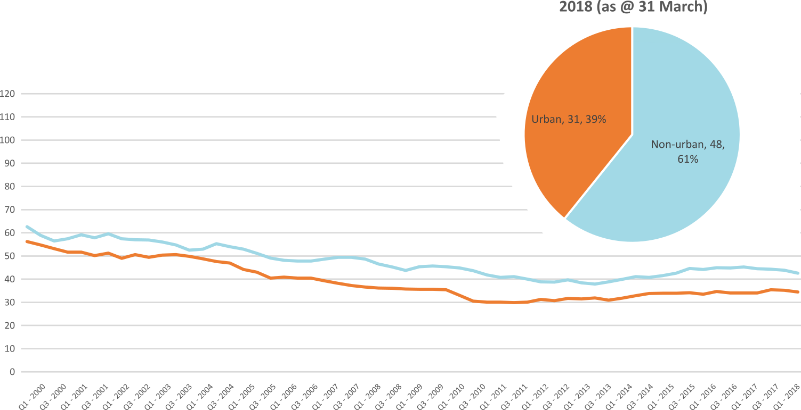
Based on the Australian Bureau of Statistics’ ‘significant urban area’ geographic definition.
Serious Casualty locations as @ 31 March 2018 (Black = Fatality, Red = Serious Injury)
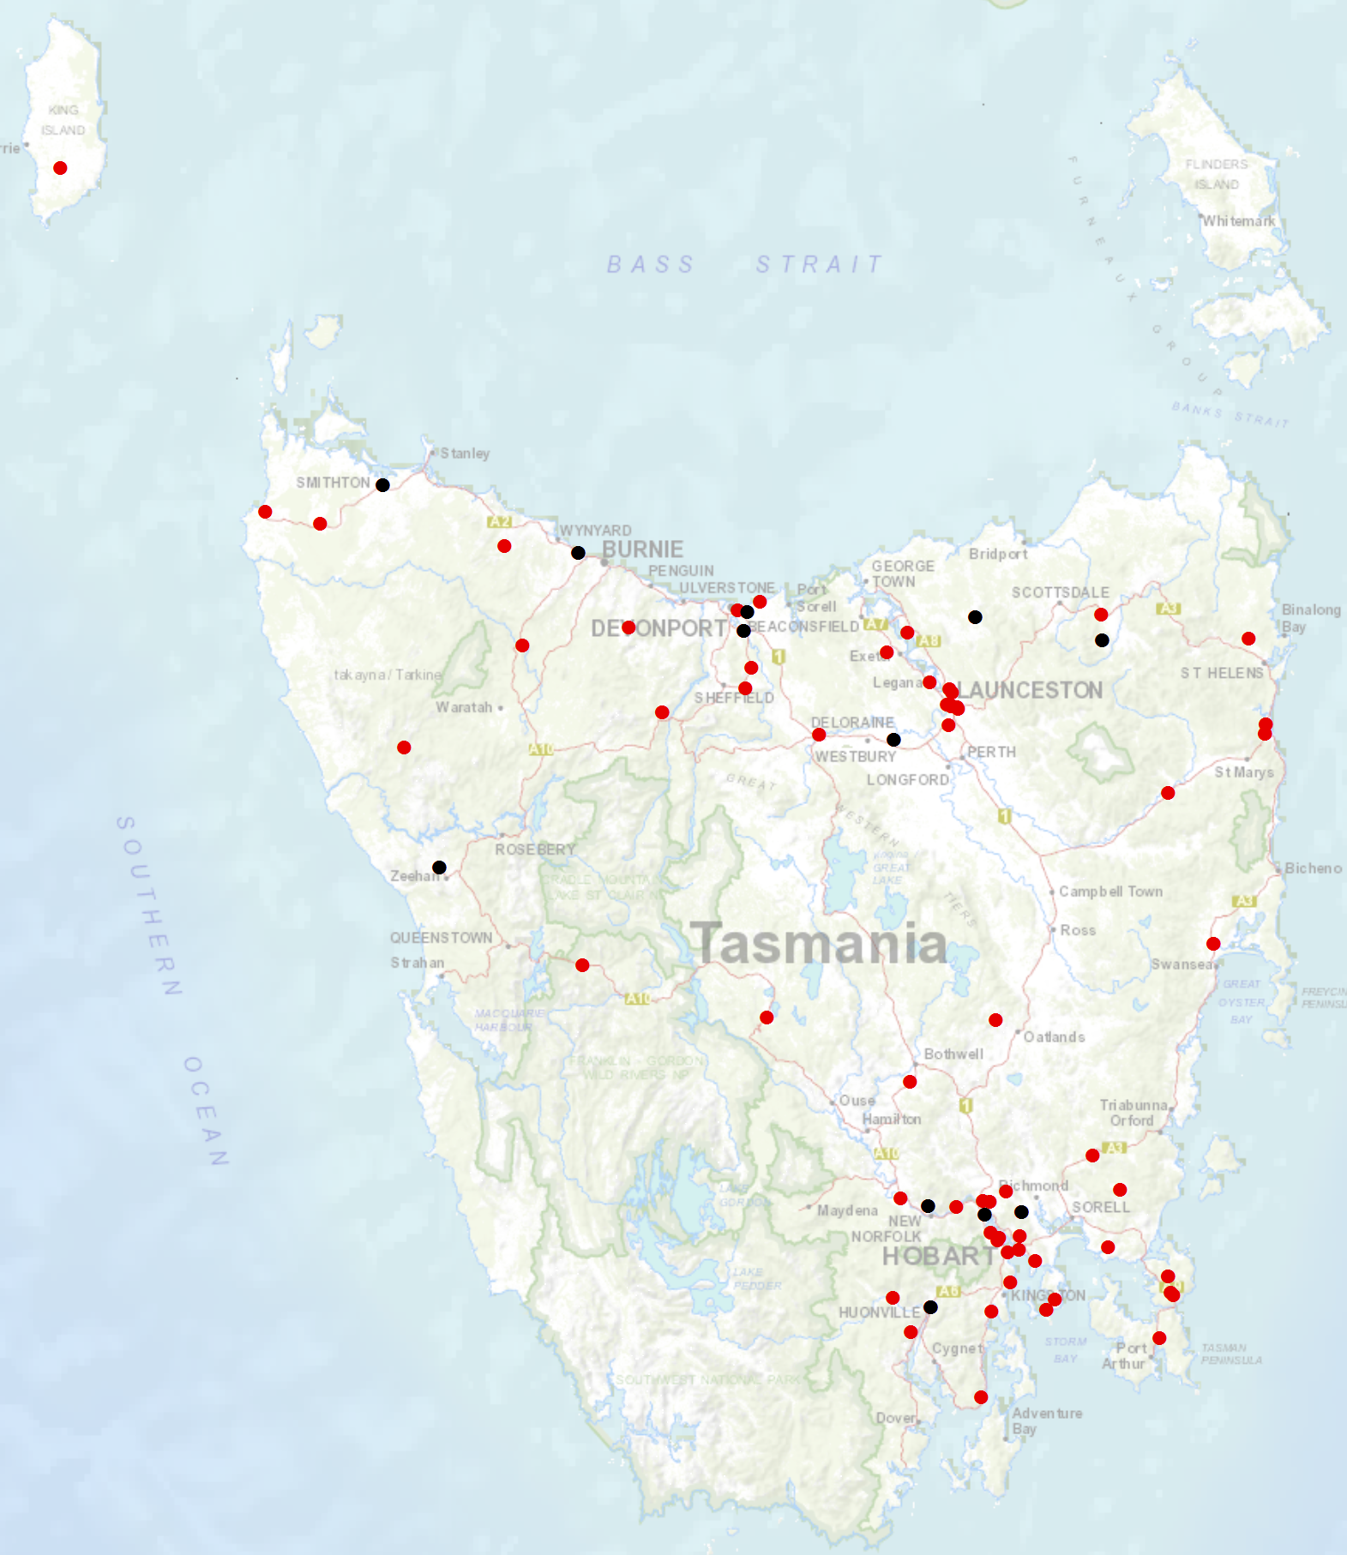

Priority Actions 2017-2019

Safe Road Users

- Improve the Graduated Licensing System to reduce serious casualties for young road users (17-25 year olds).
- Introduce safety initiatives to reduce motorcyclist serious casualties.
- Promote safer road user behaviour through education and enforcement.

Safe Roads and Roadsides

- Reduce run-off-road and head-on crashes through improved infrastructure.
- Reduce the severity of intersection crashes through improved infrastructure treatments.
- Embrace safe system thinking in road design.
- Reduce serious casualties through improved delineation such as line marking.

Safe Vehicles

- Improve the star rating of Tasmania’s vehicle fleet to include vehicles with better safety features.
- Increase the number of motorcycles with ABS.

Safe Speeds

- Introduce more appropriate speed limits to reduce serious casualties.
- Increase enforcement through technology to reduce speed related serious casualty crashes.

Progress on projects
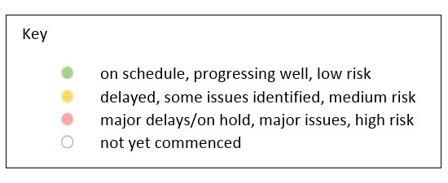
Action Plan 2017-2019
Safe Road Users
Project | Responsibility | Status | Milestones achieved | Milestones planned |  | Comments | Budget  Life of project  $ | YTD  2017/18  $
GLS Implementation  Following on from GLS Review | Road Safety, State Growth |  | Stage 2 of the GLS Implementation has commenced.  On 18 March 2018 the Steering Committee endorsed the proposed changes to the GLS Project Plan Stage 2 Implementation, Communication Strategy, contracting an expert technical consultant and the approach to procurement for the development of the integrated learning platform, branding, public education campaign and resources and materials. | A package will be prepared for Cabinet on the recommended changes to the GLS and pathway for implementation.  Concurrently, work is being progressed on the tender package for the development of a digital platform, brand and public education activity also consulting with relevant internal and external stakeholders on the proposed GLS changes. |  | Stage 2 will have many phases that include communication, consultation and procurement. These will inform the development of the new GLS. | 3,000,000 | 1,357
New motorcycle training and assessment program | Registration & Licensing, State Growth |  | The progressive roll out of the new Motorcycle and Assessment Program has concluded with the commencement of the Program in the North on 8 January 2018.  A transitional training program has been implemented in all regions.  The new training film demonstrating the safety benefits of the new Program and the top 5 motorcycle crashes has been developed and released.  The communication strategy has been finalised including contacting all existing motorcycle learner licence holders affected by the transitional arrangements in the all regions. | Finalise the development of the auditing and compliance monitoring framework and resourcing structure.  Commence scoping the Longitudinal Study that will look to evaluate the new Program and any potential linkages to crash statistics in the future.  Implementation of the electronic results portal, scheduled for April/May 2018. The results portal interfaces directly with the Motor Registry System to enable instant result reporting for licencing upgrades and provides real time confirmation of licensing eligibility. |  | Implementation Project complete.  The Grant Deed established to fund the transitional arrangements is ongoing until end 2019. | 810,000 | 612,765
Protective gear for motorcyclists | Road Safety, State Growth |  | The recently produced Motorcycle Protective Gear video and supporting collateral has now been incorporated into the new Motorcycle Training and Assessment Program. Every learner will watch the video and receive a supporting brochure.  Additional collateral has been distributed State-wide to motorcycle retailers. |  |  | Project complete. | 75,000 | 39,965
Towards Zero Enforcement Project - Introduce rear-facing automated speed cameras | Tasmania Police |  | Decision made to seek cost estimate to reconfigure existing fixed camera asset and convert some locations to rear-facing.  No new fixed speed camera locations identified or recommended. | Submit costing of proposed reconfiguration to RSAC for consideration. |  |  | 132,000  To review 5 projects | 132,000
Towards Zero Enforcement Project - Increased motorcycle-focused enforcement | Tasmania Police |  | Project commenced.  Reviewed motorcycle related strategies from other jurisdictions.  Discussed project at Senior Traffic Officers (STO) meeting. | Assess motorcycle related crash data.  Liaise with police at District level to identify high-risk motorcycle road sections, behaviours, potential enforcement strategies etc.  Draft District specific motorcycle enforcement strategies. |  | As enforcement is managed at the level of District, future motorcycle enforcement activities need to align with current delivery model.
Towards Zero Enforcement Project - Increased enforcement of high-risk behaviours | Tasmania Police |  | Project brief approved by Tasmania Police.  Project yet to commence.
Promote safe behaviours through media campaigns | EESC,  Road Safety, State Growth |  |  | Long-term enforcement campaign to complement Police media activity during holiday periods launched in December. |  | Funding approved by RSAC in May. | Road Safety Levy funding  $350,000 | 208,108
Building Road Safety Knowledge in Tasmania –  Community engagement | Road Safety, State Growth |  | The Young Driver Symposium: a public forum focused on the overrepresentation of young drivers in road trauma in Road Safety Week.  Community Road Safety Grants presentations for councils and key stakeholders. | Two regional workshops that follow on from the Symposium to be held in Burnie and Launceston later in 2018. |  | Funding approved by RSAC in March 2018 meeting.  Minute to the Minister pending approval. | $50,000 | 0

Safe Roads and Roadsides
Project | Responsibility | Status | Milestones achieved | Milestones planned | Comments | Budget  Life of project  $ | YTD  2017/18  $
Flexible barrier installation program | State Roads, State Growth |  |  | Scoping and planning phase to identify suitable projects and locations underway. Identify sections of roads for treatment; scope and develop project plan. |  | 7.5 million
Audi-tactile line marking program | State Roads, State Growth |  |  | Scoping and planning phase to identify suitable projects and locations underway. Identify sections of roads for treatment; scope and develop project plan.
Shoulder sealing program | State Roads, State Growth |  |  | Scoping and planning phase to identify suitable projects and locations underway. Identify sections of roads for treatment; scope and develop project plan.
Improved delineation on high risk roads | State Roads, State Growth |  |  | Scoping and planning phase to identify suitable projects and locations underway. Identify sections of roads for treatment; scope and develop project plan.
Intersection treatment program | State Roads, State Growth |  |  | Scoping and planning phase to identify suitable projects and locations underway. Identify sections of roads for treatment; scope and develop project plan.
Building Road Safety Knowledge in Tasmania –  Safe system thinking in road design | Road Safety, State Growth |  | Safe System Solution training courses (2 X Safe System Principles Courses and 1 X Safe System Application Course) held in Burnie and Launceston. Trainings targeted engineers and councils. | Additional Safe System Solution Principles and Application Courses to be held in Hobart. | The $50,000 noted above for Building Road Safety Knowledge in Tasmania – Community Engagement falls within this program.  Funding approved by RSAC in March 2018 meeting.  Minute to the Minister pending approval. |  | 0

Safe Vehicles
Project | Responsibility | Status | Milestones achieved | Milestones planned | Comments | Budget  Life of project  $ | YTD
Increase the number of motorcycles with ABS | Road Safety, State Growth |  |  |  | ADR being introduced at a national level. May undertake
Government Vehicle Fleet Safety Policy Review | Road Safety, State Growth |  | Project planning and scoping completed.  Review of the Government Vehicle Fleet Safety Policy complete.  Proposed policy and recommendations endorsed by RSAC at 21 November 2017 meeting.  In March 2018 the draft Cabinet package was sent out to all agencies for comment. | Cabinet package going to Minister in April 2018.  Expected that Cabinet will agree to the changes and implementation of the new policy effective from 1 July 2018. | Cabinet package is now progressing through the clearance process. | 0 | NA
Government Business Enterprise and State Owned Company Fleet Review | Road Safety, State Growth
Promote vehicle fleet safety standards for commercial fleets | Road Safety, State Growth
Safe Speeds
Project | Responsibility | Status | Milestones achieved | Milestones planned | Comments | Budget  Life of project  $ | YTD  $
Development of speed limit setting guidelines | Road Safety, State Growth
Assessment of speed limits on 100km/h roads | Road Safety, State Roads, State Growth
Towards Zero Enforcement Project - Review of point to point (P2P) speed cameras on high risk rural roads | Tasmania Police |  | Completed extensive review of DIER Business Case. Sites identified in Business Case no longer suited to Fixed P2P – various reasons.  Defined ‘Site Determination Criteria’ for Fixed P2P defined.  Applied criteria to road network to identify potential sites.  No suitable sites identified.  Focus has shifted to investigate the potential application of mobile P2P in Tasmania. | Meet with providers of P2P technologies to better understand potential application in Tasmania. | Mobile P2P is unproven technology in Australia, yet is considered the ‘way of the future’. Mobile P2P will in theory provide a more flexible and effective means of fixed/average speed detection in Tasmania. Recommendation is to monitor developments in technology and cost. | 132,000  To review 5 projects | 132,000
Towards Zero Enforcement Project - Increased fixed speed cameras in urban areas | Tasmania Police |  | Completed extensive review of speed camera data.  High-crash frequency locations without speed cameras were identified.  None were deemed suitable for new cameras – various reasons. No new fixed speed camera sites recommended.  Recommendation is to reconfigure existing fixed speed camera asset. Proposed reconfiguration sent to current provider to workshop. | Refine proposed reconfiguration with current provider.  Develop indicative cost estimate.  Submit cost estimate to RSAC. | Cameras not effective at reducing crash frequency.  Cameras are very effective at promoting compliance with sign-posted speed limit.  Cost estimate for proposed reconfiguration only sent to current provider as the back-end systems and processes are a proprietary product i.e. an alternate provider would require an entirely new installation e.g. hardware, software.
Reducing Urban Arterial Speed Limits in Tasmania from 60km/h to 50km/h. | Road Safety State Growth |  | Project planning and scoping completed. |  | Remaining roads are low volume (aside from urban arterials) and may have less community support.  Road safety benefit not immediate, but would be long term.  On hold as not a priority project, but will be progressed as a demonstration of appropriate speeds. | TBC

Road Safety Work Program
Safe Road Users
Project | Responsibility | Status | Milestones achieved | Milestones planned |  | Comments | Budget  Life of project  $ | YTD  $
MAIP Review | Road Safety, State Growth |  | MAIP Review Report signed off by Steering Committee | Commence implementation of recommendations. |  |  | State Growth funded | 0
Distance makes the Difference campaign Stage 2 | Road Safety, State Growth |  |  |  |  | Phase 2 has been well received. Good audience engagement through a managed Youtube campaign. Also TV, radio and bus back advertising.  The campaign is scheduled to run through until March 2019. | 400,000 | 244,884
Implementation of minimum passing distance legislation | Road Safety, State Growth |  | Legislation commenced on 27 September 2017. | Follow up road user survey planned for Apr 2018 to gauge public acceptance of new laws.

Project | Responsibility | Status | Milestones achieved | Milestones planned |  |  | Comments | Budget  Life of project  $ | YTD  $
Tourist road safety campaign – Phase 2 (2017-2019) | Road Safety, State Growth |  | Visiting drivers’ website launched December 2017. 6 x 15 second films running in Hobart Airport and other key locations. Collateral continues to be distributed. Extending messaging through stakeholder networks. Seasonal worker campaign launched in December 2017. | Second workshop with rental car companies and stakeholders planned for June 2018.  Second Motorcycle workshop planned for June.  Updating of international tourist material to be released in November 2018(date TBC). |  |  | Good progress is being made with stakeholders,  Productive meetings have taken place with the Tourism Visitor Information Network (TVIN), groups representing Bruny Island (DAP and BIAC) and a number of Councils.  Feedback from stakeholders on the new website and other initiatives underway has been very positive.  Two new motorcycle road safety films will go live in April 2018. | 650,000 | 122,283
Community Road Safety Grants Program | Road Safety, State Growth |  | Community Road Safety Grants open 23rd March. This will be the final round of funding under the original Election commitment on $200,000 per year over three years. | Community Road Safety Grants open 23 March 2018 and close 20 April 2018.  Funds will be delivered to successful applicants before the end of the financial year. |  |  | Most acquittals from previous funding rounds are due and a report will be completed for RSAC at a later date. | 200,000  p/a | 140,195
Learner Driver Mentor Program and Driver Mentoring Tasmania | Road Safety, State Growth |  | Funding was delivered to 16 LDMPs for 2017 - 2018.  An evaluation of the LDMP and DMT programs was conducted in November 2017. Recommendations from the evaluation will inform ongoing delivery of LDMP program beyond 2018. | Next funding round to open 7 April 2018.  Assessment of applications will take place in May and successful applicants will receive their funds by the end of the financial year. |  |  | The Department is working to re-define the role of the DMT coordinator to address the systemic challenges faced by LDMPs listed in the evaluation report. | 500,000  p/a  702,000 approved for 2017/18. | 691,358
Learner Driver Mentor Program evaluation | Road Safety, State Growth |  | An evaluation of the LDMP and DMT programs was conducted in November 2017. Recommendations from the evaluation will inform ongoing delivery of LDMP program beyond 2018. | The Department is working to re-define the role of the DMT coordinator to address the systemic challenges faced by LDMPs listed in the evaluation report. |  |  | The Department is working to re-define the role of the DMT coordinator to address the systemic challenges faced by LDMPs listed in the evaluation report. | 50,000 | 45,761
RYDA program | Road Safety, State Growth |  | Program funded to continue throughout 2017/18. | Discussions with RSE have been successful and the future program will be more reflective of the Tasmanian landscape. A meeting with Rotary is planned to discuss gaps in program delivery. |  |  |  | 75,000 | 0
Pedestrian safety package – Stage 1: Pedestrian Countdown Timers (PCTs) Trial | State Roads, State Growth |  | All Launceston sites operating January 2018. |  | Final payments to be made next quarter. |  |  | 70,000 | 25,425
Pedestrian safety package – Stage 2 | State Roads  State Growth |  |  |  |  | RSAC has referred consideration of education about pedestrian distraction from mobile phones to the EESC. |  | 430,000 | 0
Motorcycle safety package – infrastructure safety improvements | State Roads, State Growth |  |  |  | Engage safety specialist. |  |  | 300,000 | 86,788
Vulnerable Road User Program  2013-2017 | State Roads, State Growth |  | Two of the four outstanding projects completed – to be paid next quarter. |  | Final two projects to be completed next quarter. |  |  | 2,500,000 | 1,892,793
Vulnerable Road User Program  2017-2022 | State Roads  State Growth |  | One project underway.  Grant deeds in process for three projects. |  | Projects’ design plans to be finalised next quarter for 11 projects. |  |  | 2,500,000 | 0
Esk Main Road shoulder sealing, edge line marking and safety improvements | State Roads, State Growth |  |  |  | Final seal and line marking to be done 2018-19 construction season. | Overly high contract prices received; after site inspection State Roads decided to delay final seal to 2018-19 construction year to include in reseal program in order to get better pricing. |  | 5,860,000 | 5,085,666
Lyell Highway, south of Hamilton shoulder sealing | State Roads, State Growth |  | Final seal and line marking completed – to be paid next quarter. |  |  |  |  | 1,272,000) | 1,097,696
Lyell Highway Ouse to Strickland Road | State Roads  State Growth |  | Construction started early January. |  | Construction be completed by end April. |  |  | $4,000,000 | 2,458,753
Midland Highway Safety Improvements | State Roads, State Growth |  | Projects progressing on the 10 year infrastructure upgrade. |  | Continuation of projects. |  |  | 20,000,000 | 14,115,733

Safe Vehicles
Project | Responsibility | Status | Milestones achieved | Milestones planned | Comments | Budget  Life of project  $ | YTD  $
ANCAP support | Road Safety, State Growth |  | 2016/17 payment | 2017/18 payment |  | 12,000 p/a | 11,851

Safe Speeds
N/A. There are no current Safe Speed projects under the Road Safety Work Program.

Other
Project | Responsibility | Status | Milestones achieved | Milestones planned | Comments | Budget  Life of project  $ | YTD  $
RSAC and Towards Zero Strategy support | Road Safety, State Growth |  | Funding for Manager RSAC Secretariat, Senior Project Officer TEB, Chair and Expert sitting fees and operation of RSAC. |  |  | Up to 400,000  p/a | 211,984
MAIP Transitional arrangements | Registration & Licensing, State Growth |  |  |  |  | 3,300,000 | 93,482
Lane filtering for motorcyclists | Road Safety, State Growth |  | Legislation commenced on 29 January 2018. | Updates to the Road Rules Book and Driver Knowledge Test by June 2018. |  | 30,000 | 27,935
Discretionary Activities Fund | Road Safety, State Growth |  | Redevelopment of RSAC Website |  |  | 250,000 | 4,125
 |  |  | Road Torque |  |  |  | 30,662
 |  |  | Safe System Infrastructure Workshop |  |  |  | 35,486
 |  |  | Road Safety Week |  |  |  | 6,230
 |  |  | Capacity Building |  |  |  | 16,253
 |  |  | LDMP Evaluation |  |  |  | 45,761
 |  |  |  |  |  |  | 138,517

Funding

Road Safety Levy Overview
As at 31 March 2018
2017/18 Financial Year | Proposed budget  $ | Actual (ytd)  $
Opening balance (as at 1 July 2017) |  | 14,367,364
Revenue 2017/18
Road safety levy collected | 13,500,000 | 10,274,930
Funds available for distribution | 10,900,000 | 7,674,930
Total funds available for distribution | 25,267,364 | 22,042,294
Expenditure
Roads and Roadsides |  | 3,792,392
Policy and Projects |  | 2,482,386
Total Expenditure |  | 6,274,778
Balance |  | 15,767,516
Allocated funding
Safe Roads and Roadsides |  | 7,000,000
Policy and Projects |  | 4,303,614
Total allocated funding |  | 11,303,614
Unallocated funding
Safe Roads and Roadsides |  | 500,000
Policy and Projects |  | 3,963,902
Unallocated funding balance |  | 4,463,902

MAIB Funding
As at 31 March 2018
2017/18 Financial Year | Budget  $ | Actual (ytd)  $ | Balance  $
Expenditure (State Growth)
Administration & Public Relations | 283,194 | 193,879 | 89,315
Public Education | 964,126 | 422,059 | 542,067
Research | 82,724 | 22,400 | 60,324
Subtotal | 1,330,044 | 638,338 | 691,706
Expenditure (Tasmania Police)
Salaries | 1,853,259 | 1,327,512 | 525,747
Operating Expenses | 317,642 | 123,785 | 193,857
Equipment | 888,646 | 668,749 | 219,897
Subtotal | 3,059,547 | 2,120,046 | 939,501
Total | 4,389,591 | 2,758,384 | 1,631,207
Includes Carried Forward of
$ 43,150 (State Growth)
$429,547 (Police)

Correspondence received from the Coroner on 10 April 2018 advised that a motor vehicle-related death in Norwood, Launceston, on 7 November 2017, was the result of natural causes. As per reporting guidelines this death has been removed from the road toll revising the previously reported figure for 2017 of 36 to 35.

