Fewer than 200 serious injuries and deaths on our roads by 2026
Towards Zero Tasmanian Road Safety Strategy 2017–2026

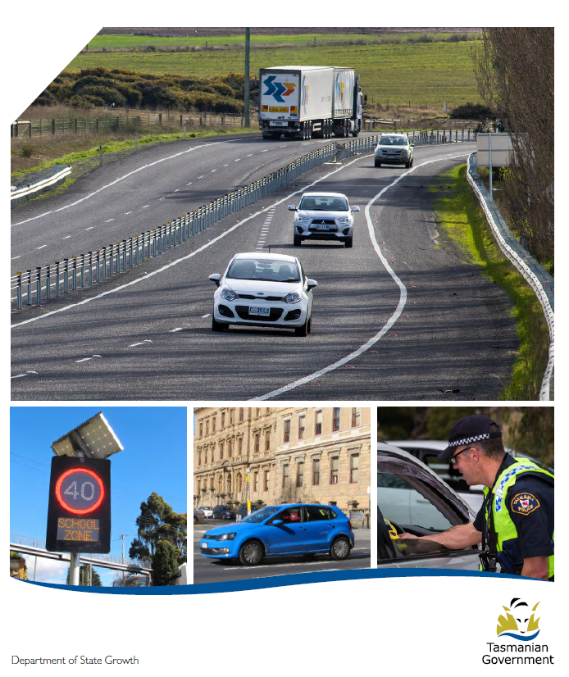

Quarterly Progress Report to RSAC
as at 31 December 2017

Progress on meeting Towards Zero Strategy targets
The key interim target for the Towards Zero – Tasmanian Road Safety Strategy 2017-2026 (Towards Zero Strategy) is to reduce the number of annual serious injuries and deaths on Tasmanian roads to fewer than 200 by 2026. This is an ambitious target of 100 fewer serious casualties per year than for the period 2012-2016 (annual average) and will move us towards the long-term goal of zero serious casualties on Tasmanian roads.

Serious Casualties
The number of serious casualties in 2017 was 303, compared to 318 in 2016, a 4.7 per cent decrease. The 2017 figure of 303 is a 0.2 per cent increase on the five year serious casualty average of 302.4 (2012-2016).

Fatalities
In 2017, there were 36 fatalities on Tasmanian roads which is the same number as recorded in 2016. The figure of 36 fatalities in 2017 is a 7.1 per cent increase on the five year fatalities average of 33.6 (2012-2016).

Serious Casualties Tasmania – Annual Count and Towards Zero Target
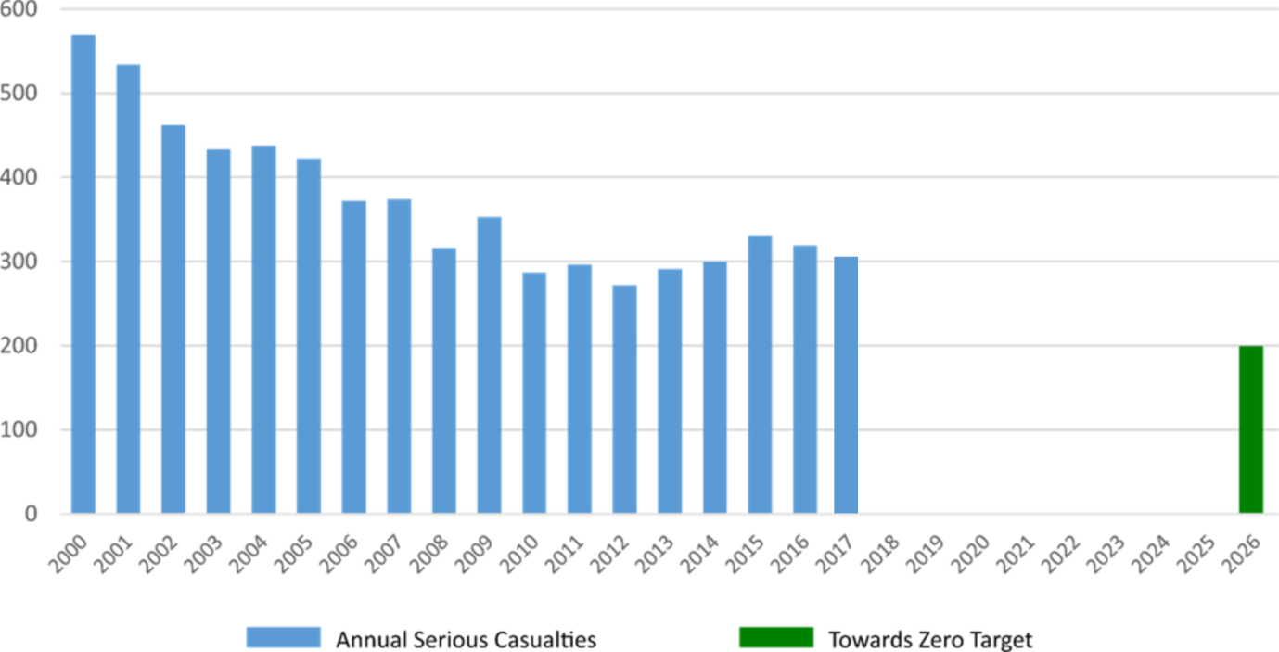

Annual fatalities – Rate per 100,000 population

Note: NT omitted from chart for clarity purposes.

Progress on meeting MAIB targets

Motor Accidents Insurance Board (MAIB) injury statistics show the number of fatalities and the level of claims for serious injuries on our roads.
Various claim reduction targets are specified in the Memorandum of Understanding between the Department of State Growth (State Growth) and the MAIB. Progress against high level targets is shown below, expressed as 12 month moving totals.

Fatalities – 12 Month Rolling Total
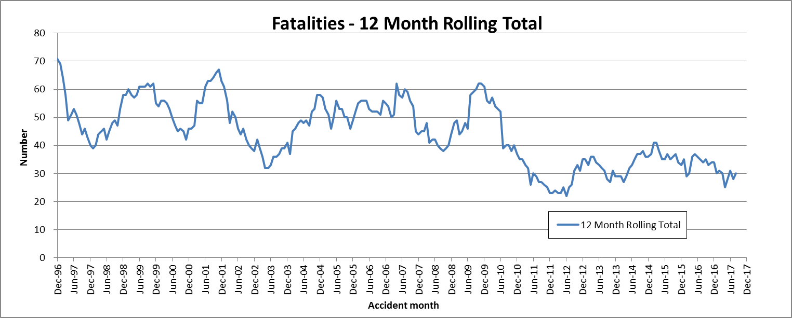

Total Serious Claims – 12 Month Rolling Total
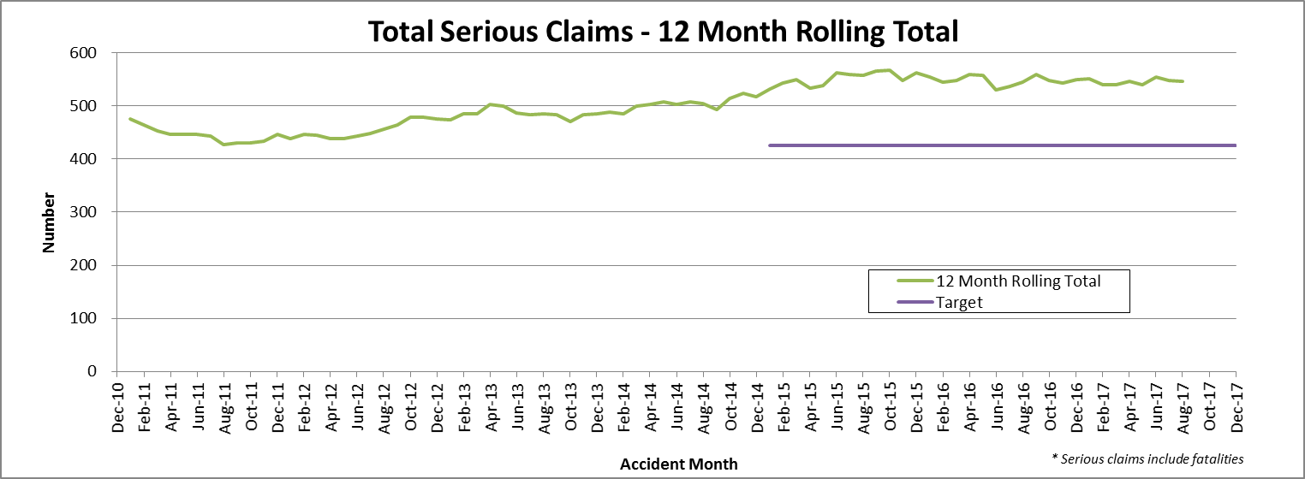

Statistics
Serious Casualties by Quarter by Age Group – 12 period moving average
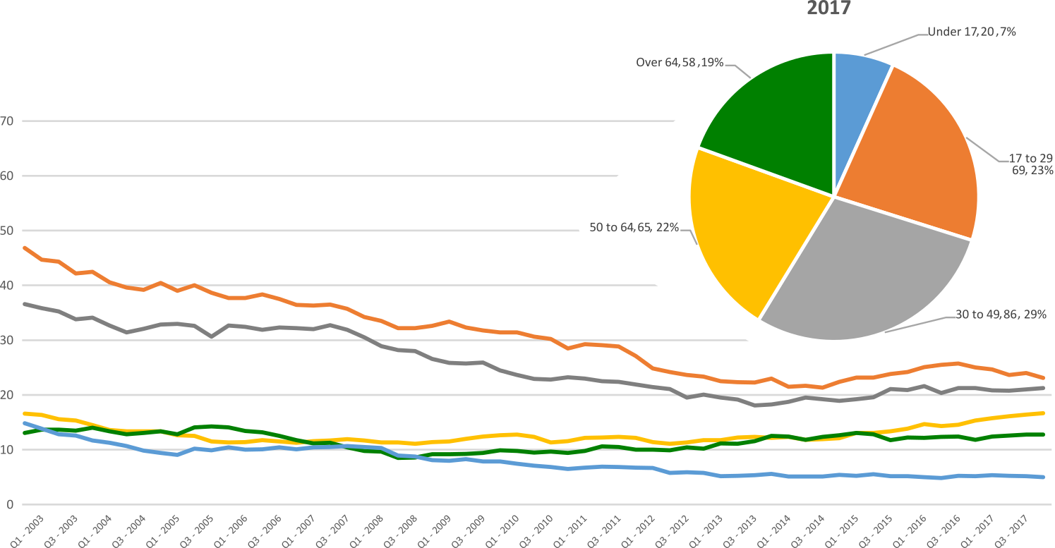

Serious Casualties by Quarter by Gender – 12 period moving average
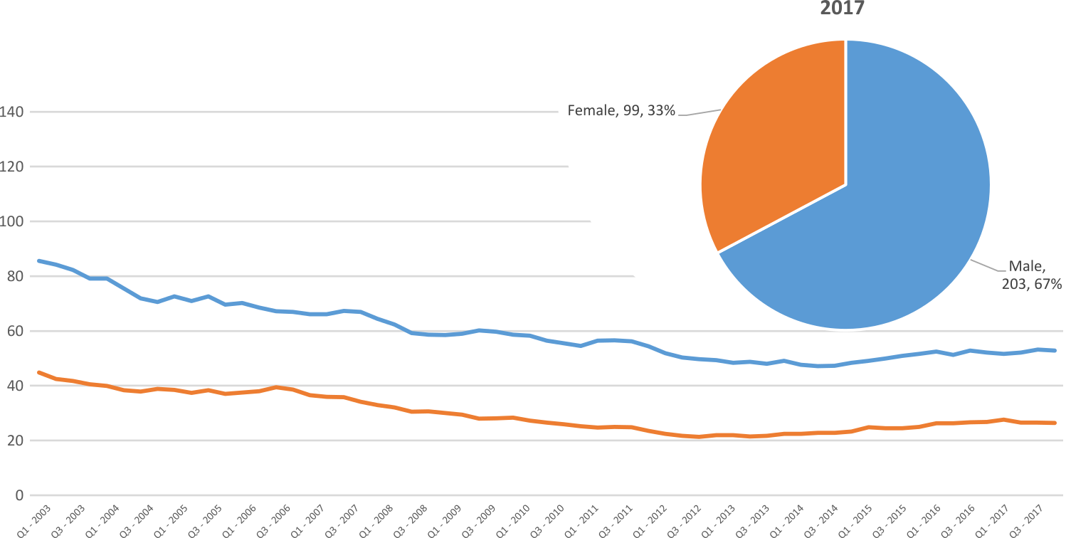

Serious Casualties by Quarter by Road User Type – 12 period moving average
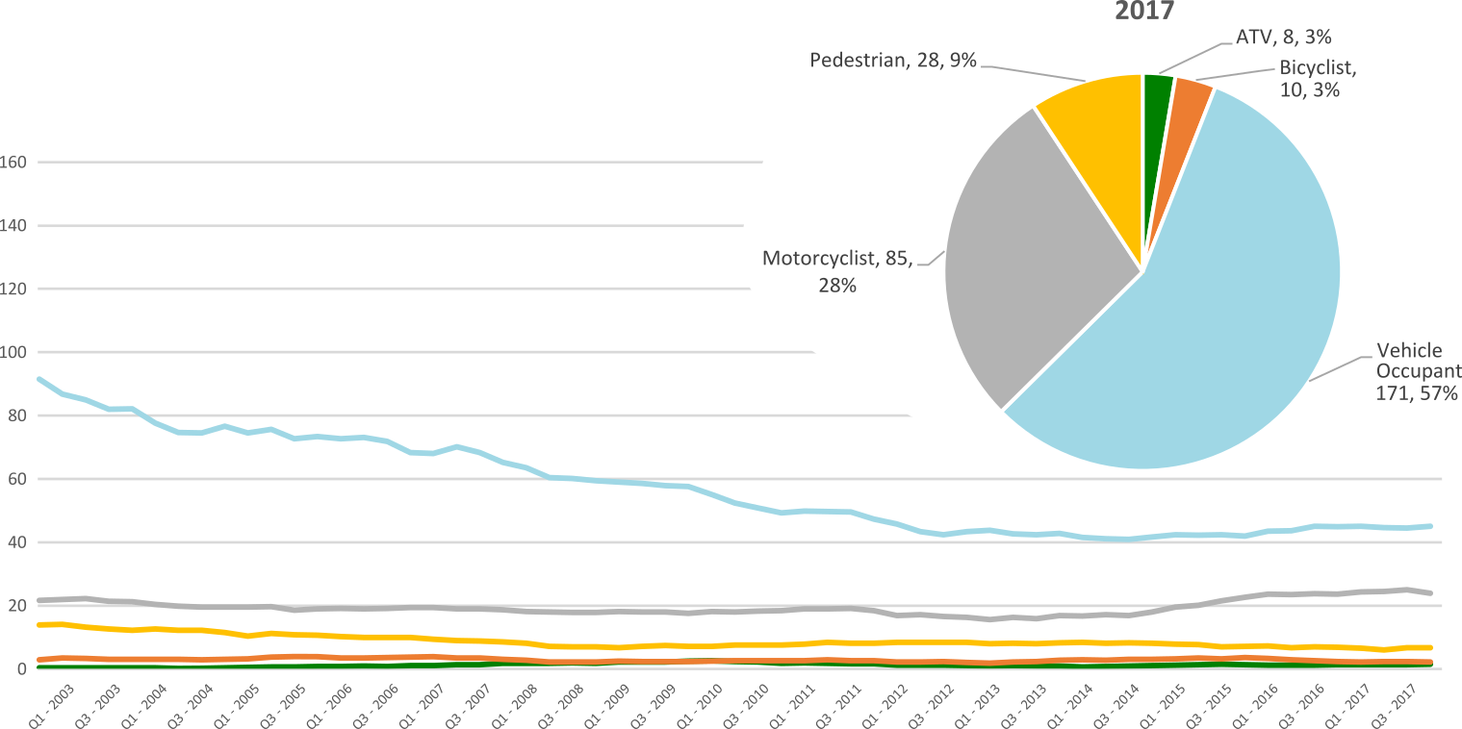

Serious Casualties by Quarter by Speed Zone – 12 period moving average
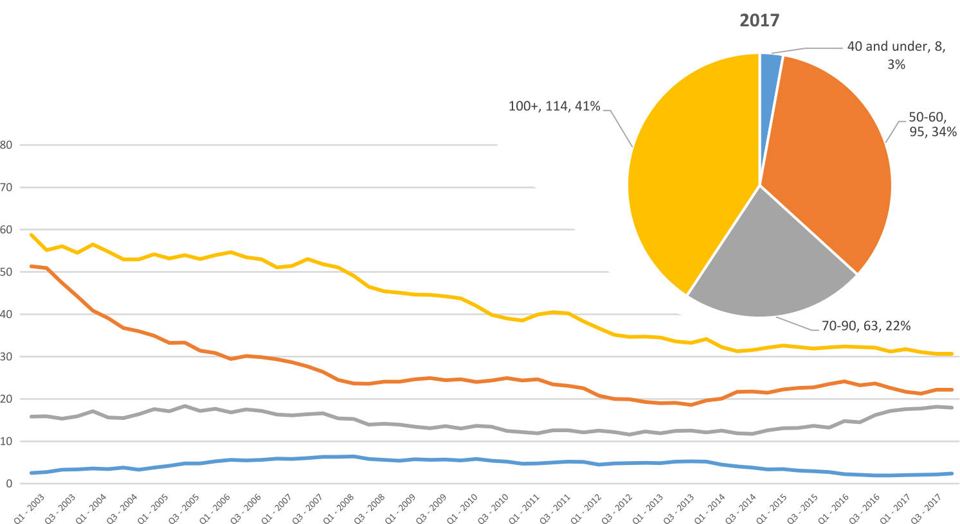
Pie chart excludes serious casualties where speed zone is recorded as ‘not known’

Serious Casualties by Quarter by Crash Type (DCA) – 12 period moving average
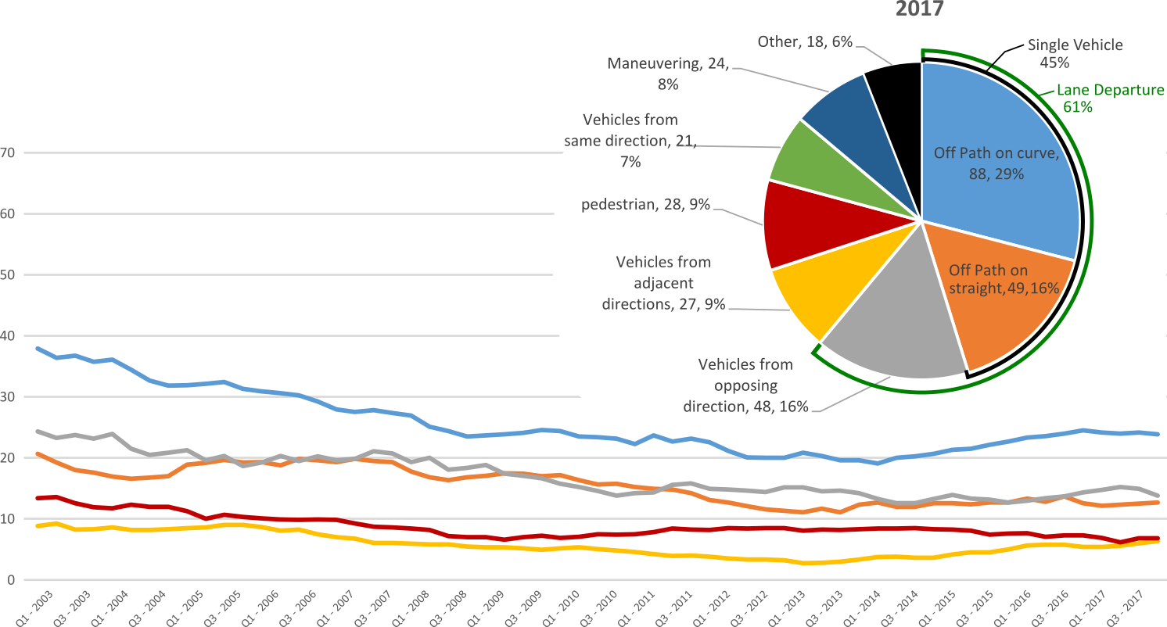
Other includes crash types: on-path (4%), overtaking (4%), passenger & miscellaneous (2%)

Serious Casualties by Quarter by Urban/Non-Urban – 12 period moving average
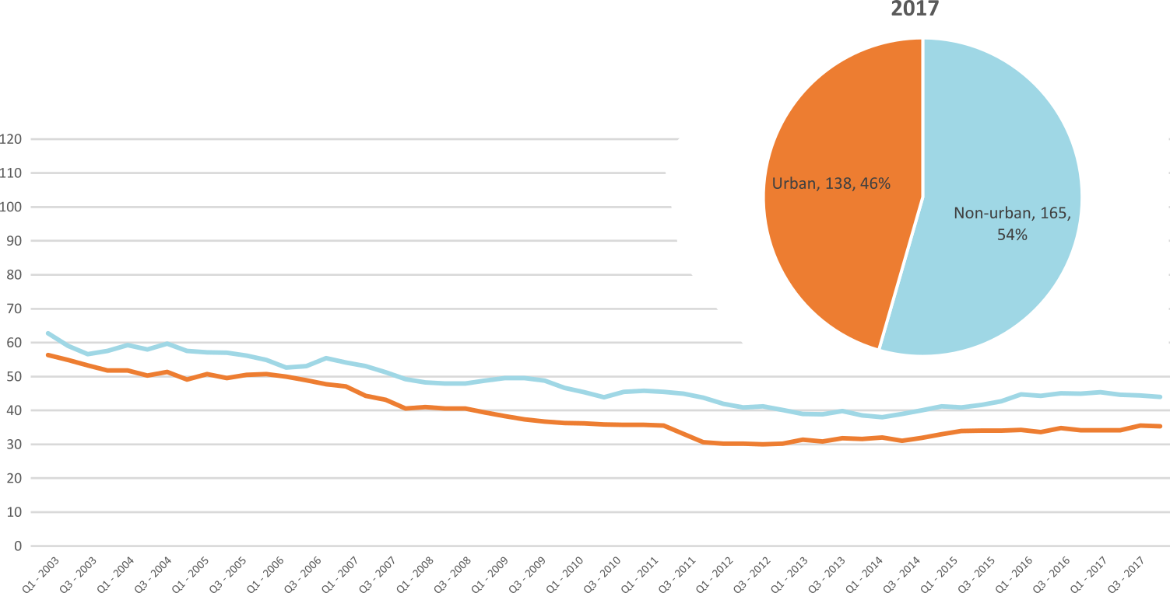
Based on the Australian Bureau of Statistics’ ‘significant urban area’ geographic definition.
Serious Casualty locations 2017 (Black = Fatality, Red = Serious Injury)
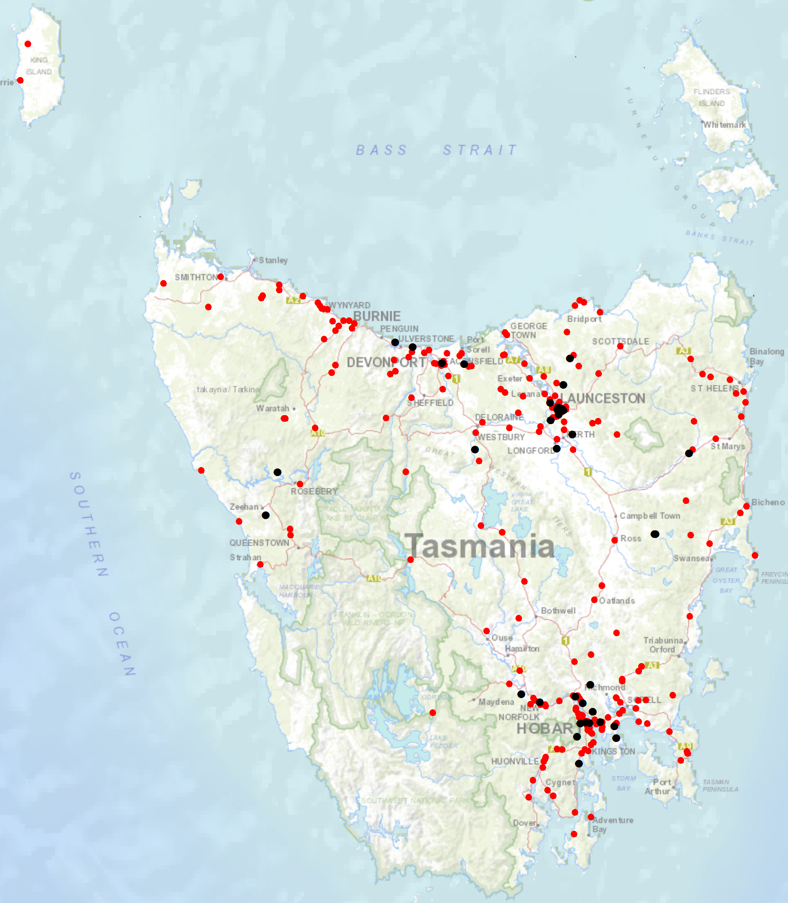

Priority Actions 2017-2019

Safe Road Users

- Improve the Graduated Licensing System to reduce serious casualties for young road users (17-25 year olds).
- Introduce safety initiatives to reduce motorcyclist serious casualties.
- Promote safer road user behaviour through education and enforcement.

Safe Roads and Roadsides

- Reduce run-off-road and head-on crashes through improved infrastructure.
- Reduce the severity of intersection crashes through improved infrastructure treatments.
- Embrace safe system thinking in road design.
- Reduce serious casualties through improved delineation such as line marking.

Safe Vehicles

- Improve the star rating of Tasmania’s vehicle fleet to include vehicles with better safety features.
- Increase the number of motorcycles with ABS.

Safe Speeds

- Introduce more appropriate speed limits to reduce serious casualties.
- Increase enforcement through technology to reduce speed related serious casualty crashes.

Progress on projects
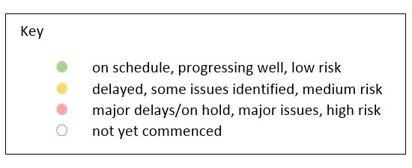
Action Plan 2017-2019
Safe Road Users
Project | Responsibility | Status | Milestones achieved | Milestones planned |  | Comments | Budget  Life of project  $ | YTD  2017/18  $
Review of GLS for novice drivers | Road Safety, State Growth |  | Stage 1 complete which included analysis of Tasmanian GLS, Novice Kit, and comparison with the national policy framework and jurisdictional best practice.  Paper went to RSAC Out-of-Session on 9 October 2017 on the recommended changes to Tasmanian GLS. | Stage 2 of the GLS Review has commenced which will involve seeking endorsement from the Steering Committee on the recommended changes to the GLS, legislative changes, procurement of information technology platforms and communications and consultation. |  | Commencement of Stage 2 has involved the development of another project plan and sub-groups to lead specific areas of the project. | 3,000,000 | 1,148
New motorcycle training and assessment program | Registration & Licensing, State Growth |  | Following the Minister’s announcement on 29 June 2017, the progressive roll out of the new Motorcycle and Assessment Program commenced in Devonport on 29 July 2017, followed by Hobart end August 2017.  The new training facilities at Launceston have been developed, including the new range and on-road routes.  The new training film demonstrating the safety benefits of the new Program and the top 5 motorcycle crashes has been developed.  Existing motorcycle learner licence holders affected by the transitional arrangements in the North West and South have been contacted.  The Grant Deed has been established to fund the transitional arrangements. | New Program scheduled to commence in Launceston on 8 January 2018 when AJL offices reopen.  Commence direct communication with those affected by the transitional arrangements in the North on 2 January 2018.  Recontact those affected by the transitional arrangements in the Northwest and South following the outcomes of the review of the transitional arrangements.  Finalise the communication strategy, including updating the website regarding the final state wide roll out and the outcomes of the review of the transitional arrangements by first week of January 2018. |  | Commence the development of the auditing and compliance monitoring framework.  Commence scoping the Longitudinal Study that will look to evaluate the new Program and any potential linkages to crash statistics in the future.  The Transitional Arrangements have been reviewed and revised subsidy allocation for the mandatory group is currently with the Minister for approval.  All new Trainee Assessors must participate in the Registrar of Motor Vehicles’ approved trainee assessor training program and demonstrate competency in delivering the new Program prior to receiving accreditation. | Implementation Project 350,000  Transitional Arrangement 300,000  Balance for Communications 160,000 | 281,610
Protective gear for motorcyclists | Road Safety, State Growth |  | The recently produced Motorcycle Protective Gear video and supporting collateral has now been incorporated into the new Motorcycle Training and Assessment Program. Every learner will watch the video and receive a supporting brochure.  Additional collateral has been distributed State-wide to motorcycle retailers. |  |  | Project complete. | 75,000 | 39,965
Towards Zero Enforcement Project - Introduce rear-facing automated speed cameras | Tasmania Police |  |  |  |  | Project objectives captured by the project ‘increase number of fixed speed cameras in urban areas’. Refer to SOC paper  Project not to be reported on as a standalone project | 132,000  To review 5 projects | 132,000
Towards Zero Enforcement Project - Increased motorcycle-focused enforcement | Tasmania Police |  | Project brief approved by Tasmania Police but not yet commenced. | Project scheduled to be completed next quarter.
Towards Zero Enforcement Project - Increased enforcement of high-risk behaviours | Tasmania Police |  | Project brief approved by Tasmania Police. | Nil for next quarter.
Promote safe behaviours through media campaigns | EESC,  Road Safety, State Growth |  |  | Long-term enforcement campaign to complement Police media activity during holiday periods launched in December. |  | Funding approved by RSAC in May. | Road Safety Levy funding  $350,000 | 64,350

Safe Roads and Roadsides
Project | Responsibility | Status | Milestones achieved | Milestones planned | Comments | Budget  Life of project  $ | YTD  2017/18  $
Flexible barrier installation program | State Roads, State Growth |  |  | Scoping and planning phase to identify suitable projects and locations underway. Identify sections of roads for treatment; scope and develop project plan. |  | 7.5 million
Audi-tactile line marking program | State Roads, State Growth |  |  | Scoping and planning phase to identify suitable projects and locations underway. Identify sections of roads for treatment; scope and develop project plan.
Shoulder sealing program | State Roads, State Growth |  |  | Scoping and planning phase to identify suitable projects and locations underway. Identify sections of roads for treatment; scope and develop project plan.
Improved delineation on high risk roads | State Roads, State Growth |  |  | Scoping and planning phase to identify suitable projects and locations underway. Identify sections of roads for treatment; scope and develop project plan.
Intersection treatment program | State Roads, State Growth |  |  | Scoping and planning phase to identify suitable projects and locations underway. Identify sections of roads for treatment; scope and develop project plan.
Safe system thinking in road design | Road Safety, State Growth |  |  | Community engagement and technical training currently being developed through the Building Tasmania’s Road Safety Knowledge framework. |  | 300 000 | 0

Safe Vehicles
Project | Responsibility | Status | Milestones achieved | Milestones planned | Comments | Budget  Life of project  $ | YTD
Increase the number of motorcycles with ABS | Road Safety, State Growth
Minimum safety specifications for all new passenger and light commercial vehicles in the Tasmanian Government fleet. | Road Safety, State Growth |  | Project planning and scoping completed.  Review of the Government Vehicle Fleet Safety Policy complete.  Proposed policy and recommendations endorsed by RSAC at 21 November 2017 meeting. | Cabinet documents prepared on the proposed policy for consideration by the Minister in the first quarter of 2018. | On hold due to State Election. | 0 | NA
Promote vehicle fleet safety standards for commercial fleets | Road Safety, State Growth

Safe Speeds
Project | Responsibility | Status | Milestones achieved | Milestones planned | Comments | Budget  Life of project  $ | YTD  $
Development of speed limit setting guidelines | Road Safety, State Growth
Assessment of speed limits on 100km/h roads | Road Safety, State Roads, State Growth
Towards Zero Enforcement Project - Review of point to point (P2P) speed cameras on high risk rural roads | Tasmania Police |  | Project brief approved by Tasmania Police.  Previous business case reviewed.  Literature review commenced. | Review crash data.  Desktop assessment of P2P application in Tasmania.  Jurisdictional sweep of P2P.  Preparation of a report. | The P2P sites identified in the previous business case are not supported by Tasmania Police.  Should Tasmania Police recommend that P2P form part of the future speed enforcement strategy, a separate project would need to be progressed and resourced. | 132,000  To review 5 projects
Towards Zero Enforcement Project - Increased fixed speed cameras in urban areas | Tasmania Police |  | Project brief approved by Tasmania Police.  Working Group formed and first meeting held on 29 February 2018.  Performance summary of existing fixed camera assets. | Undertake actions identified by Working Group  Complete project within next quarter. | On average, the existing fixed cameras detect <1% of passing vehicles.  Crash frequency post camera installation (with exception of Tasman Bridge cameras) has not reduced.  1 in 5 of all speeding infringements are issued by fixed cameras.  Two key outcomes of the Working Group were that identifying new sites based on the previous methodology was not appropriate, and that new sites should (where practical) integrate variable speed limit, weather detection and speed detection technologies. Scope for an innovative project.
Reducing Urban Arterial Speed Limits in Tasmania from 60km/h to 50km/h. | Road Safety State Growth |  | Project planning and scoping completed. |  | Initial data analysed suggests project would be of low road safety benefit.  On hold. | TBC

Road Safety Work Program
Safe Road Users
Project | Responsibility | Status | Milestones achieved | Milestones planned |  | Comments | Budget  Life of project  $ | YTD  $
MAIP Review | Road Safety, State Growth |  | Draft MAIP Report completed | Sign-off by MAIP Review Steering Committee  Sign-off by Minister  Release of report |  | Steering Committee soon to receive final report. | State Growth funded | 0
Distance makes the Difference campaign Stage 2 | Road Safety, State Growth |  |  |  |  | Phase 2 has been well received. Good audience engagement through a managed Youtube campaign. Also TV, radio and bus back advertising.  The campaign is scheduled to run through until March 2019. | 400,000 | 302,362
Implementation of minimum passing distance legislation | Road Safety, State Growth |  | Legislation commenced on 27 September 2017. | Follow up road user survey planned for Mar/Apr 2018 to gauge public acceptance of new laws.

Project | Responsibility | Status | Milestones achieved | Milestones planned | Comments | Budget  Life of project  $ | YTD  $
Tourist road safety campaign – Phase 2 (2017-2019) | Road Safety, State Growth |  | Visiting drivers’ website launched December 2017. 6 x 15 second films running in Hobart Airport and other key locations. Collateral continues to be distributed. Extending messaging through stakeholder networks. Seasonal worker campaign launched in December 2017. | Workshop with rental car companies and stakeholders planned for March 2018. |  | 650,000 | 16,001
Community Road Safety Grants Program | Road Safety, State Growth |  | Community Road Safety Grants complete 2017, There is one more funding round to be conducted. | Remaining funding round will be advertised in April 2018. | Acquittals from previous funding rounds are due and a report will be completed for RSAC at a later date. | 200,000  p/a | 100
Learner Driver Mentor Program and Driver Mentoring Tasmania | Road Safety, State Growth |  | Funding has been delivered to 16 LDMPs 2017/18. | The current LDMP Evaluation will inform ongoing delivery of LDMP program beyond 2018. |  | 500,000  p/a  702,000 approved for 2017/18. | 691,358
Learner Driver Mentor Program evaluation | Road Safety, State Growth |  | Draft Evaluation plan completed. | Final evaluation will be presented to RSAC at the next meeting for discussion. | Funded by Discretionary Fund | 50,000 | 0
RYDA program | Road Safety, State Growth |  | Program funded to continue throughout 2017/18. | Discussions with RSE have been successful and the future program will be more reflective of the Tasmanian landscape. Meeting with Rotary early 2018 to discuss gaps in program delivery. |  | 75,000 | 0

Safe Roads and Roadsides
Project | Responsibility | Status | Milestones achieved | Milestones planned | Comments | Budget  Life of project  $ | YTD  $
Pedestrian safety package – Stage 1: Pedestrian Countdown Timers (PCTs) Trial | State Roads, State Growth |  | Hobart PCTs installed week of 23 October 2017.  One Launceston PCT site installed week of 11 December 2017.  UTAS monitoring in November and December. | Two remaining PCT sites in Launceston to be installed in January 2018. | Problems encountered with Launceston sites; State Roads is working with the manufacturer to overcome technical problems. | 70,000 | 25,425
Pedestrian safety package – Stage 2 | State Roads  State Growth |  |  |  |  | 430,000 | 0
Motorcycle safety package – infrastructure safety improvements | State Roads, State Growth |  |  | Engage safety specialist. |  | 300,000 | 86,788
Vulnerable Road User Program  2013-2017 | State Roads, State Growth |  | Four projects still to be completed. | Projects to be completed next quarter. |  | 2,500,000 | 1,892,793
Vulnerable Road User Program  2017-2022 | State Roads  State Growth |  | Letters sent advising councils of assessment outcome for Round 5 (2017-18) in November. Councils submitting detailed plans for State Roads approval. One project approved and grant deed sent. | Grant deeds to be sent next quarter for each of the 14 remaining projects. |  | 2,500,000 | 0

Project | Responsibility | Status | Milestones achieved | Milestones planned | Comments | Budget  Life of project  $ | Actual  Life of project  $
Esk Main Road shoulder sealing, edge line marking and safety improvements | State Roads, State Growth |  | Safety barrier on small section near rail crossing installed | Final seal and line marking to be done 2017-18 construction season. |  | 5,860,000 | 5,085,666
Lyell Highway, south of Hamilton shoulder sealing | State Roads, State Growth |  | Safety barrier installed. | Final seal and line marking (2017-18 season). |  | 1,272,000) | 1,080,841
Lyell Highway Ouse to Strickland Road | State Roads  State Growth |  | Detailed design and scoping completed.  RSAC and Minister approved additional funding of $1m to address issues identified in design stage. | Construction to start January 2018. | Design stage identified northern end pavement width and verge material unsuitable for road construction. | $4,000,000 | 177,953
Midland Highway Safety Improvements | State Roads, State Growth |  | Projects progressing on the 10 year infrastructure upgrade. | Continuation of projects. |  | 20,000,000 | 13,588,890

Safe Vehicles
Project | Responsibility | Status | Milestones achieved | Milestones planned | Comments | Budget  Life of project  $ | YTD  $
ANCAP support | Road Safety, State Growth |  | 2016/17 payment | 2017/18 payment |  | 12,000 p/a | 11,851

Safe Speeds
N/A. There are no current Safe Speed projects under the Road Safety Work Program.

Other
Project | Responsibility | Status | Milestones achieved | Milestones planned | Comments | Budget  Life of project  $ | YTD  $
RSAC and Towards Zero Strategy support | Road Safety, State Growth |  | Funding for Manager RSAC Secretariat, Senior Project Officer TEB, Chair and Expert sitting fees and operation of RSAC. |  |  | Up to 400,000  p/a | 141,089
MAIP Transitional arrangements | Registration & Licensing, State Growth |  |  |  |  | 3,300,000 | 40,996
Lane filtering for motorcyclists | Road Safety, State Growth |  | Regulations made by Governor on 19 December 2017 | Communications package to commence on 22 January 2018.  New laws to commence on 29 January 2018. | Communications package includes radio ads, online ads, web content and video for RSAC site, posts on Police, RACT and TMC Facebook pages. | 30,000

Project | Responsibility | Status | Items funded | Budget  17/18  $ | YTD
Discretionary Activities Fund | Road Safety, State Growth |  | Redevelopment of RSAC Website | 250,000 | 3,400
 |  |  | Road Torque |  | 30,662
 |  |  | Safe System Infrastructure Workshop |  | 35,486
 |  |  | Road Safety Week |  | 6,170
 |  |  | Capacity Building |  | 14,453
 |  |  | LDMP Evaluation |  | 21,901
 |  |  |  |  | 112,072

Funding

Road Safety Levy Overview
As at 31 December 2017
2017/18 Financial Year | Proposed budget  $ | Actual (ytd)  $
Opening balance (as at 1 July 2017) |  | 14,663,962
Revenue 2017/18
Road safety levy collected | 13,500,000 | 6,662,800
Funds available for distribution | 10,900,000 | 4,062,800
Total funds available for distribution | 25,563,962 | 18,726,762
Expenditure
Roads and Roadsides |  | 1,469,034
Policy and Projects |  | 1,783,045
Total Expenditure |  | 1,368,087
Balance |  | 15,474,683
Allocated funding
Safe Roads and Roadsides |  | 7,000,000
Policy and Projects |  | 4,972,955
Total allocated funding |  | 11,972,955
Unallocated funding
Safe Roads and Roadsides |  | 500,000
Policy and Projects |  | 3,001,728
Unallocated funding balance |  | 3,501,728

MAIB Funding
As at 31 December 2017
2017/18 Financial Year | Budget  $ | Actual (ytd)  $ | Balance  $
Expenditure (State Growth)
Administration & Public Relations | 283,194 | 137,377 | 145,817
Public Education | 964,126 | 283,211 | 680,915
Research | 82,724 | 22,400 | 60,324
Subtotal | 1,330,044 | 442,988 | 887,056
Expenditure (Tasmania Police)
Salaries | 1,853,259 | 889,464 | 963,795
Operating Expenses | 317,642 | 70,036 | 247,606
Equipment | 888,646 | 130,400 | 758,246
Subtotal | 3,059,547 | 1,089,901 | 1,969,646
Total | 4,389,591 | 1,532,889 | 2,856,702
Includes Carried Forward of
$ 43,150 (State Growth)
$429,547 (Police)

