Fewer than 200 serious injuries and deaths on our roads by 2026
Towards Zero Tasmanian Road Safety Strategy 2017–2026

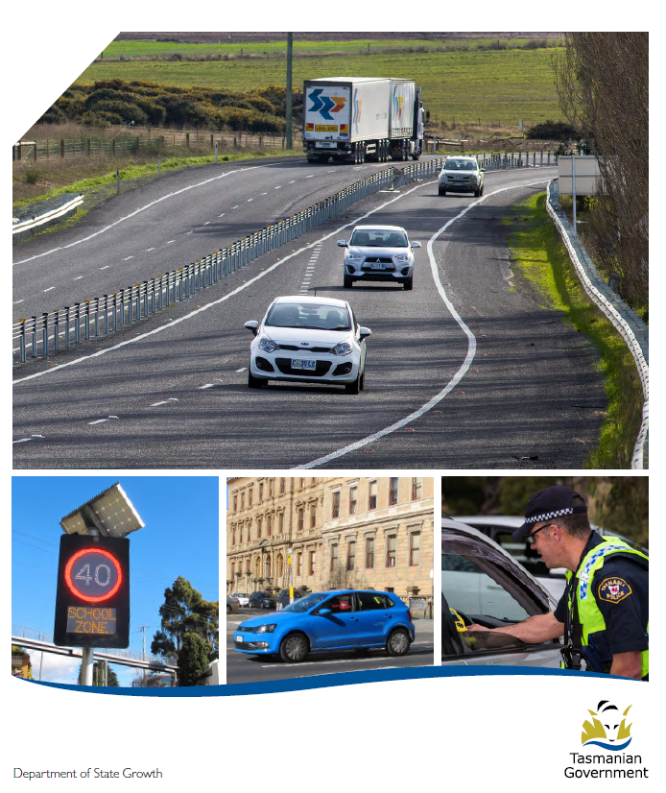

Quarterly Progress Report to RSAC
as at 30 September 2017

Progress on meeting Towards Zero Strategy targets
The key interim target for the Towards Zero – Tasmanian Road Safety Strategy 2017-2026 (Towards Zero Strategy) is to reduce the number of annual serious injuries and deaths on Tasmanian roads to fewer than 200 by 2026. This is an ambitious target of 100 fewer serious casualties per year than for the period 2012-2016 (annual average) and will move us towards the long-term goal of zero serious casualties on Tasmanian roads.

Serious Casualties
The number of serious casualties in 2016 was 319, compared to 331 in 2015, a 3.6 per cent decrease. The 2016 figure of 319 is a 7 per cent increase on the five year serious casualty average of 298 (2011-2015).

Fatalities
In 2016, there were 37 fatalities on Tasmanian roads which is four more than the 33 recorded in 2015. The figure of 37 fatalities in 2016 is an 18.6 per cent increase on the five year fatalities average of 31.2 (2011-2015).

2017 YTD
There have been 216 serious casualties (24 fatalities and 192 serious injuries) to 30 September 2017, down 8.9 per cent on the same period last year of 237 serious casualties (29 fatalities and 208 serious injuries) and down 1.3 per cent on the five year average of 218.8 serious casualties.

Serious Casualties Tasmania – Annual Count and Towards Zero Target
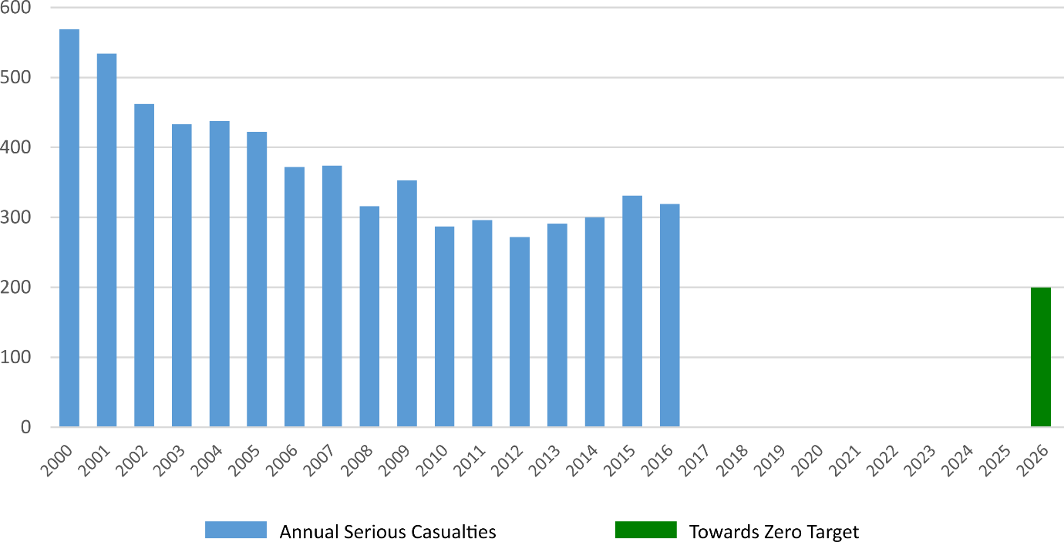

Annual fatalities – Rate per 100,000 population
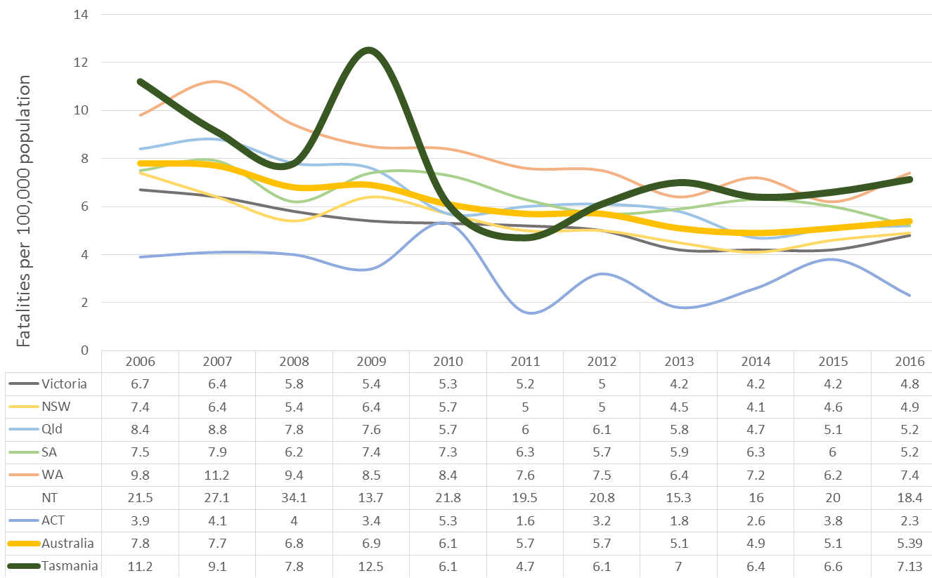
Note: NT omitted from chart for clarity purposes.

Progress on meeting MAIB targets

Motor Accidents Insurance Board (MAIB) injury statistics show the number of fatalities and the level of claims for serious injuries on our roads.
Various claim reduction targets are specified in the Memorandum of Understanding between the Department of State Growth (State Growth) and the MAIB. Progress against high level targets is shown below, expressed as 12 month moving totals.

Fatalities – 12 Month Rolling Total
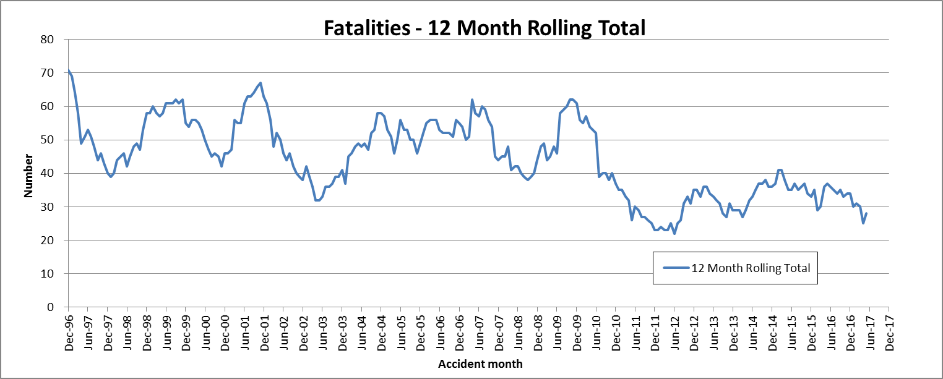

Total Serious Claims – 12 Month Rolling Total
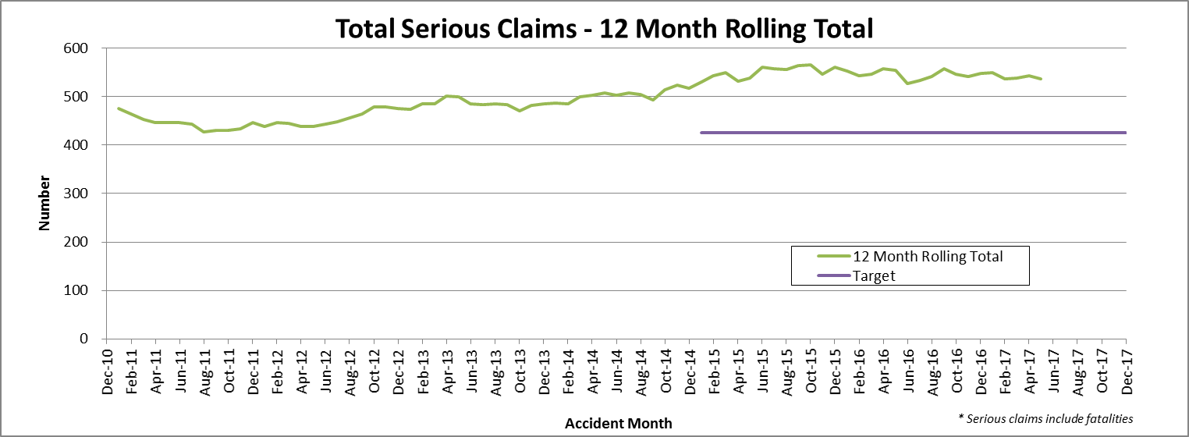

Statistics
Serious Casualties by Quarter by Age Group – 12 period moving average
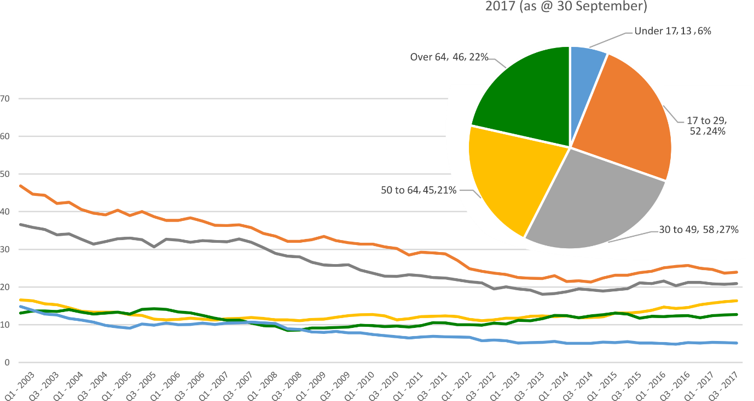

Serious Casualties by Quarter by Gender – 12 period moving average
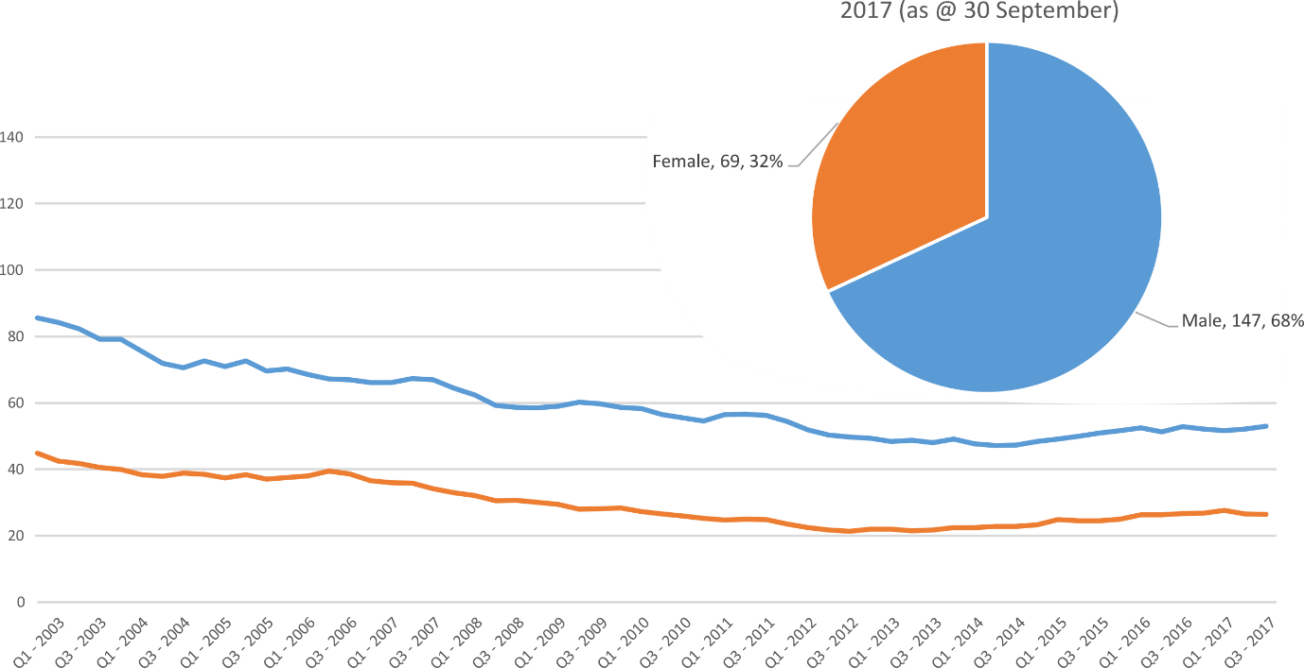

Serious Casualties by Quarter by Road User Type – 12 period moving average
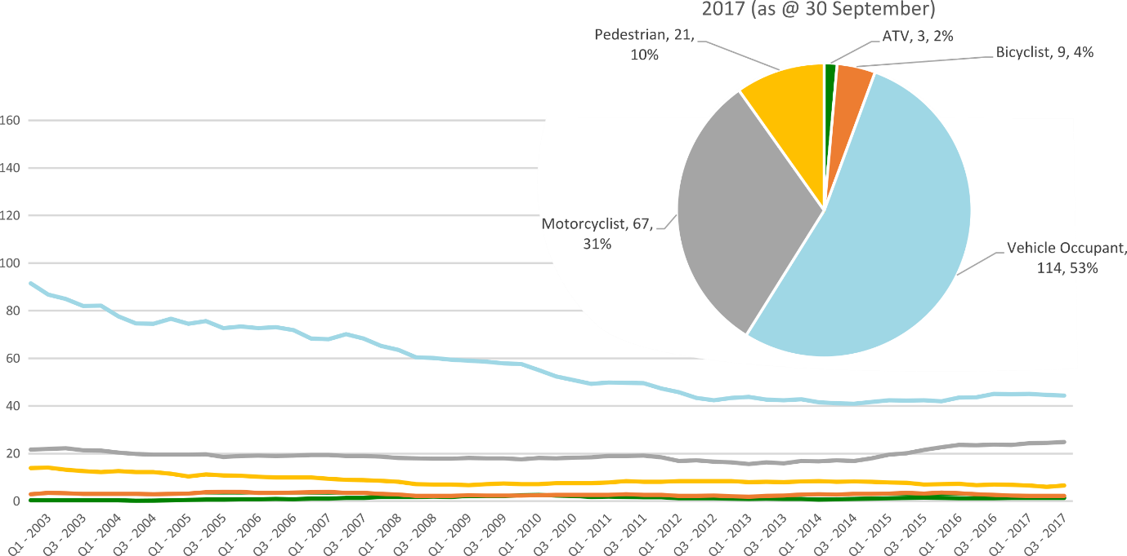

Serious Casualties by Quarter by Speed Zone – 12 period moving average
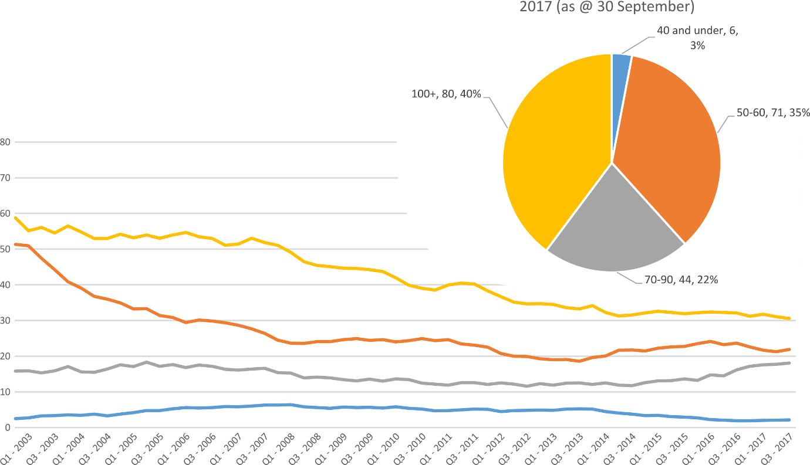
Pie chart excludes serious casualties where speed zone is recorded as ‘not known’

Serious Casualties by Quarter by Crash Type (DCA) – 12 period moving average
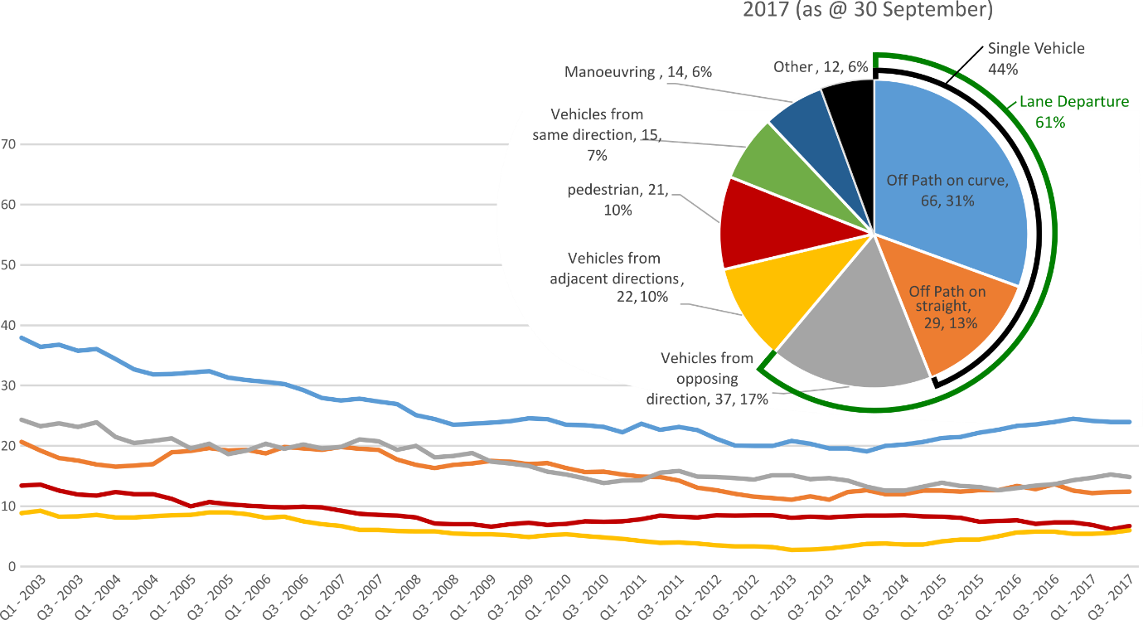
Other includes crash types: on-path (4%), overtaking (2%), passenger & miscellaneous (2%)

Serious Casualties by Quarter by Urban/Non-Urban – 12 period moving average
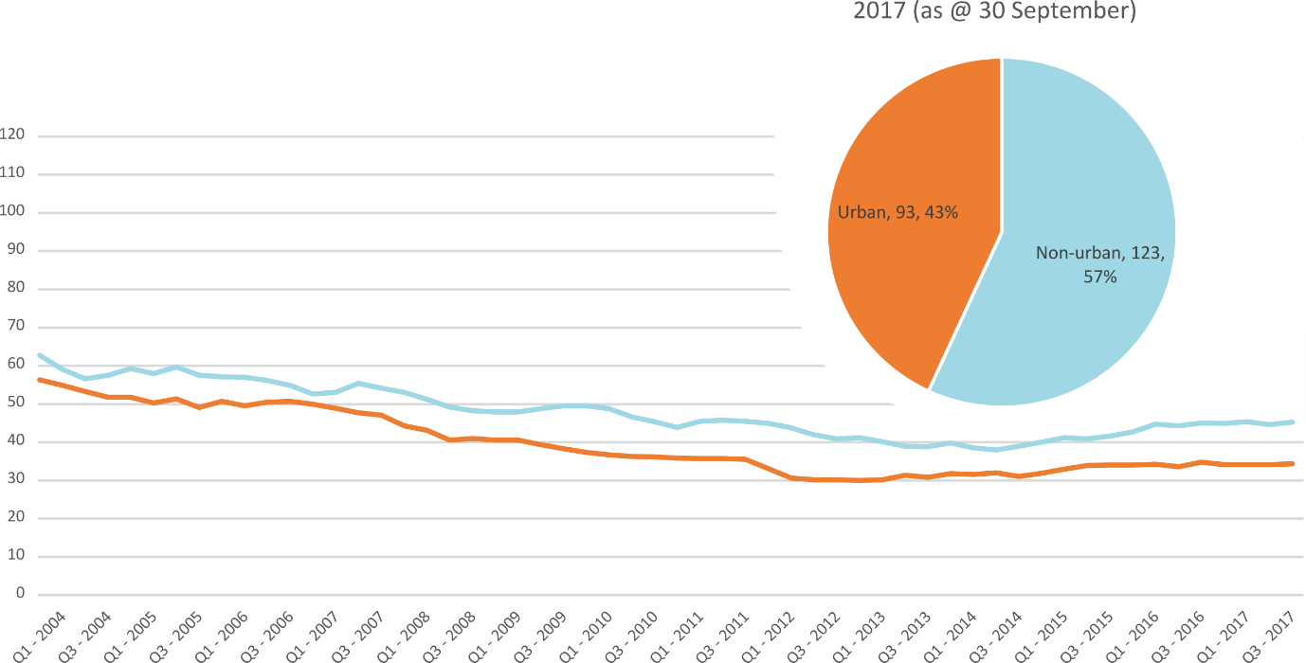
Based on the Australian Bureau of Statistics’ ‘significant urban area’ geographic definition.
Serious Casualty locations as @ 30 September 2017 (Black = Fatality, Red = Serious Injury)
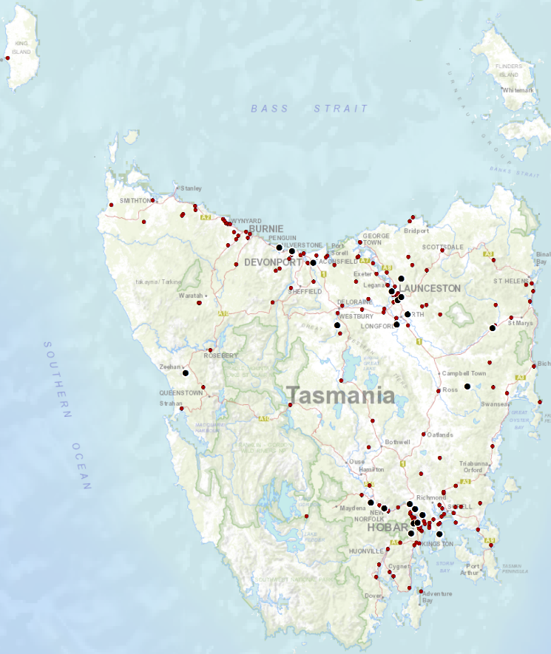

Priority Actions 2017-2019

Safe Road Users

- Improve the Graduated Licensing System to reduce serious casualties for young road users (17-25 year olds).
- Introduce safety initiatives to reduce motorcyclist serious casualties.
- Promote safer road user behaviour through education and enforcement.

Safe Roads and Roadsides

- Reduce run-off-road and head-on crashes through improved infrastructure.
- Reduce the severity of intersection crashes through improved infrastructure treatments.
- Embrace safe system thinking in road design.
- Reduce serious casualties through improved delineation such as line marking.

Safe Vehicles

- Improve the star rating of Tasmania’s vehicle fleet to include vehicles with better safety features.
- Increase the number of motorcycles with ABS.

Safe Speeds

- Introduce more appropriate speed limits to reduce serious casualties.
- Increase enforcement through technology to reduce speed related serious casualty crashes.

Progress on projects
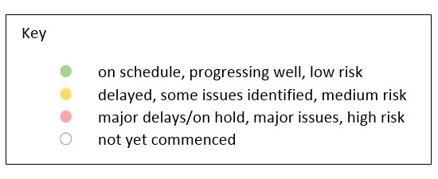
Action Plan 2017-2019
Safe Road Users
Project | Responsibility | Status | Milestones achieved | Milestones planned |  | Comments | Budget  Life of project  $ | YTD  2017/18  $
Review of GLS for novice drivers | Road Safety, State Growth |  | Review of Tasmanian GLS against Australian GLS Policy Framework has been completed (Stage 1).  - Analysis of crashes involving young drivers Options paper developed.  - Out of session options paper provided for RSAC endorsement (October 2017). | Stage 2 of the GLS Review has commenced:  - Review current resources supporting the GLS and best practice in other jurisdictions; and  - Develop recommended changes to improve the communication pathway for GLS (pre-learners, learners, supervisors). |  | Development of new communication material for pre-learners, learners and supervisor drivers  Commenced investigation of e-logbook in Tasmania  Commenced drafting of a Communications and Stakeholder Plan | 3,000,000 | 0
New motorcycle training and assessment program | Registration & Licensing, State Growth |  | Following the Ministers announcement on 29 June 2017, the progressive roll out of the new Motorcycle and Assessment Program commenced in Devonport on 29 July 2017, followed by Hobart end August 2017.  The Launceston implementation is aimed for end of 2017.  Existing motorcycle learner licence holders affected by the transitional arrangements in the North West and South have been contacted.  All assessors have participated in the two staged training program.  The Grant Deed has been established to fund the transitional arrangements | Range, on-road routes and training facility set up in Launceston to occur following council approval, aimed for Mid November 2017.  Commence delivery of new bridging and pre-learner course in Launceston in December 2017.  Finalise the communication strategy including a new training film demonstrating the safety benefits of the new Program and the top 5 motorcycle crashes.  Commence direct communication with those affected by the transitional arrangements in the South in Mid November 2017. |  | Commence the development of the auditing and compliance monitoring framework. | Implementation Project 350,000  Transitional Arrangement 300,000  Balance for Communications 160,000 | 27,223
Protective gear for motorcyclists | Road Safety, State Growth |  | The recently produced Motorcycle Protective Gear video and supporting collateral has now been incorporated into the new Motorcycle Training and Assessment Program. Every learner will watch the video and receive a supporting brochure.  Additional collateral has been distributed State-wide to motorcycle retailers. |  |  | Project complete. | 75,000 | 39,965
Introduce rear-facing automated speed cameras | Tasmania Police |  |  |  |  | Refer to Towards Zero Enforcement Project (Safe Speeds)
Increased motorcycle-focused enforcement | Tasmania Police |  |  |  |  | Refer to Towards Zero Enforcement Project (Safe Speeds)
Promote safe behaviours through media campaigns | EESC,  Road Safety, State Growth |  | Concept approved by Police and Road Safety Advisory Council Education and Enforcement Sub-Committee. In production. | Long-term enforcement campaign to complement Police media activity during holiday periods to be launched in December. |  | Funding approved by RSAC in May. | Road Safety Levy funding | $350,000
Increased enforcement of high-risk behaviours | Tasmania Police |  |  |  |  | Refer to Towards Zero Enforcement Project (Safe Speeds)

Safe Roads and Roadsides
Project | Responsibility | Status | Milestones achieved | Milestones planned | Comments | Budget  Life of project  $ | YTD  2017/18  $
Flexible barrier installation program | State Roads, State Growth |  |  | Scoping and planning phase to identify suitable projects and locations underway. Identify sections of roads for treatment; scope and develop project plan. |  | 7.5 million
Audi-tactile line marking program | State Roads, State Growth |  |  | Scoping and planning phase to identify suitable projects and locations underway. Identify sections of roads for treatment; scope and develop project plan.
Shoulder sealing program | State Roads, State Growth |  |  | Scoping and planning phase to identify suitable projects and locations underway. Identify sections of roads for treatment; scope and develop project plan.
Improved delineation on high risk roads | State Roads, State Growth |  |  | Scoping and planning phase to identify suitable projects and locations underway. Identify sections of roads for treatment; scope and develop project plan.
Intersection treatment program | State Roads, State Growth |  |  | Scoping and planning phase to identify suitable projects and locations underway. Identify sections of roads for treatment; scope and develop project plan.
Safe system thinking in road design | Road Safety, State Growth |  | Safe System workshops held.  Proforma strategy template prepared for local government. | Presentations to councils and stakeholders.  Promotion of training courses. |  | 300 000 | 0

Safe Vehicles
Project | Responsibility | Status | Milestones achieved | Milestones planned | Comments | Budget  Life of project  $ | YTD
Increase the number of motorcycles with ABS | Road Safety, State Growth
Minimum safety specifications for all new passenger and light commercial vehicles in the Tasmanian Government fleet. | Road Safety, State Growth |  | Project planning and scoping completed.  Review of the Government Vehicle Fleet Safety Policy complete.  Paper developed and recommendations provided for endorsement. | Pending RSAC endorsement, the proposed new Government Vehicle Fleet Safety Policy will be provided to Government for consideration in December 2017, with the intention to be implemented 1 January 2018. |  | 0 | NA
Promote vehicle fleet safety standards for commercial fleets | Road Safety, State Growth

Safe Speeds
Project | Responsibility | Status | Milestones achieved | Milestones planned | Comments | Budget  Life of project  $ | YTD  $
Development of speed limit setting guidelines | Road Safety, State Growth
Assessment of speed limits on 100km/h roads | Road Safety, State Roads, State Growth
Review of point to point speed cameras on high risk rural roads | Tasmania Police |  |  |  | Principal Project Manager recruited and commenced in October 2017. | 132,000  To review 5 projects
Increased fixed speed cameras in urban areas | Tasmania Police |  |  |  | Principal Project Manager recruited and commenced in October 2017. | 132,000  To review 5 projects
Reducing Urban Arterial Speed Limits in Tasmania from 60km/h to 50km/h. | Road Safety State Growth |  | Project planning and scoping completed. | A Policy Paper is currently being finalised which will seek to reduce all remaining 60km/h urban arterial roads to 50km/h. | Policy paper and recommendations to be presented to RSAC at its March 2018 meeting. | TBC

Road Safety Work Program
Safe Road Users
Project | Responsibility | Status | Milestones achieved | Milestones planned |  | Comments | Budget  Life of project  $ | YTD  $
MAIP Review | Road Safety, State Growth |  | Draft MAIP Report completed | Sign-off by MAIP Review Steering Committee  Sign-off by Minister  Release of report |  | Awaiting final approval of MAIP Review Report by project Steering Committee. | State Growth funded | 50,222
Distance makes the Difference campaign Stage 2 | Road Safety, State Growth |  |  | A request for quote process relating to the next phase of activity is currently underway. |  | Awaiting report on last round of activity. Initial reports are very positive. | 400,000 | 80,703
Implementation of minimum passing distance legislation | Road Safety, State Growth |  | Legislation commenced on 27 September 2017. | Follow up road user survey planned for Mar/Apr 2018 to gauge public acceptance of new laws.
Tourist road safety campaign – Phase 2 (2017-2019) | Road Safety, State Growth |  |  | Planning of next phase (includes seasonal workers, international students and interstate motorcyclists). |  | Collateral continues to be distributed. Currently consulting with stakeholders, reviewing activity to date and planning next phase. | 650,000 | 0
Community Road Safety Grants Program | Road Safety, State Growth |  | Community Road Safety Grants advertised August 2017 and Closed September 1. | Funding to be delivered to successful applicants by 1 November 2017. |  | Information on Variable Message Trailer Agreements and Intellectual Property to be provided to RSAC. | 200,000  p/a | 0
Learner Driver Mentor Program and Driver Mentoring Tasmania | Road Safety, State Growth |  | Funding is being delivered to 15 existing LDMPs and one new program for 2017-18. | Evaluation to inform ongoing delivery of LDMP program. |  |  | 500,000  p/a  702,000 approved for 2017/18 | 691,358
Project | Responsibility | Status | Milestones achieved | Milestones planned |  | Comments | Budget  Life of project  $ | YTD  $
Learner Driver Mentor Program evaluation | Road Safety, State Growth |  | Evaluation plan completed. | Contractual arrangements with potential evaluator to be finalised mid October 2017. Delivery of draft evaluation expected late December 2017. |  |  | 50,000 | 0
RYDA program | Road Safety, State Growth |  | Funding has been delivered to the program to continue throughout 2017-18. |  |  | Craig Hoey and Alysse Gavlik attended RYDA on 29 August 2017. Feedback to Rotary and RSE being prepared. | 75,000 | 0

Safe Roads and Roadsides
Project | Responsibility | Status | Milestones achieved | Milestones planned | Comments | Budget  Life of project  $ | YTD  $
Pedestrian safety package – Stage 1: Pedestrian Countdown Timers (PCTs) Trial | State Roads, State Growth |  | UTAS developed methodology for monitoring and evaluation. Pre-installation research completed by UTAS Masters student. | PCTs to be installed week of 23 October 2017. |  | 70,000 | 24,475
Pedestrian safety package – Stage 2 | State Roads  State Growth |  |  |  |  | 430,000 | 0

Project | Responsibility | Status | Milestones achieved | Milestones planned | Comments | Budget  Life of project  $ | Actual  Life of project  $
Motorcycle safety package – infrastructure safety improvements | State Roads, State Growth |  |  | Engage safety specialist. |  | 300,000 | 86,788
Vulnerable Road User Program | State Roads, State Growth |  | Majority of projects in Round 4 completed.  Assessment of Round 5 applications in progress. | Letters to be sent advising councils of assessment outcome next quarter. |  | 2,500,000 | 1,656,894
Esk Main Road shoulder sealing, edge line marking and safety improvements | State Roads, State Growth |  | Safety barrier on small section near rail crossing installed | Final seal and line marking to be done 2017-18 construction season. |  | 5,860,000 | 5,085,666
Lyell Highway, south of Hamilton shoulder sealing | State Roads, State Growth |  | Safety barrier installed. | Final seal and line marking (2017-18 season). |  | 1,272,000) | 1,063,986
Midland Highway Safety Improvements | State Roads, State Growth |  | Projects progressing on the 10 year infrastructure upgrade. | Continuation of projects. |  | 20,000,000 | 12,867,663

Safe Vehicles
Project | Responsibility | Status | Milestones achieved | Milestones planned | Comments | Budget  Life of project  $ | YTD  $
ANCAP support | Road Safety, State Growth |  | 2016/17 payment | 2017/18 payment |  | 12,000 p/a | 11,851

Safe Speeds
N/A. There are no current Safe Speed projects under the Road Safety Work Program.

Other
Project | Responsibility | Status | Milestones achieved | Milestones planned | Comments | Budget  Life of project  $ | YTD  $
RSAC and Towards Zero Strategy support | Road Safety, State Growth |  | Funding for Manager RSAC Secretariat, Senior Project Officer TEB, Chair and Expert sitting fees and operation of RSAC. |  |  | Up to 400,000  p/a | 62,250
MAIP Transitional arrangements | Registration & Licensing, State Growth |  |  |  |  | 3,300,000 | 40,996
Lane filtering for motorcyclists | Road Safety, State Growth |  | Implementation budget approved. | Developing legislative changes and communication strategy.

Project | Responsibility | Status | Items funded | Budget  17/18  $ | YTD
Discretionary Activities Fund | Road Safety, State Growth |  | Redevelopment of RSAC Website | 250,000 | 3,150
 |  |  | Road Torque |  | 30,662
 |  |  | Safe System Infrastructure Workshop |  | 17,303
 |  |  | Road Safety Week |  | 6,170
 |  |  |  |  | 57,285

Funding

Road Safety Levy Overview
As at 30 September 2017
2017/18 Financial Year | Proposed budget  $ | Actual (ytd)  $
Opening balance (as at 1 July 2017) |  | 14,663,962
Revenue 2017/18
Road safety levy collected | 13,500,000 | 3,444,342
Funds available for distribution | 10,900,000 | 844,342
Total funds available for distribution | 25,563,962 | 15,508,304
Expenditure
Roads and Roadsides |  | 311,173
Policy and Projects |  | 1,056,914
Total Expenditure |  | 1,368,087
Balance |  | 14,140,217
Allocated funding
Safe Roads and Roadsides |  | 6,000,000
Policy and Projects |  | 5,650,086
Total allocated funding |  | 11,650,086
Unallocated funding
Safe Roads and Roadsides |  | 1,500,000
Policy and Projects |  | 990,131
Unallocated funding balance |  | 2,490,131

MAIB Funding
As at 30 September 2017
2017/18 Financial Year | Budget  $ | Actual (ytd)  $ | Balance  $
Expenditure (State Growth)
Administration & Public Relations | 283,194 | 72,507 | 210,687
Public Education | 964,126 | 101,499 | 862,627
Research | 82,724 | 22,400 | 60,324
Subtotal | 1,330,044 | 196,406 | 1,133,638
Expenditure (Tasmania Police)
Salaries | 1,853,259 | 403,633 | 1,449,626
Equipment | 1,206,288 | 87,872 | 1,118,416
Subtotal | 3,059,547 | 491,505 | 2,568,042
Total | 4,389,591 | 687,911 | 3,701,680

