Fewer than 200 serious injuries and deaths on our roads by 2026
Towards Zero Tasmanian Road Safety Strategy 2017–2026

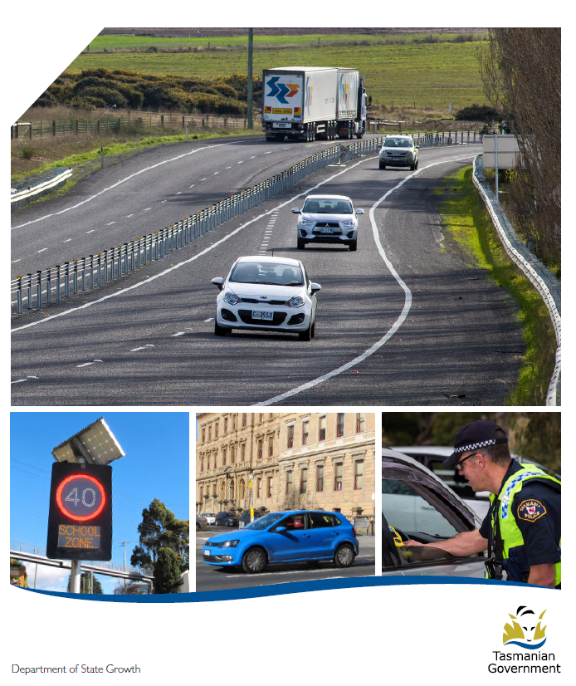

Quarterly Progress Report to RSAC
as at 30 June 2017

Progress on meeting Towards Zero Strategy targets
The key interim target for the Towards Zero – Tasmanian Road Safety Strategy 2017-2026 (Towards Zero Strategy) is to reduce the number of annual serious injuries and deaths on Tasmanian roads to fewer than 200 by 2026. This is an ambitious target of 100 fewer serious casualties per year than for the period 2012-2016 (annual average) and will move us towards the long-term goal of zero serious casualties on Tasmanian roads.

Serious Casualties
The number of serious casualties in 2016 was 318, compared to 331 in 2015, a 3.9 per cent decrease. The 2016 figure of 318 is a 6.7 per cent increase on the five year serious casualty average of 298 (2011-2015).

Fatalities
In 2016, there were 37 fatalities on Tasmanian roads which is four more than the 33 recorded in 2015. The figure of 37 fatalities in 2016 is an 18.6 per cent increase on the five year fatalities average of 31.2 (2011-2015).

2017 YTD
There have been 158 serious casualties (17 fatalities and 141 serious injuries) to 30 June 2017, down 6 per cent on the same period last year of 168 serious casualties (22 fatalities and 146 serious injuries) and down 1.4 per cent on the five year average of 160.2 serious casualties.

Serious Casualties Tasmania – Annual Count and Towards Zero Target
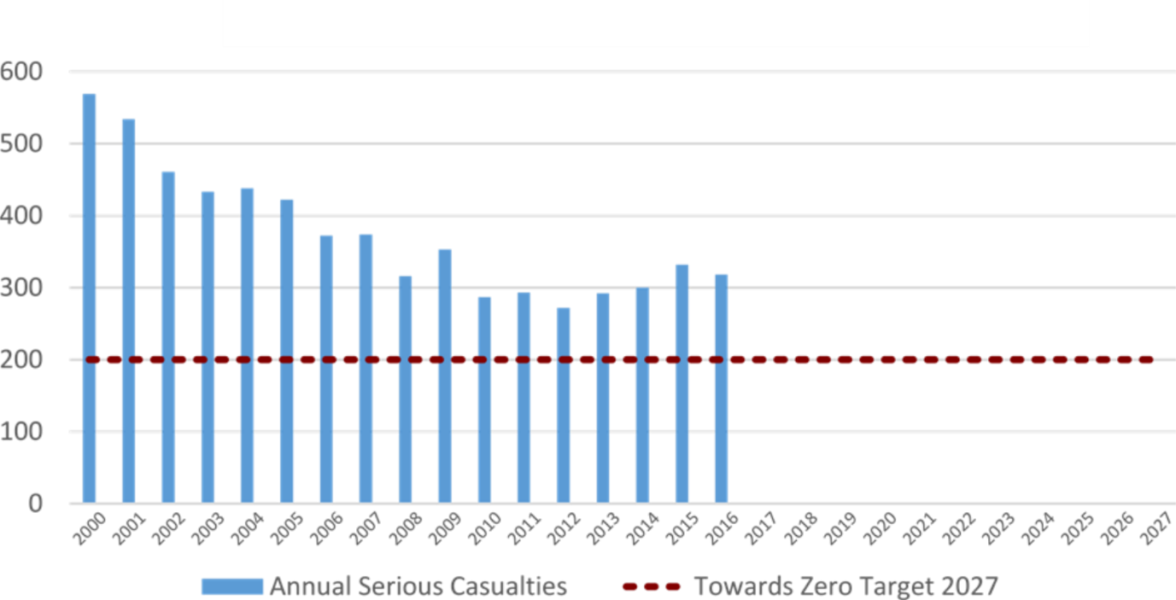
Annual fatalities – Rate per 100,000 population
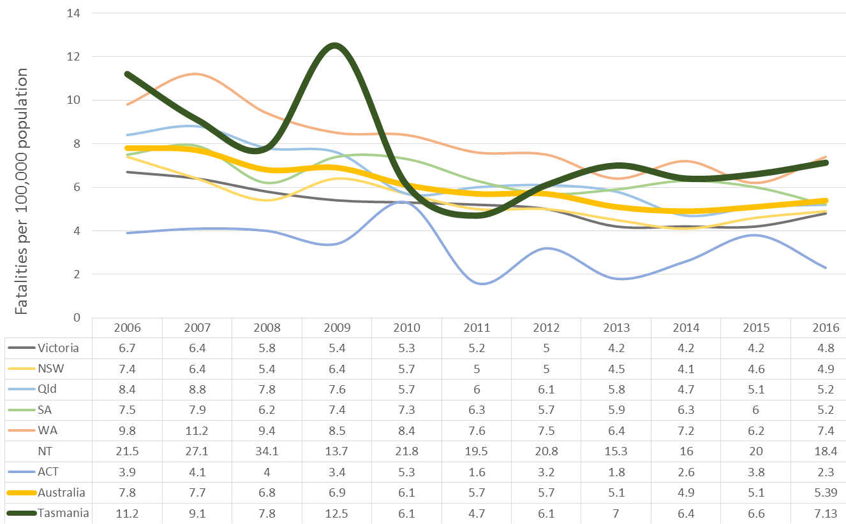
Note: NT omitted from chart for clarity purposes.

Progress on meeting MAIB targets

Motor Accidents Insurance Board (MAIB) injury statistics show the number of fatalities and the level of claims for serious injuries on our roads.
Various claim reduction targets are specified in the Memorandum of Understanding between the Department of State Growth (State Growth) and the MAIB. Progress against high level targets is shown below, expressed as 12 month moving totals.

Fatalities – 12 Month Rolling Total
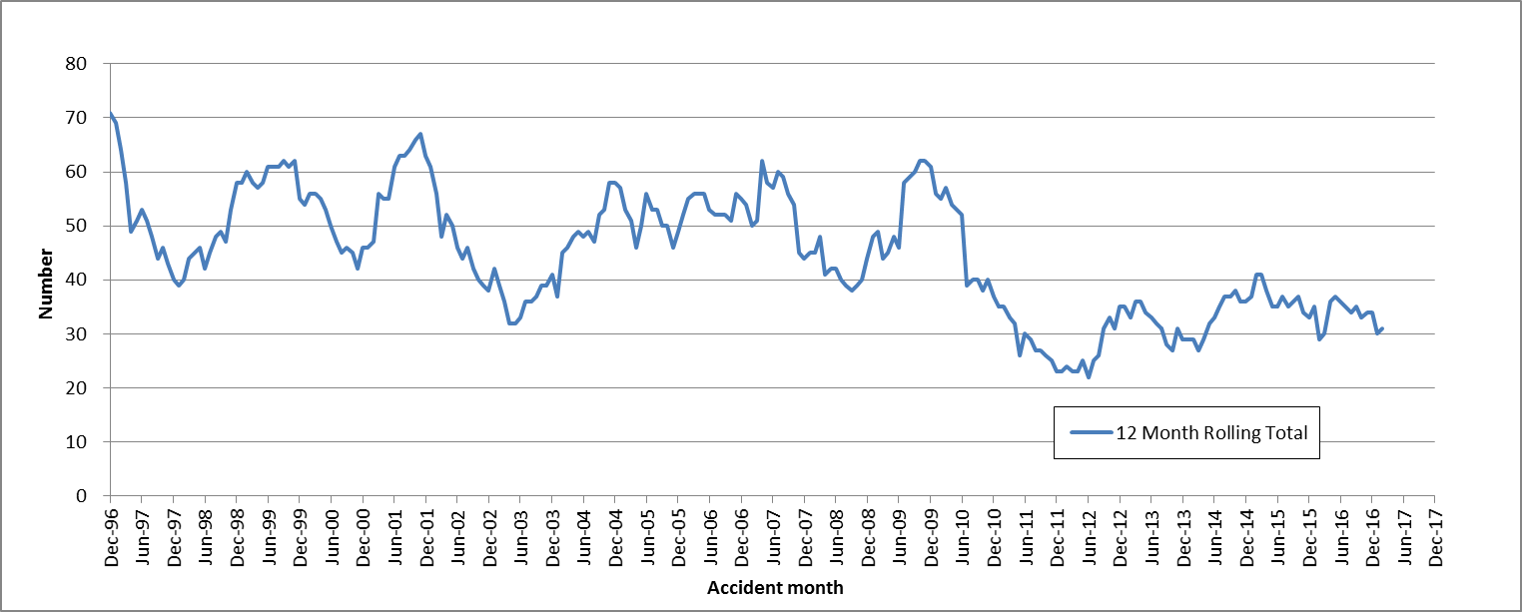

Total Serious Claims – 12 Month Rolling Total
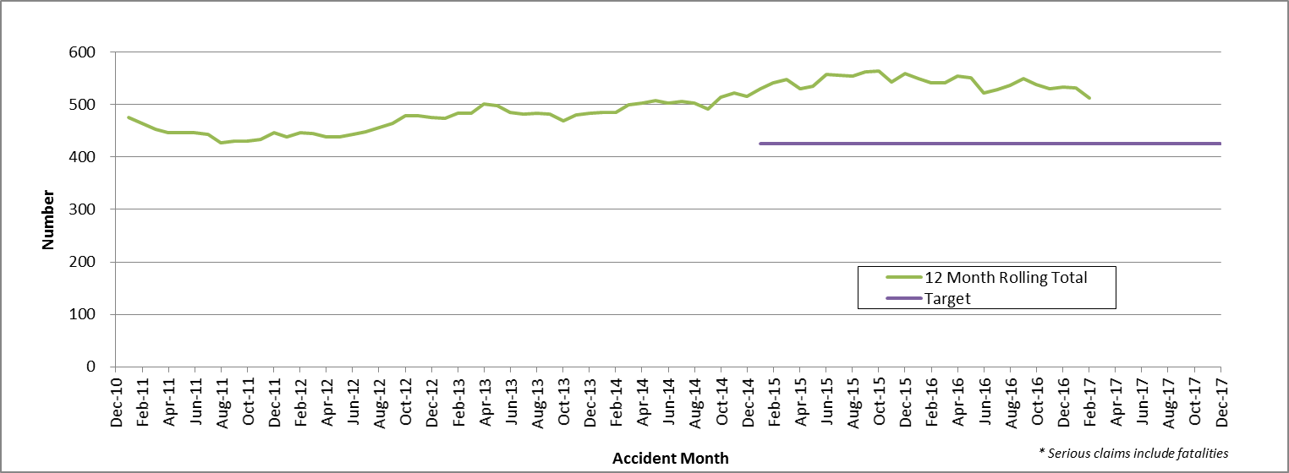

Statistics
Serious Casualties by Quarter by Age Group – 12 period moving average

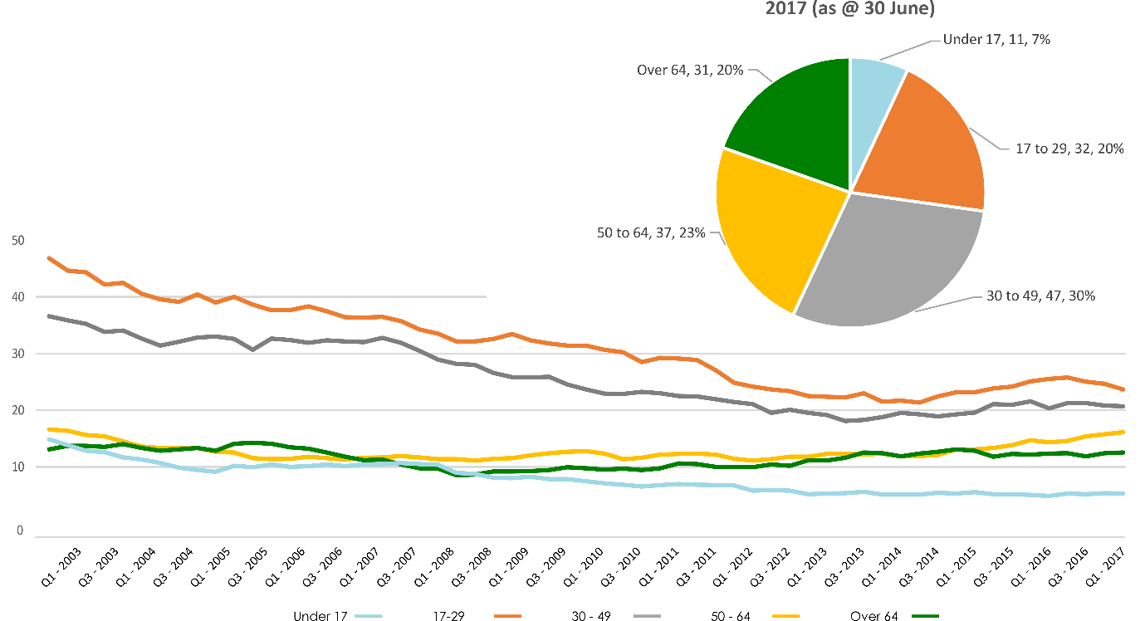

Serious Casualties by Quarter by Gender – 12 period moving average

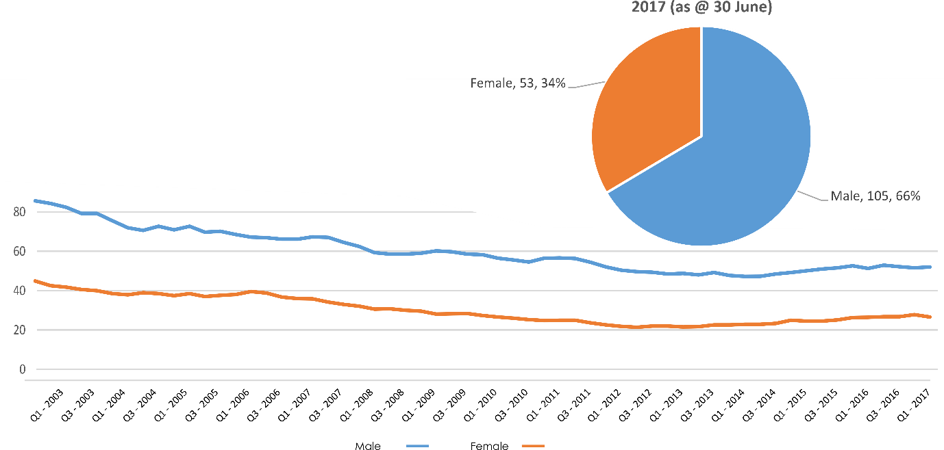

Serious Casualties by Quarter by Road User Type – 12 period moving average
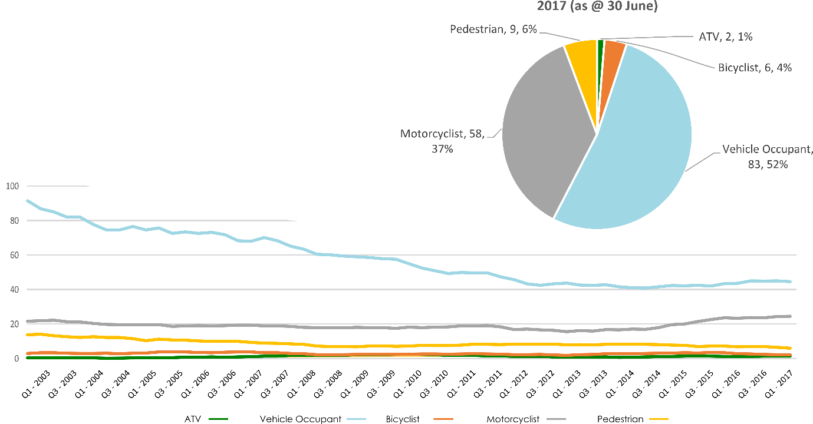

Serious Casualties by Quarter by Speed Zone – 12 period moving average
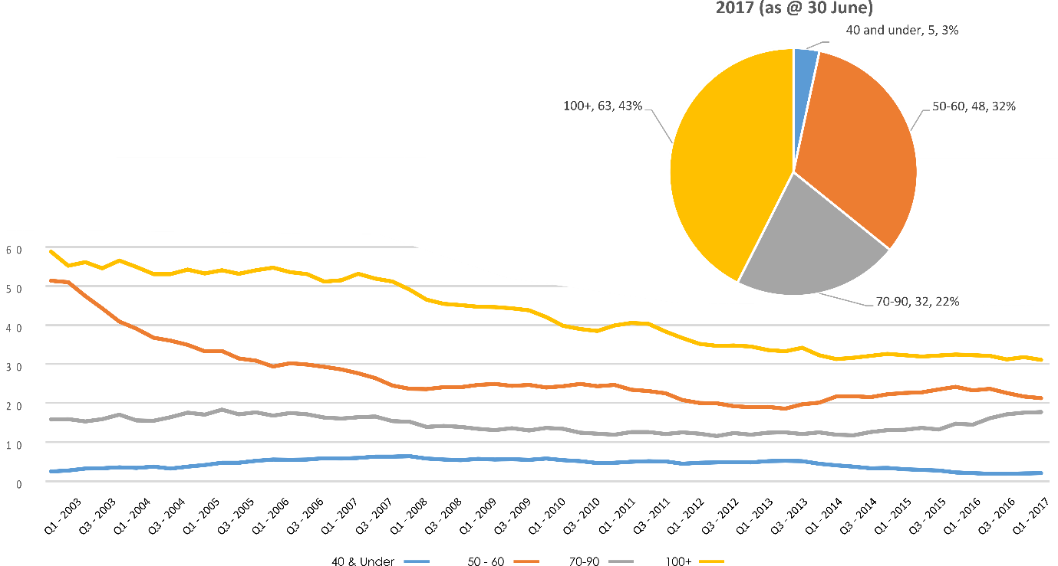
Pie chart excludes serious casualties where speed zone is recorded as ‘not known’

Serious Casualties by Quarter by Crash Type (DCA) – 12 period moving average
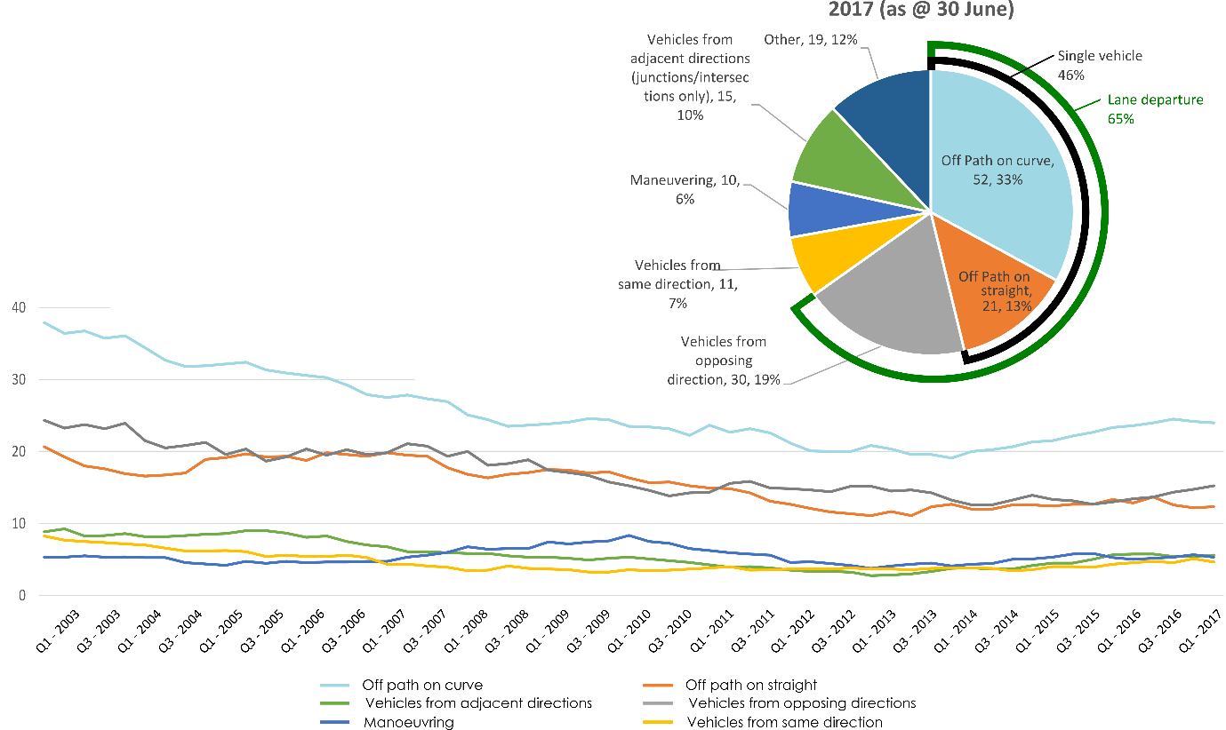
Other includes crash types: Pedestrian (6%), on-path (3%), passenger & miscellaneous (2%) and overtaking (1%)

Serious Casualties by Quarter by Urban/Non-Urban – 12 period moving average
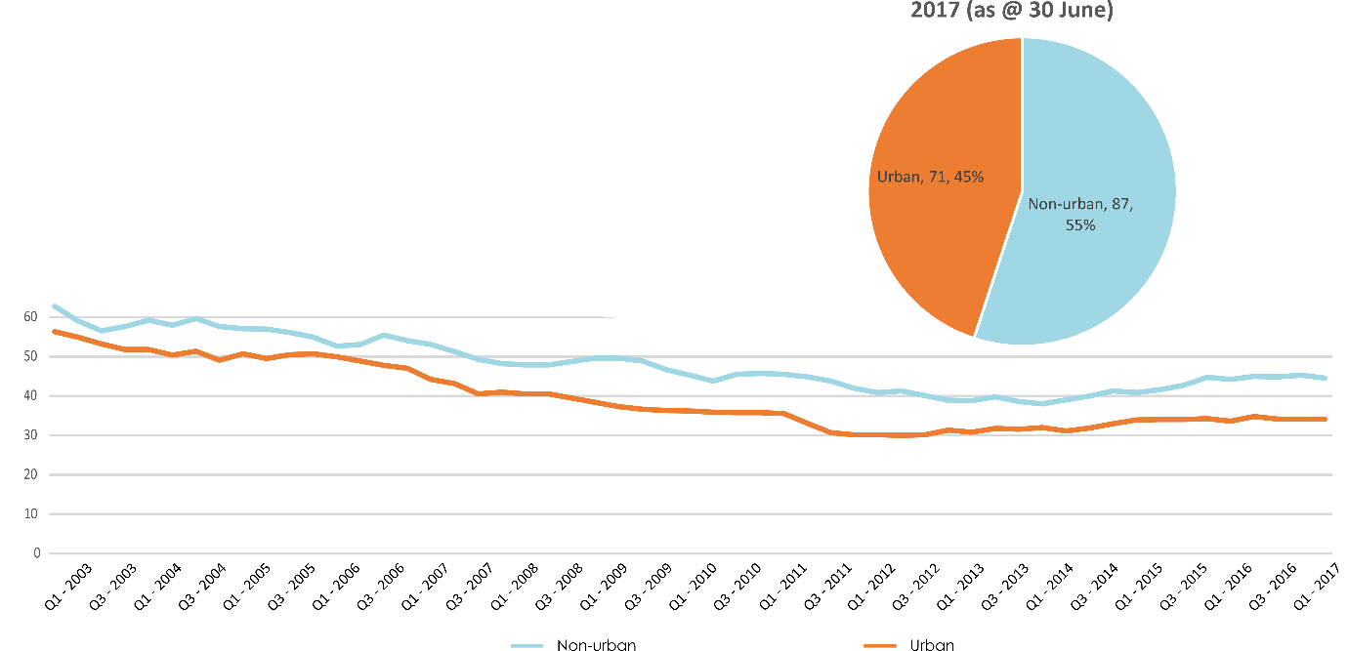
Based on the Australian Bureau of Statistics’ ‘significant urban area’ geographic definition.
Serious Casualty locations as @ 30 June 2017 (Black = Fatal, Red = Serious Injury)
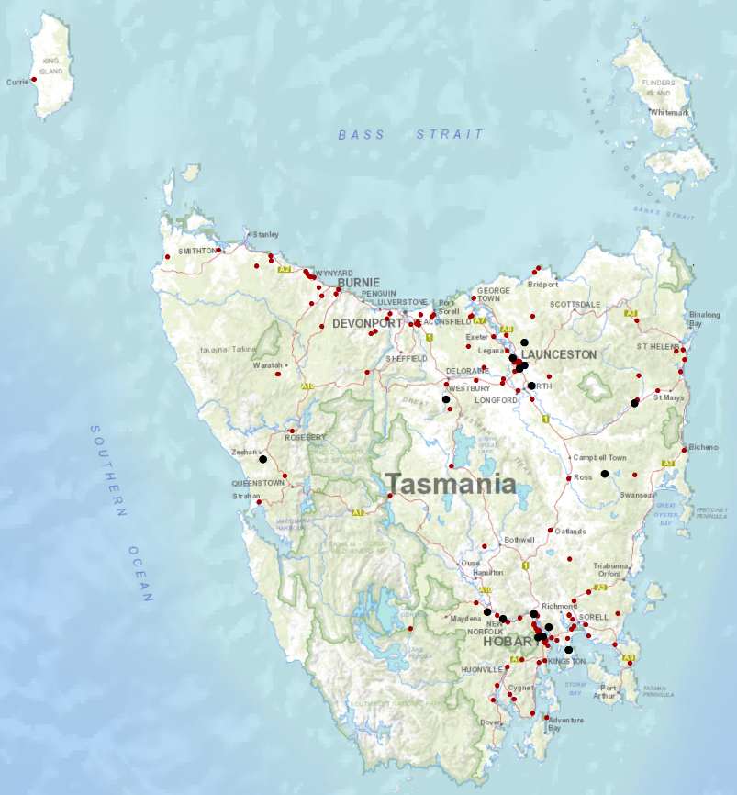

Priority Actions 2017-2019

Safe Road Users

- Improve the Graduated Licensing System to reduce serious casualties for young road users (17-25 year olds).
- Introduce safety initiatives to reduce motorcyclist serious casualties.
- Promote safer road user behaviour through education and enforcement.

Safe Roads and Roadsides

- Reduce run-off-road and head-on crashes through improved infrastructure.
- Reduce the severity of intersection crashes through improved infrastructure treatments.
- Embrace safe system thinking in road design.
- Reduce serious casualties through improved delineation such as line marking.

Safe Vehicles

- Improve the star rating of Tasmania’s vehicle fleet to include vehicles with better safety features.
- Increase the number of motorcycles with ABS.

Safe Speeds

- Introduce more appropriate speed limits to reduce serious casualties.
- Increase enforcement through technology to reduce speed related serious casualty crashes.

Progress on projects
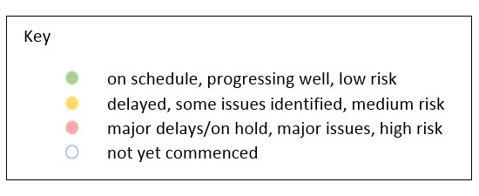
Action Plan 2017-2019
Safe Road Users
Project | Responsibility | Status | Milestones achieved | Milestones planned |  | Comments | Budget  Life of project  $ | Actual  Life of project  $
Review of GLS for novice drivers | Road Safety, State Growth |  | Project planning and scoping  Review of Tasmanian GLS against Australian GLS Policy Framework  Analysis of crashes involving young drivers  Options paper developed. | Review current resources supporting the GLS and best practice in other jurisdictions and develop recommended changes to GLS in Tasmania. |  |  | 3,000,000 | 0
New motorcycle training and assessment program | Registration & Licensing, State Growth |  | On the 29 June 2017, the Minister announced the progressive roll out of the new Motorcycle Training and Assessment Program across Tasmania, starting with Devonport from Late July, then Hobart and Launceston by end of 2017  First round of Assessor training conducted in North West. | Grant Deed being established` to fund the transitional arrangements.  Range and Training location set up in Hobart to occur in July and Launceston in November 2017.  Commence delivery of new bridging course and pre-learner in Devonport in July.  Conduct second round of Lead Assessor Training in mid-August.  Finalise communication Strategy including training V Log.  Commence direct communication with those affected by the transitional arrangements, starting with the North-West Region in July 2017. |  |  | Implementation Project 350,000  Transitional Arrangement 300,000  Balance for Communications 160,000 | 87,349
Protective gear for motorcyclists | Road Safety, State Growth |  | Finalising the Motorcycle Protective Gear video and collateral material for use in the new Motorcycle Training and Assessment Program. The collateral material will also be distributed State-wide to all retailers. | Project commenced in May 2017.  First planned communications activity is a short training video and collateral material on protective gear to be included as part of the new Motorcycle Training Program. Collateral material will be distributed to retailers state-wide to engage all motorcyclists. |  | Project budget and activities subject to approval at RSAC meeting of 16 May 2017. | 75,000 | 0
Introduce rear-facing automated speed cameras | Tasmania Police |  |  |  |  | Principal Project Manager position to be advertised end of July 2017 | 132,000  To review 5 projects
Increased motorcycle-focused enforcement | Tasmania Police |  |  |  |  | Principal Project Manager position to be advertised end of July 2017 | 132,000  To review 5 projects
Promote safe behaviours through media campaigns | EESC,  Road Safety, State Growth |  | Anti-distraction and inattention campaign launched 24 February 2017. | Anti-drink-driving campaign for men aged between 17 and 25, “Real Mates”, to be updated.  Anti-drink-driving television commercial “Nobody Cheers” to be updated. |  | Approved by EESC in January. | MAIB funding
Promote safe behaviours through media campaigns | EESC,  Road Safety, State Growth |  | Planning with Police has started. | Long-term enforcement campaign to complement Police media activity during holiday periods to be launched in December. |  | Funding approved by RSAC in May. | Road Safety Levy funding | $350,000
Increased enforcement of high-risk behaviours | Tasmania Police |  |  |  |  | Principal Project Manager position to be advertised end of July 2017 | 132,000  To review 5 projects

Safe Roads and Roadsides
Project | Responsibility | Status | Milestones achieved | Milestones planned | Comments | Budget  Life of project  $ | Actual  Life of project  $
Flexible barrier installation program | State Roads, State Growth |  |  | Scoping and planning phase to identify suitable projects and locations underway. Identify sections of roads for treatment; scope and develop project plan. |  | 7.5 million
Audi-tactile line marking program | State Roads, State Growth |  |  | Scoping and planning phase to identify suitable projects and locations underway. Identify sections of roads for treatment; scope and develop project plan.
Shoulder sealing program | State Roads, State Growth |  |  | Scoping and planning phase to identify suitable projects and locations underway. Identify sections of roads for treatment; scope and develop project plan.
Improved delineation on high risk roads | State Roads, State Growth |  |  | Scoping and planning phase to identify suitable projects and locations underway. Identify sections of roads for treatment; scope and develop project plan.
Intersection treatment program | State Roads, State Growth |  |  | Scoping and planning phase to identify suitable projects and locations underway. Identify sections of roads for treatment; scope and develop project plan.
Safe system thinking in road design | Road Safety, State Growth |  | Safe System workshops held.  Proforma strategy template prepared for local government. | Presentations to councils and stakeholders.  Promotion of training courses. |  | 300,000 | 0
Safe Vehicles
Project | Responsibility | Status | Milestones achieved | Milestones planned | Comments | Budget  Life of project  $ | Actual  Life of project  $
Increase the number of motorcycles with ABS | Road Safety, State Growth
Minimum safety specifications for all new passenger and light commercial vehicles in the Tasmanian Government fleet. | Road Safety, State Growth
Promote vehicle fleet safety standards for commercial fleets | Road Safety, State Growth

Safe Speeds
Project | Responsibility | Status | Milestones achieved | Milestones planned | Comments | Budget  Life of project  $ | Actual  Life of project  $
Development of speed limit setting guidelines | Road Safety, State Growth
Assessment of speed limits on 100km/h roads | Road Safety, State Roads, State Growth
Review of point to point speed cameras on high risk rural roads | Tasmania Police |  |  |  | Principal Project Manager position to be advertised end of July 2017 | 132,000  To review 5 projects
Increased fixed speed cameras in urban areas | Tasmania Police |  |  |  | Principal Project Manager position to be advertised end of July 2017 | 132,000  To review 5 projects

Road Safety Work Program
Safe Road Users
Project | Responsibility | Status | Milestones achieved | Milestones planned |  | Comments | Budget  Life of project  $ | Actual  Life of project  $
MAIP Review | Road Safety, State Growth |  | Draft MAIP Report completed | Sign-off by MAIP Review Steering Committee  Sign-off by Minister  Release of report |  | Awaiting final approval of MAIP Review Report by project Steering Committee. | State Growth funded | 50,222
Distance makes the Difference campaign Stage 1 | Road Safety, State Growth |  | Campaign delivered. | Complete. |  | Bus backs continue to end of 2016/17 financial year. | 350,000 | 368,166
Distance makes the Difference campaign Stage 2 | Road Safety, State Growth |  |  | A request for quote process relating to the next phase of activity is currently underway. |  | Awaiting report on last round of activity. Initial reports are very positive. | 400,000 | 15,500
Implementation of minimum passing distance legislation | Road Safety, State Growth |  | Review has been successfully completed. | Planning of implementation of minimum passing distance laws in Tasmania. |  | The laws will be introduced in Tasmania in September 2017.
Tourist road safety campaign – Phase 1 | Road Safety, State Growth |  | Complete. |  |  |  | 250,000 | 141,337
Tourist road safety campaign – Phase 2 (2017-2019) | Road Safety, State Growth |  |  | Planning of next phase (includes seasonal workers, international students and interstate motorcyclists). |  | Collateral continues to be distributed. Currently consulting with stakeholders, reviewing activity to date and planning next phase. | 650,000 | 0
Community Road Safety Grants Program | Road Safety, State Growth |  |  | The next round of funding will open in July 2017 to deliver program funding for the 2018 calendar year |  | Report of first funding round is being prepared for RSAC’s August meeting. | 200,000  p/a | 191,565
Project | Responsibility | Status | Milestones achieved | Milestones planned |  | Comments | Budget  Life of project  $ | Actual  Life of project  $
Learner Driver Mentor Program and Driver Mentoring Tasmania | Road Safety, State Growth |  | Funding is being delivered to 15 existing LDMPs and one new program for 2017-18. | Evaluation to inform ongoing delivery of LDMP program. |  |  | 500,000  p/a  702,000 approved for 2017/18 | 1,877,581
Learner Driver Mentor Program evaluation | Road Safety, State Growth |  |  | Internal stakeholder consultation has commenced. A presentation for potential evaluators is planned for early June 2017. |  |  | 50,000 | 0
RYDA program | Road Safety, State Growth |  | Funding has been delivered to the program to continue throughout 2017-18. |  |  | Final year of funding under the current election commitment (2017-18). | 75,000 | 229,250

Safe Roads and Roadsides
Project | Responsibility | Status | Milestones achieved | Milestones planned | Comments | Budget  Life of project  $ | Actual  Life of project  $
Pedestrian safety package – Stage 1: Pedestrian Countdown Timers (PCTs) Trial | State Roads, State Growth |  | UTAS developed methodology for monitoring and evaluation. Pre-installation research completed by UTAS Masters student. | PCTs to be installed week of 31 July 2017. |  | 70,000 | 0
Pedestrian safety package – Stage 2 | State Roads  State Growth |  |  |  |  | 430,000 | 0

Project | Responsibility | Status | Milestones achieved | Milestones planned | Comments | Budget  Life of project  $ | Actual  Life of project  $
Motorcycle safety package – infrastructure safety improvements | State Roads, State Growth |  |  | Engage safety specialist. |  | 300,000 | 86,788
Vulnerable Road User Program | State Roads, State Growth |  | Majority of projects in Round 4 completed. | Letters inviting submissions for Round 5 to be sent in July. |  | 2,500,000 | 1,656,894
Esk Main Road shoulder sealing, edge line marking and safety improvements | State Roads, State Growth |  | Safety barrier on small section near rail crossing installed | Final seal and line marking to be done 2017-18 construction season. |  | 5,860,000 | 5,085,666
Lyell Highway, south of Hamilton shoulder sealing | State Roads, State Growth |  | Safety barrier installed. | Final seal and line marking (2017-18 season). |  | 1,272,000) | 1,063,986
Midland Highway Safety Improvements | State Roads, State Growth |  | Projects progressing on the 10 year infrastructure upgrade. | Continuation of projects. |  | 20,000,000 | 12,556,490

Safe Vehicles
Project | Responsibility | Status | Milestones achieved |  | Milestones planned | Comments |  | Budget  Life of project  $ | Actual  Life of project  $
ANCAP support | Road Safety, State Growth |  | 2016/17 payment | 2017/18 payment |  |  |  | 12,000 p/a | 75,928

Safe Speeds
N/A. There are no current Safe Speed projects under the Road Safety Work Program.

Other
Project | Responsibility | Status | Milestones achieved | Milestones planned | Comments | Budget  Life of project  $ | Actual  Life of project  $
Development of the Towards Zero Strategy | Road Safety, State Growth |  | Strategy, Action Plan and Work Program complete and launched. |  | To be removed at end of financial year. | 400,000 | 347,030
RSAC and Towards Zero Strategy support | Road Safety, State Growth |  | Funding for Manager RSAC Secretariat, Senior Project Officer TEB, Chair and Expert sitting fees and operation of RSAC. |  |  | Up to 400,000  p/a | 3,944,340  YTD=  307,711
MAIP Transitional arrangements | Registration & Licensing, State Growth |  |  |  |  | 300,000  2016/17 | 2,155,068
Lane filtering for motorcyclists | Road Safety, State Growth |  |  |  |  | TBC

Project | Responsibility | Status | Items funded | Budget  2016/17  $ | Actual  2016/17  $
Discretionary Activities Fund | Road Safety, State Growth |  | Redevelopment of RSAC Website | 250,000 | 11,119
 |  |  | AGFEST ANCAP Display |  | 268
 |  |  | Safe System Infrastructure Workshop |  | 19,766
 |  |  | Sponsorship Trauma Tasmania Symposium |  | 4,545
 |  |  | Road Safety Week |  | 33,514
 |  |  |  |  | 69,212

Funding

Road Safety Levy Overview
As at 30 June 2017
2016/17 Financial Year | Proposed budget  $ | Actual (ytd)  $
Opening balance (as at 1 July 2016) |  | 16,787,282
Revenue 2016/17
Road safety levy collected | 13,100,000 | 13,545,852
Funds available for distribution | 10,500,000 | 10,945,852
Total funds available for distribution | 27,287,282 | 27,733,134
Expenditure
Roads and Roadsides |  | 10,933,659
Policy and Projects |  | 2,135,513
Total Expenditure |  | 13,069,172
Balance |  | 14,663,962
Allocated funding
Safe Roads and Roadsides |  | 6,119,842
Policy and Projects |  | 5,820,487
Total allocated funding |  | 11,940,329
Unallocated funding
Safe Roads and Roadsides |  | 0
Policy and Projects |  | 2,723,633
Unallocated funding balance |  | 2,723,633

MAIB Funding
As at 30 June 2017
2016/17 Financial Year | Budget  $ | Actual (ytd)  $ | Balance  $
Expenditure (State Growth)
Administration & Public Relations | 299,617 | 298,595 | 1,022
Public Education | 914,258 | 891,854 | 22,404
Research | 62,324 | 42,600 | 19,724
Subtotal | 1,276,199 | 1,233,049 | 43,150
Expenditure (Tasmania Police)
Salaries | 1,727,443 | 1,775,557 | 48,114-
Operating Expenses | 186,000 | 163,306 | 22,694
Equipment | 616,072 | 254,853 | 361,219
Subtotal | 2,529,515 | 2,193,716 | 335,799
Total | 3,805,714 | 3,426,765 | 378,949

