Fewer than 200 serious injuries and deaths on our roads by 2026
Towards Zero Tasmanian Road Safety Strategy 2017–2026

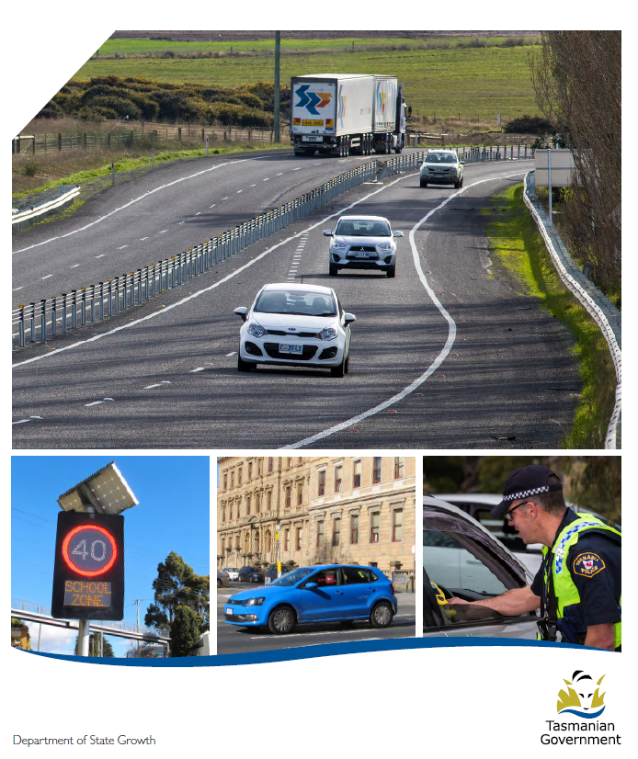

Quarterly Progress Report to RSAC
to 31 March 2017

Progress on meeting Towards Zero Strategy targets
The key interim target for the Towards Zero – Tasmanian Road Safety Strategy 2017-2026 (Towards Zero Strategy) is to reduce the number of annual serious injuries and deaths on Tasmanian roads to fewer than 200 by 2026. This is an ambitious target of 100 fewer serious casualties per year than for the period 2012-2016 (annual average) and will move us towards the long-term goal of zero serious casualties on Tasmanian roads.

Serious Casualties
The number of serious casualties in 2016 was 318, compared to 331 in 2015, a 3.9 per cent decrease. The 2016 figure of 318 is a 6.7 per cent increase on the five year serious casualty average of 298 (2011-2015).

Fatalities
In 2016, there were 37 fatalities on Tasmanian roads which is four more than the 33 recorded in 2015. The figure of 37 fatalities in 2016 is an 18.6 per cent increase on the five year fatalities average of 31.2 (2011-2015).

2017 YTD
There have been 90 serious casualties (5 fatalities and 85 serious injuries) to 31 March 2017, down 17 per cent on the same period last year of 108 serious casualties (11 fatalities and 97 serious injuries) and down 1.5 per cent on the five year average of 91.4 serious casualties.

Serious Casualties Tasmania – Annual Count and Towards Zero Target
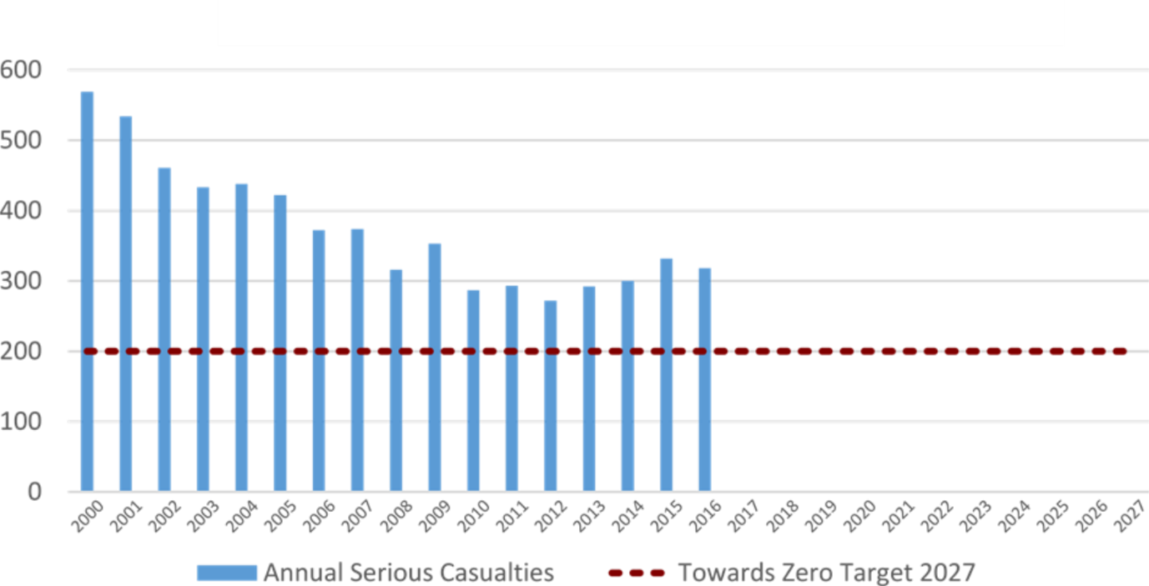
Annual fatalities – Rate per 100,000 population
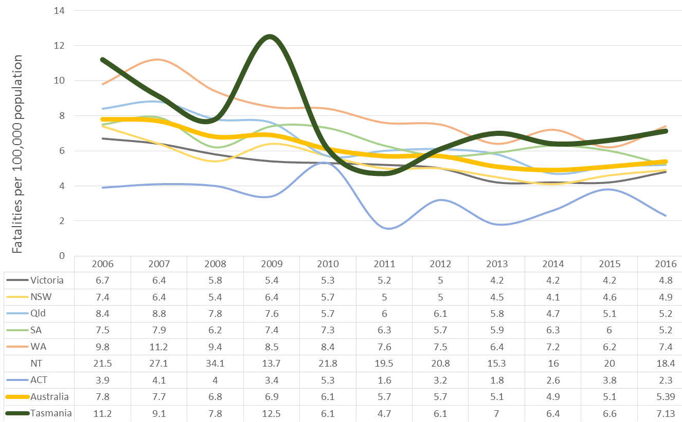
Note: NT omitted from chart for clarity purposes.

Progress on meeting MAIB targets

Motor Accidents Insurance Board (MAIB) injury statistics show the number of fatalities and the level of claims for serious injuries on our roads.
Various claim reduction targets are specified in the Memorandum of Understanding between the Department of State Growth (State Growth) and the MAIB. Progress against high level targets is shown below, expressed as 12 month moving totals.

Fatalities – 12 Month Rolling Total
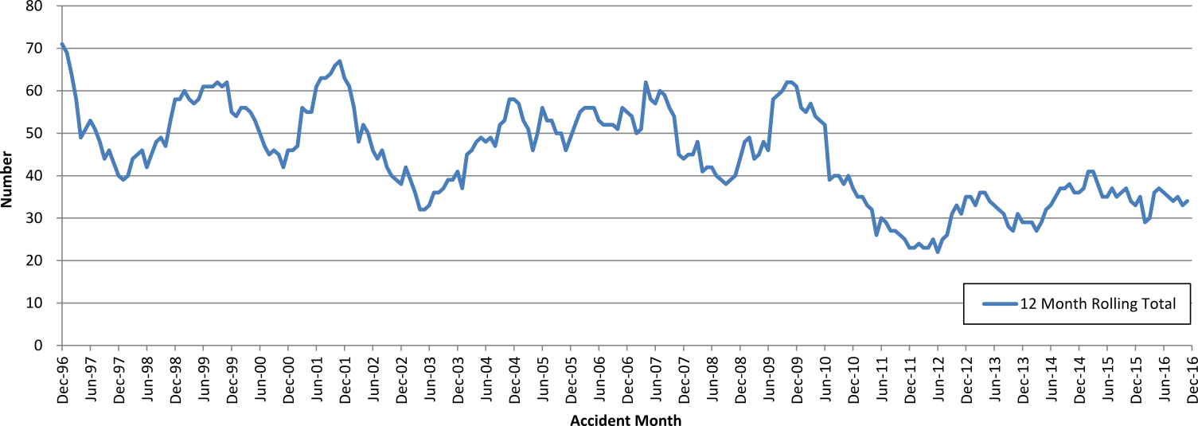

Total Serious Claims – 12 Month Rolling Total
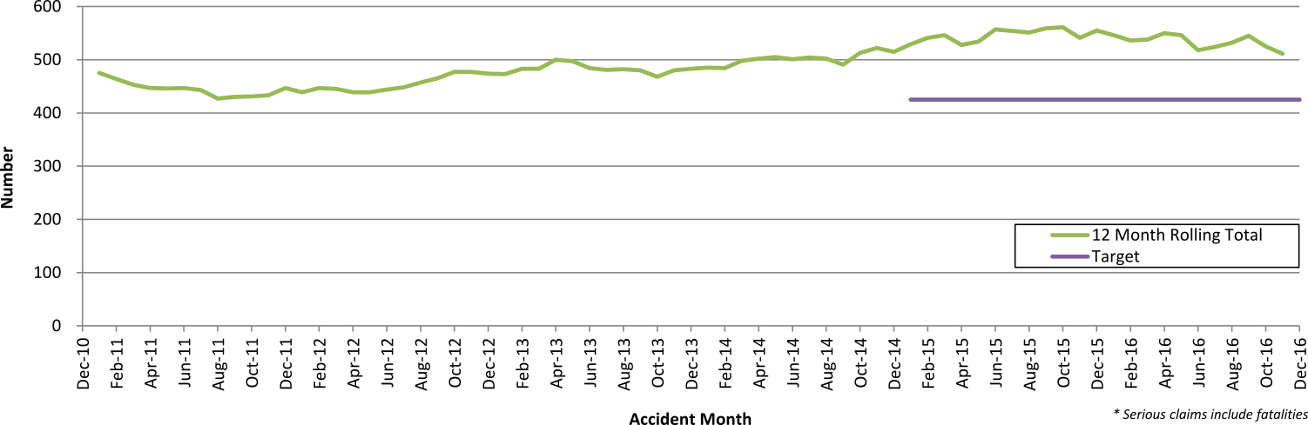

Statistics
Serious Casualties by Quarter by Age Group – 12 Month moving average
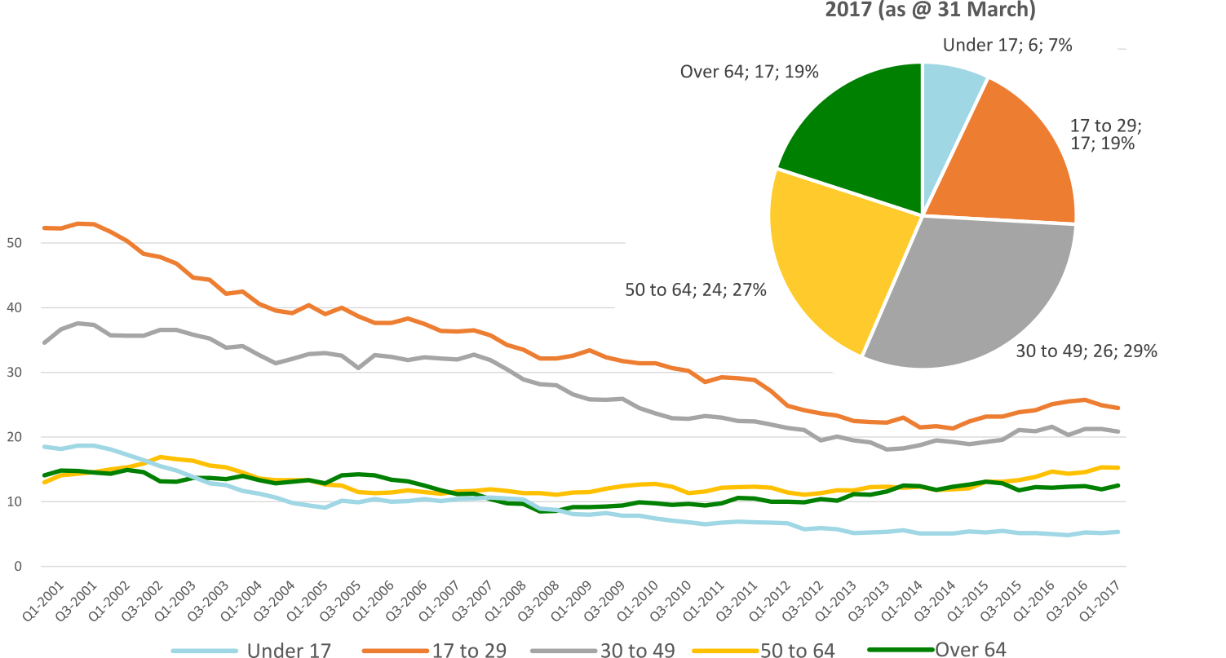

Serious Casualties by Quarter by Gender – 12 Month moving average
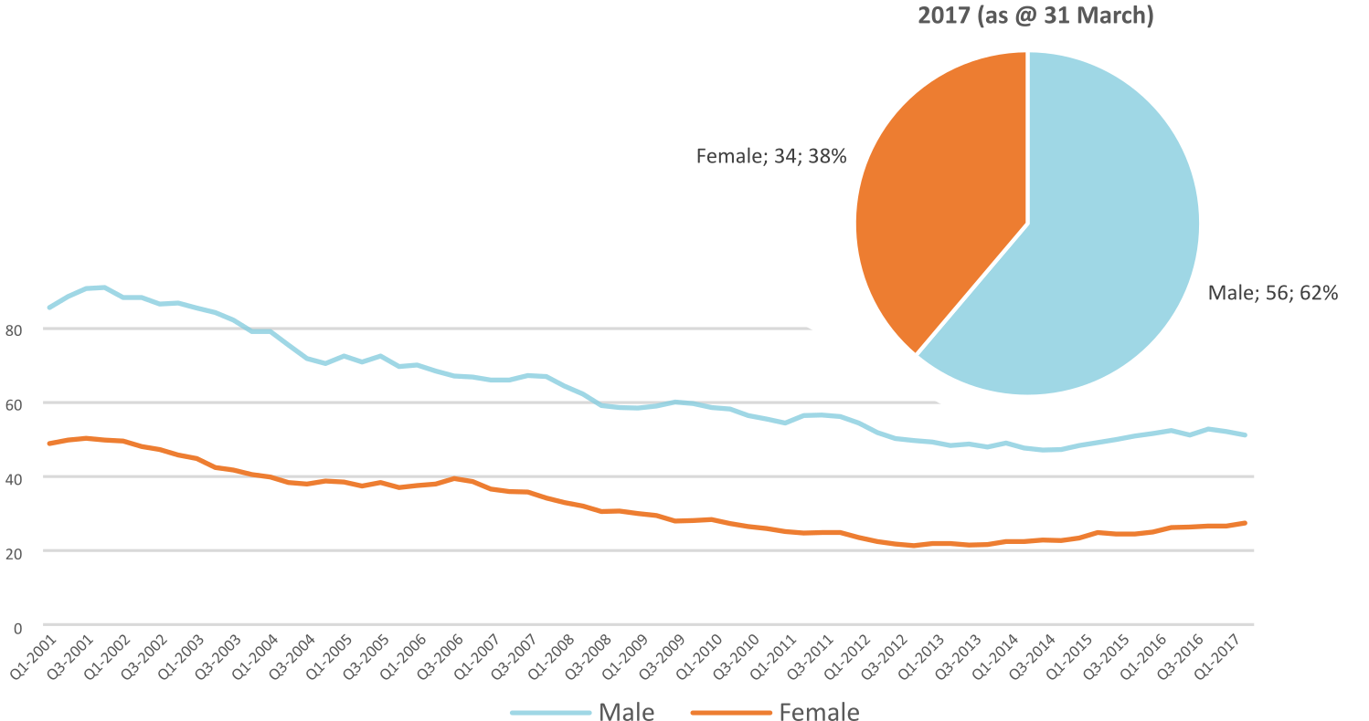

Serious Casualties by Quarter by Road User Type – 12 Month moving average
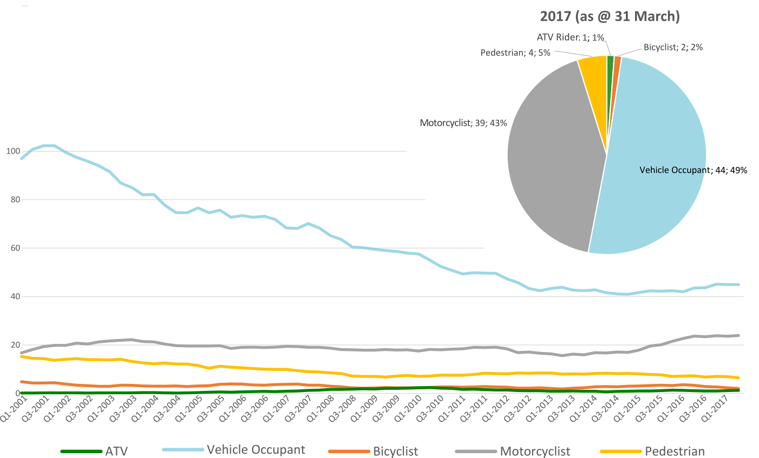

Serious Casualties by Quarter by Speed Zone – 12 Month moving average
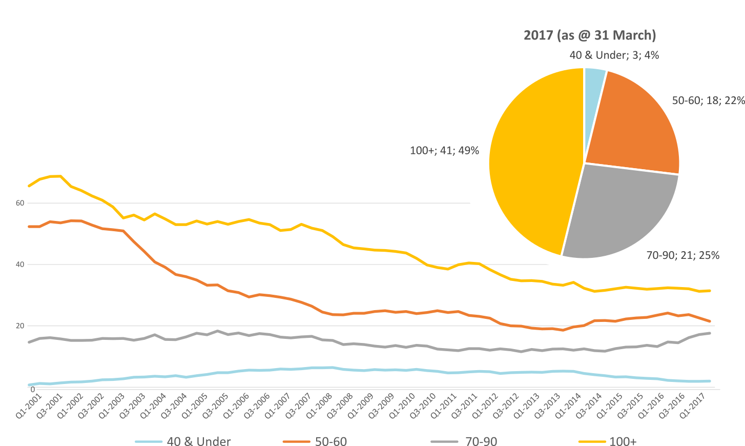
Pie chart excludes seven serious casualties where speed zone is recorded as ‘not known’
Serious Casualties by Quarter by Crash Type (DCA) – 12 Month moving average
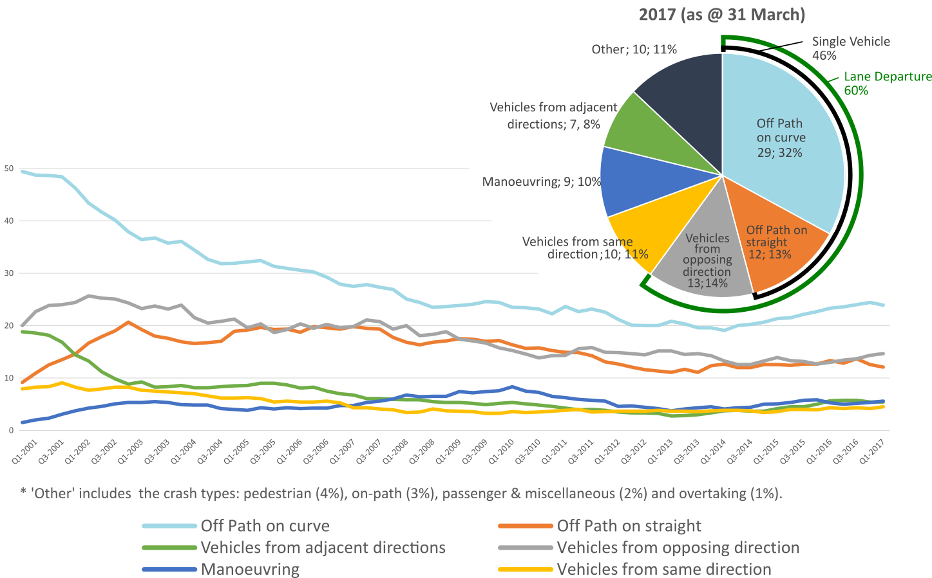

Serious Casualties by Quarter by Urban/Non-Urban – 12 Month moving average
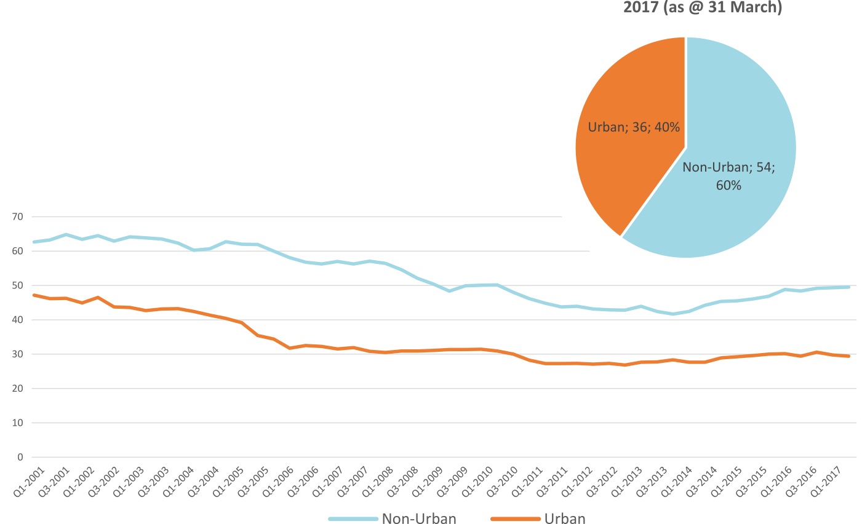
Based on the Australian Bureau of Statistics’ ‘significant urban area’ geographic definition.
Serious Casualty locations as @ 31 March 2017 (Black = Fatal, Red = Serious Injury)
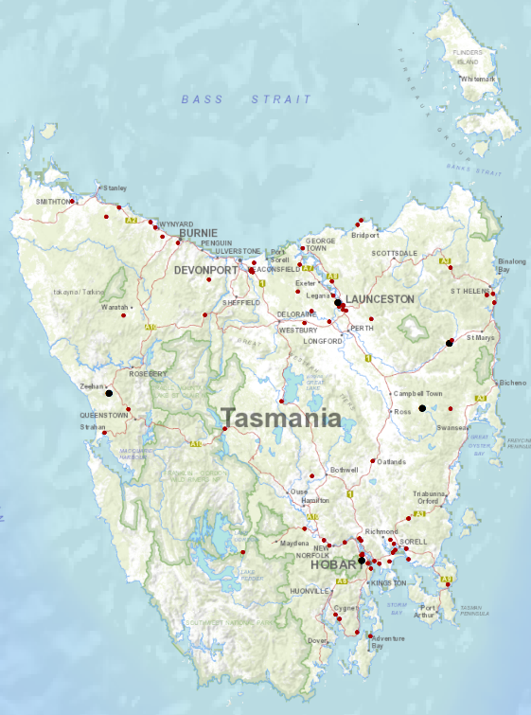

Priority Actions 2017-2019

Safe Road Users

- Improve the Graduated Licensing System to reduce serious casualties for young road users (17-25 year olds).
- Introduce safety initiatives to reduce motorcyclist serious casualties.
- Promote safer road user behaviour through education and enforcement.

Safe Roads and Roadsides

- Reduce run-off-road and head-on crashes through improved infrastructure.
- Reduce the severity of intersection crashes through improved infrastructure treatments.
- Embrace safe system thinking in road design.
- Reduce serious casualties through improved delineation such as line marking.

Safe Vehicles

- Improve the star rating of Tasmania’s vehicle fleet to include vehicles with better safety features.
- Increase the number of motorcycles with ABS.

Safe Speeds

- Introduce more appropriate speed limits to reduce serious casualties.
- Increase enforcement through technology to reduce speed related serious casualty crashes.

Progress on projects
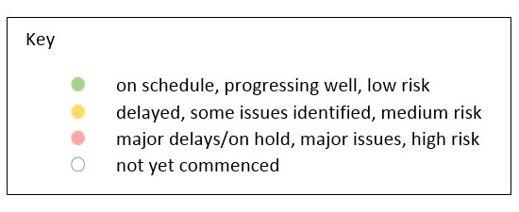
Action Plan 2017-2019
Safe Road Users
Project | Responsibility | Status | Milestones achieved | Milestones planned |  | Comments | Budget  Life of project  $ | Actual  Life of project  $
Review of GLS for novice drivers | Road Safety, State Growth |  | Project planning and scoping  Review of Tasmanian GLS against Australian GLS Policy Framework  Analysis of crashes involving young drivers | Review current resources supporting the GLS and best practice in other jurisdictions and develop recommended changes to GLS in Tasmania  Consultation regarding potential changes to the GL:S |  |  | 3,000,000 | 0
New motorcycle training and assessment program | Registration & Licensing, State Growth |  | Stage 1 of the Application for Services closed, successful applicants invited to submit an application for stage 2.  Stage 2 closed on 21 February 2017. Evaluation Panel seeking further information to ensure conformity of proposed ranges. | Commence contract negotiations to commence in April to enable delivery of services.  Range and Training location set up.  Conduct Lead Assessor Training.  Commence direct communication with those affected by the transitional arrangement.  Commence delivery of new bridging course and pre-learner. Develop communication Strategy including training V Log. |  |  | Implementation Project 350,000  Transitional Arrangement 300,000  Balance for Communications 160,000 | 87,349
Project | Responsibility | Status | Milestones achieved | Milestones planned |  | Comments | Budget  Life of project  $ | Actual  Life of project  $
Protective gear for motorcyclists | Road Safety, State Growth |  |  | Project scheduled to commence in May 2017.  First planned communications activity is a short training video on protective gear to be included as part of the new Motorcycle Training Program. |  | Project budget and activities subject to approval at RSAC meeting of 16 May 2017. | 75,000 | 0
Introduce rear-facing automated speed cameras | Tasmania Police
Increased motorcycle-focused enforcement | Tasmania Police
Promote safe behaviours through media campaigns | EESC,  Road Safety, State Growth |  | Anti-distraction and inattention campaign launched 24 February 2017. | Anti-drink-driving campaign for men aged between 17 and 25, “Real Mates”, to be updated.  Anti-drink-driving television commercial “Nobody Cheers” to be updated.  Road Safety Week second week of May. |  | Approved by EESC in January. | MAIB funding
Increased enforcement of high-risk behaviours | Tasmania Police

Safe Roads and Roadsides
Project | Responsibility | Status | Milestones achieved | Milestones planned | Comments | Budget  Life of project  $ | Actual  Life of project  $
Flexible barrier installation program | State Roads, State Growth |  | . | Scoping and planning phase to identify suitable projects and locations underway. Identify sections of roads for treatment; scope and develop project plan. | RSAC to consider scoping of potential future projects at its 16 May meeting. | 7.5 million
Audi-tactile line marking program | State Roads, State Growth |  |  | Scoping and planning phase to identify suitable projects and locations underway. Identify sections of roads for treatment; scope and develop project plan.
Shoulder sealing program | State Roads, State Growth |  |  | Scoping and planning phase to identify suitable projects and locations underway. Identify sections of roads for treatment; scope and develop project plan.
Improved delineation on high risk roads | State Roads, State Growth |  |  | Scoping and planning phase to identify suitable projects and locations underway. Identify sections of roads for treatment; scope and develop project plan.
Intersection treatment program | State Roads, State Growth |  |  | Scoping and planning phase to identify suitable projects and locations underway. Identify sections of roads for treatment; scope and develop project plan.

Project | Responsibility | Status | Milestones achieved | Milestones planned | Comments | Budget  Life of project  $ | Actual  Life of project  $
Safe system thinking in road design | Road Safety, State Growth |  | Safe System workshops held.  Proforma strategy template prepared for local government. | Presentations to councils and stakeholders.  Promotion of training courses. |  | 300,000 | 0
Safe Vehicles
Project | Responsibility | Status | Milestones achieved | Milestones planned | Comments | Budget  Life of project  $ | Actual  Life of project  $
Increase the number of motorcycles with ABS | Road Safety, State Growth
Minimum safety specifications for all new passenger and light commercial vehicles in the Tasmanian Government fleet. | Road Safety, State Growth
Promote vehicle fleet safety standards for commercial fleets | Road Safety, State Growth

Safe Speeds
Project | Responsibility | Status | Milestones achieved | Milestones planned | Comments | Budget  Life of project  $ | Actual  Life of project  $
Development of speed limit setting guidelines | Road Safety, State Growth
Assessment of speed limits on 100km/h roads | Road Safety, State Roads, State Growth
Review of point to point speed cameras on high risk rural roads | Tasmania Police
Increased fixed speed cameras in urban areas | Tasmania Police

Road Safety Work Program
Safe Road Users
Project | Responsibility | Status | Milestones achieved | Milestones planned |  | Comments | Budget  Life of project  $ | Actual  Life of project  $
MAIP Review | Road Safety, State Growth |  | Draft MAIP Report completed | Sign-off by MAIP Review Steering Committee  Sign-off by Minister  Release of report |  | Awaiting final approval of MAIP Review Report by project Steering Committee. | State Growth funded | 50,222
Distance makes the Difference campaign Stage 1 | Road Safety, State Growth |  | Campaign delivered. | Complete. |  | Bus backs continue to end of 2016/17 financial year. | 350,000 | 368,166
Distance makes the Difference campaign Stage 2 | Road Safety, State Growth |  |  | A request for quote process relating to the next phase of activity is currently underway. |  | Awaiting report on last round of activity. Initial reports are very positive. | 400,000 | 0
Review of minimum passing distance legislation | Road Safety, State Growth |  | Review has been successfully completed. | Planning of implementation of minimum passing distance laws in Tasmania. |  | In November 2016 the Minister for Infrastructure announced that the laws will be introduced in Tasmania.
Tourist road safety campaign – Stage 1 | Road Safety, State Growth |  | Complete. |  |  |  | 150,000 | 132,547
Tourist road safety campaign – Stage 2 | Road Safety, State Growth |  |  | Planning of next phase (includes seasonal workers, international students and interstate motorcyclists). |  | Collateral continues to be distributed. Currently consulting with stakeholders, reviewing activity to date and planning next phase. | 100,000 | 0
Community Road Safety Grants Program | Road Safety, State Growth |  |  | The next round of funding will open in July 2017 to deliver program funding for the 2018 calendar year |  | Report of first funding round is being prepared for RSAC’s August meeting. | 200,000  p/a | 191,565
Project | Responsibility | Status | Milestones achieved | Milestones planned |  | Comments | Budget  Life of project  $ | Actual  Life of project  $
Learner Driver Mentor Program and Driver Mentoring Tasmania | Road Safety, State Growth |  | Applications for funding are currently open and will officially close on 28 April 2017. | Funding will be available to programs in the next financial year (2017-18). |  |  | 500,000  p/a | 1,846,102
Learner Driver Mentor Program evaluation | Road Safety, State Growth |  |  | Internal stakeholder consultation has commenced. A presentation for potential evaluators is planned for early June 2017. |  |  | 50,000 | 0
RYDA program | Road Safety, State Growth |  |  | Funding will be available to the program in the next financial year (2017-18). |  | Final year of funding under the current election commitment (2017-18). | 75,000 | 229,250

Safe Roads and Roadsides
Project | Responsibility | Status | Milestones achieved | Milestones planned | Comments | Budget  Life of project  $ | Actual  Life of project  $
Pedestrian safety package – Stage 1: Pedestrian Countdown Timers (PCTs) Trial | State Roads, State Growth |  | In conjunction with councils, trial sites selected – three in Launceston and three in Hobart. | With UTAS, develop methodology for monitoring and evaluating trial. PCTs to be installed July 2017. |  | 70,000 | 0
Pedestrian safety package – Stage 2 | State Roads  State Growth |  |  |  |  | 430,000 | 0

Project | Responsibility | Status | Milestones achieved | Milestones planned | Comments | Budget  Life of project  $ | Actual  Life of project  $
Motorcycle safety package – infrastructure safety improvements | State Roads, State Growth |  | Scoping and planning to engage a motorcycle safety specialist to review popular motorcycle touring routes. | Engage safety specialist next quarter. |  | 300,000 | 86,788
Vulnerable Road User Program | State Roads, State Growth |  | Projects in Round 4 progressing well. | Majority of projects completed next quarter. |  | 2,500,000 | 1,586,894
Esk Main Road shoulder sealing, edge lining and safety improvements | State Roads, State Growth |  | Final line marking with audible centre lines completed on section from Midland Hwy to Stynes Creek Bridge.  Shoulder sealing completed on Stynes Creek to St Pauls Bridge section. | Safety barrier on small section near rail crossing to be installed next quarter.  Final seal and line marking to be done 2017-18 construction season. |  | 5,860,000 | 4,554,160
Lyell Highway, south of Hamilton shoulder sealing | State Roads, State Growth |  | Shoulder sealing completed. | Safety barrier installation; final seal and line marking (2017-18 season). | $1.9m allocated to Esk Main Road, Cove Hill Road and Lyell Highway; savings from two projects allowed higher allocation to Lyell. | 400,000  (revised to 1,272,000) | 841,416
Midland Highway Safety Improvements | State Roads, State Growth |  | Projects progressing on the 10 year infrastructure upgrade. | Continuation of projects. |  | 20,000,000 | 10,341,331
Fixed Speed Camera Signage | State Roads,  State Growth |  | All gateway signs installed. | Project completed. |  | 50,000 | 27,349

Safe Vehicles
Project | Responsibility | Status | Milestones achieved |  | Milestones planned | Comments |  | Budget  Life of project  $ | Actual  Life of project  $
ANCAP support | Road Safety, State Growth |  | 2016/17 payment | 2017/18 payment |  |  |  | 12,000 p/a | 75,928

Safe Speeds
N/A. There are no current Safe Speed projects under the Road Safety Work Program.

Other
Project | Responsibility | Status | Milestones achieved | Milestones planned | Comments | Budget  Life of project  $ | Actual  Life of project  $
Development of the Towards Zero Strategy | Road Safety, State Growth |  | Strategy, Action Plan and Work Program complete and launched. |  | To be removed at end of financial year. | 400,000 | 326,505
RSAC and Towards Zero Strategy support | Road Safety, State Growth |  | Funding for Manager RSAC Secretariat, Senior Project Officer TEB, Chair and Expert sitting fees and operation of RSAC. |  |  | Up to 400,000  p/a | 3,866,307  YTD=  229,679
MAIP Transitional arrangements | Registration & Licensing, State Growth |  |  |  |  | 300,000  2016/17 | 2,108,069
Lane filtering for motorcyclists | Road Safety, State Growth |  |  |  |  | TBC

Project | Responsibility | Status | Items funded | Budget  2016/17  $ | Actual  2016/17  $
Discretionary Activities Fund | Road Safety, State Growth |  | Redevelopment of RSAC Website | 250,000 | 11,119
 |  |  | AGFEST ANCAP Display |  | 268
 |  |  | Safe System Infrastructure Workshop |  | 11,643
 |  |  |  |  | 23,030

Funding

Road Safety Levy Overview
As at 31 March 2017
2016/17 Financial Year | Proposed budget  $ | Actual (ytd)  $
Opening balance (as at 1 July 2016) |  | 16,787,282
Revenue 2016/17
Road safety levy collected | 13,100,000 | 9,953,041
Funds available for distribution | 10,500,000 | 7,353,041
Total funds available for distribution | 27,287,282 | 24,140,323
Expenditure
Roads and Roadsides |  | 6,876,079
Policy and Projects |  | 1,784,067
Total Expenditure |  | 8,660,146
Balance |  | 15,480,177
Allocated funding
Safe Roads and Roadsides |  | 2,777,815
Policy and Projects |  | 6,087,933
Total allocated funding |  | 8,865,748
Unallocated funding
Safe Roads and Roadsides |  | 4,600,000
Policy and Projects |  | 2,014,429
Unallocated funding balance |  | 6,614,429

MAIB Funding
As at 31 March 2017
2016/17 Financial Year | Budget  $ | Actual (ytd)  $ | Balance  $
Expenditure (State Growth)
Administration & Public Relations | 267,617 | 214,576 | 53,041
Public Education | 946,257 | 778,956 | 167,301
Research | 62,324 | 42,600 | 19,724
Subtotal | 1,276,198 | 1,036,132 | 240,066
Expenditure (Tasmania Police)
Salaries | 1,821,461 | 1,296,334 | 525,127
Operating Expenses | 186,000 | 110,325 | 75,675
Equipment | 616,072 | 160,044 | 456,028
Subtotal | 2,623,533 | 1,566,702 | 1,056,831
Total | 3,899,731 | 2,602,834 | 1,296,897

