Our Safety
Our Future

Tasmanian Road Safety Strategy 2007-2016
Progress Report
to the
Road Safety Advisory Council
including progress on the Work Program

as at
30 SEPTEMBER 2016

Executive Summary
Progress on meeting the Tasmanian Road Safety Strategy targets | 4
Progress on meeting the MAIB targets | 6
Key achievements since last report | 7
Strategic Direction 1 – Safer Travel Speeds
Road Safety Levy Funded Projects
Safer Travel Speeds on Rural Roads Program | 10
Fixed Speed Cameras – Information Signage | 11
Strategic Direction 2 – Best Practice Infrastructure
Road Safety Levy Funded Projects
Esk Main Road Shoulder Sealing, Edge Lining and Safety Improvements | 12
Motorcycle Safety Package – Infrastructure Safety Improvements | 14
Safer Roads: Vulnerable Road User Program | 16
East Derwent Highway, Old Beach – Cassidy’s Road to Baskerville Road | 19
Midland Highway Safety Improvements | 21
Lyell Highway, south of Hamilton – Shoulder Sealing | 23
Strategic Direction 3 – Improved Safety for Young Road Users
Road Safety Levy Funded Projects
Learner Driver Mentor Program Grant Funding | 24
Rotary Youth Driver Awareness Program | 26

Strategic Direction 4 – Enhanced Vehicle Safety
Road Safety Levy Funded Projects
Australasian New Car Assessment Program | 27
Strategic Direction 5 – Complementary Initiatives (Road Users)
Road Safety Levy Funded Projects
Mandatory Alcohol Interlock Program (MAIP) | 28
MAIP Review | 29
RSAC and TRSS Support | 30
Development of ‘the Towards Zero’ – Tasmanian Road Safety Strategy 2017-2026 | 31
Driver Mentoring Tasmania | 32
Motorcycle Safety Package | 33
Distance Makes a Difference - Cyclists Public Education Campaign | 36
Tourist Safety | 37
Community Road Safety Grants Program | 40
Securing Your Loads on Light Vehicles | 42
Discretionary Activities Fund | 43
Funding | 44
Statistics | 46

Progress on meeting the Tasmanian Road Safety Strategy targets
- There have been 235 serious casualties (29 fatalities and 206 serious injuries) to 30 September 2016, down 1.7 per cent on the same period last year of 239 serious casualties (26 fatalities and 213 serious injuries) and up 9.2 per cent on the five year average of 215.2 serious casualties.
- The number of serious casualties in 2015 was 332, compared to 300 in 2014, an 11 per cent increase. The 2015 figure of 332 is a 14.9 per cent increase on the five year serious casualty average of 289.0 (2010-2014).
- For the 2015 calendar year, there were 34 fatalities on Tasmanian roads which is one more than the 33 recorded in 2014. This is a 9.4 per cent increase on the five year fatalities average of 30.8 (2010-2014).
- The table below outlines road crash deaths for individual states and territories for the period 2005 to 2015

 | NSW | VIC | QLD | SA | WA | TAS | NT | ACT | AUST
2005 | 508 | 346 | 330 | 148 | 163 | 51 | 55 | 26 | 1,627
2006 | 496 | 337 | 335 | 117 | 200 | 55 | 45 | 13 | 1,598
2007 | 435 | 332 | 360 | 124 | 235 | 45 | 58 | 14 | 1,603
2008 | 374 | 303 | 328 | 99 | 205 | 39 | 75 | 14 | 1,437
2009 | 454 | 290 | 331 | 119 | 191 | 63 | 31 | 12 | 1,491
2010 | 405 | 288 | 249 | 118 | 193 | 31 | 50 | 19 | 1,353
2011 | 364 | 287 | 269 | 103 | 179 | 24 | 45 | 6 | 1,277
2012 | 369 | 282 | 280 | 94 | 183 | 31 | 49 | 12 | 1,300
2013 | 333 | 243 | 271 | 98 | 162 | 35 | 37 | 7 | 1,186
2014 | 307 | 249 | 223 | 107 | 183 | 33* | 39 | 10 | 1,153
2015 | 348 | 257 | 242 | 102 | 160 | 34 | 49 | 15 | 1,209
% change 2014-15 | 13.4% | 3.2% | 8.5% | -4.7% | -12.6% | 3.0% | 25.6% | 50% | 4.9%

* Note: The previous 2014 fatality figure of 35 has been revised to 33 following the outcome of coronial investigations.

- The first target of ‘by 2010: a 20% reduction in serious injuries and fatalities from 2005’ has been reached with a reduction of 32%. Progress is indicated on the chart below.
- The second target of ‘by 2015: a 20% reduction in serious injuries and fatalities from 2010’ has not been met. Reasons for this include the fact that the number of serious casualties recorded in 2010 was the second lowest recorded, combined with the fact that since 2012 the number of serious casualties has been gradually increasing.
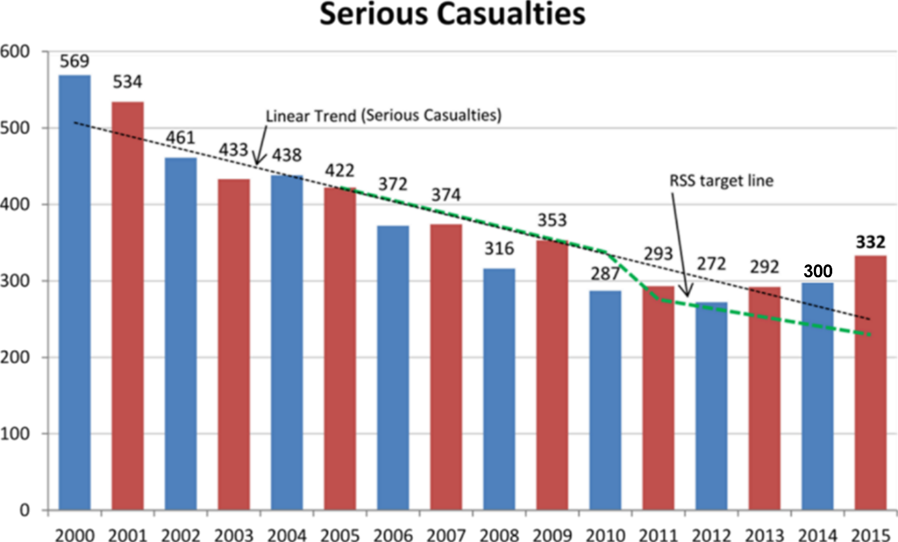

- The method above, used to determine the TRSS target, compares points in time – a comparison between the year 2005 and the year 2010 and between 2010 and 2015.
- As an additional measure, the five year averages (and part thereof) are included below. This methodology smooths out anomalies between individual years and provides a holistic picture of serious casualties in Tasmania
Five year average timeframe | Average | % of change | Period
Annual average of serious casualties 2001 - 2005 | 457.6 | N/A | Baseline period
Annual average of serious casualties 2006 – 2010 | 340.4 | - 25.6 | Period 1
Annual average of serious casualties 2011 – 2015 | 297.8 | -12.5 | Period 2

Progress on meeting the MAIB targets
- MAIB injury statistics show the number of fatalities and the level of claims for injuries on our roads. The charts below show the forecast level of claims for serious injuries.
- Various claim reduction targets are specified in the Memorandum of Understanding with the Motor Accidents Insurance Board (MAIB). Progress against high level targets is shown below, expressed as 12-month moving totals.

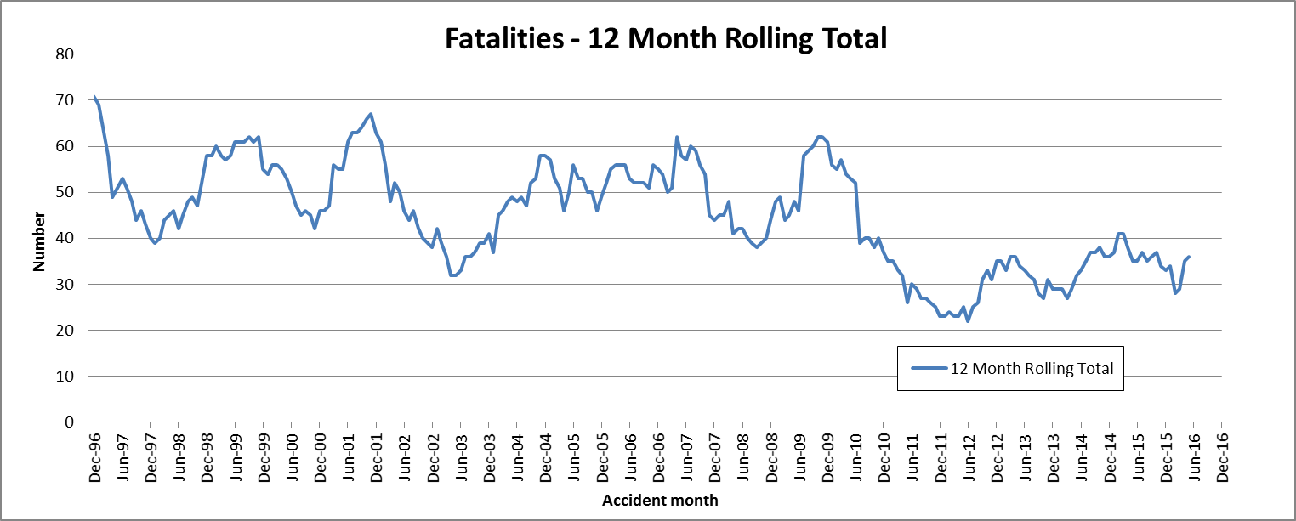

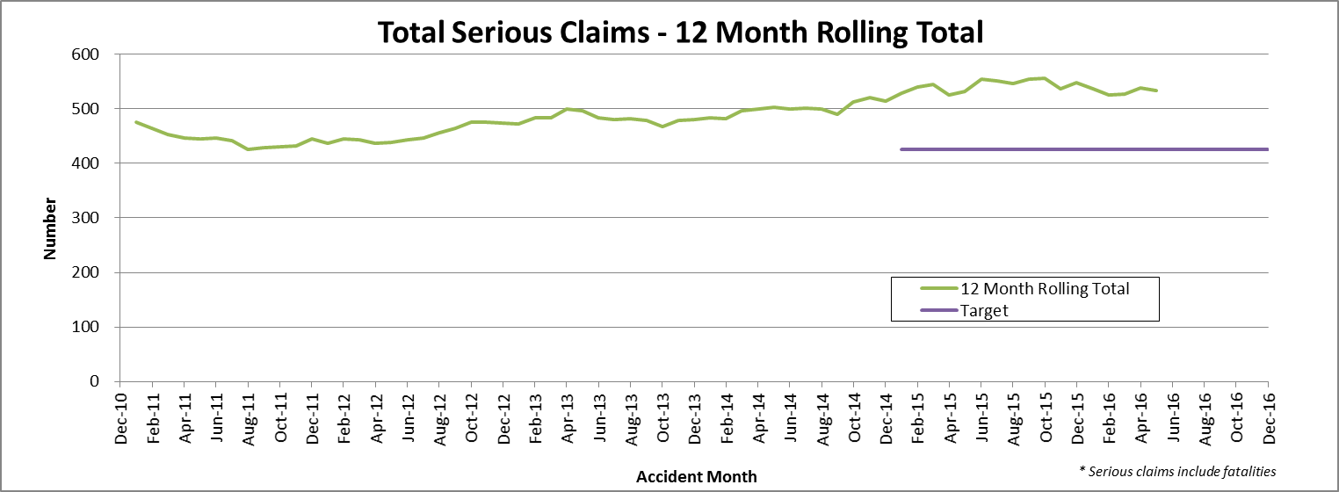

Key achievements since last report

Key project milestones
- The Motorcycle Training Review of the Motorcycle Safety Package is now complete. A Motorcycle Training Implementation Plan is now being prepared.
Projects completed this quarter
- Safer Travel Speeds on Rural Roads has been removed from this report. Safe speed projects will be addressed under the new Towards Zero Strategy 2017-2026.
- Graduated Licensing System Review has been removed from this report but carried forward to Towards Zero Strategy 2017-2016
Projects previously completed and removed from Progress Report
- Midland Highway at Symmons Plains – 2 Plus 1.
- Bass Highway, North of Gannons Hill – 2 Plus 1.
- Weather Warning Signs – Tunnel Hill, Tasman Highway.

Projects with budget variance more than 10% (further detail provided under specific projects)
Over Budget
2202/2203 – Tourist Safety Strategy – Stage 1
Allocated budget: $50,000
Forecast expenditure: $77,054
Overspend: $27,054
Reason
Produced higher quality v-log than originally anticipated and expanded Bobbie the Bear materials due to popularity.

2322 – Securing Loads on Light Vehicles Campaign
Allocated budget: $10,000
Forecast expenditure: $29,346
Overspend: $19,346
Reason
Expanded the campaign to include erection of permanent signs (2400mm by 900mm) at the entrances to 12 refuge disposal sites, ‘tips’, around the state. Also, additional print advertising was used to promote the campaign.

Project progress: schedule and budget
Budget information, milestones and project status are correct as at 30 June 2016.

Project progress | Number of projects
More than 12 months late | 0
Between 6 and 12 months late | 0
Between 3 and 6 months late | 0
Less than 3 months late or on target | 14
Ongoing | 3
Completed | 2
On hold | 3
TOTAL | 22

Road Safety Levy Funded Project
1995 Safer Travel Speeds on Rural Roads Program
Description
In Tasmania, there is a serious crash problem on non-urban roads with a 100km/h speed limit, with more than 40% of serious casualty crashes occurring on these roads. The Safer Roads: Non-Urban Road Network Strategy was developed to address this issue. The Strategy, which is based on Safe System principles, identified the need to balance infrastructure treatments and speed management measures to improve the overall safety of the non-urban road network. The Strategy built on recommendations made to the previous Government by the RSAC and the results of community consultation.
The main focus of the Strategy was on improving, where possible, road and roadside infrastructure, with speed management being utilised as a risk mitigation measure where an infrastructure response was not possible. Independent criteria – the ‘Tasmanian Criteria for 100km/h Roads’ – were developed to assess whether roads are of a suitable standard to retain a 100km/h speed limit.
It was estimated that more than 100 people over six years would be spared serious injury or death should the non-urban speed limit be reduced to 90km/h on those roads that do not meet the Tasmanian criteria.
Following a decision by the former Government not to reduce the default speed limit from 100km/h to 90km/h on rural sealed roads, a program will be developed to consult with councils and local communities to negotiate appropriate speed limits on those roads determined to be unable to meet the Tasmanian criteria and that have a high crash risk. This new program is the Safer Travel Speeds on Rural Roads Program.

Status
This project is closed.
Safe speeds projects will be addressed under the new Towards Zero – Tasmanian Road Safety Strategy 2017-2026.

Road Safety Levy Funded Project
1997 Fixed Speed Cameras – Information Signage
Description

With the installation of the new fixed speed cameras, it is timely to review the network of signs across the State. There is an existing network of approximately 16 general information ‘Red Light and Speed Cameras Operate in Tasmania’ signs placed on major arterial routes around Tasmania; installed in 1992, these are ageing and in varying conditions of repair.
In August 2015 RSAC agreed to allocate funds for the installation of new speed camera information signs at the ports of entry and in the vicinity of the newly installed cameras; it was also agreed to remove the existing ageing speed camera signage to ensure a consistent approach to signing across the State.

Milestone Schedule |  | Milestone Progress
Date |  | Date
December 2015 | Install new signs in vicinity of newly installed fixed speed cameras | December 2015 | Completed
March 2016 | Install new signs at the five ports of entry | March 2016 | Final camera installed
April 2016 | Remove all existing ‘red light and speed cameras operate in Tasmania’ signs | June 2016 | All signs removed
 |  | September 2016 | Gateway signs delayed to second quarter
Status
Gateway signs at the five ports-of-entry will be installed in the next quarter.
Budget ($)
Total allocated budget for project | 50,000
Expenditure in 2015/16 | 16,999
Expenditure in 2016/17 to date | 0
Total expenditure to date | 16,999
Current Balance | 33,001
Forecast total expenditure on completion |  | 50,000
Forecast balance remaining on completion |  | 0

Road Safety Levy Funded Project
R320009 Esk Main Road Shoulder Sealing, Edge Line Marking and Safety Improvements
Description
Esk Main Road is the principal route to the East Coast from the Midland Highway and is a significant collector, carrying freight and commuters between regional communities.
The lack of sealed shoulders along sections of the Esk Main Road is a recognised deficiency in the State Arterial Road Network and is the highest priority road for shoulder sealing. Crash analysis for the 20 km section of the highway between Midland Highway and west of Avoca indicates that off-road-on-curve is the major crash type occurring along the road, resulting in a high injury rate of 60%.
Works to be undertaken include shoulder sealing, provision of edge lines and safety improvements. These works will be undertaken in two stages.
Stage 1: Develop a method-based contract, instead of standard detail design contract, over a 3.6km section of the Esk Main Road from the junction with the Midland Highway. Work for Stage 1 will be undertaken through a variation to an existing contract for Esk Main Road improvements, awarded under the Community Roads Program.
Stage 2: Successful methodology applied in Stage 1 will enable shoulder sealing to be delivered more efficiently and cost effectively between Midland Highway and Avoca.
Milestone Schedule |  | Milestone Progress
Date |  | Date
 | Stage 3 | June 2016 | Tender for Stage 3 prepared and will be released in July
 |  | September 2016 | Tender release delayed to first week of October

Status
Stage 1: All work completed.
Stage 2: Final seal applied; final line marking will be undertaken in spring/summer 2016.
Stage 3: For reasons of efficiency a State-funded project east of Fingal was included in the tender documentation; necessitating a small delay in release.
Budget ($)
Total allocated budget for project | 8,500,000
Expenditure in 2012/13 | 208,386
Expenditure in 2013/14 | 848,541
Expenditure in 2014/15 | 2,716,272
Expenditure in 2015/16 | 742,228
Expenditure in 2016/17 to date | 0
Total expenditure to date | 4,515,427
Current Balance | 1,344,573
Forecast total expenditure on completion |  | 5,860,000
Forecast balance remaining on completion |  | 0
Comments
In May 2015, RSAC agreed that savings from the audible line markings projects on the Bass and East Tamar Highways be allocated to the Esk Main Road project to allow for the completion of the section from the Midland Highway to Avoca. The reallocated savings totalled $1,000,000 providing a total budget to the project of $5,860,000.
In August 2014, RSAC agreed that $3.64m from the Esk Main Road Shoulder Sealing and Edge Lining and Safety Improvements project be re-allocated to the Road Safety Levy’s commitment to the Midland Highway Safety Improvements Program. This left a total amount of $4,860,000 to this project.
Road Safety Levy Funded Project
2301 Motorcycle Safety Package – Infrastructure Safety Improvements
Description
The Hodgman Government made a commitment at the last state election to implement motorcycle safety measures along the Great Eastern Drive (the newly named section of the Tasman Highway from Orford to St Helens). Motorcyclists continue to be over-represented in fatal and serious crashes in Tasmania.
The rollout of motorcycle safety infrastructure treatments is aimed at reducing the risk of injury to motorcyclists in the event of a crash. This initiative has been included in the Strategy’s Third Action Plan, with $300,000 being allocated to the project from the Road Safety Levy over three years (i.e. $100,000 per annum).
Milestone Schedule |  | Milestone Progress
Date |  | Date
May 2014 | Motorcycle Safety Working Group Established | May 2014 | Completed
October 2014 | Commencement of infrastructure projects for 2014/15 financial year (year 1) | December 2014 | Scoping completed. Work to begin early 2015
April 2015 | Completion of 2014/15 financial year projects (year 1) | March 2015 | Contractor engaged to undertake rub rail and signage works
July 2015 | Identification and endorsement of 2015/16 projects (year 2) | June 2015 | Rub rail and signage work completed  Scoping for 15-16 work underway
October 2015 | Commencement of infrastructure projects for 2015/16 financial year (year 2) | September 2015 | Final scoping and costing for works in Sheffield area completed
May 2016 | Completion of 2015/16 financial year projects (year 2) | December 2015 | Executed grant deed sent to Council; work to commence early 2016
 | Safety improvements in Sheffield area underway | March 2016 | Safety improvements in Sheffield area underway
July 2016 | Identification and endorsement of 2016/17 projects (year 3) | June 2016 | All work in Sheffield area completed
October 2016 | Commencement of infrastructure projects for 2016/17 financial year (year 3) | September 2016 | No additional projects scoped
April 2017 | Completion of 2016/17 financial year projects (year 3)
Status
Majority of Tasmanian Motorcycle Council identified issues are being addressed under State Roads’ Maintenance Program; others will be assessed for possible solutions.
Budget ($)
Total allocated budget for project | 300,000
Expenditure in 2014/15 | 0
Expenditure in 2015/16 | 83,131
Expenditure in 2016/17 to date | 0
Total expenditure to date | 83,131
Current Balance | 216,869
Forecast total expenditure on completion |  | 300,000
Forecast balance remaining on completion |  | 0

Road Safety Levy Funded Project
2006 Safer Roads: Vulnerable Road User Program
Description
The Safer Roads: Vulnerable Road User Program has been developed to improve the overall safety of vulnerable road users by minimising the opportunities for conflict between them and motor vehicles. The aim of the program is to reduce serious road crashes involving vulnerable road users. For the purposes of the program, vulnerable road users include pedestrians, cyclists and motorcyclists.
The program is funded at $1.5 million over the two years (2013/14 and 2014/15), and $500 000 a year in future years through the Tasmanian Road Safety Levy (for the life of the Levy, currently to 30 November 2017).
Milestone Schedule |  | Milestone Progress
Date |  | Date
April 2013 | Submissions for funding invited | April 2013 | Completed
June 2013 | Assessment of submissions and recommendations made to Program Steering Committee | July 2013 | Completed
June 2013 | Successful projects for 2013/2014 financial year announced | 30 July 2013 | Announced  11 August 2013
July 2013 | Commencement of projects for 2013/14 financial year | September 2013 | Many projects to be underway during October-December reporting quarter
July 2013 | Commencement of projects for 2013/14 financial year | December 2013 | Three projects underway
February 2014 | New round of submissions & assessment for projects commencing in financial year 2014/15 | March 2014 | Three projects completed; 10 underway
May 2014 | Assessment of submissions and recommendations made to Program Steering Committee | June 2014 | Submissions assessed with advice to councils in July
June 2014 | Projects for the 2013/14 financial year to be completed | June 2014 | 9 projects completed; 5 delayed; 2 reviewed
June 2014 | Successful projects for 2014/2015 financial year announced | June 2014 | Announced August 2014
December 2014 | Final funding provided by State Government for 2013/14 projects after completion audits | September 2014 | 1 project completed; 4 delayed; 1 withdrawn and 1 postponed
December 2014 | Remaining projects in 2013-14 year to be completed.  Design plans for 2014-15 year to be finalised | December 2014 | 2 projects completed; 2 almost completed  Final design plans for 2014-15 projects being received. One further project approved for funding
March 2015 | Submissions sought for 2015/16 projects | March 2015 | Letters to councils for the 2015-16 year have been sent. Two projects from the 2013-14 year are yet to be completed; 10 out of 12 2014-15 projects are underway
April 2015 | 2015/16 submissions close | June 2015 | All submissions received end May
May 2015 | Assessment of 2015/16 submissions and recommendations made to Program Steering Committee | June 2015 | Assessment Committee met in June; recommendations to Steering Committee in July
June 2015 | Projects for the 2014/15 financial year to be completed | June 2015 | No projects completed
June-July 2015 | Meeting of Program Steering Committee (via tele- or video conference) to discuss assessment of 2015/16 applications | September 2015 | Completed
July-August 2015 | Successful projects for 2015/16 announced | September 2015 | Completed
September 2015 | Commencement of projects for 2015/16 | September 2015 | Seven of the 12 projects in the 2014-15 round have been completed. Detailed plans being submitted for the 2015-16 projects
December 2015 | Final funding provided by State Government for 2014/15 projects after completion audits | December 2015 | 11 of the 12 projects have been completed
 |  | March 2016 | Final project for 2014/15 round underway
 |  | June 2016 | Bike lanes completed; submissions for Round 4 received  Round 3 projects underway
 |  | September 2016 | 7 projects completed; 2 to be completed next quarter

Status
Round 3 – 2015-16
Central Coast (1 project), Devonport (3 projects) and Launceston (3 projects) have been completed; Clarence City project is well underway and Sorell’s is almost completed.
Round 4 – 2016-17
Approval process underway.

Budget ($)
Total allocated budget for project | 2,500,000
Expenditure in 2013/14 | 329,200
Expenditure in 2014/15 | 409,920
Expenditure in 2015/16 | 575,705
Expenditure in 2016/17 | 165,069
Total expenditure to date | 1,479,894
Current Balance | 1,020,106
Forecast total expenditure on completion |  | 2,500,000
Forecast balance remaining on completion |  | 0

Road Safety Levy Funded Project
R320004 East Derwent Highway, Old Beach – Cassidy’s Road to Baskerville Road
Description
The ‘Safe System’ approach aims to create safer roadsides to compensate for driver error, using infrastructure improvements. This project will consist of approximately 1.3km of shoulder sealing and the addition of three dedicated right turn lanes at junctions to reduce intersection crashes and reduce the severity of the S-curve near Cassidy’s Road junction.
At this site there were 29 crashes over a five year period (15 casualty crashes; 14 property damage crashes). These occurred in three clusters:
- Nine loss-of-control crashes (three casualty) on the S-curve near Cassidy’s Road;
- Seven loss-of-control crashes (three casualty) on the bend at Melane Road; and
- Three casualty crashes resulting from loss-of-control and five crashes (three casualty) at the Baskerville Road junction.
Shoulder sealing reduces run-off-road crashes by 30% and head on crashes by 15%. Dedicated right turn lanes at junctions reduce rear-end collisions by 60%. Reduces the severity of curves and hence reduces run-off-road crashes by 60%.
Milestone Schedule |  | Milestone Progress
Date |  | Date
October/early Nov 2010 | Tender award | January 2011 | Awarded February 2011
December 2010 | Commence works | January 2011 | Commenced March 2011.
April 2011 | Complete works | September 2011 | Work suspended due to weather and settlement
Summer 2011/12 | Final seal | December 2011 | Monitoring land settlement Interim works planned.
 |  | March 2012 | Interim reseal of existing road completed
 |  | December 2012 | Work to be finalised
June 2013 | All work completed | December 2013 | All major work completed
June 2013 | All work completed | June 2014 | Contractor considering best approach to batter banks
June 2013 | All work completed | September 2014 | All work completed
 |  | Dec 2014 | Property boundary adjustments to be finalised
 |  | Sept 2015 | Negotiations with private landholder well underway
 |  | December 2015 | Property boundary negotiations continuing
 |  | March 2016 | Negotiations in final stages
 |  | June 2016 | No further progress
 |  | September 2016 | No further progress

Budget ($)
Total allocated budget for project | 2,000,000
Expenditure in 2008/09 | 151,543
Expenditure in 2009/10 | 91,162
Expenditure in 2010/11 | 1,002,227
Expenditure in 2011/12 | 90,541
Expenditure in 2012/13 | 254,946
Expenditure in 2013/14 | 68,037
Expenditure in 2014/15 | 149,502
Expenditure in 2015/16 | 13,059
Expenditure in 2016/17 to date | 0
Total expenditure to date | 1,821,017
Current Balance | 178,983
Forecast total expenditure on completion |  | 2,000,000

Road Safety Levy Funded Project
R360001 Midland Highway Safety Improvements – Integration with Commonwealth Funding
Description
A program of work is currently being prepared for priority road safety infrastructure improvements along the Midland Highway. Methodology being used is very similar to that endorsed by RSAC in February 2014 for projects to be funded under the Levy.
Projects are being identified by applying the ‘Safe System’ approach, adopted by all state and territory road authorities. The ‘Safe System’ approach recognises that persons will make mistakes, often resulting in crashes and that road infrastructure needs to be designed to take account of these errors. An important objective for safety improvements on the Midland Highway is to achieve a minimum 3 Stars Risk Rating based on AusRAP reporting methodology.
A number of infrastructure treatments are being scoped and planned including:
- installation of median flexible safety barriers and where appropriate edge flexible safety barriers;
- widening shoulders;
- audible edge and centre lines;
- additional climbing and/or overtaking lanes where required;
- junction improvements; and
- road cross-sections for the next generation of heavy vehicles.

AusRAP Star Rating
Midland Highway projects are being scoped to meet an AusRAP Rating of 3 stars using the following criteria:
- where sections of median barrier are to be introduced, it will be important to provide consistency and reduce unnecessary driver confusion when transitioning from sections of road with a median barrier to sections without a median barrier;
- road improvement projects identified under the Midlands Partnership Agreement;
- road risk data from AusRAP; and
- road auditing to ensure best practice infrastructure standards are met.
In November 2014 RSAC agreed that progress on the Midland Highway Safety Improvements Program will be reported on in the Progress Report for each RSAC meeting; with particular emphasis on the Midland Highway projects which have been cash-flowed from the Levy contribution.
Milestone Schedule
Ongoing to end of current Road Safety Strategy – November 2017

Status
In the 2016-17 year the Levy will contribute to four safety improvement projects:
- 2 Plus 1 with flexible safety barrier continuing from South of Kempton to Melton Mowbray.
- 2 Plus 1 with flexible safety barrier at White Lagoon-Mona Vale.
- Safety improvements through Bagdad.
- Safety improvements through Mangalore.

Budget ($)
Total allocated budget for project | 20,000,000
Expenditure in 2014/15 | 2,043,878
Expenditure in 2015/16 | 1,878,744
Expenditure in 2016/17 to date | 246,542
Total expenditure to date | 4,169,164
Current Balance | 15,830,836
Forecast total expenditure on completion |  | 20,000,000
Forecast balance remaining on completion |  | 0

Comments
The Commonwealth Government is providing $400 million over ten years under the Infrastructure Investment Program for improvements on the Midland Highway. The funding is contingent on the State providing a co-contribution of 20% of the project value.
In September 2014 RSAC endorsed that $20m from the Road Safety Levy be provided to form part of Tasmania’s commitment to the Midland Highway Program.
In November 2014 RSAC endorsed that the contribution from the Road Safety Levy to the Safety Improvements on the Midland Highway be allocated to a range of projects identified by the Department of State Growth.

Road Safety Levy Funded Project
R320014 Lyell Highway, south of Hamilton – Shoulder Sealing
Description
There were nine reported crashes (1 serious injury, 4 minor injury and 4 property damage) on this section of road in the five-year period 1 January 2010 to 31 December 2014. All involved loss-of-control.
Widening the carriageway to provide 3.0 metre wide traffic lanes and 1.0 metre wide sealed shoulders, will significantly reduce the risk of vehicles going into the gravel and losing control.
The widening will extend for some 5.5 kilometres. Sealed shoulders have already been provided to the south of the project site.
It will not be possible to provide 1.0 metre wide sealed shoulders past a series of four rock cuttings on the western side of the road, it is envisaged that works along this section of the road will be limited to the provision of a sealed spoon drain.
In addition to the above works a basic right turn facility in accordance with Austroads Guidelines is to be provided at the Hollow Tree Road junction.
Funds are primarily coming from The Safer Roads Program with the Road Safety Levy contributing towards the cost of design and construction. Design will be undertaken in the 2015-16 year with works to be undertaken in the 2016-17 construction period.
Milestone Schedule |  | Milestone Progress
Date |  | Date
 |  | March 2016 | Detailed design work progressing
May 2016 | Design work completed and request for tender to be released | June 2016 | Design work completed, tender to be released July
May 2017 | Project completed | Sept 2016 | Tender period closed 27 July
Status
Tender assessment underway; to be awarded October 2016.
Budget ($)
Total allocated budget for project | 400,000
Expenditure in 2015/16 | 66,362
Expenditure in 2016/17 to date | 1,096
Total expenditure to date | 67,548
Current Balance | 332,542
Forecast total expenditure on completion |  | 400,000
Forecast balance remaining on completion |  | 0

In May/June 2015 approval was given that $900,000 in savings from other projects be reallocated to co-fund two new projects with the Safer Roads Program: the Cove Hill Road Roundabout and Lyell Highway South of Hamilton shoulder sealing and line marking. Savings from the Cove Hill Road Roundabout project will be redirected to the Lyell Highway project.
Road Safety Levy Funded Project
2009 Learner Driver Mentor Programs Grant Funding
Description
The Government has allocated $1.5 million over three years (2014 -2017) from the Road Safety Levy to continue to support Learner Driver Mentor Programs (LDMPs) and Driver Mentoring Tasmania (DMT), in recognition of their significant contribution towards assisting disadvantaged learner drivers to enter the licensing system.
Programs can apply for Government funding to establish, consolidate or expand their LDMP, providing a strong business case can be demonstrated.

The first round of funding was provided for a six month period, ending 30 June 2015. The second round of funding is for 12 months from 1 July 2015 – 30 June 2016 and has been completed.

Milestone Schedule |  | Milestone Progress
Date |  | Date
November - December 2014 | First Funding Round advertised (6 month funding), applications assessed and applicants notified of outcome | November 2014 | Complete
May – June 2015 | Second Funding Round advertised (12 month funding), applications assessed and applicants notified of outcome | May 2015 | Complete
November 2015 | Review 5x low performing programs and applications for further 6 month funding | November 2015 | Complete
May – June 2016 | Third Funding Round to be advertised (12 month funding), applications to be assessed and applicants to be notified of outcome | July 2016 | Complete
February 2017 | Independent Evaluation on benefits of LDMPs
Status

Round 3

In accordance with the Funding Assessment Panel’s advice, the Minister approved funding to 12 existing LDMPs totalling $396,852 and an additional $78,753 from the Road Safety Levy to support the three remaining LDMPs that met program requirements, which could not be funded under the initial allocation from the levy.

The additional $78,753 from the Road Safety Levy was necessary to continue funding three programs that would be unlikely to continue to operate should they not receive Government funding. All three programs were based on the north-west coast and it would significantly disadvantage this regional community should they no longer have access to an LDMP service. The significant number of learner drivers engaged in these respective programs would no longer be able to complete the required hours to gain their driver licence. As a consequence the flow-on social affects including the potential to increase unlicensed driving in the region was considered to be a high risk.

An independent evaluation of the LDMP Funding Program is to be undertaken in early 2017.

Budget
Total allocated budget for project | 1,500,000
Expenditure in 2014/15 | 399,637
Expenditure in 2015/16 | 568,083
Expenditure in 2016/17 | 579,666
Total expenditure to date | 1,547,440
Current Balance | -47,440

*NB: $120,000 in funding for DMT is included in this amount.

Road Safety Levy Funded Projects
2032 Rotary Youth Driver Awareness Program (RYDA)
Description
The Government made an election commitment to provide Rotary Tasmania with $300,000 from road safety levy funding, over four years, to support the ongoing delivery of the RYDA program in Tasmania.
RYDA involves grade 10 students participating in road safety education sessions organised by volunteers from Rotary Tasmania. The sessions are conducted State-wide.
RYDA is a one day course presented to students in mostly off-campus facilities. Students participate in six 40 minute sessions. The topics covered are;
- Stopping Distances
- Hazard Distractions and Risk
- Plan B: Alcohol, Medicines, Fatigue and Driving
- Police – You choose – the choice is yours
- Accidents do happen – Personal stories from accident victims
- My Wheels – Choosing and maintaining a safe vehicle
Milestone Schedule |  | Milestone Progress
Date |  | Date
September 2014 | Funding released - $75,000 for 2014/15 | September 2014 | Complete
July 2015 | Funding released - $75,000 for 2015/16 | July 2015 | Complete
July 2016 | Funding released | July 2016 | Complete
July 2016 | Funding released | June 2017
Status
Currently Rotary Tasmania requires $100,000 each year ($75,000 approximately of which is funded from the Road Safety Levy) to conduct RYDA state-wide. In addition to the Government’s funding, Rotary Tasmania has previously attracted funding from RACT and MAIB. As a result of the Government’s funding, Rotary Tasmania has agreed to work in partnership with the State Growth to review and evaluate how the program is organised and conducted within the state in order to achieve greater sustainability into the future.
Budget ($)
Total allocated budget for project | 300,000
Total Expenditure to date | 229,250
Current Balance | 70,750
Forecast total expenditure on completion (2017/18) |  | 300,000
Forecast balance remaining on completion |  | 0

Road Safety Levy Funded Project
2015 Australasian New Car Assessment Program (ANCAP)
Description
ANCAP aims to increase consumer awareness of the importance of purchasing a safer vehicle. Levy funds will be allocated annually to ANCAP for this purpose (approximately $11,000 per annum).

Milestone Schedule
This funding will be provided on an ongoing basis for the life of the Road Safety Levy
Status
This is an ongoing program.

Budget
Total allocated budget for project per annum | 12,500
Expenditure in 2010/11 | 9,981
Expenditure in 2011/12 | 10,310
Expenditure in 2012/13 | 10,630
Expenditure in 2014/15 | 11,157
Expenditure in 2015/16 | 11,380
Expenditure in 2016/17 | 11,608
Total expenditure to date | 65,066
Comments
Since 2010/11 the Road Safety Levy has been used to support ANCAP.

Road Safety Levy Funded Project
2019 Mandatory Alcohol Interlock Program
Description
In July 2013, the former Government introduced the Mandatory Alcohol Interlock Program (MAIP), targeting high-level and repeat drink drivers.
Following discussions with the Joint Standing Committee on Subordinate Legislation, on 27 November 2013 a fee waiver was introduced for those people eligible to participate in the MAIP whose offence occurred prior to 31 July 2013.
Milestone Schedule | Milestone Progress
Transitional arrangement in place while participants whose trigger offences were prior to 31 July 2013 return to the licensing system
Status
As at 30 September 2016, 270 MAIP participants were in receipt of the fee waiver. 576 participants who were receiving the fee waiver have now successfully completed the MAIP.
It was originally estimated that up to 1,621 people would be eligible for the fee waiver, costing up to $5 million. Based on current participation rates, it is estimated that the fee waiver will cost around $3.3 million, spread over 7 years from 2013/14 to 2019/20.

Budget ($)
Total allocated budget for project | 5,000,000
Expenditure in 2013/14 | 427,258
Expenditure in 2014/15 | 936,777
Expenditure in 2015/16 | 437,106
Expenditure in 2016/17 | 61,191
Estimated commitment to Provider | 407,000
Revised forecast total expenditure on completion | 3,300,000
Total expenditure to date (including Provider commitment) | 2,269,332
Revised forecast balance remaining on completion | 1,030,668
Comments
* This figure is based on the average of the last six monthly payments to the Provider.
Note: Auditing of the fee waiver element of MAIP has identified issues with one of the providers which is likely to result in a significant refund to the Agency. This is likely to be due to a billing system issue that the provider has advised the Agency of, which has resulted in the Agency receiving no invoices from the provider since November 2015. The Agency is working with the provider to resolve this issue as a priority.
The exact balance remaining to be paid to those people in receipt of the fee waiver is dependent upon how many of the people eligible for the fee waiver return to the licensing system and participate in the MAIP.
Road Safety Levy Funded Project
2300 MAIP Review
Description
The review of the MAIP is an initiative under the Third Action Plan of the Tasmanian Road Safety Strategy 2007-2016.
The MAIP Review consists of four major components: legislative, financial, policy and evaluation framework.
- Legislative Framework: to consider the compliance and suitability of the MAIP’s current legislative framework. This includes identifying changes that could improve business processes and remove unnecessary impediments for participants.
- Financial Sustainability: to consider the short and long term financial sustainability of the MAIP, including identifying key issues affecting the sustainability of the Program. This includes consideration of the current three provider business model, the fee waiver scheme and the current fee structure.
- Policy Framework: to consider the MAIP’s policy framework within the Program’s current operating model. This includes identifying and recommending potential changes to the MAIP to improve its effectiveness and efficiency.
- Evaluation Framework: to develop a framework for conducting an outcome and process evaluation of the MAIP. This includes details regarding the timing, potential methodology and data requirements for a future in-depth analysis of the effectiveness (outcome) and efficiency (process) of the MAIP.
Milestone Schedule |  | Milestone Progress
Date |  | Date
June 2015 | Initial financial modelling | June 2015 | Complete
July 2015 | Legislative compliance register complete | July 2015 | Complete
August 2015 | Community and participant surveys | August 2015 | Complete
August-October 2015 | Stakeholder consultation | September 2015 | Complete
November 2015 | Policy Framework report complete |  | Ongoing
November 2015 | Legislative Framework report complete |  | Complete
November 2015 | Financial Sustainability report complete |  | Ongoing
November 2015 | Evaluation Framework report complete |  | Ongoing
December 2015 | Recommendations provided to Minister |  | August/September 2015
Status
A report outlining the findings of the four components of the MAIP Review, including recommended changes to the program, is currently being finalised.
Budget ($)
Total allocated budget for project | TBA
Expenditure in 2015/16 | 7,900
Total expenditure to date | 7,900
Current Balance
Road Safety Levy Funded Project
2021 RSAC and TRSS Support
Description
Road Safety Levy funding was approved for two positions to assist with the co-ordination and implementation of projects delivered under the Tasmanian Road Safety Strategy, for the life of the Levy. One position is within the Road Safety Branch and one within the Traffic Engineering Branch.
This funding also supports the costs for operation of the Road Safety Advisory Council, including sitting fees for the Chair and expert advice to the Council.
Milestone Schedule
Ongoing
Status
Support of the RSAC and Tasmanian Road Safety Strategy projects is ongoing.
Budget
Total allocated budget for project | N/A
Expenditure in 2007/08 | 95,017
Expenditure in 2008/09 | 121,411
Expenditure in 2009/10 | 287,119
Expenditure in 2010/11 | 379,972
Expenditure in 2011/12 | 384,448
Expenditure in 2012/13 | 204,448
Expenditure in 2013/14 | 284,028
Expenditure in 2014/15 | 280,740
Expenditure in 2015/16 | 296,960
Expenditure in 2016/17 | 79,114
Total expenditure to date | 2,413,257

2223 Development of the Towards Zero – Tasmanian Road Safety Strategy 2017-2026
Description
The current Tasmanian Road Safety Strategy 2007-2016 is nearing the end of its life (end 2016). The current Strategy was developed under the auspices of the former Tasmanian Road Safety Council (TRSC) and provided strategic directions to guide road safety activities in Tasmania over the 10 year period 2007-2016.
The development of the new Towards Zero – Tasmanian Road Safety Strategy 2017-2026 (Towards Zero Strategy) is an initiative identified in the Third Action Plan of the current road safety strategy which was endorsed by the Road Safety Advisory Council and the Minister for Infrastructure.
Milestone Schedule |  |  | Milestone Progress
Date |  |  | Date
June 2016 |  | RSAC Workshop to prioritise actions | June 2016 | Complete
June 2016 |  | Develop Stakeholder and Public Consultation Report – Stage 2 | June 2016 | Complete
July – August 2016 |  | Consultation feedback to participants | July 2016 | Complete
July - August 2016 |  | Draft Strategy and first Action Plan | August 2016 | Complete
August 2016 |  | Draft Strategy and first Action Plan to RSAC for endorsement | August 2016 | Complete
October 2016 |  | Cabinet Minute and final draft strategy to Government for endorsement
December 2016 |  | Launch new strategy
Status
The draft Towards Zero Strategy and Towards Zero Action Plan 2017-2019 (Action Plan 2017-2019) were endorsed by the RSAC at its meeting of 16 August 2016.
A Minute to the Minister seeking endorsement of the Towards Zero Strategy and Action Plan 2017-2019 and seeking approval to draft a Cabinet Minute has now been prepared.
The Towards Zero Strategy and Action Plan 2017-2019 remain on track to be launched in December 2016.
Budget
Total allocated budget for project | 400,000
Expenditure in 2015/16 | 266,488
Expenditure in 2016/17 | 21,071
Total expenditure to date |  | 287,559
Current Balance |  | 112,441
Forecast total expenditure on completion |  | 400,000

Road Safety Levy Funded Project
2026 Driver Mentoring Tasmania Inc
Description
Driver Mentoring Tasmania Inc (DMT), is the peak body representing Learner Driver Mentor Programs (LDMPs) in Tasmania. The Government has committed $1.5 million from the road safety levy to continue to support DMT and LDMPs for the next three years. Of this funding, approximately $120,000 will be provided to DMT each year for the next three financial years, to support DMT and in particular to continue the role of the state-wide coordinator.
Milestone Schedule |  | Milestone Progress
Date |  | Date
July and August 2014 | Grant Deed Established and funds transferred | July 2014 | Complete
March 2015 | Commence discussions and development of 2015-16 business priorities and DMT operational plan | March 2015 | Complete
June 2015 | Business plan and budget for 2015/16 submitted | June 2015 | Complete
July 2015 | Grant Deed established and funds transferred | June 2015 | Completed
May 2016 | DMT to provide twelve month Progress Report for the period 2015/16 | May 2016 | Complete
June 2016 | Grant Deed Established and funds transferred | July 2016 | Complete
Status
DMT submitted their Operational Plan to support their submission for funding from the government for the 2016/17 financial year in June 2016. DMT submitted a budget totalling $111,840 (excluding GST) which was accepted.

Budget
Total allocated budget for project
Expenditure in 2014/15 | 120,000
Expenditure in 2015/16 | 120,000
Expenditure in 2016/17 | 111,840
Total expenditure to date | 351,840

Road Safety Levy Funded Projects
2301 Motorcycle Safety Package – Safety Programs and Training
Description
The Hodgman Government made an election commitment to carry out a full review of motorcyclist training and safety programs and have them assessed against best practice in other jurisdictions.
Milestone Schedule |  | Milestone Progress
Date |  | Date
August 2015 | Expert consultant to be engaged to undertake gap analysis | September 2015 | Gap analysis and recommendation report received and accepted by members of the Motorcycle Safety Working Group
October 2015 | Television advertisement targeting motorcycle rider safety to commence for six month period | September 2015 | Endorsed by Motorcycle Safety Working Group
October 2015 | Commence arrangements (including seeking Ministerial approval) to engage the University of New South Wales (UNSW) to analyse the applicability of the new Victorian curriculum against Tasmanian crash causes | December 2015 | Complete, endorsement from Minister received 19 October 2015
November 2015 | Commence a review of the current requirements for Assessors/Instructors and review current training assessment locations and range layouts to determine potential impacts | December 2015 | Complete, findings to be outlined in the implementation strategy following the feasibility assessment
November 2015 | Seek outcomes from VicRoads regarding the pilot of the new curriculum to gain understanding of any potential issues | June 2016 | Completed
December 2015 | UNSW commence crash causation analysis work to determine the applicability of the new Victorian curriculum in Tasmania | June 2016 | Completed
March 2016 | Development of a communication strategy that includes a discussion paper to enable the community to provide feedback on any proposed changes | June 2016 | Communication strategy paper currently being scoped. It is anticipated communication activities will be undertaken in stages to ensure consistent messaging.
March 2016 | Commence undertaking a feasibility assessment which will include a comprehensive cost analysis to identify impacts to both community, business and Government | June 2016 | Completed
July 2016 | Present findings from the crash causation analysis, VicRoads trial results and costs analysis to Minister for future direction | June 2016 | Completed. Final report received from UNSW May 2016.
August/ September 2016 | Commence developing an implementation strategy which will include the Motorcycle Assessor/Instructor training strategy and training location transitional plan | June 2016 | Complete.
September 2016 | Review expected to be finalised. The Findings and recommendations are to be presented to RSAC and the Minister for consideration | September 2016 | Complete recommendations endorsed by RSAC and the Minister.
October/November | Investigation into reproducing a motorcycle crash card for distribution to Tasmanian motorcycle riders as part of the Motorcycle Summer Safety Campaign
October | Develop implementation plan for existing motorcycle learners. This includes a detailed transitional plan (including the delivery of a “Bridging Course” and an incentive program) as well as a comprehensive communication strategy
November | Present the Transitional Plan, including seeking funding for the development of the “Bridging Course” and the incentive program to RSAC and Minister for endorsement
Status
The Review has now been finalised. On 13 September 2016, the Minister endorsed the recommendation to adopt the new Victorian Motorcycle Training and Assessment Framework (Framework) in its entirety in Tasmania (i.e., the new pre-learner curriculum, on-road activity, check ride and learner licence exit test [known as the pre-provisional test in Tasmania]). In addition the Minister endorsed a funding allocation of up to $350,000 from the Road Safety Levy to implement the Framework.
Project planning has commenced to ensure a smooth and successful implementation of the Framework by 1 July 2017, this includes a comprehensive transitional plan for current Tasmanian motorcycle learner licence holders or those who obtain a Tasmanian motorcycle learner licence prior to implementation of the new motorcycle training and assessment curriculum.
The transitional plan will include the development of a “Bridging Course” which will enable current motorcycle learners to be upskilled with the higher order riding skills and knowledge to undertake the new on-road coaching and mentoring ride “check ride” and the new pre-provisional test.

Budget ($)
Total allocated budget for project | 200,000
Total expenditure to date | 37,943
Current Balance | 162,057
Forecast total expenditure on completion |  | 200,000
Forecast balance remaining on completion |  | 0

Comments
The Third Action Plan of the Tasmanian Road Safety Strategy 2007-2016 identifies public education to promote motorcycle safety and a review of training and safety programs for motorcyclists. $200,000 has been allocated from the Road Safety Levy to fund such initiatives.

Road Safety Levy Funded Projects
2235 Distance makes the difference – cyclist safety campaign
Description
RSAC’s Cycling Safety Steering Committee (CSSC) recommended that the Department of State Growth should monitor the Queensland trial of the one metre law over the next two years, and develop a major education campaign encouraging motorists to overtake cyclists with a minimum passing distance of one metre (in speed zones 60km/h and under) and of 1.5 metres (in speed zones greater than 60km/h).
Milestone Schedule |  | Milestone Progress
Date |  | Date
October 2015 | Launch of campaign | 18 October 2015 | Complete
August 2016 | Review of one metre law and development of stage 2 of campaign | June 2016
August – December 2016 | Ministerial decision on introduction of minimum passing distance legislation | August 2016 | On hold pending decision
This campaign is the priority project under the Cycling Safety Package. Development of the campaign will be ongoing over a minimum of two years. A wide range of communication tools and media will be used to communicate this key message to road users.
Status
On hold.

The campaign will be reviewed and stage 2 of the campaign developed for summer 2016/17. Any changes to the law mandating a minimum passing distance of 1 metre will be taken into consideration before stage 2 is developed.
Budget ($)
Total allocated budget for project | 350,000
Total expenditure to date | 310,068
Current Balance | 39,932
Forecast total expenditure on completion |  | 350,000
Forecast balance remaining on completion |  | 0

Road Safety Initiatives Funded Project
2302 & 2303 Tourist Safety Strategy
Description
Tourism brings around 1.3 billion Australian dollars into the Tasmanian economy every year. Perceptions of safety and security are an important component in the attractiveness of any tourist destination.
In particular, international tourists are of concern, as road crashes are the most common cause of injury or death for international visitors in Australia, however interstate tourists present a significant statistical concern.
Milestone Schedule |  | Milestone Progress
Date |  | Date
April 2015 | Commence investigation of tourist crashes in Tasmania | April 2015 | Complete
May 2015 | Complete investigation of tourist crashes in Tasmania | May 2015 | Complete
July 2015 | Develop Strategy and Actions | July 2015 | Complete
August 2015 | Tourist Road Safety Strategy (Strategy) and funding endorsed by RSAC | August 2015 | Complete
September- October 2015 | Development of Stage 1 initiatives of the Strategy including motorcycle v-log | November 2015 | Complete
February 2016 | Review of RSAC endorsed tourist strategy and stage 1 deliverables. Concept development for Stage 2 and budget. | March 2016 | Complete
March 2016 | RSAC to note progress and endorse stage 2 | March 2016 | Carried over to August meeting
August 2016 | RSAC to note stage 2 campaign and deliverables | August 2016 | On hold
Status
State Growth prepared a report for RSAC, investigating the crash rate of interstate and international tourists on Tasmanian roads. The investigation included an in-depth analysis of the available crash data and the Tasmanian Visitor Survey which provides a profile of the characteristics, travel behaviour and expenditure of international and domestic visitors to Tasmania.
Available crash data indicates that between 2010 and 2014, there was a total of 1,249 serious casualty crashes in Tasmania, of these there were 131 crashes involving tourists.
This means that interstate and international tourists accounted for 10 per cent of all serious casualty crashes in Tasmania (2010 – 2014). Interstate motorcycle riders made up 46 per cent of tourist serious casualty crashes.
On 19 May 2015, RSAC recommended the development of an evidence-based strategy addressing tourist safety which was endorsed at the 18 August meeting.
The Tourist Road Safety Strategy (Strategy) targets three groups that have a high crash risk whilst visiting Tasmania; interstate motorcyclists, interstate drivers and international drivers. The initiatives contained in the Strategy are designed to be innovative and capitalise on existing tourist networks.
The Strategy is being delivered in two stages.
Stage one:
Motorcyclists
Stage one involved the development of a short video aimed at interstate motorcyclists (motorcycle v-log). The v-log is designed to create awareness of Tasmania’s unique riding conditions and provide practical road safety advice to riders on how to explore Tasmania safely. The video is being distributed through tourist networks, including Tasmanian and interstate motorcycle clubs, the Spirit of Tasmania as well as via other key stakeholders, including the RACT.
This video was used to provide information about riding safely in Tasmania to the 4,000 interstate Ulysses motorcycle riders who visited Tasmania in February 2016. Ulysses also assisted with broad dissemination of the v-log.
International Tourists
The second part of stage one focused on international tourists and in particular Chinese visitors. Through a partnership with Bridestowe Lavender Farm, ‘Bobbie Bear’ has been used as a mascot to engage visitors and promote road safety messages. High quality DL flyers have been made available at airports with life size ‘Bobbie Bear’ cut-outs providing an innovative drawcard to capture visitor attention. The campaign has also include distribution of posters and DL flyers across the Tasmania’s tourist network.
Stage Two:
Stage 2 will continue to engage visitors to promote road safety in Tasmania and will be informed through review of Stage 1.
Budget
Total allocated budget for project | 50,000
Expenditure in 2015/16 | 76,522
Expenditure in 2016/17 | 532
Total expenditure to date | 77,054

Comments
The original budget of $50,000 has been overspent. The original budget was based on a v-log being produced in a GoPro (low budget) format, but a decision was made to upgrade the production to create a higher quality product with more options for re-using in other formats.
Due to the popularity of the ‘Bobbie Bear’ collateral, re-prints have been ordered, stock replacement was arranged and additional opportunities taken to promote the key messages, such as at Chinese New Year celebrations.
Stage 2 of the tourist campaign is on hold and will resume when resources have been identified.

Road Safety Levy Funded Project
2222 Community Road Safety Grants Program
Description
The Community Road Safety Grants (CRSG) Program seeks to reduce the number of serious casualties on Tasmanian roads each year, through:
- supporting community involvement in addressing local road safety issues and promoting road safety; and
- assisting key road safety stakeholders and the community to develop and implement effective community road safety programs that contribute to positive and sustainable road safety outcomes.
$600,000 has been made available from the Road Safety Levy to support the new CRSG Program over three years, from 2015-16 until 2017-18. Up to $200,000 each financial year has been allocated.
Projects that will be considered for funding under this grants program must be evidence-based, using research or best practice principles. They must address identified localised road safety issues or be of road safety benefit, targeting a specific group or issue and align with the Tasmanian Road Safety Strategy 2007 – 2016.
Milestone Schedule |  | Milestone Progress
Date |  | Date
July – October 2015 | Administer first funding round | October 2015 | Complete
February – April 2016 | Administer second funding round | July 2016 | Complete
February – July 2017 | Administer third funding round
Status
Round 1 - The first funding round of the CRSG Program was advertised on 11 July 2015 and applications closed on 11 September 2015. 20 applications were received. Of the 20 applications received, eight received CRSG funding, totalling $103,057.
Round 2 - The second round of the CRSG Funding Program for 2015-16 closed on 1 April 2016. In total, 11 applications were received, however seven applications were recommended for funding, and a total of $86,477 will be awarded.

Projects funded under this second round of the CRSG Program will contribute to positive road safety outcomes, specifically in the areas of:
- Encouraging road users to travel at safer speeds and drive to the conditions;
- Assisting disadvantaged pre-learner drivers to enter the licensing system;
- Assisting older drivers remain safe on the road; and
- Encouraging safe motorbike use, including wearing protective equipment and discouraging illegal behaviour.
It is considered that the successful applications propose good solutions to localised road safety issues and will contribute to positive road safety outcomes, in line with the aims of the CRSG Funding Program.
Budget
Budget for project (3 year program up to $200,000 p/a) | 600,000
Expenditure in 2015/16 | 105,087
Expenditure in 2016/17 | 86,477
Total expenditure to date |  | 191,564
Current Balance |  | 408,436

Road Safety Levy Funded Project
2322 Securing loads on light vehicles campaign
Description
Unsecured loads can cause serious crashes by falling onto the road and into the path of other vehicles. People have died in crashes caused by unsecured loads In Tasmania.
A ‘Secured Loads’ education campaign will be launched in May, with targeted initiatives running up until the end of July 2016. The campaign will target all road users, but specifically Ute and trailer owners, reminding them to ensure their loads are safe and secure.
The tagline for the campaign is ‘Keep Your Load off the Road’ and key initiatives of the campaign include distributing flyers to the owners of Utes and trailers through their registration renewal notices and installing 12 large signs at selected waste disposal sites throughout the state. The campaign is of a similar look and feel to RSAC’s very successful ‘Distance Makes a Difference’ campaign.
Stage 2 of the campaign will focus on secure loads for heavy vehicles.
Milestone Schedule |  | Milestone Progress
Date |  | Date
March 2016 | Develop and print campaign collateral | March 2016 | Complete
May – July 2016 | Insert flyers into registration renewals | July 2016 | Complete
May 2016 | Install 12x signs at selected waste disposal sites state-wide | June 2016 | Complete
May –July 2016 | Advertise in major newspapers and industry publications | July 2016 | Complete
19 May 2016 | Launch campaign | May 2016 | Complete
July 2016 | Develop stage 2 heavy vehicle campaign | June 2016 | On hold
Status
The campaign was launched on 19 May 2016 at one of the sign sites at the McRobbies Gully Landfill in Hobart. Stage 2 of the campaign, targeting heavy vehicle load security is currently on hold.
.
Budget
Total allocated budget for project | 10,000
Expenditure in 2015/16 | 7,514
Expenditure in 2016/17 | 21,832
Total expenditure to date | 29,346
Current Balance | -19,346

Road Safety Levy Funded Project
Description
A Discretionary Activities Fund has been established under the Road Safety Levy as a funding source for discretionary activities including small road safety campaigns, program evaluations, facilitation and attendance at workshops and other small projects within the road safety work program.

Cost Code | Description | Expenditure
2186 | Agfest ANCAP crashed car display | 268
2197 | Safe System Infrastructure Workshop | 6,564

Budget
Total allocated budget for project | 250,000
Expenditure in 2016/17 | 6,832
Current Balance | 243,168
Forecast total expenditure on completion |  | 250,000
Forecast balance remaining on completion |  | 0

Road Safety Levy 2016/17
As at 30 September 2016
2016/17 Financial Year | Proposed Budget 2016/17 | Actual (ytd) 2016/17
Opening Balance (at 1 July 2016) |  | 16,787,282
Revenue
Road Safety Levy collected | 13,100,000 | 3,094,780
Funds available for distribution | 10,500,000 | 494,780
Total Funds available for distribution | 27,287,282 | 17,282,062
Expenditure
Safer Travel Speeds |  | 0
Best Practice Infrastructure |  | 443,230
Improved Safety for Young Road Users |  | 579,666
Enhanced Vehicle Safety |  | 11,608
Complementary Initiatives |  | 1,643,944
Discretionary Activities Fund |  | 305,918
Total |  | 2,984,366
Closing Balance |  | 14,297,696

The above figures include completed projects that are not reported on in this progress report.

MAIB Funding

As at 30 September 2016

2016/17 Financial Year | Budget 2016/17 | Actual  2016/17 |  | Balance
Expenditure (State Growth)
Administration & Public Relations | 267,617 | 62,885 |  | 204,732
Public Education | 946,257 | 249,378 |  | 696,879
Research | 62,324 | 10,800 |  | 51,524
 | 1,276,198 | 323,063 |  | 953,135
Expenditure (Police)
Salaries | 1,821,461 | 387,228 |  | 1,434,233
Operating Expenses | 186,000 | 38,800 |  | 147,200
Equipment | 616,072 | 33,602 |  | 582,470
 | 2,623,533 | 459,630 |  | 2,163,903
Total | 3,899,731 | 782,693 |  | 3,117,038

Please note: Budget includes carry forwards of $14,537 to State Growth and $174,417 to Police.

Statistics Overview

To 30 September 2016
- There have been 235 serious casualties (29 fatalities and 206 serious injuries) to 30 September 2016, down 1.7 per cent on the same period last year of 239 serious casualties (26 fatalities and 213 serious injuries) and up 9.2 per cent on the five year average of 215.2 serious casualties.

- Motorcyclists (riders and pillion passengers) account for 28.9 per cent of serious casualties to 30 September 2016.
- 37.8 per cent of serious casualties occurred in 100 and 110km/h speed zones.
- The highest reported crash factors to 30 September 2016 are:
  - Other and Excessive speed for the conditions / circumstances – 16.3%
  - Inexperience – 10.6%
  - Inattentiveness – 10.3%
  - Alcohol – 8.7%
  - Drugs and Fail to give way, both 6.8%; and
  - Undetermined – 6.1%
• Run off road crashes account for 49.8 per cent of serious casualties to 30 September 2016.
The source is data from Police reports at the time of the crash.

2015
- The number of serious casualties in 2015 was 332, compared to 300 in 2014, an 11% increase. The 2015 figure of 332 is a 14.6% increase on the five year serious casualty average of 289.6 (2010-2014).
- For the 2015 calendar year, there were 34 fatalities on Tasmanian roads which is one more than the 33 recorded in 2014. This is a 9.5% increase on the five year fatalities average of 30.8 (2010-2014).
- The number of motorcyclists as a proportion of all serious casualties is trending upwards. Motorcyclists accounted for 32.8% of serious casualties in 2015, 26.8% of serious casualties in 2014 and 24.8% of serious casualties over the five year average. Motorcycles account for approximately 4% of vehicle registrations in Tasmania.
- There was a single bicyclist fatality in 2015, one more than the zero recorded in 2014. There were 13 bicyclist serious casualties in 2015, which was one more than the number recorded in 2014 and slightly up on the 5 year average of 11 serious casualties.
- 17 of the 34 fatalities (50%) occurred in 100km/h or 110km/h zones while 100 of the 298 serious injuries (33.5%) occurred in speed zones 60km/h or less.
- The highest contributing crash factors in 2015 were; excessive speed for the conditions/circumstances (22.8%), alcohol (17.6%), inattentiveness (15.2%) and inexperience (11.7%). Note: more than one crash factor can be attributed to a single crash.
- Run-off road continues to be the major crash type accounting for 43.6% of serious casualties, followed by head-on crashes with 15.9%.

 |  | 2005 | 2006 | 2007 | 2008 | 2009 | 2010 | 2011 | 2012 | 2013 | 2014 | 2015
 | TOTAL Serious Casualties | 422 | 372 | 374 | 316 | 353 | 288 | 296 | 272 | 291 | 300 | 332
By Police District | North | 124 | 94 | 87 | 58 | 98 | 71 | 84 | 92 | 91 | 82 | 114
 | West | 102 | 99 | 94 | 86 | 87 | 80 | 77 | 52 | 80 | 92 | 75
 | South | 78 | 71 | 65 | 67 | 56 | 51 | 55 | 51 | 60 | 51 | 56
 | East | 118 | 108 | 128 | 105 | 112 | 86 | 80 | 77 | 60 | 75 | 85
By Speed Zone | 60 or less | 136 | 124 | 110 | 120 | 132 | 97 | 103 | 91 | 104 | 103 | 107
 | 70-90 | 67 | 59 | 59 | 49 | 48 | 49 | 48 | 51 | 46 | 54 | 59
 | 100-110 | 219 | 189 | 205 | 147 | 173 | 142 | 145 | 130 | 135 | 120 | 132
 | Not stated | 0 | 0 | 0 | 0 | 0 | 0 | 0 | 0 | 0 | 1 | 0
By Road User Type | Driver | 190 | 148 | 169 | 139 | 138 | 122 | 131 | 121 | 91 | 113 | 123
 | Passenger | 85 | 96 | 94 | 68 | 83 | 43 | 52 | 52 | 66 | 57 | 54
 | Pedestrian | 44 | 31 | 27 | 26 | 32 | 32 | 33 | 36 | 30 | 31 | 25
 | Motorcyclist | 78 | 80 | 66 | 68 | 76 | 77 | 68 | 51 | 83 | 81 | 106
 | ATV Rider | 6 | 4 | 11 | 7 | 11 | 4 | 4 | 4 | 3 | 6 | 8
 | Bicyclist | 17 | 12 | 7 | 8 | 13 | 10 | 8 | 7 | 18 | 12 | 13
 | Other | 2 | 1 | 0 | 0 | 0 | 0 | 0 | 1 | 0 | 0 | 0
By Age Group | Under 17 | 50 | 35 | 41 | 21 | 32 | 25 | 24 | 20 | 23 | 22 | 19
 | 17-29 | 136 | 144 | 131 | 116 | 130 | 96 | 99 | 85 | 92 | 92 | 107
 | 30-49 | 141 | 112 | 113 | 94 | 87 | 99 | 78 | 65 | 76 | 87 | 89
 | 50-64 | 46 | 43 | 51 | 43 | 58 | 38 | 50 | 53 | 43 | 49 | 74
 | Over 64 | 45 | 37 | 35 | 38 | 46 | 29 | 45 | 48 | 57 | 45 | 44
 | Not known | 3 | 1 | 3 | 4 | 0 | 1 | 0 | 1 | 0 | 5 | 0
By Crash Type | Multi-Vehicle
 | From adjacent directions | 28 | 21 | 22 | 21 | 19 | 15 | 12 | 12 | 16 | 16 | 28
 | From opposing direction | 64 | 94 | 74 | 58 | 57 | 56 | 66 | 60 | 45 | 53 | 53
 | From same direction | 19 | 18 | 9 | 18 | 12 | 14 | 17 | 15 | 13 | 13 | 21
 | Overtaking | 27 | 11 | 23 | 4 | 20 | 10 | 11 | 5 | 10 | 5 | 13
 | Manoeuvring | 22 | 18 | 31 | 29 | 31 | 18 | 18 | 14 | 22 | 24 | 24
 | Pedestrian & Other
 | Pedestrian | 43 | 32 | 26 | 26 | 31 | 33 | 34 | 35 | 31 | 34 | 26
 | Passenger & Misc | 12 | 5 | 3 | 2 | 4 | 2 | 3 | 5 | 5 | 5 | 7
 | Single Vehicle
 | Off path on curve | 118 | 98 | 107 | 79 | 107 | 81 | 83 | 76 | 76 | 95 | 100
 | Off path on straight | 80 | 64 | 70 | 71 | 65 | 48 | 45 | 44 | 59 | 50 | 45
 | On path | 9 | 11 | 9 | 8 | 7 | 11 | 7 | 6 | 14 | 5 | 14
Crash Factor  (as per police report at scene of crash) | Alcohol  Animal on road  Asleep-fatigue  Distraction – external to  vehicle  Distraction – in vehicle  Drugs | 88  4  25  19  14  32 | 77  4  30  17  19  38 | 86  8  43  32  12  62 | 93  8  15  30  13  48 | 91  4  25  40  12  53 | 73  15  12  42  15  32 | 63  5  18  37  9  24 | 55  6  12  25  10  23 | 37  8  9  30  16  45 | 51  4  12  6  4  38 | 51  6  11  8  7  25
 | Exceeding speed limit  Excessive speed for the  conditions/circumstances | 49  111 | 65  110 | 45  73 | 59  74 | 57  85 | 34  66 | 31  88 | 28  78 | 29  85 | 27  57 | 31  66
There may be more  than one crash factor  associated with a crash. | Fail to give way  Fail to obey traffic signals  Fail to observe road signs  & markings  Improper overtaking  Inattentiveness  Inexperience  Other  Other obstruction on road  Pedestrian on road  Reversing without care  Road defect  Turning without care  Unwell-infirm  Using a mobile phone  Vehicle defect | 19  3  31  17  186  78  0  6  35  6  22  7  26  2  23 | 29  6  12  8  145  98  0  8  22  4  29  15  37  2  18 | 25  5  17  21  147  107  0  12  22  4  18  12  32  3  28 | 36  7  21  7  160  93  0  6  19  5  23  19  40  1  18 | 31  2  25  27  158  126  0  12  28  3  20  22  44  1  49 | 27  6  18  14  75  103  0  15  29  5  20  18  36  2  13 | 38  5  12  13  11  75  0  12  33  7  10  20  35  2  21 | 38  3  27  7  13  84  5  5  35  7  10  21  44  1  22 | 38  9  21  10  32  75  15  2  28  3  17  17  17  0  11 | 28  5  11  4  43  43  57  2  17  3  29  15  18  4  8 | 29  1  17  13  44  34  84  0  13  7  17  15  11  0  6
 | TOTAL Crash Factors | 803 | 793 | 814 | 795 | 915 | 670 | 569 | 559 | 554 | 486 | 499
- Note: From 1 January 2011 ‘inattentiveness’ will only be reported if there is no other relevant crash factor.

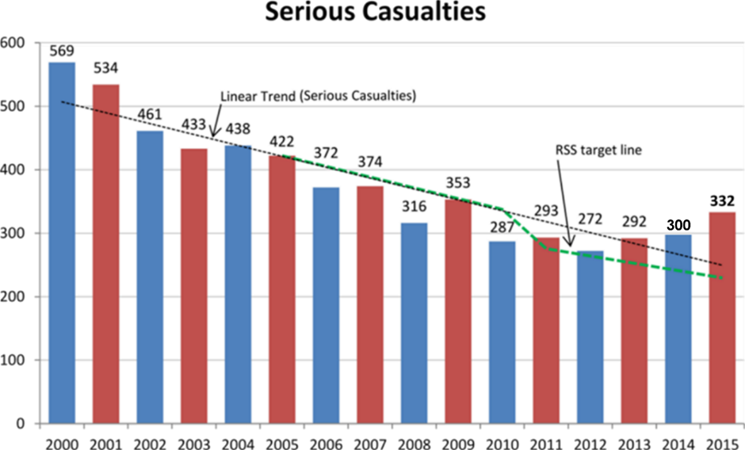

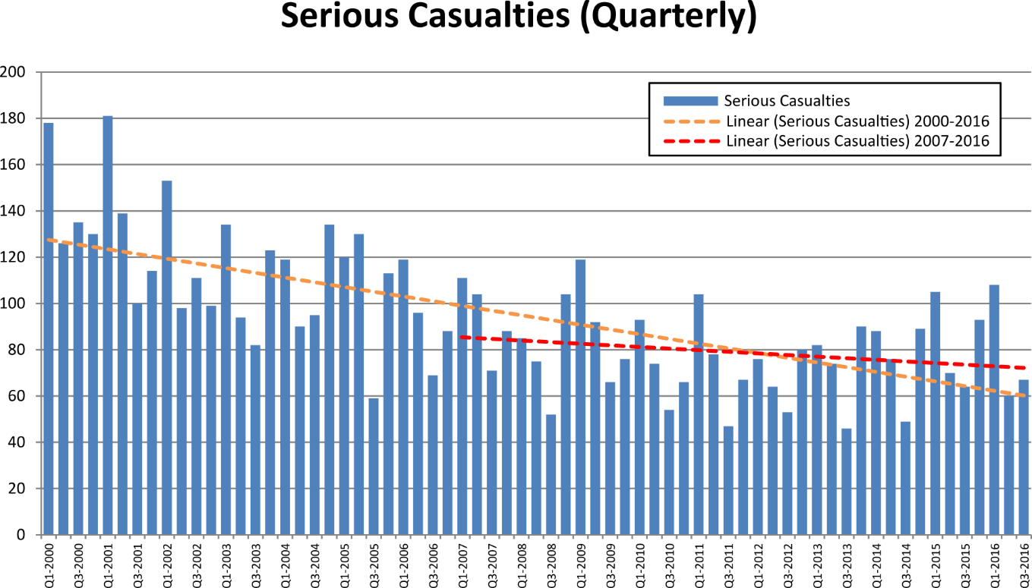

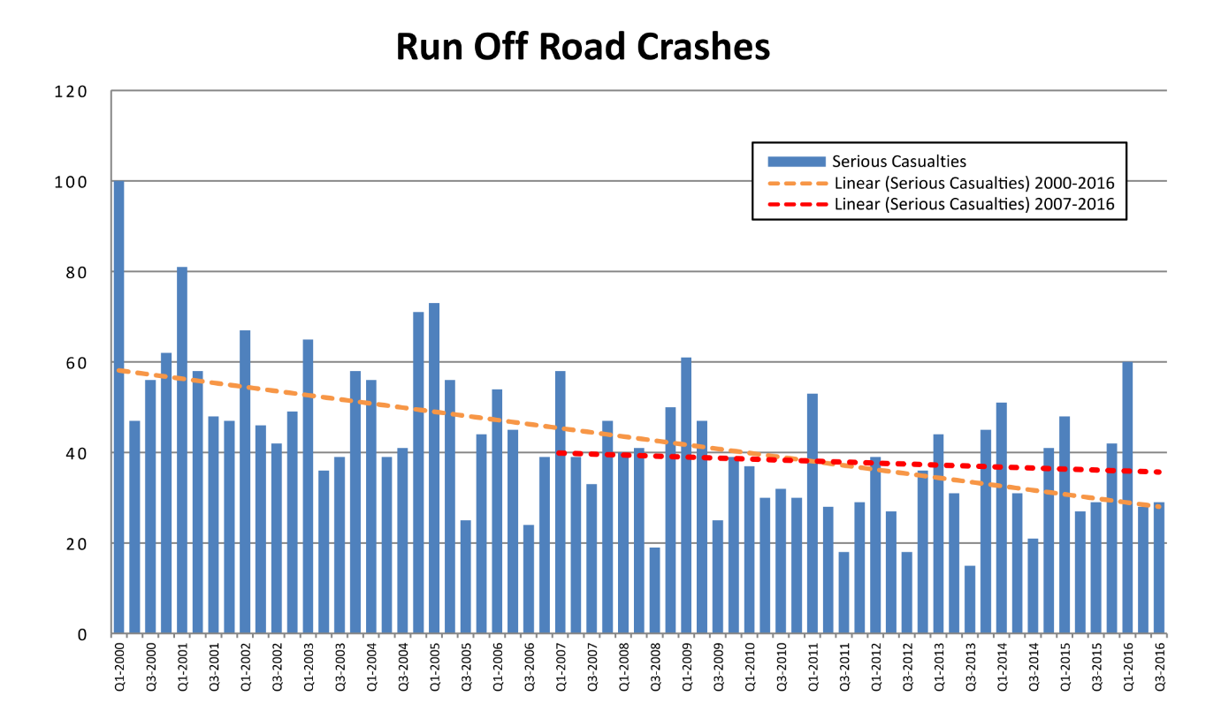

*Depicts serious casualties where a crash has occurred with the vehicle travelling off path through a curve or off path travelling straight

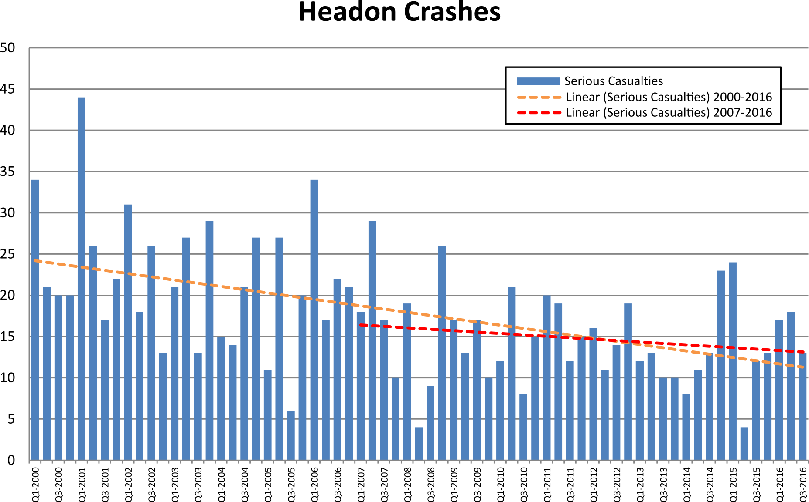
*Depicts serious casualties where a crash has occurred between vehicle from opposing directions

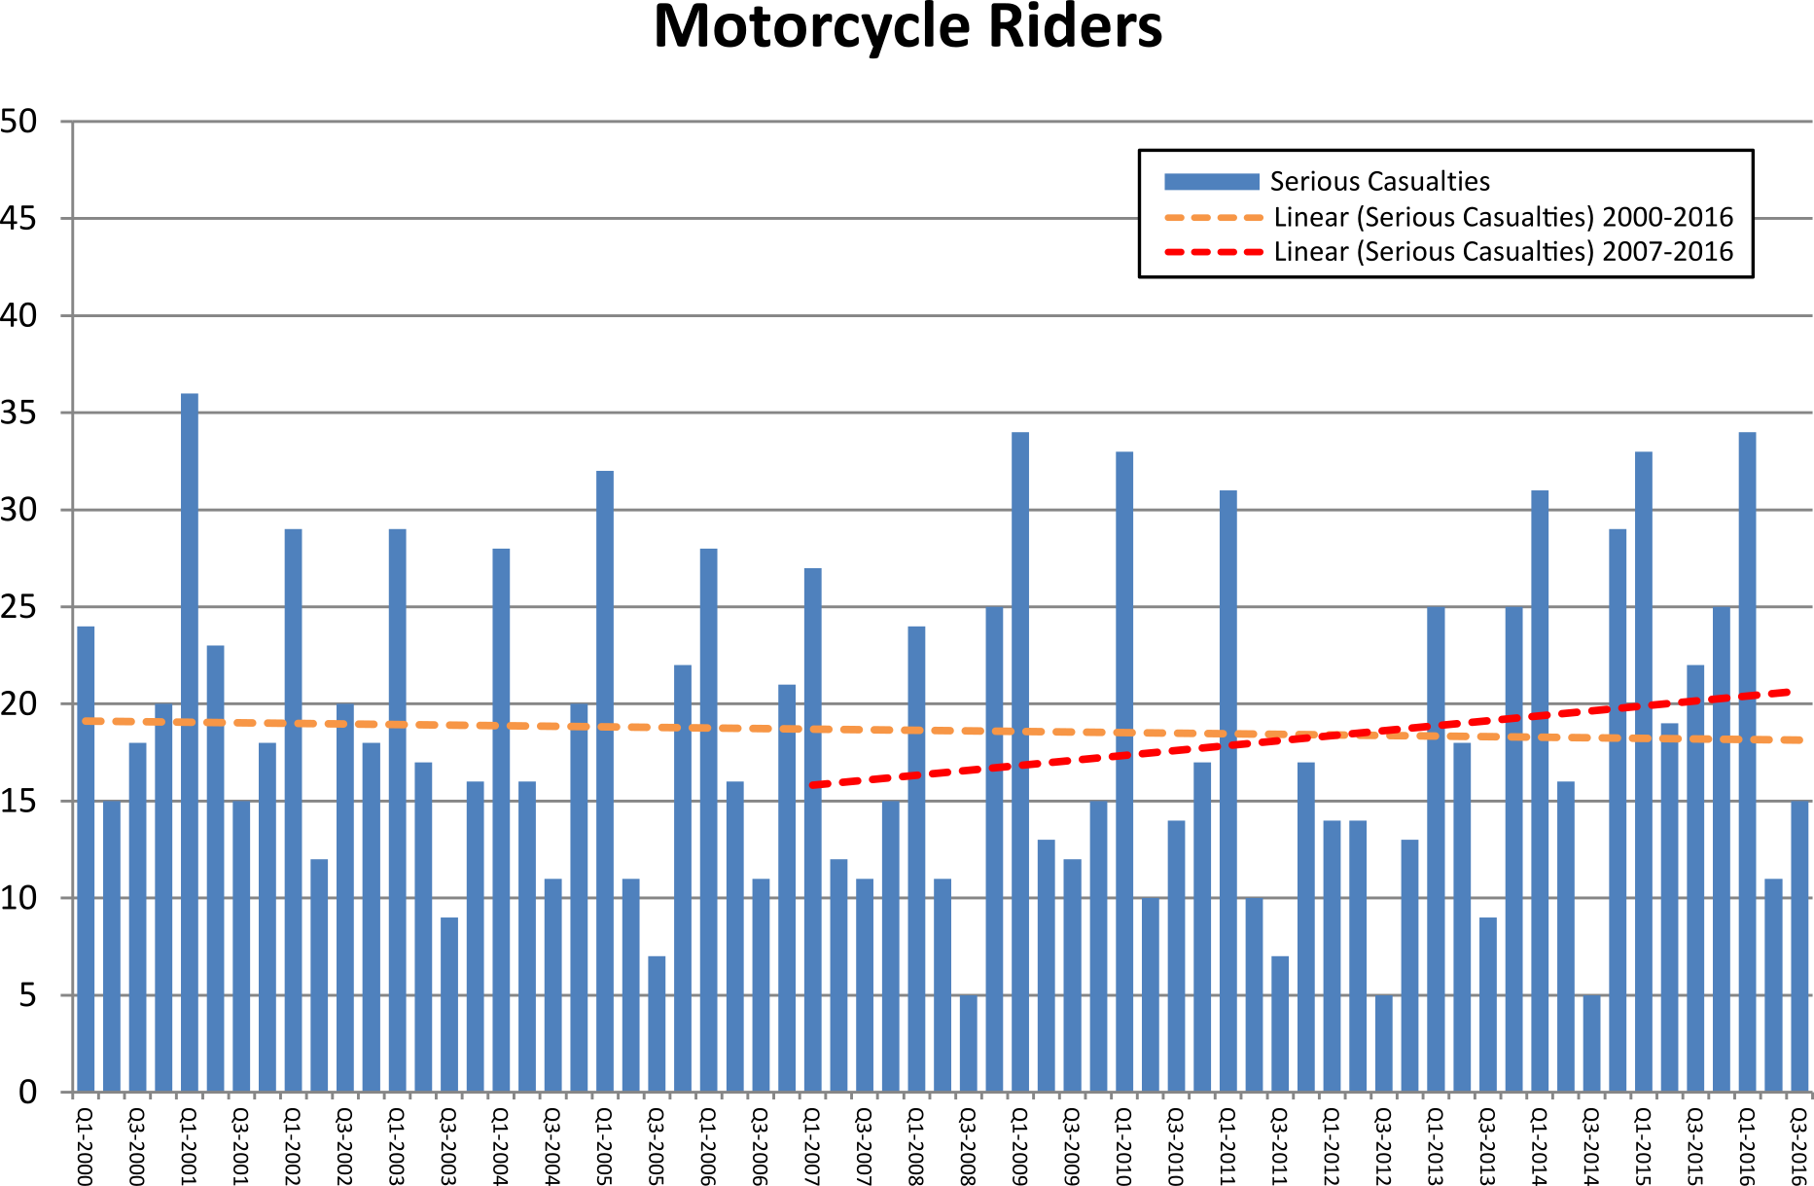

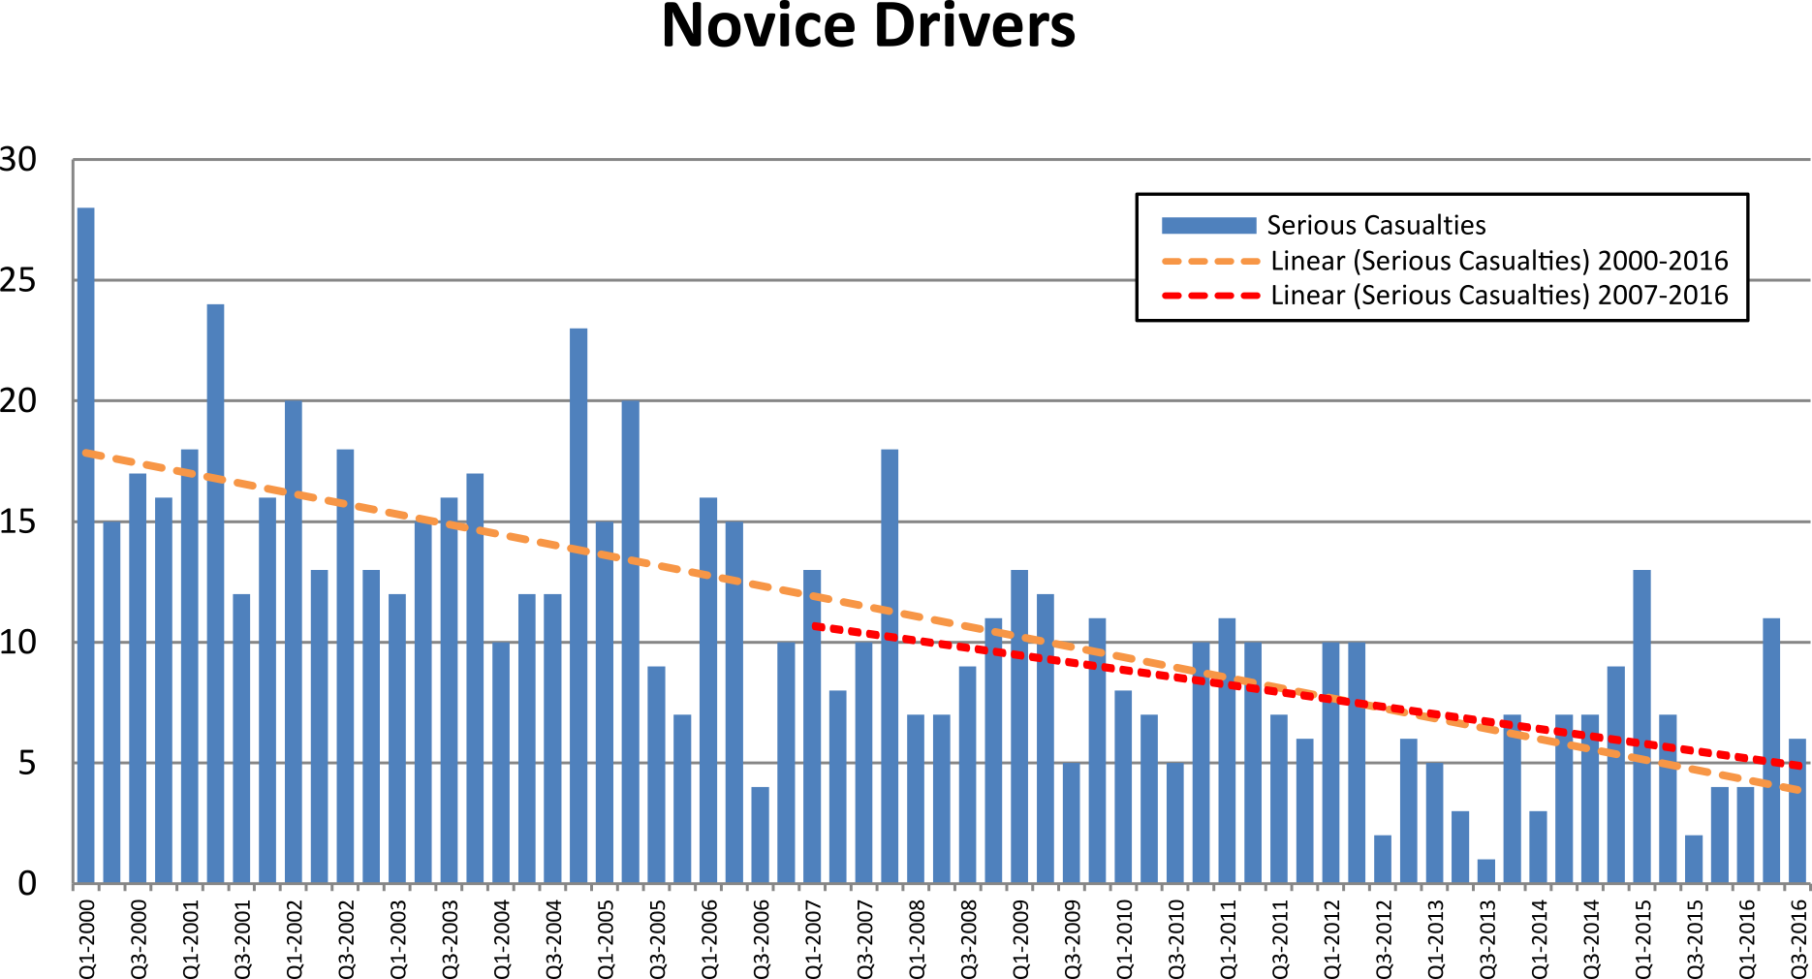
*Depicts serious casualties for drivers of a motor vehicle from 16 – 25 years of age

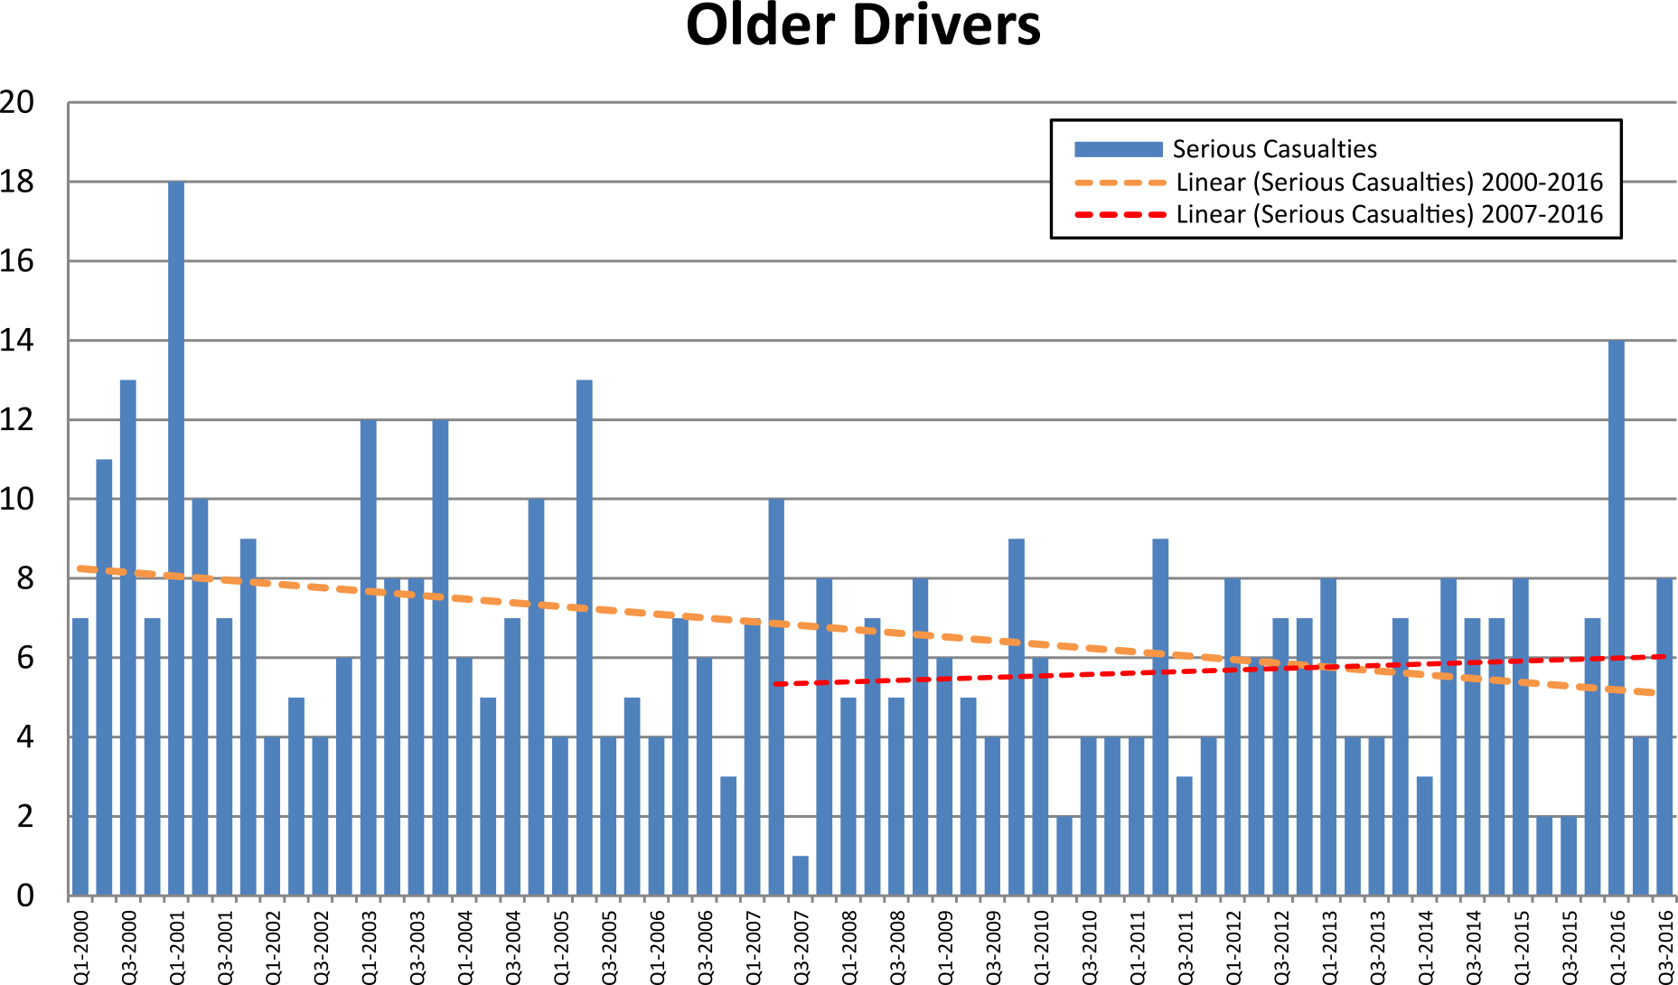

*Depicts serious casualties for drivers of a motor vehicle from 65 – 99 years of age
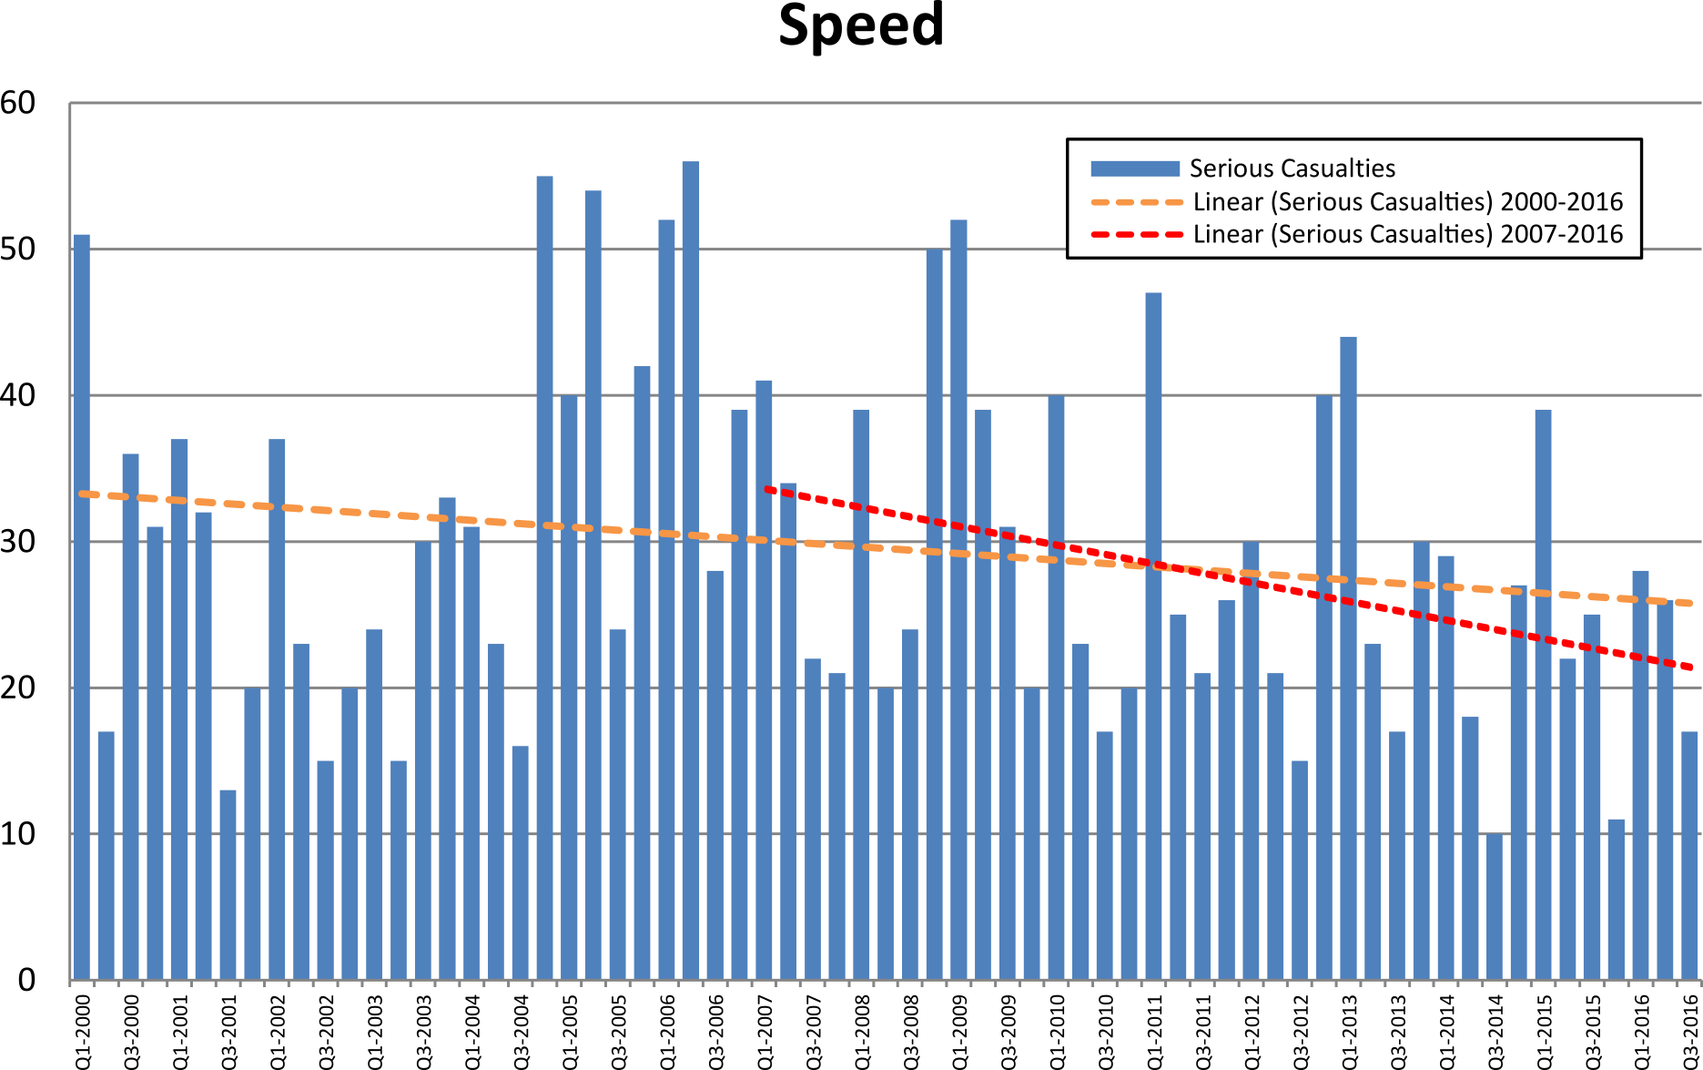
*Depicts serious casualties where the crash factor of exceeding the speed limit and/or excessive speed for the conditions/circumstances is listed as a contributing factor to the crash. There may be instances where both speed factors are recorded for a single crash.
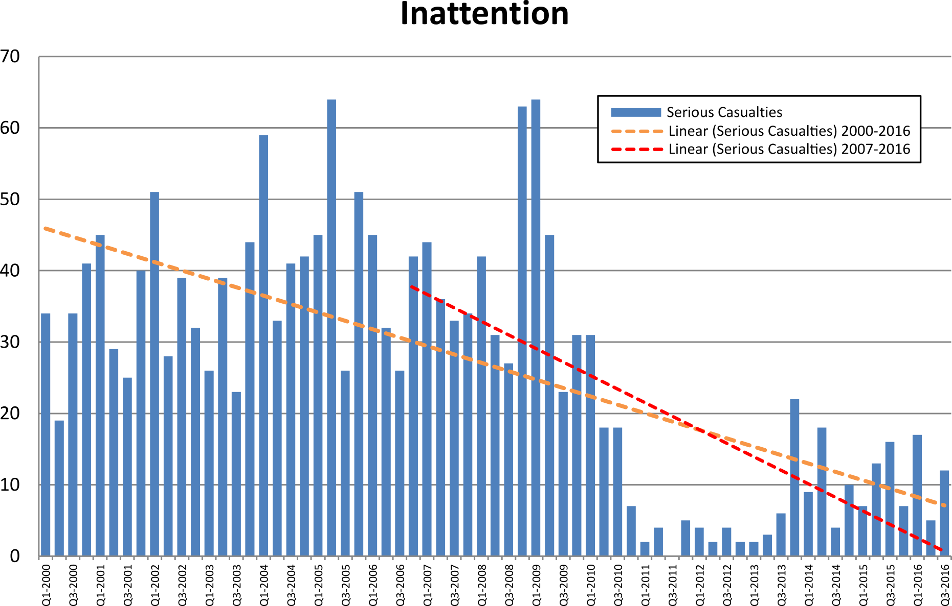

*From 1 January 2011 ‘inattentiveness’ will only be reported if there is no other relevant crash factor.

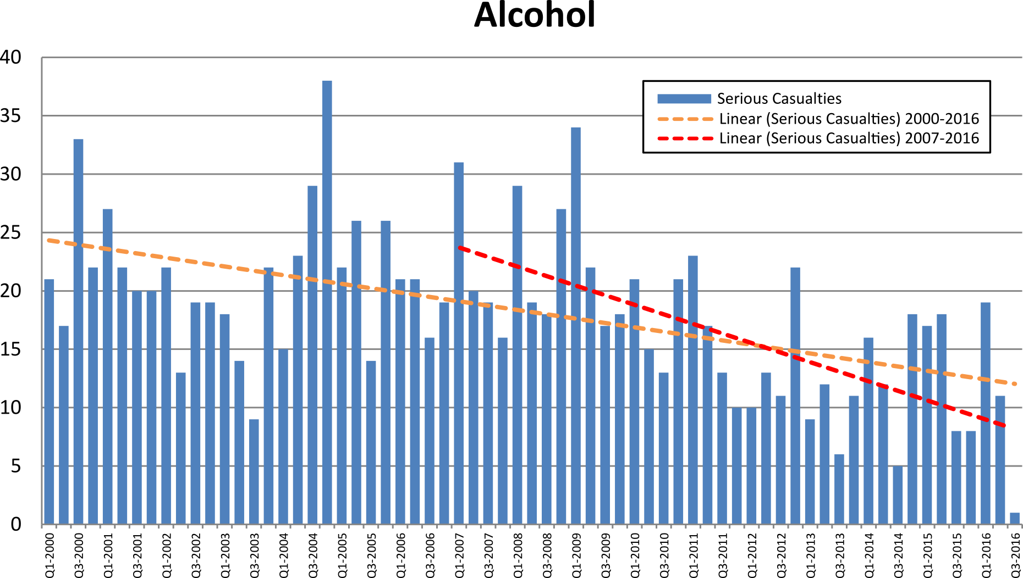*Depicts serious casualties where alcohol is listed as a contributing factor

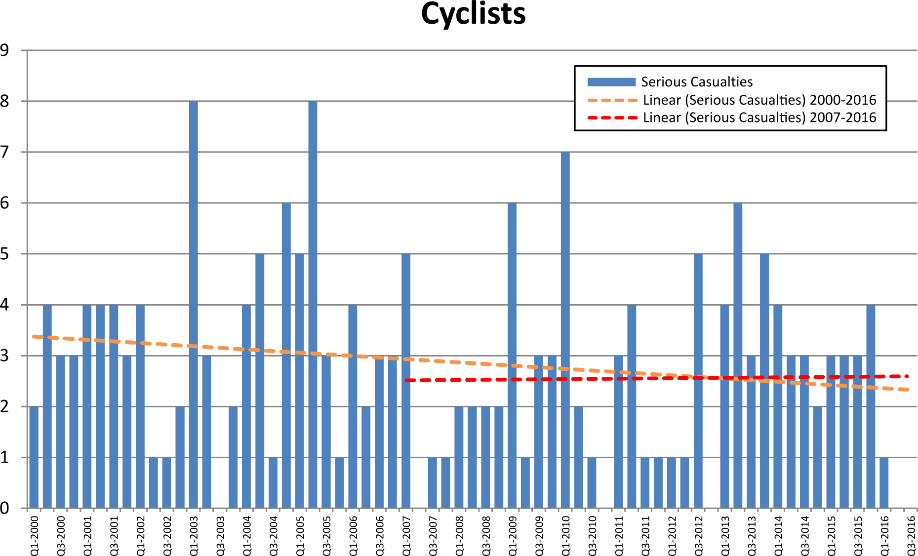

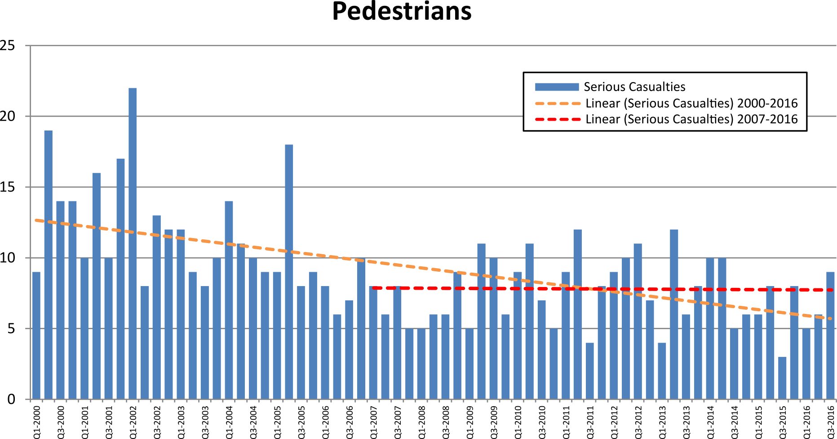

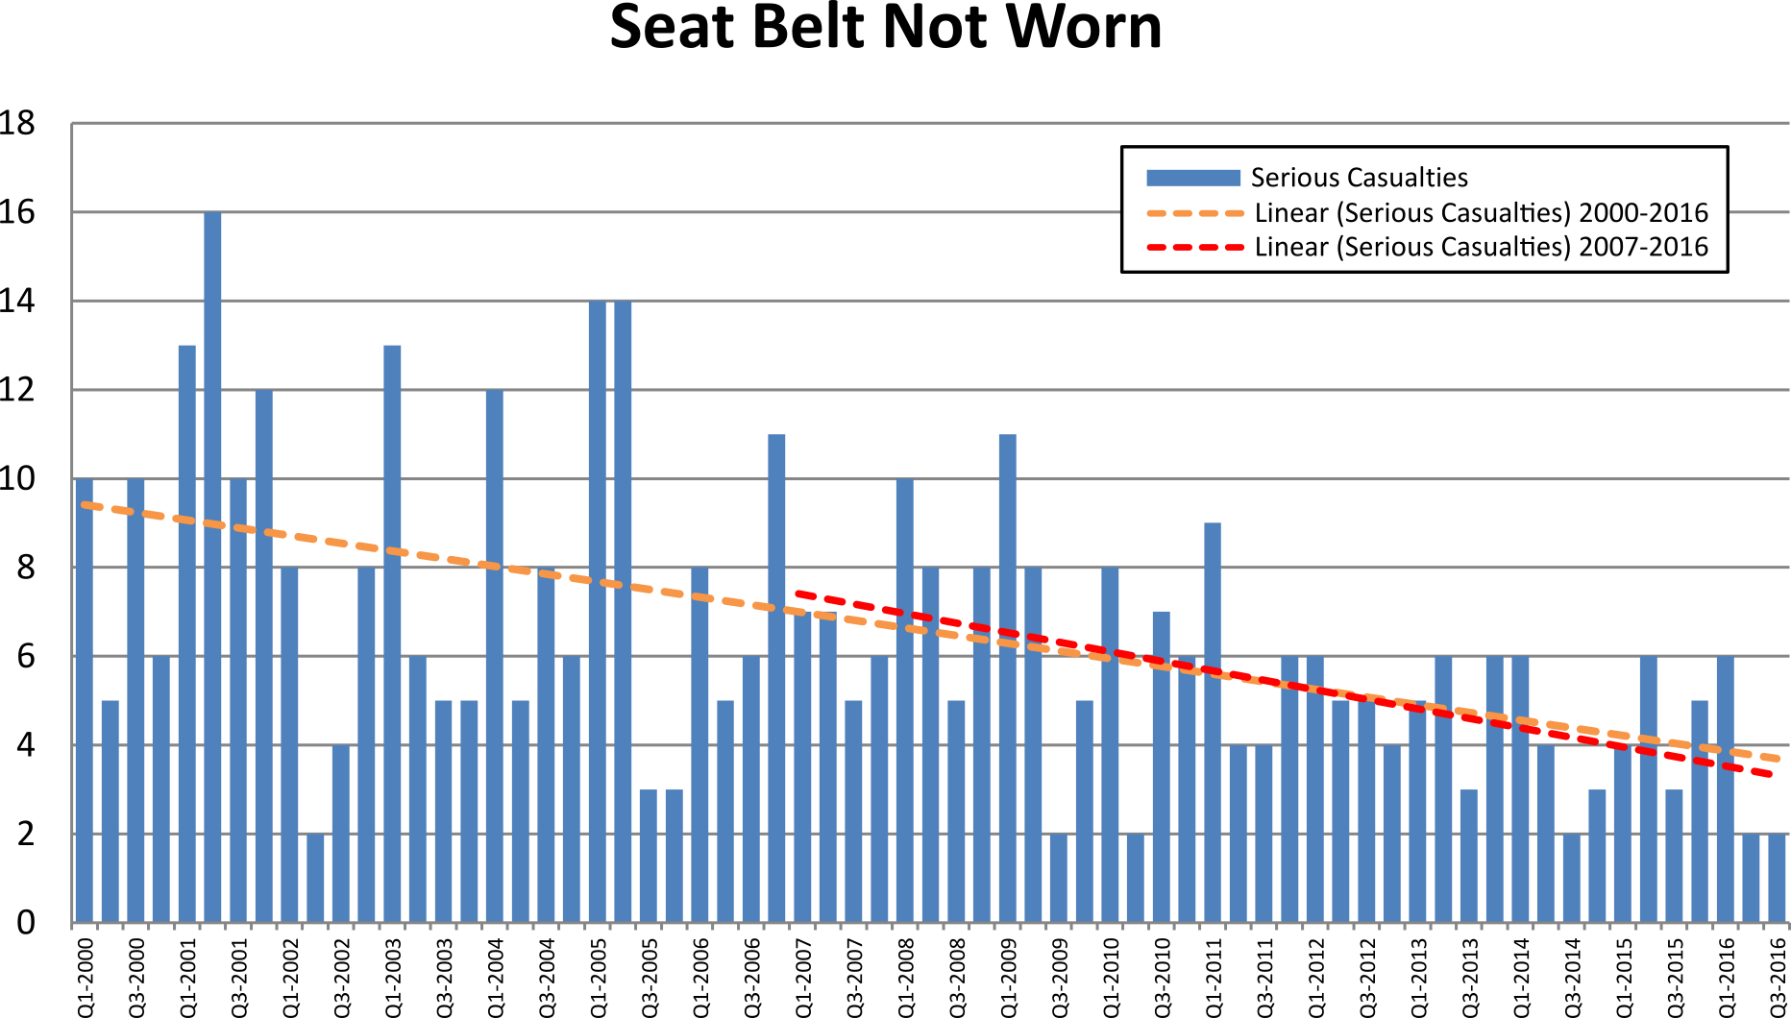

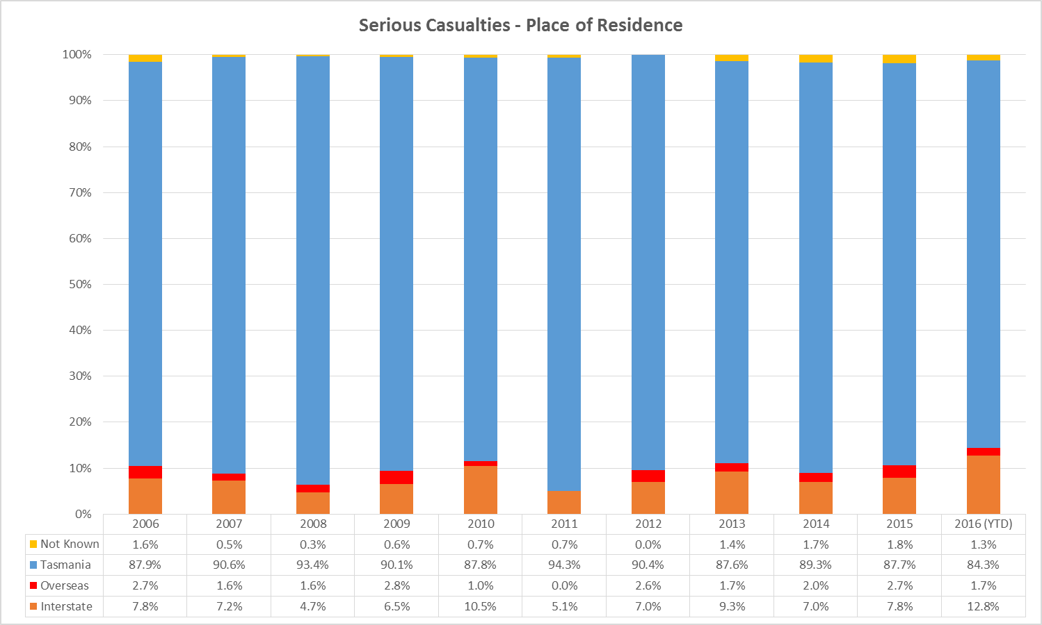

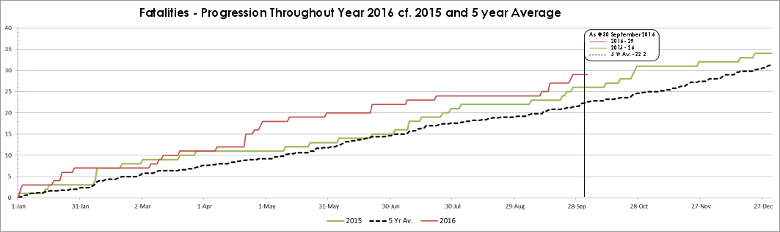

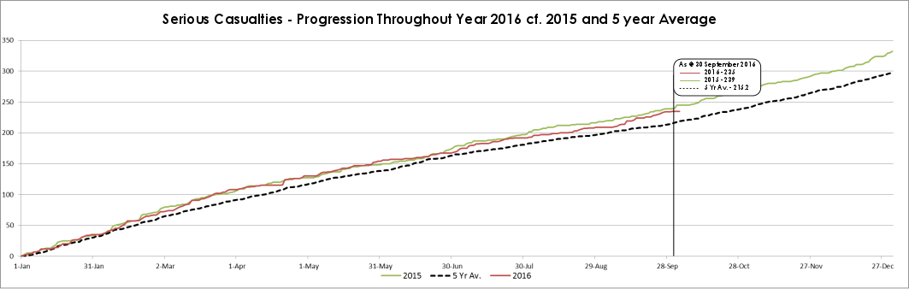
Serious Casualty locations as @ 30 September 2016 (Black = Fatal, Red = Serious Injury)
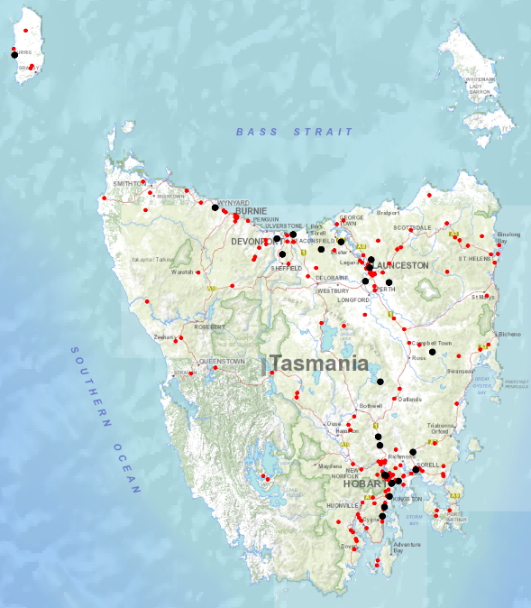

‘Other’ as a crash factor can be used in situations where the reporting police officer believes that the circumstances of the crash are not adequately covered by the existing list of 23 crash factors or where, in the case of a fatality, the death is subject to a coronial inquest. In cases where the Coroner makes findings in relation to the cause or causes of a fatality, the crash record is amended from ‘other’ to reflect the Coroner’s findings.

