Our Safety
Our Future

Tasmanian Road Safety Strategy 2007-2016
Progress Report
to the
Road Safety Advisory Council
including progress on the Work Program

as at
30 JUNE 2016

Executive Summary
Progress on meeting the Tasmanian Road Safety Strategy targets | 4
Progress on meeting the MAIB targets | 6
Key achievements since last report | 7
Strategic Direction 1 – Safer Travel Speeds
Road Safety Levy Funded Projects
Safer Travel Speeds on Rural Roads Program | 10
Fixed Speed Cameras – Information Signage | 12
Strategic Direction 2 – Best Practice Infrastructure
Road Safety Levy Funded Projects
Esk Main Road Shoulder Sealing, Edge Lining and Safety Improvements | 13
Motorcycle Safety Package – Infrastructure Safety Improvements | 15
Weather Warning Signs – Tunnel Hill, Tasman Highway | 17
Safer Roads: Vulnerable Road User Program | 19
East Derwent Highway, Old Beach – Cassidy’s Road to Baskerville Road | 22
Midland Highway at Symmons Plains – 2 Plus 1 | 24
Bass Highway, North of Gannons Hill Road – 2 Plus 1 | 26
Midland Highway Safety Improvements | 28
East Derwent Highway/Cove Hill Roundabout | 30
Lyell Highway, south of Hamilton – Shoulder Sealing | 31
Strategic Direction 3 – Improved Safety for Young Road Users
Road Safety Levy Funded Projects
Learner Driver Mentor Program Grant Funding | 33
Rotary Youth Driver Awareness Program | 35
Bike Safety in Schools – Ride2School Program | 37

Strategic Direction 4 – Enhanced Vehicle Safety
Road Safety Levy Funded Projects
Australasian New Car Assessment Program | 43
Strategic Direction 5 – Complementary Initiatives
Mandatory Alcohol Interlock Program (MAIP) | 44
MAIP Review | 47
RSAC and TRSS Support | 48
Development of ‘the Towards Zero’ – Tasmanian Road Safety Strategy 2017-2026 | 49
Driver Mentoring Tasmania | 50
Motorcycle Safety Package | 52
Distance Makes a Difference - Cyclists Public Education Campaign | 55
Tourist Safety | 56
Community Road Safety Grants Program | 59
Securing Your Loads on Light Vehicles | 61
Discretionary Activities Fund | 62
Funding | 63
Statistics | 65

Progress on meeting the Tasmanian Road Safety Strategy targets
- The number of serious casualties in 2015 was 332, compared to 300 in 2014, an 11 per cent increase. The 2015 figure of 332 is a 14.9 per cent increase on the five year serious casualty average of 289.0 (2010-2014).

- For the 2015 calendar year, there were 34 fatalities on Tasmanian roads which is one more than the 33 recorded in 2014. This is a 9.4 per cent increase on the five year fatalities average of 30.8 (2010-2014).

- There have been 168 serious casualties (22 fatalities and 146 serious injuries) to 30 June 2016, down 4.0 per cent on the same period last year of 175 serious casualties (15 fatalities and 160 serious injuries) and up 2.9 per cent on the five year average of 163.2 serious casualties.

- The table below outlines road crash deaths for individual states and territories for the period 2005 to 2015

 | NSW | VIC | QLD | SA | WA | TAS | NT | ACT | AUST
2005 | 508 | 346 | 330 | 148 | 163 | 51 | 55 | 26 | 1,627
2006 | 496 | 337 | 335 | 117 | 200 | 55 | 45 | 13 | 1,598
2007 | 435 | 332 | 360 | 124 | 235 | 45 | 58 | 14 | 1,603
2008 | 374 | 303 | 328 | 99 | 205 | 39 | 75 | 14 | 1,437
2009 | 454 | 290 | 331 | 119 | 191 | 63 | 31 | 12 | 1,491
2010 | 405 | 288 | 249 | 118 | 193 | 31 | 50 | 19 | 1,353
2011 | 364 | 287 | 269 | 103 | 179 | 24 | 45 | 6 | 1,277
2012 | 369 | 282 | 280 | 94 | 183 | 31 | 49 | 12 | 1,300
2013 | 333 | 243 | 271 | 98 | 162 | 35 | 37 | 7 | 1,186
2014 | 307 | 249 | 223 | 107 | 183 | 33* | 39 | 10 | 1,153
2015 | 348 | 257 | 242 | 102 | 160 | 34 | 49 | 15 | 1,209
% change 2014-15 | 13.4% | 3.2% | 8.5% | -4.7% | -12.6% | 3.0% | 25.6% | 50% | 4.9%

* Note: The previous 2014 fatality figure of 35 has been revised to 33 following the outcome of coronial investigations.

- The first target of ‘by 2010: a 20% reduction in serious injuries and fatalities from 2005’ has been reached with a reduction of 32%. Progress is indicated on the chart below.
- The second target of ‘by 2015: a 20% reduction in serious injuries and fatalities from 2010’ has not been met. Reasons for this include the fact that the number of serious casualties recorded in 2010 was the second lowest recorded, combined with the fact that since 2012 the number of serious casualties has been gradually increasing.
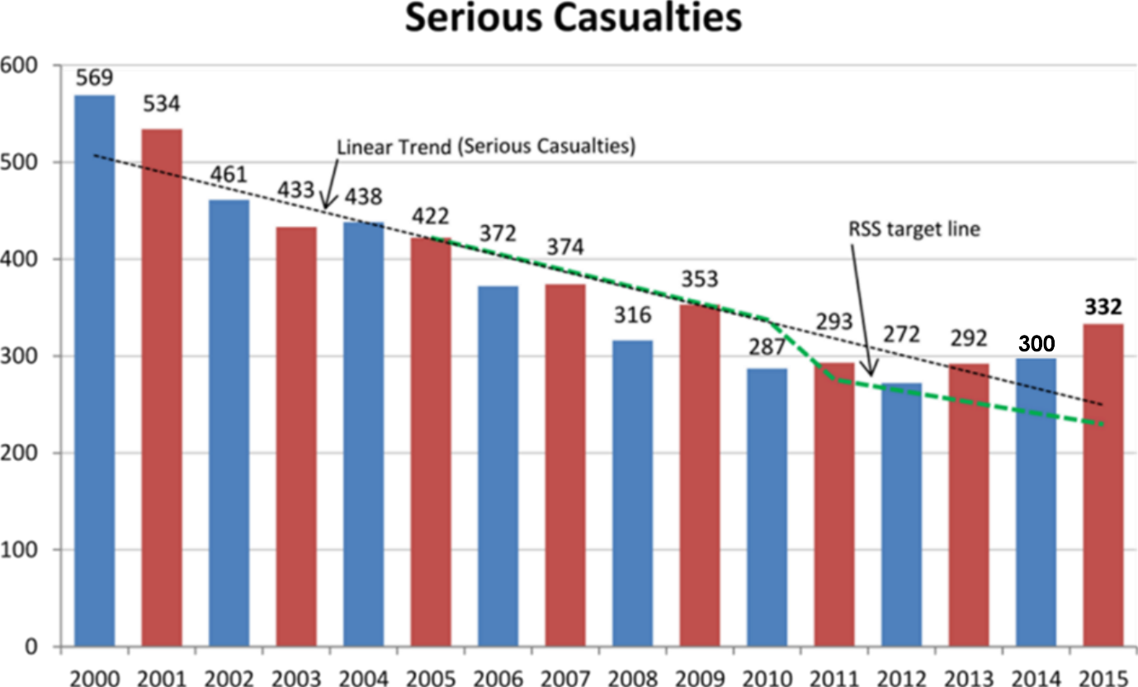

- The method above, used to access the TRSS target, compares points in time – a comparison between the year 2005 and the year 2010 and between 2010 and 2015.
- As an additional measure, the five year averages (and part thereof) are included below. This methodology smooths out anomalies between individual years and provides a holistic picture of serious casualties in Tasmania
Five year average timeframe | Average | % of change | Period
Annual average of serious casualties 2001 - 2005 | 457.6 | N/A | Baseline period
Annual average of serious casualties 2006 – 2010 | 340.4 | - 25.6 | Period 1
Annual average of serious casualties 2011 – 2015 | 297.8 | -12.5 | Period 2

Progress on meeting the MAIB targets
- MAIB injury statistics show the number of fatalities and the level of claims for injuries on our roads. The charts below show the forecast level of claims for serious injuries.
- Various claim reduction targets are specified in the Memorandum of Understanding with the Motor Accidents Insurance Board (MAIB). Progress against high level targets is shown below, expressed as 12-month moving totals.

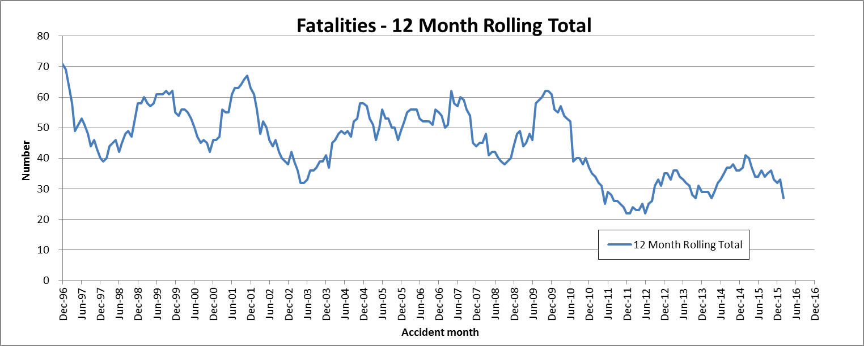

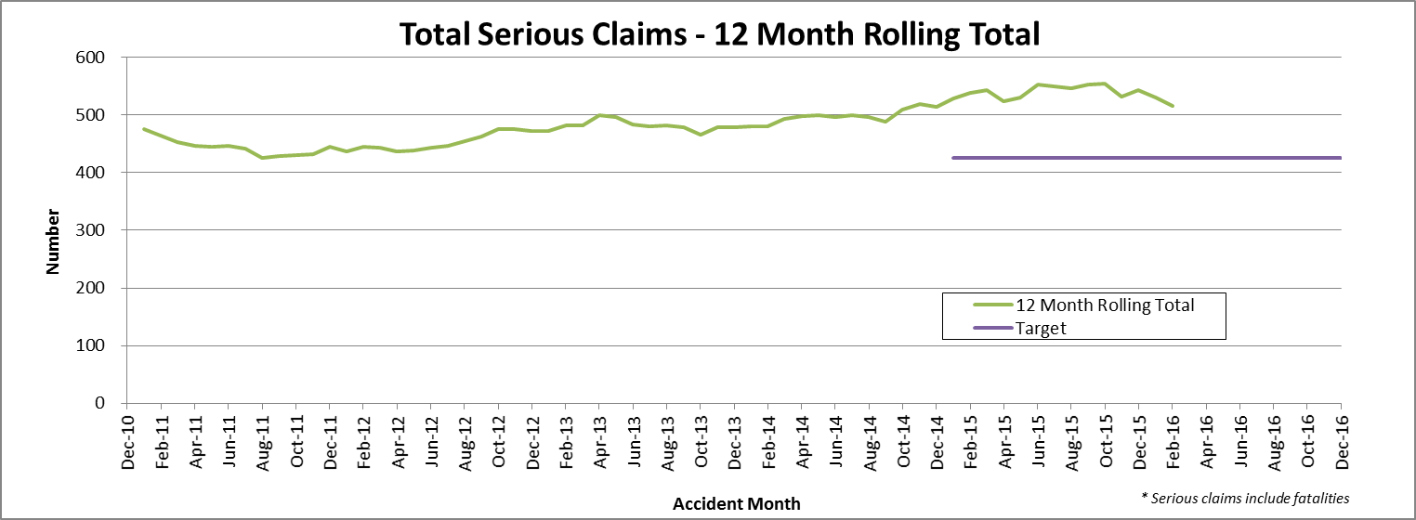

Key achievements since last report

Key project milestones
- Towards Zero – Tasmanian Road Safety Strategy 2017-2026 Discussion Paper developed and released for public comment.

Projects completed this quarter
- Midland Highway at Symmons Plains – 2 Plus 1
- Bass Highway, North of Gannons Hill – 2 Plus 1
- Weather Warning Signs – Tunnel Hill, Tasman Highway
- East Derwent Highway, Cove Hill Roundabout
- Bike Safety in Schools – Ride2School

Projects with budget variance more than 10% (further detail provided under specific projects)
Under Budget
65210034/R310015 – Midland Highway, Symmons Plains – 2 Plus 1
Allocated budget: $7,750,000
Total expenditure: $6,824,747
Underspend: $925,253 (12%)
65210034/R310016 – Bass Highway, North of Gannons Hill – 2 Plus 1
Allocated budget: $7,365,000
Total expenditure: $5,554,729
Underspend: $1,810,271 (24%)

Over Budget
2202/2203 – Tourist Safety Strategy – Stage 1
Allocated budget: $50,000
Forecast expenditure: $76,522
Overspend: $26,522
Reason
Produced higher quality Vlog than originally anticipated and expanded Bobbie the Bear materials due to popularity.

Project progress: schedule and budget
Budget information, milestones and project status are correct as at 30 June 2016.

Project progress | Number of projects
More than 12 months late | 0
Between 6 and 12 months late | 0
Between 3 and 6 months late | 0
Less than 3 months late or on target | 22
Ongoing | 2
Completed | 5
On hold | 1
TOTAL | 30

Road Safety Levy Funded Project
1995 Safer Travel Speeds on Rural Roads Program
Description
In Tasmania, there is a serious crash problem on non-urban roads with a 100km/h speed limit, with more than 40% of serious casualty crashes occurring on these roads. The Safer Roads: Non-Urban Road Network Strategy was developed to address this issue. The Strategy, which is based on Safe System principles, identified the need to balance infrastructure treatments and speed management measures to improve the overall safety of the non-urban road network. The Strategy built on recommendations made to the previous Government by the RSAC and the results of community consultation.
The main focus of the Strategy was on improving, where possible, road and roadside infrastructure, with speed management being utilised as a risk mitigation measure where an infrastructure response was not possible. Independent criteria – the ‘Tasmanian Criteria for 100km/h Roads’ – were developed to assess whether roads are of a suitable standard to retain a 100km/h speed limit.
It was estimated that more than 100 people over six years would be spared serious injury or death should the non-urban speed limit be reduced to 90km/h on those roads that do not meet the Tasmanian criteria.
Following a decision by the former Government not to reduce the default speed limit from 100km/h to 90km/h on rural sealed roads, a program will be developed to consult with councils and local communities to negotiate appropriate speed limits on those roads determined to be unable to meet the Tasmanian criteria and that have a high crash risk. This new program is the Safer Travel Speeds on Rural Roads Program.
Milestone Schedule |  | Milestone Progress
Date |  | Date
February 2013 | Assessment of State Road Network against the ‘Tasmanian Criteria’ | June 2013 | Final Draft – on-site validations completed. Final Draft – Desk top assessments completed.
February 2013 | Assessment of nominated Local Government roads against the ‘Tasmanian Criteria’ | June 2013 | Final Draft – on-site validations completed. Final Draft - Desk top assessments completed.
February 2013 | Development of campaign to educate community about reduced non-urban speed limit and new signage | May 2013 | Communication Action Plan completed. Brief for engaging a communications consultant completed.
April 2013 | Launch of media campaign | February 2014
May/June 2013 | Installation of new signage | February 2014 | Sign contract development 95% completed, upcoming tasks, confirming procurement strategy and associated processes.

June 2013 | Introduction of new speed limits | February 2014 | New limits on gravel roads to commence 1 February 2014.
August 2013 | 12-month Evaluation | February 2014 | TBA
June 2013 | Amendment to road rules – subordinate legislation | February 2014 | Regulation changes commenced 1 February 2014.
December 2014 | Develop program for consultation with local government about appropriate speed limits on local sealed rural roads taking into account crash risk and ability to meet Tasmanian criteria. |  | Not commenced.  On hold.
Status
State Growth will develop a framework to engage with local councils to review speed limits on sections of roads within their municipalities and where necessary to deliver more appropriate speed limits.
However, this has not yet commenced due to other priority projects. This project will be considered under the new Towards Zero – Tasmanian Road Safety Strategy 2017-2026.
Budget ($)
Total allocated budget for project | 1,000,000*
Expenditure in 2012/13 | 85,639
Expenditure in 2013/14 | 520,473
Expenditure in 2014/15 | 19,556
Total expenditure to date | 625,668
Current Balance | 374,334
Forecast total expenditure on completion |  | 1,000,000
Forecast balance remaining on completion |  | 0
Comments
* Note: RSAC endorsed a revised budget at its meeting of 26 November 2013. Original budget was $1,500,000.

Road Safety Levy Funded Project
1997 Fixed Speed Cameras – Information Signage
Description

With the installation of the new fixed speed cameras, it is timely to review the network of signs across the State. There is an existing network of approximately 16 general information ‘Red Light and Speed Cameras Operate in Tasmania’ signs placed on major arterial routes around Tasmania; installed in 1992, these are ageing and in varying conditions of repair.
In August 2015 RSAC agreed to allocate funds for the installation of new speed camera information signs at the ports of entry and in the vicinity of the newly installed cameras; it was also agreed to remove the existing ageing speed camera signage to ensure a consistent approach to signing across the State.

Milestone Schedule |  | Milestone Progress
Date |  | Date
December 2015 | Install new signs in vicinity of newly installed fixed speed cameras | December 2015 | Completed
March 2016 | Install new signs at the five ports of entry | March 2016 | Final camera installed
April 2016 | Remove all existing ‘red light and speed cameras operate in Tasmania’ signs | June 2016 | All signs removed.
Status
The 19 existing ‘red light and speed cameras operate in Tasmania’ signs installed across the State were removed in May.
Gateway signs at the five ports-of-entry will be installed in the next quarter.
Budget ($)
Total allocated budget for project | 50,000
Expenditure in 2015/16 | 16,999
Expenditure in 2016/17 to date | 0
Total expenditure to date | 16,999
Current Balance | 33,001
Forecast total expenditure on completion |  | 50,000
Forecast balance remaining on completion |  | 0

Road Safety Levy Funded Project
R320009 Esk Main Road Shoulder Sealing, Edge Lining and Safety Improvements
Description
Esk Main Road is the principal route to the East Coast from the Midland Highway and is a significant collector, carrying freight and commuters between regional communities.
The lack of sealed shoulders along sections of the Esk Main Road is a recognised deficiency in the State Arterial Road Network and is the highest priority road for shoulder sealing. Crash analysis for the 20 km section of the highway between Midland Highway and west of Avoca indicates that off-road-on-curve is the major crash type occurring along the road, resulting in a high injury rate of 60%.
Works to be undertaken include shoulder sealing, provision of edge lines and safety improvements. These works will be undertaken in two stages.
Stage 1: Develop a method-based contract, instead of standard detail design contract, over a 3.6km section of the Esk Main Road from the junction with the Midland Highway. Work for Stage 1 will be undertaken through a variation to an existing contract for Esk Main Road improvements, awarded under the Community Roads Program.
Stage 2: Successful methodology applied in Stage 1 will enable shoulder sealing to be delivered more efficiently and cost effectively between Midland Highway and Avoca.
Milestone Schedule |  | Milestone Progress
Date |  | Date
Stage 1
December 2012 | Award contract | December 2012 | Variation to existing contract.
February 2013 | Undertake geotechnical tests | March 2013 | Geotechnical tests and report completed.
April 2013 | Commence works on 3.6km section
June 2013 | Complete works on 3.6km section | September 2013 | Initial works completed. Final seal of section to be completed in 2013-2014 construction period.
June 2013 | Complete works on 3.6km section | December 2013 | All works completed.
Stage 2
October 2013 | Award contract | December 2013 | Stage 2 delayed 12 months.
January 2014 | Commence works | March 2014 | Scoping work has commenced.
June 2014 | Complete works | June 2014 | Tender to be released late July.
 |  | September 2014 | Tender advertised late July; successful tenderer to be announced in October.
 |  | December 2014 | Tender announced October. Work commenced early Nov.
 |  | March 2015 | All major shoulder work completed; some minor works to be completed early April.
 |  | June 2015 | Outstanding minor works completed May 2015.
 |  | Sept 2015 | Stage 3 scoping underway with works planned for summer season.
 |  | Dec 2015 | Stage 2 seal work to begin in January 2016; discussions with contractor for Stage 3 underway.
 |  | March 2016 | Final seal on Stage 2 completed. Stage 3 to be undertaken 2016/17.
Stage 3
 |  | June 2016 | Tender for Stage 3 prepared and will be released in July.

Status
Stage 1: All work completed.
Stage 2: Final seal applied; final line marking will be undertaken in spring/summer 2016.
Stage 3: Contractors did not have the capacity to include work in current construction period. Tender documents will be released in July for work to be undertaken spring/summer 2016.
Budget ($)
Total allocated budget for project | 8,500,000
Expenditure in 2012/13 | 208,386
Expenditure in 2013/14 | 848,541
Expenditure in 2014/15 | 2,716,272
Expenditure in 2015/16 | 742,228
Expenditure in 2016/17 to date | 0
Total expenditure to date | 4,515,427
Current Balance | 1,344,573
Forecast total expenditure on completion |  | 5,860,000
Forecast balance remaining on completion |  | 0
Comments
In May 2015, RSAC agreed that savings from the audible line markings projects on the Bass and East Tamar Highways be allocated to the Esk Main Road project to allow for the completion of the section from the Midland Highway to Avoca. The reallocated savings totalled $1,000,000 providing a total budget to the project of $5,860,000.
In August 2014, RSAC agreed that $3.64m from the Esk Main Road Shoulder Sealing and Edge Lining and Safety Improvements project be re-allocated to the Road Safety Levy’s commitment to the Midland Highway Safety Improvements Program. This left a total amount of $4,860,000 to this project.
Road Safety Levy Funded Project
2301 Motorcycle Safety Package – Infrastructure Safety Improvements
Description
The Hodgman Government made a commitment at the last state election to implement motorcycle safety measures along the Great Eastern Drive (the newly named section of the Tasman Highway from Orford to St Helens). Motorcyclists continue to be over-represented in fatal and serious crashes in Tasmania.
The rollout of motorcycle safety infrastructure treatments is aimed at reducing the risk of injury to motorcyclists in the event of a crash. This initiative has been included in the Strategy’s Third Action Plan, with $300,000 being allocated to the project from the Road Safety Levy over three years (i.e. $100,000 per annum).
Milestone Schedule |  | Milestone Progress
Date |  | Date
May 2014 | Motorcycle Safety Working Group Established | May 2014 | Completed
October 2014 | Commencement of infrastructure projects for 2014/15 financial year (year 1) | December 2014 | Scoping completed. Work to begin early 2015.
April 2015 | Completion of 2014/15 financial year projects (year 1) | March 2015 | Contractor engaged to undertake rub rail and signage works.
July 2015 | Identification and endorsement of 2015/16 projects (year 2) | June 2015 | Rub rail and signage work completed. Scoping for 15-16 work underway.
October 2015 | Commencement of infrastructure projects for 2015/16 financial year (year 2) | September 2015 | Final scoping and costing for works in Sheffield area completed.
May 2016 | Completion of 2015/16 financial year projects (year 2) | Dec 2015 | Executed grant deed sent to Council; work to commence early 2016.
 | Safety improvements in Sheffield area underway. | March 2016 | Safety improvements in Sheffield area underway.
July 2016 | Identification and endorsement of 2016/17 projects (year 3) | June 2016 | All work in Sheffield area completed.
October 2016 | Commencement of infrastructure projects for 2016/17 financial year (year 3)
April 2017 | Completion of 2016/17 financial year projects (year 3)
Status
Safety improvements in the Sheffield area were completed in May; unfortunately some works were severely damaged during the June 2016 flooding.
The Tasmanian Motorcycle Council will identify treatments for 2016-17 on gateways to the Great Eastern Drive and other popular motorcycle routes.

Budget ($)
Total allocated budget for project | 300,000
Expenditure in 2014/15 | 0
Expenditure in 2015/16 | 83,131
Expenditure in 2016/17 to date | 0
Total expenditure to date | 83,131
Current Balance | 216,869
Forecast total expenditure on completion |  | 300,000
Forecast balance remaining on completion |  | 0

Road Safety Levy Funded Project
R340004 Weather Warning Signs – Tunnel Hill, Tasman Highway
Description
The installation of two adverse weather warning signs at Tunnel Hill, Tasman Highway forms part of the Department of State Growth’s coordinated monitoring, evaluation and upgrading of the Variable Speed Limit (VSL) system on the Tasman Highway between the Cambridge Road Interchange and Liverpool Street, Hobart.
The provision of a VSL system on this section of the Tasman Highway was funded by the Road Safety Levy. The system went ‘live’ in January 2013 and incorporates a Road Weather Information Station (RWIS) at Tunnel Hill. The RWIS is fully automated and speed limits on the VSL signs are lowered at Tunnel Hill when the RWIS detects wet or icy road conditions.
Analysis of traffic data generated in the first 12 months of the VSL system’s operation suggested that compliance is poor when speed limits are reduced, if the reason for lowering the speed limit is not immediately apparent, e.g. the presence of black ice.
Research has shown that driver compliance to lowered speed limits significantly increases when a reason is provided. The proposed warning signage at Tunnel Hill will provide adverse weather warning advice to drivers. Increased driver response time to lowered speed limits at Tunnel Hill, will decrease the likelihood of a crash along this section of the highway.
One weather warning sign will be placed for inbound traffic and one for outbound traffic. Each sign will be able to display either ‘wet road’ or ‘icy road’ depending on road conditions.
Milestone Schedule |  | Milestone Progress
Date |  | Date
November 2014 | Warning Signs ordered | December 2014 | Delayed to early 2015
March 2015 | Warning signs delivered | March 2015 | Warning signs have been ordered.
April 2015 | Installation of warning signs and period of testing | June 2015 | Signs to be delivered by end of October.
May 2015 | Warning signs fully operational | Sept 2015 | Operational by end of year.
 |  | Dec 2015 | Warning signs under test.
 |  | March 2016 | Safety barrier installed.
 |  | June 2016 | Project Completed  Signs operational.

Status
Two new weather warning signs were installed and commissioned in May 2016.

Budget ($)
Total allocated budget for project | 50,000
Expenditure in 2014/15 | 3,040
Expenditure in 2015/16 | 64,611
Total expenditure to date | 67,651
Current Balance | (2,651)
Forecast total expenditure on completion |  | 65,000
Forecast balance remaining on completion |  | (17,651)

Comments
Due to site constraints, the signs are installed within the normal deflection distance of the steel w-beam barrier. In order to comply with Australian Standards sections of the barrier adjacent to the signs were strengthened to reduce deflection in the event of a vehicle striking the barrier. This work necessitated a small additional expenditure of $2,651.
Road Safety Levy Funded Project
2006 Safer Roads: Vulnerable Road User Program
Description
The Safer Roads: Vulnerable Road User Program has been developed to improve the overall safety of vulnerable road users by minimising the opportunities for conflict between them and motor vehicles. The aim of the program is to reduce serious road crashes involving vulnerable road users. For the purposes of the program, vulnerable road users include pedestrians, cyclists and motorcyclists.
The program is funded at $1.5 million over the two years (2013/14 and 2014/15), and $500 000 a year in future years through the Tasmanian Road Safety Levy (for the life of the Levy, currently to 30 November 2017).
Milestone Schedule |  |  | Milestone Progress
Date |  |  | Date
April 2013 | Submissions for funding invited |  | April 2013 | Completed
June 2013 | Assessment of submissions and recommendations made to Program Steering Committee |  | July 2013 | Completed
June 2013 | Successful projects for 2013/2014 financial year announced |  | 30 July 2013 | Announced  11 August 2013.
July 2013 | Commencement of projects for 2013/14 financial year |  | September 2013 | Many projects to be underway during October-December reporting quarter.
July 2013 | Commencement of projects for 2013/14 financial year |  | December 2013 | Three projects underway.
February 2014 | New round of submissions & assessment for projects commencing in financial year 2014/15 |  | March 2014 | Three projects completed; 10 underway.
May 2014 | Assessment of submissions and recommendations made to Program Steering Committee |  | June 2014 | Submissions assessed with advice to councils in July.
June 2014 | Projects for the 2013/14 financial year to be completed |  | June 2014 | 9 projects completed; 5 delayed; 2 reviewed.
June 2014 | Successful projects for 2014/2015 financial year announced |  | June 2014 | Announced August 2014.
December 2014 | Final funding provided by State Government for 2013/14 projects after completion audits |  | September 2014 | 1 project completed; 4 delayed; 1 withdrawn and 1 postponed.
December 2014 | Remaining projects in 2013-14 year to be completed.  Design plans for 2014-15 year to be finalised. |  | December 2014 | 2 projects completed; 2 almost completed.  Final design plans for 2014-15 projects being received. One further project approved for funding.
March 2015 | Submissions sought for 2015/16 projects |  | March 2015 | Letters to councils for the 2015-16 year have been sent. Two projects from the 2013-14 year are yet to be completed; 10 out of 12 2014-15 projects are underway.
April 2015 | 2015/16 submissions close |  | June 2015 | All submissions received end May.
May 2015 | Assessment of 2015/16 submissions and recommendations made to Program Steering Committee |  | June 2015 | Assessment Committee met in June; recommendations to Steering Committee in July.
June 2015 | Projects for the 2014/15 financial year to be completed |  | June 2015 | No projects completed.
June-July 2015 | Meeting of Program Steering Committee (via tele- or video conference) to discuss assessment of 2015/16 applications. |  | Sept 2015 | Completed
July-August 2015 | Successful projects for 2015/16 announced |  | Sept 2015 | Completed
September 2015 | Commencement of projects for 2015/16 |  | Sept 2015 | Seven of the 12 projects in the 2014-15 round have been completed. Detailed plans being submitted for the 2015-16 projects.
December 2015 | Final funding provided by State Government for 2014/15 projects after completion audits. |  | Dec 2015 | 11 of the 12 projects have been completed.
 |  |  | March 2016 | Final project for 2014/15 round underway.
 |  |  | June 2016 | Bike lanes completed; submissions for Round 4 received.  Round 3 projects underway.

Status
Round 2 – 2014-15
Glenorchy City Council’s bike lanes project along Main Road from Abbotsfield Road, Claremont to St Virgil’s College Austins Ferry was completed in May 2016.
Round 3 – 2015-16
Launceston City Council has completed the bike lanes project along St Leonards Road.
Derwent Valley Council has decided not to progress with the footpath through Westerway due to challenging site constraints.
One council is yet to finalise drawings.
Seven projects are progressing with finalisation in the next quarter.
Round 4 – 2016-17
Letters seeking submissions for Round 4 were sent to all councils in May with due date mid-June, this was extended to 30 June for flood-affected councils; 22 submissions have been received. The Assessment Committee will meet mid-July to select appropriate projects to recommend to the Steering Committee for funding.

Budget ($)
Total allocated budget for project | 2,500,000
Expenditure in 2013/14 | 329,200
Expenditure in 2014/15 | 409,920
Expenditure in 2015/16 | 575,705
Expenditure in 2016/17 | 0
Total expenditure to date | 1,314,825
Current Balance | 1,185,175
Forecast total expenditure on completion |  | 2,500,000
Forecast balance remaining on completion |  | 0

Road Safety Levy Funded Project
R320004 East Derwent Highway, Old Beach – Cassidy’s Road to Baskerville Road
Description
The ‘Safe System’ approach aims to create safer roadsides to compensate for driver error, using infrastructure improvements. This project will consist of approximately 1.3km of shoulder sealing and the addition of three dedicated right turn lanes at junctions to reduce intersection crashes and reduce the severity of the S-curve near Cassidy’s Road junction.
At this site there were 29 crashes over a five year period (15 casualty crashes; 14 property damage crashes). These occurred in three clusters:
- Nine loss-of-control crashes (three casualty) on the S-curve near Cassidy’s Road;
- Seven loss-of-control crashes (three casualty) on the bend at Melane Road; and
- Three casualty crashes resulting from loss-of-control and five crashes (three casualty) at the Baskerville Road junction.
Shoulder sealing reduces run-off-road crashes by 30% and head on crashes by 15%. Dedicated right turn lanes at junctions reduce rear-end collisions by 60%. Reduces the severity of curves and hence reduces run-off-road crashes by 60%.
Milestone Schedule |  | Milestone Progress
Date |  | Date
October/early Nov 2010 | Tender Award | January 2011 | Awarded February 2011.
December 2010 | Commence Works | January 2011 | Commenced March 2011.
April 2011 | Complete Works | September 2011 | Work suspended due to weather and settlement.
Summer 2011/12 | Final Seal | December 2011 | Monitoring land settlement. Interim works planned.
 |  | March 2012 | Interim reseal of existing road completed.
 |  | December 2012 | Work to be finalised.
June 2013 | All work completed. | December 2013 | All major work completed.
June 2013 | All work completed | June 2014 | Contractor considering best approach to batter banks.
June 2013 | All work completed | Sept 2014 | All work completed.
 |  | Dec 2014 | Property boundary adjustments to be finalised.
 |  | Sept 2015 | Negotiations with private landholder well underway.
 |  | Dec 2015 | Property boundary negotiations continuing.
 |  | March 2016 | Negotiations in final stages.
 |  | June 2016 | No further progress.
Status
Work continues on boundary readjustments with the council and adjacent landholder.
Budget ($)
Total allocated budget for project | 2,000,000
Expenditure in 2008/09 | 151,543
Expenditure in 2009/10 | 91,162
Expenditure in 2010/11 | 1,002,227
Expenditure in 2011/12 | 90,541
Expenditure in 2012/13 | 254,946
Expenditure in 2013/14 | 68,037
Expenditure in 2014/15 | 149,502
Expenditure in 2015/16 | 13,059
Total expenditure to date | 1,821,017
Current Balance | 178,983
Forecast total expenditure on completion |  | 2,000,000

Road Safety Levy Funded Project
R310015 Midland Highway at Symmons Plains - 2 Plus 1
Description
Detailed design and construction to widen the carriageway and provide two lanes in one direction and one lane in the other direction, separated by a painted median with wire rope safety fencing.
Milestone Schedule |  | Milestone Progress
Date |  | Date
July 2012 | Detailed design report to be received from engineering consultants | December 2011 | Consultant engaged.
July 2012 | Detailed design report to be received from engineering consultants | March 2012 | DA lodged with Northern Midlands Council.
July 2012 | Detailed design report to be received from engineering consultants | June 2012 | Detailed design report on track.
August 2012 | Tender process for construction phase | September 2012 | Tender process ongoing.
October 2012 | Award tender | December 2012 | Tender awarded.
December 2012 | Commence works | December 2012 | Works to commence early 2013.
December 2014 | Complete works | March 2014 | All major work completed.
 |  | March 2015 | Pavement repair work still being completed. Line marking scheduled for April 2015.
 |  | June 2015 | Pavement repairs completed; 90% of audible lines installed.
 |  | Sept 2015 | Audible lines on edge repair site to be done in summer.
 |  | Dec 2015 | Work to be undertaken in 2016.
 |  | June 2016 | All work completed.

Status
All work has been completed.
Budget ($)
Total allocated budget for project | 7,750,000
Expenditure in 2011/12 | 326,455
Expenditure in 2012/13 | 2,109,831
Expenditure in 2013/14 | 3,948,030
Expenditure in 2014/15 | 246,859
Expenditure in 2015/16 | 193,572
Total expenditure | 6,824,747
Current Balance | 925,253
Total expenditure on completion |  | 6,824,747
Balance remaining on completion |  | 925,253

Comments
The projected savings were reallocated in 2014 to form part of the Levy’s contribution to the Midland Highway Safety Improvements Program.

Road Safety Levy Funded Project
R310016 Bass Highway, North of Gannons Hill Road - 2 Plus 1
Description
Detailed design and construction to widen the carriageway and provide two lanes in one direction and one lane in the other direction, separated by a painted median with wire rope safety fencing.
Milestone Schedule |  | Milestone Progress
Date |  | Date
July 2012 | Detailed design report to be received from engineering consultants | December 2011 | Consultant engaged.
July 2012 | Detailed design report to be received from engineering consultants | March 2012 | DA lodged with Meander Valley Council.
July 2012 | Detailed design report to be received from engineering consultants | June 2012 | Detailed design work on track.
August 2012 | Tender process for construction phase | September 2012 | Tender advertised 29 September 2012.
October 2012 | Award tender | December 2012 | Tender awarded.
November 2012 | Commence works | March 2013 | Work commenced early January 2013.
December 2013 | Complete works | December 2013 | Major construction works completed.
 |  | March 2014 | Final seal to be done in April 2014.
 |  | Dec 2014 | Line marking scheduled for March/April 2015.
 |  | June 2015 | Pavement repair work still to be completed; line marking completed over 80% of site.  Weighbridge site to be completed July 2015.
 |  | Sept 2015 | Weighbridge site completed and opened end July.
 |  | Dec 2015 | Pavement and line marking work on repair sites to be completed first half of 2016.
 |  | March 2016 | Seal repair work at northern end completed.
 |  | June 2016 | All work completed.

Status
All work has been completed

Budget ($)
Total allocated budget for project | 7,365,000
Expenditure in 2011/12 | 231,539
Expenditure in 2012/13 | 4,042,978
Expenditure in 2013/14 | 873,962
Expenditure in 2014/15 | 280,178
Expenditure in 2015/16 to date | 126,072
Total expenditure to date | 5,554,719
Current Balance | 1,810,281
Total expenditure on completion |  | 5,554,729
Balance remaining on completion |  | 1,810,271

Comments
The projected savings were reallocated in 2014 to form part of the Levy’s contribution to the Midland Highway Safety Improvements Program.

Road Safety Levy Funded Project
R360001 Midland Highway Safety Improvements – Integration with Commonwealth Funding
Description
A program of work is currently being prepared for priority road safety infrastructure improvements along the Midland Highway. Methodology being used is very similar to that endorsed by RSAC in February 2014 for projects to be funded under the Levy.
Projects are being identified by applying the ‘Safe System’ approach, adopted by all state and territory road authorities. The ‘Safe System’ approach recognises that persons will make mistakes, often resulting in crashes and that road infrastructure needs to be designed to take account of these errors. An important objective for safety improvements on the Midland Highway is to achieve a minimum 3 Stars Risk Rating based on AusRAP reporting methodology.
A number of infrastructure treatments are being scoped and planned including:
- installation of median flexible safety barriers and where appropriate edge flexible safety barriers;
- widening shoulders;
- audible edge and centre lines;
- additional climbing and/or overtaking lanes where required;
- junction improvements; and
- road cross-sections for the next generation of heavy vehicles.

AusRAP Star Rating
Midland Highway projects are being scoped to meet an AusRAP Rating of 3 stars using the following criteria:
- where sections of median barrier are to be introduced, it will be important to provide consistency and reduce unnecessary driver confusion when transitioning from sections of road with a median barrier to sections without a median barrier;
- road improvement projects identified under the Midlands Partnership Agreement;
- road risk data from AusRAP; and
- road auditing to ensure best practice infrastructure standards are met.
In November 2014 RSAC agreed that progress on the Midland Highway Safety Improvements Program will be reported on in the Progress Report for each RSAC meeting; with particular emphasis on the Midland Highway projects which have been cash-flowed from the Levy contribution.
Milestone Schedule
Ongoing to end of current Road Safety Strategy – November 2017.

Status
In the 2015-16 year the Levy contributed to seven safety improvement projects:
- 2 Plus 1 with flexible safety barrier north of Spring Hill.
- 2 Plus 1 with flexible safety barrier continuing from South of Kempton to Melton Mowbray.
- 2 Plus 1 with flexible safety barrier at White Lagoon-Mona Vale.
- Safety improvements through Bagdad.
- Safety improvements through Mangalore.
- Junction upgrade and safety improvements at Mud Walls Road.
- 2 Plus 1 with flexible safety barrier Symmons Plains to Perth.

Budget ($)
Total allocated budget for project | 20,000,000
Expenditure in 2014/15 | 2,043,878
Expenditure in 2015/16 | 1,878,744
Expenditure in 2016/17 to date | 0
Total expenditure to date | 3,922,622
Current Balance | 16,077,378
Forecast total expenditure on completion |  | 20,000,000
Forecast balance remaining on completion |  | 0

Comments
The Commonwealth Government is providing $400 million over ten years under the Infrastructure Investment Program for improvements on the Midland Highway. The funding is contingent on the State providing a co-contribution of 20% of the project value.
In September 2014 RSAC endorsed that $20m from the Road Safety Levy be provided to form part of Tasmania’s commitment to the Midland Highway Program.
In November 2014 RSAC endorsed that the contribution from the Road Safety Levy to the Safety Improvements on the Midland Highway be allocated to a range of projects identified by the Department of State Growth.

Road Safety Levy Funded Project
R320013 East Derwent Highway / Cove Hill Road Roundabout
Description
In the five year period 2009-2013 there were 11 reported crashes, including three serious casualty crashes at the Cove Hill Road and Green Point Road junctions with the East Derwent Highway.
To address this high incidence of crashes, a new roundabout will be installed at the East Derwent Highway / Cove Hill Road junction, Bridgewater. The treatment is expected to reduce the incidence of angle collisions at this location by 85%.
Works will include a new link to Green Point Road by way of a fourth leg at the roundabout. The existing junction between Green Point Road and East Derwent Highway will be closed.
The new roundabout will be constructed to accommodate B-doubles; and new street lighting will be installed.
Funds are primarily coming from The Safer Roads Program with the Road Safety Levy contributing towards the cost of design and construction.
Milestone Schedule |  | Milestone Progress
Date |  | Date
September 2015 | Complete design work. | September 2015 | Design work being finalised.
December 2015 | Construction of roundabout and new link road underway. | Dec 2015 | Design work still being finalised; construction in 2016.
May 2016 | Project completed | June 2016 | All work completed.

Budget ($)
Total allocated budget for project | 500,000
Expenditure in 2015/16 | 34,000
Expenditure in 2016/17 to date | 0
Total expenditure to date | 34,000
Current Balance | 466,000
Forecast total expenditure on completion |  | 164,000
Forecast balance remaining on completion |  | 336,000

Comments
The Safer Roads Program provided the major part of the funding for this project; contractor payments for work completed late June to be processed early next quarter.
In May/June 2015 approval was given that $900,000 in savings from other projects be reallocated to co-fund two new projects with the Safer Roads Program: the Cove Hill Road Roundabout and Lyell Highway South of Hamilton shoulder sealing and line marking. Savings from the Cove Hill Road Roundabout project will be redirected to the Lyell Highway project.
Road Safety Levy Funded Project
R320014 Lyell Highway, south of Hamilton – Shoulder Sealing
Description
There were nine reported crashes (1 serious injury, 4 minor injury and 4 property damage) on this section of road in the five-year period 1 January 2010 to 31 December 2014. All involved loss-of-control.
Widening the carriageway to provide 3.0 metre wide traffic lanes and 1.0 metre wide sealed shoulders, will significantly reduce the risk of vehicles going into the gravel and losing control.

The widening will extend for some 5.5 kilometres. Sealed shoulders have already been provided to the south of the project site.

It will not be possible to provide 1.0 metre wide sealed shoulders past a series of four rock cuttings on the western side of the road, it is envisaged that works along this section of the road will be limited to the provision of a sealed spoon drain.

In addition to the above works a basic right turn facility in accordance with Austroads Guidelines is to be provided at the Hollow Tree Road junction.
Funds are primarily coming from The Safer Roads Program with the Road Safety Levy contributing towards the cost of design and construction. Design will be undertaken in the 2015-16 year with works to be undertaken in the 2016-17 construction period.
Milestone Schedule |  | Milestone Progress
Date |  | Date
 |  | March 2016 | Detailed design work progressing.
May 2016 | Design work completed and request for tender to be released. | June 2016 | Design work completed. Tender to be released July.
May 2017 | Project completed
Status
Detailed design work completed. Release of tender for construction works to be released July 2016 with construction in 2016-17.
Budget ($)
Total allocated budget for project | 400,000
Expenditure in 2015/16 | 66,362
Expenditure in 2016/17 to date | 0
Total expenditure to date | 66,362
Current Balance | 333,638
Forecast total expenditure on completion |  | 400,000
Forecast balance remaining on completion |  | 0

In May/June 2015 approval was given that $900,000 in savings from other projects be reallocated to co-fund two new projects with the Safer Roads Program: the Cove Hill Road Roundabout and Lyell Highway South of Hamilton shoulder sealing and line marking. Savings from the Cove Hill Road Roundabout project will be redirected to the Lyell Highway project.
Road Safety Levy Funded Project
2009 Learner Driver Mentor Programs Grant Funding
Description
The Government has allocated $1.5 million over three years (2014 -2017) from the Road Safety Levy to continue to support Learner Driver Mentor Programs (LDMPs) and Driver Mentoring Tasmania (DMT), in recognition of their significant contribution towards assisting disadvantaged learner drivers to enter the licensing system.
Programs can apply for Government funding to establish, consolidate or expand their LDMP, providing a strong business case can be demonstrated.

The first round of funding was provided for a six month period, ending 30 June 2015. The second round of funding is for 12 months from 1 July 2015 – 30 June 2016 and has been completed. The final funding round in 2016-17 is also for a 12 month period.

Milestone Schedule |  | Milestone Progress
Date |  | Date
November - December 2014 | First Funding Round advertised (6 month funding), applications assessed and applicants notified of outcome | November 2014 | Completed
May – June 2015 | Second Funding Round advertised (12 month funding), applications assessed and applicants notified of outcome | May 2015 | Completed
November 2015 | Review 5x low performing programs and applications for further 6 month funding | November 2015 | Completed
May – June 2016 | Third Funding Round to be advertised (12 month funding), applications to be assessed and applicants to be notified of outcome | July 2016 | In progress
November 2016 | Independent Evaluation on benefits of LDMPs
Status

Round 3
The Funding Assessment Panel recommended providing a total of $497,931.10 in funding to 15 programs as part of the third and final round of funding for the LDMP Funding Program.

All applications assessed by the Panel received an overall performance score of medium or high.

Between October 2014 and 31 March 2016, approximately 157 L2 licences and 141 P1 licences have been obtained as a direct result of a learner accessing mentoring services. As of March 2016, there are 166 active mentors and 333 eligible participants on waiting lists.

An independent evaluation of the LDMP Funding Program is to be undertaken in late 2016.

Budget
Total allocated budget for project | 1,500,000
Expenditure in 2014/15 | 399,637
Expenditure in 2015/16 | 568,083
Total expenditure to date | 967,720
Current Balance | 532,280
Forecast total expenditure on completion | 1,500,000
Forecast balance remaining on completion | 0

*NB: $120,000 in funding for DMT is included in this amount.
Road Safety Levy Funded Projects
2032 Rotary Youth Driver Awareness Program (RYDA)
Description
The Government made an election commitment to provide Rotary Tasmania with $300,000 from road safety levy funding, over four years, to support the ongoing delivery of the RYDA program in Tasmania.
RYDA involves grade 10 students participating in road safety education sessions organised by volunteers from Rotary Tasmania. The sessions are conducted State-wide.
RYDA is a one day course presented to students in mostly off-campus facilities. Students participate in six 40 minute sessions. The topics covered are;
- Stopping Distances
- Hazard Distractions and Risk
- Plan B: Alcohol, Medicines, Fatigue and Driving
- Police – You choose – the choice is yours
- Accidents do happen – Personal stories from accident victims
- My Wheels – Choosing and maintaining a safe vehicle
Milestone Schedule |  | Milestone Progress
Date |  | Date
July 2014 | Implementation process discussed and agreed to by Rotary Tasmania | July 2014 | Completed
August 2014 | Implementation process approved by the Minister | August 2014 | Completed
September 2014 | Funding Deed Developed | September 2014 | Completed
September 2014 | Funding released - $75,000 for 2014/15 | September 2014 | Completed
October 2014 | Media Event – Rotary Tasmania and Minister | October 2014 | Completed
June 2015 | Funding Deed established for second funding round | June 2015 | Completed
July 2015 | Funding released - $75,000 for 2015/16 | July 2015 | CompleteD
June 2016 | Funding Deed established for third funding round | June 2016 | Completed
July 2016 | Funding released | July 2016 | In progress
Status
Currently Rotary Tasmania requires $100,000 each year ($75,000 of which is funded from the Road Safety Levy) to conduct RYDA state-wide. In addition to the Government’s funding, Rotary Tasmania has previously attracted funding from RACT and MAIB. As a result of the Government’s funding, Rotary Tasmania has agreed to work in partnership with the State Growth to review and evaluate how the program is organised and conducted within the state in order to achieve greater sustainability into the future.
In addition, Rotary Tasmania will use RYDA sessions to better engage schools to determine their delivery of and commitment to school road safety education both prior to and immediately following RYDA sessions.
The Government encourages all secondary schools to develop and deliver a comprehensive road safety education course. RYDA is a complementary activity which can add value to a school’s road safety education program, therefore, Government funding allocated to RYDA should be used to enhance existing school road safety education programs not replace them.
In 2014-15 Rotary delivered the RYDA program to 4,615 Tasmanian students.

Budget ($)
Total allocated budget for project | 300,000
Total expenditure for 2014 /15 | 75,000
Total expenditure for 2015/16 | 75,000
Current Balance | 150,000
Forecast total expenditure on completion (2017/18) |  | 300,000
Forecast balance remaining on completion |  | 0

Road Safety Levy Funded Project
2221 Bike Safety in Schools – Ride2School Program
Description
The Ride2School program will enhance bike knowledge and skills in Tasmanian students, with an emphasis on road safety and awareness. This will create a generation of young road users who are active and commute safely on our road network. By engaging with schools through an initial data recording program (HandsUp!) and self-assessment, we can highlight areas which would benefit from a range of road safety interventions and skill development for young Tasmanians. This strategy was endorsed through by State Growth through the Ride2School plan document.
Schools will be ranked in order of need and risk, subject to the main focus locations of Greater Hobart, Launceston, Devonport, Burnie and Kingborough. Initiatives will be undertaken with regard to specific need by schools, based on the maximum positive outcome for the students within the expected 12 major initiatives Ride2School has forecast for completion during the 15/16 period.
Table 1
Milestone Schedule |  | Milestone Progress
Date |  | Date
Term 2, 2016 | School visits (16) final round | complete 16 undertaken
Term 2, 2016 | Registered Schools | Ongoing 83
Term 2, 2016 | Actively Participating Schools | Ongoing 18
Term 2, 2016 | Implement final round of initiatives (6) | complete 6, | 4 paths – 2 bike parking.
Term 2, 2016 | HandsUp! Monitoring | ongoing 38.35% active travel rate
Term 2, 2016 | Total students directly delivered safety and health messaging | complete 3,121 (5,252 total for 15/16)
Term 2, 2016 | Evaluation and recommendations | attached See appendix i)) Evaluation  and Recommendations

Status
Term 2 2016 has shown the messaging of the Ride2School program is beginning to become recognised in the broader school community. We are now being approached by schools for knowledge and support in regards to safety and active travel options for students. As an ongoing focus, we are ensuring the “Stop, Look, Listen, Think” safety messaging and signage awareness is underpinning all of our activities. The outreach extends further to helmet usage, appropriate shared path behaviour and safer routes to school.
Final Initiatives and school engagements undertaken and complete in line with the agreement. Active Travel percentage across ALL schools registered with Ride2School HandsUp! equals 38.35%.
Of the KPIs outlined in the agreement, the program has fallen short but in respect to a very narrow measure of actual effectiveness: the measure of Actively Participating Schools. This in particular is very limited in terms of indicating a school’s recording of data of travel method to school, yet does not reflect behaviour of the individual student in a real-world situation.

Ride2School has achieved good results in the areas of engaging directly with students and the greater school body, including engaging parents to reinforce behaviour change in their children. Through direct question and answer, students are indicating a greater knowledge of their responsibilities, potential dangers and appropriate behaviour on shared pathways and near roads and crossings.
Outcomes
Safer routes to school have been workshopped and have led to the installation of ACTIVEpaths in four schools across Tasmania (Austins Ferry, Bowen Road, East Ulverstone and West Ulverstone Primary schools). A further set of ACTIVEpaths are set for installation to support Youngtown Primary School in term 3, 2016 due to an unforeseen setback with production and weather, which otherwise would have seen these installed and implemented in term 2.
ACTIVEpath launches incorporate a parent and teacher briefing and a walk through of the routes to ensure the school population is aware of the reasons and associated hazard-avoidance involved with the trip to and from school. Correct behaviour near the road and crossing points is learnt and reinforced in a fun and collaborative environment.
Delivery of direct safety messaging has been provided for 3,121 students this term, with a further 8,656 having direct access through classroom materials and teacher aids. Registration with our program has given 83 schools direct access to our safety and activity messaging resources. They are also regular recipients of our “Behind the Bike Shed” newsletter and incentives to encourage commitment to the program. This extends our potential reach to 11,777 students across Tasmania.*
*These numbers are based on a formula which accounts for average number of students in schools registered with the program, factoring in the active travel percentage to generate a final figure.

A total of 83 schools (table 4) are now registered with Ride2School, with seasonal difficulties in engaging with some schools across Tasmania meaning a slightly lower number than expected compared to the final goal of 90 as stated in the initial metrics.
We have recorded a total of 18 actively participating schools (table 3), with a further 2 schools on 3 counts, 1 school on 2 counts and 2 schools on 1 count, which begins their relationship with Ride2School.
These counts are all based on the 12-month period 1 July, 2015 to 30 June, 2016 as per the funding agreement. Although this is short of the initially agreed target of 30, it highlights the need to intensively support schools in continually engaging with the program, and to review how engagement levels are scored in relation to desired program outcomes. As can be seen through registration and direct reach by messaging to students through assembly presentations, a high number of primary- aged students have received safety and health messaging, regardless of their HandsUp! key performance indicator score.
Engagement levels are performing well, with more schools and council interest to support the program across term 3 2016. In addition, a further 4 Schools have reached active participation status across the calendar year of 2015, with a further 3 schools on 2 counts and 10 schools on 1 count. Although we look at actively participation rates based on a 12-month cycle, this accounting for terms 1 and 2 of 2015 brings the number of actively participating schools to 22.
16 different schools were visited. Visits include teacher engagement and program introduction, requesting information on barriers and issues that the school face. In some cases, school visits include an assembly or classroom presentation in line with the goals of the program. (see table 2)
Table 2
School
Austins Ferry Primary* | Longford Primary*
Bowen Road Primary* | Mt Stuart Primary*
Burnie Primary** | South Hobart Primary*
Channel Christian School* | The Cottage School
East Ulverstone Primary* | Waverley Primary
Glenora District School | West Ulverstone Primary*
Lansdowne Crescent Primary | Westerway Primary*
Lauderdale Primary* | Youngtown Primary*
*Assembly Presentation

School visits have reached the committed areas and councils across Tasmania. This period covered the Burnie Council, Central Coast Council, Clarence Council, Derwent Valley Council, Hobart City Council, Glenorchy City Council, Kingborough Council, Launceston Council and Northern Midlands Council areas.
Table 3
Actively Participating Schools*
School | Active Travel % average (as at June 30, 2016)** | Direct Delivery activity
Austins Ferry Primary | 19.68% | ACTIVEpaths
Bowen Road Primary | 33.06% | ACTIVEpaths
Channel Christian School | 39.95% | Skills and Ride day, Award.
East Ulverstone Primary | 23.36% | ACTIVEpaths
Fairview Primary | 44.52% | Skills and School presentation
Goulburn Street Primary | 55.81% | School presentation
Invermay Primary | 31.58% | Skills and Ride day, School presentation
Lauderdale Primary | 23.53% | School Presentation
Mt Stuart Primary | 34.09% | School presentation
Princes Street Primary | 60.81% | Skills and School presentation
Ravenswood Primary | 43.65% | Bike Set, School presentation, Skills focus
South Hobart Primary | 50.35% | School Presentation
Strahan Primary | 53.85% | ACTIVEpaths
The Hutchins School | 15.71% | Award
Waimea Heights Primary | 31.28% | School presentation
Warrane Primary | 41.92% | Staff presentation
West Ulverstone Primary | 27.97% | ACTIVEpaths
Westerway Primary | 5.46% | School presentation

*These schools are gauged as Actively Participating by entering 4 HandsUp! Counts over a 12-month period. Due to Seasonal fluctuations, schools that may have been deemed Actively Participating over the calendar year of 2015 but did not record any further entries, would have been removed from this list. This Performance indicator is to be reviewed and further support to ensure constant engagement by schools in being investigated to ensure better compliance and commitment to the program.
**Active travel average percentage across all HandsUp! Counts during the 12-month period funded.
Further schools have recorded data and slipped outside the 12-month period for classification of Actively Participating. These are: Bicheno, Port Sorell, Sandy Bay Infant, and Youngtown.

In total, 40 schools have participated in recording data and engaging on some level with the Ride2School program.

Table 4

Registered Schools Tasmania
Albuera Street Primary School | Ogilvie High School
Austins Ferry Primary School | Our Lady Of Lourdes Primary School (Devonport)
Bicheno Primary School | Port Sorell Primary School
Bowen Road Primary School | Princes Street Primary School
Bridport Primary School | Ravenswood Heights Primary School
Brighton Primary | Richmond Primary School (Richmond) Tas
Burnie Primary School | Risdon Vale Primary School
Cape Barren Island School | Rosebery District High School
Channel Christian School | Sacred Heart Catholic School (Launceston)
Clarendon Vale Primary School | Sacred Heart Catholic School (Ulverstone)
Cygnet Primary School | Sandy Bay Infant School
Deloraine Primary School | Scotch Oakburn College
Devonport Primary School | Seabrook Christian School
Dodges Ferry | Snug Primary School
Dunalley Primary School | Sorell School
East Tamar Primary | South Arm Primary
East Ulverstone Primary School | South Hobart Primary School
Evandale Primary School | Spreyton Primary School
Fairview Primary School (New Norfolk) | Springfield Gardens Primary School
Glenora District School | St Peter Channel Primary School (Smithton)
Goulburn Street Primary School | St Aloysius College
Hillcrest Primary School (Devonport) | St Brigids Primary School (Wynyard)
Invermay Primary School (Tasmania) | St Pauls Catholic School Bridgewater
John Paul II Primary School | St Peter Chanel Catholic School- Smithton
Kempton Primary School | St Virgils College
Kings Meadows High School | Strahan Primary School
Kingston High School | Summerdale Primary School
Kingston Primary School (Kingston) | Swansea Primary School
Lansdowne Crescent Primary School | Tarremah P-9
Latrobe High School | The Cottage School
Lauderdale Primary School | The Friends School
Launceston College | The Hutchins School
Lenah Valley Primary School | Trevallyn Primary School
Lindisfarne North Primary School | Ulverstone Primary School
Longford Primary School (Longford) | Waimea Heights Primary School
Mackillop Catholic College | Warrane Primary School
Miandetta Primary School | Waverley Primary School
Montagu Bay Primary School | West Ulverstone Primary School
Montrose Bay High School (Rosetta Campus) | Westerway Primary School
Mount Stuart Primary | Youngtown Primary School
New Town High School | Zeehan Primary School
New Town Primary School | 83 total

Table 5.
Budget
Total allocated budget for project |  | $100,000
Expenditure in 2015/16 |  | $32,000 $68,000
Total expenditure to date |  | $93,578.89
Current Balance |  | $6,421.11
Forecast total expenditure on completion |  | $100,000
Forecast balance remaining on completion |  | $0
Budget breakdown
Wages | $25,671.00 .6 FTE sta | ff costs
Corporate recharge | $10,014.00 Super, leave, support, office.
Printing | 00000000000000000000000  $245.00
Program fulfilment, collateral, comms | $18,035.00 Incl. travel
Rewards, barrier busters | $6,354
Reported June 30 Status | $60,319.00
Invoiced expenditure yet to be paid | $15,709.89
Salary top up | $7,329.00
active path installations | $1,636.35 East and West Ulverstone and Youngtown
ACTIVEpath decal printing | $4,580.00 Bowen Road and Austins Ferry
Rebel Sport vouchers | $2,164.54 Incentive | awards
SUB TOTAL | $76,028.89
Committed Expenditure | $17,550.00
evaluation report | $5,000.00 internal expense
re-print decals youngtown | $2,000.00 Committed, to be installed
re-installation youngtown | $550.00 Committed, to be installed
Sandy Bay Infant school | $1,500.00 Planning | skills course, incomplete
Warrane primary school | $2,500.00 Active pa | ths, start term 4, 2016
bike storage | $1,000.00 fleet of bikes in Hobart, skills training tools
Mind.Body.Pedal | $5,000.00 Event costs, committed for October due to weather.
OVERALL TOTAL | $93,578.89
Continuing funds | $6,421.11 Ongoing HandsUp! Promotion, monitoring, school visits.
Total expenditure | $100,000.00

At time of reporting, some invoices were outstanding for services rendered, and projects initially intended and committed for term 2, 2016 were rescheduled due to circumstances outside our control. As such, planned expenditure around these is included as committed and sits outside the reporting period covered.

Budget
Total allocated budget for project | $100,000
Expenditure in 2015/16 | $32,000 | $68,000
Total expenditure to date | $39,649
Current Balance | $60,351
Forecast total expenditure on completion | $100,000
Forecast balance remaining on completion | $0

Road Safety Levy Funded Project
2015 Australasian New Car Assessment Program (ANCAP)
Description
ANCAP aims to increase consumer awareness of the importance of purchasing a safer vehicle. Levy funds will be allocated annually to ANCAP for this purpose (approximately $11,000 per annum).

Milestone Schedule
This funding will be provided on an ongoing basis for the life of the Road Safety Levy
Status
This is an ongoing program.

Budget
Total allocated budget for project per annum | 12,500
Expenditure in 2010/11 | 9,981
Expenditure in 2011/12 | 10,310
Expenditure in 2012/13 | 10,630
Expenditure in 2014/15 | 11,157
Expenditure in 2015/16 | 11,380
Total expenditure to date | 53,458
Comments
Since 2010/11 the Road Safety Levy has been used to support ANCAP.

Road Safety Levy Funded Project
2019 Mandatory Alcohol Interlock Program
Description
In July 2013, the former Government introduced the Mandatory Alcohol Interlock Program (MAIP), targeting high-level and repeat drink drivers.
Following discussions with the Joint Standing Committee on Subordinate Legislation, on 27 November 2013 a fee waiver was introduced for those people eligible to participate in the MAIP whose offence occurred prior to 31 July 2013.

Milestone Schedule | Milestone Progress
Transitional arrangement in place while participants whose trigger offences were prior to 31 July 2013 return to the licensing system.
Status
As at 30 June 2016, 295 MAIP participants were in receipt of the fee waiver. 536 participants who were receiving the fee waiver have now successfully completed the MAIP.
It was originally estimated that up to 1,621 people would be eligible for the fee waiver, costing up to $5 million. Based on current participation rates, it is estimated that the fee waiver will cost around $3.3 million, spread over 7 years from 2013/14 to 2019/20.

Budget ($)
Total allocated budget for project | 5,000,000
Expenditure in 2013/14 | 427,258
Expenditure in 2014/15 | 936,777
Expenditure in 2015/16 | 437,106
Estimated commitment to pay Provider (as at July 16)* | 296,000
Total expenditure to date (including Guardian commitment) | 2,097,141
Revised forecast total expenditure on completion | 3,300,000
Revised forecast balance remaining on completion | 1,700,000
Comments
* This figure is based on the average of the last six monthly payments to the Provider.
Note: Auditing of the fee waiver element of MAIP has identified issues with one of the providers which is likely to result in a significant refund to the Agency. This is likely to be due to a billing system issue that the provider has advised the Agency of, which has resulted in the Agency receiving no invoices from the provider since November 2015. The Agency is working with the provider to resolve this issue as a priority.
The exact balance remaining to be paid to those people in receipt of the fee waiver is dependent upon how many of the people eligible for the fee waiver return to the licensing system and participate in the MAIP.

Road Safety Levy Funded Project
2300 MAIP Review
Description
The review of the MAIP is an initiative under the Third Action Plan of the Tasmanian Road Safety Strategy 2007-2016.
The MAIP Review consists of four major components: legislative, financial, policy and evaluation framework.
- Legislative Framework: to consider the compliance and suitability of the MAIP’s current legislative framework. This includes identifying changes that could improve business processes and remove unnecessary impediments for participants.
- Financial Sustainability: to consider the short and long term financial sustainability of the MAIP, including identifying key issues affecting the sustainability of the Program. This includes consideration of the current three provider business model, the fee waiver scheme and the current fee structure.
- Policy Framework: to consider the MAIP’s policy framework within the Program’s current operating model. This includes identifying and recommending potential changes to the MAIP to improve its effectiveness and efficiency.
- Evaluation Framework: to develop a framework for conducting an outcome and process evaluation of the MAIP. This includes details regarding the timing, potential methodology and data requirements for a future in-depth analysis of the effectiveness (outcome) and efficiency (process) of the MAIP.

Milestone Schedule |  | Milestone Progress
Date |  | Date
Jun 15 | Initial financial modelling | Jun 15 | Complete
Jul 15 | Legislative compliance register complete | Jul 15 | Complete
Aug 15 | Community and participant surveys | Aug 15 | Complete
Aug-Oct 15 | Stakeholder consultation | Sept 15 | Complete
Nov 15 | Policy Framework report complete |  | Ongoing
Nov 15 | Legislative Framework report complete |  | Complete
Nov 15 | Financial Sustainability report complete |  | Ongoing
Nov 15 | Evaluation Framework report complete |  | Ongoing
Dec 15 | Recommendations provided to Minister |  | Aug/Sept 2015
Status
A report outlining the findings of the four components of the MAIP Review, including recommended changes to the program, is currently being finalised.
Budget ($)
Total allocated budget for project | TBA
Expenditure in 2015/16 | 7,900
Total expenditure to date | 7,900
Current Balance

Road Safety Levy Funded Project
2021 RSAC and TRSS Support
Description
Road Safety Levy funding was approved for two positions to assist with the co-ordination and implementation of projects delivered under the Tasmanian Road Safety Strategy, for the life of the levy. One position is within the Road Safety Branch and one within the Traffic Engineering Branch.
This funding also supports the costs for operation of the Road Safety Advisory Council, including sitting fees for the Chair and expert advice to the Council.
Milestone Schedule
Ongoing
Status
Support of the RSAC and Tasmanian Road Safety Strategy projects is ongoing.
Budget
Total allocated budget for project | N/A
Expenditure in 2007/08 | 95,017
Expenditure in 2008/09 | 121,411
Expenditure in 2009/10 | 287,119
Expenditure in 2010/11 | 379,972
Expenditure in 2011/12 | 384,448
Expenditure in 2012/13 | 204,448
Expenditure in 2013/14 | 284,028
Expenditure in 2014/15 | 280,740
Expenditure in 2015/16 | 296,960
Total expenditure to date | 2,334,143

2223 Development of the Towards Zero – Tasmanian Road Safety Strategy 2017-2026
Description
The current Tasmanian Road Safety Strategy 2007-2016 is nearing the end of its life (end 2016). The current Strategy was developed under the auspices of the former Tasmanian Road Safety Council (TRSC) and provided strategic directions to guide road safety activities in Tasmania over the 10 year period 2007-2016.
The development of the new Towards Zero – Tasmanian Road Safety Strategy 2017-2026 (Towards Zero Strategy) is an initiative identified in the Third Action Plan of the current road safety strategy which was endorsed by the Road Safety Advisory Council and the Minister for Infrastructure.
Milestone Schedule |  | Milestone Progress
Date |  | Date
June 2016 | RSAC Workshop to prioritise actions | June 2016 | Complete
June 2016 | Develop Stakeholder and Public Consultation Report – Stage 2 | June 2016 | Complete
July – August 2016 | Consultation feedback to participants | July 2016 | Complete
July - August 2016 | Draft Strategy and first Action Plan
August 2016 | Draft Strategy and first Action Plan to RSAC for endorsement
October 2016 | Cabinet Minute and final draft strategy to Government for endorsement
December 2016 | Launch new strategy
Status
The second stage of community and stakeholder consultation is now complete and reports detailing the results have been made available.
A list of priority key directions was presented to the RSAC for workshopping at its meeting 21 June 2016. A final list of thirteen key directions was endorsed by the council. These key directions have formed the basis of the Towards Zero Strategy. The draft Towards Zero Strategy and Action Plan 2017-2019 will be considered at RSAC at its August 2016 meeting.
Budget
Total allocated budget for project | 400,000
Expenditure in 2015/16 |  | 266,488
Total expenditure to date |  | 266,488
Current Balance |  | 133,512
Forecast total expenditure on completion |  | 400,000
Forecast balance remaining on completion |  | 0

Road Safety Levy Funded Project
2026 Driver Mentoring Tasmania Inc
Description
Driver Mentoring Tasmania Inc (DMT), is the peak body representing Learner Driver Mentor Programs (LDMPs) in Tasmania. The Government has committed $1.5 million from the road safety levy to continue to support DMT and LDMPs for the next three years. Of this funding, approximately $120,000 will be provided to DMT each year for the next three financial years, to support DMT and in particular to continue the role of the state-wide coordinator.
The remaining funding of $1.14 million will be used to support LDMPs through the 2014-17 LDMP Grant Funding program.
Milestone Schedule |  | Milestone Progress
Date |  | Date
January 2013 | Grant Deed established and funds transferred | January 2013 | Completed
July 2013 | Interim progress report presented by DMT | October 2013 | Report timings were changed to align with 2012/13 LDMP Grant Funding six monthly reports. First report covers period to October 2013.  The next report is due at the end of April 2014.
April 2014 | Report to be presented by DMT | April 2014 | Report presented
July and August 2014 | Grant Deed Established and funds transferred | July 2014 | Completed
March 2015 | Commence discussions and development of 2015-16 business priorities and DMT operational plan | March 2015 | Completed
June 2015 | Business plan and budget for 2015/16 submitted | June 2015 | Completed
June - July 2015 | Grant Deed established and funds transferred | June 2015 | Completed
April 2016 | DMT to provide Budget submission including Operation Plan for 2016-17 to be provided to State Growth for consideration | May 2016 | Completed
May 2016 | DMT to provide twelve month Progress Report for the period 2015/16 | May 2016 | Completed
June 2016 | Grant Deed Established and funds transferred | July 2016 | In progress
Status
DMT continues to report to State Growth on the progress of individual programs at monthly catch-up meetings.
DMT submitted their Operational Plan to support their submission for funding from the government for the 2016/17 financial year in June 2016. DMT submitted a budget totalling $$111,840.17 (excluding GST) which was accepted.

Budget
Total allocated budget for project
Expenditure in 2014/15 | 120,000*
Expenditure in 2015/16 | 120,000*
Total expenditure to date | 240,000
Current Balance | 0

*NB: Funding for DMT comes from the $1.5 million in funding committed to supporting LDMPs and DMT. Full reporting on the expenditure of these funds is under the LDMP funding program report.

Road Safety Levy Funded Projects
2301 Motorcycle Safety Package – Safety Programs and Training
Description
The Hodgman Government made an election commitment to carry out a full review of motorcyclist training and safety programs and have them assessed against best practice in other jurisdictions.
Milestone Schedule |  | Milestone Progress
Date |  | Date
May 2014 | Motorcycle Safety Working Group Established | May 2014 | Completed
July 2014 | Endorsement by Motorcycle Safety Working Group of public education and safety programs for inclusion in Motorcycle Safety Package | July 2014 | Funding endorsed to undertake training review and implement changes resulting from this process
August 2014 | Endorsement by RSAC of public education and safety programs for inclusion in Motorcycle Safety Package | August 2014 | Funding endorsed to undertake training review and implement changes resulting from this process
September 2014 | Endorsement by the Minister for Infrastructure of public education and safety programs for inclusion in Motorcycle Safety Package | September 2014 | Funding endorsed to undertake training review and implement changes resulting from this process
May 2015 | Motorcycle Working Group members to undertake investigative trip to discuss Victorian trial’s applicability for Tasmania | May 2015 | Completed
August 2015 | Expert consultant to be engaged to undertake gap analysis | September 2015 | Gap analysis and recommendation report received and accepted by members of the Motorcycle Safety Working Group
October 2015 | Television advertisement targeting motorcycle rider safety to commence for 6 month period | September 2015 | Endorsed by Motorcycle Safety Working Group.
October 2015 | Commence arrangements (including seeking Ministerial approval) to engage the University of New South Wales (UNSW) to analyse the applicability of the new Victorian curriculum against Tasmanian crash causes. | December 2015 | Complete, endorsement from Minister received 19 October 2015.
November 2015 | Commence a review of the current requirements for Assessors/Instructors and review current training assessment locations and range layouts to determine potential impacts. | December 2015 | Complete, findings to be outlined in the implementation strategy following the feasibility assessment.
November 2015 | Seek outcomes from VicRoads regarding the pilot of the new curriculum to gain understanding of any potential issues. | June 2016 | Completed
December 2015 | UNSW commence crash causation analysis work to determine the applicability of the new Victorian curriculum in Tasmania. | June 2016 | Completed
March 2016 | Development of a communication strategy that includes a discussion paper to enable the community to provide feedback on any proposed changes. | June 2016 | Communication strategy paper currently being scoped. It is anticipated communication activities will be undertaken in stages to ensure consistent messaging.
March 2016 | Commence undertaking a feasibility assessment which will include a comprehensive cost analysis to identify impacts to both community, business and Government. | June 2016 | Completed
July 2016 | Present findings from the crash causation analysis, VicRoads trial results and costs analysis to Minister for future direction. | June 2016 | Completed. Final report received from UNSW May 2016.
August/ September 2016 | Commence developing an implementation strategy which will include the Motorcycle Assessor/Instructor training strategy and training location transitional plan. | June 2016 | In progress. Will be finalised following endorsement of the Working Group recommendations by RSAC and Minister. Envisaged to occur by September 2016.

Status
The University of New South Wales (UNSW) presented its findings from the analysis of Tasmanian motorcycle crash data. This was undertaken to examine whether the new Victorian curriculum and activities could address the crash causes that may be unique to Tasmania. The UNSW outlined in its final report in May 2016, that motorcycle learner crash causations were sufficiently similar between the two jurisdictions and subsequently the new curriculum would be highly relevant for Tasmania.
In May 2016, Members of the Working Group (including representatives from the Tasmanian Motorcycle Council) returned to Victoria to view the new training curriculum in operation and to take on board any learnings for Tasmania. Members reported the following:
- The new Victorian curriculum was far superior to the current Tasmanian curriculum with an increased focus on risk identification management and mitigation techniques.
- The incorporation of adult learning principles that underpin the new curriculum provides greater participation with trainees, which increases the awareness of establishing good riding practices and crash avoidance techniques.
- Increased supervised riding practice (both on range and through the introduction of the new on-road activity). In Victoria a trainee now gains approximately 50km of supervised riding in the new pre-learner curriculum, opposed to approximately 17km in the existing Tasmanian pre-learner course. This better prepares trainees to safely ride solo in the future.

The Review is now in its final stages following the recent findings (outlined above). The Working Group is scheduled to reconvene in July 2016 to finalise its recommendations which will be presented to RSAC at its meeting in August 2016.
It is anticipated that the recommendation will be to adopt the new Victorian Motorcycle Training and Assessment Framework (Framework) in its entirety in Tasmania (ie, the new pre-learner curriculum, on-road activity, check ride and learner licence exit test [known as the pre-provisional assessment in Tasmania]).
To successfully adopt the new Victorian Framework, a number of activities will need to be factored into the implementation planning and project development phase, i.e. seeking funding, developing the communication strategy and training framework, and progressing regulatory amendments and procurement processes.

Budget ($)
Total allocated budget for project | 200,000
Total expenditure to date | 34,960
Current Balance | 165,040
Forecast total expenditure on completion |  | 200,000
Forecast balance remaining on completion |  | 0

Comments
The Third Action Plan of the Tasmanian Road Safety Strategy 2007-2016 identifies public education to promote motorcycle safety and a review of training and safety programs for motorcyclists. $200,000 has been allocated from the Road Safety Levy to fund such initiatives.

Road Safety Levy Funded Projects
2235 Distance makes the difference – cyclist safety campaign
Description
RSAC’s Cycling Safety Committee (CSSC) recommended that the Department of State Growth should monitor the Queensland trial of the one metre law over the next two years, and develop a major education campaign encouraging motorists to overtake cyclists with a minimum passing distance of one metre (in speed zones 60km/h and under) and of 1.5 metres (in speed zones greater than 60km/h).
Milestone Schedule |  | Milestone Progress
Date |  | Date
October 2015 | Launch of campaign | 18 October 2015 | Complete
August 2016 | Review of 1 metre law and development of stage 2 of campaign | June 2016
August – December 2016 | Ministerial decision on introduction of minimum passing distance legislation | August 2016 | On hold pending decision
This campaign is the priority project under the Cycling Safety Package. Development of the campaign will be ongoing over a minimum of two years. A wide range of communication tools and media will be used to communicate this key message to road users.
Status
The campaign was launched on 18 October 2015. The campaign has proven to be very successful with:
- 152,000 views on YouTube
- TVN News Poland requesting permission to run the ad
- Well over 1 million views on Cycle Australia Facebook page
- Stories on SBS, Herald Sun, Daily Telegraph websites and story of its success on Southern Cross news.
- it featuring on the Best Ads on TV website alongside Nike, IBM, Harley Davidson and Pizza Hut (running second to IBM’s Runkeeper campaign).
The campaign will be reviewed and stage 2 of the campaign developed for summer 2016/17. Any changes to the law mandating a minimum passing distance of 1 metre will be taken into consideration before stage 2 is developed.
Budget ($)
Total allocated budget for project | 350,000
Total expenditure to date | 272,842
Current Balance | 77,158
Forecast total expenditure on completion |  | 350,000
Forecast balance remaining on completion |  | 0

Road Safety Initiatives Funded Project
2302 & 2303 Tourist Safety Strategy
Description
Tourism brings around 1.3 billion Australian dollars into the Tasmanian economy every year. Perceptions of safety and security are an important component in the attractiveness of any tourist destination.
In particular, international tourists are of concern, as road crashes are the most common cause of injury or death for international visitors in Australia, however interstate tourists present a significant statistical concern.
Milestone Schedule |  | Milestone Progress
Date |  | Date
April 2015 | Commence investigation of tourist crashes in Tasmania | April 2015 | Complete
May 2015 | Complete investigation of tourist crashes in Tasmania | May 2015 | Complete
July 2015 | Develop Strategy and Actions | July 2015 | Complete
August 2015 | Tourist Road Safety Strategy (Strategy) and funding endorsed by RSAC | August 2015 | Complete
September & October 2015 | Development of Stage 1 initiatives of the Strategy including motorcycle v-log | November 2015 | Complete
February 2016 | Review of RSAC endorsed tourist strategy and stage 1 deliverables. Concept development for Stage 2 and budget. | March 2016 | Complete
March 2016 | RSAC to note progress and endorse stage 2 | March 2016 | Carried over to August meeting
August 2016 | RSAC to note stage 2 campaign and deliverables | August 2016 | On hold
Status
State Growth prepared a report for RSAC, investigating the crash rate of interstate and international tourists on Tasmanian roads. The investigation included an in-depth analysis of the available crash data and the Tasmanian Visitor Survey which provides a profile of the characteristics, travel behaviour and expenditure of international and domestic visitors to Tasmania.
Available crash data indicates that between 2010 and 2014, there was a total of 1,249 serious casualty crashes in Tasmania, of these there were 131 crashes involving tourists.
This means that interstate and international tourists accounted for 10 per cent of all serious casualty crashes in Tasmania (2010 – 2014). Interstate motorcycle riders made up 46 per cent of tourist serious casualty crashes.
On 19 May 2015, RSAC recommended the development of an evidence-based strategy addressing tourist safety which was endorsed at the 18 August meeting.
The Tourist Road Safety Strategy (Strategy) targets three groups that have a high crash risk whilst visiting Tasmania; interstate motorcyclists, interstate drivers and international drivers. The initiatives contained in the Strategy are designed to be innovative and capitalise on existing tourist networks.
The Strategy is being delivered in two stages.
Stage one:
Motorcyclists
Stage one involved the development of a short video aimed at interstate motorcyclists (motorcycle v-log). The v-log is designed to create awareness of Tasmania’s unique riding conditions and provide practical road safety advice to riders on how to explore Tasmania safely. The video is being distributed through tourist networks, including Tasmanian and interstate motorcycle clubs, the Spirit of Tasmania as well as via other key stakeholders, including the RACT.
This video was used to provide information about riding safely in Tasmania to the 4,000 interstate Ulysses motorcycle riders who visited Tasmania in February 2016. Ulysses also assisted with broad dissemination of the v-log.
International Tourists
The second part of stage one focused on international tourists and in particular Chinese visitors. Through a partnership with Bridestowe Lavender Farm, ‘Bobbie Bear’ has been used as a mascot to engage visitors and promote road safety messages. High quality DL flyers have been made available at airports with life size ‘Bobbie Bear’ cut-outs providing an innovative drawcard to capture visitor attention. The campaign has also include distribution of posters and DL flyers across the Tasmania’s tourist network.
Stage Two:
Stage 2 will continue to engage visitors to promote road safety in Tasmania and will be informed through review of Stage 1.
Budget
Total allocated budget for project | 50,000
Expenditure in 2015/16 | 76,522
Total expenditure to date | 76,522

Comments
The original budget of $50,000 has been overspent. The original budget was based on a Vlog being produced in a GoPro (low budget) format, but a decision was made to upgrade the production to create a higher quality product with more options for re-using in other formats.
Due to the popularity of the ‘Bobbie Bear’ collateral, re-prints have been ordered, stock replacement was arranged and additional opportunities taken to promote the key messages, such as at Chinese New Year celebrations.
Stage 2 of the tourist campaign is on hold and will resume when resources have been identified.

Road Safety Levy Funded Project
2222 Community Road Safety Grants Program
Description
The Community Road Safety Grants (CRSG) Program seeks to reduce the number of serious casualties on Tasmanian roads each year, through:
- supporting community involvement in addressing local road safety issues and promoting road safety; and
- assisting key road safety stakeholders and the community to develop and implement effective community road safety programs that contribute to positive and sustainable road safety outcomes.
$600,000 has been made available from the Road Safety Levy to support the new CRSG Program over three years, from 2015-16 until 2017-18. Up to $200,000 each financial year has been allocated.
For the first year, two funding rounds have been administered. However, future funding rounds will be conducted annually to reflect available human resourcing.
Projects that will be considered for funding under this grants program must be evidence-based, using research or best practice principles. They must address identified localised road safety issues or be of road safety benefit, targeting a specific group or issue and align with the Tasmanian Road Safety Strategy 2007 – 2016.
Milestone Schedule |  | Milestone Progress
Date |  | Date
July – October 2015 | Administer first funding round | September 2015 | Complete
February – April 2016 | Administer second funding round | July 2016 | In progress

Status
Round 1
The first funding round of the CRSG Program was advertised on 11 July 2015 and applications closed on 11 September 2015. 20 applications were received. Of the 20 applications received, eight received CRSG funding, totalling $103,056.70. The successful applications proposed good solutions to localised road safety issues and will contribute to positive road safety outcomes. The projects involve a range of stakeholders (local councils, community organisations and a school) and provide good state-wide and regional coverage.
Round 2
The second round of the CRSG Funding Program for 2015-16 closed on 1 April 2016.
In total, 11 applications were received, however seven applications were recommended for funding, and a total of $86,477 will be awarded.
Projects funded under this second round of the CRSG Program will contribute to positive road safety outcomes, specifically in the areas of:
- Encouraging road users to travel at safer speeds and drive to the conditions;
- Assisting disadvantaged pre-learner drivers to enter the licensing system;
- Assisting older drivers remain safe on the road; and
- Encouraging safe motorbike use, including wearing protective equipment and discouraging illegal behaviour.
It is considered that the successful applications propose good solutions to localised road safety issues and will contribute to positive road safety outcomes, in line with the aims of the CRSG Funding Program.
Budget
Annual budget for project (3 year program totalling $600,000) | 200,000
Expenditure in 2015/16 |  | 105,087
Total expenditure to date |  | 105,087
Current Balance |  | 94,913
Forecast total expenditure on completion |  | 200,000
Forecast balance remaining on completion |  | 0

Road Safety Levy Funded Project
2322 Securing loads on light vehicles campaign
Description
Unsecured loads can cause serious crashes by falling onto the road and into the path of other vehicles. People have died in crashes caused by unsecured loads In Tasmania.
A ‘Secured Loads’ education campaign will be launched in May, with targeted initiatives running up until the end of July 2016. The campaign will target all road users, but specifically Ute and trailer owners, reminding them to ensure their loads are safe and secure.
The tagline for the campaign is ‘Keep Your Load off the Road’ and key initiatives of the campaign include distributing flyers to the owners of Utes and trailers through their registration renewal notices and installing 12 large signs at selected waste disposal sites throughout the state. The campaign is of a similar look and feel to RSAC’s very successful ‘Distance Makes a Difference’ campaign.
Stage 2 of the campaign will focus on secure loads for heavy vehicles.
Milestone Schedule |  | Milestone Progress
Date |  | Date
March 2016 | Develop and print campaign collateral | March 2016 | Complete
May – July 2016 | Insert flyers into registration renewals |  | In progress
May 2016 | Install 12x signs at selected waste disposal sites state-wide | June 2016 | Complete
May –July 2016 | Advertise in major newspapers and industry publications |  | In progress
19 May 2016 | Launch campaign | May 2016 | Complete
July 2016 | Develop stage 2 heavy vehicle campaign | June 2016 | On hold
Status
The campaign was launched on 19 May 2016 at one of the sign sites at the McRobbies Gully Landfill in Hobart. Stage 2 of the campaign, targeting heavy vehicle load security is currently on hold.
.
Budget
Total allocated budget for project | 10,000
Expenditure in 2015/16 |  | 7,514
Total expenditure to date | 7,514
Current Balance | 2,486
Forecast total expenditure on completion |  | 10,000
Forecast balance remaining on completion |  | 0

Road Safety Levy Funded Project
Description
A Discretionary Activities Fund has been established under the Road Safety Levy as a funding source for discretionary activities including small road safety campaigns, program evaluations, facilitation and attendance at workshops and other small projects within the road safety work program.

Cost Code | Description | Expenditure
2056 | Secure Your Loads Campaign Stage 2 – training of transport inspectors to support campaign | 1,500
2185 | Redevelopment of RSAC website | 3,706
2186 | Agfest ANCAP crashed car display | 4,625
2058 | Program evaluation – ‘In the Driver’s Seat’ RYDA program | 4,350

Budget
Total allocated budget for project | 250,000
Expenditure in 2015/16 |  | 14,181
Total expenditure to date | 14,181
Current Balance | 235,819
Forecast total expenditure on completion |  | 250,000
Forecast balance remaining on completion |  | 0

Road Safety Levy 2015/16
As at 30 June 2016
2015/16 Financial Year | Proposed Budget 2015/16 | Actual (ytd) 2015/16
Opening Balance (at 1 July 2015) |  | 12,751,774
Revenue
Road Safety Levy collected | 12,600,000 | 13,095,676
Funds available for distribution | 10,000,000 | 10,495,676
Total Funds available for distribution | 22,751,774 | 23,591,352
Expenditure
Safer Travel Speeds | 100,000 | 86,529
Best Practice Infrastructure | 7,620,000 | 4,271,242
Improved Safety for Young Road Users | 1,075,000 | 779,794
Enhanced Vehicle Safety | 62,500 | 11,380
Complementary Initiatives | 3,020,000 | 1,643,944
Discretionary Activities Fund | 250,000 | 11,181
Total | 12,127,500 | 6,804,070
Closing Balance | 10,624,274 | 16,787,282

The above figures include completed projects that are not reported on in this progress report.

MAIB Funding

As at 30 June 2016

2015/16 Financial Year | Budget 2015/16 | Actual  2015/16 |  | Balance
Expenditure (State Growth)
Administration & Public Relations | 601,579 | 208,294 |  | 393,285
Public Education | 649,859 | 1,089,849 |  | -442,990
Research | 161,638 | 97,396 |  | 64,242
 | 1,410,076 | 1,395,539 |  | 14,537
Expenditure (Police)
Salaries | 1,847,303 | 1,815,502 |  | 31,801
Operating Expenses | 186,000 | 179,390 |  | 6,610
Equipment | 462,389 | 326,653 |  | 135,736
 | 2,495,692 | 2,321,545 |  | 174,147
Total | 3,905,768 | 3,717,084 |  | 188,684

Please note: Budget includes carry forwards of $176,211 to State Growth and $94,598 to Police.
Public Education revenue adjustment of -$3061 in State Growth Budget

Statistics Overview

2015
- The number of serious casualties in 2015 was 332, compared to 300 in 2014, an 11% increase. The 2015 figure of 332 is a 14.6% increase on the five year serious casualty average of 289.6 (2010-2014).
- For the 2015 calendar year, there were 34 fatalities on Tasmanian roads which is one more than the 33 recorded in 2014. This is a 9.5% increase on the five year fatalities average of 30.8 (2010-2014).

- The number of motorcyclists as a proportion of all serious casualties is trending upwards. Motorcyclists accounted for 32.8% of serious casualties in 2015, 26.8% of serious casualties in 2014 and 24.8% of serious casualties over the five year average. Motorcycles account for approximately 4% of vehicle registrations in Tasmania.
- There was a single bicyclist fatality in 2015, one more than the zero recorded in 2014. There were 13 bicyclist serious casualties in 2015, which was one more than the number recorded in 2014 and slightly up on the 5 year average of 11 serious casualties.
- 17 of the 34 fatalities (50%) occurred in 100km/h or 110km/h zones while 100 of the 298 serious injuries (33.5%) occurred in speed zones 60km/h or less.
- The highest contributing crash factors in 2015 were; excessive speed for the conditions/circumstances (22.8%), alcohol (17.6%), inattentiveness (15.2%) and inexperience (11.7%). Note: more than one crash factor can be attributed to a single crash.
- Run-off road continues to be the major crash type accounting for 43.6% of serious casualties, followed by head-on crashes with 15.9%.

To 30 June 2016
- There have been 168 serious casualties (22 fatalities and 146 serious injuries) to 30 June 2016, down 4.0 per cent on the same period last year of 175 serious casualties (15 fatalities and 160 serious injuries) and up 2.9 per cent on the five year average of 163.2 serious casualties.
- Motorcyclists (riders and pillion passengers) account for 32.0 per cent of serious casualties to 30 June 2016.
- 42.8 per cent of serious casualties occurred in 100 and 110km/h speed zones.
- The highest reported crash factors to 30 June 2016 are:
  - Other - 17.3%
  - Excessive speed for the conditions / circumstances - 14.2%
  - Alcohol – 9.3%
  - Inexperience – 9.3%
  - Inattentiveness – 8.4%
  - Drugs and Fail to give way, both 5.8%; and
  - Fail to observe road signs and markings - 4.9%
• Run off road crashes account for 53.6 per cent of serious casualties to 30 June 2016.
The source is data from Police reports at the time of the crash.

 |  | 2005 | 2006 | 2007 | 2008 | 2009 | 2010 | 2011 | 2012 | 2013 | 2014 | 2015
 | TOTAL Serious Casualties | 422 | 372 | 374 | 316 | 353 | 288 | 296 | 272 | 291 | 300 | 332
By Police District | North | 124 | 94 | 87 | 58 | 98 | 71 | 84 | 92 | 91 | 82 | 114
 | West | 102 | 99 | 94 | 86 | 87 | 80 | 77 | 52 | 80 | 92 | 75
 | South | 78 | 71 | 65 | 67 | 56 | 51 | 55 | 51 | 60 | 51 | 56
 | East | 118 | 108 | 128 | 105 | 112 | 86 | 80 | 77 | 60 | 75 | 85
By Speed Zone | 60 or less | 136 | 124 | 110 | 120 | 132 | 97 | 103 | 91 | 104 | 103 | 107
 | 70-90 | 67 | 59 | 59 | 49 | 48 | 49 | 48 | 51 | 46 | 54 | 59
 | 100-110 | 219 | 189 | 205 | 147 | 173 | 142 | 145 | 130 | 135 | 120 | 132
 | Not stated | 0 | 0 | 0 | 0 | 0 | 0 | 0 | 0 | 0 | 1 | 0
By Road User Type | Driver | 190 | 148 | 169 | 139 | 138 | 122 | 131 | 121 | 91 | 113 | 123
 | Passenger | 85 | 96 | 94 | 68 | 83 | 43 | 52 | 52 | 66 | 57 | 54
 | Pedestrian | 44 | 31 | 27 | 26 | 32 | 32 | 33 | 36 | 30 | 31 | 25
 | Motorcyclist | 78 | 80 | 66 | 68 | 76 | 77 | 68 | 51 | 83 | 81 | 106
 | ATV Rider | 6 | 4 | 11 | 7 | 11 | 4 | 4 | 4 | 3 | 6 | 8
 | Bicyclist | 17 | 12 | 7 | 8 | 13 | 10 | 8 | 7 | 18 | 12 | 13
 | Other | 2 | 1 | 0 | 0 | 0 | 0 | 0 | 1 | 0 | 0 | 0
By Age Group | Under 17 | 50 | 35 | 41 | 21 | 32 | 25 | 24 | 20 | 23 | 22 | 19
 | 17-29 | 136 | 144 | 131 | 116 | 130 | 96 | 99 | 85 | 92 | 92 | 107
 | 30-49 | 141 | 112 | 113 | 94 | 87 | 99 | 78 | 65 | 76 | 87 | 89
 | 50-64 | 46 | 43 | 51 | 43 | 58 | 38 | 50 | 53 | 43 | 49 | 74
 | Over 64 | 45 | 37 | 35 | 38 | 46 | 29 | 45 | 48 | 57 | 45 | 44
 | Not known | 3 | 1 | 3 | 4 | 0 | 1 | 0 | 1 | 0 | 5 | 0
By Crash Type | Multi-Vehicle
 | From adjacent directions | 28 | 21 | 22 | 21 | 19 | 15 | 12 | 12 | 16 | 16 | 28
 | From opposing direction | 64 | 94 | 74 | 58 | 57 | 56 | 66 | 60 | 45 | 53 | 53
 | From same direction | 19 | 18 | 9 | 18 | 12 | 14 | 17 | 15 | 13 | 13 | 21
 | Overtaking | 27 | 11 | 23 | 4 | 20 | 10 | 11 | 5 | 10 | 5 | 13
 | Manoeuvring | 22 | 18 | 31 | 29 | 31 | 18 | 18 | 14 | 22 | 24 | 24
 | Pedestrian & Other
 | Pedestrian | 43 | 32 | 26 | 26 | 31 | 33 | 34 | 35 | 31 | 34 | 26
 | Passenger & Misc | 12 | 5 | 3 | 2 | 4 | 2 | 3 | 5 | 5 | 5 | 7
 | Single Vehicle
 | Off path on curve | 118 | 98 | 107 | 79 | 107 | 81 | 83 | 76 | 76 | 95 | 100
 | Off path on straight | 80 | 64 | 70 | 71 | 65 | 48 | 45 | 44 | 59 | 50 | 45
 | On path | 9 | 11 | 9 | 8 | 7 | 11 | 7 | 6 | 14 | 5 | 14
Crash Factor  (as per police report at scene of crash) | Alcohol  Animal on road  Asleep-fatigue  Distraction – external to  vehicle  Distraction – in vehicle  Drugs | 88  4  25  19  14  32 | 77  4  30  17  19  38 | 86  8  43  32  12  62 | 93  8  15  30  13  48 | 91  4  25  40  12  53 | 73  15  12  42  15  32 | 63  5  18  37  9  24 | 55  6  12  25  10  23 | 37  8  9  30  16  45 | 51  4  12  6  4  38 | 51  6  11  8  7  25
 | Exceeding speed limit  Excessive speed for the  conditions/circumstances | 49  111 | 65  110 | 45  73 | 59  74 | 57  85 | 34  66 | 31  88 | 28  78 | 29  85 | 27  57 | 31  66
There may be more  than one crash factor  associated with a crash. | Fail to give way  Fail to obey traffic signals  Fail to observe road signs  & markings  Improper overtaking  Inattentiveness  Inexperience  Other  Other obstruction on road  Pedestrian on road  Reversing without care  Road defect  Turning without care  Unwell-infirm  Using a mobile phone  Vehicle defect | 19  3  31  17  186  78  0  6  35  6  22  7  26  2  23 | 29  6  12  8  145  98  0  8  22  4  29  15  37  2  18 | 25  5  17  21  147  107  0  12  22  4  18  12  32  3  28 | 36  7  21  7  160  93  0  6  19  5  23  19  40  1  18 | 31  2  25  27  158  126  0  12  28  3  20  22  44  1  49 | 27  6  18  14  75  103  0  15  29  5  20  18  36  2  13 | 38  5  12  13  11  75  0  12  33  7  10  20  35  2  21 | 38  3  27  7  13  84  5  5  35  7  10  21  44  1  22 | 38  9  21  10  32  75  15  2  28  3  17  17  17  0  11 | 28  5  11  4  43  43  57  2  17  3  29  15  18  4  8 | 29  1  17  13  44  34  84  0  13  7  17  15  11  0  6
 | TOTAL Crash Factors | 803 | 793 | 814 | 795 | 915 | 670 | 569 | 559 | 554 | 486 | 499
- Note: From 1 January 2011 ‘inattentiveness’ will only be reported if there is no other relevant crash factor.

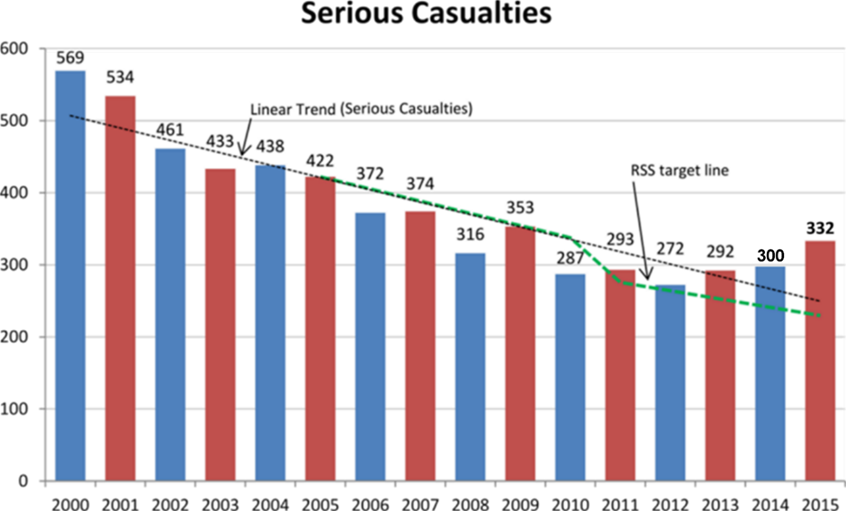

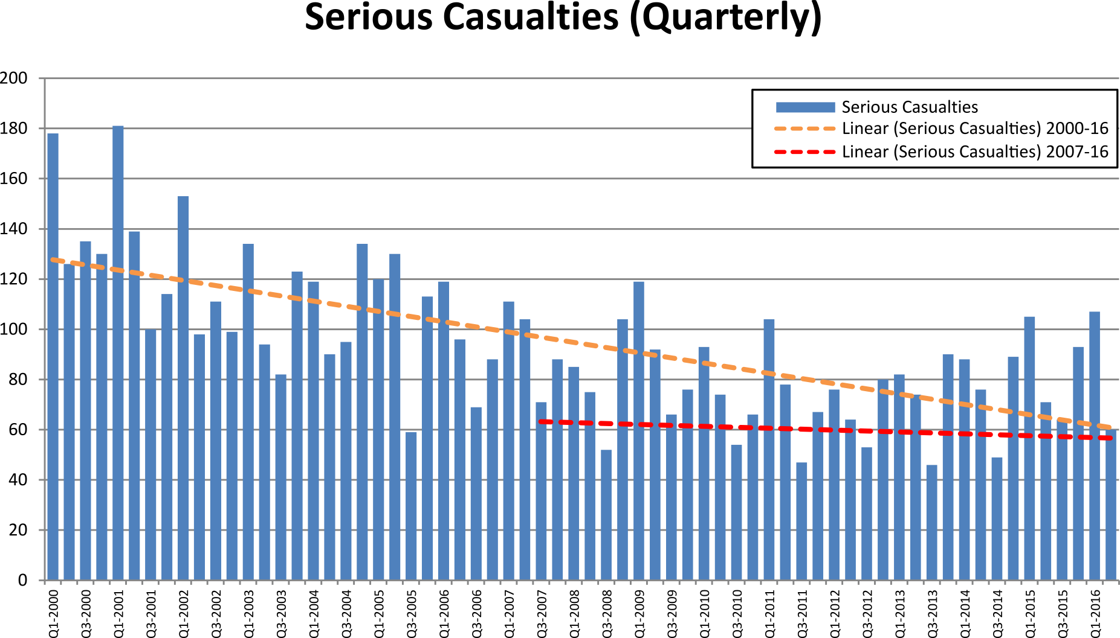

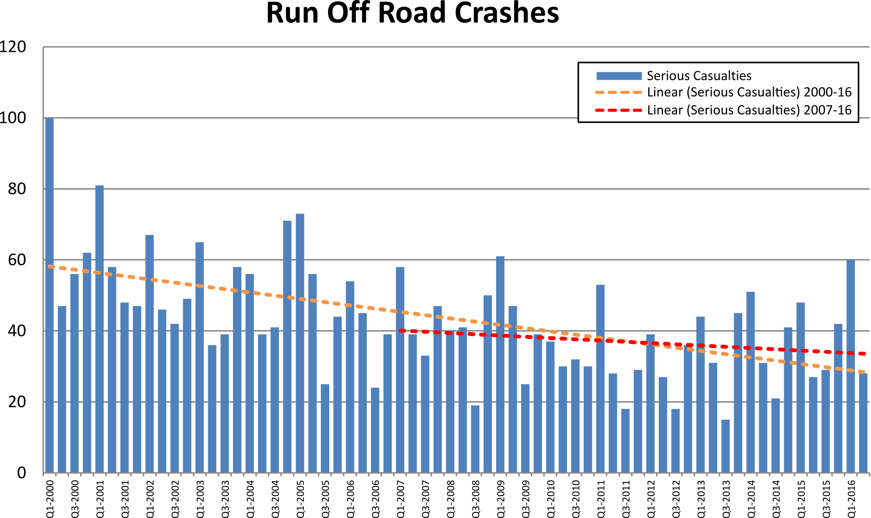

*Depicts serious casualties where a crash has occurred with the vehicle travelling off path through a curve or off path travelling straight

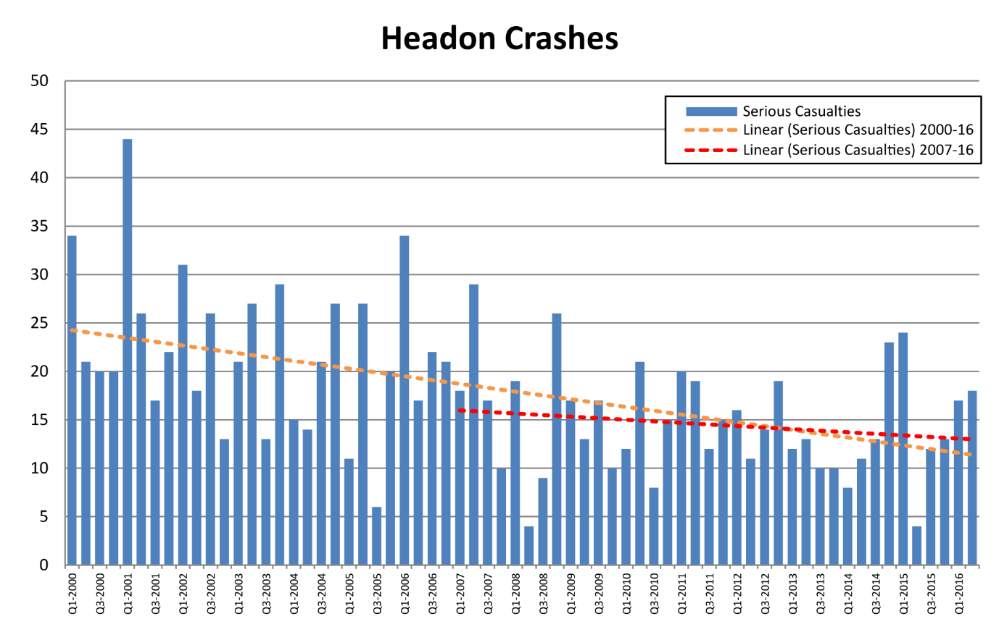
*Depicts serious casualties where a crash has occurred between vehicle from opposing directions

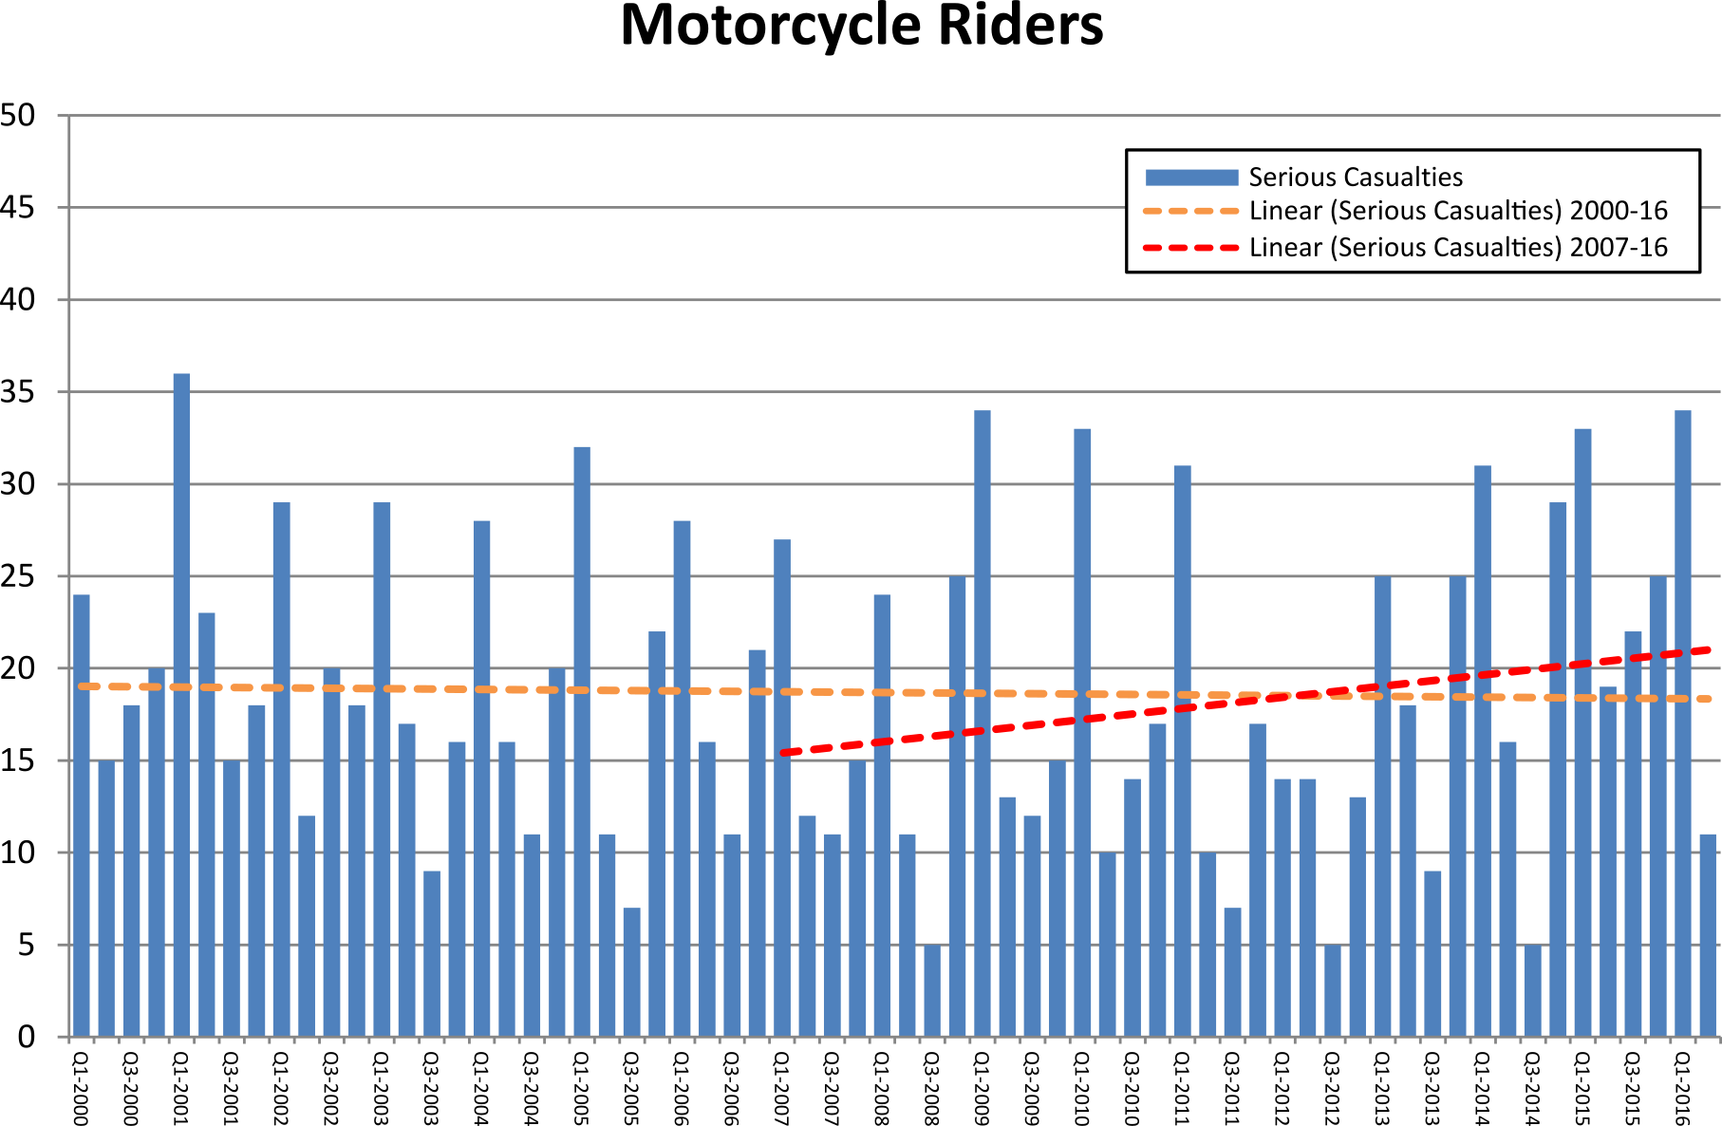

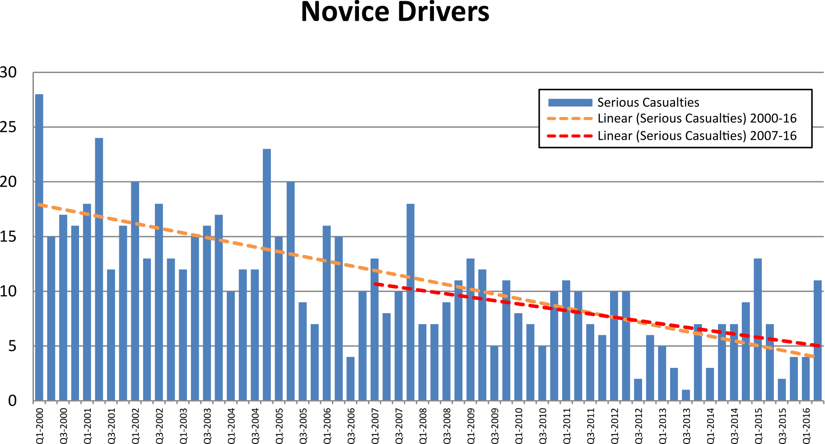
*Depicts serious casualties for drivers of a motor vehicle from 16 – 25 years of age

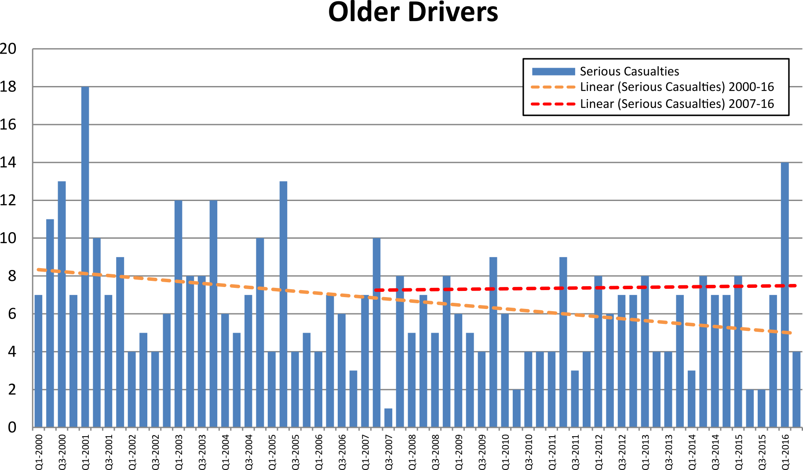

*Depicts serious casualties for drivers of a motor vehicle from 65 – 99 years of age
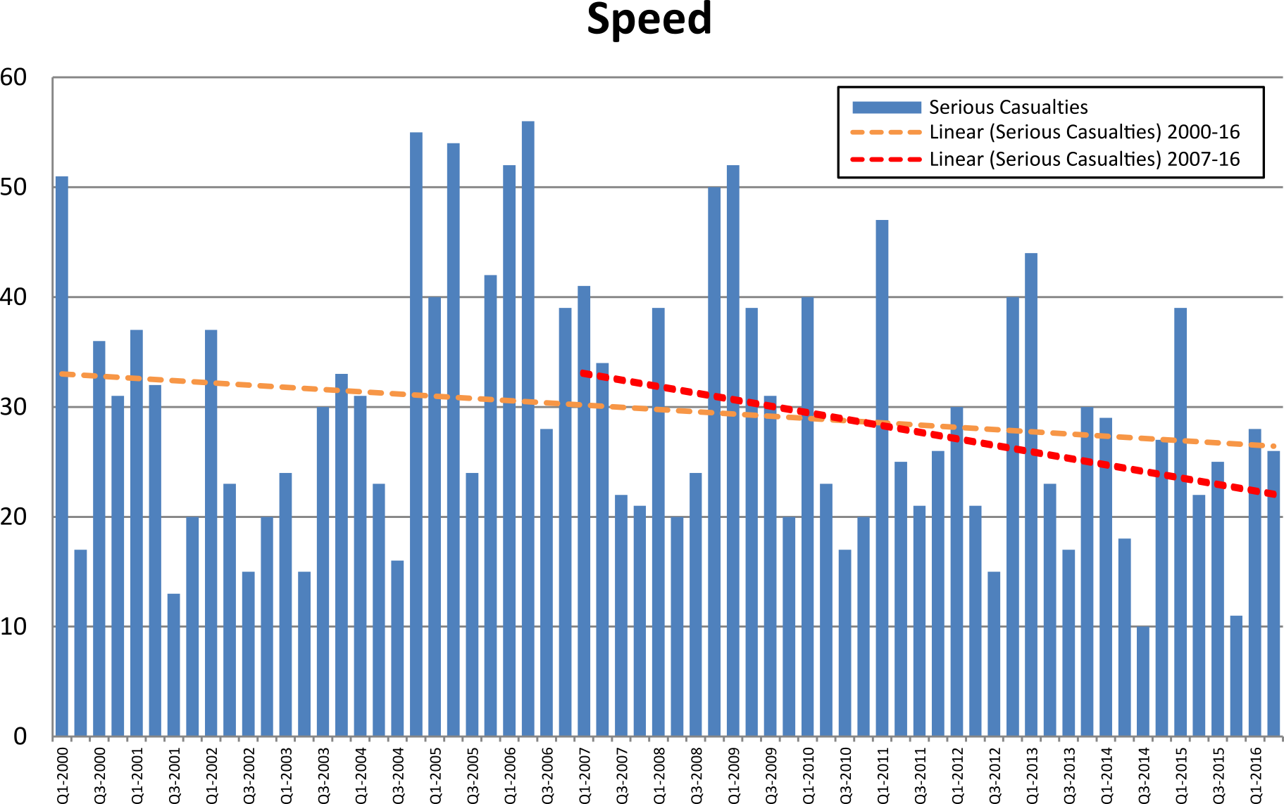
*Depicts serious casualties where the crash factor of exceeding the speed limit and/or excessive speed for the conditions/circumstances is listed as a contributing factor to the crash. There may be instances where both speed factors are recorded for a single crash.
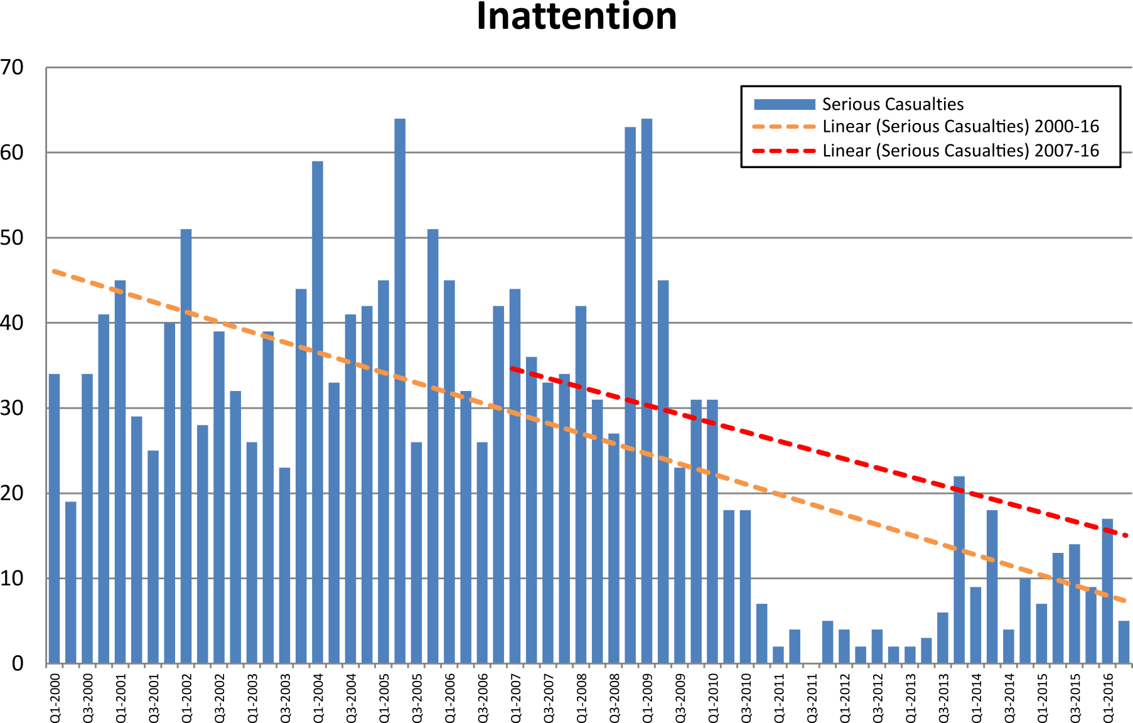

*From 1 January 2011 ‘inattentiveness’ will only be reported if there is no other relevant crash factor.

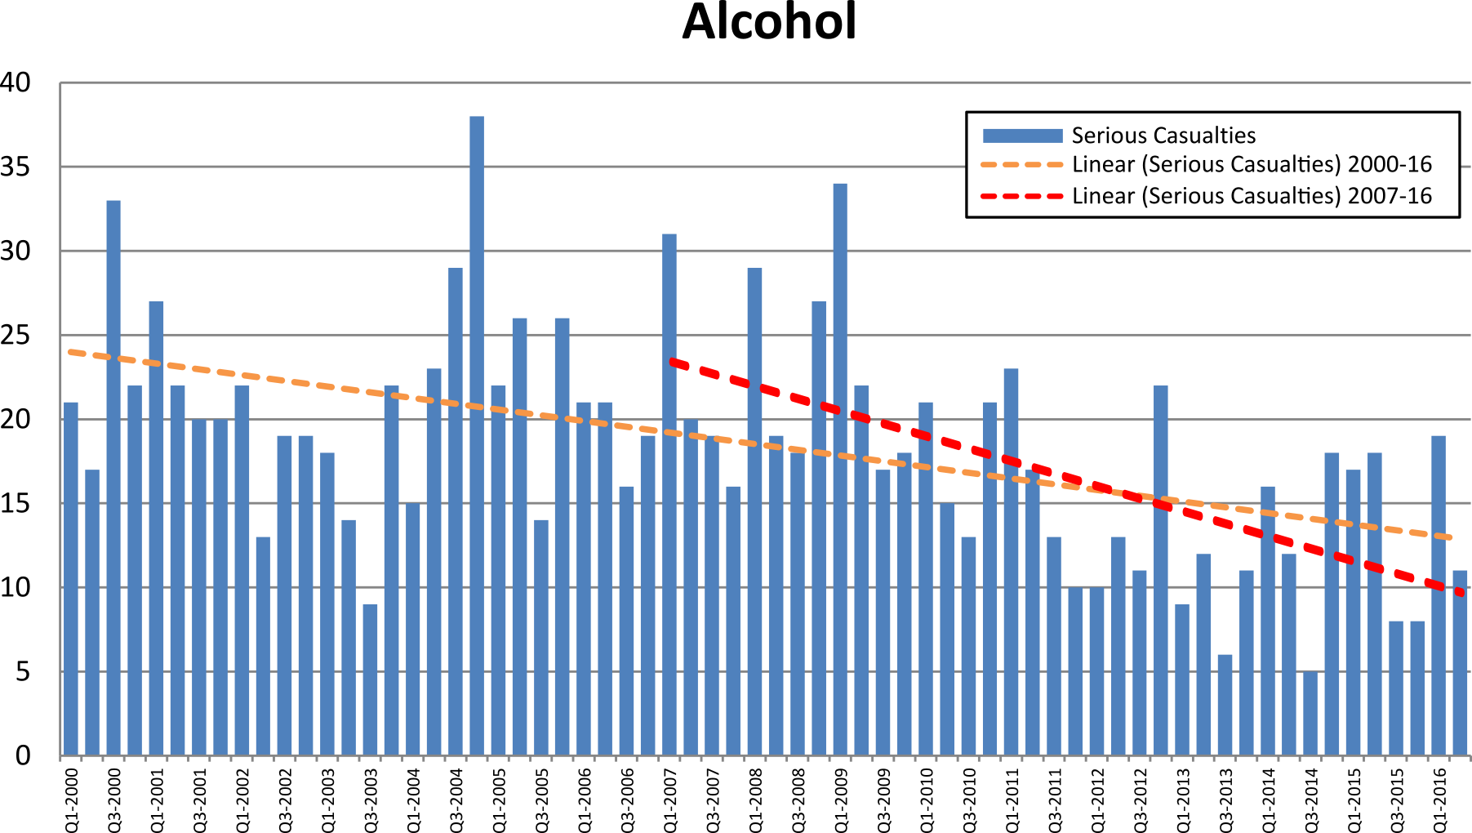*Depicts serious casualties where alcohol is listed as a contributing factor

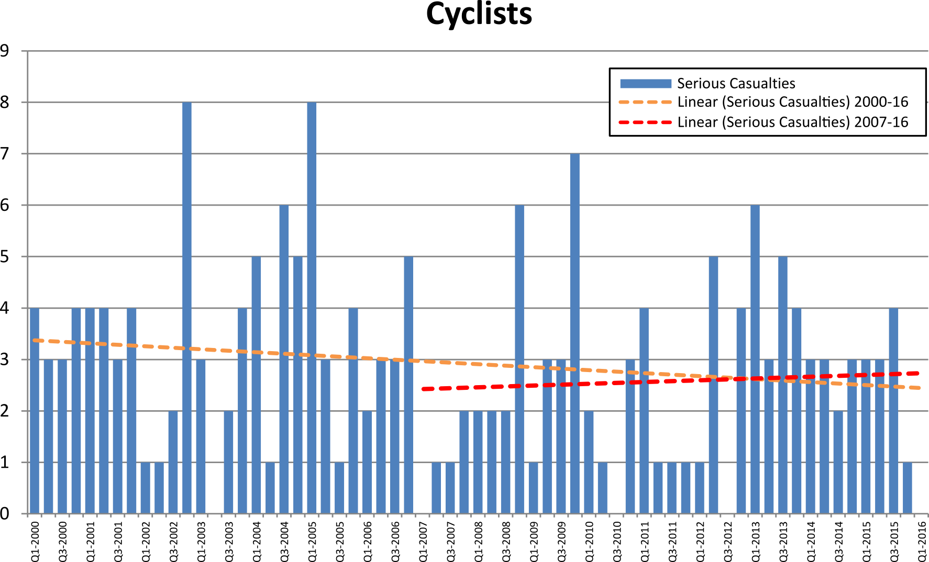

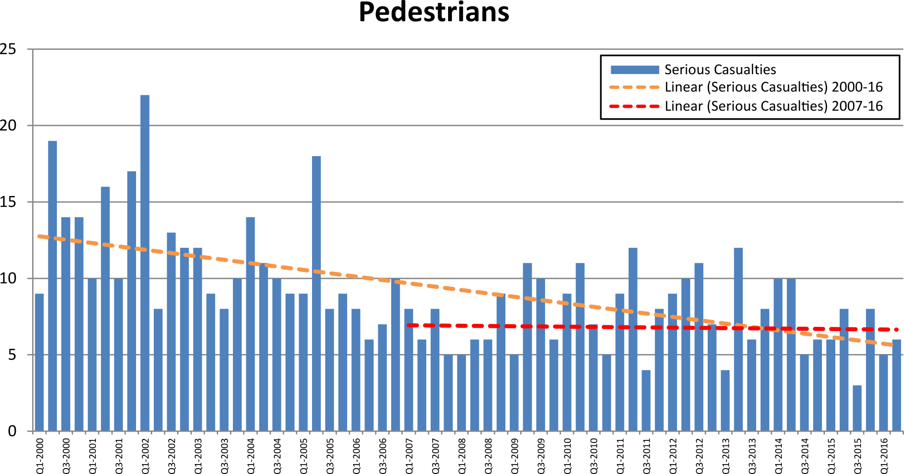

0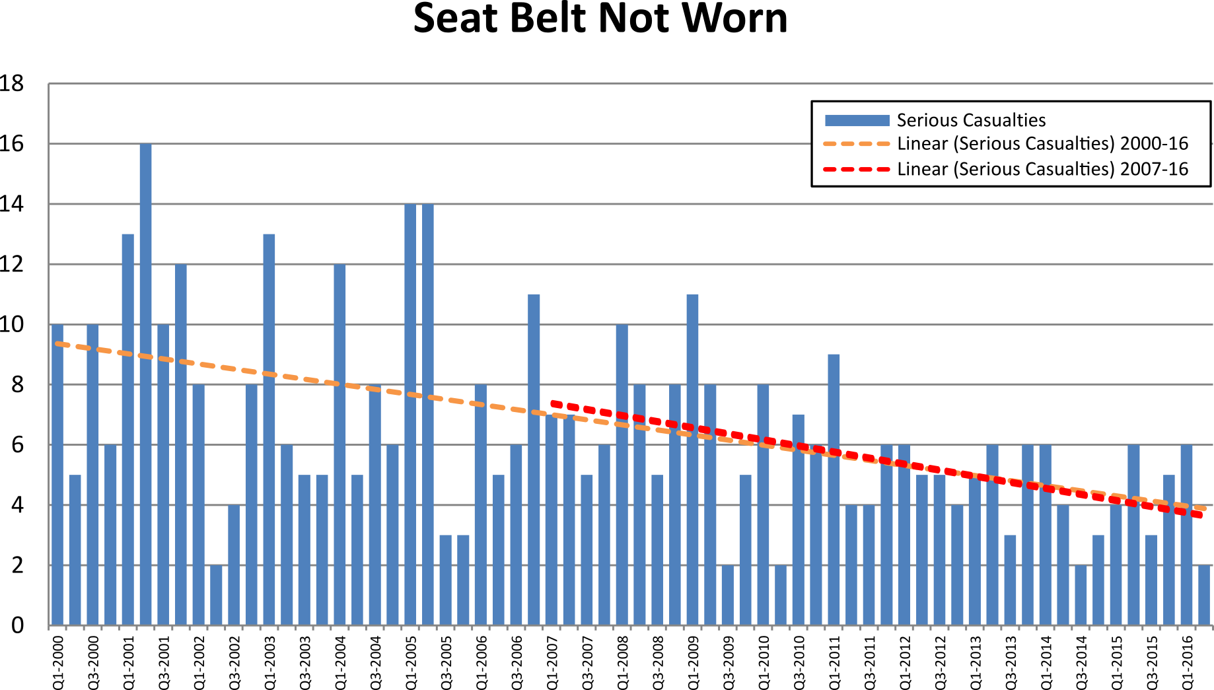

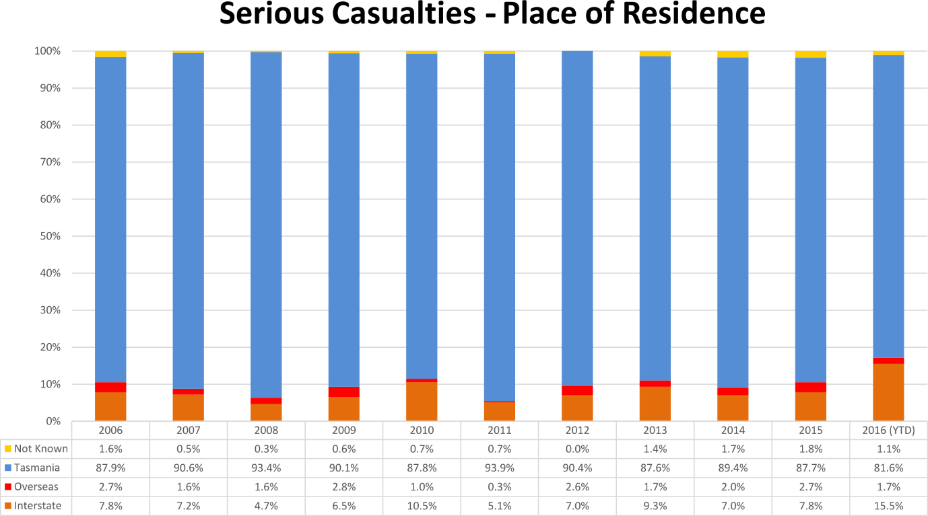

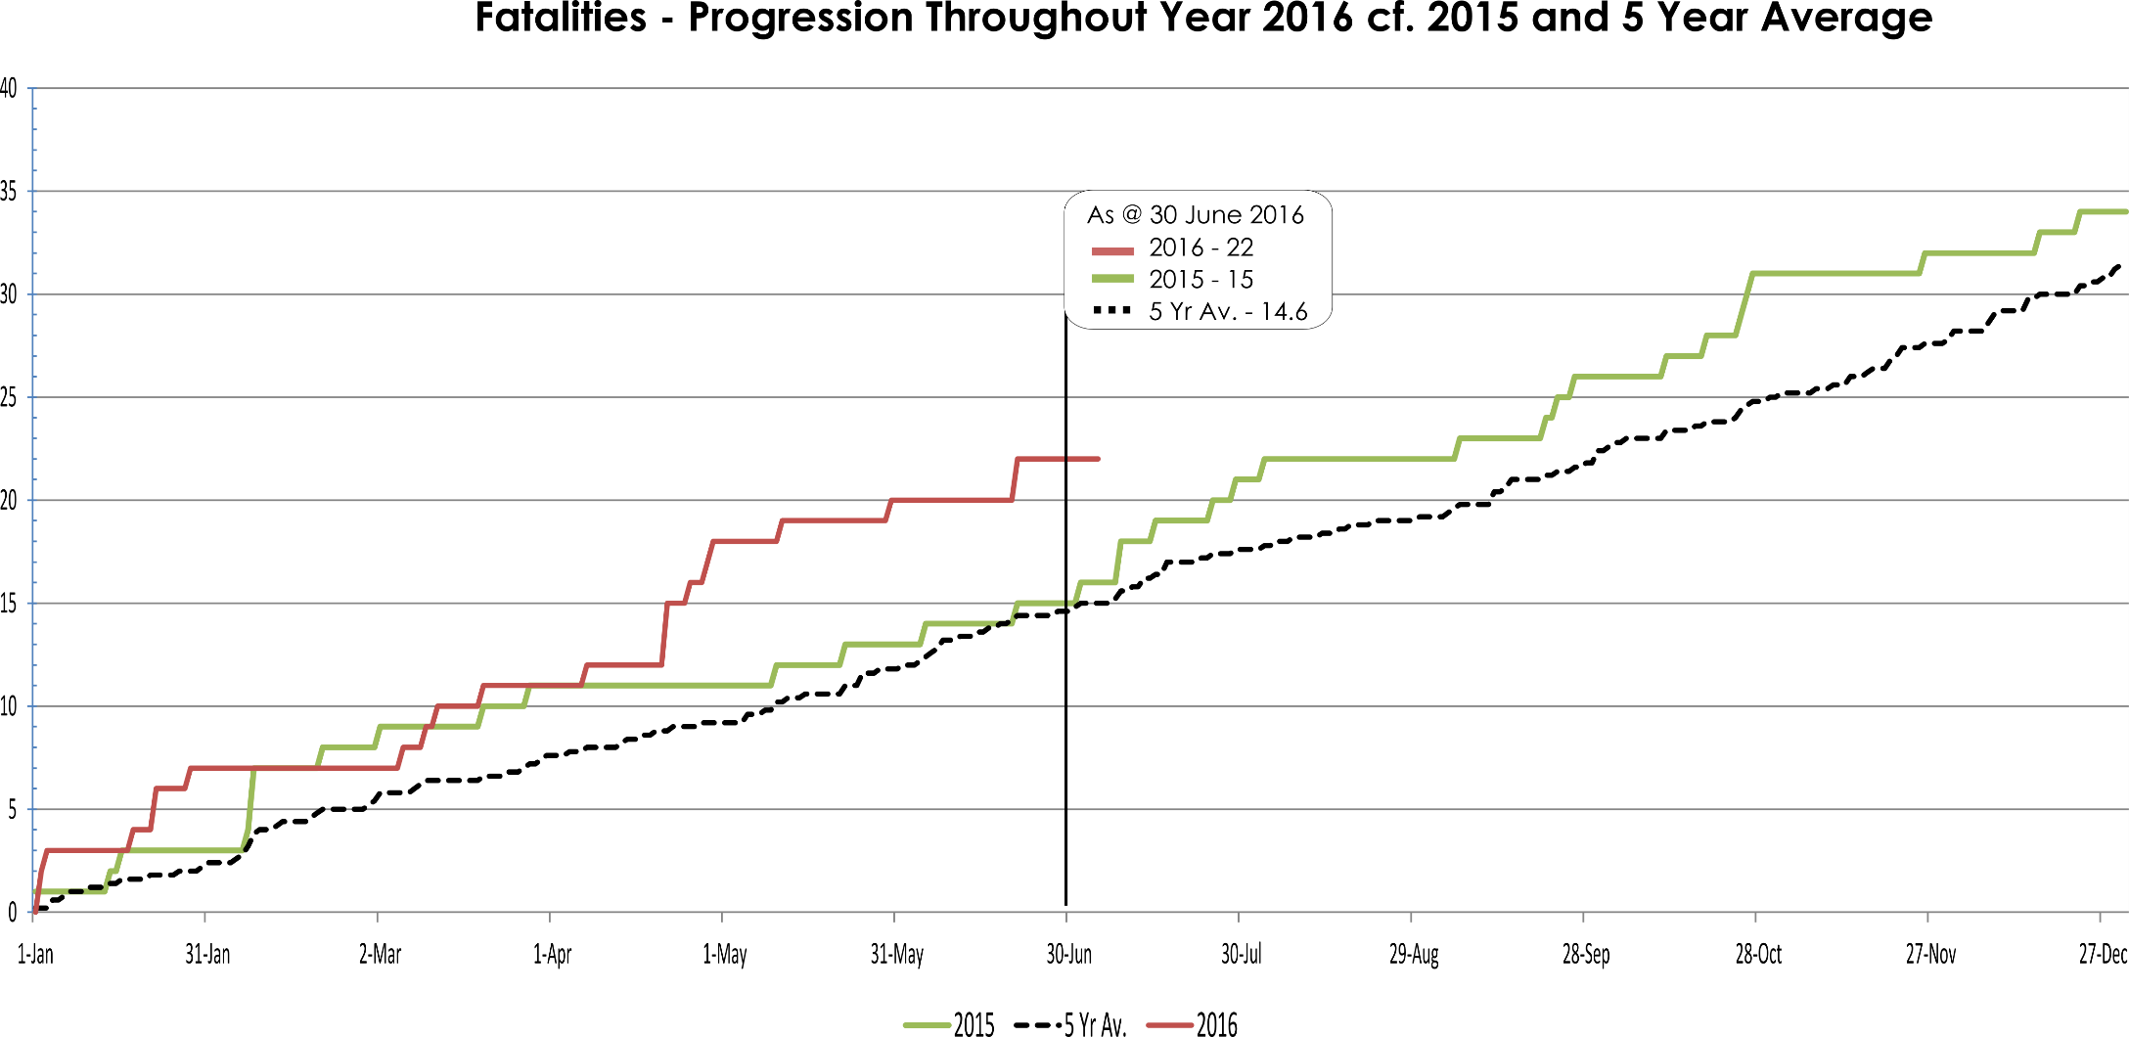
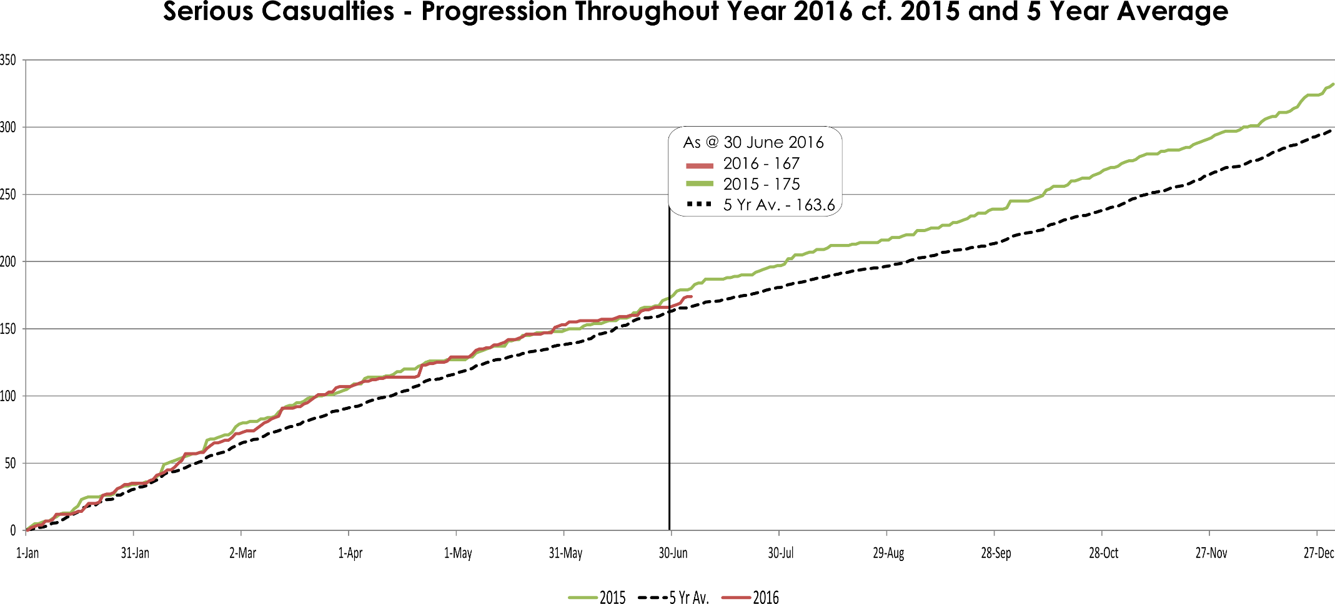
Serious Casualty locations as @ 30 June 2016 (Black = Fatal, Red = Serious Injury)
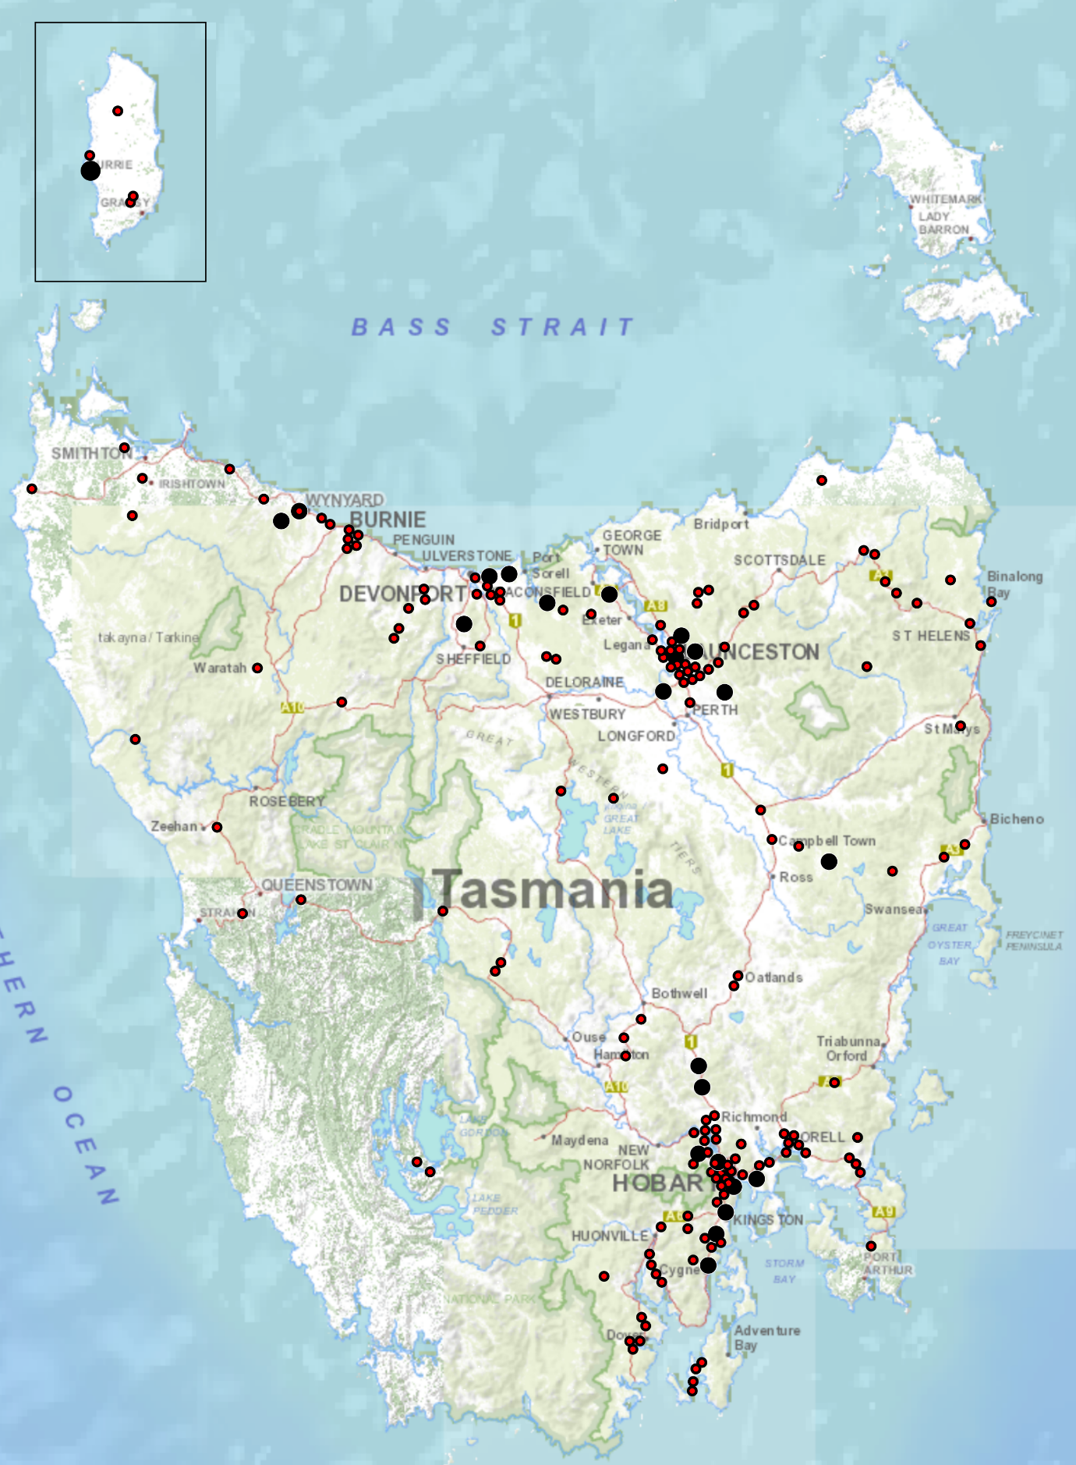

‘Other’ as a crash factor can be used in situations where the reporting police officer believes that the circumstances of the crash are not adequately covered by the existing list of 23 crash factors or where, in the case of a fatality, the death is subject to a coronial inquest. In cases where the Coroner makes findings in relation to the cause or causes of a fatality, the crash record is amended from ‘other’ to reflect the Coroner’s findings.

